**Project**

Reference GitHub Repo: <https://github.com/iam-veeramalla/GitHub-Actions-Zero-to-Hero>

SRC folder - Will have python code and on which we will write the GitHub Actions pipeline.

Examples folder – will have some sample templated that we can use in future if we are using any kind of same architecture.

.github/workflows folder – Will have the GitHub actions pipeline file.

Step -1: Clone the repo to local. Push it to GitHub to a new Separate Repo in order to execute GitHub Actions pipeline.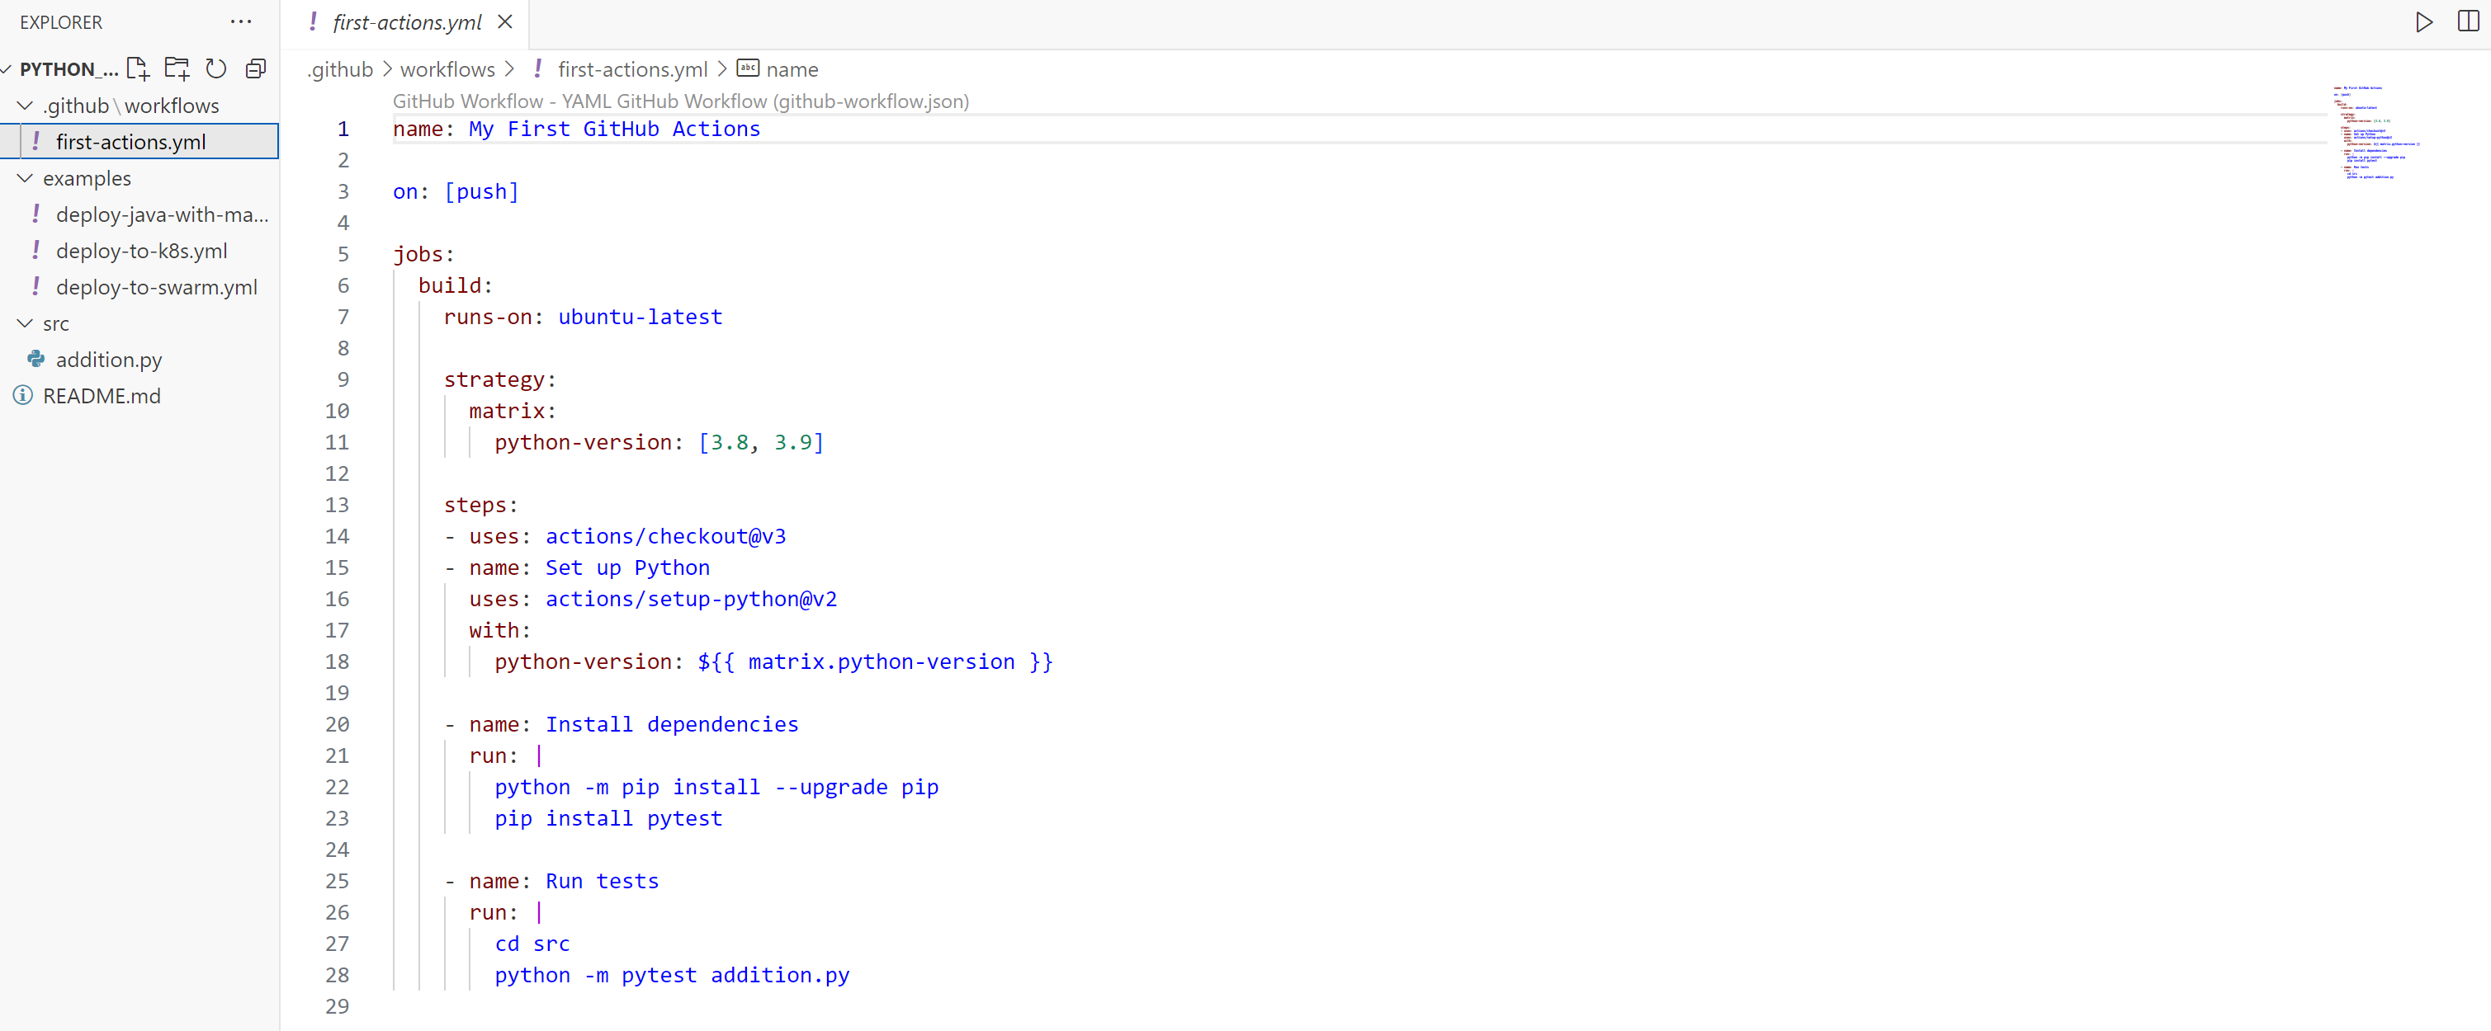 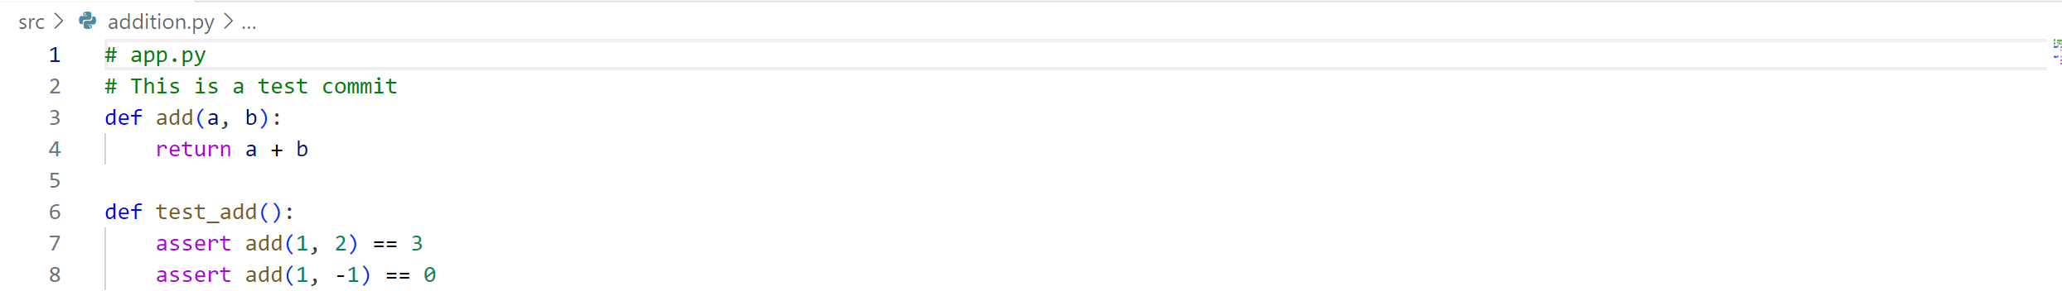Now push it to GitHub to check the GitHub Actions flow. 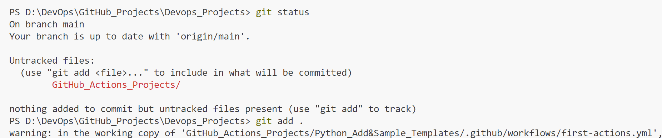 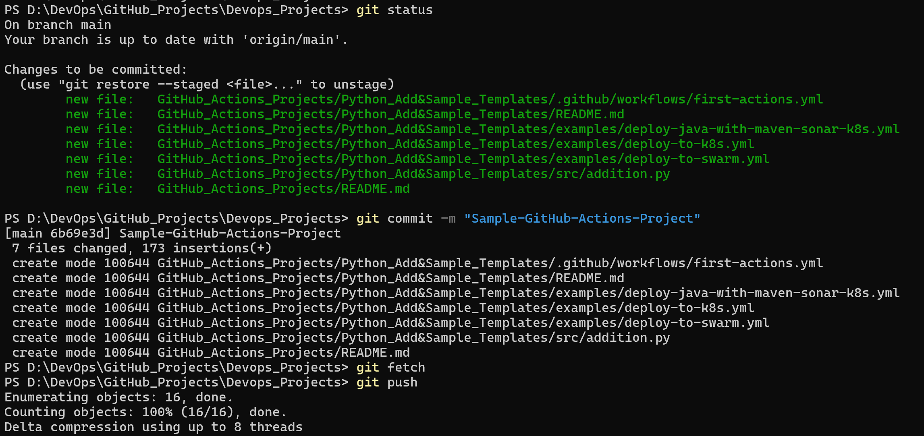The Project Directory is in Separate GitHub repo now.

Repo URL: <https://github.com/VarunTej06/GitHub-Actions-Project>

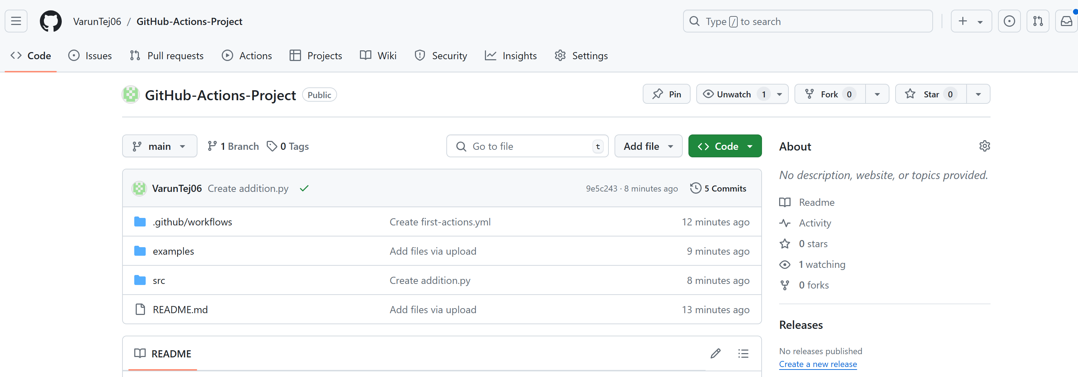Now let’s do some changes:

Can change in Local IDE and push to repo or directly change and commit in GitHub to invoke GitHub Actions pipeline. Remove line number 2 in addition.py file. After remove it will look like this.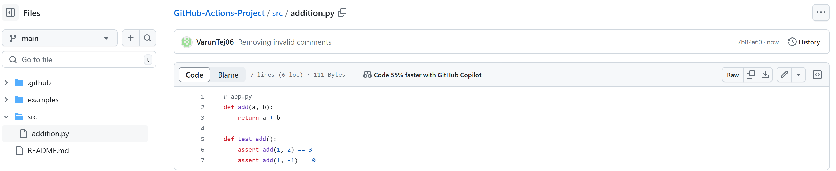 Go to the Repo main directory. You can see brown color dot which indicates GitHub Actions pipeline started running. 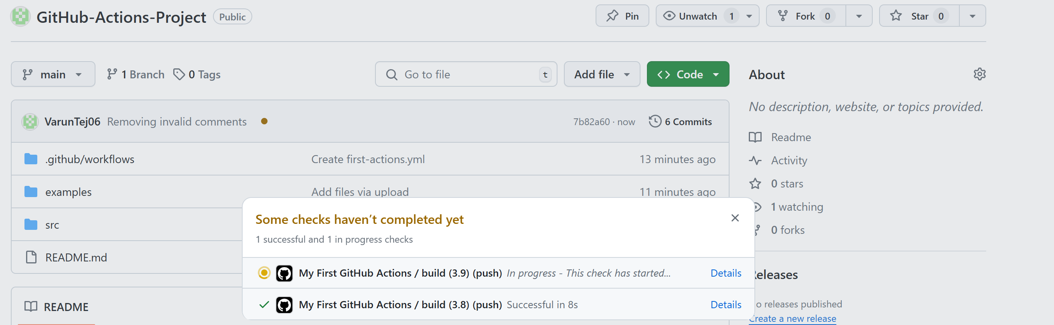 Click on Details: You can see build flow clearly. 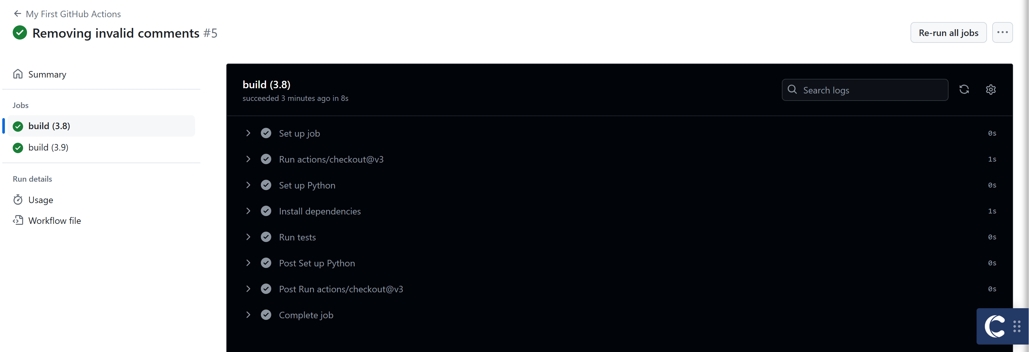Once the build is success you can green tick mark indicating success. 