**Project**

Writing Deployment file. Create a folder for Deployment Project. Then create deployemnt.yaml file in VS code.

Take reference from replica set yaml file to create this deployment file. 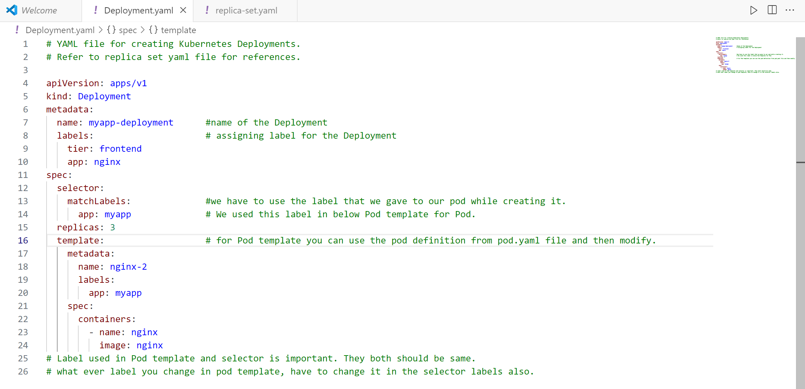  3 /3 pods are available. Can see from above. To know the pod details use below command. 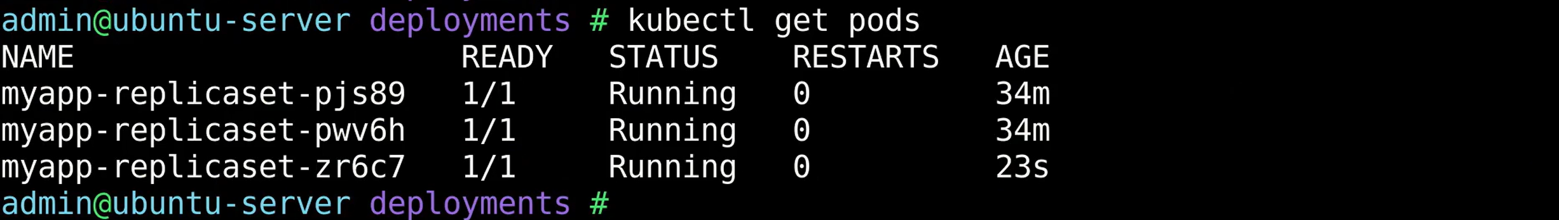 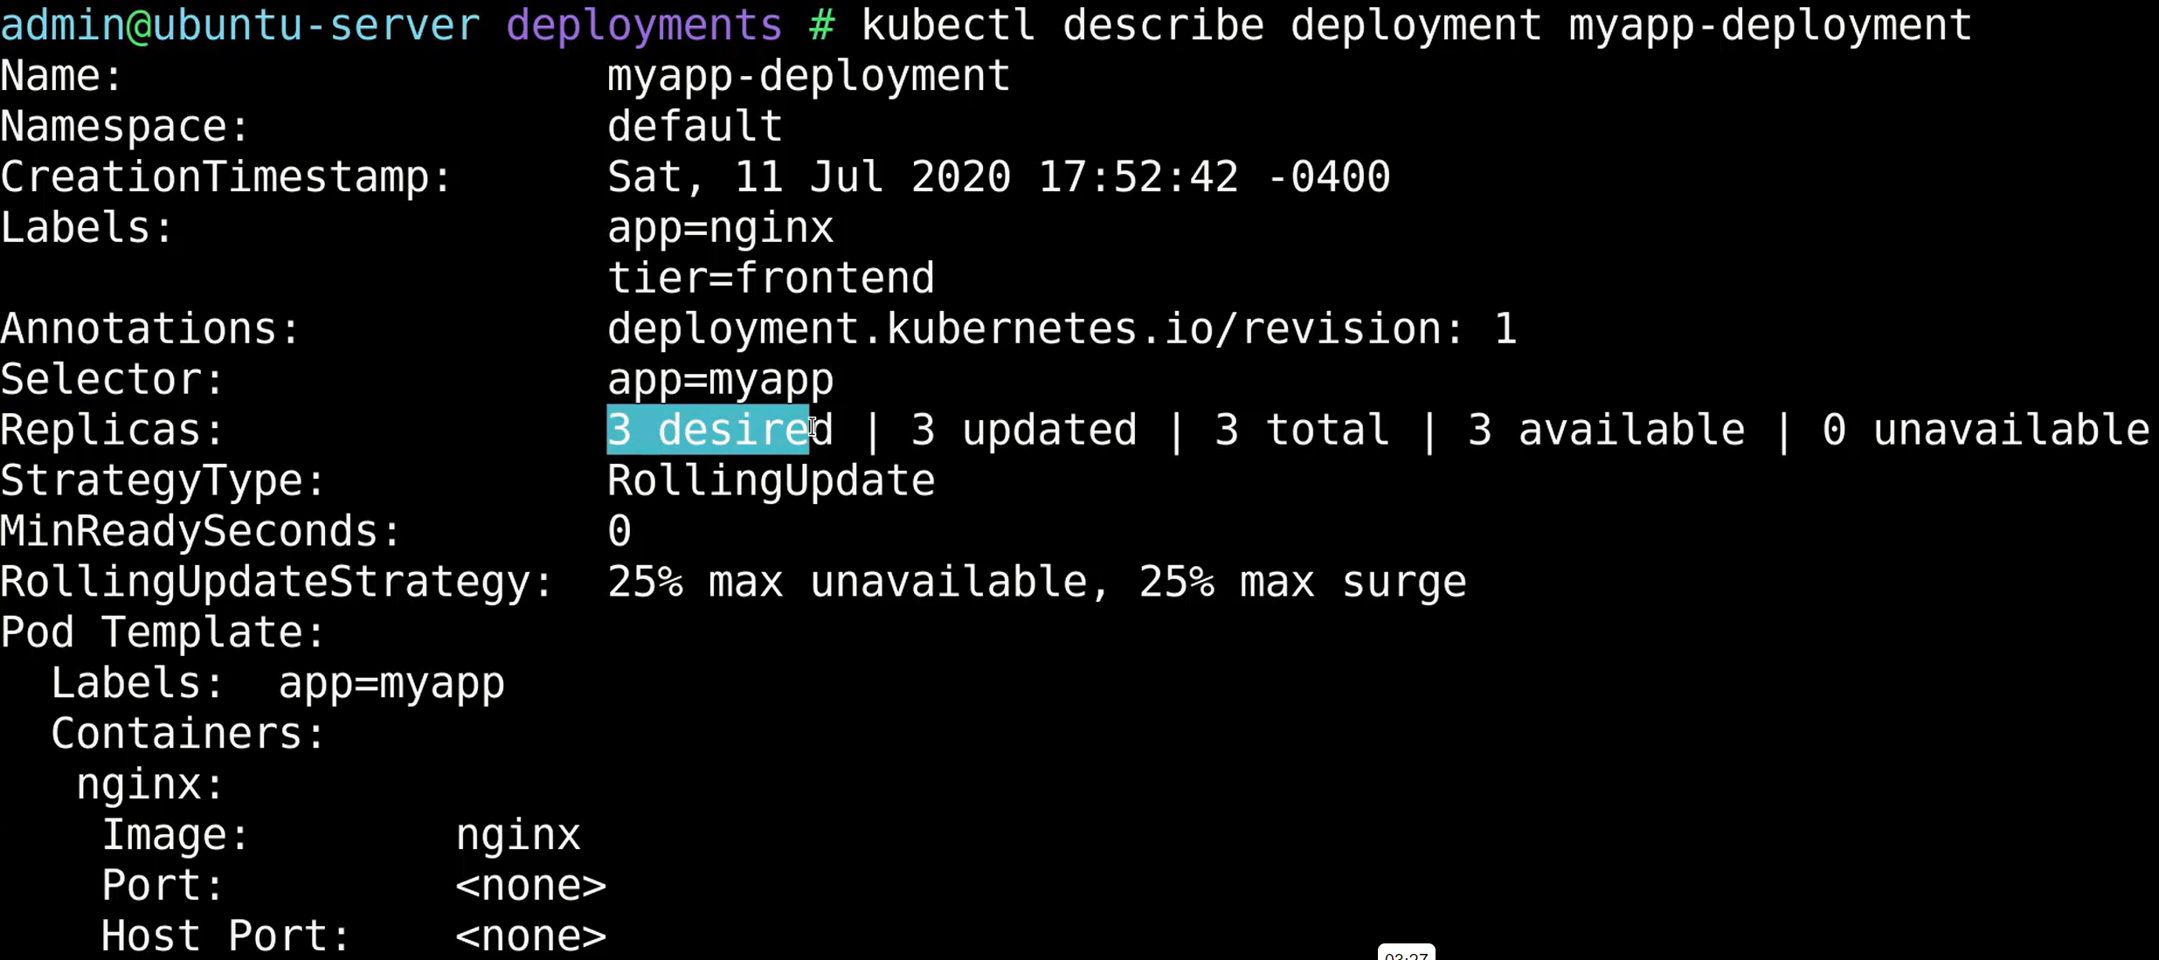 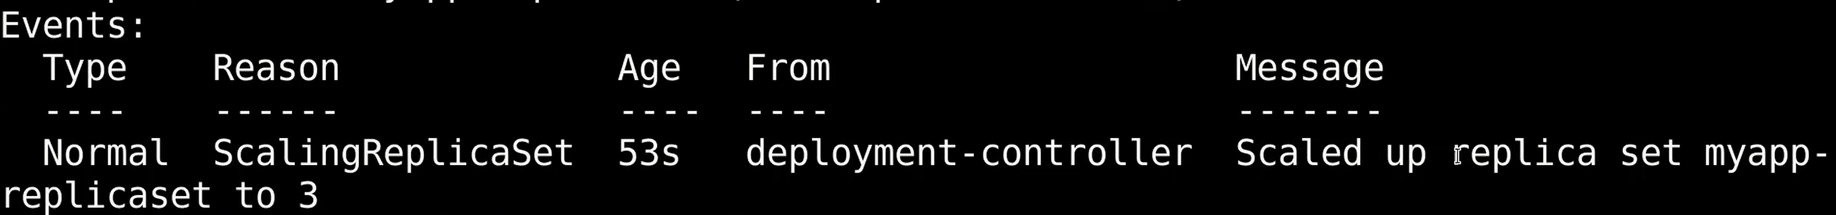 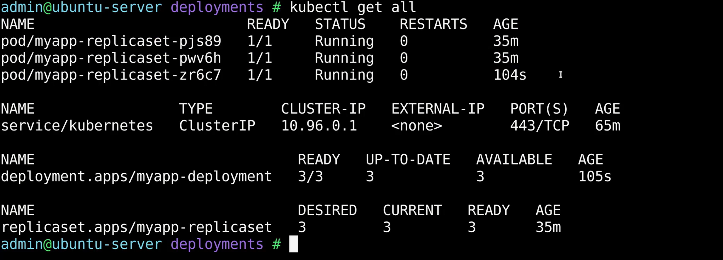**Another Deployment.yaml file:** 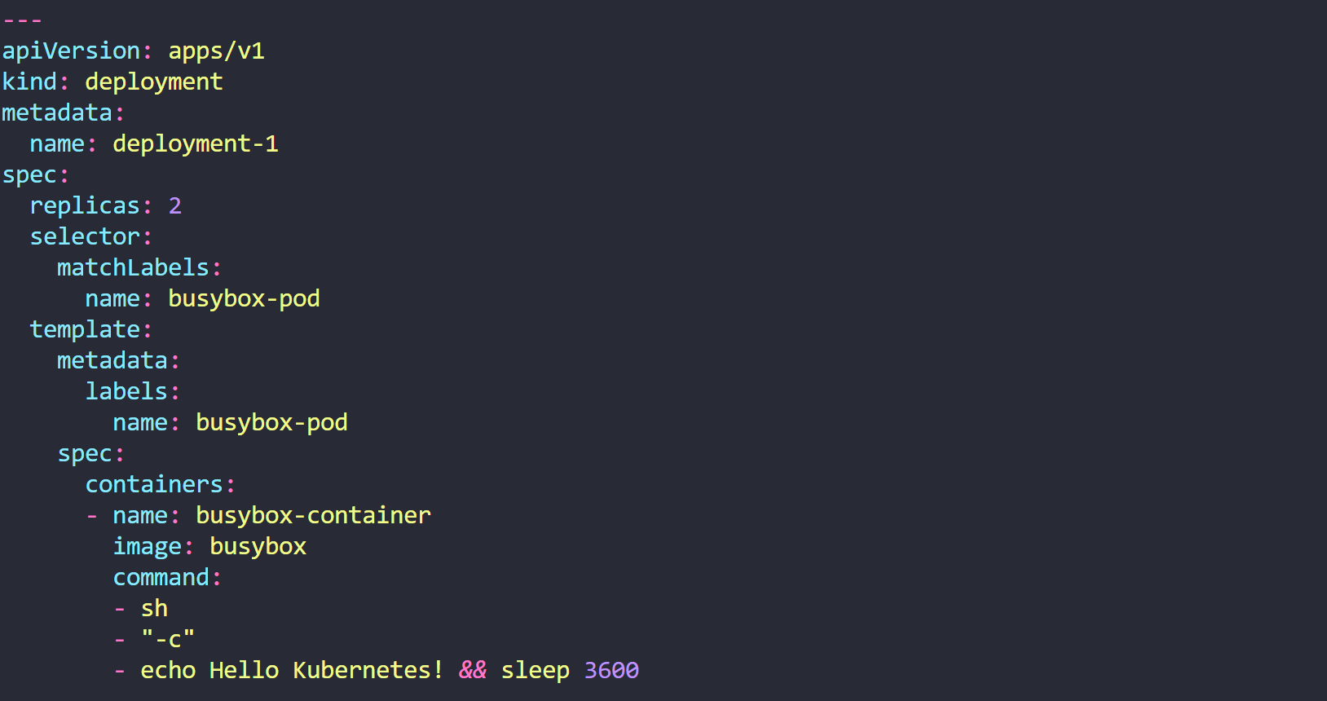 Create a new Deployment with the below attributes using your own deployment definition file. Name: httpd-frontend; Replicas: 3; Image: httpd:2.4-alpine

