**Project**

Lets try some minor project on Services. I previous project we create 6 pods by creating a deployment. Lets check the status of those first. We have a deployment and 6 pods running in K8 cluster. 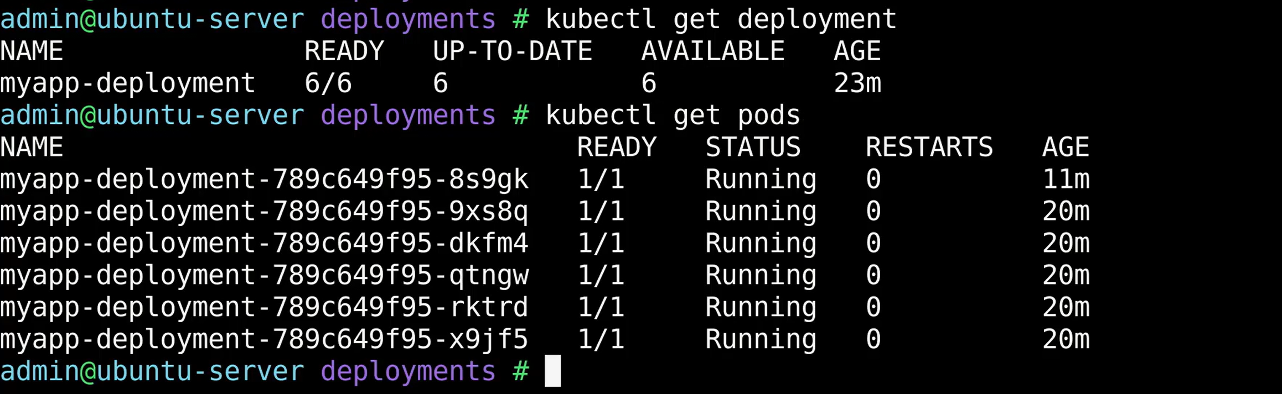Now, we have an application which is created to run on thi scluster. In order for the end user to access it on their web browser, we have to create a service. Create a new dirctory called service and create a new file called service-definition.yaml

Nginx listens on port 80. For the lables in selector check the deployment-definition yaml file and use the same label. 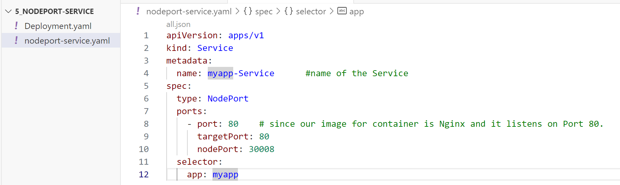Navigate to the directory and give kubectl create command.  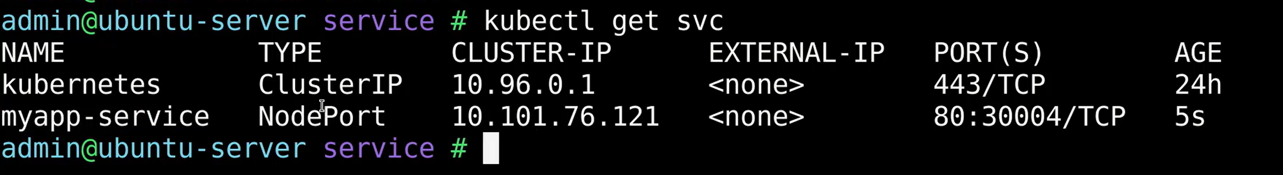New service is created. You can see type of service, port of node, etc. If we know the IP of worker node, then we can add this port number and access it.

Since we are running services on minikube, we can also run the minikube service command followed by the name of the service and use the option “--URL”. It should print us the URL where the service is available. You can access it from a browser using above URL.

