SYSTEM DESIGN
STUDY GUIDE
From Foundations to Advanced Concepts
A sequential, module-by-module companion covering mental models,
building blocks, and the seven-step design framework.

Contents

How to use this guide
This guide is built in twelve modules that follow the natural learning order: first the foundations every design rests on, then the seven-step framework you apply to any problem, and finally how to practice toward mastery. Work through them in sequence — each module assumes the previous ones.
For every concept, run the same four-step loop: learn the mechanism and the problem it solves; place it (know when you would reach for it and what it costs); apply it in a mock design; then stress it by asking what breaks at ten times the scale and what the failure mode is. A concept you cannot poke holes in is not learned yet. The goal is judgment, not vocabulary.
How each module is structured
- Theory — the core ideas, explained for understanding rather than memorization.
- Visuals — a chart or diagram for each major concept to anchor the mental model.
- Comparison tables — side-by-side so you learn not just what each option is, but when to choose it.
- Self-check — questions to confirm you can reason about the topic, not just recall it.

PART ONE — FOUNDATIONS
Before you can design systems you need the vocabulary of components and the laws that govern them. Spend real time here; these modules are what separate someone who memorizes answers from someone who can reason about novel systems.

Module 1 — Core Mental Models
These five ideas underlie every decision you will make. Internalize them before touching components.

1.1 Latency vs. throughput
Latency is the time a single request takes; throughput is how many requests the system handles per unit time. They are different goals and often trade off — batching work raises throughput but adds latency, while serving each request immediately lowers latency but can cap throughput. Always know which one a given system optimizes for. Crucially, measure latency in percentiles (p50, p95, p99), never averages: averages hide the slow tail of requests that real users actually feel.

1.2 Vertical vs. horizontal scaling
Vertical scaling means a bigger machine; horizontal scaling means more machines. Vertical is simple but hits a hard ceiling and leaves a single point of failure. Horizontal scaling is the only path to large scale, but it introduces the real difficulty of system design: coordinating state across many nodes.
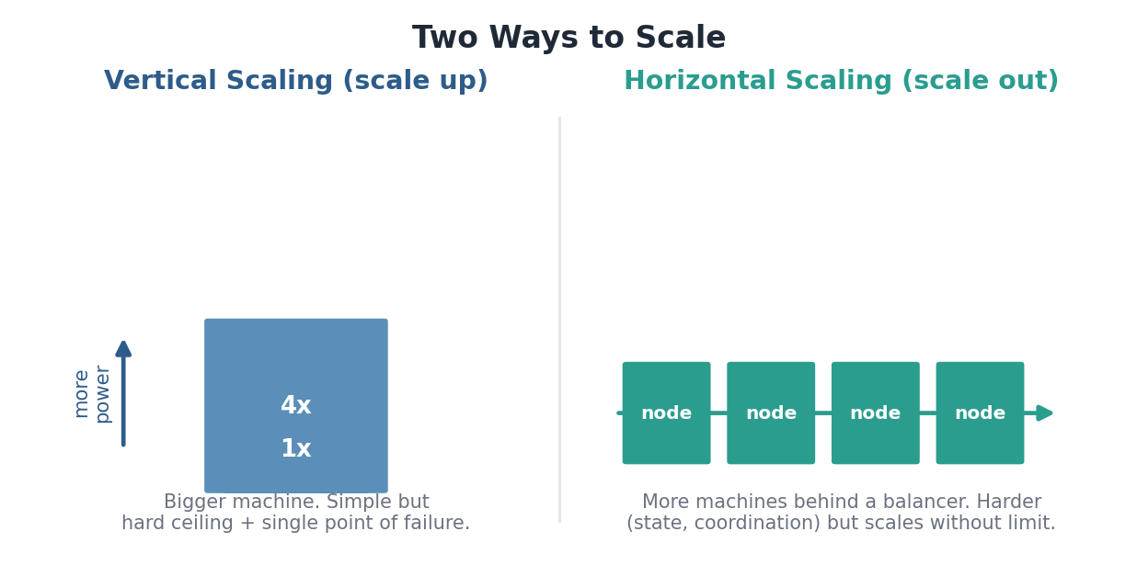
Figure: Scaling up adds power to one node; scaling out adds nodes behind a balancer.

1.3 Stateless vs. stateful services
A stateless service holds no client-specific data between requests, so any instance can handle any request and you scale it simply by adding instances. State is where all the difficulty lives. The central design move is to push state out of your application tier into databases, caches, and queues, keeping the application layer stateless and trivially scalable.

1.4 The CAP theorem
CAP states that during a network partition, a distributed system must choose between Consistency (every read sees the latest write) and Availability (every request gets a response). You cannot have both while partitioned. Real systems pick a point on a spectrum rather than a binary; the PACELC refinement adds that even without partitions (Else) you still trade Latency against Consistency.
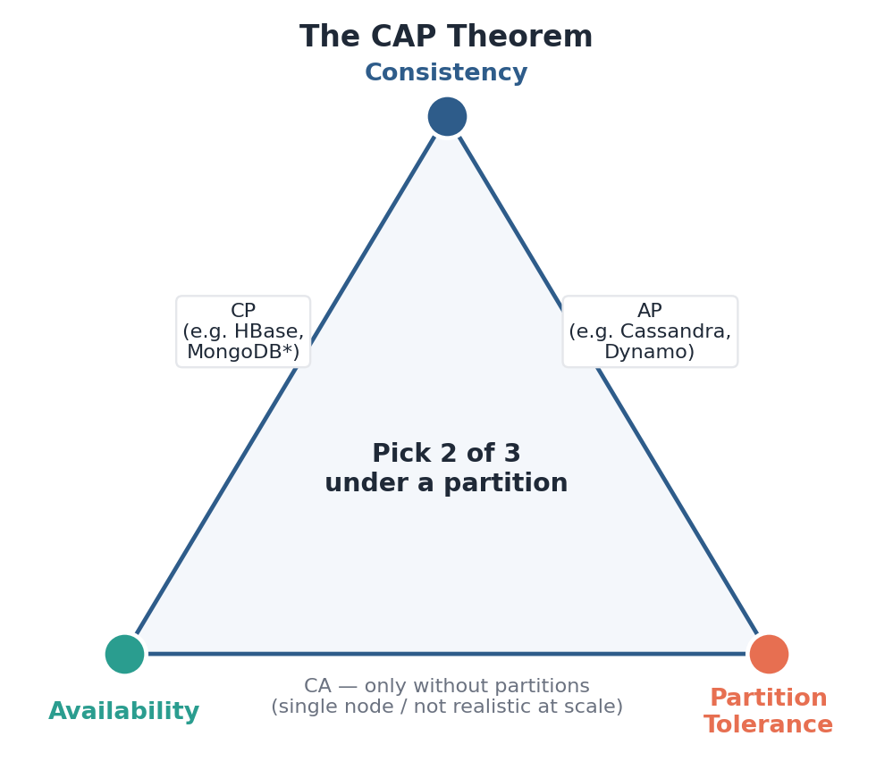
Figure: Under a partition you choose two of three. CA systems only exist without partitions.

1.5 Consistency models
Consistency is not on/off — it is a spectrum of guarantees, each with a cost. Stronger models are easier to reason about but slower and less available; weaker models are fast and resilient but force you to handle stale or out-of-order data. Match the model to the data: a bank balance needs strong consistency, a like-count is fine with eventual.
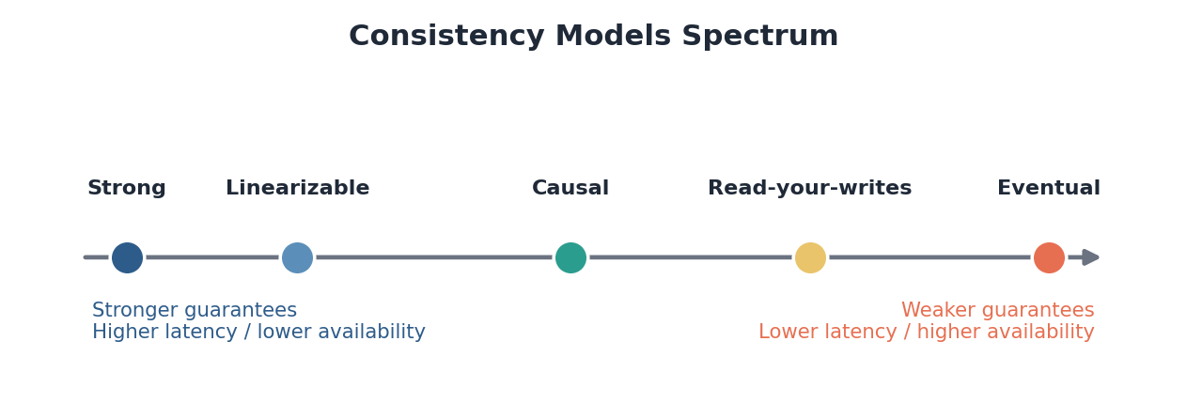
Figure: Stronger guarantees on the left cost latency and availability; weaker on the right buy speed.

Self-check
- Why do averages mislead when measuring latency, and what should you report instead?
- Give one piece of data that needs strong consistency and one that is fine with eventual — and why.
- A service must stay available during a network partition. What must it give up, per CAP?
- Why does making a service stateless make it so much easier to scale horizontally?

Module 2 — The Building Blocks
Every architecture is assembled from a small set of recurring components. For each one, you should be able to state what it does, when to reach for it, and how it fails.
Component | What it does / when to use | Key failure mode
Load balancer | Distributes traffic across instances (L4 transport vs. L7 application). Algorithms: round-robin, least-connections, consistent hashing. | Becomes a bottleneck or SPOF if not itself redundant.
Cache | Stores hot data in fast memory close to use. Patterns: cache-aside, write-through, write-back. | Stale data; stampede when a hot key expires.
CDN | Serves static / cacheable content from edge locations near users. | Stale assets until cache invalidates / TTL expires.
Message queue / stream | Decouples producers from consumers; absorbs spikes; enables async work (Kafka, RabbitMQ). | Backlog growth; duplicate or out-of-order delivery.
API gateway / reverse proxy | Single entry point for auth, routing, rate limiting, TLS termination. | SPOF; added latency on every request.
Object / blob storage | Stores large files, images, video, backups (S3-style). | High latency for many small objects.
Search index | Full-text and faceted search over data (Elasticsearch). | Lag behind source of truth; reindex cost.

2.1 Caching patterns
Caching is usually your single biggest performance lever, and the hard parts are invalidation and stampedes. The three write patterns differ in how cache and database stay in sync, trading write speed against consistency and durability.
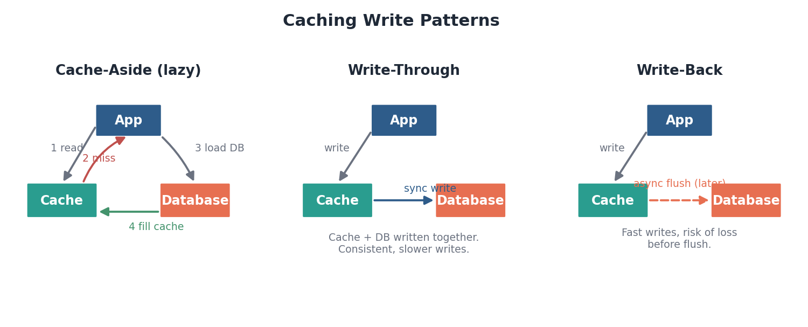
Figure: Cache-aside loads lazily on a miss; write-through writes both synchronously; write-back flushes later.

2.2 Replication
Replication keeps copies of data on multiple nodes for read scaling and availability. The common leader-follower model sends all writes to a leader, which asynchronously copies them to followers that serve reads. The catch is replication lag: a follower can briefly return stale data, which interacts directly with your consistency choice.
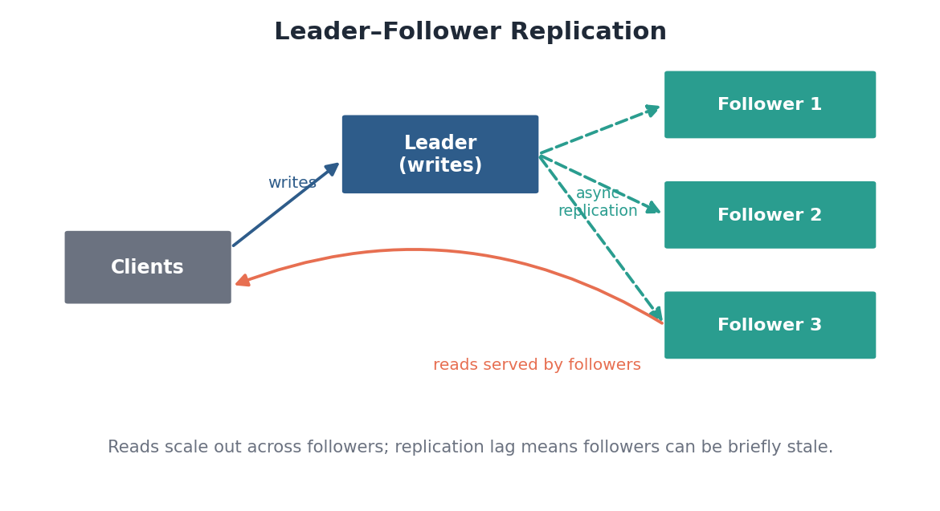
Figure: Writes go to the leader; reads fan out across followers, which may lag slightly behind.

2.3 Sharding (horizontal partitioning)
When data outgrows a single node, you split it across nodes by a shard key. This is one of the highest-leverage and hardest decisions in system design: a poorly chosen key creates hot spots where one shard takes disproportionate traffic, and resharding later is painful. Consistent hashing reduces how much data must move when nodes are added or removed.
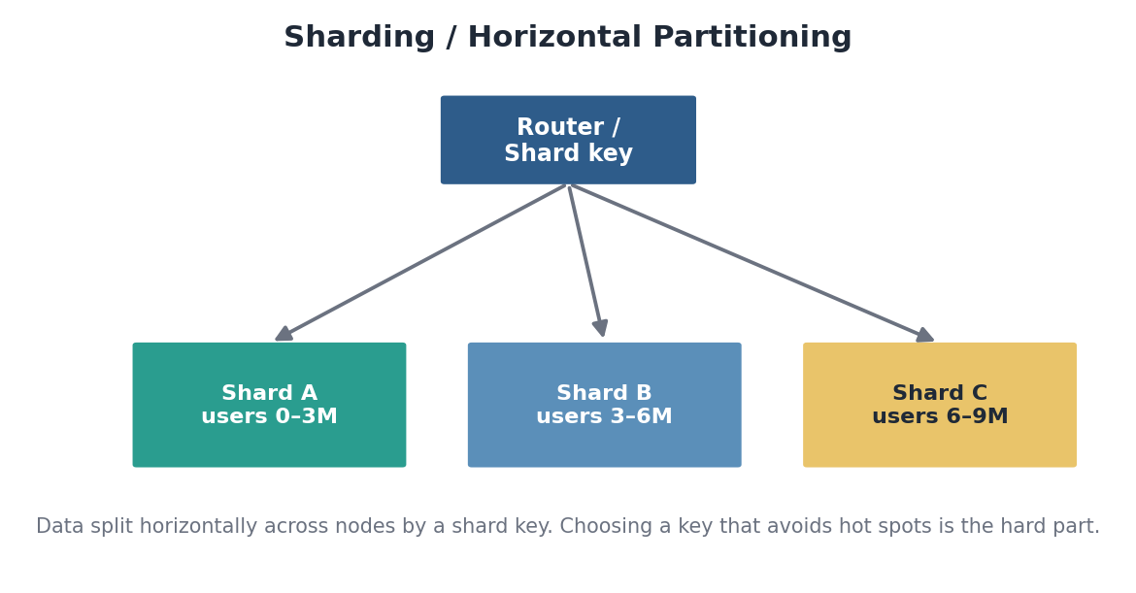
Figure: Data is partitioned by a shard key; the key must spread load evenly and support the main queries.

2.4 Choosing a datastore: SQL vs. NoSQL
Dimension | Relational (SQL) | NoSQL families
Schema | Fixed, enforced | Flexible / schema-on-read
Consistency | Strong, ACID transactions | Often eventual / tunable
Relationships | Joins, foreign keys | Denormalized; app-side joins
Scaling | Vertical first; sharding is work | Built for horizontal scale
Best for | Complex queries, integrity, money | Scale, flexible data, known access patterns
Examples | PostgreSQL, MySQL | Cassandra, DynamoDB, MongoDB, Redis

Rule of thumb
- Default to a relational database until a concrete requirement (scale, flexible schema, a specific access pattern) forces otherwise.
- Large systems rarely pick one — they use polyglot persistence: the right store for each job.

Self-check
- When would you choose write-through over cache-aside, and what do you give up?
- What is replication lag, and how can it surprise a user who just wrote data?
- Describe the hot-key problem and one way a poor shard key causes it.
- Name a workload where NoSQL clearly beats relational, and explain why.

Module 3 — Networking & Protocols
You need enough networking to reason about how requests travel and where they can fail — not to recite RFCs.

3.1 The lifecycle of a request
Being able to trace one request end to end, and name what could fail at each hop, is a core foundational skill. The path below is the backbone of almost every web system.
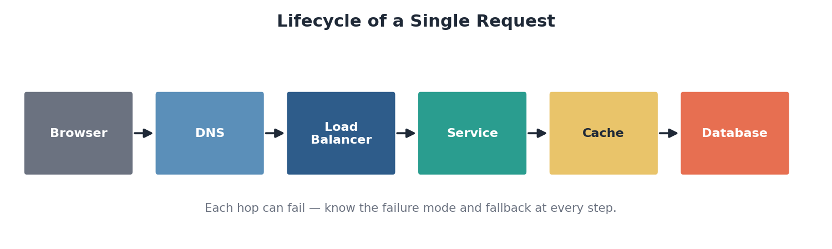
Figure: Browser to DNS to load balancer to service to cache or database, and back.

3.2 Protocols worth knowing
- TCP — connectionless, reliable, ordered byte stream; the default for web traffic.
- UDP — connectionless and unreliable but low-overhead; used for video, gaming, DNS.
- HTTP/HTTPS — the request/response semantics of the web; learn status codes, methods, and idempotency.
- gRPC — a binary, high-performance RPC protocol favored for internal service-to-service calls.
- DNS — translates human-readable names to IP addresses; the first hop of nearly every request.

3.3 Real-time communication options
Several features (chat, live dashboards, notifications) need the server to push data to clients. The options trade simplicity against efficiency.
Technique | How it works | Best for
Short polling | Client asks repeatedly on a timer | Simple, infrequent updates
Long polling | Server holds the request open until it has data | Near-real-time without WebSockets
Server-Sent Events | One-way server-to-client stream over HTTP | Live feeds, notifications
WebSockets | Full-duplex persistent connection | Chat, collaboration, gaming

Self-check
- Trace a request from browser to database and name a failure mode at each hop.
- Why might an internal microservice call use gRPC instead of REST over JSON?
- For a live sports-score ticker, would you pick SSE or WebSockets? Justify it.

PART TWO — THE SEVEN-STEP FRAMEWORK
This is the structure of nearly every system design problem and interview. Apply the steps in order. As a rough budget: requirements 15%, estimation 10%, APIs 10%, high-level design 25%, data 20%, scale and reliability 15%, and tradeoffs threading through everything.
# | Step | Output of the step
1 | Requirements | A bounded list of functional + non-functional needs
2 | Estimations | Peak QPS, storage, and whether the hot set fits in memory
3 | APIs | A minimal set of endpoints covering the requirements
4 | High-level design | A diagram + a walkthrough of a read and a write
5 | Database design | Schema, store choice, sharding and replication plan
6 | Scale & reliability | A design that survives 10x load and component failure
7 | Tradeoffs & bottlenecks | Justified decisions and where the system breaks first

Module 4 — Step 1: Requirements
The most common failure in system design is building the wrong system. Never start drawing boxes until you have bounded the problem. Requirements come in two kinds.
Functional requirements | Non-functional requirements
What the system does — its features. | The qualities it must have.
Get the core 2–4 features; defer the rest explicitly. | Availability, latency, consistency, durability, scale.
Example (chat): send/receive messages, presence, group chats. | Example: 99.99% available, p99 under 200 ms, messages never lost.

4.1 The availability nines
Each additional nine is an order of magnitude more engineering effort and cost. Pick a target deliberately — do not default to the highest.
Availability | Downtime per year | Typical use
99% (two nines) | ~3.65 days | Internal tools
99.9% (three nines) | ~8.8 hours | Standard web apps
99.99% (four nines) | ~52 minutes | Business-critical services
99.999% (five nines) | ~5 minutes | Telecom, payments infrastructure

Skills that signal seniority
- Ask sharp clarifying questions, and state your assumptions out loud when you do not get answers.
- Narrow scope aggressively: “I’ll focus on X and Y and treat Z as out of scope” is strength, not weakness.
- Translate a vague ask (“design Twitter”) into concrete, testable requirements.

Self-check
- For “design a ride-sharing app,” list three functional and three non-functional requirements.
- What does moving from 99.9% to 99.99% availability actually cost you in engineering terms?
- Why is explicitly declaring something out of scope a good move, not a cop-out?

Module 5 — Step 2: Estimations
Back-of-the-envelope math turns a vague problem into concrete infrastructure decisions: one database or a thousand, whether data fits in memory, where the pressure will be. Round aggressively and reason out loud — nobody wants exact arithmetic, they want to see you move from numbers to architecture.

5.1 What to estimate
- Traffic — daily active users to requests/sec, with a read:write ratio (often 100:1) and a peak multiplier (2–10x average).
- Storage — bytes per record times records/day times retention, projected years out.
- Bandwidth — requests/sec times payload size, for ingress and egress.
- Memory — what would it take to cache the hot dataset? (The 80/20 rule: ~20% of data serves ~80% of requests.)

5.2 Latency numbers to internalize
The orders of magnitude matter more than the exact figures. Notice the cliffs: memory is roughly a hundred thousand times faster than a cross-continent round trip.
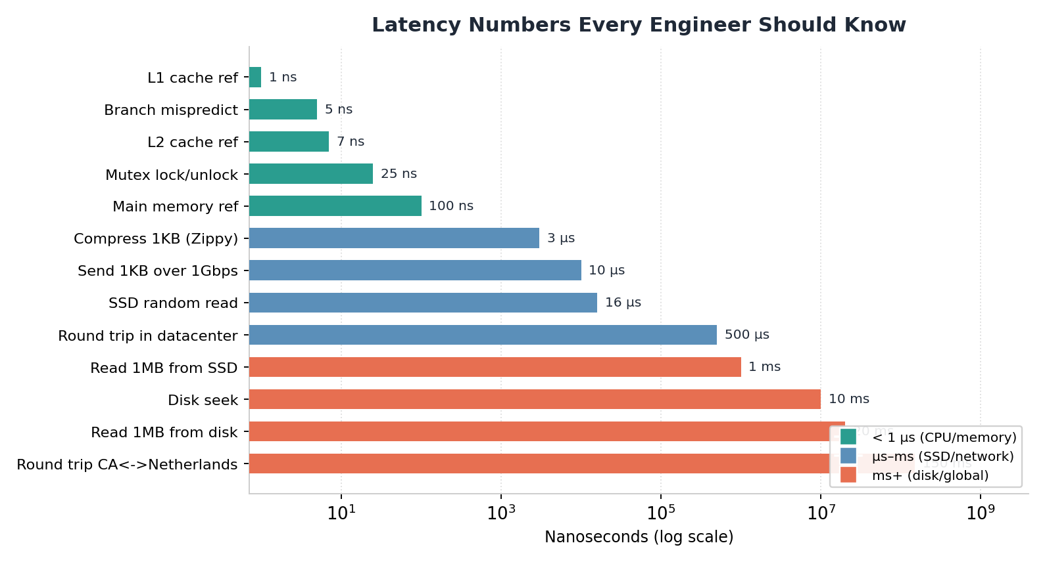
Figure: Approximate latencies on a log scale — anchor your estimates to these magnitudes.

5.3 Numbers worth memorizing
Quantity | Approximate value
Seconds in a day | ~86,400 (≈ 100K for quick math)
1 million writes/day | ~12 writes/sec average
Data size steps | KB → MB → GB → TB → PB (×1000 each)
Memory reference | ~100 ns
Datacenter round trip | ~0.5 ms
Cross-continent round trip | ~150 ms
SSD random read | ~16 µs

Worked micro-example
- A service ingests 500 GB/day and retains data for 5 years.
- 500 GB × 365 × 5 ≈ 900 TB — far beyond one node.
- Conclusion: the data must be sharded. The estimate directly drove an architecture decision.

Self-check
- 10 million DAU each make 20 requests/day. Estimate average and peak requests/sec.
- Why does the 80/20 rule make caching so effective, and how do you size the cache?
- Roughly how many times slower is a cross-continent round trip than a memory reference?

Module 6 — Step 3: APIs
The API is the contract between clients and your system. Defining it forces clarity about what data flows in and out and anchors the rest of the design. Design the minimum set of endpoints the requirements demand — no more.

6.1 Choosing an API style
Style | Strengths | Choose when
REST | Simple, cacheable, universal | Public CRUD APIs, broad client support
gRPC | Binary, fast, streaming, typed | Low-latency internal service-to-service
GraphQL | Client picks fields, one round trip | Clients need flexible, aggregated reads

6.2 Details that separate good APIs from naive ones
- Idempotency — a retried write must not double-charge or double-post; use idempotency keys.
- Pagination — prefer cursor-based over offset-based; it stays correct and fast as data grows.
- Auth & rate limiting — usually live at the gateway, not in each service.
- Versioning — plan how the contract evolves without breaking existing clients.

6.3 HTTP status codes to know
Range | Meaning | Common examples
2xx | Success | 200 OK, 201 Created, 204 No Content
3xx | Redirection | 301 Moved, 304 Not Modified
4xx | Client error | 400 Bad Request, 401, 403, 404, 429 Too Many
5xx | Server error | 500 Internal, 502, 503 Unavailable, 504

Self-check
- Write the two endpoints a URL shortener needs, with method, path, and response.
- How does an idempotency key prevent a double charge on a retried payment?
- Why does cursor-based pagination scale better than offset-based?

Module 7 — Step 4: High-Level Design
Now you connect components into an architecture. Build it up in layers rather than drawing the final picture at once.
- Start simple: client → load balancer → service → database, one clean path that meets the requirements.
- Trace the core flows: walk a write and a read end to end. This reveals what is missing.
- Add components only as a flow demands them: a cache when reads are hot, a queue for async work, a CDN for static assets, a search index for full-text.
- Separate the read path from the write path where their requirements differ — this leads naturally to CQRS and fan-out choices.

7.1 The classic fan-out decision
Building a timeline or feed forces a choice that perfectly illustrates read/write path separation. Fan-out-on-write makes reads cheap but writes expensive (the celebrity-with-millions-of-followers problem); fan-out-on-read does the reverse. Most real systems use a hybrid: push for normal users, pull for celebrities.
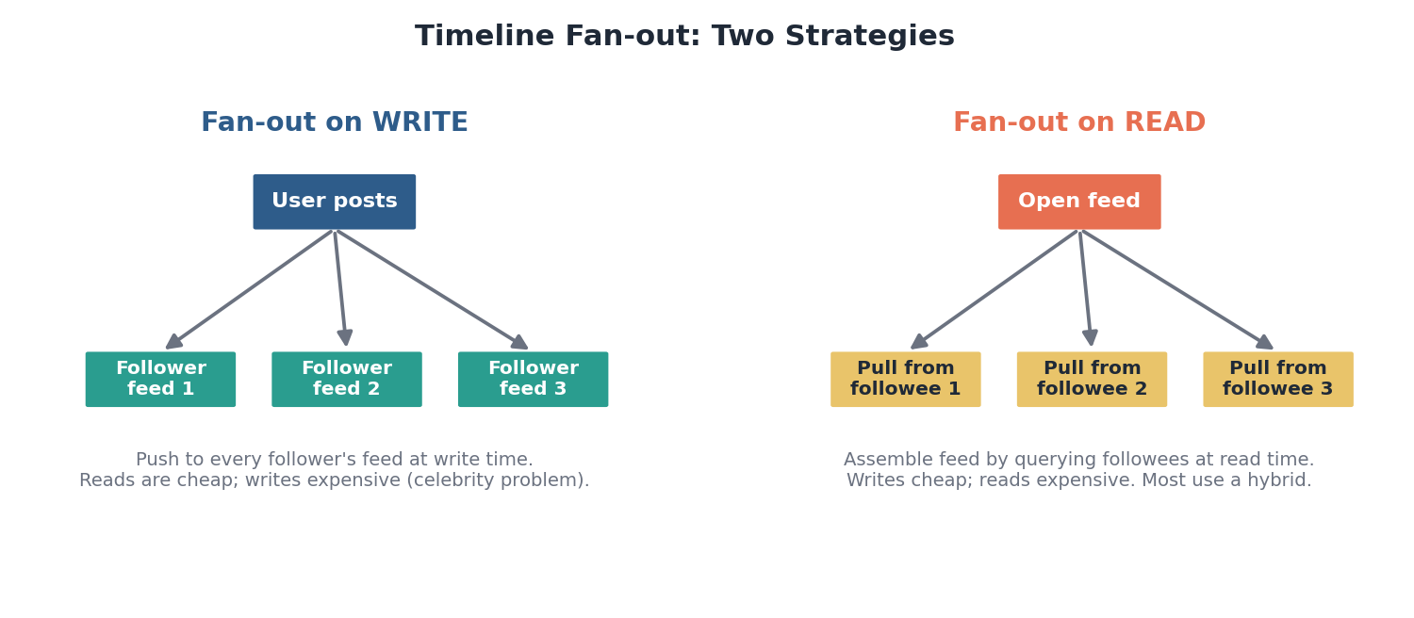
Figure: Push at write time vs. assemble at read time — the central feed-design tradeoff.

7.2 Patterns to recognize
Pattern | What it gives you
Async processing with queues | Accept fast, process later; absorbs spikes
Fan-out (push / pull / hybrid) | Controls where feed-assembly cost falls
CQRS | Separate, independently optimized read and write models
Event-driven architecture | Services react to events on a stream; loose coupling
Microservices vs. monolith | Independent scaling vs. operational simplicity

Discipline of this step
- Justify every box — if you cannot say why it is there and what it costs, remove it.
- Resist over-engineering: the right first design is the simplest one that meets the requirements.
- Add complexity only when a traced flow forces it.

Self-check
- Walk a read and a write through a simple URL-shortener design.
- When does fan-out-on-write break down, and how does a hybrid fix it?
- Give one concrete reason to add a queue, and one to add a CDN.

Module 8 — Step 5: Database Design
Where and how you store data determines most of your system’s properties. This step has two halves: the schema, and the storage strategy at scale.

8.1 Data modeling
- Entities & relationships — define core entities and how they relate before choosing a store.
- Access patterns first — for NoSQL especially, model backward from your queries, not from your entities.
- Indexing — index what you query on; remember every index slows writes and costs space.

8.2 Normalization vs. denormalization
Normalizing avoids data anomalies and keeps writes clean; denormalizing duplicates data to make hot reads fast. Most large systems denormalize heavily and accept the write-time cost, because reads usually dominate.
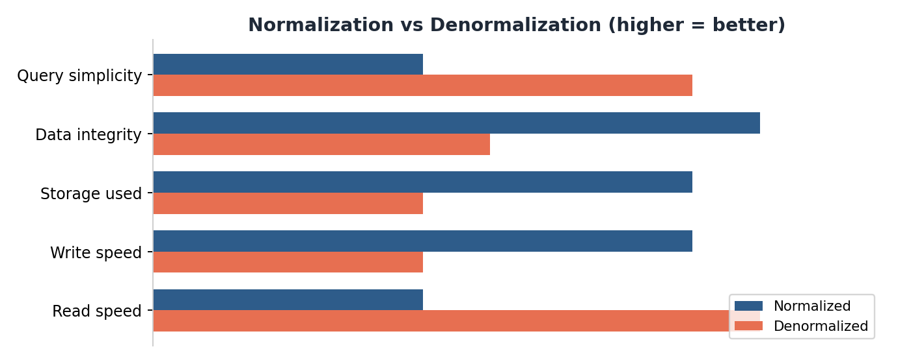
Figure: Normalized data favors integrity and write simplicity; denormalized favors read speed.

8.3 Storage at scale
- Replication — read scaling and availability; watch replication lag against your consistency needs.
- Sharding — the shard-key choice is among the highest-leverage decisions; learn consistent hashing.
- Transactions — single-node ACID is easy; distributed transactions are hard — use the Saga pattern for multi-service workflows.
- Polyglot persistence — use the right store for each job: Postgres for core data, Redis for cache, Elasticsearch for search, S3 for blobs, a time-series DB for metrics.

8.4 Distributed transactions: the Saga pattern
When a workflow spans several services, a single ACID transaction is impossible. A Saga breaks it into a sequence of local transactions, each with a compensating action that undoes it if a later step fails. You trade strict atomicity for availability and eventual consistency.

Self-check
- Given access patterns for a chat app, sketch how you would model messages for fast reads.
- Why do read-heavy systems usually denormalize despite the write cost?
- Explain how a Saga handles a payment that succeeds but a later shipping step fails.

Module 9 — Step 6: Scale & Reliability
The naive design works for a thousand users. This step makes it work for millions and keeps working when things break — and they will.

9.1 Scaling levers
Cache at every layer you can; each layer absorbs load before it reaches the next, and caching is usually the single biggest performance win.
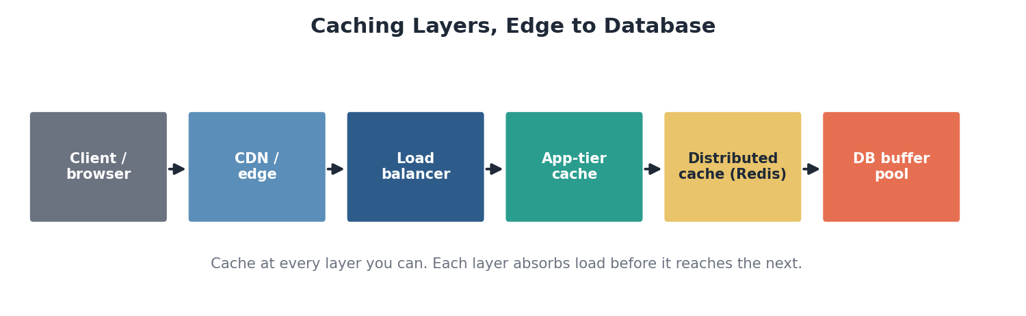
Figure: Caching opportunities from the client all the way down to the database buffer pool.
- Scale out — scale reads with replicas, writes with sharding, and stateless services horizontally behind a balancer with autoscaling.
- Async + buffering — queues smooth spikes and apply backpressure so a burst does not topple downstream services.

9.2 Resilience patterns
Pattern | Protects against
Redundancy / multi-AZ / multi-region | Single point of failure
Automatic failover & leader election | Loss of a primary node
Circuit breaker | Cascading failure from a sick dependency
Retries with exponential backoff + jitter | Transient errors (without retry storms)
Rate limiting / throttling | Overload and abuse
Graceful degradation | Total outage — serve a reduced experience instead
Dead-letter queues + idempotency | Corruption from failed or duplicate processing

9.3 The circuit breaker
A circuit breaker stops a failing dependency from dragging down the whole system. After errors cross a threshold it trips open and fails fast, then periodically probes to see whether the dependency has recovered before closing again.
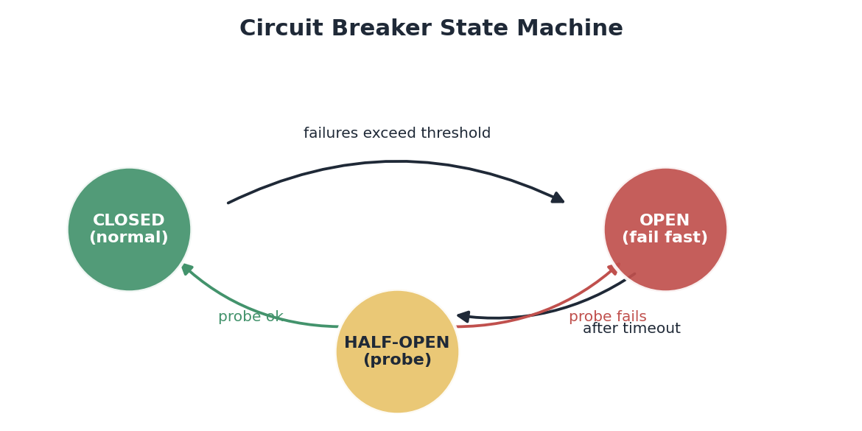
Figure: Closed serves normally; open fails fast; half-open probes for recovery.

9.4 Observability
You cannot operate what you cannot see. The three pillars are metrics (what is happening), logs (what happened in detail), and traces (the path of a request across services), wired to alerting. Pair them with disaster-recovery planning: backups, defined RPO/RTO targets, and restores you have actually tested.

Self-check
- For any design you have drawn, identify the single point of failure and remove it.
- How do retries without backoff and jitter make an outage worse?
- What is graceful degradation? Give an example for a video site under heavy load.

Module 10 — Step 7: Tradeoffs & Bottlenecks
This is what distinguishes a senior engineer. There is no perfect system, only deliberate tradeoffs. Your job is to name them, justify your choices, and know where the design bends first.

10.1 The tradeoffs you will keep meeting
Decision | One side | The other side
Consistency vs. availability | Correct, possibly unavailable | Available, possibly stale
Read- vs. write-optimized | Cheap reads, costly writes | Cheap writes, costly reads
Normalize vs. denormalize | Integrity, clean writes | Fast reads, duplication
Sync vs. async | Simple, immediate | Resilient, eventually consistent
Monolith vs. microservices | Simple ops | Independent scaling, complex ops
Cost vs. performance | Cheaper, slower | Faster, more infrastructure

10.2 Finding the bottleneck
Under rising load, one component saturates first — usually the database, a hot shard, a single-threaded service, or a hot cache key. Know your scaling ceiling for each component and your next move when you hit it. Past the knee, latency climbs sharply while throughput flattens or falls; that is where cascading failure begins and where backpressure must be applied.
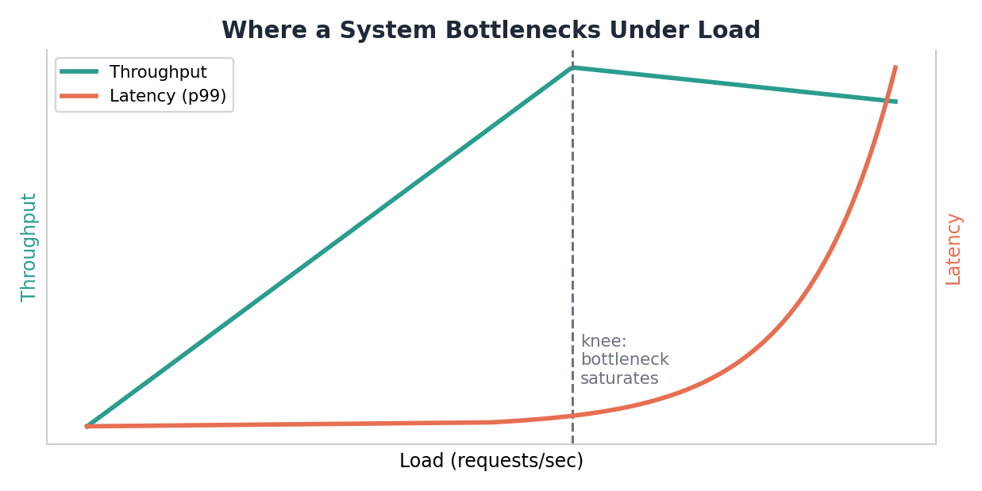
Figure: Past the saturation knee, throughput plateaus while tail latency explodes.

How to show this skill
- State tradeoffs unprompted: “I chose eventual consistency to keep the feed fast; the cost is a brief read-your-writes gap, which I mitigate with a session cache.”
- Name your design’s weakest point before anyone asks — interviewers love it and real systems demand it.

Self-check
- For one design, give a one-sentence justification and the accepted cost for each major decision.
- Which component in your design saturates first under 10x load, and what do you do next?
- Explain a cascading failure and where you would apply backpressure to stop it.

PART THREE — PRACTICE & MASTERY

Module 11 — Practice & Mastery
Knowledge becomes skill only through repetition under realistic conditions. Reading about system design will not make you good at it; reps will.

11.1 The practice loop
- Set a 45-minute timer (interview length).
- Walk all seven steps out loud or in writing — never skip estimation or tradeoffs.
- Draw the diagram.
- Compare against a reference solution and find at least three things you missed.
- Redo the same problem a week later from scratch — the second pass is where the framework becomes automatic.

11.2 Classic problems, by difficulty
Warm-up | Core | Advanced
URL shortener | News feed / Twitter timeline | Video streaming (YouTube)
Pastebin | Chat / messaging (WhatsApp) | Ride-sharing (Uber)
Rate limiter | Web crawler | Distributed file storage (Dropbox)
Key-value store | Notification system | Search engine
 | Typeahead / autocomplete | Payment system / ad-click aggregation

11.3 Go deeper on the theory
Once the framework is comfortable, study the distributed-systems concepts that make designs robust:
- Consensus — Paxos and Raft (leader election, replicated logs), conceptually.
- Consistent hashing — including virtual nodes; the basis of even data distribution.
- Quorums — R + W > N for tunable consistency.
- Logical clocks — ordering events without a global clock (vector clocks, Lamport timestamps).
- Probabilistic structures — Bloom filters, HyperLogLog, count-min sketch — huge space savings for approximate answers.
- CRDTs — conflict-free replicated data types for collaborative and offline-first apps.

11.4 Recommended resources
- Book — Designing Data-Intensive Applications by Martin Kleppmann — the best book for the theory beneath these designs.
- Repo — The “System Design Primer” open-source repository — a free, comprehensive index of concepts and worked problems.
- Real systems — Engineering blogs from companies like Netflix, Uber, Discord, Stripe, and Cloudflare — read one write-up a week to see how these ideas play out in production.
A note on resources
- These reflect the well-established landscape. Tooling and courses change — verify the current best options before committing time.

Module 12 — One-Page Cheat Sheet
When you sit down with any problem, run these seven steps in order. This page is the whole framework distilled.
Step | Ask yourself | Deliverable
1. Requirements | What does it do? How available/fast/consistent must it be? What scale? | Bounded functional + non-functional list
2. Estimations | Peak QPS? Total storage over N years? Does the hot set fit in memory? | Numbers tied to design consequences
3. APIs | What is the minimal contract? REST, gRPC, or GraphQL? Idempotent writes? | A handful of well-specified endpoints
4. High-level design | What is the simplest path that works? What do traced flows demand? | Diagram + read/write walkthrough
5. Database design | SQL or NoSQL? What is the shard key? How do I replicate? | Schema + storage + sharding plan
6. Scale & reliability | Where do I cache? Where is the SPOF? What at 10x? | Redundant, cached, shardable design
7. Tradeoffs & bottlenecks | What did I trade away? What breaks first? | Justified decisions + named weak point

The whole game, in one paragraph
- Learn the building blocks and the laws cold. Then, for every problem, run the same seven steps: clarify requirements, estimate, define the API, draw a simple design and grow it only as flows demand, model and shard the data, make it scale and survive failure, and finish by naming your tradeoffs and bottlenecks out loud. Practice on progressively harder classic problems until the structure is automatic — at which point you are no longer recalling answers, you are reasoning to them.

