MODULE 4 — STEP 1
REQUIREMENTS
The Ultimate Interview Prep
Scoping the problem before you build it — the phase that decides whether
everything that follows solves the right problem. With scripts, question banks,
worked examples, and the mistakes that fail candidates.

Contents

Why This Step Decides the Whole Interview
The single most common way candidates fail a system design interview is not a weak diagram or a shaky estimate — it is solving the wrong problem. They hear “design Twitter,” start drawing boxes within thirty seconds, and spend forty minutes building something the interviewer never asked for. The requirements phase exists to prevent exactly this. It is short, but it sets the target everything else aims at.
Requirements gathering is also the clearest seniority signal in the entire interview. Junior candidates jump to solutions; senior engineers first establish what success means, what is in scope, and what they are deliberately leaving out. Interviewers at every major company watch for this. Done well, the first seven minutes earn you trust that carries through the rest of the session.
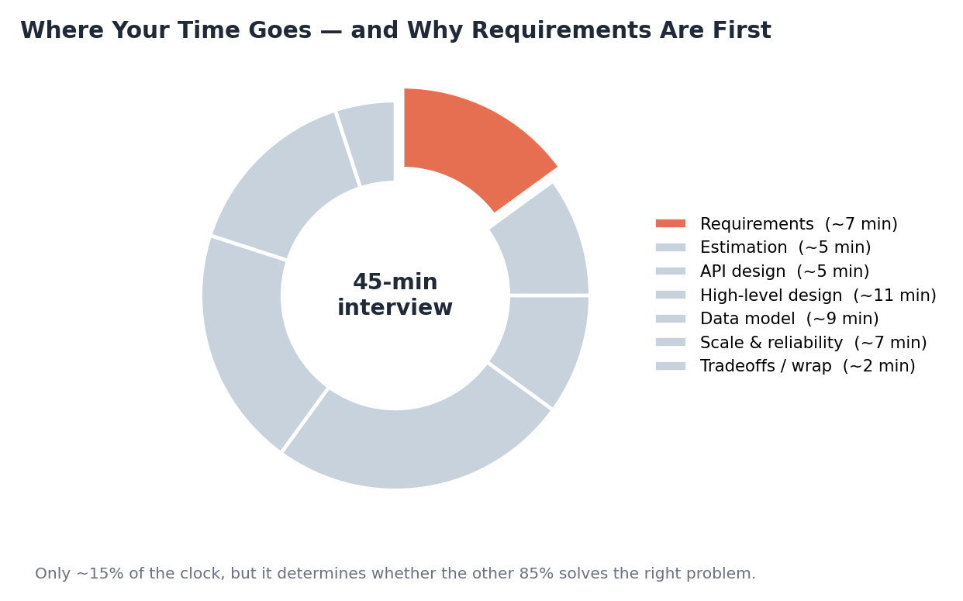
Figure: Requirements take only about 15% of the clock, yet they determine whether the remaining 85% is aimed correctly.
What you will master in this module
- Functional requirements — defining the core features and explicitly deferring the rest.
- Non-functional requirements — the qualities (availability, latency, consistency, durability, scale) that shape the architecture.
- The availability ‘nines’ and the SLI / SLO / SLA vocabulary.
- The art of clarifying questions — a reusable question bank.
- Scoping and MVP thinking — narrowing aggressively without losing the point.
- Turning a vague prompt into bounded requirements, with worked examples.
- A repeatable interview script, a requirements canvas, and the mistakes to avoid.

1. Functional Requirements
Functional requirements describe what the system does — its features, expressed as actions a user or another system can take. They are the verbs of the design: post, follow, search, book, pay, stream. Your job is not to list every conceivable feature but to identify the two-to-four core ones that define the product, and to explicitly set the rest aside.
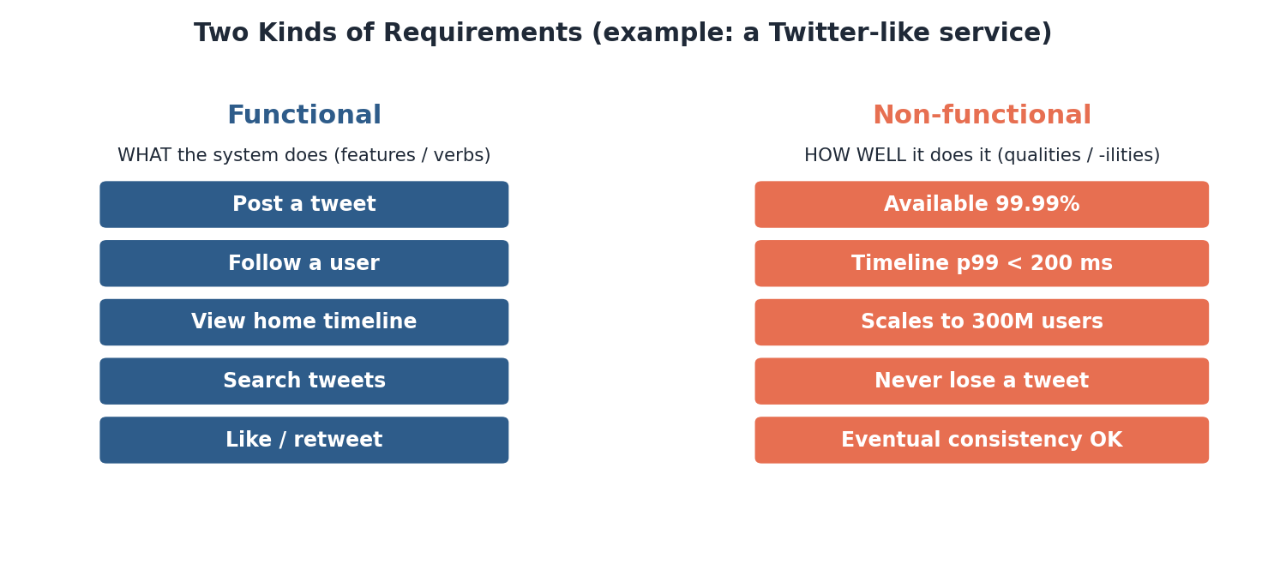
Figure: Functional requirements are what the system does; non-functional are how well it does it.

1.1 Finding the core features
Most prompts name a familiar product, and familiar products have dozens of features — but a 45-minute design cannot cover all of them, and trying to is itself a mistake. Identify the handful that are essential to the product’s identity and that exercise the interesting parts of the system. For a Twitter-like service that is roughly: post a tweet, follow users, and view a home timeline. Likes, search, DMs, and ads are real, but secondary.

1.2 The power of explicit deferral
Stating what you will not build is as important as stating what you will. “I’ll focus on posting and the timeline, and treat search, ads, and DMs as out of scope for now — we can revisit if time allows” does three things at once: it bounds the problem, it shows you can prioritize, and it invites the interviewer to redirect you if they wanted something else. That redirect is a gift; it is far cheaper to get it in minute three than minute thirty.
What to say in the room
- Restate the prompt in your own words, then propose the core features: “So we’re building X. I think the core features are A, B, and C — does that match what you have in mind?”
- Always offer your scope as a proposal the interviewer can adjust, not a decision you have unilaterally made.
- Name what you’re deferring out loud, with a reason.
In the real world
- “Design Twitter/X” — core = post a tweet, follow, home timeline (the fan-out problem). Search and ads are usually deferred.
- “Design Uber” — core = request a ride, match rider to nearby driver, track location. Pricing and ratings are secondary.
- “Design WhatsApp” — core = send/receive messages, delivery status, group chat. Calls and stories are out of scope.
- “Design a URL shortener” — core = create short URL, redirect. Analytics and custom aliases are nice-to-haves.
Self-check
- For “design Instagram,” name the three or four core functional requirements you would propose.
- Why is explicitly stating out-of-scope features a sign of seniority?
- How should you phrase your proposed scope so the interviewer can redirect you?

2. Non-Functional Requirements
If functional requirements are what the system does, non-functional requirements (NFRs) are how well it must do it. They are the qualities — the “-ilities” — and they matter enormously because they, far more than the feature list, drive the architecture. A photo-sharing app and a banking ledger might share features, but their consistency and durability requirements lead to completely different designs.
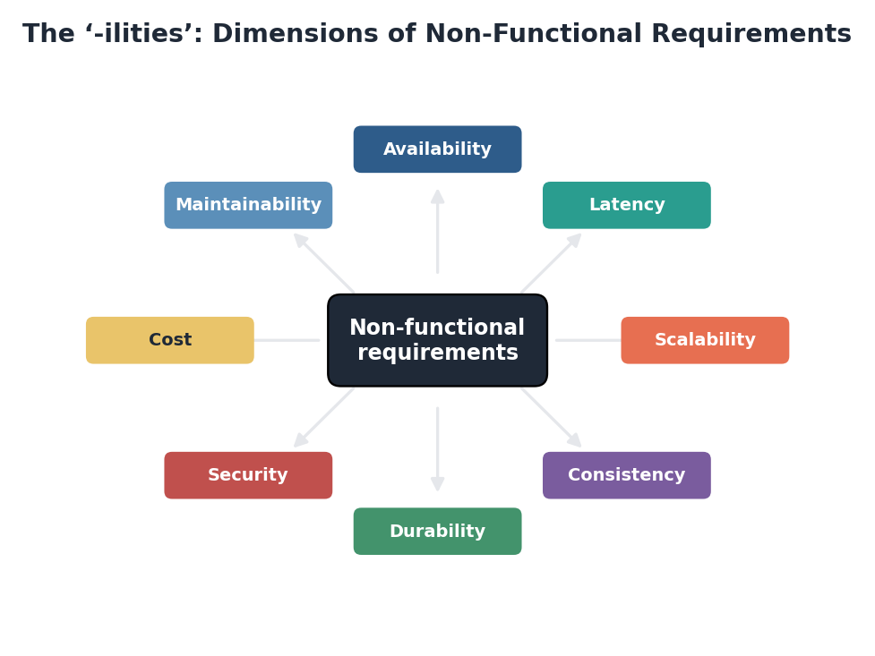
Figure: The major non-functional dimensions; a strong requirements phase names a target for the ones that matter.

2.1 The dimensions that matter most
Dimension | The question to answer | Why it shapes design
Availability | What uptime is required? | Drives redundancy, failover, multi-region
Latency | How fast must responses be (p99)? | Drives caching, CDNs, data locality
Scalability | How many users / requests / data? | Drives sharding, horizontal scaling
Consistency | Is stale data acceptable? | Strong vs. eventual changes the data layer
Durability | Can data ever be lost? | Drives replication, backups, write guarantees
Security | How sensitive is the data? | Drives auth, encryption, access control
Cost | What is the budget? | Trades performance against spend

You will not set a target for all of these in seven minutes — nor should you. Identify the two or three that genuinely shape this system and pin numbers to them. For a feed, latency and availability dominate; for a payments system, consistency and durability do. Naming which NFRs matter, and which do not, is itself a design judgment.

2.2 Always think in percentiles, not averages
When you state a latency requirement, state it as a percentile: “p99 under 200 ms,” not “200 ms average.” As covered in Module 1, averages hide the slow tail that real users feel. Quoting percentiles in the requirements phase signals that you understand how latency actually behaves at scale — a small phrase that lands well.
What to say in the room
- “What scale are we targeting — thousands of users or hundreds of millions?” The answer changes everything downstream.
- “Is this read-heavy or write-heavy?” Most consumer systems are read-heavy, which justifies caching and replicas.
- “Can reads be slightly stale, or do we need strong consistency?” This single question often decides your whole data layer.
In the real world
- Amazon — famously found that every extra 100 ms of latency measurably cut sales — latency is a business NFR, not a nicety.
- Amazon S3 — is designed for eleven nines of durability (99.999999999%) — durability and availability are distinct targets.
- Banking & payments — prioritize strong consistency and durability over raw latency; a feed makes the opposite trade.
- Netflix — prioritizes availability and streaming latency, accepting eventual consistency for things like view counts.
Self-check
- Which two NFRs dominate a payments system, and which dominate a social feed?
- Why should a latency requirement be stated as a percentile?
- Give an example where two products share features but need very different NFRs.

3. Availability, the ‘Nines,’ and SLAs
Availability deserves its own treatment because candidates routinely throw out “highly available” without knowing what they are committing to. Availability is measured in “nines,” and each additional nine is roughly an order of magnitude more engineering effort and cost.
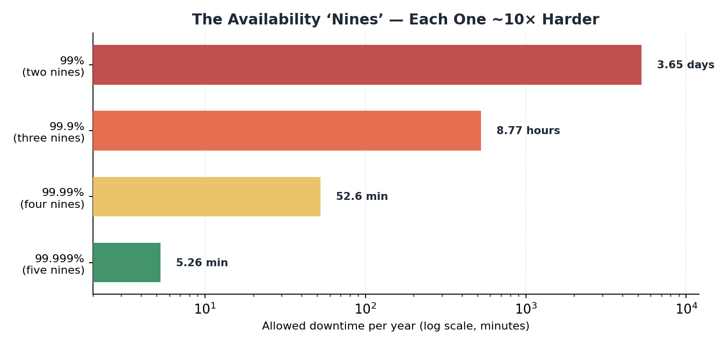
Figure: Allowed downtime per year drops ten-fold with each nine — so the right target is a deliberate choice, not a reflex.
Availability | Downtime / year | Typical use
99% (two nines) | ~3.65 days | Internal tools, early prototypes
99.9% (three nines) | ~8.8 hours | Standard consumer web apps
99.99% (four nines) | ~52 minutes | Business-critical services
99.999% (five nines) | ~5 minutes | Telecom, payments infrastructure

3.1 SLI vs. SLO vs. SLA
These three terms are interview gold when used correctly. They build on each other: an SLI is the metric you measure, an SLO is the target you set on it, and an SLA is the external promise (with consequences) you make to customers.
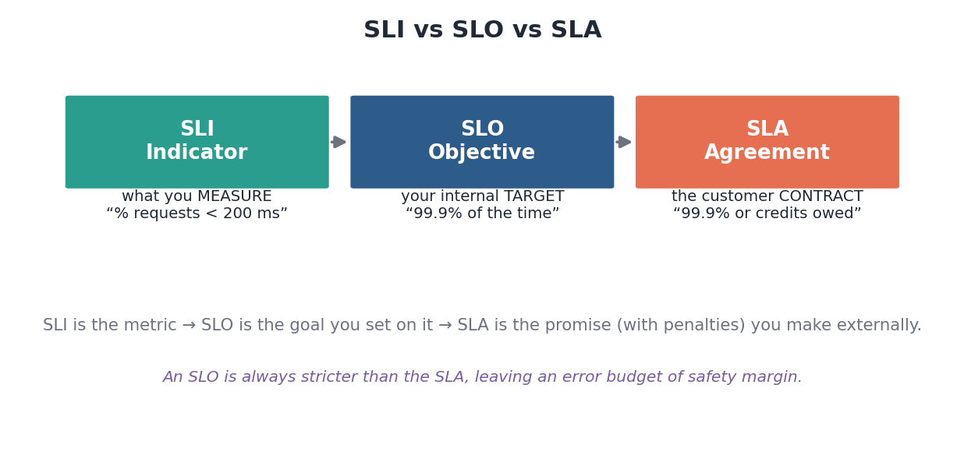
Figure: The indicator is measured, the objective is the internal goal, the agreement is the customer-facing contract.
Term | Stands for | Meaning | Example
SLI | Service Level Indicator | A metric you measure | % of requests served under 200 ms
SLO | Service Level Objective | Your internal target on an SLI | 99.9% of requests meet it
SLA | Service Level Agreement | A contract with penalties | 99.9% or the customer gets credits

The error budget idea
- Set your internal SLO stricter than your external SLA — the gap is your safety margin.
- The allowed unreliability (e.g. the 0.1% of a 99.9% SLO) is an error budget: a quantified amount of failure you can ‘spend’ on releases and risk.
- This framing comes from Google’s Site Reliability Engineering practice and signals real operational maturity.
In the real world
- Cloud SLAs — AWS, Google Cloud, and Azure publish SLAs (often 99.9%–99.99%) and issue service credits when they miss — a concrete SLA in action.
- Google SRE — popularized SLI/SLO/error-budget thinking; the SRE book is the canonical reference.
- Durability ≠ availability — S3 targets 99.999999999% durability (not losing data) but a lower availability (being reachable) — keep the two separate.
Self-check
- How much downtime per year does 99.99% allow?
- Distinguish an SLI, an SLO, and an SLA with one example each.
- Why is an SLO usually set stricter than the SLA, and what is an error budget?

4. The Art of Clarifying Questions
Requirements are not handed to you — you extract them. The prompt is deliberately vague, and the interviewer is waiting to see whether you ask the right questions before committing to a design. Good questions are specific, purposeful, and tied to decisions you will make. “How many users?” is useful; “Tell me more about it” is not.

4.1 A question bank, by category
Keep a mental checklist organized by category so you can sweep the problem quickly and completely. You will not ask all of these — pick the ones that matter for this system.
Category | Questions to consider
Users & scale | Who uses it? How many DAU? Expected growth? Geographic spread?
Core features | What are the must-have actions? What can we defer?
Read vs. write | Is it read-heavy or write-heavy? What’s the rough ratio?
Data | What data, how big per item, how long retained?
Consistency | Is stale data acceptable, or do we need strong consistency?
Latency/availability | How fast must it feel? What uptime is required?
Access patterns | What are the dominant queries? Any real-time needs?
Constraints | Mobile clients? Offline? Regulatory or budget limits?

4.2 State assumptions when you don’t get answers
Sometimes the interviewer deflects (“what do you think?”) or you simply need to move on. Do not stall — state a reasonable assumption out loud and proceed: “I’ll assume 100 million daily users and a read:write ratio of about 100:1; tell me if that’s off.” This keeps momentum while leaving the door open for correction, and it demonstrates judgment about what reasonable defaults look like.
What good questions sound like
- “Are we designing for read-heavy or write-heavy traffic?” — tied directly to caching and replica decisions.
- “Does the timeline need to be real-time, or is a few seconds of delay fine?” — decides push vs. pull.
- “Is this a global product or single-region to start?” — decides whether multi-region complexity is in scope.
- Bad question: “What technologies should I use?” — that is your job to decide and justify.
Self-check
- Name four categories of clarifying question and one question from each.
- What should you do when the interviewer won’t give you a number?
- Why is “read-heavy or write-heavy?” one of the highest-value questions to ask early?

5. Scoping & MVP Thinking
Once you understand the problem, you must shrink it to something buildable in the time available. Scoping is the discipline of narrowing a broad prompt to a focused, well-defined system — without losing the parts that make it interesting.
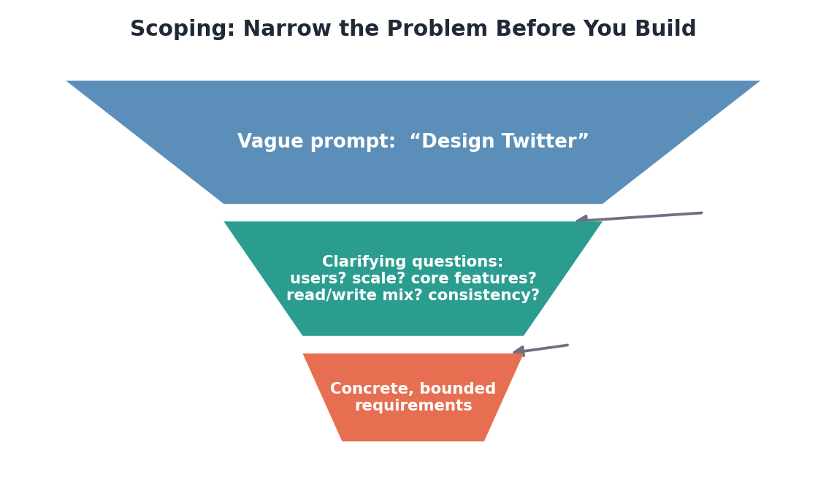
Figure: A vague prompt becomes bounded requirements by passing through deliberate clarifying questions.

5.1 Narrow toward the interesting core
Aggressive narrowing is a strength, but narrow toward the parts that exercise real design challenges, not away from them. For Twitter, dropping search and ads is fine; dropping the timeline would gut the problem, because the timeline’s fan-out is the whole point. Choose a scope small enough to finish but rich enough to show depth.

5.2 Plan for the happy path first, then extend
Establish the core flow working end to end before adding edge cases, optimizations, or secondary features. This mirrors how real systems are built — a minimum viable product first — and it guarantees you have a complete, coherent design even if you run out of time. Interviewers far prefer a finished simple system to an unfinished elaborate one.
Common mistakes that sink candidates
- Trying to cover every feature of a huge product — you will run out of time with nothing finished.
- Narrowing so far that nothing interesting is left to design.
- Choosing scope silently instead of confirming it with the interviewer.
- Adding bells and whistles before the core flow works end to end.
Self-check
- Why should you narrow toward, not away from, the interesting core of a problem?
- What does ‘happy path first’ mean and why does it protect you in a timed interview?
- Give an example of over-narrowing that would gut a design problem.

6. From Vague Prompt to Requirements: Worked Examples
Theory becomes skill through patterns. Here are three classic prompts taken through the requirements phase the way you would in the room — core features, the NFRs that matter, scale assumptions, and what to defer.

6.1 “Design a URL shortener” (warm-up)
Aspect | Requirement
Functional | Create a short URL from a long one; redirect a short URL to the original.
Non-functional | Very high availability; very low redirect latency; redirects must be reliable.
Consistency | Eventual is fine — a new short link appearing a second late is acceptable.
Scale (assumed) | Read-heavy by far (e.g. ~100:1 reads:writes); billions of stored URLs over time.
Out of scope | Custom aliases, analytics dashboards, link expiry (mention, then defer).

6.2 “Design Twitter/X” (core)
Aspect | Requirement
Functional | Post a tweet; follow users; view a home timeline of followed users’ tweets.
Non-functional | High availability; timeline reads fast (p99 < ~200 ms); huge fan-out scale.
Consistency | Eventual — a tweet appearing in followers’ feeds a few seconds late is fine.
Scale (assumed) | Hundreds of millions of users; extremely read-heavy; celebrity hot-spots.
Out of scope | Search, ads, DMs, trends, media transcoding (name them, defer).

6.3 “Design Uber” (advanced)
Aspect | Requirement
Functional | Rider requests a ride; match to a nearby available driver; live-track location.
Non-functional | High availability; low-latency matching; location updates near real-time.
Consistency | Strong for the match/booking (one driver, one rider); eventual for location pings.
Scale (assumed) | Millions of concurrent users; heavy geospatial write load from GPS updates.
Out of scope | Pricing/surge, ratings, payments, driver onboarding (defer).

The pattern across all three
- Two-to-four core features, never the whole product.
- Two-to-three NFRs with concrete targets — the ones that actually shape the design.
- An explicit consistency call, because it dictates the data layer.
- Stated scale assumptions, and an out-of-scope list.

7. Putting It Together: A Repeatable Method
Bring all of this into one reliable routine you can run on any prompt. The goal is that the first seven minutes feel automatic, so your attention is free for judgment rather than process.

7.1 The requirements canvas
Mentally (or literally, in the corner of the whiteboard) fill in four quadrants. If all four are populated, you are ready to design with a clear target.
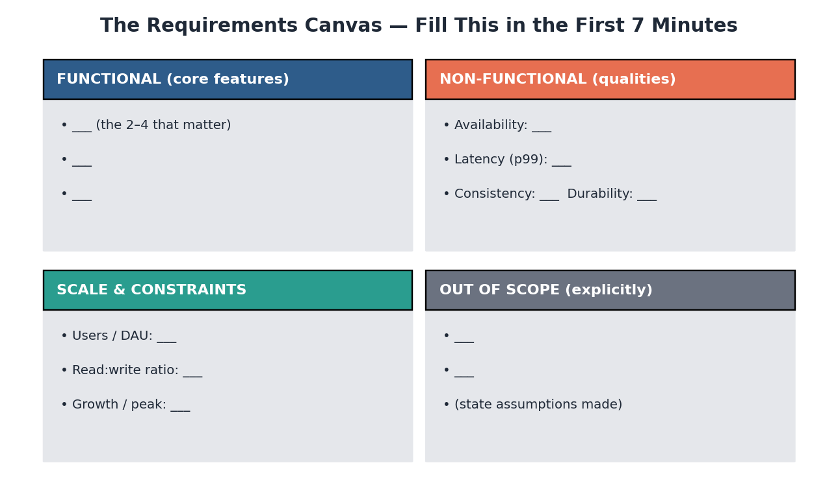
Figure: A reusable template: functional features, non-functional targets, scale and constraints, and an explicit out-of-scope list.

7.2 A minute-by-minute script
- Restate the prompt in your own words to confirm understanding.
- Propose the 2–4 core functional requirements; invite correction.
- Ask the highest-value clarifying questions: scale, read/write mix, consistency.
- State the 2–3 non-functional targets that matter (with percentiles and nines).
- Declare what is out of scope, with brief reasons.
- Summarize: “So we’re building X, optimizing for Y and Z, at this scale, deferring W. Shall I move to estimation?”
That closing summary is powerful: it confirms alignment, signals structure, and hands you a clean transition into Module 5 (Estimations).

7.3 What the interviewer is really evaluating
They are checking whether you... | Because it predicts...
Clarify before designing | You won’t build the wrong thing on the job
Prioritize and scope | You can ship under real-world constraints
Quantify NFRs | You understand scale, not just features
Communicate and check alignment | You collaborate rather than disappear into a solution

Common mistakes that sink candidates
- Diving into architecture before establishing requirements — the cardinal sin.
- Treating the prompt as fully specified and never asking a question.
- Saying ‘highly available’ or ‘scalable’ without numbers behind them.
- Designing in silence — not narrating your reasoning or checking alignment.
- Ignoring the interviewer’s hints; they often steer you toward what they want to probe.
The one habit that most improves this phase
- Narrate everything. Say why you are asking each question and what each answer changes. The interviewer is grading your reasoning, not just your conclusions — make the reasoning audible.
Self-check
- Recite the six-step requirements script from memory.
- What are the four quadrants of the requirements canvas?
- Name three things an interviewer is really evaluating during this phase.

The Bottom Line
Requirements is the cheapest phase to get right and the most expensive to get wrong. It costs a few minutes and a handful of good questions; skipping it costs the entire interview. Establish what the system must do, pin numbers to the qualities that shape it, scope aggressively toward the interesting core, and confirm alignment before you draw a single box. Do that, and everything downstream — estimation, APIs, design, data, scale — has a clear target to aim at.
Requirements in one paragraph
- Restate the prompt, then propose two-to-four core functional requirements as a checkable proposal. Pin concrete targets to the two or three non-functional requirements that actually shape the system — availability in nines, latency in percentiles, and an explicit consistency call. Ask the highest-value clarifying questions (scale, read/write mix, consistency) and state assumptions when answers don’t come. Declare what is out of scope. Then summarize and move on. Short, structured, and aligned — the foundation the whole design stands on.

