MODULE 2
THE BUILDING BLOCKS
A Deep Dive, with Real-World Systems
The recurring components every architecture is assembled from — what each one
does, how it works, how it fails, and the real systems that use it.

Contents
Contents 1
Before You Begin 1
1. Load Balancers 1
1.1 L4 vs. L7 1
1.2 Distribution algorithms 1
2. Caching 1
2.1 Where caches live 1
2.2 Write patterns 1
2.3 The hard parts 1
3. Content Delivery Networks (CDNs) 1
3.1 What it accelerates 1
3.2 Why it matters 1
4. Databases: SQL vs. NoSQL 1
4.1 Relational (SQL) 1
4.2 NoSQL 1
4.3 Choosing 1
5. Replication 1
5.1 The common model: single-leader 1
5.2 Topologies 1
6. Sharding (Partitioning) 1
6.1 Strategies 1
6.2 Consistent hashing 1
6.3 The hard part: the shard key 1
7. Indexes 1
7.1 The tradeoff 1
7.2 Two underlying structures 1
8. Message Queues & Streams 1
8.1 Queue vs. pub/sub 1
8.2 The log: streaming 1
8.3 Delivery guarantees 1
9. API Gateways & Reverse Proxies 1
9.1 What it centralizes 1
10. Object / Blob Storage 1
10.1 Why a separate system 1
10.2 Block vs. file vs. object 1
11. Search Indexes 1
11.1 What search engines add 1
11.2 A secondary store, not the source of truth 1
Putting the Blocks Together 1

Before You Begin
Where Module 1 gave you the laws of distributed systems, Module 2 gives you the parts. Almost every architecture you will ever draw is assembled from the same small kit of building blocks. Mastery here is not about memorizing definitions; it is about knowing, for each component, exactly what problem it solves, when to reach for it, how it behaves under load, and how it fails.
This guide walks through eleven building blocks in a deliberate order, from the front door of a system (load balancers, CDNs, gateways) inward to where data lives (databases, replication, sharding, indexes) and the connective tissue between services (queues and streams, object storage, search). Each section ends with a real-world panel naming the actual systems and how well-known companies use them, so the ideas stay concrete.
The eleven building blocks
- Load balancers — spread traffic across many servers.
- Caching — keep hot data in fast memory.
- CDNs — serve content from the network edge.
- Databases (SQL vs. NoSQL) — the system of record.
- Replication — copies for read scaling and availability.
- Sharding — split data across nodes to scale writes.
- Indexes — turn slow scans into fast lookups.
- Message queues & streams — decouple and buffer work.
- API gateways & reverse proxies — a managed front door.
- Object / blob storage — cheap, massive file storage.
- Search indexes — fast full-text and faceted search.

1. Load Balancers
A load balancer sits in front of a pool of servers and distributes incoming requests across them. It is the component that makes horizontal scaling actually work: without it, clients would have to know about individual servers. It also provides health checking, so traffic is routed only to instances that are alive, and it is a natural place to terminate TLS.
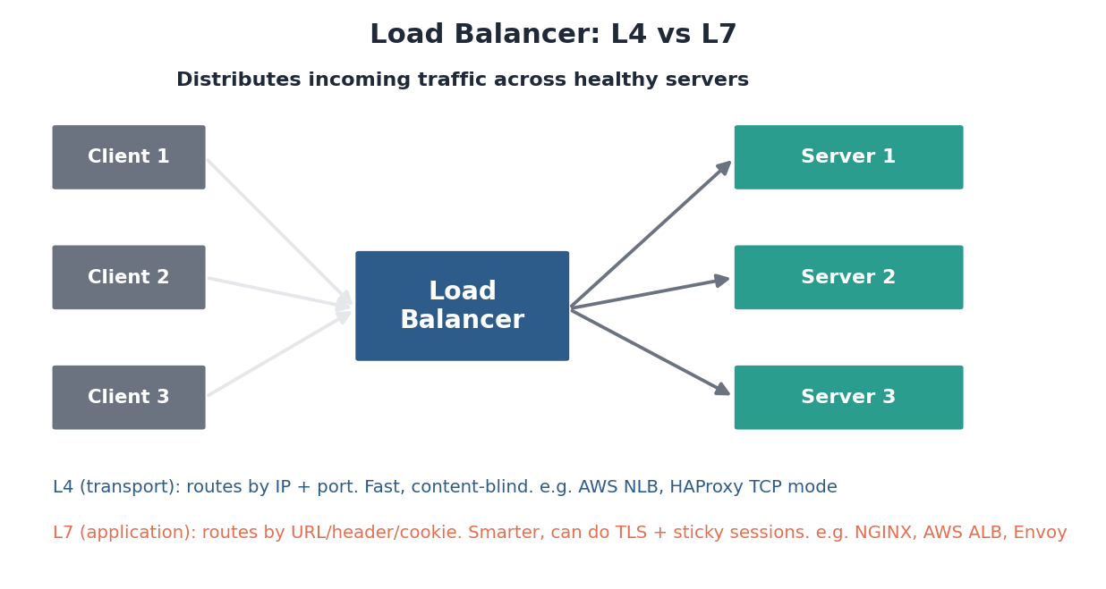
Figure: A load balancer fronts a server pool; it can operate at L4 (transport) or L7 (application).

1.1 L4 vs. L7
Load balancers operate at one of two layers. An L4 (transport-layer) balancer routes by IP address and port without looking inside the traffic — it is extremely fast and content-blind. An L7 (application-layer) balancer reads the actual HTTP request, so it can route by URL path, header, or cookie, terminate TLS, and support sticky sessions. L7 is smarter; L4 is faster and simpler.

1.2 Distribution algorithms
Algorithm | How it picks a server | Good for
Round-robin | Each server in turn | Uniform servers and requests
Least-connections | Server with fewest active conns | Uneven or long-lived requests
Consistent hashing | Same client/key → same server | Cache affinity, sticky routing
Weighted | Proportional to server capacity | Mixed hardware

How it fails
- The balancer itself can become a single point of failure — run it redundantly (active-passive or active-active) with a floating IP.
- A misconfigured health check can pull healthy servers out of rotation, or keep sending traffic to dead ones.
In the real world
- NGINX & HAProxy — the workhorse software load balancers, widely self-hosted.
- AWS ELB family — ALB (L7), NLB (L4); Google Cloud Load Balancing and Azure Load Balancer are equivalents.
- Envoy — a modern L7 proxy that powers service meshes like Istio at companies such as Lyft (its origin).
- DNS-based balancing (e.g. via Route 53) spreads users across whole regions before they ever reach a server-level balancer.
Self-check
- When would you choose an L4 balancer over an L7 one?
- Why is least-connections often better than round-robin for long-lived connections?
- How do you stop the load balancer itself from being a single point of failure?

2. Caching
A cache stores a copy of data in fast storage (usually memory) close to where it is needed, so repeated reads avoid a slow trip to the database or a recomputation. Caching is typically the single highest-leverage performance optimization in a system, because most workloads are read-heavy and follow an 80/20 pattern where a small fraction of data serves most requests.

2.1 Where caches live
Caching happens at many layers: the browser, a CDN at the edge, an in-process cache inside the application, a shared distributed cache like Redis, and the database’s own buffer pool. Each layer absorbs load before it reaches the next. A request that is satisfied by an edge cache never touches your servers at all.

2.2 Write patterns
The hard part of caching is keeping the cache and the source of truth in sync. The three classic write patterns make different tradeoffs between write speed, consistency, and durability.
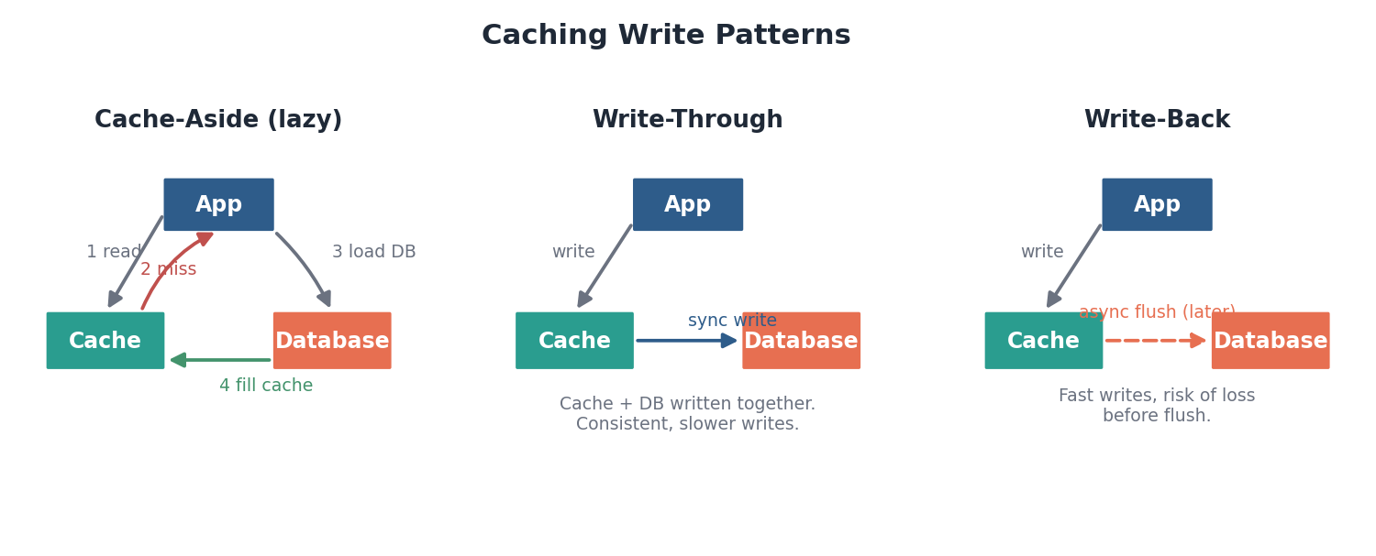
Figure: Cache-aside loads lazily on a miss; write-through writes both stores synchronously; write-back flushes to the database later.
- Cache-aside (lazy loading) — the application checks the cache, and on a miss loads from the database and fills the cache. Simple and common, but the first request after an expiry is slow.
- Write-through — writes go to the cache and database together, keeping them consistent at the cost of slower writes.
- Write-back — writes hit the cache and are flushed to the database later — very fast, but data can be lost if the cache fails before the flush.

2.3 The hard parts
Two failure modes deserve special attention. Invalidation is famously difficult: deciding when cached data is stale and removing it correctly is a frequent source of bugs. A cache stampede (or thundering herd) happens when a popular key expires and thousands of requests simultaneously miss and hammer the database; mitigations include staggered expiry, request coalescing, and serving slightly stale data while one request refreshes.
How it fails
- Stale reads when invalidation lags behind a write.
- Cache stampede when a hot key expires under high traffic.
- Eviction of needed data when the cache is undersized (tune the policy: LRU, LFU, TTL).
In the real world
- Redis & Memcached — the dominant in-memory caches; Redis adds rich data structures and persistence.
- Facebook — famously runs an enormous Memcached tier in front of its databases; its scaling challenges are a classic case study.
- Reddit — caches rendered content heavily in Memcached/Redis to survive traffic spikes.
- CDNs (next section) are themselves a massive caching layer at the edge.
Self-check
- Why is caching usually the biggest single performance win in a read-heavy system?
- Contrast write-through and write-back on speed, consistency, and durability.
- What is a cache stampede and how would you prevent one?

3. Content Delivery Networks (CDNs)
A CDN is a globally distributed network of edge servers that cache content close to users. When someone in Tokyo requests an image hosted in Virginia, the CDN serves it from a nearby Tokyo edge instead of crossing the planet, cutting latency dramatically and offloading traffic from the origin.
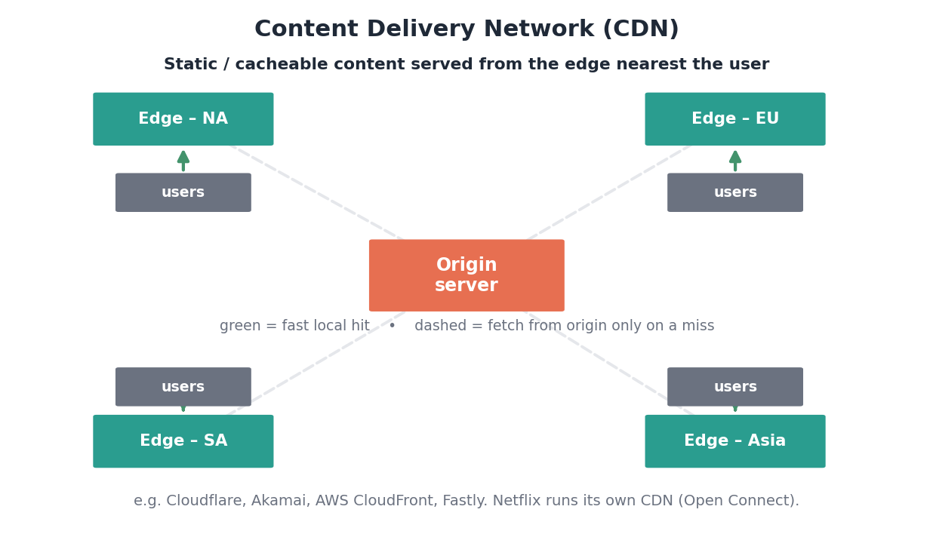
Figure: Users are served from the nearest edge; the edge fetches from the origin only on a cache miss.

3.1 What it accelerates
CDNs were built for static, cacheable assets — images, video, CSS, JavaScript, downloads — where the same bytes are served to many users. Modern CDNs also cache API responses, route dynamic traffic over optimized backbone paths, and increasingly run code at the edge (edge functions) so even personalized responses can be assembled near the user.

3.2 Why it matters
- Latency — the dominant factor in perceived page speed is distance to the content; the edge collapses it.
- Offload — the origin serves a tiny fraction of requests, since edges absorb the rest.
- Resilience — the distributed capacity absorbs traffic spikes and helps blunt DDoS attacks.
How it fails
- Stale content if cache-control headers and invalidation are misconfigured — users see old assets until the TTL expires or you purge.
- Cache misses for highly personalized content that cannot be shared between users.
In the real world
- Cloudflare, Akamai, Fastly, AWS CloudFront — the major commercial CDNs.
- Netflix Open Connect — Netflix built its own CDN, placing caching appliances inside ISPs so most streaming traffic never traverses the public internet.
- Cloudflare Workers / Lambda@Edge — run code at the edge for personalization and routing close to users.
Self-check
- What kinds of content are the best fit for a CDN, and why?
- How does a CDN reduce load on the origin server?
- Why did Netflix build its own CDN instead of only renting one?

4. Databases: SQL vs. NoSQL
The database is the system of record — where the durable truth lives. The first and most consequential storage decision is the family of database, and it should be made deliberately against your actual requirements, not by habit.

4.1 Relational (SQL)
Relational databases store data in tables with a fixed schema and enforce relationships through foreign keys and joins. Their defining strength is ACID transactions — atomic, consistent, isolated, durable — which guarantee correctness even under concurrent access. They are the right default whenever data is highly structured, relationships matter, and correctness is paramount, as with financial records.

4.2 NoSQL
“NoSQL” is an umbrella over several families, each tuned for a particular access pattern and for horizontal scale. They typically trade strict consistency and rich querying for the ability to scale out across many nodes and to evolve schemas freely.
NoSQL family | Shape | Use it for | Examples
Key-value | Key → opaque value | Sessions, caches, simple lookups | Redis, DynamoDB
Document | Key → JSON document | Flexible, nested records | MongoDB, Couchbase
Wide-column | Rows with dynamic columns | Huge write volume, time-series | Cassandra, HBase, Bigtable
Graph | Nodes + edges | Relationships, networks | Neo4j, Neptune

4.3 Choosing
Dimension | Relational (SQL) | NoSQL
Schema | Fixed, enforced | Flexible
Transactions | Strong ACID | Limited / tunable
Querying | Rich joins, ad hoc | Optimized for known patterns
Scaling | Vertical first; sharding is work | Built to scale horizontally
Pick when | Integrity, relationships, money | Scale, flexible data, set access patterns

The honest rule of thumb
- Default to a relational database until a concrete requirement forces otherwise — it is the most flexible and best-understood option.
- Large systems rarely choose one. They use polyglot persistence: Postgres for core data, Redis for sessions, Cassandra for a firehose of events, Elasticsearch for search.
In the real world
- PostgreSQL & MySQL — power the core of countless companies; MySQL famously underpinned early Facebook and still runs much of it.
- Amazon DynamoDB — a key-value/document store built for predictable scale; runs Amazon’s shopping cart and much of its retail platform.
- Cassandra / ScyllaDB — Discord stores billions of chat messages in a wide-column store for massive write throughput.
- MongoDB — popular for fast-moving product data with evolving schemas.
Self-check
- Name three properties of ACID and why they matter for money.
- Match each to a NoSQL family: a session store, a social graph, a time-series firehose.
- What does ‘polyglot persistence’ mean and why do big systems use it?

5. Replication
Replication keeps copies of the same data on multiple nodes. It serves two goals at once: availability (if one node dies, another has the data) and read scaling (reads can be spread across copies). The cost is the complexity of keeping copies in sync.

5.1 The common model: single-leader
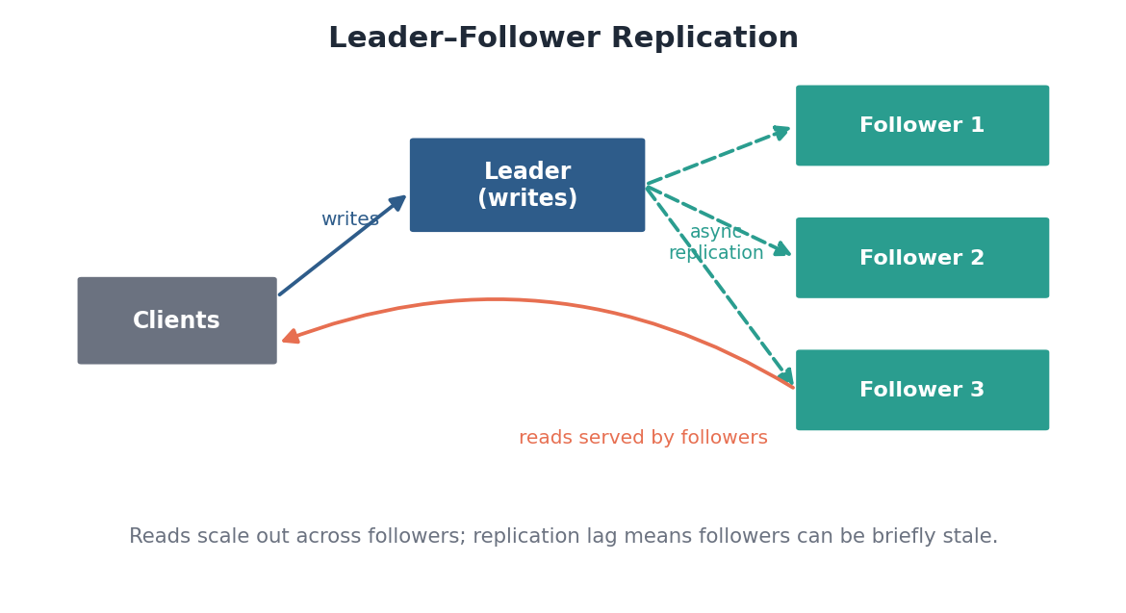
Figure: Writes go to the leader, which replicates to followers; reads are served by followers, which may lag slightly.
In single-leader (primary-replica) replication, all writes go to one leader, which streams its changes to followers that serve reads. This is simple and avoids write conflicts entirely, but it introduces replication lag: a follower can briefly return stale data, which is exactly the consistency tradeoff from Module 1. If the leader fails, a follower must be promoted — a failover that must be handled carefully to avoid lost writes or split-brain.

5.2 Topologies
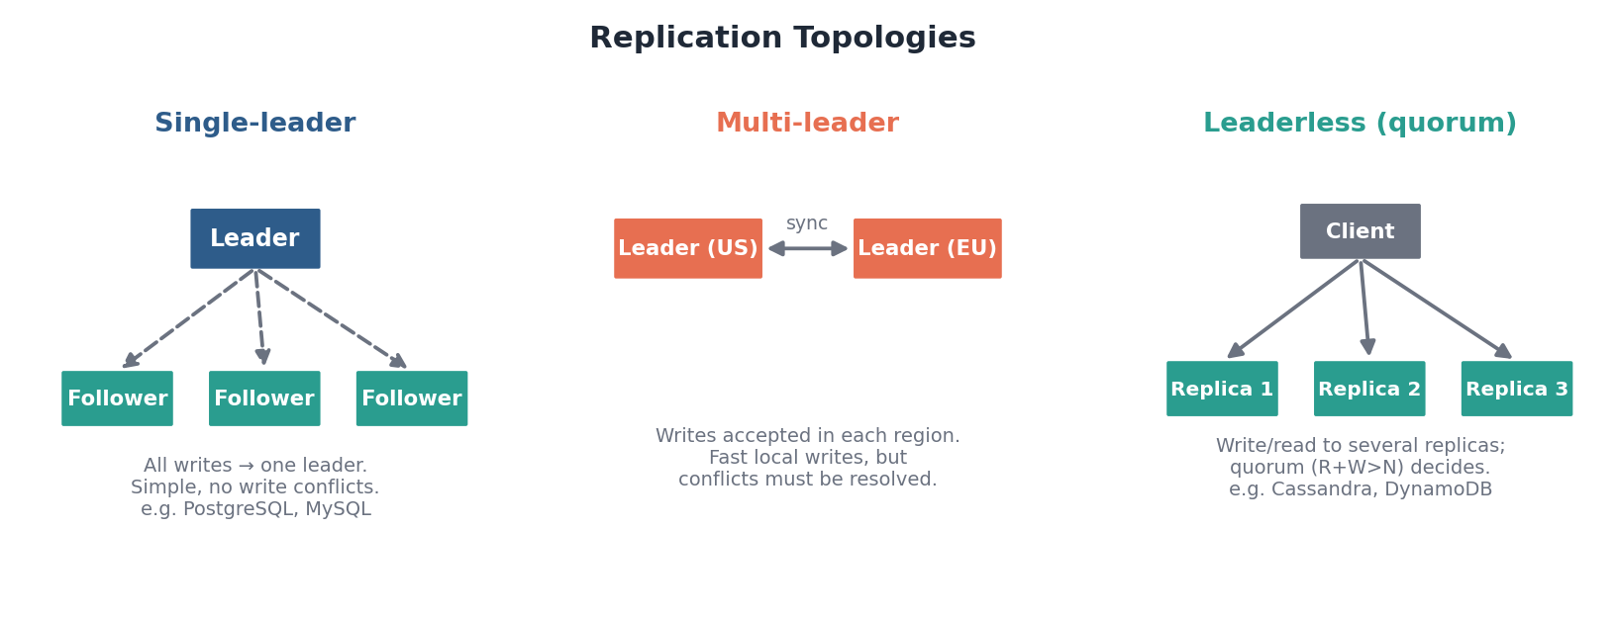
Figure: Single-leader is simplest; multi-leader allows local writes per region; leaderless uses quorums.
- Single-leader — one leader takes all writes. Simple, no conflicts, but the leader is a write bottleneck and a failover point.
- Multi-leader — multiple leaders accept writes (often one per region) and sync to each other. Fast local writes, but write conflicts must be detected and resolved.
- Leaderless — any replica accepts reads and writes; a quorum (R + W > N) determines correctness. Highly available, used by Dynamo-style systems.
How it fails
- Replication lag means followers serve stale reads — route critical read-your-writes traffic to the leader.
- Failover can lose recently-acknowledged writes or cause split-brain if two nodes both think they are leader.
In the real world
- PostgreSQL / MySQL — use single-leader streaming replication with read replicas — the standard scaling story for relational reads.
- Cassandra & DynamoDB — are leaderless and quorum-based, prioritizing availability across data centers.
- Multi-leader — appears in geo-distributed and offline-sync systems where each region or device must accept writes locally.
Self-check
- What two distinct problems does replication solve?
- Why does single-leader replication avoid write conflicts, and what is its main downside?
- What is split-brain, and which topology is most prone to write conflicts?

6. Sharding (Partitioning)
Replication copies the whole dataset to each node, which scales reads but not writes or storage — every node still holds everything. Sharding (horizontal partitioning) instead splits the dataset across nodes so each holds only a slice. It is how systems scale writes and store data far larger than a single machine.
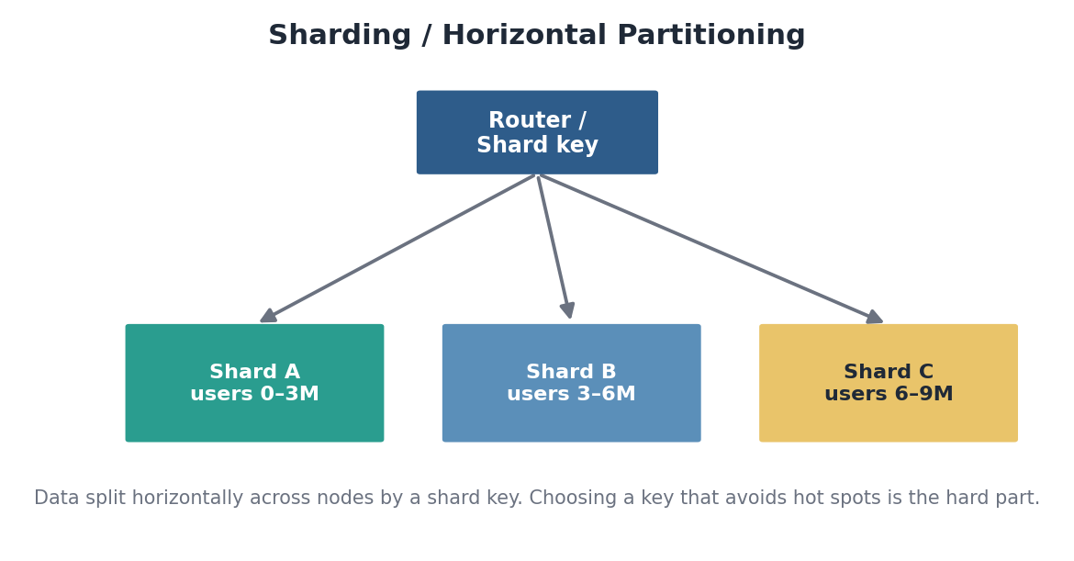
Figure: Data is partitioned across nodes by a shard key, with a router directing each request to the right shard.

6.1 Strategies
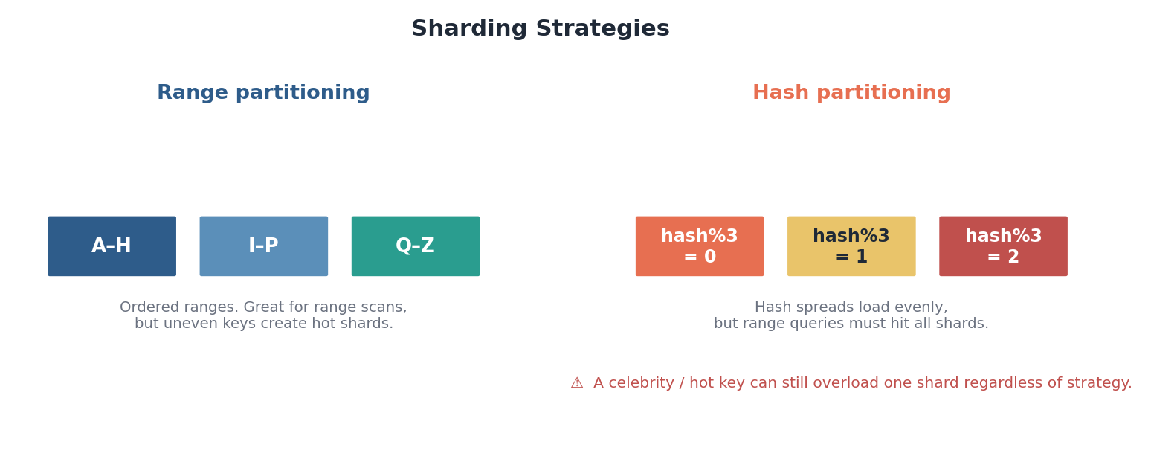
Figure: Range partitioning keeps order but risks hot ranges; hash partitioning spreads load but scatters range queries.
- Range partitioning — split by ordered key ranges (A–H, I–P, …). Great for range scans, but skewed data creates hot shards.
- Hash partitioning — assign each key by a hash of it. Spreads load evenly, but range queries must touch every shard.

6.2 Consistent hashing
Naive hashing (key mod N) remaps almost everything whenever you add or remove a node — catastrophic at scale. Consistent hashing places nodes and keys on a ring; each key belongs to the next node clockwise, so adding or removing a node only remaps the keys adjacent to it. Virtual nodes (many ring positions per physical node) smooth out the load distribution.
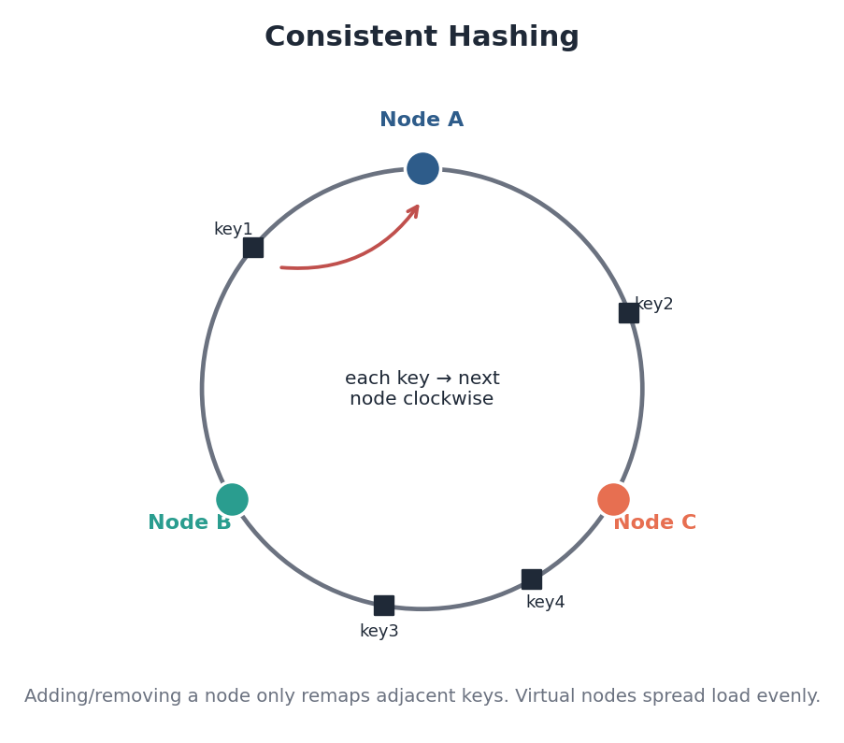
Figure: On the ring, each key maps to the next node clockwise; only adjacent keys move when membership changes.

6.3 The hard part: the shard key
Choosing the shard key is one of the highest-leverage decisions in system design. A good key spreads load evenly and keep related data together for your main queries. A bad key creates a hot shard — the classic case being a celebrity user whose traffic all lands on one node — and resharding a live system later is painful. Pick the key for your dominant access pattern, and stress-test it against skew.
How it fails
- Hot shards / hot keys when load is skewed toward one partition regardless of strategy.
- Expensive resharding and data movement when the cluster grows (mitigated by consistent hashing).
- Cross-shard queries and transactions become slow and complex.
In the real world
- Instagram — shards its PostgreSQL data by user ID across many logical shards — a widely-cited design.
- Discord — partitions chat data by channel/guild in Cassandra/ScyllaDB to spread an enormous write load.
- Vitess — the sharding layer that lets YouTube scale MySQL horizontally.
- Consistent hashing originated in Amazon’s Dynamo paper and underlies Cassandra and many caches.
Self-check
- Why does sharding scale writes when replication alone does not?
- Contrast range and hash partitioning on range queries and hot spots.
- What problem does consistent hashing solve over naive key-mod-N hashing?

7. Indexes
An index is a secondary data structure that lets the database find rows without scanning the whole table. Without one, finding matching rows is O(n) — the database reads every row. With one, it becomes a fast lookup. Indexes are the difference between a query that returns in a millisecond and one that takes seconds.
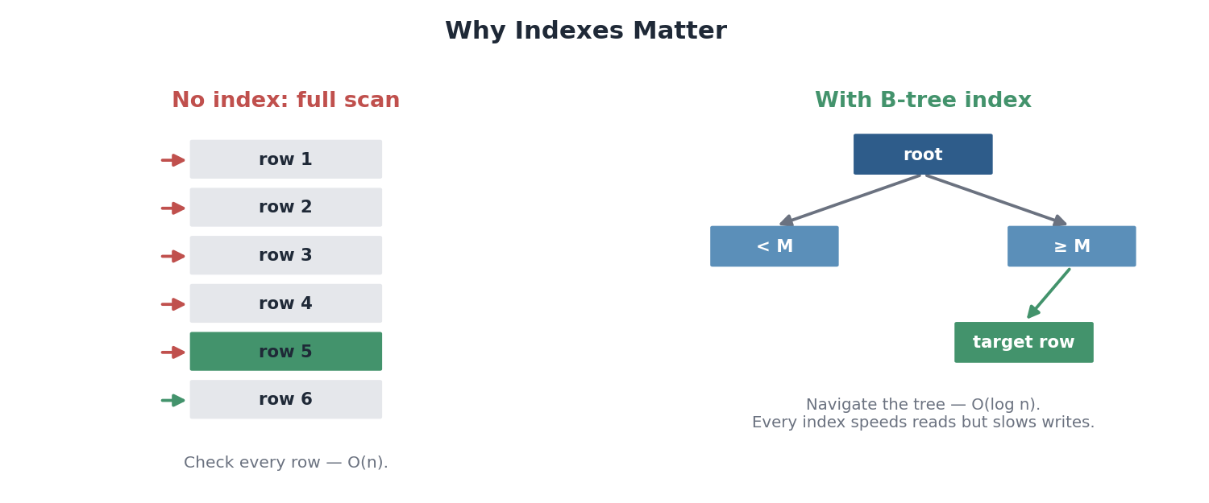
Figure: Without an index the database scans every row; a B-tree index turns the search into an O(log n) traversal.

7.1 The tradeoff
Indexes are not free. Every index must be updated on every write to the underlying table, so each one you add speeds up reads but slows down writes and consumes storage. The art is indexing exactly the columns your queries filter and sort on — no more. Over-indexing a write-heavy table can cripple it.

7.2 Two underlying structures
Structure | How it works | Optimized for | Used by
B-tree | Balanced tree; O(log n) lookups | Reads, range scans | PostgreSQL, MyS/InnoDB
LSM-tree | Buffer writes in memory, flush sorted runs | High write throughput | Cassandra, RocksDB, LevelDB

B-trees keep data sorted for fast reads and range queries and are the default in relational databases. LSM-trees batch writes in memory and flush them sequentially, trading some read complexity for very high write throughput — which is why write-heavy NoSQL stores favor them.
How it fails
- Too many indexes slow writes and bloat storage.
- An index on the wrong column is never used by the query planner — wasted cost.
- A query that does not match any index quietly falls back to a full table scan.
In the real world
- PostgreSQL — offers B-tree, hash, GIN, and GiST indexes; GIN powers fast searches inside JSON and arrays.
- Cassandra & RocksDB — are built on LSM-trees to sustain heavy write workloads.
- Databases also keep statistics so the query planner can decide whether using an index is actually cheaper than a scan.
Self-check
- Why does adding an index speed reads but slow writes?
- When would an LSM-tree be a better fit than a B-tree?
- What happens to a query whose filter column has no matching index?

8. Message Queues & Streams
Message systems decouple producers of work from consumers of it. Instead of calling a service directly and waiting, a producer drops a message and moves on; consumers process it when ready. This buys three things: asynchrony (accept fast, process later), buffering (absorb spikes without overwhelming downstream), and resilience (work survives a consumer being temporarily down).

8.1 Queue vs. pub/sub
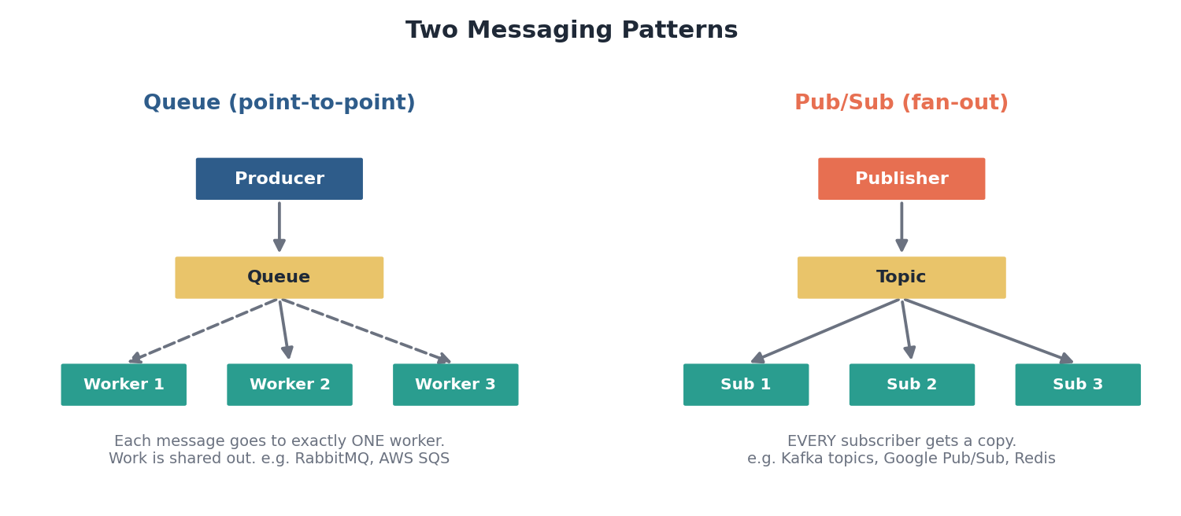
Figure: A queue delivers each message to exactly one worker; pub/sub delivers a copy to every subscriber.
- Queue (point-to-point) — each message is consumed by exactly one worker, so work is distributed across a pool. Ideal for task processing.
- Pub/Sub (fan-out) — every subscriber receives a copy of each message, so one event can trigger many independent reactions.

8.2 The log: streaming
Streaming systems generalize the queue into a durable, append-only log. Messages are not deleted when read; they persist and can be replayed. Each consumer group tracks its own position (offset) independently, so the same stream feeds many different consumers reading at their own pace. This is the foundation of event-driven architectures and real-time data pipelines.
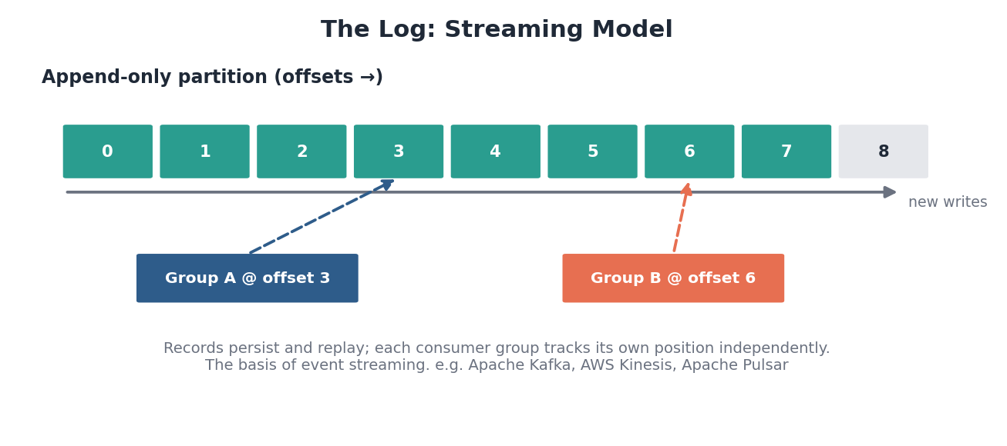
Figure: An append-only log: records persist with offsets, and each consumer group reads at its own independent position.

8.3 Delivery guarantees
Guarantee | Meaning | Cost
At-most-once | May be lost, never duplicated | Simplest, can drop messages
At-least-once | Never lost, may be duplicated | Consumers must be idempotent
Exactly-once | Processed once, no loss/dup | Hardest, more overhead

How it fails
- Consumer backlog: if consumers fall behind producers, the queue grows unbounded — monitor lag.
- Duplicate or out-of-order delivery under at-least-once — design idempotent consumers.
- A poison message that repeatedly fails should be routed to a dead-letter queue, not retried forever.
In the real world
- Apache Kafka — the dominant streaming log; LinkedIn built it, and it underpins data pipelines at countless companies.
- RabbitMQ & AWS SQS — classic task queues for distributing background work.
- Uber & DoorDash — use streaming backbones to move ride/order events between services in real time.
- AWS Kinesis, Google Pub/Sub, Apache Pulsar — managed and alternative streaming platforms.
Self-check
- What three benefits does putting a queue between services provide?
- How does a streaming log differ from a traditional queue?
- Why must at-least-once consumers be idempotent, and what is a dead-letter queue for?

9. API Gateways & Reverse Proxies
A reverse proxy sits in front of your servers and forwards client requests to them, shielding the servers and centralizing cross-cutting concerns. An API gateway is the richer, microservices-era version of this idea: a single managed entry point for many backend services.
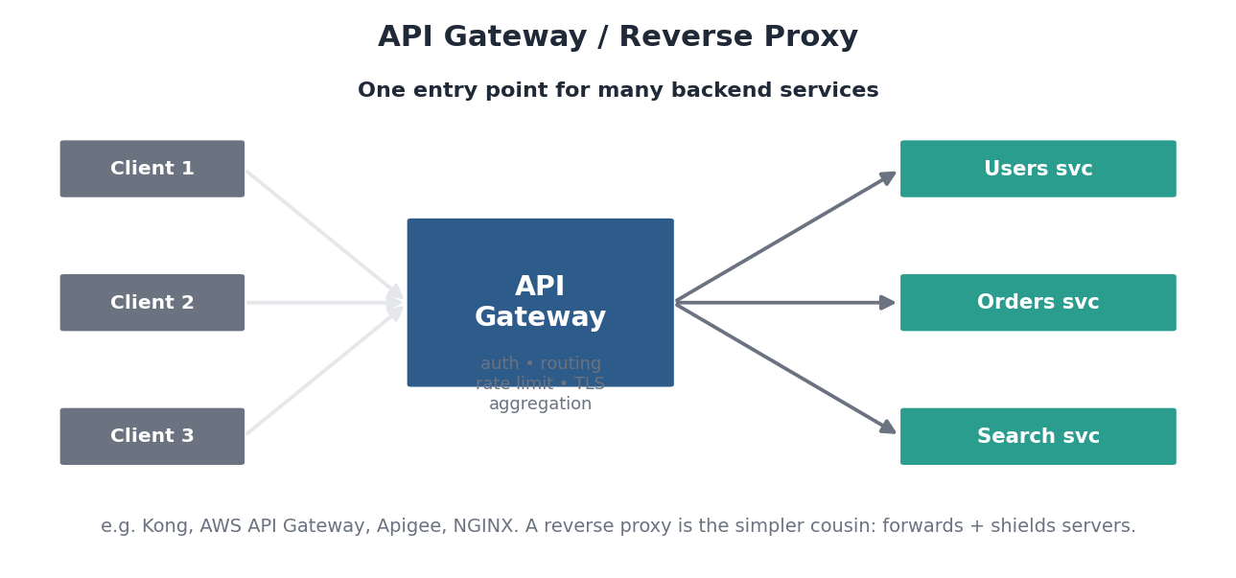
Figure: The gateway is one front door for many services, centralizing auth, routing, rate limiting, and TLS.

9.1 What it centralizes
Rather than making every microservice implement authentication, rate limiting, and TLS, the gateway handles them once at the edge. It routes each request to the right service, can aggregate several backend calls into one response for the client, and presents a stable external API even as services change behind it.
- Authentication — verify identity and tokens once, before requests reach any service.
- Rate limiting — protect backends from overload and abuse with throttling.
- Routing — direct each path to the correct service and version.
- Offloading — terminate TLS and handle request/response transformation centrally.
How it fails
- As the single front door, the gateway is a potential single point of failure and a latency hop — run it redundantly and keep it lean.
- Putting too much business logic in the gateway turns it into a bottleneck and a deployment chokepoint.
In the real world
- Kong, AWS API Gateway, Apigee — managed/standalone API gateways.
- NGINX & Envoy — serve as reverse proxies and gateway data planes.
- Netflix Zuul — Netflix’s gateway routed and filtered traffic to its sprawling microservice fleet.
- A simple reverse proxy (NGINX in front of a few app servers) is the lightweight version most small systems start with.
Self-check
- What is the difference between a reverse proxy and an API gateway?
- Name three cross-cutting concerns a gateway handles so services do not have to.
- What is the risk of putting business logic into the gateway?

10. Object / Blob Storage
Object storage holds large, unstructured files — images, video, audio, backups, logs, data-lake files — as objects in a flat namespace, each addressed by a key and carrying metadata. It is built for essentially unlimited scale and durability at low cost, and is accessed over an HTTP API rather than mounted like a disk.
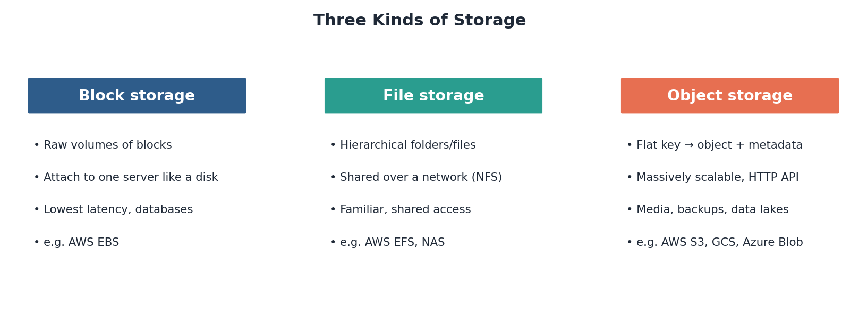
Figure: Block storage is raw volumes for one server; file storage is shared hierarchy; object storage is a flat, web-scale key→object map.

10.1 Why a separate system
Databases are the wrong place for large binaries — they bloat, slow down, and become expensive. The standard pattern is to store the file in object storage and keep only its URL (and metadata) in the database. Object stores also offer extreme durability (many copies across facilities), lifecycle rules to tier old data to cheaper cold storage, and direct integration with CDNs for serving.

10.2 Block vs. file vs. object
Type | Model | Best for
Block | Raw blocks, attached to one host | Databases, low-latency disks
File | Hierarchical folders over a network | Shared drives, legacy apps
Object | Flat key → object + metadata, HTTP | Media, backups, data lakes, web-scale

How it fails
- Higher per-request latency than a local disk — not for tiny, latency-critical reads.
- Listing or scanning huge buckets is slow; design keys thoughtfully.
- Misconfigured access policies are a notorious source of public data leaks — lock down permissions.
In the real world
- Amazon S3 — the defining object store; backs a huge share of the internet’s media, backups, and data lakes.
- Google Cloud Storage & Azure Blob Storage — the equivalents on other clouds.
- Dropbox — famously ran on S3 before building its own exabyte-scale object storage system (Magic Pocket).
- The common web pattern: upload to object storage, serve through a CDN, store only the URL in the database.
Self-check
- Why store large files in object storage rather than in the database?
- Distinguish block, file, and object storage by access model.
- What is the typical pattern linking object storage, a CDN, and a database?

11. Search Indexes
General-purpose databases are poor at full-text search — finding the documents that contain certain words, ranked by relevance, with typo tolerance and faceting. A dedicated search engine solves this with an inverted index: a structure that maps each term to the list of documents containing it, turning search from a full scan into a fast lookup.
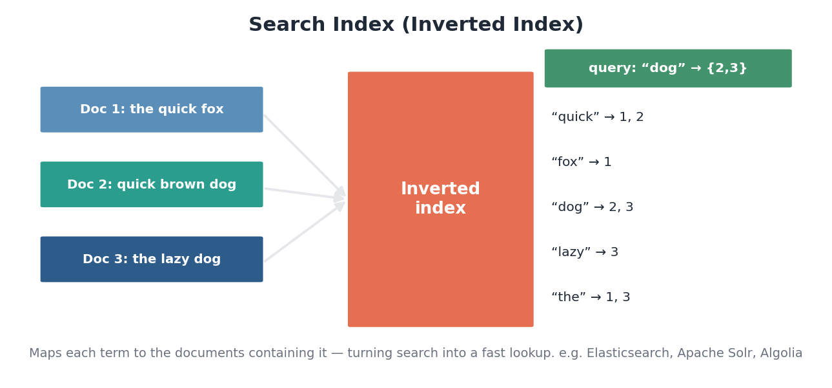
Figure: An inverted index maps each term to the documents containing it, so a query becomes a set lookup and intersection.

11.1 What search engines add
Beyond the inverted index, search systems provide relevance ranking (scoring how well a document matches), tokenization and stemming (so “running” matches “run”), fuzzy matching for typos, faceted filtering, and autocomplete. They are typically kept in sync with the primary database asynchronously — which means search results can lag slightly behind the source of truth, an acceptable tradeoff for most applications.

11.2 A secondary store, not the source of truth
A crucial design point: the search index is a derived, secondary store optimized for querying, not the system of record. The database remains authoritative; the search index is populated from it (often via a stream) and can be rebuilt from scratch if needed. This separation lets each system do what it is good at.
How it fails
- Index lag: search reflects the database only after async updates propagate.
- Reindexing large corpora is expensive — plan for it.
- Treating the search index as the source of truth risks data loss, since it is rebuildable, not authoritative.
In the real world
- Elasticsearch (and OpenSearch) — the dominant search and log-analytics engine, built on Apache Lucene.
- Apache Solr — another long-standing Lucene-based engine.
- Algolia — a hosted search service tuned for instant, typo-tolerant as-you-type search.
- The ELK stack (Elasticsearch + Logstash + Kibana) is also ubiquitous for searching and visualizing logs.
Self-check
- How does an inverted index make full-text search fast?
- Name three capabilities a search engine adds beyond a plain database.
- Why is the search index treated as a secondary store rather than the source of truth?

Putting the Blocks Together
These eleven components are not used in isolation — they compose into the systems you already use every day. A single image upload might flow through nearly all of them: a request arrives at a load balancer, passes an API gateway that authenticates it, the file lands in object storage while its metadata goes to a sharded, replicated database, a message on a stream triggers a thumbnail worker and a search-index update, the image is then served worldwide through a CDN, and hot metadata is kept in a cache. Learning the blocks individually is step one; recognizing how they snap together is what lets you design whole systems.
The synthesis
- Front door: load balancers, CDNs, and API gateways spread, accelerate, and guard incoming traffic.
- Source of truth: a database — relational by default — made scalable and durable through replication and sharding, and fast through indexes.
- Connective tissue: queues and streams decouple services; object storage holds the big files; search indexes make data findable.
- Caching threads through all of it, absorbing load at every layer.
- Pick each block for the specific problem it solves, and always know how it fails.

