MODULE 3
NETWORKING & PROTOCOLS
A Deep Dive, with Real-World Systems
How a request actually travels — names, connections, encryption, and the
protocols that carry it, from the address bar to real-time push.

Contents
Contents 1
Before You Begin 1
1. The Lifecycle of a Request 1
1.1 Step by step 1
2. DNS — The Internet’s Address Book 1
2.1 How a lookup works 1
2.2 Common record types 1
2.3 DNS as a system-design tool 1
3. TCP vs. UDP — The Transport Layer 1
3.1 TCP: reliable and ordered 1
3.2 UDP: fast and connectionless 1
4. TLS / HTTPS — Securing the Connection 1
4.1 The handshake 1
4.2 Certificates and trust 1
5. The HTTP Family 1
5.1 Methods and idempotency 1
5.2 Status codes 1
5.3 The evolution: HTTP/1.1 → 2 → 3 1
6. gRPC — Fast, Typed RPC Between Services 1
6.1 Why it is fast 1
6.2 Four call patterns 1
6.3 When to choose it 1
7. Real-Time Communication 1
7.1 The four techniques 1
7.2 Choosing 1
Putting the Layers Together 1

Before You Begin
You do not need to recite RFCs to design good systems, but you do need enough networking to reason about how a request travels, where it can slow down, and where it can fail. This module builds that intuition layer by layer.
We start with the whole journey — the lifecycle of a single request — then descend the stack one layer at a time: how a name becomes an address (DNS), how a connection is made (TCP vs. UDP), how it is secured (TLS/HTTPS), and how the application talks over it (the HTTP family and gRPC). We finish at the top with the techniques that let a server push data to a client in real time. Each section names the real protocols and systems in use, so the ideas stay concrete.
What this module covers
- The request lifecycle — the end-to-end path every request takes.
- DNS — resolving a human name into an IP address.
- TCP vs. UDP — the two transport models and when each wins.
- TLS / HTTPS — how connections are encrypted.
- The HTTP family — methods, status codes, and the leap from 1.1 to 2 to 3.
- gRPC — fast, typed, binary RPC between services.
- Real-time communication — polling, long polling, SSE, and WebSockets.
A quick orientation before we dive in: protocols are organized into layers, each riding on the one beneath it. Keeping this picture in mind tells you where every topic in this module fits.
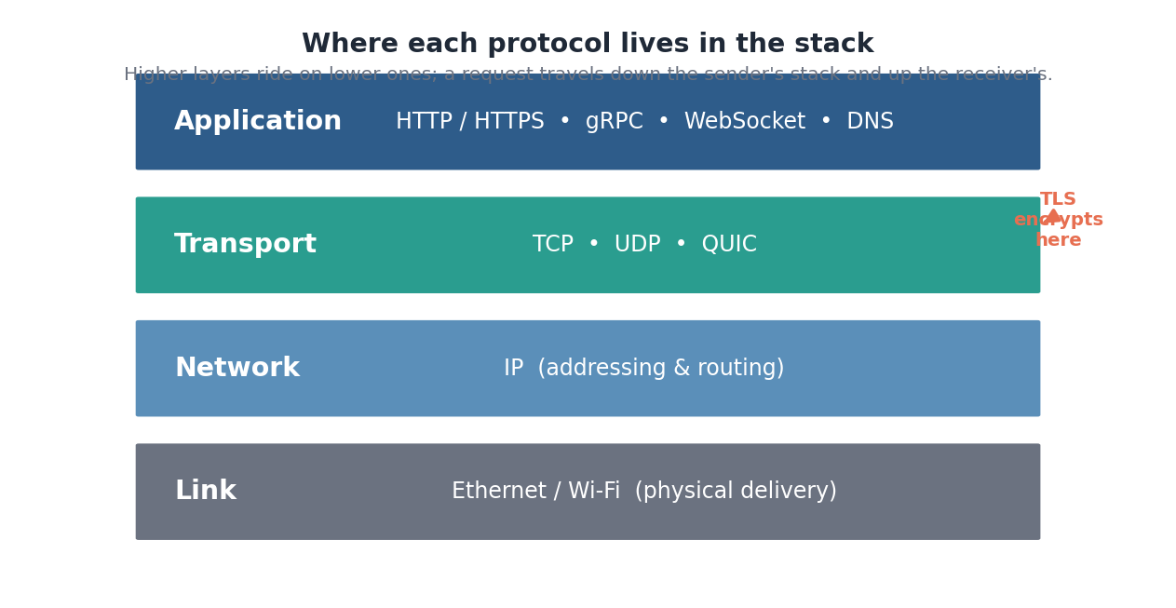
Figure: The layered model: a request travels down the sender's stack and back up the receiver's. TLS encrypts between the application and transport layers.

1. The Lifecycle of a Request
Before zooming into individual protocols, it helps to see the whole journey. Typing a URL and pressing enter sets off a chain of steps, each handled by a different component and a different protocol. Being able to trace this path — and name what could fail at each hop — is one of the most useful skills in system design.
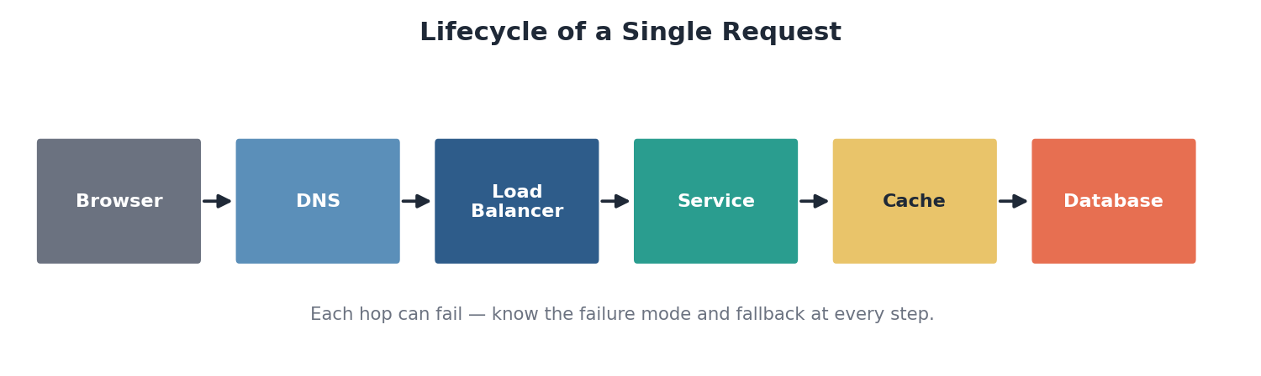
Figure: Browser to DNS to load balancer to service to cache or database, and back.

1.1 Step by step
- Resolve the name — the browser first needs the server’s IP address, so it performs a DNS lookup (Section 2).
- Connect & secure — it opens a TCP connection to that IP and, for HTTPS, completes a TLS handshake to encrypt it (Sections 3–4).
- Send the request — the browser sends an HTTP request, which arrives at a load balancer that forwards it to a healthy server (Section 5).
- Process & respond — the service may hit a cache or database, assemble a response, and send it back down the same encrypted connection.
Where it can fail
- DNS resolution fails or is slow — the user never reaches you.
- TCP/TLS setup adds round trips — latency before any data flows.
- The load balancer routes to an unhealthy server, or the database is the bottleneck.
- Each hop is a place to add a timeout, a retry, and a fallback.
In the real world
- Opening any website, say wikipedia.org, runs this exact sequence in well under a second.
- Browser dev tools — the Network tab breaks a real request into DNS, connect, TLS, and waiting phases — a live view of this lifecycle.
- CDNs — short-circuit the path by answering from an edge near the user before the request ever reaches the origin.
Self-check
- List the major steps from pressing Enter to seeing a page, in order.
- Name a failure mode at the DNS hop and at the load-balancer hop.
- Why does an HTTPS request take more round trips to start than a plain HTTP one?

2. DNS — The Internet’s Address Book
Humans use names like example.com; machines route by IP addresses like 93.184.216.34. The Domain Name System is the distributed directory that translates one into the other. It is the very first step of almost every request, which is why its speed and reliability matter enormously.
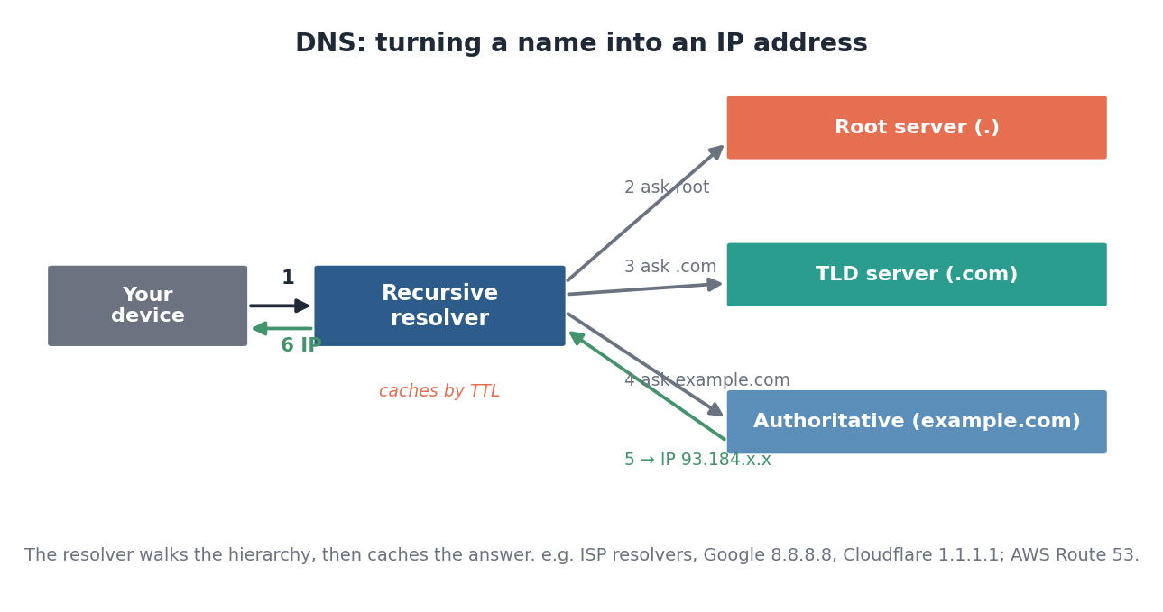
Figure: A recursive resolver walks the hierarchy — root, then TLD, then authoritative — then caches the answer by its TTL.

2.1 How a lookup works
Your device asks a recursive resolver (run by your ISP, or a public one) to find the address. If it is not already cached, the resolver walks the hierarchy: it asks a root server, which points it to the TLD server for .com, which points it to the authoritative server for example.com, which finally returns the IP. The resolver caches the answer for a duration set by the record’s TTL, so the next lookup is instant.

2.2 Common record types
Record | Maps | Used for
A / AAAA | Name → IPv4 / IPv6 address | The basic address lookup
CNAME | Name → another name | Aliases (www → root domain)
MX | Name → mail server | Email routing
NS | Domain → authoritative servers | Delegation
TXT | Name → arbitrary text | Verification, SPF/DKIM

2.3 DNS as a system-design tool
DNS is not just plumbing — it is a load-distribution and routing layer. By returning different IPs to different users, operators do global load balancing and failover at the DNS level. GeoDNS returns the address of the nearest data center; weighted records split traffic; low TTLs allow quick failover by repointing a name to a healthy region.
Where it can fail
- DNS outages take down sites that are otherwise perfectly healthy — a single misconfiguration can be global.
- Long TTLs make failover slow; very short TTLs increase lookup load. It is a real tradeoff.
- Propagation of changes is not instant because of caching down the chain.
In the real world
- Public resolvers — Google (8.8.8.8) and Cloudflare (1.1.1.1) are widely used recursive resolvers.
- AWS Route 53, Cloudflare DNS, NS1 — managed authoritative DNS with health checks, GeoDNS, and weighted routing.
- CDNs — rely on DNS to send each user to their nearest edge location.
- Major DNS outages (such as the 2016 Dyn attack) have taken down large swaths of the internet — a reminder that DNS is critical infrastructure.
Self-check
- Walk through the four servers a cold DNS lookup may contact.
- What does a record’s TTL control, and what is the tradeoff in setting it low?
- How can DNS be used to route users to the nearest data center?

3. TCP vs. UDP — The Transport Layer
Once you have an IP address, you need a way to actually send bytes to it. That is the transport layer, and it offers two very different models. The choice between them is a fundamental tradeoff between reliability and speed.
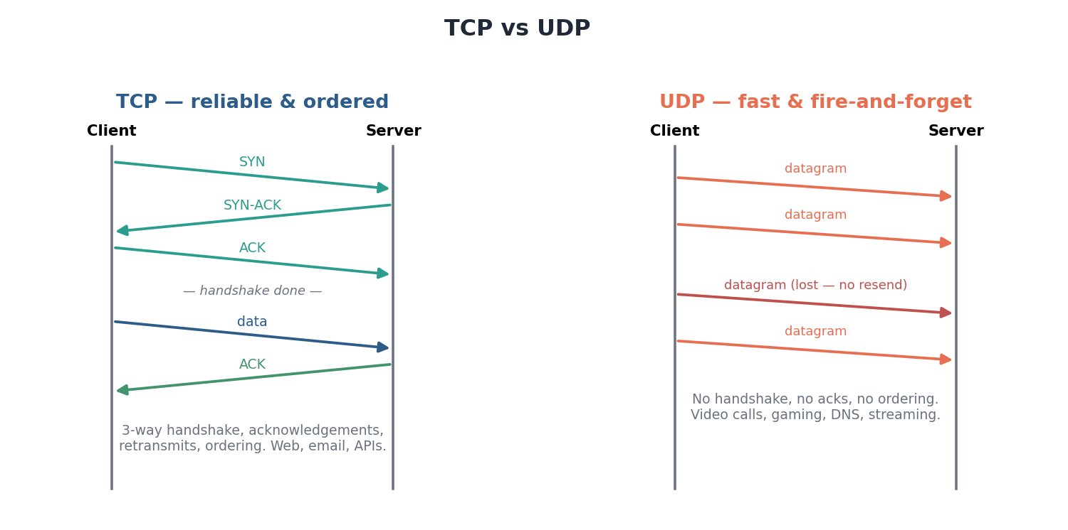
Figure: TCP establishes a connection and guarantees delivery and order; UDP just fires datagrams with no guarantees.

3.1 TCP: reliable and ordered
TCP establishes a connection with a three-way handshake (SYN, SYN-ACK, ACK) before any data flows. It then guarantees that every byte arrives, exactly once, in order — lost packets are detected and retransmitted, and flow control prevents overwhelming the receiver. This reliability is why the web, email, and most APIs run on TCP. The cost is overhead: the handshake adds a round trip, and ordering means a single lost packet can stall everything behind it (head-of-line blocking).

3.2 UDP: fast and connectionless
UDP sends independent datagrams with no handshake, no acknowledgements, and no ordering. Packets may be lost, duplicated, or arrive out of order, and the application must cope. In exchange it is lean and low-latency — ideal when fresh data matters more than complete data. In a video call, a dropped frame is better skipped than resent late, which is exactly UDP’s strength.
 | TCP | UDP
Connection | Handshake first | None
Reliability | Guaranteed, retransmits | Best-effort, may drop
Ordering | In order | No ordering
Overhead / latency | Higher | Lower
Use for | Web, email, file transfer, APIs | Video/voice, gaming, DNS, streaming

In the real world
- TCP — carries HTTP/1.1 and HTTP/2, SMTP email, SSH, and database connections.
- UDP — underlies real-time media (Zoom, WebRTC), online games, DNS queries, and live streaming.
- QUIC — Google built a reliable, multiplexed transport on top of UDP to get TCP’s guarantees without its head-of-line blocking — it now carries HTTP/3 (Section 5).
Self-check
- What does TCP’s three-way handshake accomplish before data is sent?
- Why is UDP a better fit than TCP for a live video call?
- What is head-of-line blocking, and how does QUIC sidestep it?

4. TLS / HTTPS — Securing the Connection
HTTPS is simply HTTP running over a connection encrypted by TLS (Transport Layer Security). Without it, anyone between the user and the server could read or tamper with traffic. TLS provides three guarantees at once: encryption (eavesdroppers see only ciphertext), integrity (tampering is detected), and authentication (the certificate proves you are really talking to the right server).
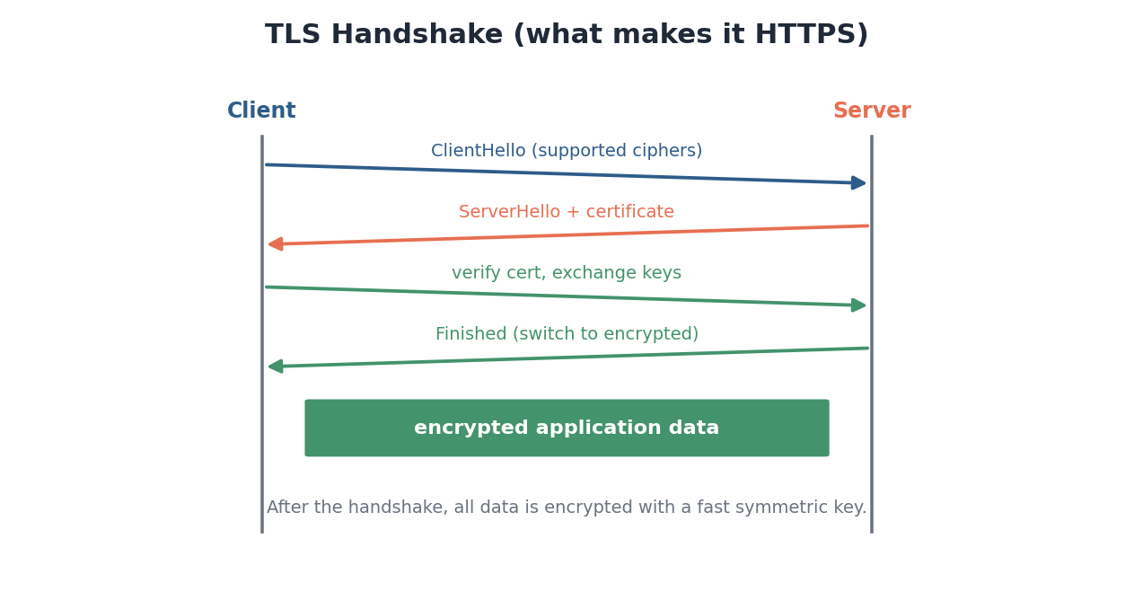
Figure: The handshake negotiates ciphers, presents a certificate, and exchanges keys; afterward all data is encrypted.

4.1 The handshake
After the TCP connection is open, the TLS handshake runs: the client offers the cipher suites it supports, the server responds and presents its certificate, the client verifies that certificate against a trusted Certificate Authority and the two sides agree on a shared secret key. From then on, all application data is encrypted with fast symmetric cryptography. The handshake costs extra round trips, though modern TLS 1.3 trims this significantly, and session resumption avoids repeating it.

4.2 Certificates and trust
Trust rests on certificates issued by Certificate Authorities (CAs). The certificate binds a domain name to a public key and is signed by a CA your browser already trusts, forming a chain of trust. This is what produces the padlock in the address bar and prevents impersonation.
Where it can fail
- Expired or misconfigured certificates break the connection and alarm users — automate renewal.
- The extra handshake round trips add latency, which matters most on the first connection from far away.
- Trusting a compromised CA undermines the whole model, which is why CA security is tightly governed.
In the real world
- Let’s Encrypt — a free, automated CA that made HTTPS universal; tools like Certbot auto-renew certificates.
- TLS 1.3 — the current standard, with a faster handshake than its predecessors.
- CDNs — terminate TLS at the edge so the expensive handshake happens close to the user.
- Browsers now mark plain HTTP pages as ‘Not Secure,’ making HTTPS effectively mandatory.
Self-check
- What three guarantees does TLS provide?
- What role does a Certificate Authority play in establishing trust?
- Why do CDNs terminate TLS at the edge?

5. The HTTP Family
HTTP is the application-layer protocol of the web — the request/response language clients and servers speak. Its semantics (methods, status codes, headers) have stayed stable for decades, while the underlying transport has evolved dramatically to fix performance problems.

5.1 Methods and idempotency
HTTP requests carry a method describing intent. A key property is idempotency: whether repeating a request has the same effect as making it once. This matters because networks retry, and a retried payment must not charge twice.
Method | Purpose | Idempotent?
GET | Read a resource | Yes (and safe — no change)
PUT | Replace a resource | Yes
DELETE | Remove a resource | Yes
POST | Create / submit | No — may create duplicates
PATCH | Partially update | Not necessarily

5.2 Status codes
Range | Meaning | Examples
2xx | Success | 200 OK, 201 Created, 204 No Content
3xx | Redirection | 301 Moved, 304 Not Modified
4xx | Client error | 400, 401, 403, 404, 429 Too Many Requests
5xx | Server error | 500, 502, 503 Unavailable, 504 Timeout

5.3 The evolution: HTTP/1.1 → 2 → 3
Each version kept the same semantics but changed how bytes move, chasing lower latency. HTTP/1.1 sends one request at a time per connection, so a slow response blocks those behind it. HTTP/2 multiplexes many streams over a single TCP connection, eliminating that application-level blocking. HTTP/3 goes further, running over QUIC (on UDP) so that a single lost packet no longer stalls every stream — the head-of-line problem that TCP could not avoid.
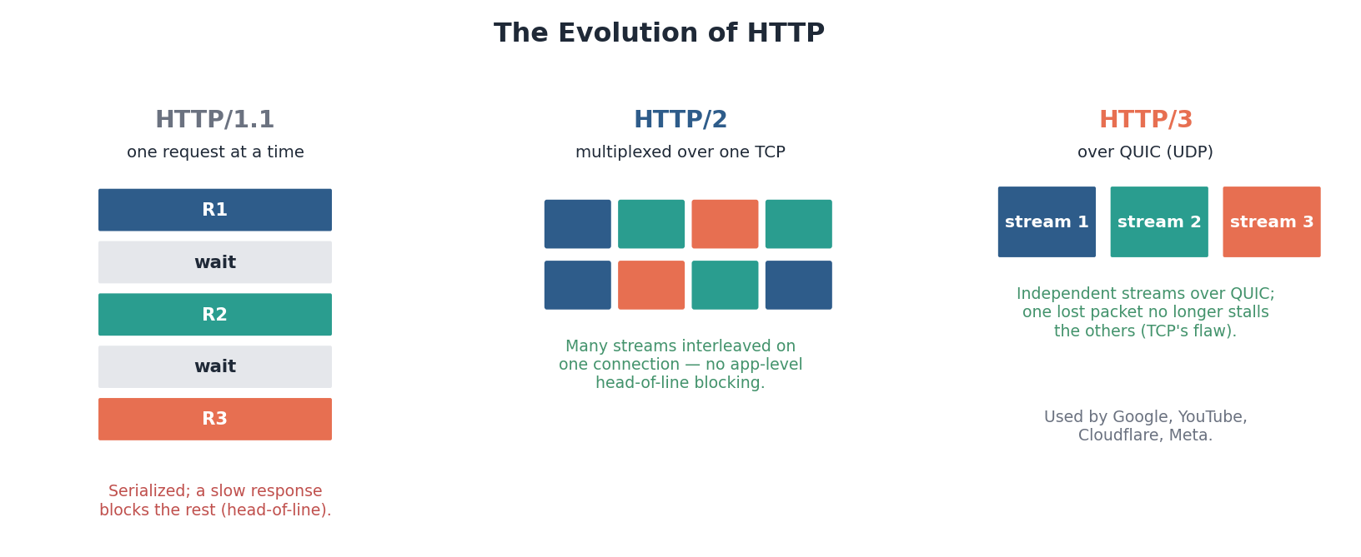
Figure: From serial requests, to multiplexing over one TCP connection, to independent streams over QUIC/UDP.
In the real world
- REST APIs — the dominant style for public web APIs, built directly on HTTP methods and status codes.
- HTTP/2 — is now widely deployed; its multiplexing sped up page loads across the web.
- HTTP/3 / QUIC — is used by Google, YouTube, Cloudflare, and Meta to cut latency, especially on lossy mobile networks.
- 429 and 503 — are the codes clients watch to back off and retry politely under load.
Self-check
- Why must a POST generally be treated as non-idempotent, and why does that matter for retries?
- What problem did HTTP/2 multiplexing solve over HTTP/1.1?
- Why does running HTTP/3 over QUIC/UDP avoid TCP’s head-of-line blocking?

6. gRPC — Fast, Typed RPC Between Services
REST over JSON is excellent for public, human-readable APIs, but it is verbose and loosely typed — not ideal for high-volume internal communication between microservices. gRPC is a framework built for that case: it serializes messages with Protocol Buffers (a compact binary format defined by a strict schema) and carries them over HTTP/2.
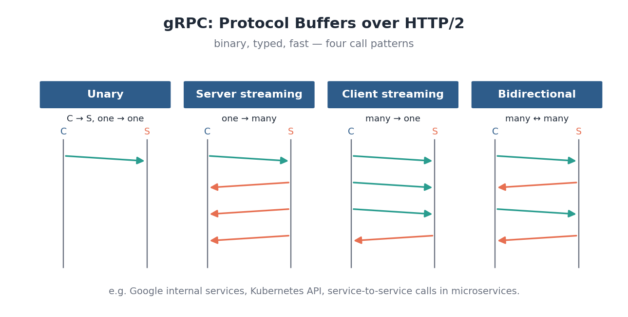
Figure: gRPC sends typed binary messages over HTTP/2 and supports four call patterns, including streaming in both directions.

6.1 Why it is fast
Because messages are binary and the schema is known on both ends, payloads are far smaller than JSON and need no expensive text parsing. The shared schema (the .proto file) also generates client and server code in many languages, giving compile-time type safety across service boundaries. Running on HTTP/2 brings multiplexing and built-in support for streaming.

6.2 Four call patterns
- Unary — a single request, a single response — the familiar RPC.
- Server streaming — one request, a stream of responses (e.g. live updates).
- Client streaming — a stream of requests, one response (e.g. uploading chunks).
- Bidirectional streaming — both sides stream simultaneously over one connection.

6.3 When to choose it
 | REST / JSON | gRPC
Format | Text (JSON), human-readable | Binary (Protobuf), compact
Typing | Loose | Strict schema, generated code
Transport | Usually HTTP/1.1 | HTTP/2, streaming built in
Best for | Public APIs, browser clients | Internal service-to-service

In the real world
- Google — created gRPC from its internal RPC system; it powers vast amounts of service-to-service traffic.
- Kubernetes — its core components and API machinery communicate using gRPC and Protocol Buffers.
- Microservice platforms — at companies like Netflix, Square, and Dropbox use gRPC for low-latency internal calls.
- Browsers cannot speak raw gRPC easily, so gRPC-Web or a REST gateway is used at the public edge.
Self-check
- Why is a binary, schema-defined format faster than JSON for internal calls?
- Give a use case for server-streaming and one for bidirectional streaming.
- Why is REST often still preferred for public, browser-facing APIs?

7. Real-Time Communication
Plain HTTP is client-initiated: the server can only answer questions the client asks. But many features — chat, live scores, notifications, collaborative editing — need the server to push data the moment it changes. Four techniques make this possible, trading simplicity against efficiency.
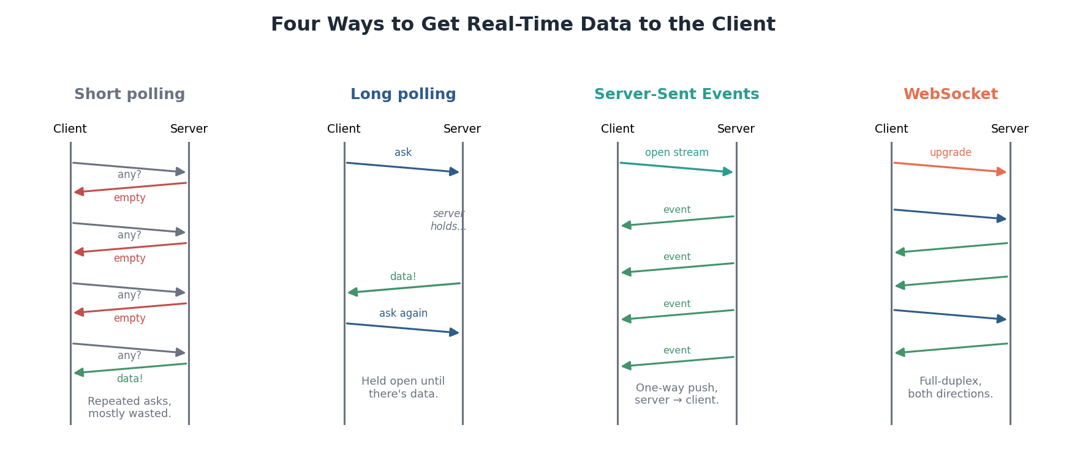
Figure: From wasteful repeated polling, to held-open long polling, to one-way SSE streams, to full-duplex WebSockets.

7.1 The four techniques
- Short polling — the client repeatedly asks “anything new?” on a timer. Dead simple, but most requests return nothing — wasteful and laggy.
- Long polling — the client asks, and the server holds the request open until it actually has data, then responds and the client immediately re-asks. Near-real-time without special protocols.
- Server-Sent Events (SSE) — the client opens one long-lived connection and the server streams a sequence of events down it. Efficient for one-way, server-to-client updates over plain HTTP.
- WebSockets — a single persistent, full-duplex connection (upgraded from HTTP) over which both sides send messages freely. The choice for truly interactive, two-way real-time.

7.2 Choosing
Technique | Direction | Connection | Best for
Short polling | Pull | New request each time | Simple, infrequent updates
Long polling | Pull (held) | Re-opened per message | Near-real-time, no WebSockets
SSE | Server → client | One long-lived | Feeds, notifications, tickers
WebSocket | Both ways | One persistent | Chat, gaming, collaboration

How to choose
- Only need the server to push one-way? SSE is simpler than WebSocket and works over normal HTTP.
- Need rich two-way interaction? Use WebSocket.
- Cannot use either (legacy constraints)? Long polling is the fallback. Short polling is the last resort.
In the real world
- WebSocket — power Slack, WhatsApp Web, Discord, and multiplayer games — anywhere both sides talk constantly.
- SSE — suits live sports scores, stock tickers, and notification feeds that flow server-to-client.
- Long polling — was the backbone of early real-time web (e.g. older chat and Facebook updates) before WebSockets were standard.
- Collaborative editors — like Google Docs and Figma rely on persistent connections to sync edits in real time.
Self-check
- Why is short polling wasteful, and how does long polling improve on it?
- When would you pick SSE over WebSockets?
- What makes WebSockets suitable for chat where SSE is not?

Putting the Layers Together
Every request you have ever made is these layers working in concert. Loading a page in a chat app shows the whole stack at once: DNS resolves the domain to an IP; TCP opens a connection and TLS encrypts it; HTTP/2 or HTTP/3 fetches the page and its assets (served fast from a CDN); behind the scenes the servers talk to each other over gRPC; and once loaded, a WebSocket stays open to stream new messages in real time. Understanding each layer in isolation is step one; seeing how they stack — name, connection, encryption, application, real-time — is what lets you reason about latency and failure across a whole system.
The synthesis
- A request descends a stack: a name is resolved (DNS), a connection is opened (TCP/UDP) and secured (TLS).
- The application speaks over it — HTTP for the web, gRPC between internal services — with HTTP evolving (1.1 → 2 → 3/QUIC) to cut latency.
- When the server must push data, real-time techniques (SSE, WebSockets) keep a connection open.
- At every hop there is a latency cost and a failure mode — know both, and add timeouts, retries, and fallbacks accordingly.

