MODULE 1
CORE MENTAL MODELS
A Deep Dive
Comprehensive explanations of the five ideas that underlie every
system design decision you will ever make.

Contents

Before You Begin
Module 1 covers five mental models. They are not components you assemble or technologies you configure — they are the lenses through which every later decision is judged. Choose a database, a cache, a replication scheme, an API style, and in each case you are really answering questions posed by these five ideas: how fast and how much, on one machine or many, with state held where, sacrificing what under failure, and promising readers what guarantee.
This guide treats each model on its own terms: what it means precisely, why it exists, how it behaves, the tradeoffs it imposes, and where it shows up in real systems. Read it slowly. The payoff is that novel problems stop looking novel — you recognize which of these five tensions is really being asked about.
The five models
- Latency vs. throughput — the two ways to measure speed, and why they fight.
- Vertical vs. horizontal scaling — bigger machine or more machines.
- Stateless vs. stateful services — where the difficult part, state, lives.
- The CAP theorem — what you must give up when the network splits.
- Consistency models — the spectrum of promises you make to readers.

1. Latency vs. Throughput
Speed is not one number. Latency and throughput are two different measurements of it, and a system can be excellent at one while terrible at the other. Conflating them is one of the most common sources of muddled design.

1.1 Definitions
- Latency — the time a single request takes from start to finish — measured in milliseconds. It answers “how long does one user wait?”
- Throughput — the number of requests the system completes per unit time — measured in requests/sec, queries/sec, or bytes/sec. It answers “how much work gets done?”
A useful analogy is a highway. Latency is how long it takes one car to drive from one end to the other; throughput is how many cars pass through per minute. Adding lanes (parallelism) raises throughput without making any single car faster. Raising the speed limit lowers latency. They are independent dials — until the road gets congested.

1.2 Why they trade off
At low load the two are unrelated, but they collide under pressure. Two mechanisms drive the tradeoff. First, batching: grouping work raises efficiency and throughput but makes early items wait for the batch to fill, adding latency. Second, queueing: when arrival rate approaches the system’s service rate, requests wait in line, and queue time dominates total latency. This is why a system can show healthy average throughput while individual requests crawl.
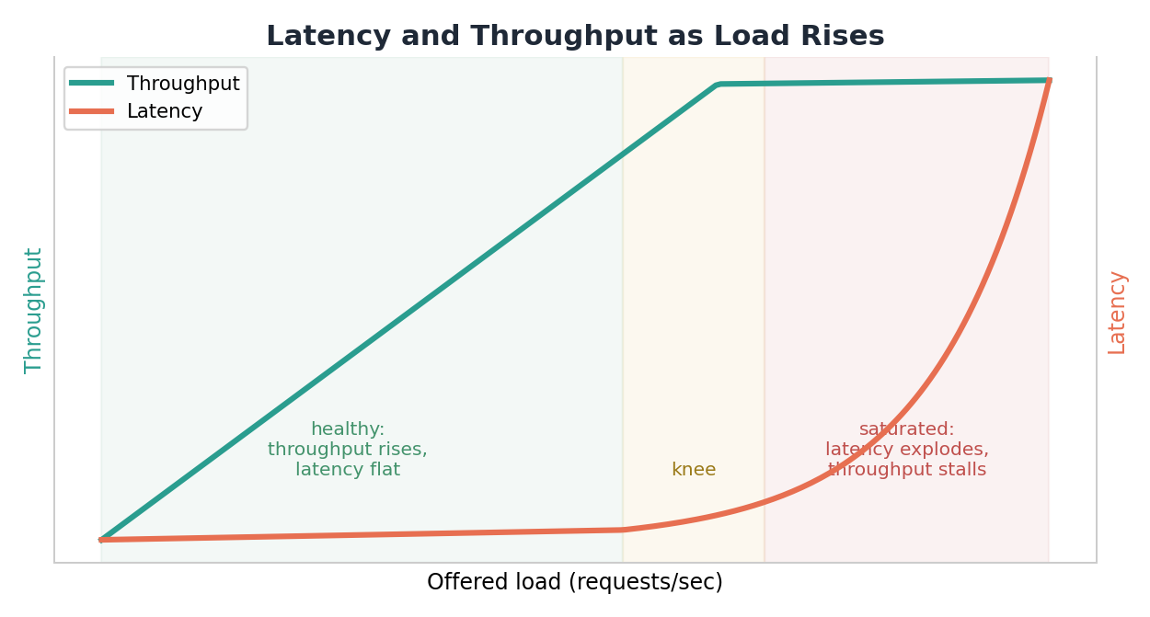
Figure: Below the knee, throughput rises while latency stays flat. Past it, the queue builds, latency explodes, and throughput stalls.
The vertical “knee” is the most important feature of this picture. To its left the system is healthy; to its right it is saturated and adding load makes everything worse. Capacity planning is largely the art of keeping operation comfortably left of the knee.

1.3 Measure percentiles, never averages
This is the single most important practical lesson about latency. An average hides the slow requests that real users actually feel. Report percentiles instead: p50 (median), p95, p99, and sometimes p99.9. The statement “p99 latency is 300 ms” means one request in a hundred is slower than 300 ms — and at scale, that is a lot of unhappy users.
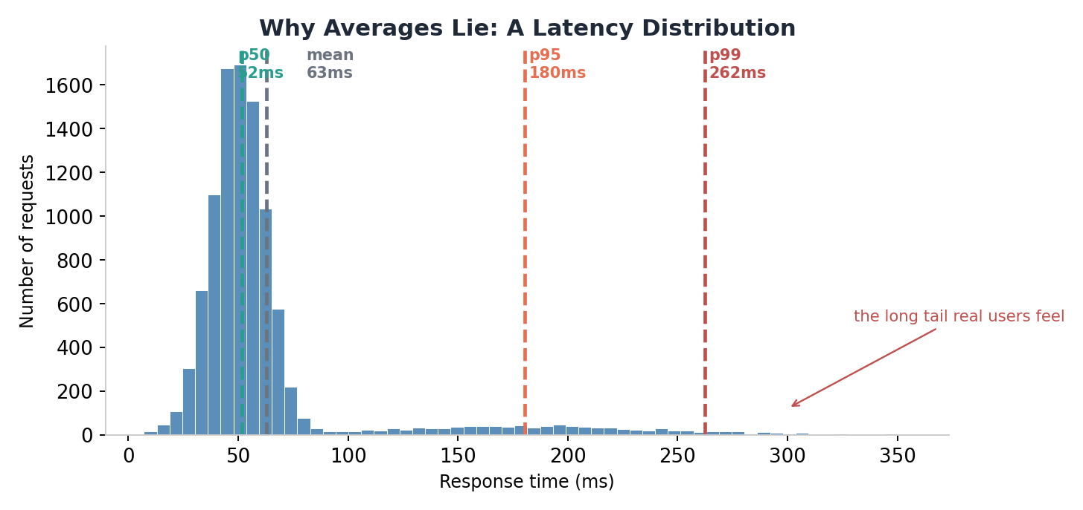
Figure: Most requests are fast, but a long tail drags far to the right. The mean sits near the median and tells you nothing about the tail.
Notice that the mean and median in the figure are close together and low, while p95 and p99 are far to the right. A system optimized for its average can still deliver a miserable experience to its tail users. High-percentile latency is what you commit to in a service-level objective, because it reflects the worst routine experience rather than the typical one.

1.4 Tail latency amplification
The tail gets worse, not better, as systems grow. When one request fans out to many backend services and must wait for all of them, the overall latency is governed by the slowest responder. If each service is slow 1% of the time, a request touching 100 of them is almost certain to hit at least one slow path. This is tail latency amplification, and it is why large distributed systems fight so hard to tame their p99.
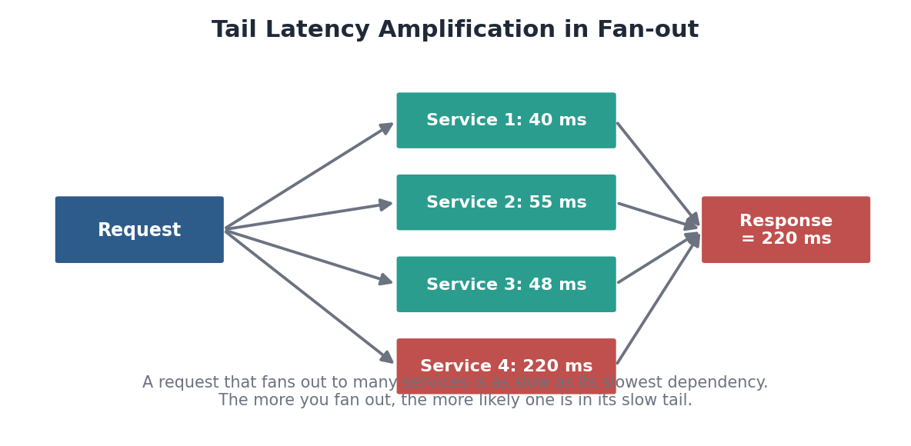
Figure: A fan-out request is only as fast as its slowest dependency; more dependencies means more chances to land in a slow tail.
Designing with this model
- Decide which metric matters: a batch analytics job optimizes throughput; an interactive API optimizes tail latency.
- Always quote latency as percentiles (p50/p95/p99); treat averages as a red flag.
- Keep operating load to the left of the knee — leave headroom for spikes.
- In fan-out systems, attack the tail directly: timeouts, hedged requests, and trimming the number of dependencies on the critical path.
Self-check
- Define latency and throughput, and give a real system that is excellent at one but poor at the other.
- Explain, using queueing, why latency spikes sharply once load passes the knee.
- Your service reports a 40 ms average but users complain it feels slow. What metric should you look at, and why?
- Why does a request that calls 50 microservices tend to have worse tail latency than one that calls 5?

2. Vertical vs. Horizontal Scaling
When a system can no longer keep up, you have two fundamentally different ways to give it more capacity. The choice shapes everything that follows, because one path stays simple and the other unlocks essentially unlimited growth at the price of real complexity.

2.1 The two paths
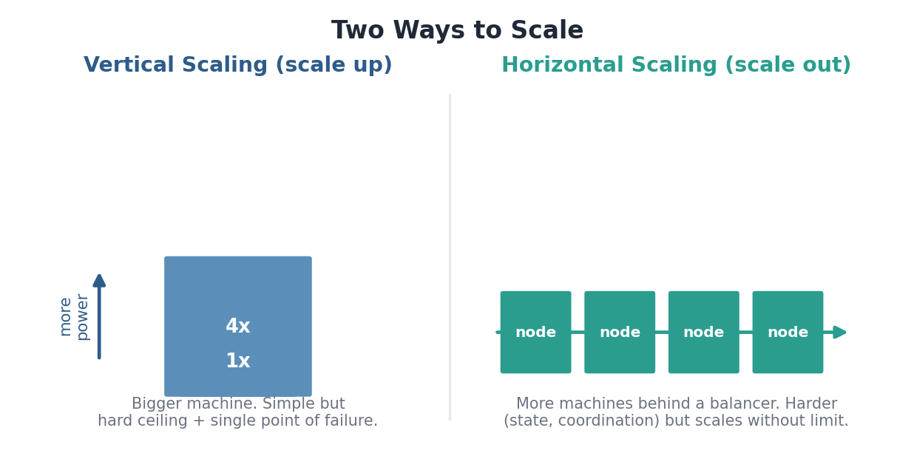
Figure: Scaling up adds power to a single machine; scaling out adds machines behind a balancer.
- Vertical scaling (scale up) — buy a bigger machine — more CPU, RAM, faster disk. The application does not change; the hardware underneath it grows.
- Horizontal scaling (scale out) — add more machines and spread the work across them, coordinated by a load balancer. The application must be built to run as many cooperating copies.

2.2 The economics
Vertical scaling is attractive at first because it requires no architectural change, but it has two fatal limits: a hardware ceiling (there is a biggest machine money can buy) and a single point of failure (when that one machine dies, everything dies). Its cost also curves upward — top-end hardware commands a steep premium. Horizontal scaling grows cost roughly linearly with capacity using commodity machines, and has no ceiling, but it forces you to solve coordination and state-distribution problems.
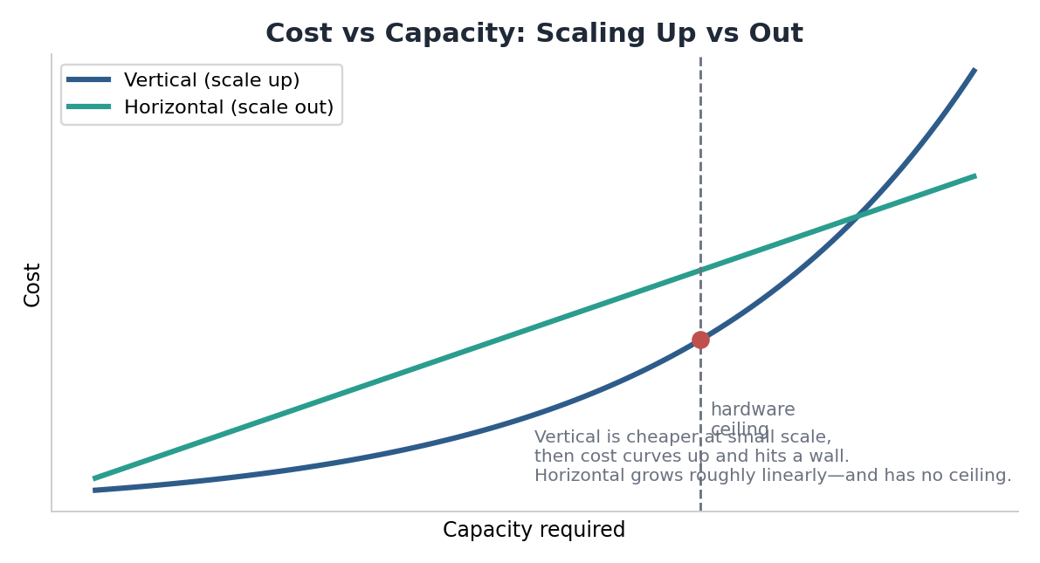
Figure: Vertical is cheaper at small scale, then curves up and hits a wall. Horizontal grows roughly linearly and never hits a ceiling.

2.3 Choosing between them
Dimension | Vertical (scale up) | Horizontal (scale out)
Complexity | Low — no app changes | High — coordination, state
Ceiling | Hard hardware limit | Effectively none
Fault tolerance | Single point of failure | Redundant by design
Cost curve | Premium at the top end | ~Linear, commodity hardware
Good first move for | Databases, quick wins | Stateless web/app tiers

In practice the two are combined. A common pattern is to scale up the hard-to-distribute parts (a primary relational database) as far as is reasonable, while scaling out the easy parts (stateless application servers) freely. The deciding question is almost always whether the component holds state — which is exactly the next mental model.
Designing with this model
- Reach for vertical scaling first when it is cheap and buys enough headroom — do not add distributed complexity you do not need.
- But never let a single vertically-scaled node be an unprotected single point of failure.
- Plan the horizontal path early for anything expected to grow large; retrofitting it is expensive.
- The thing that makes horizontal scaling hard is state, so design to minimize and isolate it.
Self-check
- Name the two hard limits of vertical scaling.
- Why does horizontal scaling cost roughly linearly while vertical scaling curves upward?
- Which tier of a typical web application is easiest to scale horizontally, and why?
- Give a realistic architecture that uses both strategies at once.

3. Stateless vs. Stateful Services
State is the data a service remembers between requests. It is also the single hardest thing to scale, replicate, and recover. This model is about recognizing where state lives and deliberately controlling it.

3.1 The distinction
- A stateless service — keeps no client-specific data between requests. Everything it needs arrives in the request or is fetched from a shared store. Any instance can therefore handle any request.
- A stateful service — remembers something about a client across requests — a session, an in-memory cache of that user’s data, a partial workflow. A given client’s requests must reach the instance that holds its state.
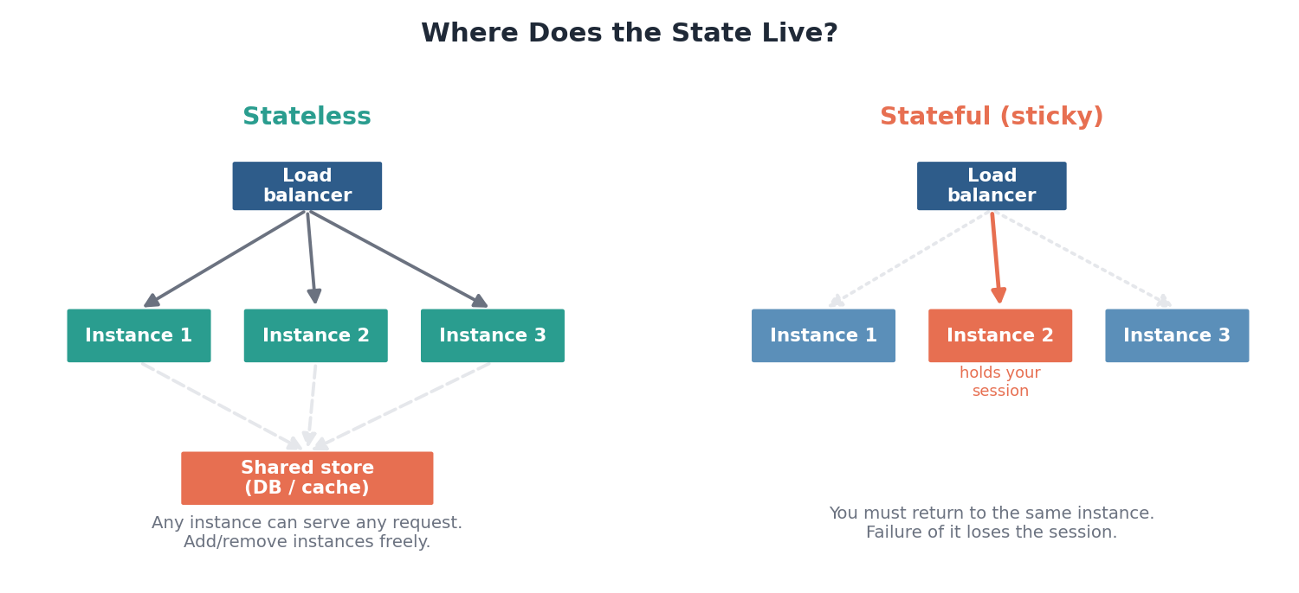
Figure: Stateless instances are interchangeable; a sticky stateful instance must keep serving the same client, and its failure loses the session.

3.2 Why statelessness is so valuable
Because any stateless instance can serve any request, three hard problems become easy. Scaling is trivial: add or remove instances and the load balancer simply spreads traffic across them. Failover is trivial: if an instance dies, its in-flight requests can be retried on any other. Deployment is trivial: roll instances one at a time without coordinating who holds what. Stateful services lose all three of these properties — a dead instance takes its sessions with it, and traffic cannot freely move.

3.3 The central design move: externalize state
The standard solution is not to eliminate state — systems obviously must remember things — but to push it out of the application tier into purpose-built stores. Sessions go to a fast shared cache like Redis; durable data goes to a database; large files go to blob storage; pending work goes to a queue. The application tier is left stateless and trivially scalable, while each kind of state lives in a system designed to store it well.
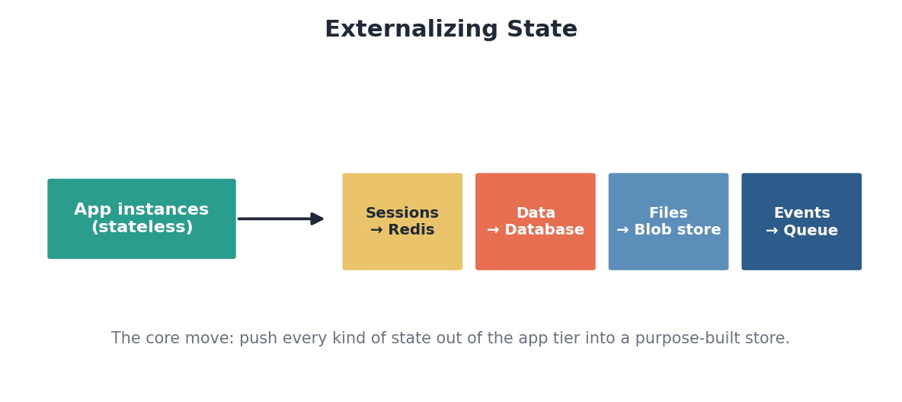
Figure: Keep the app tier stateless by moving each kind of state into a store built for it.

3.4 When state must stay local
Sometimes locality is the point — an in-memory cache, a long-lived WebSocket connection, or a game session benefits from staying on one node. Then you manage it deliberately: sticky sessions route a client back to its instance, or a token (such as a signed cookie or JWT) carries the state in the request itself so the server can stay stateless. Each approach trades efficiency against resilience, and naming that tradeoff is the skill.
Approach | How it works | Cost
Externalize to shared store | State in Redis/DB; app stateless | Extra network hop per request
Sticky sessions | Balancer pins a client to one instance | Lost session if that instance dies
Token-carried state | Client sends signed state each request | Larger requests; revocation is harder

Designing with this model
- Default the application tier to stateless; it is what makes horizontal scaling and failover easy.
- Externalize each kind of state to a store designed for it rather than holding it in the app.
- If state must be local, choose sticky sessions or token-carried state consciously and state the resilience cost.
- Ask of every service: “if this instance dies mid-request, what is lost?” The answer reveals its state.
Self-check
- What makes a service stateless, and why does that make scaling and failover easy?
- Where would you put user session data to keep your web tier stateless?
- What is the risk of sticky sessions, and when is it nonetheless acceptable?
- How does a signed token let a server remain stateless while still ‘remembering’ a user?

4. The CAP Theorem
CAP is the law that governs every distributed datastore. It is frequently misquoted, so it is worth stating precisely and then unpacking what it really forces you to decide.

4.1 The three properties
- Consistency (C) — every read receives the most recent write or an error. All nodes agree on the data at all times. (Note: this is a stronger, different notion than the “consistency” in ACID.)
- Availability (A) — every request receives a non-error response, without the guarantee that it contains the most recent write.
- Partition tolerance (P) — the system keeps operating even when the network drops or delays messages between nodes.
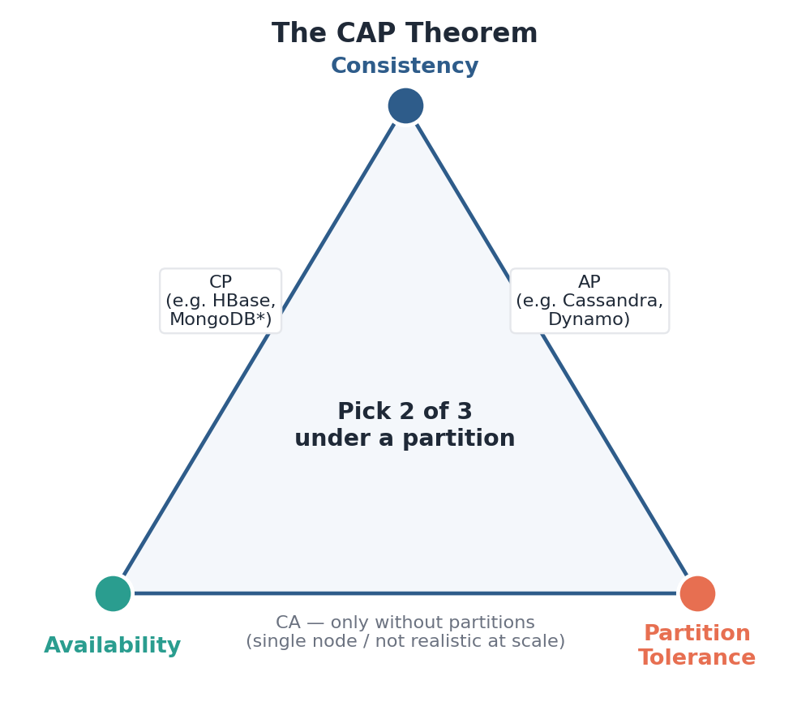
Figure: Under a partition you can satisfy at most two of the three properties.

4.2 What the theorem actually says
The precise claim is narrow: when a network partition occurs, a distributed system must choose between consistency and availability. It cannot have both while partitioned. The popular “pick two of three” framing is misleading, because in any real distributed system partitions are a fact of life, not an option — networks fail. So P is effectively mandatory, and the real choice is between CP and AP.
The choice is really CP vs. AP
- CP — keep data consistent, sacrifice availability: during a partition, refuse requests you cannot confirm.
- AP — keep serving, sacrifice consistency: answer from each side and reconcile differences afterward.
- CA — only meaningful with no partitions at all, i.e. a single node; not a real option at scale.
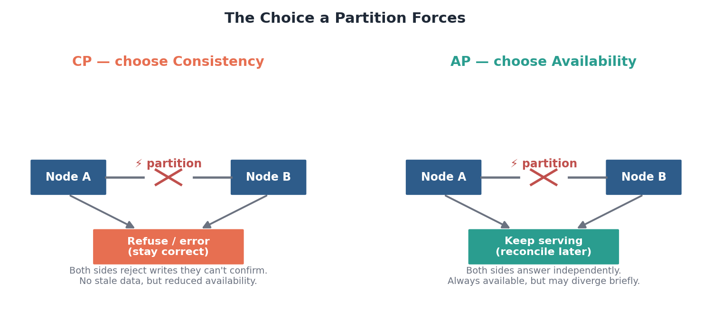
Figure: Two nodes are split by a partition. A CP system refuses to risk stale data; an AP system stays up and reconciles later.

4.3 Matching the choice to the data
 | CP — choose consistency | AP — choose availability
Behavior under partition | Reject / block unconfirmable requests | Keep responding on every side
You give up | Availability during the partition | Up-to-date reads during the partition
Fits data like | Bank balances, inventory, bookings | Likes, view counts, shopping carts
Example systems | HBase, etcd, ZooKeeper | Cassandra, DynamoDB

4.4 PACELC: the part CAP leaves out
CAP only describes behavior during a partition, which is rare. PACELC extends it to normal operation: if Partitioned, trade Availability against Consistency (the CAP case); Else, trade Latency against Consistency. This captures the everyday reality that even with a healthy network, guaranteeing strong consistency costs latency — you must coordinate across nodes before answering. PACELC is the more complete and more useful lens.
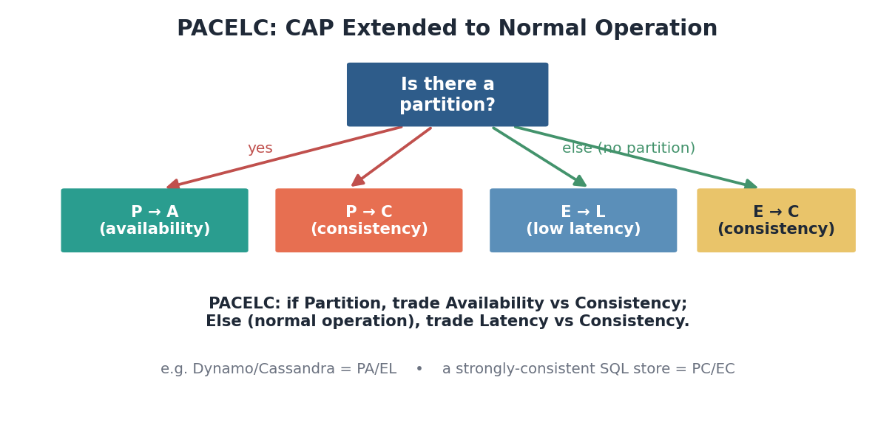
Figure: PACELC adds the ‘else’ branch: even without a partition, stronger consistency costs latency.
Designing with this model
- Assume partitions will happen; design for CP or AP rather than wishing for CA.
- Pick per data type, not per system — money is CP, a view counter is AP, in the same product.
- Use PACELC: remember that strong consistency costs latency even when the network is fine.
- Beware the loose ACID-vs-CAP overlap: CAP’s ‘C’ is about all nodes agreeing, not about transaction integrity.
Self-check
- State the CAP theorem precisely. Why is ‘pick two of three’ a misleading summary?
- Why is partition tolerance effectively non-optional in a real distributed system?
- Classify each as CP or AP and justify it: a bank ledger, a social feed’s like count.
- What does the ‘ELC’ in PACELC add that CAP alone misses?

5. Consistency Models
Once data is replicated across nodes, you must decide what you promise a reader about how fresh and how ordered their view is. That promise is the consistency model. It is not a single switch but a spectrum, and each point on it trades the ease of reasoning against latency and availability.

5.1 The spectrum
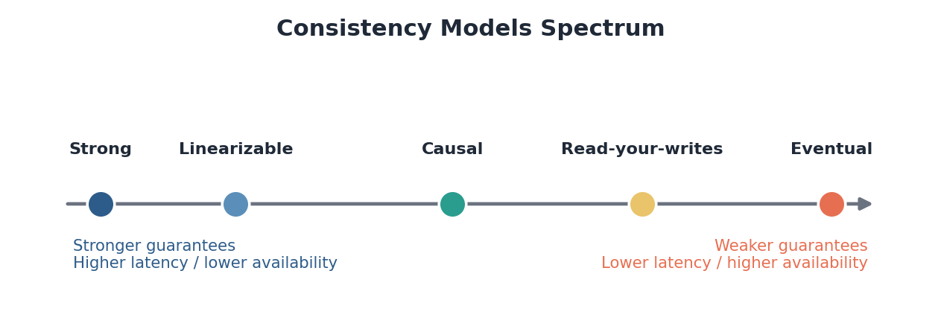
Figure: Stronger guarantees on the left are easy to reason about but costly; weaker ones on the right are fast and available but push complexity onto the application.

5.2 The models, strongest to weakest

Strong / linearizable consistency
Every read returns the result of the most recent completed write, as if there were a single copy of the data and all operations happened in a single global order. It is the easiest model to reason about — the system behaves like one machine — but it requires coordination across nodes on every operation, which costs latency and reduces availability during partitions. Use it where correctness is non-negotiable: account balances, inventory counts, distributed locks.

Causal consistency
Operations that are causally related (a reply must come after the message it answers) are seen by everyone in that order, while unrelated operations may be seen in different orders on different nodes. It preserves the cause-and-effect relationships users notice, without paying for a single global order. A good fit for comment threads and collaborative tools.

Read-your-writes consistency
A weaker, session-scoped guarantee: you always see your own updates immediately, even though others might see them after a delay. This directly solves the classic frustration where a user edits their profile, reloads, and sees the old version because the read hit a lagging replica.
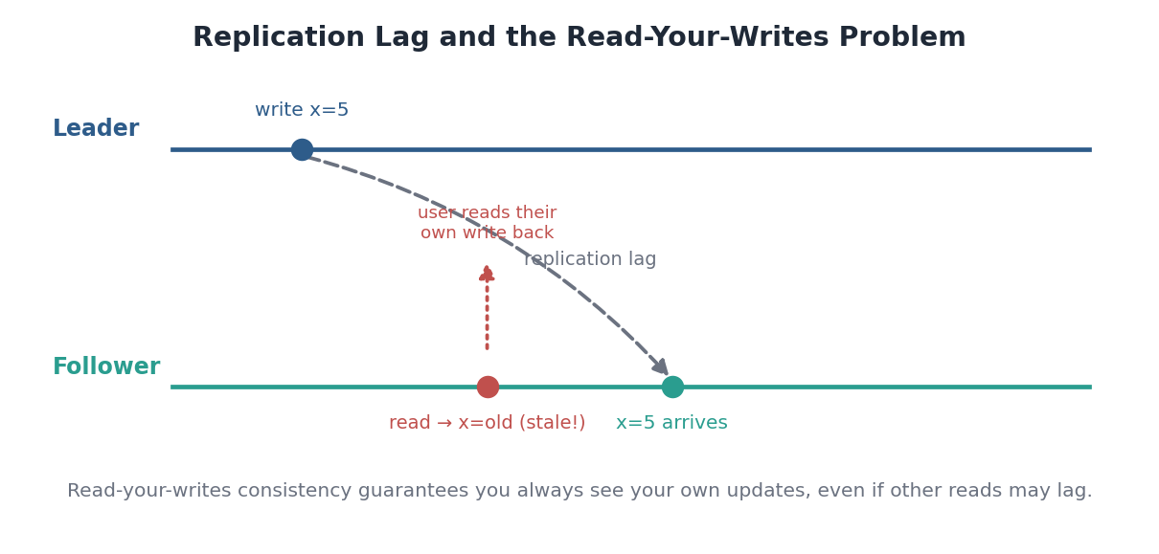
Figure: The write reaches the follower only after a lag; a read in between would be stale. Read-your-writes guarantees you, at least, see your own update.

Eventual consistency
The weakest common model: if no new writes are made, all replicas eventually converge to the same value, but in the meantime different readers may see different, stale values. It offers the best latency and availability and is the natural partner of an AP system. It is perfectly acceptable where briefly stale data is harmless — view counts, recommendations, DNS.
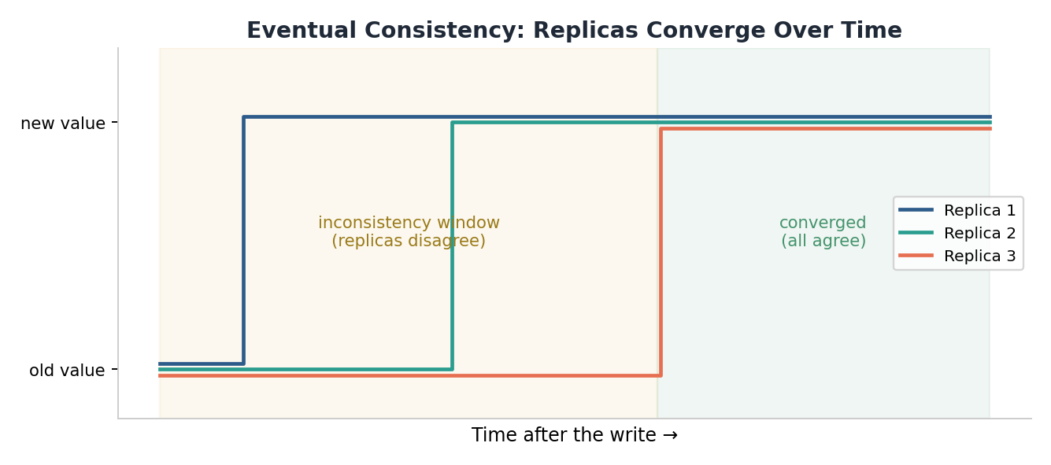
Figure: After a write, replicas disagree during an inconsistency window, then converge. Eventual consistency promises only the convergence, not when.

5.3 Choosing a model
Model | Guarantee | Cost | Typical use
Strong / linearizable | Always see the latest write | Highest latency; weak under partition | Balances, inventory, locks
Causal | Cause precedes effect for all | Moderate coordination | Threads, collaboration
Read-your-writes | See your own writes | Session tracking / routing | Profile edits, settings
Eventual | Replicas converge ‘eventually’ | Stale reads in the meantime | Counts, feeds, recommendations

Designing with this model
- Pick the weakest model that still keeps the user experience correct — it buys latency and availability.
- Match the model to the data, not the whole system: a checkout is strong, its ‘recently viewed’ list is eventual.
- Remember the link to CAP/PACELC: strong consistency is what you pay for with latency and partition-time availability.
- When you choose eventual consistency, design the application to tolerate stale reads gracefully.
Self-check
- Order these strongest to weakest: eventual, strong, read-your-writes, causal.
- Give one kind of data that demands strong consistency and one that is fine with eventual.
- Describe the user-visible bug that read-your-writes consistency fixes.
- Explain the ‘inconsistency window’ in eventual consistency and why it is often acceptable.

Tying the Five Together
These models are not independent — they form a chain of reasoning. You scale because a single machine cannot meet your latency and throughput targets. Scaling out forces you to confront state, which you externalize to keep services stateless. Externalized, replicated state raises the CAP question of what to sacrifice under a partition. And your answer there is expressed concretely as a consistency model — the promise you make to every reader. Master the five as one connected story and most system design questions resolve into: which of these tensions is this problem really about?
The one-paragraph synthesis
- Measure speed as latency and throughput, and stay left of the knee. Scale up until state or cost forces you to scale out. Scaling out means controlling state — push it into purpose-built stores and keep services stateless. Replicated state obeys CAP: under a partition, choose consistency or availability, and even without one, consistency still costs latency (PACELC). Express that choice as the weakest consistency model your users can tolerate.

