ASSIGNMENT – 3
BIKE-SHARING DEMAND ANALYSIS & PREDICTION
Name: J.Varuna
Roll No: 324103282047
Department: 3CSM1
Subject: Data Science

1. Introduction
Bike-sharing systems provide bicycles for short journeys and commuting. The number of rentals can change depending on the hour, season, weather conditions, and whether a day is a working day. Understanding these patterns can help bike-sharing operators plan bicycle availability and improve service.
The project, “Bike-Sharing Demand Analysis & Prediction,” follows an end-to-end Data Science workflow using the UCI Bike Sharing Dataset. The work includes data collection, data understanding, data cleaning, exploratory data analysis (EDA), feature preparation, regression model training, evaluation, and interpretation. The target variable is `cnt`, which represents the total number of bike rentals in an hour.
The project is implemented in Google Colab using Python. The objective is not only to generate a prediction, but also to understand the data, discover patterns, compare models, and communicate evidence-based findings.

2. Tools and Technologies Used

2.1 Google Colab and Python
Google Colab is used to run the Python notebook in a browser without requiring a local Python environment. Python is the main programming language used for the Data Science workflow.

2.2 Pandas and NumPy
Pandas is used to load, inspect, clean, filter, group, and summarize the dataset. NumPy supports numerical operations and array handling.

2.3 Matplotlib and Seaborn
Matplotlib and Seaborn are used to create visualizations such as a rental-count distribution, hourly demand line chart, working-day comparison, seasonal demand chart, weather comparison, and correlation heatmap.

2.4 Scikit-learn
Scikit-learn provides preprocessing pipelines, imputers, one-hot encoding, feature scaling, Linear Regression, Random Forest Regressor, and evaluation metrics. The preprocessing pipeline is fitted on training data to reduce data leakage.

2.5 UCI Bike Sharing Dataset
The project uses the hourly file (`hour.csv`) from the UCI Bike Sharing Dataset. It contains hourly rental counts for the Capital Bikeshare system during 2011–2012, together with calendar, season, and weather information. The target is `cnt`. Dataset source: https://archive.ics.uci.edu/dataset/275/bike+sharing+dataset

3. Data Science Process

3.1 Problem Definition
The problem is to analyze historical hourly rentals and estimate the number of rentals using time-related and weather-related variables. Since the target is numeric, this is a supervised regression problem.

3.2 Data Collection and Understanding
The dataset is downloaded from the UCI Machine Learning Repository. Initial inspection checks the number of rows and columns, column names, data types, first and last records, missing values, duplicates, and descriptive statistics. Important fields include hour, season, month, weekday, working-day status, weather situation, temperature, humidity, wind speed, and total rentals.

3.3 Data Cleaning
The notebook standardizes column names, parses the date field, removes duplicate rows, checks missing values, removes rows with a missing target, keeps the rental count non-negative, and sorts observations chronologically. The actual row counts and data-quality findings should be recorded from the executed notebook.

3.4 Exploratory Data Analysis (EDA)
EDA is used to understand demand before model training. The notebook creates a histogram of hourly rental counts, a line chart of average rentals by hour, a working-day versus non-working-day comparison, a seasonal demand chart, a weather-demand comparison, and a correlation heatmap. Observations in the final report must be based on the actual charts generated in Colab.

3.5 Feature Selection and Preprocessing
The target variable is `cnt`. Input features include season, year flag, month, hour, holiday, weekday, working-day status, weather situation, temperature, feels-like temperature, humidity, and wind speed. Categorical features are one-hot encoded, while numeric features are imputed and scaled through a scikit-learn pipeline.
The columns `casual` and `registered` are excluded because their sum equals `cnt`. Including them would cause target leakage, where the model indirectly receives the answer it is expected to predict. The record identifier `instant` is also excluded. The date is used to order observations before a chronological train/test split.

3.6 Model Development
Two regression models are trained. Linear Regression is used as a baseline model for linear relationships. Random Forest Regressor combines decision trees and can learn nonlinear patterns and interactions. Both models use the same training and testing partitions to make their evaluation comparable.

3.7 Model Evaluation
The first 80% of chronologically sorted observations are used for training and the final 20% are held out for testing. MAE measures the average absolute error in rentals; RMSE penalizes larger errors more strongly; and R² compares the model with a mean-baseline predictor. Lower MAE and RMSE are better, while higher R² is generally better. R² is not an accuracy percentage and can be negative.

4. Output and Results
After running the notebook in Google Colab, insert screenshots of the actual outputs in the spaces below. Do not enter estimated or invented model scores.

4.1 Dataset Inspection and Data Quality
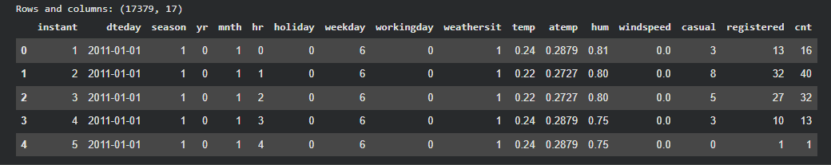
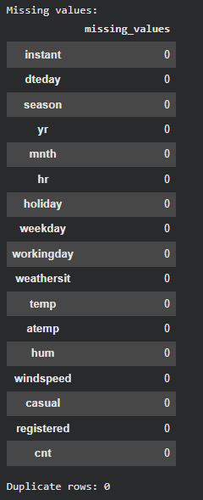
Actual rows after cleaning: 17,379
Duplicate rows removed: 0

4.2 Exploratory Data Analysis
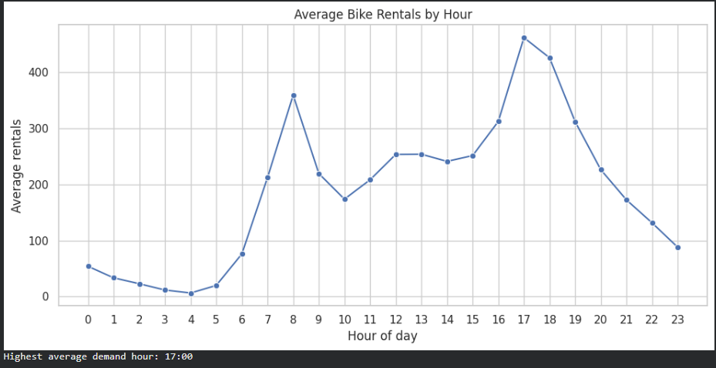
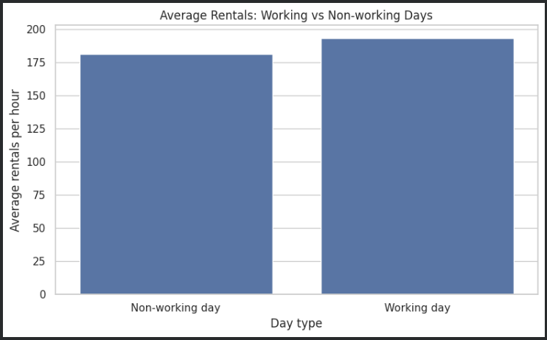
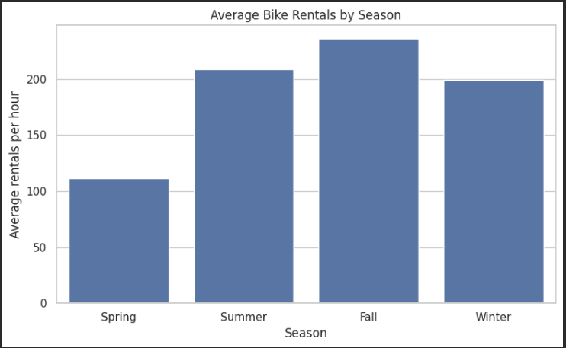
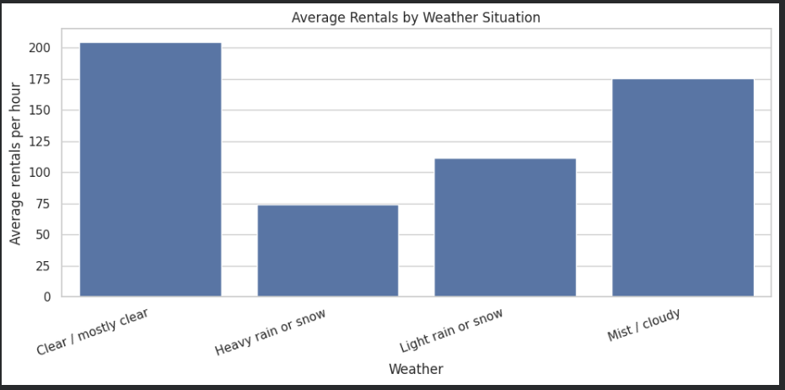
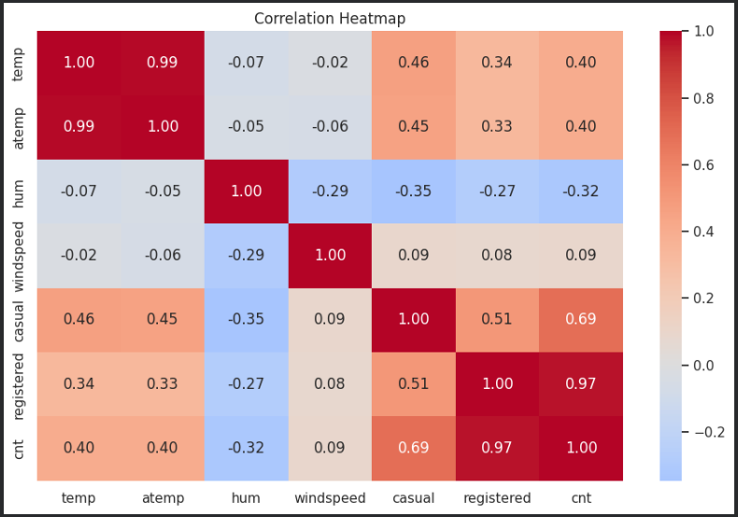
Main observations from the charts:

Bike demand was highest at 5:00 PM (17:00), with another peak at 8:00 AM (08:00), indicating increased demand during commuting hours.

Fall had the highest average seasonal demand, at approximately 236 rentals per hour. Working days also showed higher average demand (193.21 rentals/hour) than non-working days (181.41 rentals/hour).

Weather affected bike demand: clear or mostly clear conditions had the highest average demand (204.87 rentals/hour), while heavy rain or snow had the lowest (74.33 rentals/hour). Temperature was positively correlated with demand (0.40), while humidity was negatively correlated (−0.32).

4.3 Model Comparison
Model | MAE | RMSE | R²
Linear Regression | 98.691 | 133.819 | 0.632
Random Forest | 60.449 | 89.114 | 0.837
Best model based on test RMSE: Random Forest
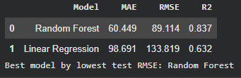
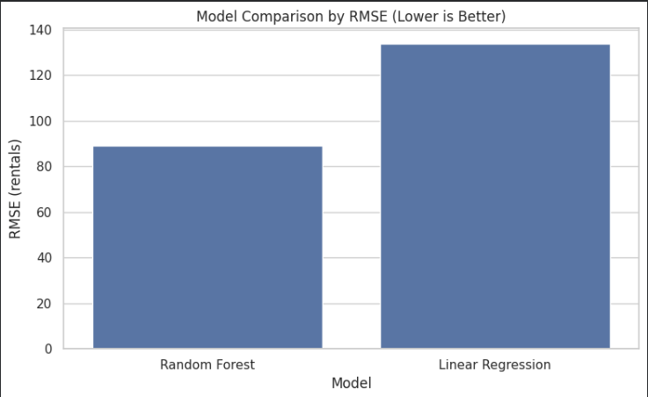
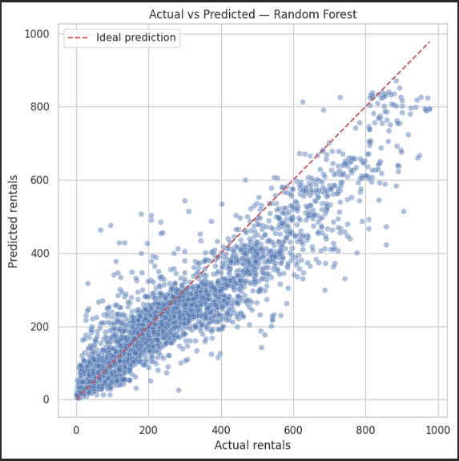

4.4 Example Prediction
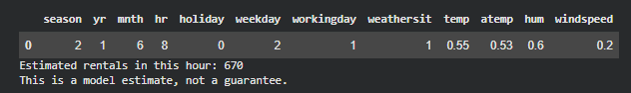

5. Conclusion
This project demonstrates the main stages of a Data Science workflow: data collection, data inspection, cleaning, exploratory analysis, feature preprocessing, model training, evaluation, and prediction. The EDA charts help investigate how hourly demand varies with time, working-day status, season, and weather. Linear Regression and Random Forest are compared on a held-out later portion of the dataset using MAE, RMSE, and R². The final conclusion should identify the model that performed better on the executed test split and summarize the observed patterns.
The project has limitations: it uses historical data rather than live station availability or live weather; the weather fields in the UCI dataset are normalized; and one chronological train/test split is not a complete time-series validation study. Future improvements could include time-series cross-validation, hyperparameter tuning, prediction uncertainty, and integration with live weather data.

References
1. UCI Machine Learning Repository, Bike Sharing Dataset: https://archive.ics.uci.edu/dataset/275/bike+sharing+dataset
2. Pandas documentation: https://pandas.pydata.org/docs/
3. Scikit-learn documentation: https://scikit-learn.org/stable/
4. Matplotlib documentation: https://matplotlib.org/stable/
5. Seaborn documentation: https://seaborn.pydata.org/

