1. Write a SQL statement to rename the table countries to country_new.  
   Here is the list of tables. tablename | tableowner  
   ---------------+------------  
   orders | postgres  
   employees | postgres  
   job_history | postgres  
   jobs | postgres  
   locations | postgres  
   regions | postgres  
   countries | postgres

**Output:**

create table orders ();417

create table employees();

create table job_history();

create table jobs();

create table locations();

create table regions();

create table countries();

\d

List of relations

Schema | Name | Type | Owner

--------+-------------+-------+----------

public | countries | table | postgres

public | emp | table | postgres

public | employees | table | postgres

public | job_history | table | postgres

public | jobs | table | postgres

public | locations | table | postgres

public | orders | table | postgres

public | regions | table | postgres

public | student | table | postgres

Alter table countries RENAME to country_new;

List of relations

Schema | Name | Type | Owner

--------+-------------+-------+----------

public | country_new | table | postgres

public | employees | table | postgres

public | job_history | table | postgres

public | jobs | table | postgres

public | locations | table | postgres

public | orders | table | postgres

public | regions | table | postgres

1. Write a SQL statement to add a column region_id to the table locations.  
   Here is the structure of the table locations.  
   postgres=# \d locations  
   Column | Type | Modifiers  
   ----------------+-----------------------+-----------   
    location_id | numeric(4,0) |   
    street_address | character varying(40) |   
    postal_code | character varying(12) |   
    city | character varying(30) |   
    state_province | character varying(25) |  
    country_id | character varying(2) |

alter table locations add region_id int;

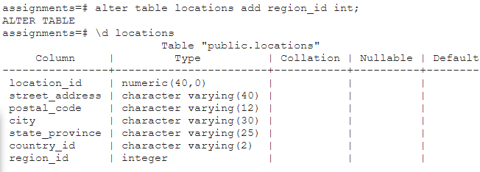

1. Write a SQL statement to change the data type of the column region_id to text in the table locations.

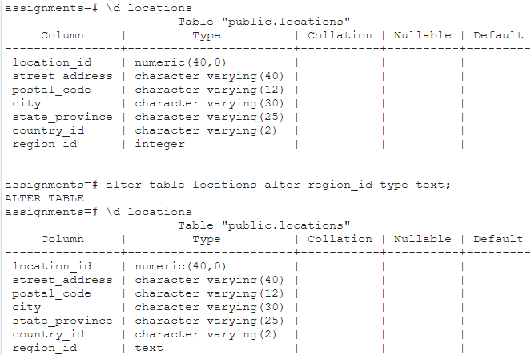

1. Write a SQL statement to drop the column city from the table locations.

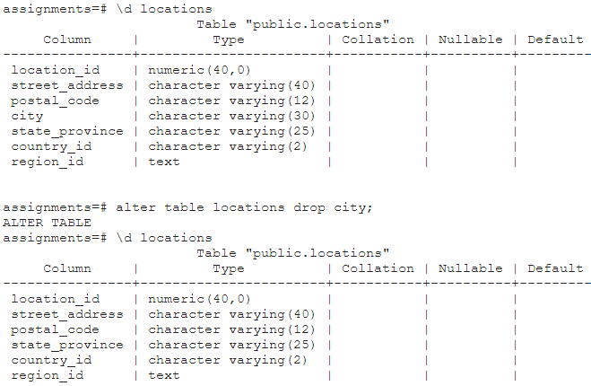

1. Write a SQL statement to add a primary key for the columns location_id in the locations table.  
   Here is the structure of the table locations.  
   