1. Write a SQL statement to change the salary of an employee to 8000 whose ID is 105, if the existing salary is less than 5000

Update employees SET salary=8000 WHERE employee_id=105 AND salary< 5000;

select * from employees where employee_id=105;

employee_id | first_name | last_name | email | phone_number | hire_date | job_id | salary | commission_pct | manager_id | department_id

-------------+------------+-----------+---------+--------------+------------+---------+---------+----------------+------------+---------------

105 | David | Austin | DAUSTIN | 590.423.4569 | 1987-06-22 | IT_PROG | 8000.00 | 0.00 | 103 | 60



1. Write a SQL statement to change the job ID of the employee which ID is 118 to SH_CLERK if the employee belongs to a department which ID is 30 and the existing job ID does not start with SH.

Update employees set job_id='SH_CLERK ' Where employee_id=118 AND department_id=30 AND Not job_id lIKE '%SH';

select * from employees where employee_id=118 AND department_id=30;

employee_id | first_name | last_name | email | phone_number | hire_date | job_id | salary | commission_pct | manager_id | department_id

-------------+------------+-----------+---------+--------------+------------+-----------+---------+----------------+------------+---------------

118 | Guy | Himuro | GHIMURO | 515.127.4565 | 1987-07-05 | SH_CLERK | 2600.00 | 0.00 | 114 | 30



1. Write a SQL statement to increase the salary of employees under the department 40, 90 and 110 according to the company rules that, the salary will be increased by 25% of the department 40, 15% for department 90 and 10% of the department 110 and the rest of the department will remain same.

Update employees set salary=salary+(salary*.25) where department_id=40;

Update employees set salary=salary+(salary*.15) where department_id=90;

Update employees set salary=salary+(salary*.10) where department_id=110;

select * from employees WHERE department_id IN (40,90,110);

employee_id | first_name | last_name | email | phone_number | hire_date | job_id | salary | commission_pct | manager_id | department_id

-------------+------------+-----------+----------+--------------+------------+------------+----------+----------------+------------+---------------

100 | Steven | King | SKING | 515.123.4567 | 1987-06-17 | AD_PRES | 27600.00 | 0.00 | 0 | 90

203 | Susan | Mavris | SMAVRIS | 515.123.7777 | 1987-09-28 | HR_REP | 8125.00 | 0.00 | 101 | 40

101 | Neena | Kochhar | NKOCHHAR | 515.123.4568 | 1987-06-18 | AD_VP | 19550.00 | 0.00 | 100 | 90

102 | Lex | De Haan | LDEHAAN | 515.123.4569 | 1987-06-19 | AD_VP | 19550.00 | 0.00 | 100 | 90

205 | Shelley | Higgins | SHIGGINS | 515.123.8080 | 1987-09-30 | AC_MGR | 13200.00 | 0.00 | 101 | 110

206 | William | Gietz | WGIETZ | 515.123.8181 | 1987-10-01 | AC_ACCOUNT | 9130.00 | 0.00 | 205 | 110

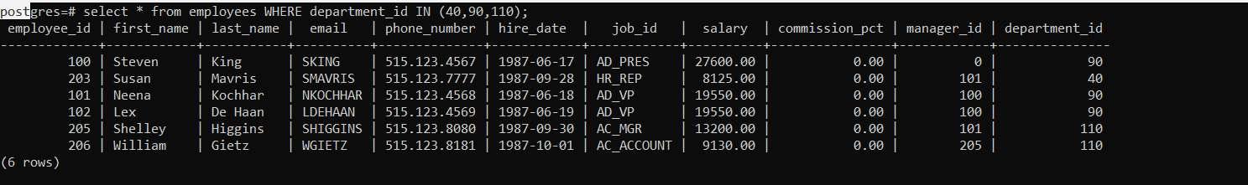

1. Write a SQL statement to change the email column of the employees table with 'not available' for those employees who belongs to the 'Accounting' department.
2. Write a SQL statement to change the email column of employees table with 'not available' for those employees whose department_id is 80 and gets a commission is less than.20%.

Update employees set email='not available' where department_id=80 AND commission_pct>.20;

select * from employees WHERE department_id=80;

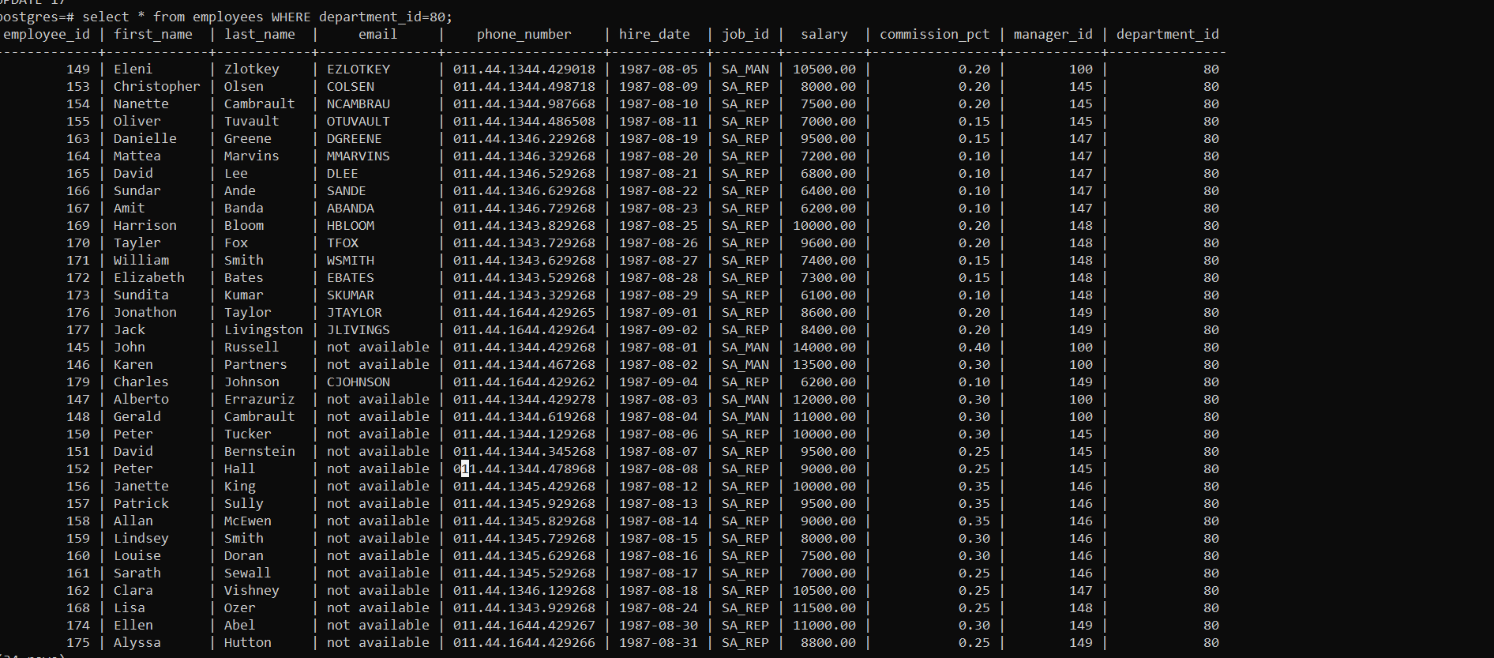

1. Write a SQL statement to change the email and commission_pct column of the employees table with 'not available' and 0.10 for all employees.

Update employees set email='not available' ,commission_pct =.10;

select * from employees;

