## **Create a class named 'PrintNumber' to print various numbers of different datatypes by creating different methods with the same name 'printn' having a parameter for each datatype.**

**Code:**

public class PrintNumber{

void printn(int a){

System.out.println("int:" +a);

}

void printn(float f){

System.out.println("Float:"+f);

}

void printn(double d){

System.out.println("Double:"+d);

}

public static void main(String[] args){

PrintNumber p1= new PrintNumber();

p1.printn(10);

p1.printn(10.34f);

p1.printn(20.35);

}

}

**Output:**

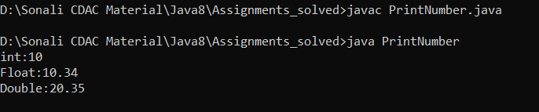

1. **Create a class to print an integer and a character with two methods having the same name but different sequence of the integer and the character parameters**

**Code:**

public class Parameter{

void sequence(int i,char c){

System.out.println("int is:"+i+ "\tchar is:"+c);

}

void sequence(char c,int i){

System.out.println("char is:"+c+ "\tint is:"+i);

}

public static void main(String[] args){

Parameter p1=new Parameter();

p1.sequence(10,'a');

p1.sequence('b',20);

}

}

**Output:**

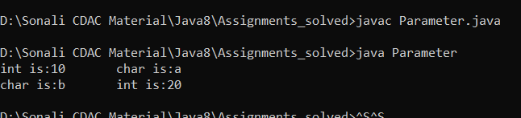

## 

## **Create a class to print the area of a square and a rectangle. The class has two methods with the same name but different number of parameters. The method for printing area of rectangle has two parameters which are length and breadth respetively while the other method for printing area of square has one parameter which is side of square.**

**Code:**

public class Area{

void areaRectangle(int length, int width){

int AreaR = length * width;

System.out.println(AreaR);

}

void areaSquare(float side){

float AreaS=side*side;

System.out.println(AreaS);

}

public static void main(String[] args){

Area a = new Area();

a.areaRectangle(10,20);

a.areaSquare(10);

}

}

**Output:**

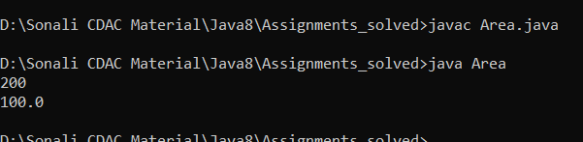

1. **Create a class 'Student' with three data members which are name, age and address. The constructor of the class assigns default values name as "unknown", age as '0' and address as "not available". It has two members with the same name 'setInfo'. First method has two parameters for name and age and assigns the same whereas the second method takes has three parameters which are assigned to name, age and address respectively. Print the name, age and address of 10 students.**