AI-Based Oil Spill Detection and Cleanup Using an Autonomous Boat

Abstract—Oil spills pose severe threats to marine ecosystems and coastal economies, demanding rapid, cost-effective response mechanisms. This paper presents an AI-based autonomous surface vehicle (ASV) that integrates real-time oil spill detection with eco-friendly mechanical recovery. A Raspberry Pi 3 Model B running a fine-tuned YOLOv11-m instance segmentation model detects surface oil at 8.3 FPS via a CSI camera. Vision-based differential-thrust navigation guides the vessel to the contaminated region, where a rotating metal disc skimmer performs continuous oleophilic oil recovery into an onboard 2 L storage tank. The modular PVC–PU hull provides stable buoyancy for the full
4.7 kg payload, while a 12 V, 7.5 Ah Li-ion battery with BMS protection delivers approximately 48 minutes of runtime. The YOLOv11-m model achieves 72% precision, 68% recall, and a mask mAP@0.5 of 0.72 on a 600-image oil spill dataset. Field tests confirm reliable end-to-end operation – detection, navigation, and skimmer activation – in controlled aquatic environments, validating a scalable and sustainable solution for localized oil spill monitoring and cleanup.
Index Terms—oil spill detection, autonomous surface vehicle, YOLOv11, instance segmentation, Raspberry Pi, disc skimmer, embedded AI
- Introduction

Oil spills contaminate water surfaces, disrupt marine ecosys- tems, and cause long-term ecological and economic damage. Conventional monitoring systems – satellite SAR, optical imaging, and aerial surveillance – are expensive, weather- dependent, and cannot perform real-time localized detection [5]. Traditional cleanup via chemical dispersants or manual skimming introduces secondary pollution and exposes workers to hazardous conditions [1].
Recent advances in edge-based deep learning and au- tonomous systems provide viable alternatives. YOLO-family models achieve real-time object detection suitable for embedded deployment [11], [13], while autonomous surface vehicles (ASVs) enable unmanned operation in hazardous environments [16]. Mechanical disc skimmers using oleophilic materials offer effective oil-water separation without chemical agents [9].
This paper proposes an integrated system combin- ing YOLOv11-m-based instance segmentation, vision-driven differential-thrust navigation, and continuous disc-skimmer recovery on a compact, low-cost floating platform – targeting small water bodies such as ponds, lakes, and harbor areas where large-scale systems are impractical.
- Related Work
Oil spill detection has evolved from handcrafted ML features on SAR data [6] to deep CNN classifiers on satellite imagery [14], [15]. Bui et al. [2] improved robustness via tailored data augmentation, while Shanmukh et al. [7] applied deep learning to complex marine environments. Infrared-based approaches
[4] identify temperature-contrast spills but depend on sensor availability. YOLO-based frameworks [5], [11] introduced real- time detection suitable for embedded platforms. For cleanup, sponge-roller ASVs [9] and GPS-navigated water drones [16] demonstrate autonomous recovery; however, fully integrated detect-navigate-recover systems with onboard AI inference remain scarce, motivating this work.
- System Design and Methodology
- System Architecture
The proposed ASV integrates six functional modules: (1) vision module (Raspberry Pi Camera V1), (2) processing unit (Raspberry Pi 3 Model B running YOLOv11-m), (3) propulsion system (dual RS-555 DC motors + IBT-2/BTS7960 drivers),
- oil recovery mechanism (disc skimmer + DC geared motor),
- oil transfer system (12 V pump motor + L298N driver), and
- power management (12 V 7.5 Ah Li-ion + BMS + buck converter).
The Raspberry Pi captures frames via CSI, runs oil spill inference, and outputs differential thrust commands to the IBT- 2 drivers. Upon reaching the spill, it activates the skimmer and pump via L298N. A 12 V–to–5 V buck converter supplies the Raspberry Pi and servos; propulsion and cleanup actuators run directly from the 12 V bus.
- Mechanical Design
The hull is constructed from PVC pipes forming a lightweight, corrosion-resistant catamaran frame. Inflatable floaters provide buoyancy, and a polyurethane (PU) deck plate mounts electronics and the oil tank above the waterline. A disc-type skimmer is deployed at the bow: oleophilic metal discs rotate partially submerged, adsorbing surface oil; PVC scrapers transfer collected oil into a drain pipe routed to the storage tank. See Fig. 2 and Fig. 3 for the CAD model and fabricated prototype respectively.

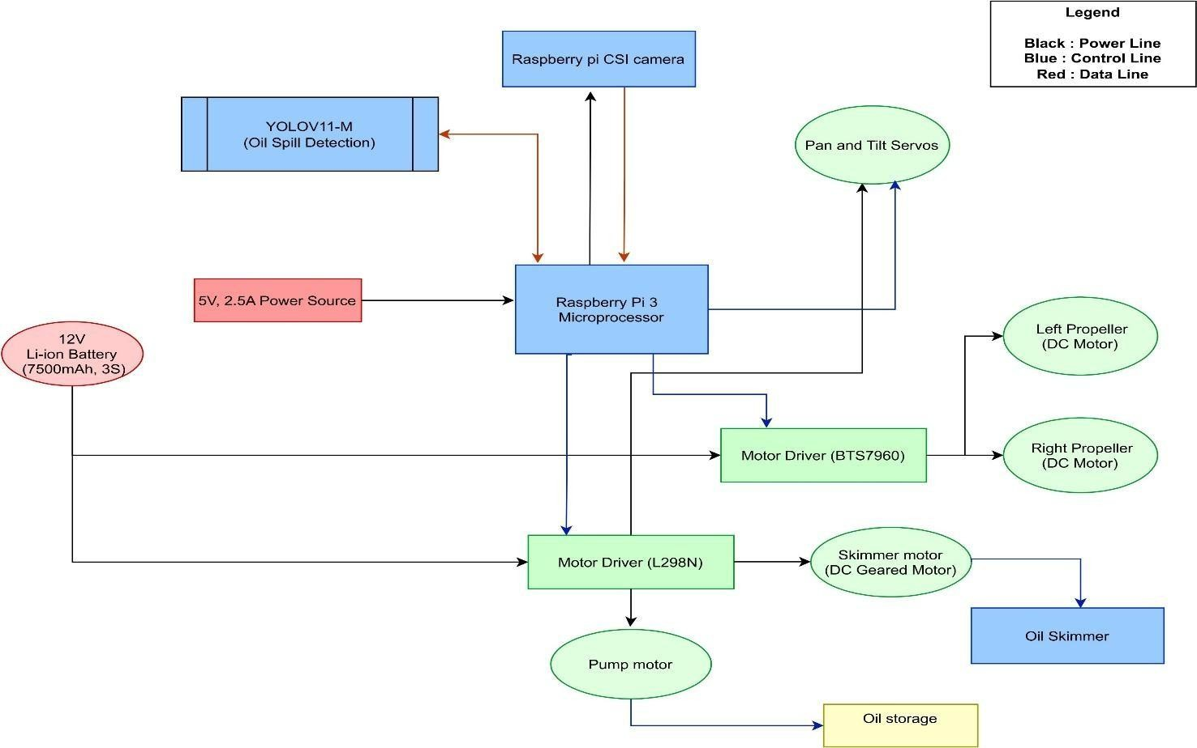
Fig. 1: System block diagram showing module interactions.

- Propulsion and Navigation
Differential thrust is achieved by independently varying the
2) Skimmer Motor Torque: With rated speed N = 60 RPM and η = 70% efficiency:

PWM duty cycle of the left and right RS-555 motors via IBT- 2 drivers. Navigation relies entirely on visual feedback: the
ω = 2πN
60
= 6.28 rad/s (4)

detected spill centroid within the camera frame determines the relative steering command – no GPS or additional sensors
η · V · I = 0.7 × 12 × 0.3 ≈ 0.40 N m (5)
ω 6.28
τ =

are required. If the centroid is left-of-center, the right motor accelerates; if right-of-center, the left motor accelerates; if centered, both motors drive forward at equal speed.
- Key Design Calculations
1) Thrust and Propulsion: The total vessel weight force (F_{w}) with maximum payload (m = 5.17 kg) is:
3) Power Budget and Runtime: Total system power con- sumption:
Ptotal = Pπ + Pprop + Pskim + Ppump + Pservo (6)
Ptotal = 5 + 24 + 3.6 + 12 + 2 = 46.6 W (7)
Battery energy capacity E = 12 × 7.5 = 90 Wh, giving:

F_{w} = mg = 5.17 × 9.81 ≈ 50.7 N (1) t =
E
Ptotal
90
= ≈ 1.93 h (8)
46.6

Required thrust is estimated at 10% of weight, shared between 4) Motor Driver Safety Margin: IBT-2 (BTS7960) maxi- two motors: mum rating vs. RS-555 stall current:
Tmotor = 0.1 × Fw = 5.07 ≈ 2.5 N (2) Safety Ratio = Idriver = 43 ≈ 6.46 (9)
2 2 Imotor,max 6.65
With each RS-555 motor producing P = 7.92 W at nominal speed V_{b} = 1 m/s:

P
Tavailable = 2 ×
V
b
= 2 × 7.92 = 15.84 N (3)

Since Tavailable ≫ Tmotor, the propulsion system provides a
3.13× safety margin.

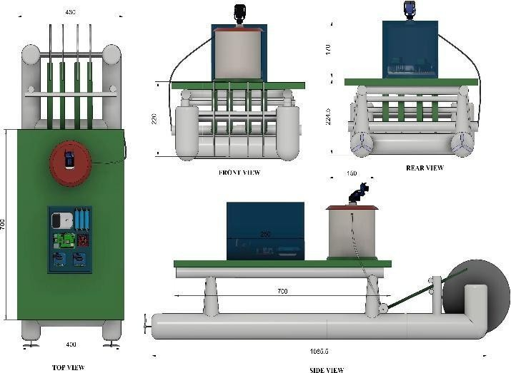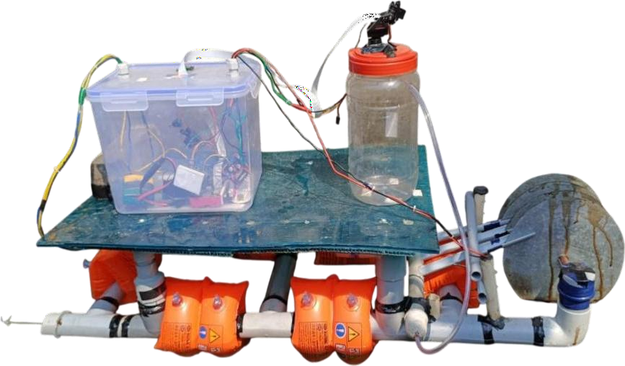

Fig. 2: CAD model (Fusion 360) showing hull structure and component layout.
Fig. 3: Fabricated ASV prototype showing assembled hull, skimmer, and electronics.

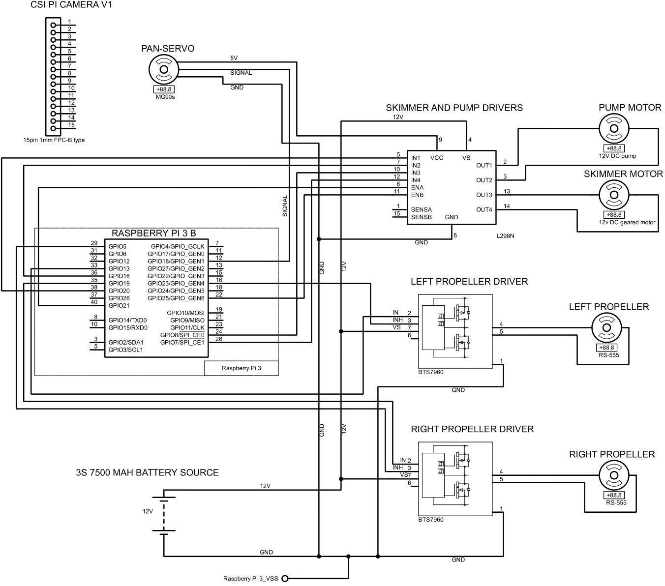

Fig. 4: Circuit diagram showing GPIO pin connections between Raspberry Pi, motor drivers, camera, and servos.

- Implementation
- Hardware Platform
The Raspberry Pi 3 Model B (ARM Cortex-A53, 1 GB RAM) serves as the edge inference and control unit. Two IBT-2 drivers handle the 12 V RS-555 propulsion motors (3000 RPM, 6.65 A stall). The L298N dual H-bridge controls the 12 V geared motor (60 RPM, 300 mA) driving the disc skimmer and the 12 V pump motor (12 W). A MG90S pan-tilt servo mount provides extended camera coverage. A 3S2P Li-ion pack (12 V, 7.5 Ah, 90 Wh) with a 20 A BMS and 10 A fuse powers the entire system.
All subsystems share a common ground. GPIO-level signals (3.3 V) directly drive IBT-2 and L298N logic inputs. A DC-DC buck converter (12 V → 5 V) powers the Raspberry Pi and servo motors.
- AI Model: YOLOv11-m
YOLOv11-m employs a Cross-Stage Partial (CSP) backbone with C3k2 blocks for efficient multi-scale feature extraction and a Path Aggregation Network (PAN) neck for feature fusion. The anchor-free decoupled head separates classification and segmentation tasks, improving convergence for irregular oil spill boundaries.
The model was trained using transfer learning on a custom 600-image oil spill dataset annotated with instance segmen- tation masks in Roboflow. Training ran for 100 epochs on Google Colab (NVIDIA T4 GPU) with the AdamW optimizer. Augmentations included horizontal flipping, rotation, bright- ness/contrast variation, and scaling to simulate varying lighting and water surface conditions. Post-training, the model was converted to TensorRT FP16 format for accelerated inference

.
- Software Control Flow
  - Pi Camera captures frame at 640 × 480 px.
  - YOLOv11-m infers segmentation mask + confidence
score.

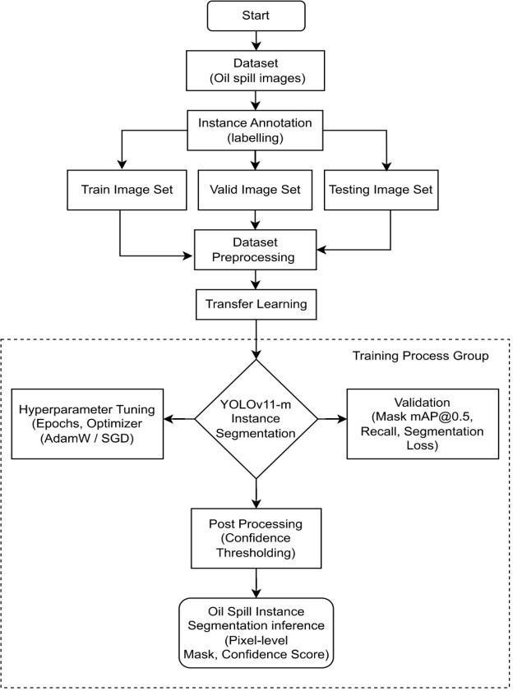

Fig. 5: YOLOv11-m training and deployment flowchart.

- Results and Discussion
- AI Model Performance
The YOLOv11-m instance segmentation model was eval- uated on a held-out test set. Table I summarizes detection performance. Training and validation losses converged steadily over 100 epochs, confirming effective learning without overfit- ting.
TABLE I: YOLOv11-m Detection Performance Metrics

  - Spill centroid position determines differential-thrust

command.
  - IBT-2 PWM signals adjust left/right motor speeds.
  - On proximity, L298N activates disc skimmer and pump.
  - System loops continuously until tank capacity or low battery.
Metric Value

Precision 72%
Recall 68%
Mask mAP@0.5 0.72
Average IoU ≈0.73 Inference Speed 8.3 FPS
The confusion matrix (Fig. 7) confirms that the majority of oil spill instances are correctly classified. Misclassifications primarily occur between thin oil films and water surface reflections due to low-contrast visual similarities – a known limitation of optical-only detection [4].
- Real-Time Detection Output
Fig. 8 shows a representative detection output. The model produces precise pixel-level masks following irregular spill contours at 8.3 FPS, sufficient for responsive navigation control.

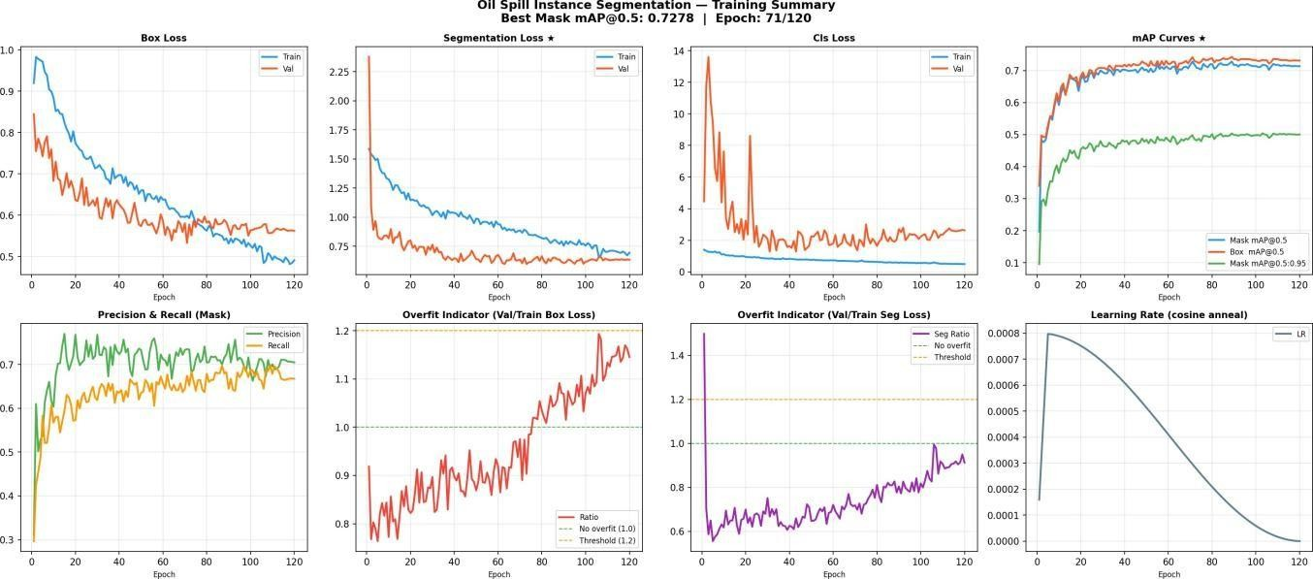
Fig. 6: Training curves: box loss, mask loss, segmentation loss, and precision/recall over 100 epochs.
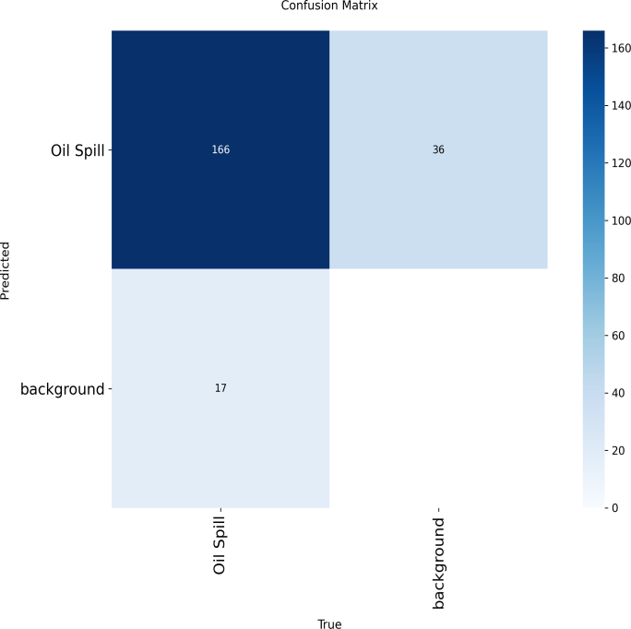
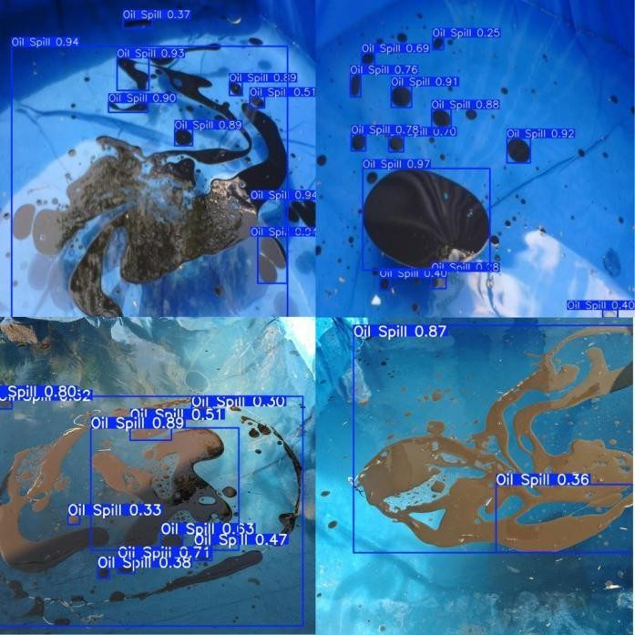

Fig. 7: Confusion matrix for oil spill vs. background classification.
Fig. 8: Real-time inference output: pixel-level segmentation mask with bounding box and confidence score overlaid on CSI camera frame.

- Field Test Results
Table II reports detection accuracy across varying environ- mental conditions observed during controlled field tests.
Oil recovery efficiency reached approximately 80% for thick slicks (>1 mm) and 50% for thin sheens (<0.5 mm). The system maintained stable autonomous operation throughout, with no critical hardware failures observed. The 2 L tank fills in approximately t = V/Q = 2/3 ≈ 0.67 min at nominal pump
flow (3 L/min).
- Comparison with Existing Methods
The proposed system uniquely combines onboard AI infer- ence with immediate mechanical recovery, eliminating post- processing delay and reducing operational cost compared to satellite or aerial approaches.

TABLE II: Detection Accuracy Under Varying Test Conditions

Condition | Detection Acc. | System Response
Calm water | ∼90% | Smooth navigation
Moderate ripples | ∼80% | Minor adjustments
High reflection | ∼70% | Delayed detection
Low lighting | ∼75% | Slower response
Thin oil film | ∼78% | Partial detection
Dense oil slick | ∼92% | Accurate detection
Continuous operation | ∼85% | Stable performance
TABLE III: Proposed System vs. Existing Detection Methods

Method Advantage Limitation Proposed

- N. A. Bui, Y. Oh, and I. Lee, “Oil spill detection and classification through deep learning and tailored data augmentation,” Int. J. Applied Earth Observation and Geoinformation, vol. 129, p. 103845, 2024.
- M. Zakzouk et al., “Automated oil spill detection using deep learning and SAR satellite data for the northern entrance of the Suez Canal,” Scientific Reports, vol. 15, no. 1, p. 20107, 2025.
- T. De Kerf, J. Gladines, S. Sels, and S. Vanlanduit, “Oil spill detection using machine learning and infrared images,” Remote Sensing, vol. 12, no. 24, p. 4090, 2020.
- Y.-J. Yang, S. Singha, and R. Mayerle, “Fully automated SAR based oil spill detection using YOLOv4,” in Proc. IGARSS 2021, 2021, pp. 149– 152.
- M. Kubat, R. C. Holte, and S. Matwin, “Machine learning for the detection of oil spills in satellite radar images,” Machine Learning, vol. 30, no. 2, pp. 195–215, 1998.
- M. P. Shanmukh, S. Baghavathi Priya, and T. Madeswaran, “Improving oil

SAR All-weather, wide area
False positives, costly
Real-time, low-cost
spill detection in marine environments through deep learning approaches,”
in Proc. ICAECT 2024, 2024.
- S. Mishra, A. Senapati, and P. Swain, “Oil spill detection and monitoring

Optical satellite
Aerial surveil- lance
High resolu- tion

Rapid cover- age
Weather/light dependent

Expensive, manpower
No satellite needed Fully
autonomous
with artificial intelligence: A futuristic approach,” J. Physics: Conf. Series,
vol. 2446, no. 1, p. 012019, 2023.
- H. Kim, S. Jeong, and C. Park, “Boat-type oil recovery skimmer using sponge rollers,” in Proc. OCEANS 2018 MTS/IEEE Charleston, 2018,
pp. 1–5.
- Z. Yongzhi, L. Hujun, W. Xiao, and W. Dan, “Edge extraction of marine oil spill in SAR images,” in Proc. Int. Conf. Challenges in Environmental

Manual Simple Labor inten- sive
Continuous monitor- ing
Science and Computer Engineering, 2010, pp. 204–207.
- G. Jocher and J. Qiu, “Ultralytics YOLO11,” Ultralytics, 2024. [Online].
Available: https://github.com/ultralytics/ultralytics
- A. Bochkovskiy, C.-Y. Wang, and H.-Y. M. Liao, “YOLOv4: Optimal

Proposed Real-time AI detection + integrated mechanical cleanup; no chemical agents; scalable to small water bodies

- Conclusion and Future Scope
This paper presented an AI-based autonomous surface vehicle for real-time oil spill detection and eco-friendly mechanical cleanup. The YOLOv11-m instance segmentation model achieves 72% precision, 68% recall, and a mask mAP@0.5 of 0.72 at 8.3 FPS on Raspberry Pi, enabling reliable localization with pixel-level boundary accuracy. Vision-based differential-thrust navigation guides the vessel without GPS, while the oleophilic disc skimmer enables continuous oil
recovery achieving ∼80% efficiency for thick slicks. The 90 Wh Li-ion system sustains approximately 1.93 hours of
full operation, with the 20 A BMS providing robust electrical protection.
Field tests confirmed end-to-end operation – detection, navigation, and skimmer activation – in realistic aquatic conditions. The modular, low-cost design is well-suited for inland water bodies, harbors, and nearshore environments.
Future work will focus on: (i) deploying a lightweight YOLOv11-n model directly on Raspberry Pi for fully stan- dalone operation; (ii) expanding dataset diversity to improve thin-film and low-light detection; (iii) integrating GPS and ultrasonic sensors for waypoint-based autonomous coverage; and (iv) scaling the hull for larger oil storage and multi-ASV coordinated deployment.

References
[1] A. A. Huby, R. Sagban, and R. Alubady, “Oil spill detection based on machine learning and deep learning: A review,” in Proc. 5th Int. Conf. Engineering Technology and its Applications (IICETA), 2022, pp. 85–90.
speed and accuracy of object detection,” arXiv preprint arXiv:2004.10934, 2020.
- J. Redmon, S. Divvala, R. Girshick, and A. Farhadi, “You only look once: Unified, real-time object detection,” in Proc. IEEE CVPR 2016, 2016, pp. 779–788.
- M. Krestenitis et al., “Oil spill identification from satellite images using deep neural networks,” Remote Sensing, vol. 11, no. 15, p. 1762, 2019.
- M. Shaban et al., “A deep-learning framework for the detection of oil spills from SAR data,” Sensors, vol. 21, no. 7, p. 2351, 2021.
- H. Jo, H. Son, S. Lee, and H. Myung, “Development of an autonomous water drone with a GPS-based waypoint navigation system for water quality monitoring,” in Proc. ICCAS 2018, 2018, pp. 165–169.

