|  |  |  |
| --- | --- | --- |
| **State**  **Number** | **Description** | **Encoding** |
| S1  (instruction_fetch) |  | 0001 |
| S2 |  | 0010 |
| S3 |  | 0011 |
| S4 |  | 0100 |
| S5 |  | 0101 |
| S6 |  | 0110 |
| S7 |  | 0111 |
| S8 |  | 1000 |
| S9 |  | 1001 |
| S10 |  | 1010 |
| S11 |  | 1011 |
| S12 |  | 1100 |
| S13 |  | 1101 |
| S14 |  | 1110 |
| S40 |  | 1111 |
| Reset | --------------------------------- | 0000 |

**FLOWGRAPH FOR VARIOUS INSTRUCTIONS**

* **ADD**

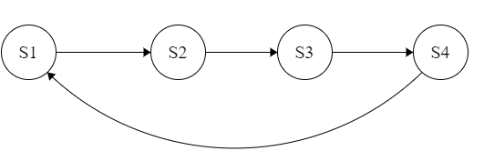

* **ADC**

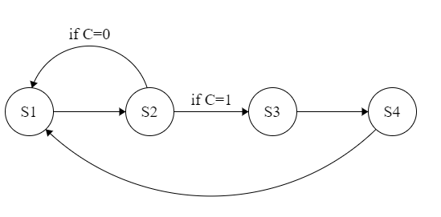

* **ADZ**

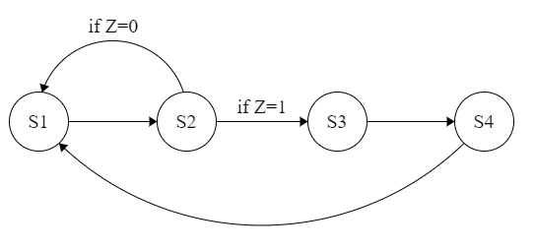

* **ADI**



* **NDU**



* **NDC**



* **NDZ**



* **LHI**

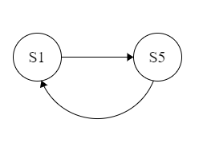

* **LW**

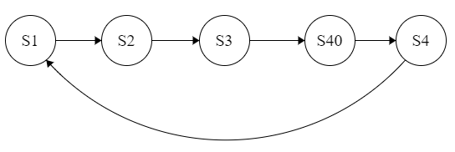

* **SW**

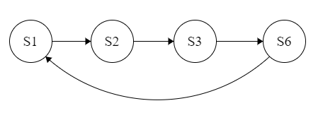

* **BEQ**

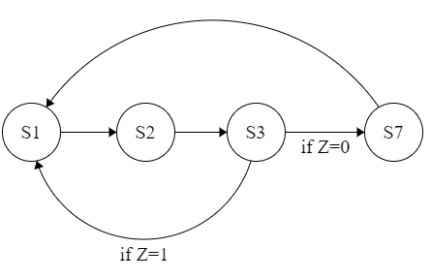

* **JAL**

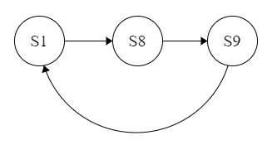

* **JLR**

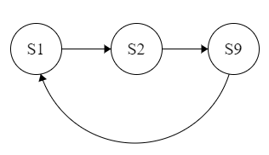

* **LM**

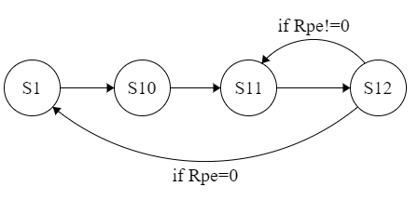

* **SM**

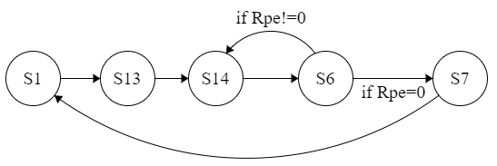

**FSM for the System:**

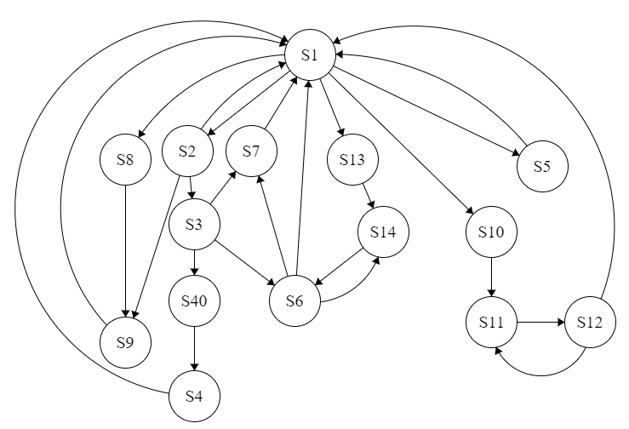

*Decoders are used after states S1, S2, S3, S6, S12 to decide what next state will be by taking into consideration the op-code given in the instruction.*