### Shri Vaishnav Vidyapeeth Vishwavidyalaya

### Indore(M P)



#### Session : 2019-2020

#### Submitted by : Varun kalra Submitted to : Mr. Sachin Chirgaiyya

#### Enroll_no : 1810DMBCSE03324 Subject : Advance Java.

#### Branch : CSE

#### Year : 2nd

#### Section : I

# **Library management project**

### Objective/ Vision

A library management software where admin can add/view/delete librarian and librarian can add/view books, issue, view issued books and return books.

### Users of the System

1. Admin
2. Libraian

### Functional Requirements

**1. Admin**(password ‘1234’)

1. Can add/view/delete librarian
2. Can logout

**2. Librarian**

1. Can add/view books
2. Can issue books
3. View issued books
4. Return Books
5. Can logout

# How it works ?

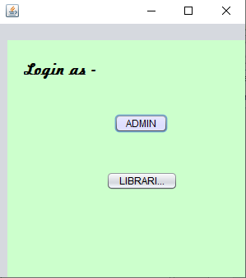

This is the welcome window where one would choose to login as a admin or a librarian.

.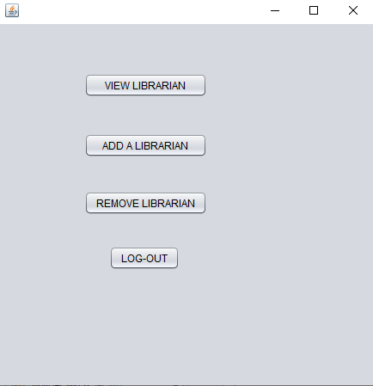

This is the window appeared when we logged in as admin, here we have to select an option.

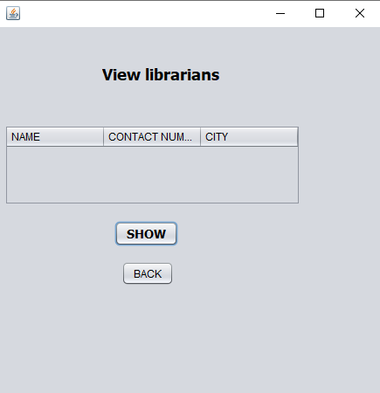

This window lets us to retrieve the details from the database.

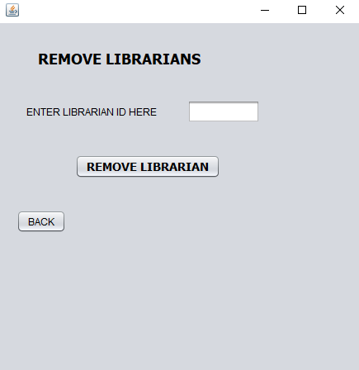

This window lets the admin to remove a librarian.

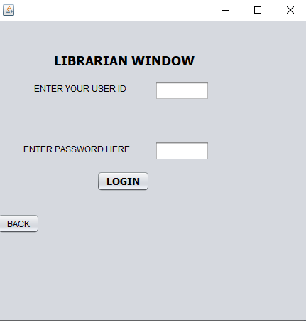

This window appears when someone logged in as a librarian.

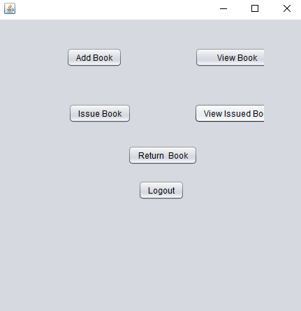

Here are some option for librarian to either add, view, issue, or view issued books .

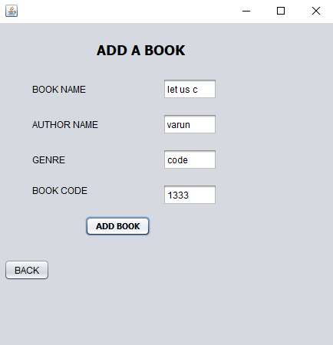

This window appears when someone wants to add some books.

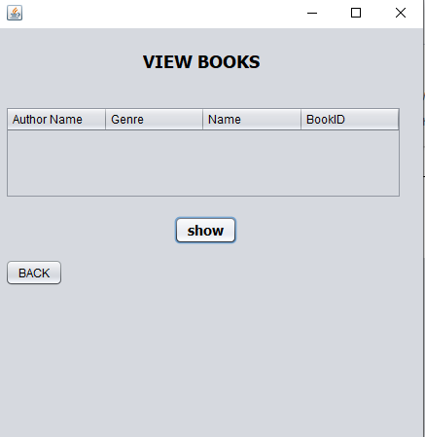

This window help us to retrieve the list of books that are available in our database.

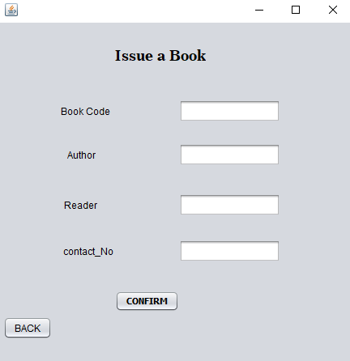

This window lets you issue the book

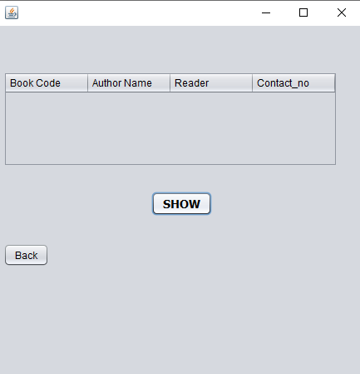

This window shows the issued books from the database.

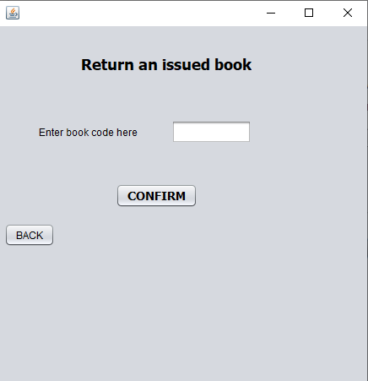

This window gives an option to remove a book from issued list

This is how the project works.