**ANALYSIS**

**- Varun Kumar Jukanti**

**Dataset: Dataset from Kingcounty.gov**

[**Dataset Link**](https://kingcounty.gov/depts/transportation/metro/travel-options/bus/app-center/developer-resources.aspx)

King County is served by three transit agencies, the City of Seattle, Metro Transit, and Sound Transit. The data available spans January to June of 2023. Given that it is currently February of 2023, this appears to be proposed information for planning public transit services to the county. A dashboard tool for visualizing the breadth and depth of service coverage is needed to evaluate adequate service coverage and the distribution of agency demand is needed on a real-time basis.

Based on the information provided in the data files, we can gain several decision-making insights about mass transit operations in King County, Washington:

* The volume of Routes, across 25 Zones, by day of the week.
* The Number of Trips within each route, by Zone, and by day of the week.
* The date range filter to observe seasonality in travel patterns over time.
* Slicing and dicing across Zones and Stop Stations gives us visibility into peak demand and availability of supply.
* Optimizing the pricing based on the above-mentioned KPIs would lead to an incremental impact on Revenue.

**Summary:**

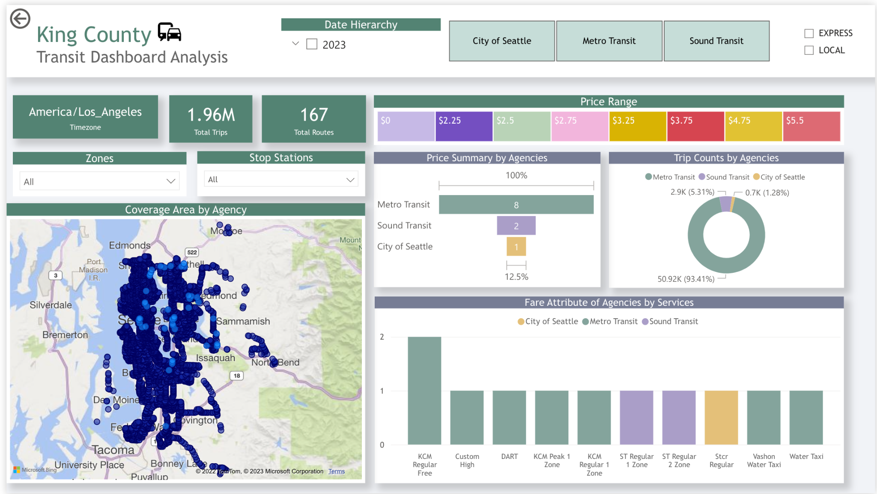

**Drill Down:**

* Examining the frequency of coverage at individual stops.
* Aggregating the total number of trips per stop.
* Assessing Key Performance Indicators (KPIs) such as the number of trips, routes, stops, service categorization by Zone, Agency, Local/Express designation, Day of the Week, and filtering based on specific date periods.
* Calculating the percentage of trip coverage by individual agencies.
* These analyses provide leaders with valuable insights for making informed decisions regarding travel options. It allows them to comprehend the popularity of various stops and routes, and facilitates a comparison of services and pricing offered by different agencies.

**Detailed Overview of Dataset Analysis:**

***Agency Information (agency.txt):***

Contains details about different transit agencies in King County, Washington, including agency ID, name, URL, time zone, language, phone number, and fare URL.

***Service Dates and Exceptions (calendar_dates.txt):***

Includes service-related details with fields like service_id, date (timestamp), and exception_type (code or description of the exception).

***Calendar Information (calendar.txt):***

Date format in "YYYYMMDD," providing information about service availability on specific dates.

***Fare Attributes (fare_attributes.txt):***

Offers information on various fares, including fare_id, agency_id, fare period_id, price, description, currency type, payment method, transfers, and transfer duration.

***Fare Rules (fare_rules.txt):***

Defines relationships between fares and routes, origins, destinations, and contained locations (if applicable).

***Bus Route Details (route.txt):***

Provides information on different bus routes, including route_id, agency_id, route names (short and long), description, route type, URL, route color, and text color.

***Geographic Shapes of Transit Routes (shapes.txt):***

Contains geographic shape points of transit routes, specifying shape_id, latitude, longitude, sequence, and distance traveled.

***Trip Schedules (stop_times.txt):***

Represents the schedule for a single trip, including arrival and departure times at each stop, stop sequence, headsign, pickup and drop-off types, shape distance traveled, and timepoint.

***Stop Information (stops.txt):***

Details about different stops, including stop_id, stop code, stop name, description, latitude, longitude, zone_id, URL, location type, parent station (if applicable), and stop timezone.

***Trip Data (trips.txt):***

Information about trips taken by public transportation vehicles, including route_id, service_id, trip_id, trip headsign, short name, direction_id, block_id, shape_id, peak flag, and fare_id.

This comprehensive overview assists in understanding transit operations, schedules, fares, and geographic details, supporting informed decision-making for public transportation services