Lab Assignment -2

Screenshot -1(index.php)

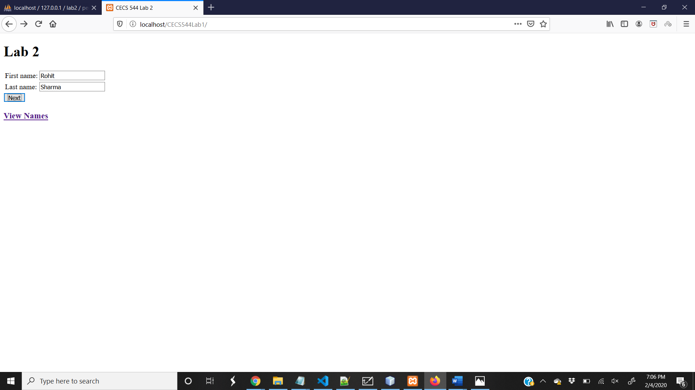

Screenshot -2 (page2.php)

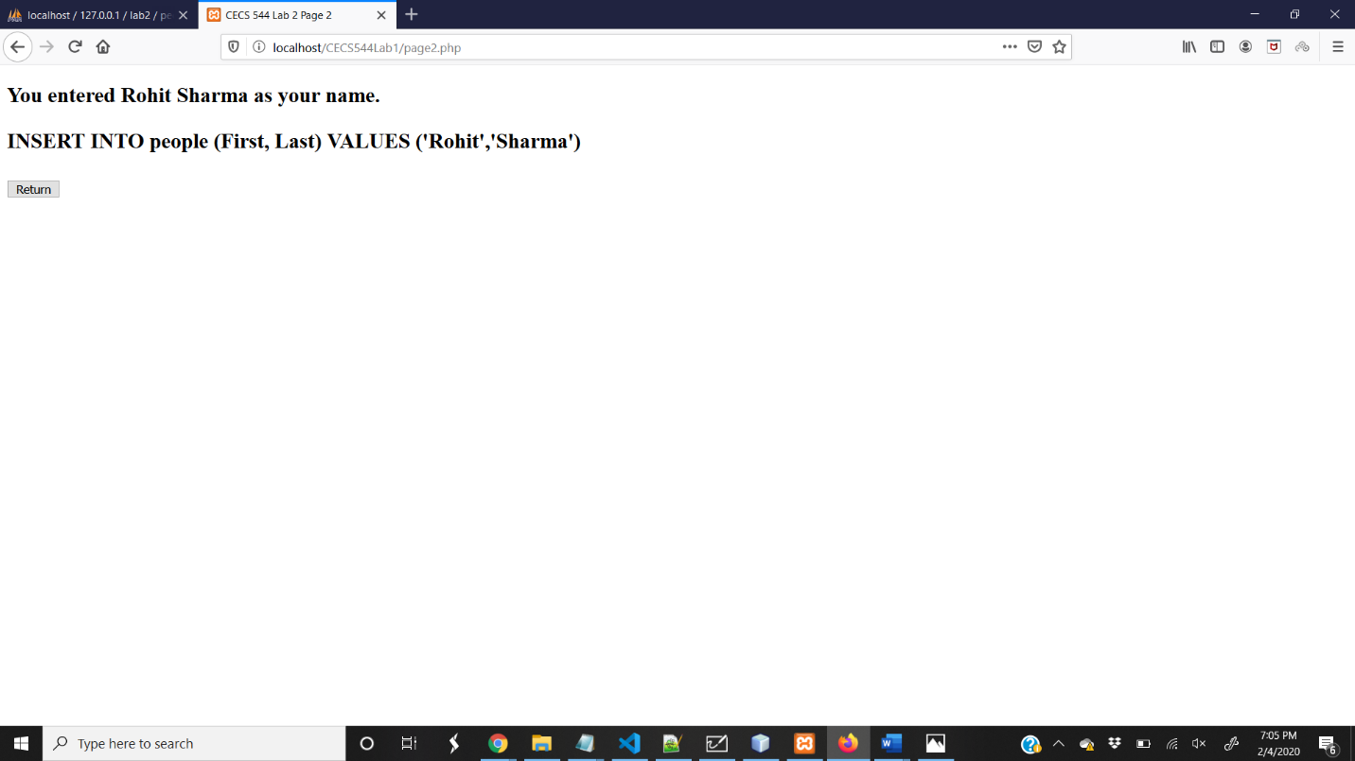

Screenshot -3 (page3.php)

