CECS544 – Lab4

Screenshot-1 (All test cases failed)

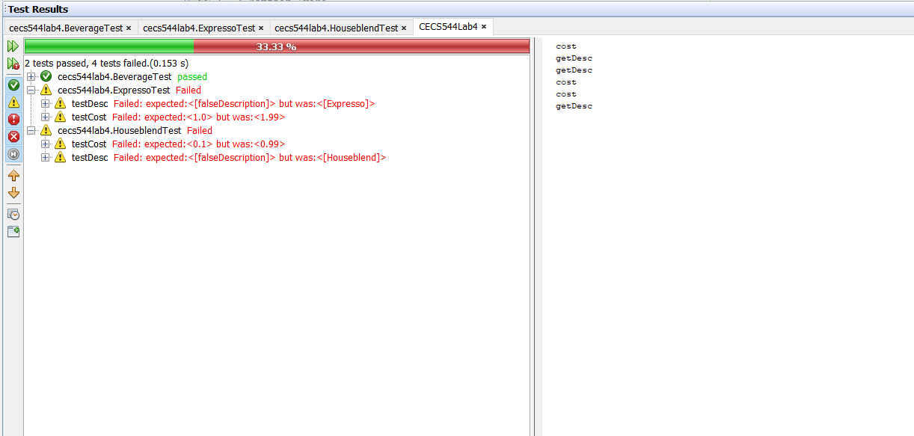

Screenshot -2 (All test cases passed)

