**PIZZA SALES SQL QUERIES**

1. **To calculate the sum of the total price**

select SUM(total_price) as Total_revenue from pizza_sales;\

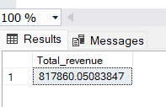

1. **Average order value**

select sum(total_price) / count(Distinct order_id) as Avg_order_value from pizza_sales;

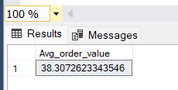

1. **Total pizza sold**

select sum(quantity) as Total_Pizzas_Sold from pizza_sales;

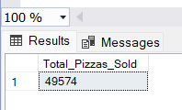

1. **Total orders**

select count(DISTINCT order_id) as Total_order from pizza_sales;

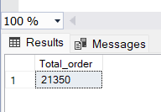

1. **Avg pizza per order**

select cast(cast(sum(quantity) as decimal(10,2)) /

cast(count(DISTINCT order_id)as decimal(10,2))as decimal(10,2)) as Avg_pizza_per_order from pizza_sales;

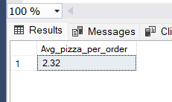

1. **Daily trend for total order**

select DATENAME(DW, order_date) as order_date, COUNT(Distinct order_id) as total_order from pizza_sales group by DATENAME(DW,order_date);

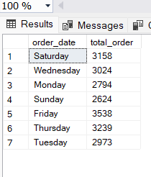

1. **Monthly trend for total order**

select DATENAME(MONTH, order_date) as Month_Name, COUNT(Distinct order_id) as total_order from pizza_sales group by DATENAME(MONTH, order_date);

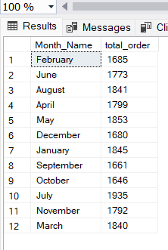

1. **Percentage sales by pizza category**

select pizza_category, sum(total_price) * 100 / (select sum(total_price) from pizza_sales) as PCT from pizza_sales group by pizza_category;

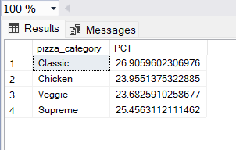

1. **Percentage sales by pizza category with total sales and only for jan month**

select pizza_category, sum(total_price) as Total_slaes,sum(total_price) * 100 / (select sum(total_price) from pizza_sales where MONTH(order_date) = 1) as PCT from pizza_sales

where MONTH(order_date) = 1

group by pizza_category;

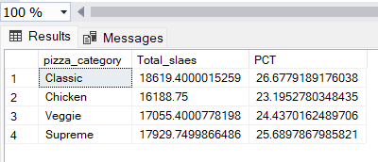

1. **Percentage sales by pizza size with total sales (used cast)**

Percentage sales by pizza category with total sales and only for jan month

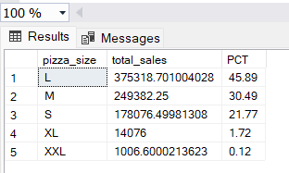

Using DATEPART(QUARTER)

select pizza_size , cast(sum(total_price) as Decimal(10,2)) as total_sales ,cast(sum(total_price) * 100 / (select sum(total_price)

from pizza_sales where datepart(QUARTER, order_date) = 1) as Decimal(10,2)) as PCT from pizza_sales

where datepart(QUARTER, order_date) = 1

group by pizza_size

order by PCT Desc;

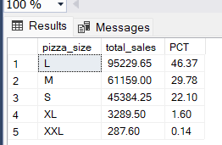

1. Top 5 pizza(using total_price)

select top 5 pizza_name , sum(total_price) as total_sales from pizza_sales

group by pizza_name

order by total_sales Desc;

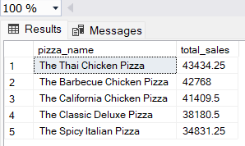

1. Bottom 5 pizzas(using total_price)

select top 5 pizza_name , sum(total_price) as total_sales from pizza_sales

group by pizza_name

order by total_sales Asc;

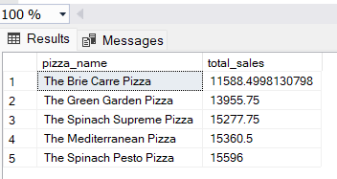

1. Top 5 pizza (using quantity)

select top 5 pizza_name , sum(quantity) as total_quantity from pizza_sales

group by pizza_name

order by total_quantity desc;

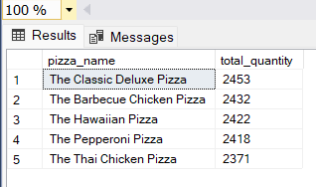

1. bottom 5 pizza (using quantity)

select top 5 pizza_name , sum(quantity) as total_quantity from pizza_sales

group by pizza_name

order by total_quantity asc;

