E-Voting System

Submitted to the
Department of Master of Computer Applications in partial fulfilment of the requirements for the Mini Project in

Web Programming Laboratory – 25MCA17
by
V. VARUN MURTHY
MCA109

Under the Guidance of
Ms. Deepali U

RAMAIAH INSTITUTE OF TECHNOLOGY
(Autonomous Institute, Affiliated to VTU)
Accredited by National Board of Accreditation & NAAC with ‘A+’ Grade
MSR Nagar, MSRIT Post, Bangalore-560054
www.msrit.edu
2026

DEPARTMENT OF MASTER OF COMPUTER APPLICATIONS

CERTIFICATE

This is to certify that the project entitled “E-VOTING SYSTEM” is carried out by V. VARUN MURTHY – MCA109 student of 1st semester, in partial fulfillment for the Mini Project in Web Programming Laboratory - 25MCA17, during the academic year 2025-2026.

Ms. Deepali U Dr. S Ajitha
Guide Head of the Department

Name of Examiners Signature with Date

ACKNOWLEDGEMENT

With deep sense of gratitude, I am thankful to our Respected HoD, Dr. S Ajitha for her pillared support and encouragement. I would like to convey my heartfelt thanks to my Project Guide Ms. Deepali U, Department of Master of Computer Applications, for giving me an opportunity to embark upon this topic and for her/his constant encouragement.

It gives me great pleasure to acknowledge the contribution of all people who helped me directly or indirectly realize it. First I would like to acknowledge the love and tremendous sacrifices that my Parents made to ensure that I always get an excellent education. For this and much more, I am forever in their debt.

I am thankful to all my friends for their moral and material support throughout the course of my project. Finally, I would like to thank all the Teaching and Non-Teaching Staff of Department of Master of Computer Applications for their assistance during various stages of my project work.

V. VARUN MURTHY

ABSTRACT

The Online Voting System is a web-based application designed to provide a simple, efficient, and user-friendly platform for conducting elections electronically. The primary objective of this project is to eliminate the limitations of traditional voting methods by enabling voters to cast their votes securely through an online interface. The system is developed using HTML5, CSS, and JavaScript, focusing on frontend technologies to demonstrate core concepts of web programming and client-side logic.
The system incorporates user authentication using predefined credentials to ensure that only authorized voters can access the voting process. Once authenticated, users are presented with a list of candidates along with their respective details and can cast their vote by selecting a single candidate. The application enforces a one-vote-per-user policy by permanently disabling multiple voting attempts. Upon successful vote submission, a confirmation page is displayed, indicating that the vote has been recorded along with the selected candidate.
Additionally, the system includes usability enhancements such as interactive animations, visual feedback for selected candidates, and a persistent dark mode feature that improves user experience across all pages. Although the project does not implement backend processing or database integration, it effectively demonstrates the fundamental workflow of an online voting system and serves as a strong foundation for future enhancements involving server-side validation, secure data storage, and real-world deployment.
This project highlights the practical application of web technologies in building interactive systems and emphasizes concepts such as authentication, state management, user interface design, and client-side data persistence.
Table of Contents

Contents | Page no
1. Introduction | 1
2.Implementation | 2
3.User interface screenshots | 10
4. Conclusion and Future Enhancement | 11

Introduction
The Online Voting System is a web-based application developed to simplify the process of conducting elections using modern web technologies. It allows users to securely log in, view a list of candidates, and cast their vote through an intuitive interface. The project demonstrates the use of HTML, CSS, and JavaScript to implement authentication, voting logic, and user interaction in a structured and efficient manner.

Problem Definition:
Traditional voting systems often involve manual processes that are time-consuming, resource-intensive, and prone to errors such as duplication and improper vote handling. There is a need for a simplified and reliable electronic voting mechanism that ensures authorized access, prevents multiple voting, and provides clear confirmation of vote submission. This project addresses these challenges by developing a basic online voting system that enables secure user authentication, single-vote enforcement, and efficient vote casting through a web-based interface.

Implementation

Code snippets:
<!DOCTYPE html>
<html lang="en">

<head>
<meta charset="utf-8">
<meta content="width=device-width, initial-scale=1.0" name="viewport">
<title>Online Voting System | Login</title>
<meta name="description" content="">
<meta name="keywords" content="">

<!-- Favicons -->
<link href="assets/img/favicon.png" rel="icon">

<!-- Fonts -->
<link href="https://fonts.googleapis.com" rel="preconnect">
<link href="https://fonts.gstatic.com" rel="preconnect" crossorigin>
<link href="https://fonts.googleapis.com/css2?family=Roboto:ital,wght@0,100;0,300;0,400;0,500;0,700;0,900;1,100;1,300;1,400;1,500;1,700;1,900&family=Poppins:ital,wght@0,100;0,200;0,300;0,400;0,500;0,600;0,700;0,800;0,900;1,100;1,200;1,300;1,400;1,500;1,600;1,700;1,800;1,900&family=Raleway:ital,wght@0,100;0,200;0,300;0,400;0,500;0,600;0,700;0,800;0,900;1,100;1,200;1,300;1,400;1,500;1,600;1,700;1,800;1,900&display=swap" rel="stylesheet">

<!-- Vendor CSS Files -->
<link href="assets/vendor/bootstrap/css/bootstrap.min.css" rel="stylesheet">
<link href="assets/vendor/bootstrap-icons/bootstrap-icons.css" rel="stylesheet">
<link href="assets/vendor/aos/aos.css" rel="stylesheet">
<link href="assets/vendor/swiper/swiper-bundle.min.css" rel="stylesheet">
<link href="assets/vendor/glightbox/css/glightbox.min.css" rel="stylesheet">

<!-- Main CSS File -->
<link href="assets/css/main.css" rel="stylesheet">

</head>

<body class="starter-page-page">

<header id="header" class="header d-flex align-items-center position-relative">
<div class="container-fluid container-xl position-relative d-flex align-items-center justify-content-between">

<a href="https://www.eci.gov.in/" class="logo d-flex align-items-center me-auto me-lg-0">
<!-- Uncomment the line below if you also wish to use an image logo -->
<img src="assets/img/logo.png" alt="Net on mado le">
<h1 class="sitename">ECI</h1>
<span>.</span>
</a>

<nav id="navmenu" class="navmenu">
<ul>
<li><a href="#hero">Home<br></a></li>
<li><a href="#about">Toll Free - 1950</a></li>
<li><a href="https://x.com/ECISVEEP"><i class="bi bi-twitter-x"></i></a></li>
<li><a href="https://www.facebook.com/ECI/"><i class="bi bi-facebook"></i></a></li>
<li><a href="https://www.instagram.com/ecisveep/"><i class="bi bi-instagram"></i></a></li>
<li><a href="http://www.youtube.com/@ECIVoterEducation"><i class="bi bi-youtube"></i></a></li>
<li class="dropdown"><a href="#"><span>Learn more</span> <i class="bi bi-chevron-down toggle-dropdown"></i></a>
<ul>
<li><a href="#">Media and publications</a></li>
<li class="dropdown"><a href="#"><span>Elections</span> <i class="bi bi-chevron-down toggle-dropdown"></i></a>
<ul>
<li><a href="#">Previous Elections</a></li>
<li><a href="#">Current Elections</a></li>
<li><a href="#">Future Elections</a></li>
</ul>
</li>
<li><a href="#">Election Management</a></li>
<li><a href="#">Voter Education</a></li>
</ul>
</li>
<li><a href="#contact">Contact</a></li>
</ul>
<i class="mobile-nav-toggle d-xl-none bi bi-list"></i>
</nav>

<a class="btn-getstarted" href="#get_started">Get Started</a>

</div>
</header>

<main class="main">

<!-- Page Title -->
<div style=" background: linear-gradient(to bottom,
rgba(255, 153, 51, 0.35),
rgba(255, 255, 255, 0.35),
rgba(19, 136, 8, 0.35)
);
">
<div class="page-title" data-aos="fade">
<div class="heading">
<div class="container">
<div class="row d-flex justify-content-center text-center">
<div class="col-lg-8">
<h1>Election Commission of India</h1>
<p class="mb-0">The Election Commission of India is an autonomous constitutional authority responsible for administering election processes in India. The body administers elections to the Lok Sabha, Rajya Sabha, State Legislative Assemblies in India, and the offices of the President and Vice President in the country.</p>
</div>
</div>
</div>
</div>
</div>
</div><!-- End Page Title -->
<div class="page-title" data-aos="fade">
<nav class="breadcrumbs">
<div class="container">
<ol>
<li><a href="https://www.eci.gov.in/">Home</a></li>
<li class="current">Login</li>
</ol>
</div>
</nav>
</div>

<!-- Starter Section Section -->
<section id="starter-section" class="starter-section section">

<!-- Section Title -->
<div class="container section-title" id="get_started" data-aos="fade-up">
<h2>Election commission of India</h2>
<p><br></p>
</div><!-- End Section Title -->
<div class="container" data-aos="fade-up">
<div class="row justify-content-center">
<div class="col-lg-5 col-md-7">
<div class="card shadow-sm border-0" data-aos="fade-up">
<div class="card-body p-4">
<h4 class="text-center mb-4 fw-bold">Secure Login</h4>
<form id="loginForm" action="Vote_cast.html">
<div class="mb-3">
<label for="userId" class="form-label">User ID</label>
<input type="text" class="form-control" id="userId" placeholder="Enter User ID" required>
</div>
<div class="mb-3">
<label for="password" class="form-label">Password</label>
<input type="password" class="form-control" id="password" placeholder="Enter Password" required>
</div>
<div class="d-grid mt-4">
<button type="submit" class="btn btn-primary" style="background-color: #000;border-color: #000;">
Login
</button>
</div>
</form>
<p class="text-center text-muted mt-3 mb-0" style="font-size: 0.85rem;">
Authorized users only. All activities are monitored.
</p>
</div>
</div>
</div>
</div>
</div>
</section><!-- /End of Starter Section Section -->
</main>

<footer id="footer" class="footer dark-background">
<div class="footer-top">
<div class="container">
<div class="row gy-4">
<div class="col-lg-4 col-md-6 footer-about">
<a href="index.html" class="logo d-flex align-items-center">
<span class="sitename">Election Commision of India</span>
</a>
<div class="footer-contact pt-3">
<p>© Election Commission of India<br>
Election Commission Of India, Nirvachan Sadan, Ashoka Road, New Delhi 110001
</p>
<p class="mt-3"><strong>Phone:</strong> <span>1950 (Toll-free Number)</span></p>
<p><strong>Email:</strong> <span>complaints@eci.gov.in</span></p>
</div>
<div class="social-links d-flex mt-4">
<a href="https://x.com/ECISVEEP"><i class="bi bi-twitter-x"></i></a>
<a href="https://www.facebook.com/ECI/"><i class="bi bi-facebook"></i></a>
<a href="https://www.instagram.com/ecisveep/"><i class="bi bi-instagram"></i></a>
<a href="http://www.youtube.com/@ECIVoterEducation"><i class="bi bi-youtube"></i></a>
</div>
</div>
<div class="col-lg-2 col-md-3 footer-links">
<h4>Quick Links</h4>
<ul>
<li><i class="bi bi-chevron-right"></i> <a href="#"> Home</a></li>
<li><i class="bi bi-chevron-right"></i> <a href="#"> About ECI</a></li>
<li><i class="bi bi-chevron-right"></i> <a href="#"> Political party registraton</a></li>
<li><i class="bi bi-chevron-right"></i> <a href="#"> Apply for voter ID</a></li>
<li><i class="bi bi-chevron-right"></i> <a href="#"> Terms of service</a></li>
</ul>
</div>
<div class="col-lg-2 col-md-3 footer-links">
<h4>Department</h4>
<ul>
<li><i class="bi bi-chevron-right"></i> <a href="#"> Recruitments</a></li>
<li><i class="bi bi-chevron-right"></i> <a href="#"> ECI Offcies</a></li>
<li><i class="bi bi-chevron-right"></i> <a href="#"> Employee benefits</a></li>
</ul>
</div>
<div class="col-lg-4 col-md-12 footer-newsletter">
<h4>Right to Information:</h4>
<p>Enter you querry and Email ID here to confront any discrepancy.</p>
<form action="forms/newsletter.php" method="post" class="php-email-form">
<div class="newsletter-form"><input type="email" name="email"><input type="submit" value="Submit"></div>
<div class="loading">Loading</div>
<div class="error-message"></div>
<div class="sent-message">Your Submission of request has been sent. Please wait while we contact you!</div>
</form>
</div>
</div>
</div>
</div>
<div class="copyright">
<div class="container text-center">
<p>© <span>Copyright</span> <strong class="px-1 sitename">| All Rights Reserved</strong></p>
<div class="credits">
<!-- All the links in the footer should remain intact. -->
<!-- You can delete the links only if you've purchased the pro version. -->
<!-- Licensing information: https://bootstrapmade.com/license/ -->
<!-- Purchase the pro version with working PHP/AJAX contact form: [buy-url] -->
Made by <a href="https://www.linkedin.com/in/varun-murthy-131200383/">ναяυи мυятну</a> | <a href="https://bootstrapmade.com/tools/">Linkedin</a>
</div>
</div>
</div>
</footer>

<!-- Scroll Top -->
<a href="top" id="scroll-top" class="scroll-top d-flex align-items-center justify-content-center"><i class="bi bi-arrow-up-short"></i></a>
<!-- Preloader -->
<div id="preloader"></div>
<!-- Vendor JS Files -->
<script src="assets/vendor/bootstrap/js/bootstrap.bundle.min.js"></script>
<script src="assets/vendor/php-email-form/validate.js"></script>
<script src="assets/vendor/aos/aos.js"></script>
<script src="assets/vendor/swiper/swiper-bundle.min.js"></script>
<script src="assets/vendor/glightbox/js/glightbox.min.js"></script>
<script src="assets/vendor/imagesloaded/imagesloaded.pkgd.min.js"></script>
<script src="assets/vendor/isotope-layout/isotope.pkgd.min.js"></script>
<script src="assets/vendor/purecounter/purecounter_vanilla.js"></script>

<!-- Main JS File -->
<script src="assets/js/main.js"></script>
</body>
</html>

User Interface Screenshots
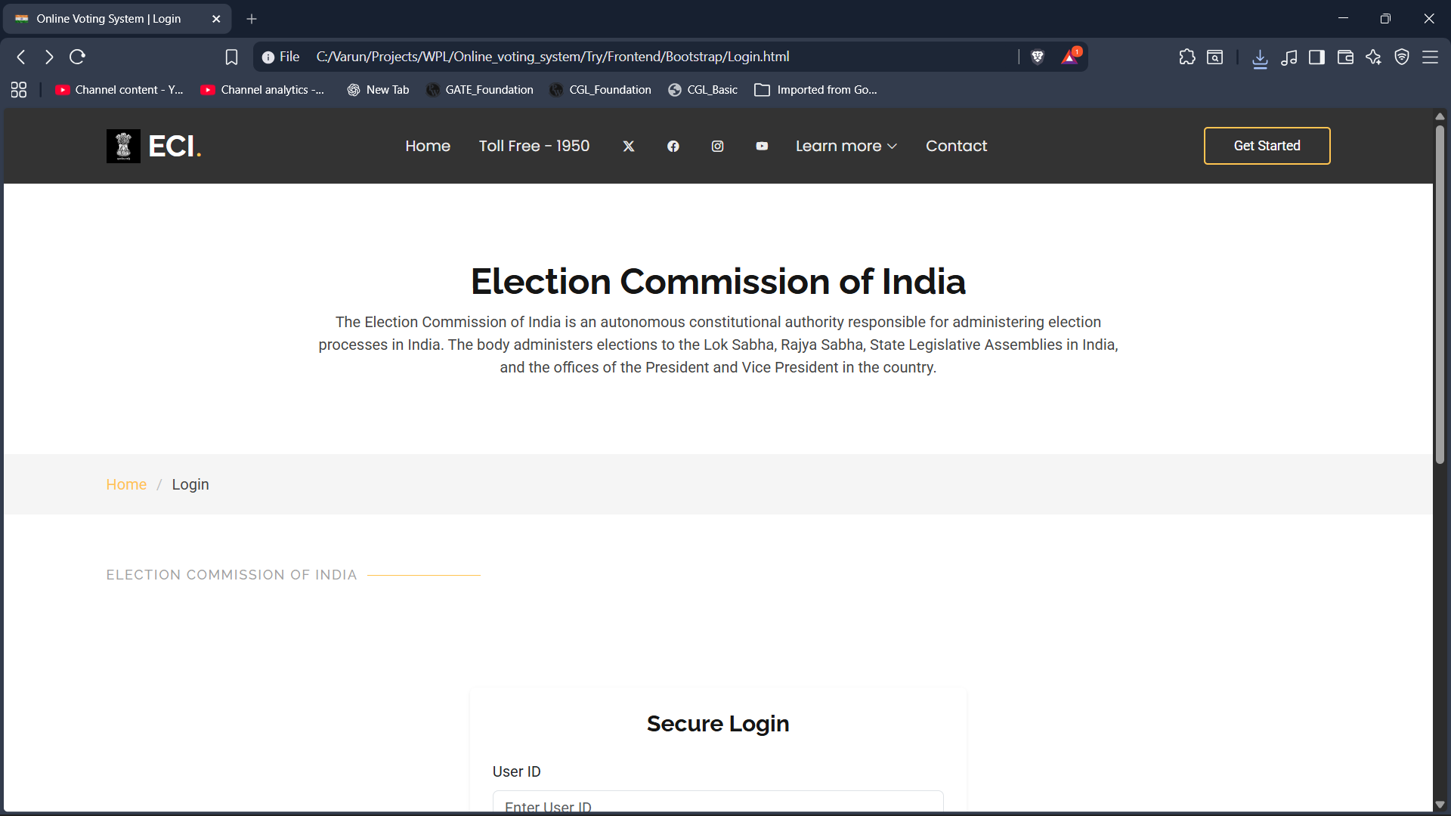
Fig. 3.1: Home page

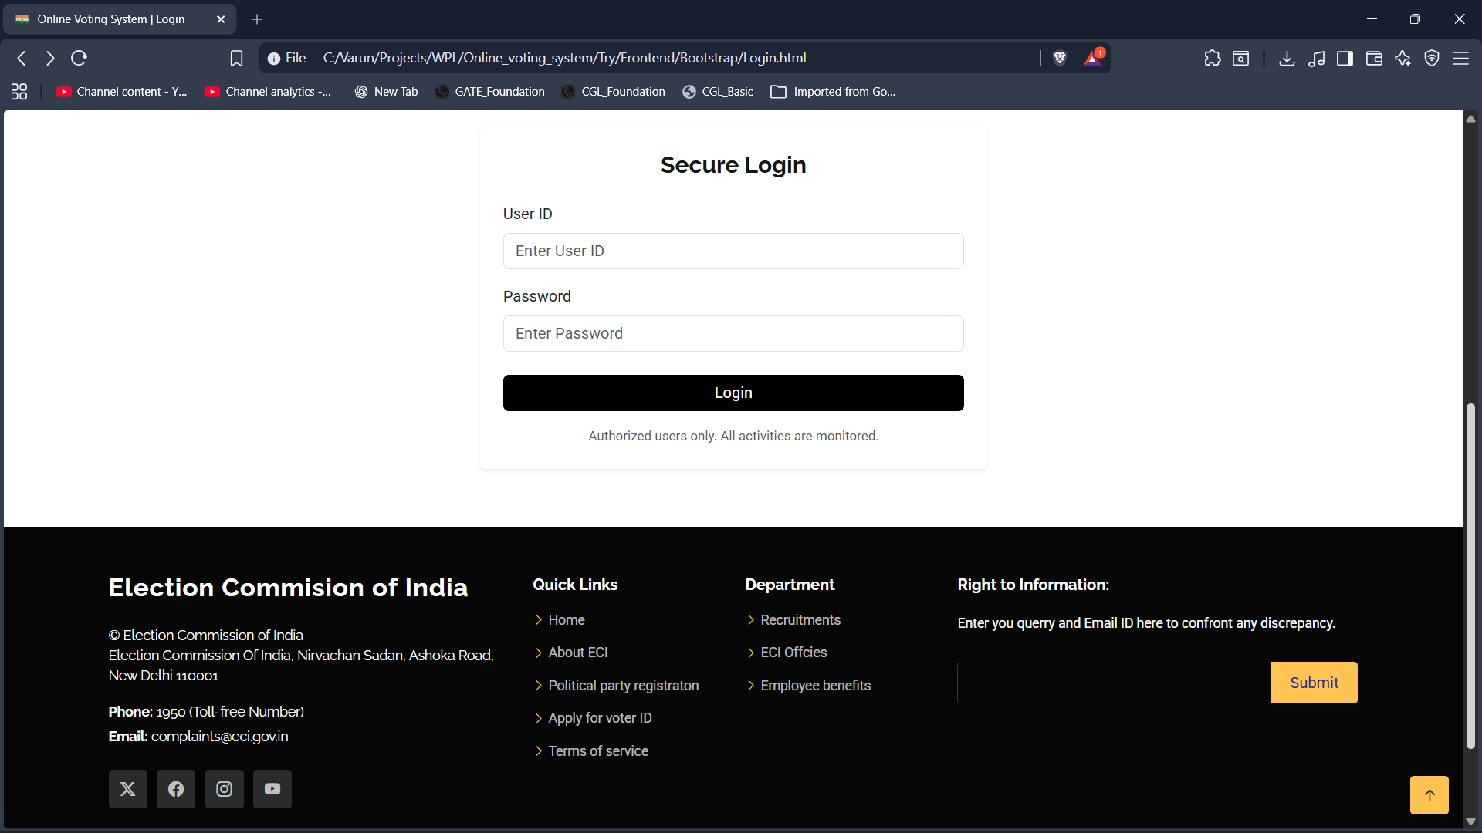
Fig. 3.2: Home page(part - 2)

Conclusion and Future Enhancement

Conclusion
The Online Voting System project successfully demonstrates the implementation of a basic electronic voting mechanism using web technologies such as HTML, CSS, and JavaScript. The system provides essential functionalities including user authentication, candidate selection, vote submission, and vote confirmation, while ensuring that each user is allowed to vote only once. Features such as interactive user interfaces, vote validation, and persistent theme settings enhance the overall usability of the application. This project effectively meets its objective of showcasing the core workflow of an online voting system and serves as a practical example of client-side web application development.

Future Enhancements:
- Integration of a backend server and database to securely store voter details and voting records.
- Implementation of strong authentication mechanisms such as OTP verification.
- Encryption of voting data to enhance security and confidentiality.
- Development of an admin module for managing candidates and viewing election results.
- Support for multiple elections and dynamic candidate management.
- Deployment of the system on a secure cloud platform for real-time access and scalability.
These enhancements would significantly improve the system’s reliability, security, and applicability in real-world election scenarios.

