Handson-1

Employee-list.component.html

<h2>Employee List</h2>

<div style="margin: 20px;">

Search &nbsp;<input type="text" placeholder="Find my name" [(ngModel)]="searchKey" (input)="Search()">

</div>

<div class="row">

<div class="container" *ngFor="let emp of employeeList">

<div class="column" style="padding: 10px;">

<span>{{emp.name}}</span>

{{emp.salary | currency : "INR"}}

</div>

</div>

Employee-list.component.ts

import { Component, OnInit } from '@angular/core';

@Component({

selector: 'app-employee-list',

templateUrl: './employee-list.component.html',

styleUrls: ['./employee-list.component.css']

})

export class EmployeeListComponent implements OnInit {

constructor() { }

employeeList:Employee[]=[];

ngOnInit(): void {

this.employeeList = [{id:1, name:"John", salary:5000, permanent:true, department:[{id:3, name:"Payroll"}],skills:[{id:1, name:"HTML"}] },

  {id:2, name:"Smith", salary:10000, permanent:true, department:[{id:6, name:"Internal"}],skills:[{id:2, name:"JAVA"}] },

  {id:3, name:"Mary", salary:55000, permanent:true, department:[{id:2, name:"Lead"}],skills:[{id:1, name:"HTML"}] },

  {id:4, name:"Sandy", salary:15000, permanent:true, department:[{id:3, name:"Payroll"}],skills:[{id:3, name:"CSS"}] },

  {id:5, name:"Martin", salary:20000, permanent:true, department:[{id:2, name:"Lead"}],skills:[{id:1, name:"HTML"}] }

]

}

public searchKey:string="";

Search()

{

  if(this.searchKey != "")

  {

    this.employeeList = this.employeeList.filter(res=>{

      return res.name.toLocaleLowerCase().match(this.searchKey.toLocaleLowerCase());

});

  }

  else if(this.searchKey == "")

  {

    this.ngOnInit();

  }

}

}

 interface Department{

  id:number;

  name:string;

}

 interface Skill{

  id:number;

  name:string;

}

 interface Employee extends Department, Skill{

  id:number;

  name:string;

  salary:number;

  permanent:boolean;

  department:Department[];

  skills:Skill[];

}

App.component.html

<a [routerLink]="['/']">View Employee</a> <br>

<a [routerLink]="['/EditEmployees']">Edit Employees</a><br>

<a [routerLink]="['/QuantityIncrement']">Quantity Increment</a><br>

<a [routerLink]="['/EditEmpReactivComponent']">EditEmpReactivComponent</a><br>

<a [routerLink]="['/EmployeeListComponent']">EmployeeListComponent</a><br>

<router-outlet></router-outlet>

Output

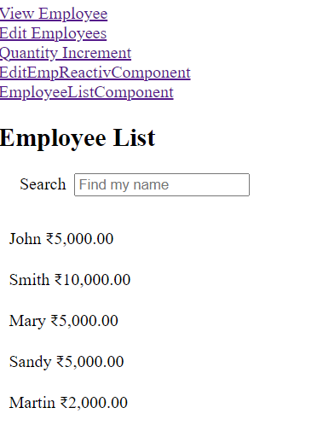

**Search bar working**

