**Handson-1**

**Startup.cs**

using Microsoft.AspNetCore.Builder;

using Microsoft.AspNetCore.Hosting;

using Microsoft.AspNetCore.HttpsPolicy;

using Microsoft.AspNetCore.Mvc;

using Microsoft.Extensions.Configuration;

using Microsoft.Extensions.DependencyInjection;

using Microsoft.Extensions.Hosting;

using Microsoft.Extensions.Logging;

using Microsoft.OpenApi.Models;

using System;

using System.Collections.Generic;

using System.Linq;

using System.Threading.Tasks;

namespace WebApplication21

{

public class Startup

{

public Startup(IConfiguration configuration)

{

Configuration = configuration;

}

public IConfiguration Configuration { get; }

// This method gets called by the runtime. Use this method to add services to the container.

public void ConfigureServices(IServiceCollection services)

{

services.AddControllers();

services.AddSwaggerGen(c =>

{

c.SwaggerDoc("v1", new OpenApiInfo

{

Title = "Swagger Demo",

Version = "v1",

Description = "TBD",

TermsOfService = new Uri("https://www.google.com"),

Contact = new OpenApiContact() { Name = "John Doe", Email = "john@xyzmail.com", Url = new Uri("https://www.example.com") },

License = new OpenApiLicense() { Name = "License Terms", Url = new Uri("https://www.example.com") }

});

});

}

// This method gets called by the runtime. Use this method to configure the HTTP request pipeline.

public void Configure(IApplicationBuilder app, IWebHostEnvironment env)

{

if (env.IsDevelopment())

{

app.UseDeveloperExceptionPage();

app.UseSwagger();

app.UseSwaggerUI(c => c.SwaggerEndpoint("/swagger/v1/swagger.json", "WebApplication21 v1"));

}

app.UseHttpsRedirection();

app.UseRouting();

app.UseAuthorization();

app.UseEndpoints(endpoints =>

{

endpoints.MapControllers();

});

}

}

}

**Output**

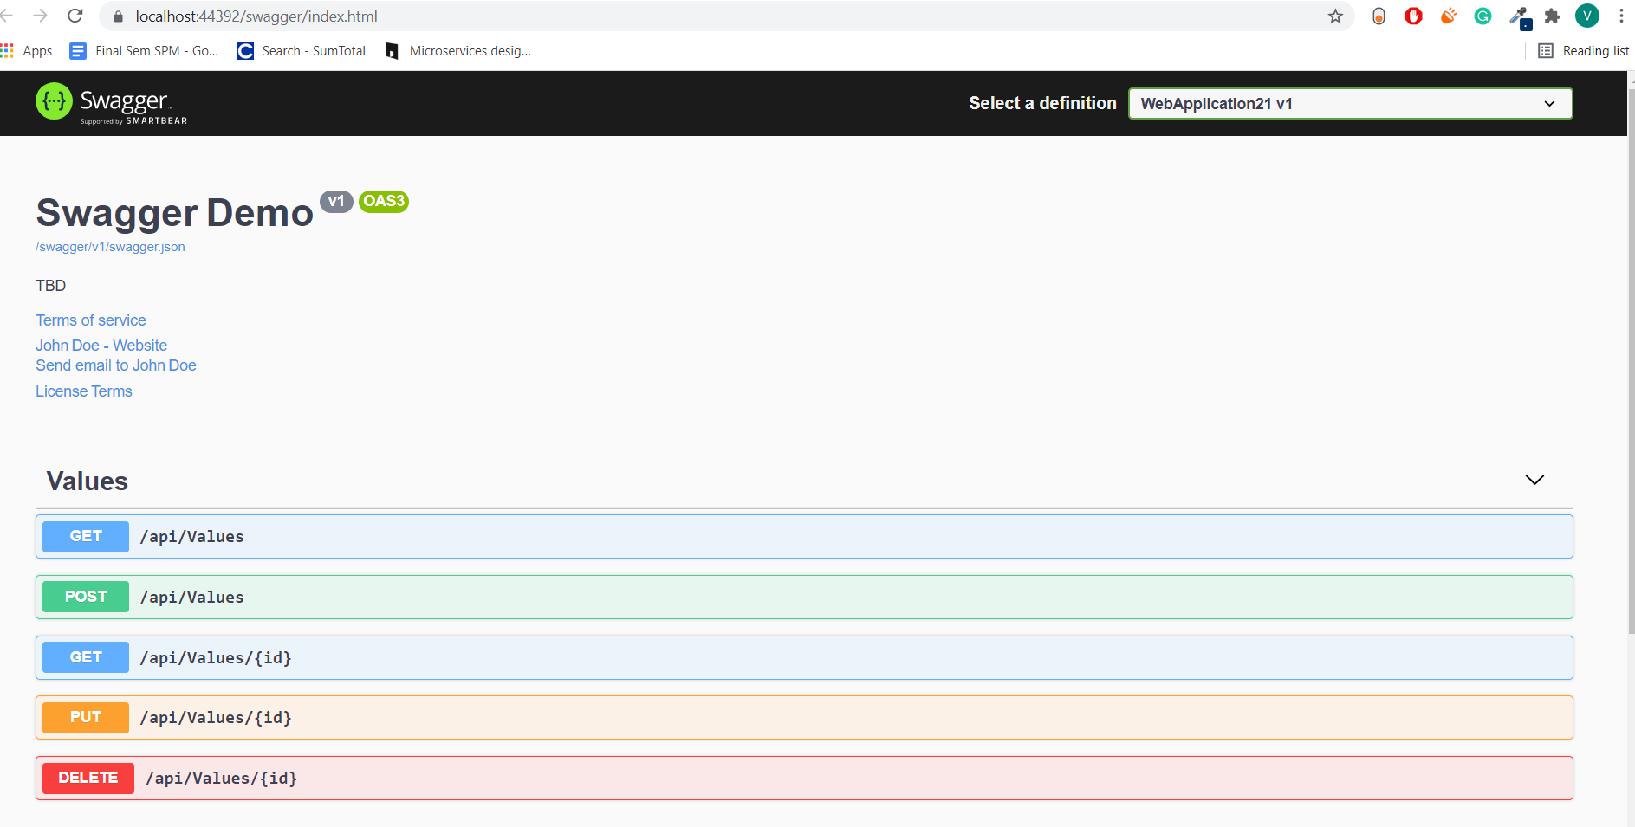

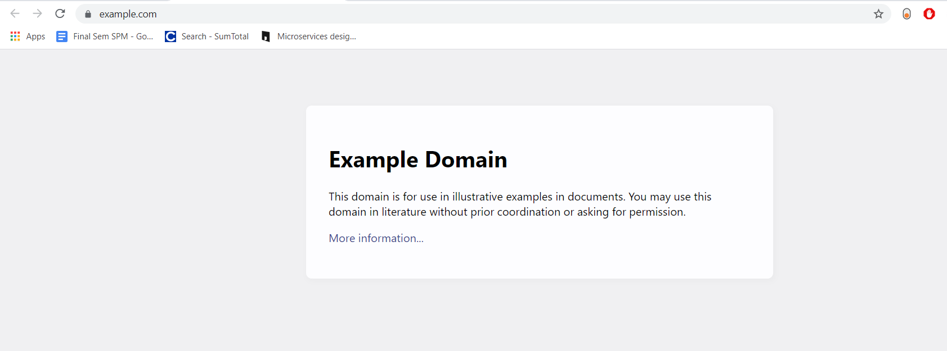

**Handson-2**

**Employee.cs**

using System;

using System.Collections.Generic;

using System.Linq;

using System.Threading.Tasks;

namespace WebApplication22.Models

{

public class Employee

{

public int Id { get; set; }

public string Name { get; set; }

public int Salary { get; set; }

public bool Permanent { get; set; }

public string Department { get; set; }

public string Skills { get; set; }

public DateTime DateOfBirth { get; set; }

}

}

**EmployeeController.cs**

using Microsoft.AspNetCore.Http;

using Microsoft.AspNetCore.Mvc;

using System;

using System.Collections.Generic;

using System.Linq;

using System.Threading.Tasks;

using WebApplication22.Models;

using WebApplication22.Filters;

namespace WebApplication22.Controllers

{

[Route("api/[controller]")]

[ApiController]

public class EmployeesController : ControllerBase

{

private Employee[] emp = new Employee[]

{

new Employee { Id=1 , Name="Varun Raj" , Salary=1000 , Permanent=true, Department="CSE",Skills="Dotnet" ,DateOfBirth=new DateTime(1999,06,09) },

new Employee { Id=2 , Name="Arun" , Salary=5000 , Permanent=true, Department="MECH",Skills="java" ,DateOfBirth=new DateTime(1999,05,03) } ,

new Employee { Id=3 , Name="Tharun" , Salary=2000 , Permanent=false, Department="CSE",Skills="php" ,DateOfBirth=new DateTime(1998,05,13) } ,

};

private IEnumerable<Employee> GetStandardEmployeeList()

{

return emp;

}

// GET: api/<ValuesController1>

[CustomAuthFilter]

[HttpGet]

public IEnumerable<Employee> Get()

{

return GetStandardEmployeeList();

}

// GET api/<ValuesController1>/5

[HttpGet("{id}")]

[ProducesResponseType(StatusCodes.Status200OK)]

[ProducesResponseType(StatusCodes.Status404NotFound)]

public IActionResult GetById(int id)

{

var prod = emp.FirstOrDefault((p) => p.Id == id);

if (prod == null)

{

return NotFound();

}

return Ok(prod);

}

// POST api/<ValuesController1>

[HttpPost]

public void Post([FromBody] string value)

{

}

// PUT api/<ValuesController1>/5

[HttpPut("{id}")]

public void Put(int id, [FromBody] string value)

{

}

// DELETE api/<ValuesController1>/5

[HttpDelete("{id}")]

public void Delete(int id)

{

}

}

}

**CustomAuthFilter.cs**

using Microsoft.AspNetCore.Mvc;

using Microsoft.AspNetCore.Mvc.Filters;

using System;

using System.Collections.Generic;

using System.Linq;

using System.Threading.Tasks;

namespace WebApplication22.Filters

{

public class CustomAuthFilter : ActionFilterAttribute

{

public override void OnActionExecuting(ActionExecutingContext context)

{

if (context.HttpContext.Request.Query.ContainsKey("Authorization") && context.HttpContext.Request.Query["Authorization"] == "true")

{

context.Result = new UnauthorizedResult();

}

else

{

base.OnActionExecuting(context);

}

}

}

}

**Output**

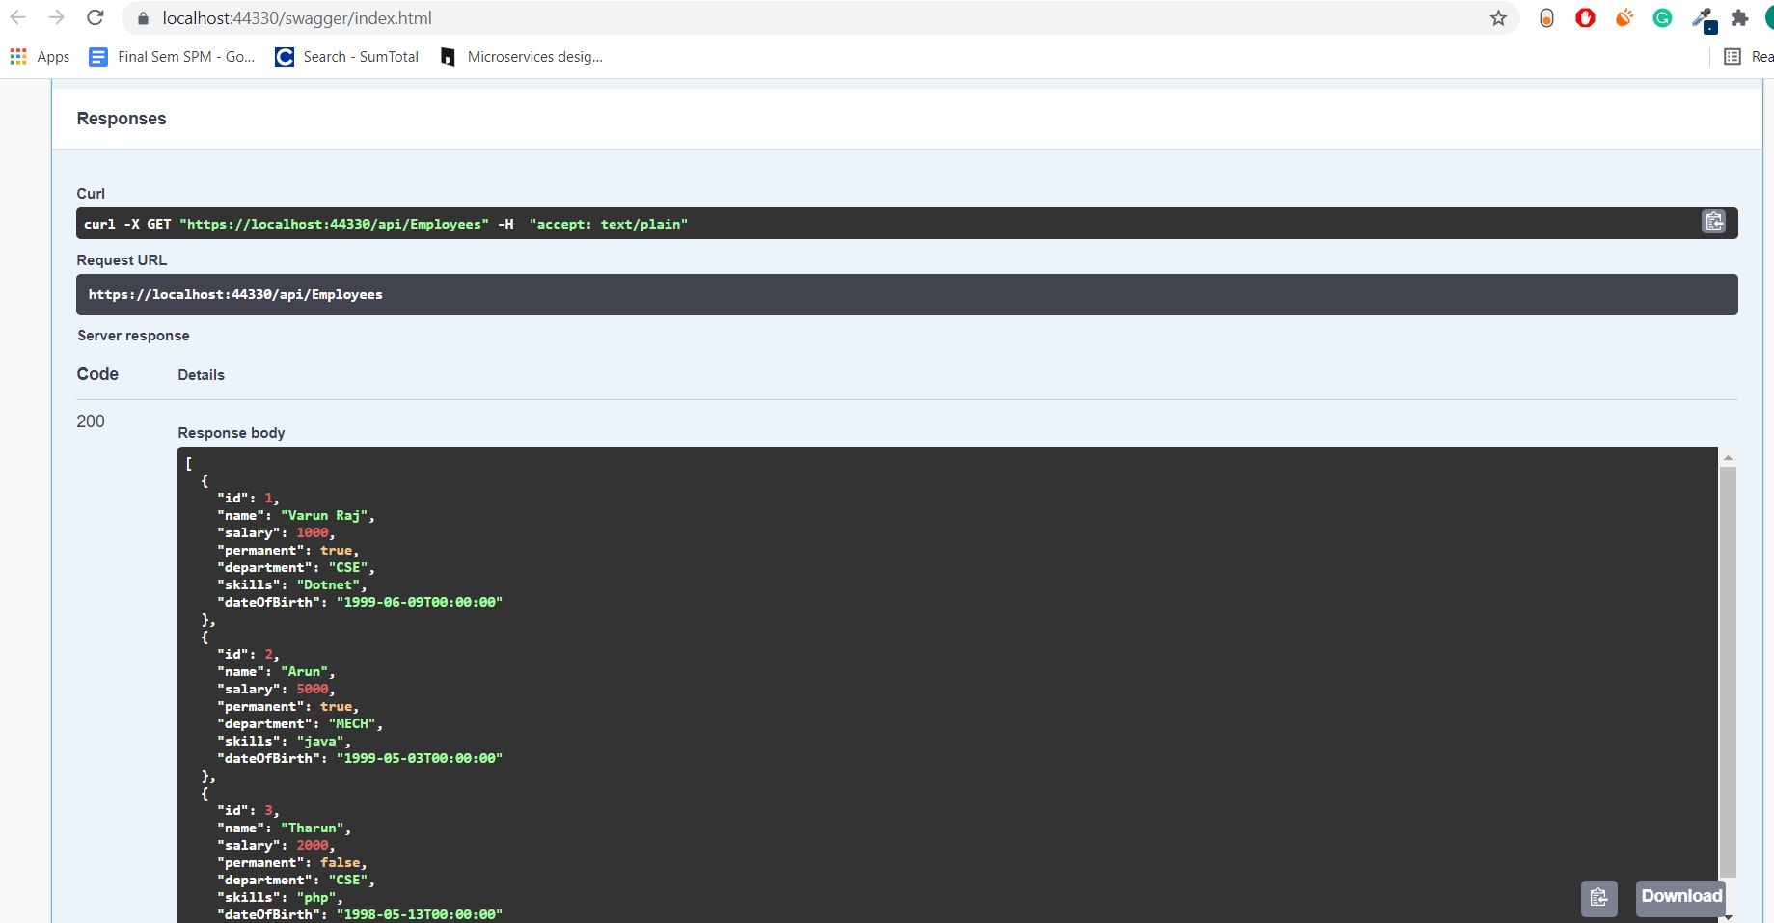

**Handson-3**

**Employee.cs**

**using System;**

**using System.Collections.Generic;**

**using System.Linq;**

**using System.Threading.Tasks;**

**namespace WebApplication23.Models**

**{**

**public class Employee**

**{**

**public int Id { get; set; }**

**public string Name { get; set; }**

**}**

**}**

**EmployeeController.cs**

**using Microsoft.AspNetCore.Mvc;**

**using System;**

**using System.Collections.Generic;**

**using System.Linq;**

**using System.Threading.Tasks;**

**using WebApplication23.Models;**

**// For more information on enabling Web API for empty projects, visit https://go.microsoft.com/fwlink/?LinkID=397860**

**namespace WebApplication23.Controllers**

**{**

**[Route("api/[controller]")]**

**[ApiController]**

**public class EmployeeController : ControllerBase**

**{**

**private static List<Employee> _emp = new List<Employee>();**

**// GET: api/<ValuesController1>**

**[HttpGet(Name = "GetAllStudent")]**

**public IActionResult Get()**

**{**

**return new ObjectResult(_emp);**

**}**

**// GET api/<ValuesController1>/5**

**[HttpGet("{id}", Name = "GetStudent")]**

**public IActionResult Get(int id)**

**{**

**return new ObjectResult(_emp.FirstOrDefault(p => p.Id == id));**

**}**

**// POST api/<ValuesController1>**

**[HttpPost(Name = "CreateStudent")]**

**public IActionResult Post([FromBody] Employee emps)**

**{**

**_emp.Add(emps);**

**return CreatedAtRoute("GetStudent", new { id = emps.Id }, emps);**

**}**

**// PUT api/<ValuesController1>/5**

**[HttpPut("{id}", Name = "UpdateStudent")]**

**public IActionResult Put(int id, [FromBody] Employee emps)**

**{**

**_emp.FirstOrDefault(p => p.Id == id).Name = emps.Name;**

**return CreatedAtRoute("GetStudent", new { id = emps.Id }, emps);**

**}**

**// DELETE api/<ValuesController1>/5**

**[HttpDelete("{id}", Name = "DeleteStudent")]**

**public IActionResult Delete(int id)**

**{**

**var _emps = _emp.FirstOrDefault(p => p.Id == id);**

**_emp.Remove(_emps);**

**return new NoContentResult();**

**}**

**}**

**}**

**Output**

