Handson-1

<script> var emp = {firstName:"John",lastName:"Stoke", salary:5000, permanentStaff:true};

console.log(emp);

</script>

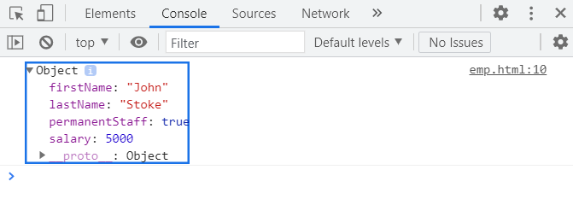

Handson-2

<script>

var obj = JSON.parse('{"firstname":"John", "lastname":"Stoke", "salary":"5000","permenantStaff":"true"}');

console.log("firstname :"+obj.firstname);

console.log("lastname :"+obj.lastname);

console.log("salary :"+obj.salary);

console.log("permenantStaff :"+obj.permenantStaff);

</script>

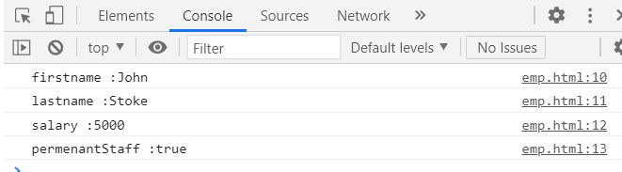

Handson-3

<script>

const value = '{"firstname":"John", "lastname":"Stoke", "salary":"5000","permanentStaff":"true", "Department":[{"id":"3","name":"payroll"}]}';

var obj = JSON.parse(value);

console.log("firstname : "+obj.firstname);

console.log("lastname : "+obj.lastname);

console.log("salary: "+obj.salary);

console.log("department id :"+ obj.Department[0].id)

console.log("department name :"+ obj.Department[0].name);

</script>

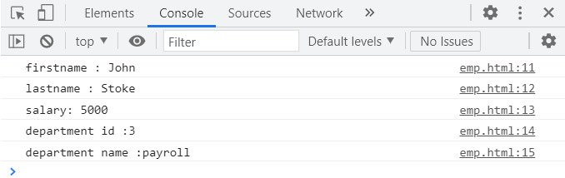

Handson 4

<script>

const value = '{"firstname":"John", "lastname":"Stoke", "salary":"5000","permanentStaff":"true", "Department":[{"id":"3","name":"payroll"}],"skill":[{"id":"1","value":"HTML"},{"id":"2","value":"CSS"},{"id":"3","value":"JavaScript"}]}';

var obj = JSON.parse(value);

console.log("firstname : "+obj.firstname);

console.log("lstname : "+obj.lastname);

console.log("salary: "+obj.salary);

console.log("department id :"+ obj.Department[0].id)

console.log("department name :"+ obj.Department[0].name);

for(var i=0;i<obj.skill.length;i++){

console.log("Skill "+(i+1)+" : "+obj.skill[i].id+","+obj.skill[i].value);

}

</script>

