Handson 1

app.component.html

<a [routerLink]="['/']">View Employee</a> <br>

<a [routerLink]="['/EditEmployees']">Edit Employees</a><br>

<a [routerLink]="['/QuantityIncrement']">Quantity Increment</a><br>

<router-outlet></router-outlet>

Viewemps.component.html

<strong>Id:</strong>{{Id}}<br>

<strong>Name:</strong>{{Name}}<br>

<strong>Salary:</strong>{{Salary}}

<br>

<span *ngIf="Permanent"><strong>Permanent</strong>Yes</span>

<br>

<strong>Department Id:</strong>{{Department_Id}}

<br>

<strong>Department Name:</strong>{{Department_Name}}

<br><br>

<strong>Skills</strong>

<br>

<span><strong>Skill Id Skill Name</strong></span>

<ol type="1">

<li *ngFor="let item of Skills">{{item}}</li>

</ol>

<strong>Date Of Birth: </strong>{{DateofBirth}}

<!-- Using pipe -->

<strong>Date Of Birth:</strong>{{DateofBirth | date}}

<br>

Viewemps.component.ts

import { Component, OnInit } from '@angular/core';

@Component({

selector: 'app-viewemps',

templateUrl: './viewemps.component.html',

styleUrls: ['./viewemps.component.css']

})

export class ViewempsComponent implements OnInit {

public Id:number=1;

  public Name:string="John";

  public Salary:number=10000;

  public Permanent:boolean=true;

  public Department_Id:number=1;

  public Department_Name:string="payroll";

  public Skills:string[]=["Html","Css","JavaScripts"];

  public DateofBirth:Date=new Date('12/31/2000');

constructor() { }

ngOnInit(): void {

}

}

Editemp.component.html

<p>editemp works!</p>

Quantity-increment.component.html

<p>Simple Button click Event!!</p>

<button (click)="first()">Click me</button>

<br>

{{result}}

Quantity-increment.component.ts

import { Component, OnInit } from '@angular/core';

@Component({

selector: 'app-quantity-increment',

templateUrl: './quantity-increment.component.html',

styleUrls: ['./quantity-increment.component.css']

})

export class QuantityIncrementComponent implements OnInit {

 public result:string="";

   public first():void{

    this.result="click me button clicked";

  }

constructor() { }

ngOnInit(): void {

}

}

Output

**Viewpage**

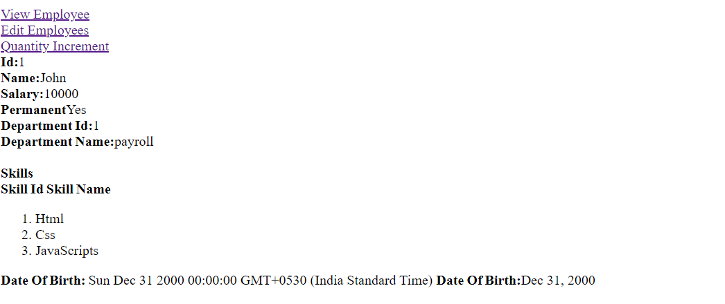

**Edit page**

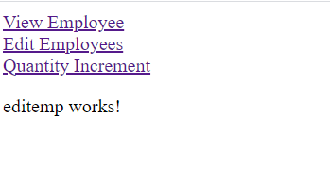

**Quantity page**

