**Handson-1**

using System;

using System.Collections.Generic;

using System.ComponentModel;

using System.Data;

using System.Drawing;

using System.Linq;

using System.Text;

using System.Text.RegularExpressions;

using System.Threading.Tasks;

using System.Windows.Forms;

namespace WindowsFormsApp2

{

public partial class Form1 : Form

{

public Form1()

{

InitializeComponent();

}

private void radioButton1_CheckedChanged(object sender, EventArgs e)

{

}

private void radioButton2_CheckedChanged(object sender, EventArgs e)

{

}

private void Form1_Load(object sender, EventArgs e)

{

}

private void button1_Click(object sender, EventArgs e)

{

string input1 = textBox1.Text;

string input2 = textBox2.Text;

if (!Regex.IsMatch(input1, @"\d+$") || !Regex.IsMatch(input2, @"\d+$"))

{

MessageBox.Show(" Please enter valid input for the operands");

}

if (radioButton1.Checked)

{

MessageBox.Show((int.Parse(input1) + int.Parse(input2)).ToString());

}

else if (radioButton2.Checked)

{

MessageBox.Show((int.Parse(input1) - int.Parse(input2)).ToString());

}

else if (radioButton3.Checked)

{

MessageBox.Show((int.Parse(input1) * int.Parse(input2)).ToString());

}

else if (radioButton4.Checked)

{

MessageBox.Show((int.Parse(input1) / int.Parse(input2)).ToString());

}

else

{

MessageBox.Show("Please Select a valid Option");

}

}

}

}

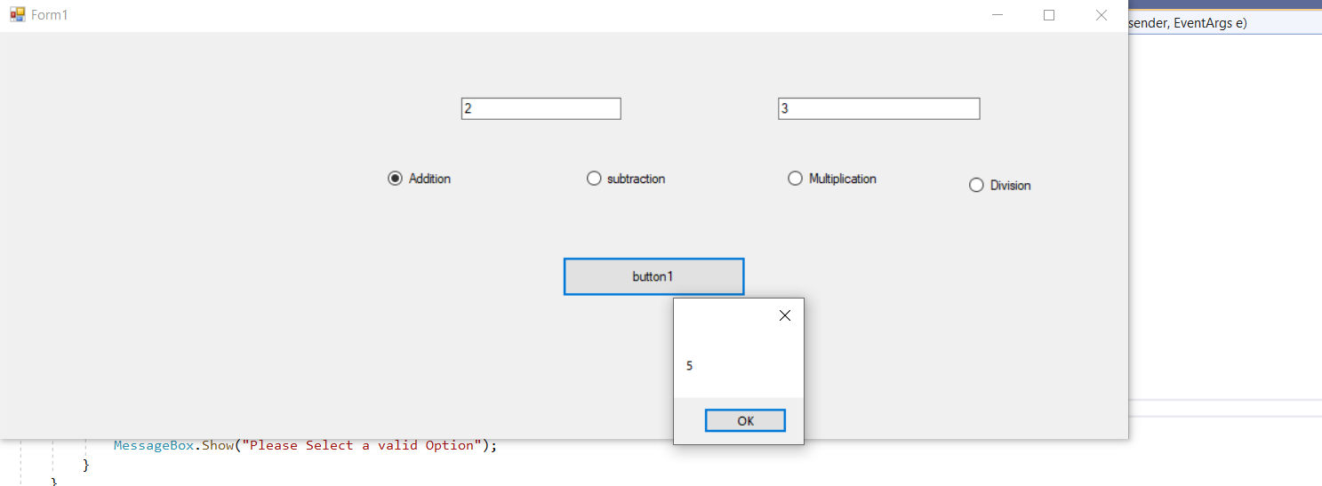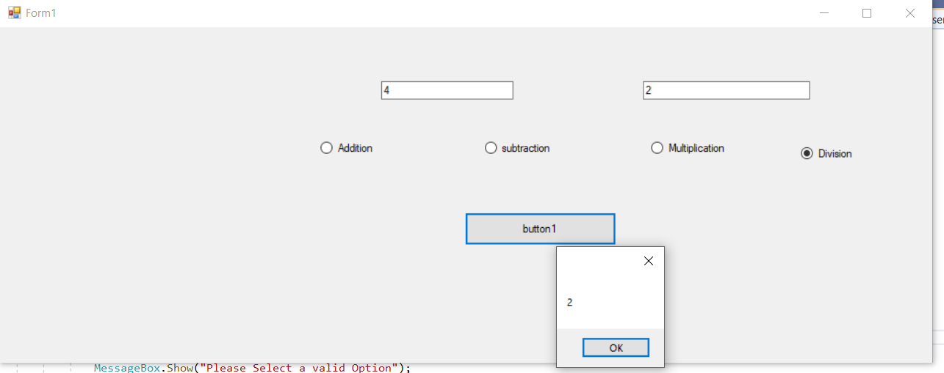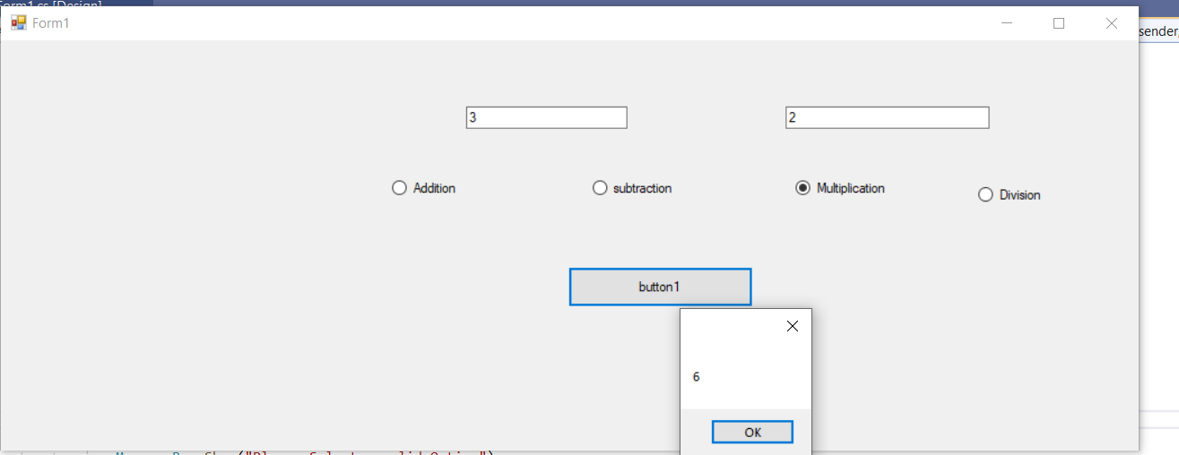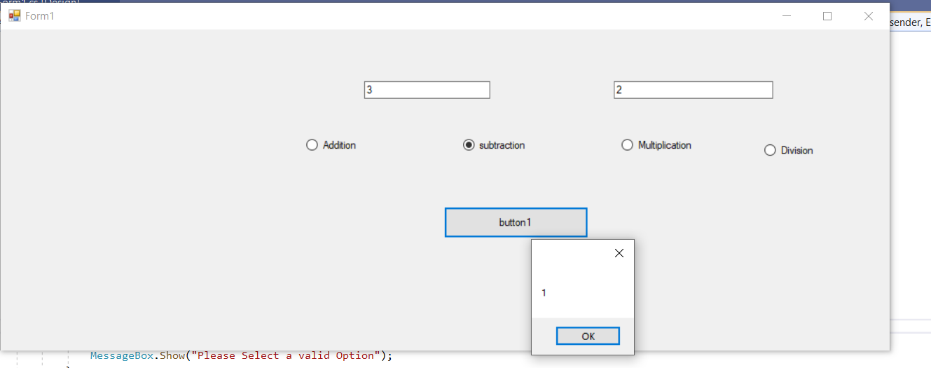

**Handson-2**

using System;

using System.Collections.Generic;

using System.ComponentModel;

using System.Data;

using System.Drawing;

using System.Linq;

using System.Text;

using System.Threading.Tasks;

using System.Windows.Forms;

namespace WindowsFormsApp3

{

public partial class Form1 : Form

{

public Form1()

{

InitializeComponent();

}

private void pictureBox1_Click(object sender, EventArgs e)

{

}

private void button1_Click(object sender, EventArgs e)

{

OpenFileDialog openFileDialog1 = new OpenFileDialog

{

InitialDirectory = @"D:\",

Filter = "images(*.jpg; *.jpeg; *.gif; *.bmp)|*.jpg; *.jpeg; *.gif; *.bmp"

};

if (openFileDialog1.ShowDialog() == DialogResult.OK)

{

pictureBox1.SizeMode = PictureBoxSizeMode.StretchImage;

pictureBox1.Image = new Bitmap(openFileDialog1.FileName);

}

}

}

}

