Handson 1

Editemp.component.html

<strong>Edit Employees</strong>

<br>

<br>

<form><label>Name:<input type="text" name="name1" #name1></label>

{{name1.value}}

<br>

</form>

<hr>

<label>Name<input type="text" name="name" [(ngModel)]="employees" #name=ngModel minlength="3" maxlength="10">

{{employees}}

<div>name.invalid - {{name.invalid}}</div>

<div>name.touched - {{name.touched}}</div>

<div>name.dirty - {{name.dirty}}</div>

<div>name.errors.minlength or maxlength - {{name.errors?.minlength | json}}</div>

</label>

<form #empForm="ngForm" (submit)="OnSubmit()">

<div class="Block">

<label>

<strong>Name</strong>

<input type="text" [(ngModel)]="emp.Name" [ngModelOptions]="{standalone: true}"><br>

</label>

<label>

<strong>Salary</strong>

<input type="number" [(ngModel)]="emp.Salary" [ngModelOptions]="{standalone: true}">

</label><br>

<label>

<strong>Is Permanent or Not?</strong>

<input type="radio" name="permanent" [(ngModel)]="emp.Permanent" [value]="true">Yes

<input type="radio" name="permanent" [(ngModel)]="emp.Permanent" [value]=" false">No

</label>

<br>

<button type="submit" [disabled]="!empForm.valid">Save</button>

</div>

</form>

<div class="block">

<strong>Employee Model</strong>

<pre>{{emp | json }}}</pre>

</div>

Editemp.component.ts

import { Component, OnInit } from '@angular/core';

@Component({

selector: 'app-editemp',

templateUrl: './editemp.component.html',

styleUrls: ['./editemp.component.css']

})

export class EditempComponent {

public employees:string;

  public myname:string;

constructor() {

this.employees = "";

    this.myname="";

}

public emp:employee={Id:1,Name:"John",Salary:10000,Permanent:false, Dept:{Id:1,Name:"Payroll"},skills:[{id:1,Name:"html"},{id:2,Name:"Css"},{id:3,Name:"Javascript"}]};

  public departmentslist:any[]=[{Id:1,Name:"Payroll"},{Id:2,Name:"Internal"},{Id:3,Name:"Hr"}];

public OnSubmit():void{

    console.log(this.emp);

}

}

class employee{

  public Id:number=0;

  public Name:string="";

  public Salary:number=0;

  public Permanent:boolean=true;

  public Dept:Department={Id:1,Name:"Payroll"};

  public skills:any[]=[{}];

}

class Department{

  public Id:number=1;

  public Name:string="";

}

App.module.ts

import { NgModule } from '@angular/core';

import { BrowserModule } from '@angular/platform-browser';

import { AppRoutingModule } from './app-routing.module';

import { AppComponent } from './app.component';

import { EditempComponent } from './editemp/editemp.component';

import {Routes,RouterModule} from '@angular/router';

import { ViewempsComponent } from './viewemps/viewemps.component';

import { QuantityIncrementComponent } from './quantity-increment/quantity-increment.component'

import { FormsModule, ReactiveFormsModule } from '@angular/forms';

const appRoutes:Routes=[{path:"" ,component:ViewempsComponent},{path:"EditEmployees" ,component:EditempComponent},{path:"QuantityIncrement",component:QuantityIncrementComponent}]

@NgModule({

declarations: [

AppComponent,

ViewempsComponent,

EditempComponent,

QuantityIncrementComponent

],

imports: [

BrowserModule,

AppRoutingModule,

RouterModule.forRoot(appRoutes),

FormsModule,

ReactiveFormsModule

],

providers: [],

bootstrap: [AppComponent]

})

export class AppModule { }

Output

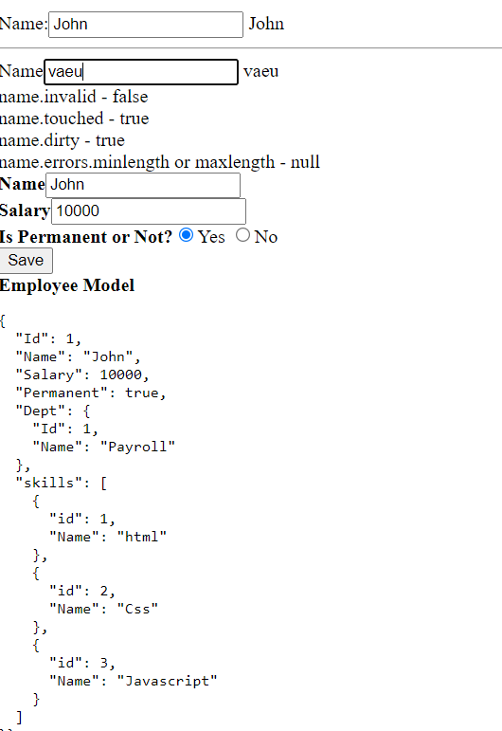

Session - 2

Edit-emp-reactiv.component.ts

import { Component, OnInit } from '@angular/core';

import { FormControl, FormGroup, Validators } from '@angular/forms';

@Component({

selector: 'app-edit-emp-reactiv',

templateUrl: './edit-emp-reactiv.component.html',

styleUrls: ['./edit-emp-reactiv.component.css']

})

export class EditEmpReactivComponent {

public emp:employee={Id:1,Name:"John",Salary:10000,Permanent:false, Dept:{Id:1,Name:"Payroll"},skills:[{id:1,Name:"html"},{id:2,Name:"Css"},{id:3,Name:"Javascript"}]};

  public departmentslist:any[]=[{Id:1,Name:"Payroll"},{Id:2,Name:"Internal"},{Id:3,Name:"Hr"}];

Name=new FormControl('John');

  public empForm:FormGroup = new FormGroup({

    'name': new FormControl(this.emp.Name, [

     Validators.required,

     Validators.minLength(4),

     Validators.maxLength(20)

    ])

    });

    public dept:FormGroup = new FormGroup({

      'department': new FormControl("")

      });

}

class employee{

  public Id:number=0;

  public Name:string="";

  public Salary:number=0;

  public Permanent:boolean=true;

  public Dept:Department={Id:1,Name:"Payroll"};

  public skills:any[]=[{}];

}

class Department{

  public Id:number=1;

  public Name:string="";

}

Edit-emp-reactiv.component.html

<h3>Edit Employee</h3>

<label>

<strong>Name</strong>

<input type="text" [formControl]="Name">

</label>

<br>

<div>

<form [formGroup]="dept">

<h3>Department</h3>

<select formControlName="department">

<option \*ngFor="let department of departmentslist"

[ngValue]="department"

[selected]="department.Id == emp.Dept.Id">

{{department.Name}}

</option>

</select>

</form>

</div>

Output

