Testing the difference in performance using OpenMP parallelisation.

Using the following code to test

https://github.com/Varunn1310/AMD/blob/main/OpenMP/MatrixMul.cc

Output:

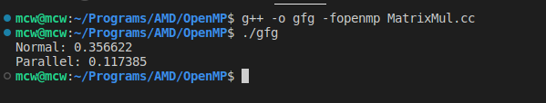
The output for MatrixMultiplication without using OpenMP took 0.356622s
Whereas the output for MatrixMultiplication using OpenMP took 0.117385s

