Using the following sample code to test OpenMP environment variables.
Filename: HelloWorld.cc
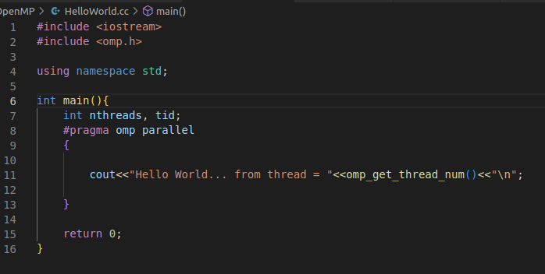
1)OMP_NUM_THREADS

Sets the maximum number of threads to use for OpenMP* parallel regions if no other value is specified in the application.
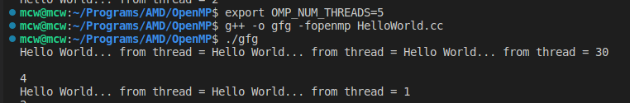
Reqr

2)OMP_SCHEDULE

Sets the run-time schedule type and an optional chunk size.

The schedule type can be set to “static” when we know that each thread has a similar workload.
Ex:-
for(int i=0;i<100;i++)
for(int j=0;j<100;j++)
c[i][j]=0;
The schedule can be set to “dynamic” when the worload for each thread is not the same.
Ex:-
for(int i=0;i<100;i++)
for(int j=0;j<i;j++)
c[i][j]=0;

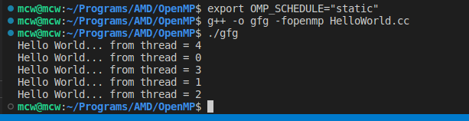
Static schedule

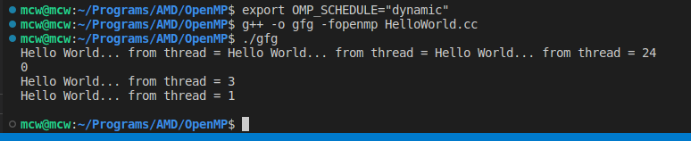
Dynamic schedule

3)OMP_DYNAMIC

Is used to enable or disable dynamic scheduling of threads.
Takes boolean value as input

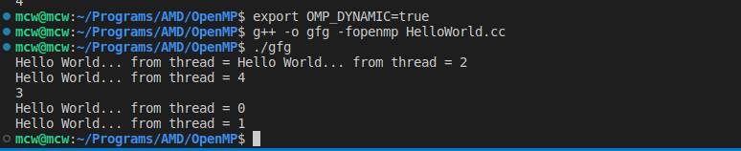
set dynamic to true

4)OMP_NESTED

Is used to enable/disable nested parallelism.
Takes boolean value as input.

Using the following code to test OMP_NESTED.

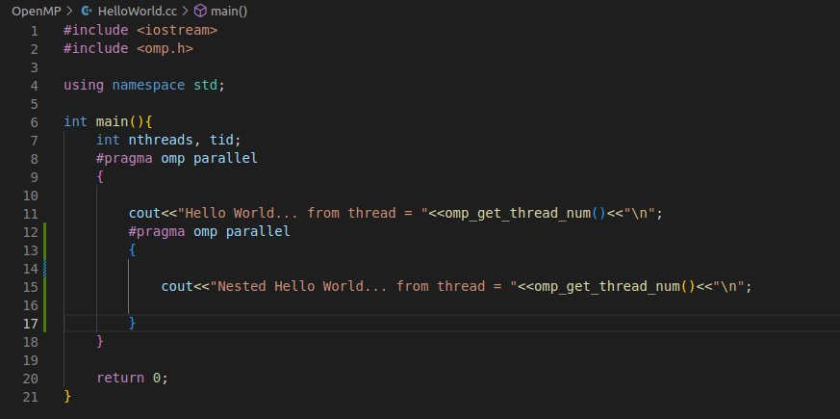
Updated code for HelloWorld.cc

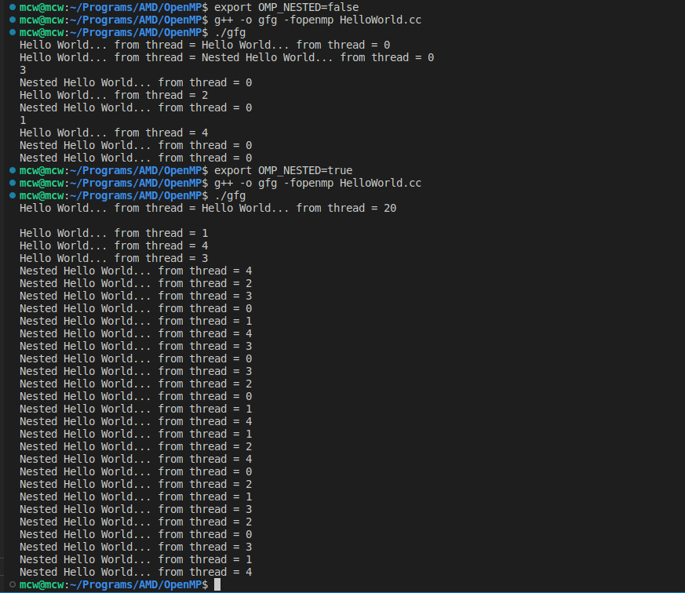
Output for OMP_NESTED

5)OMP_THREAD_LIMIT

Sets the maximum number of threads executing simultaneously.
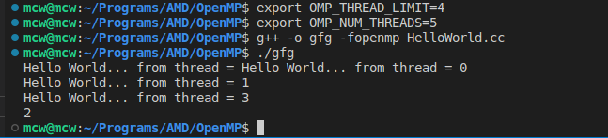
Output for OMP_THREAD_LIMIT

