**1. CONFUSION MATRIX**

A confusion matrix helps in evaluating the performance of a classification model by displaying the counts of actual versus predicted labels.

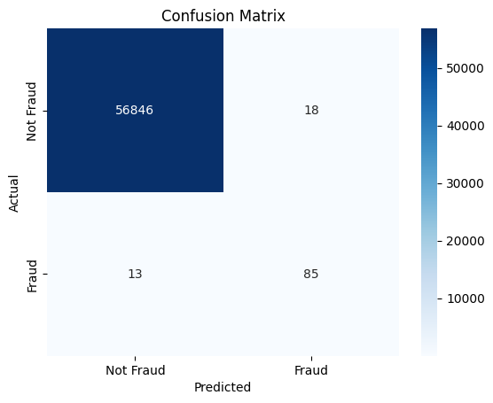

|  |  |  |
| --- | --- | --- |
|  | **Predicted: No Fraud** | **Predicted: Fraud** |
| **Actual: No Fraud** | 56,846 | 18 |
| **Actual: Fraud** | 13 | 85 |

* **True Negatives (TN):** **56846** - Correctly predicted non-fraud transactions.
* **False Positives (FP): 18** - non-fraudulent transactions incorrectly predicted as fraud.
* **False Negatives (FN): 13** - Fraudulent transactions incorrectly predicted as non-fraud.
* **True Positives (TP):** **85** - Correctly predicted fraudulent transactions.

**- The model achieves a very low rate of misclassification.**

**- It is particularly good at identifying frauds (recall for fraud = 87%).**

**2. ROC CURVE ANALYSIS**

* The ROC (Receiver Operating Characteristic) Curve is used to assess how well the model can distinguish between the two classes: fraud and non-fraud.
* The curve plots the True Positive Rate (Sensitivity) against the False Positive Rate (1 - Specificity) at various threshold settings.

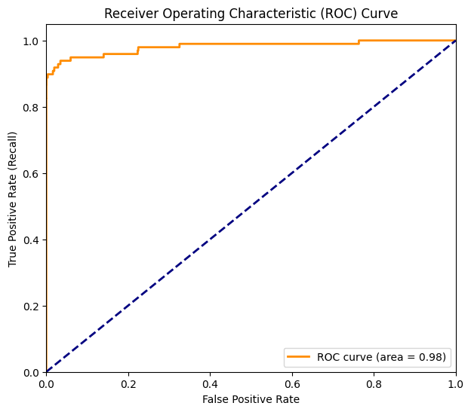

* In this analysis, the AUC (Area Under the Curve) is 0.98.

- AUC close to 1 indicates excellent performance.

- The model has a very high ability to distinguish between fraudulent and non-fraudulent transactions.