|  |  |
| --- | --- |
| CW-3  INFT 3101-01 | Varun Singh (100865156)  Date submitted: 15-11-2024 |

Table of Contents

**SCREENSHOTS OF CODE** 2

**The application running on Flutter emulator** 5

**The application runs on an external emulator 6**

**Reflection** 6

# **SCREENSHOTS OF CODE**

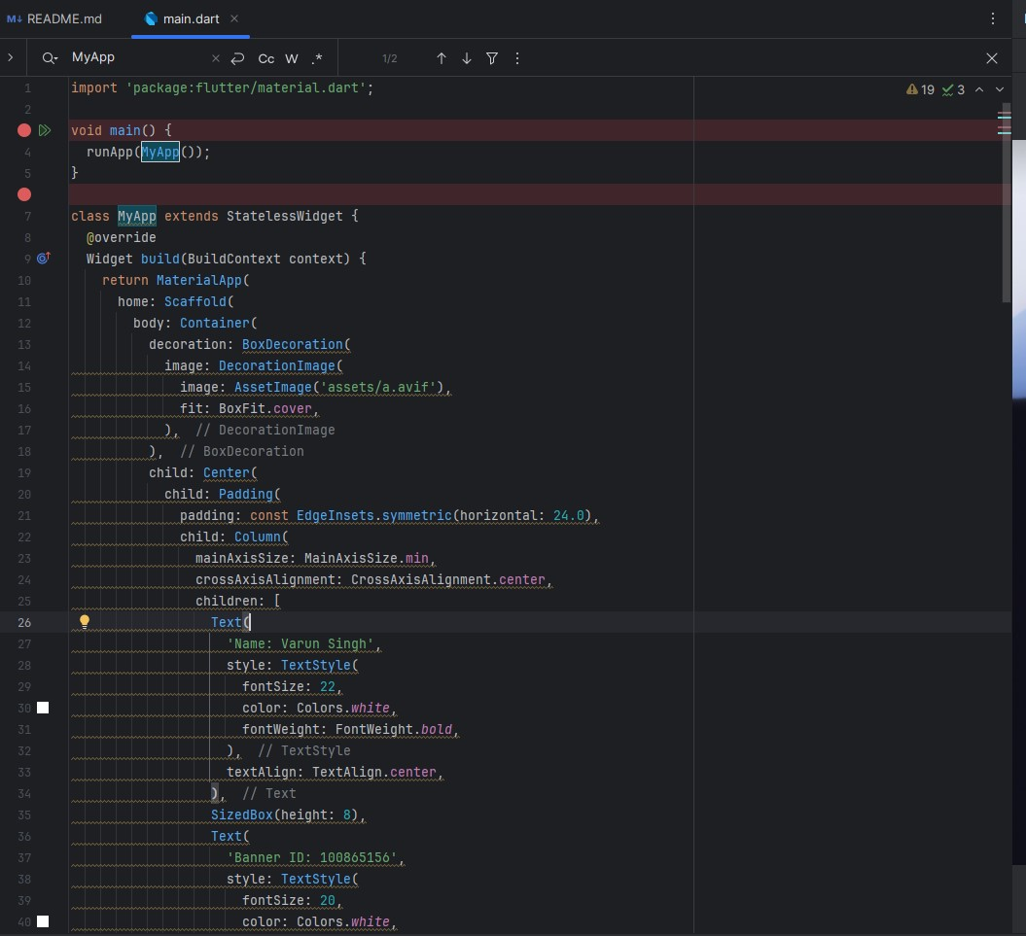

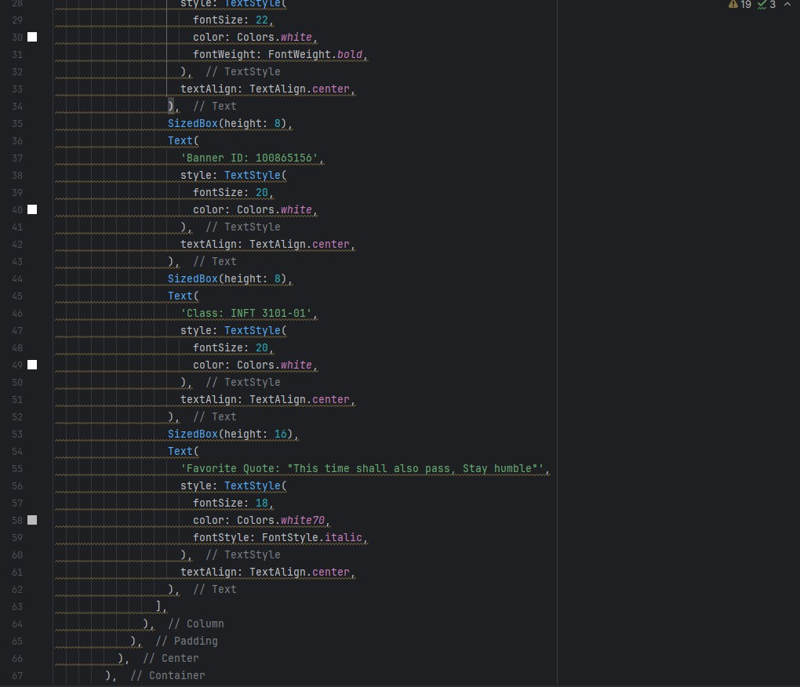

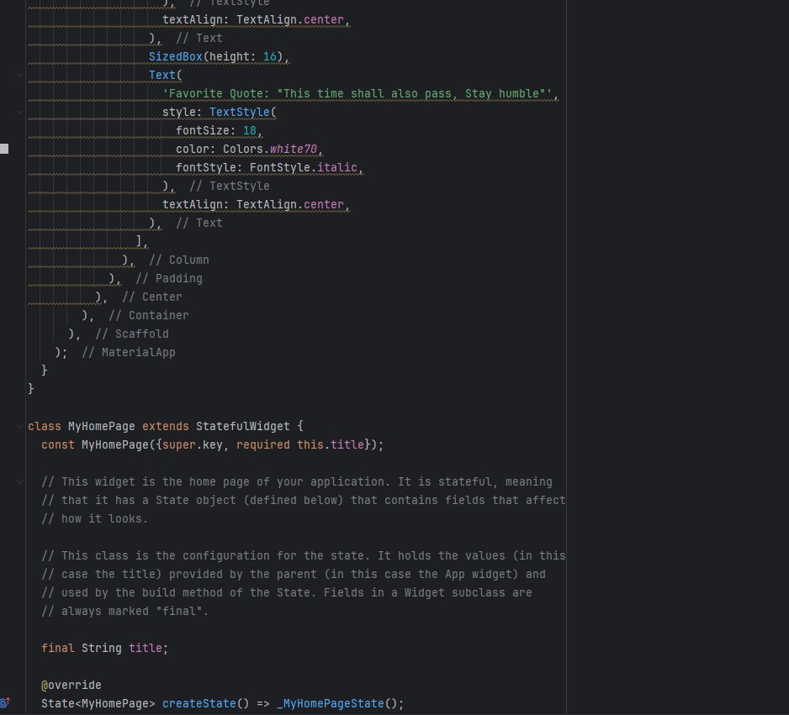

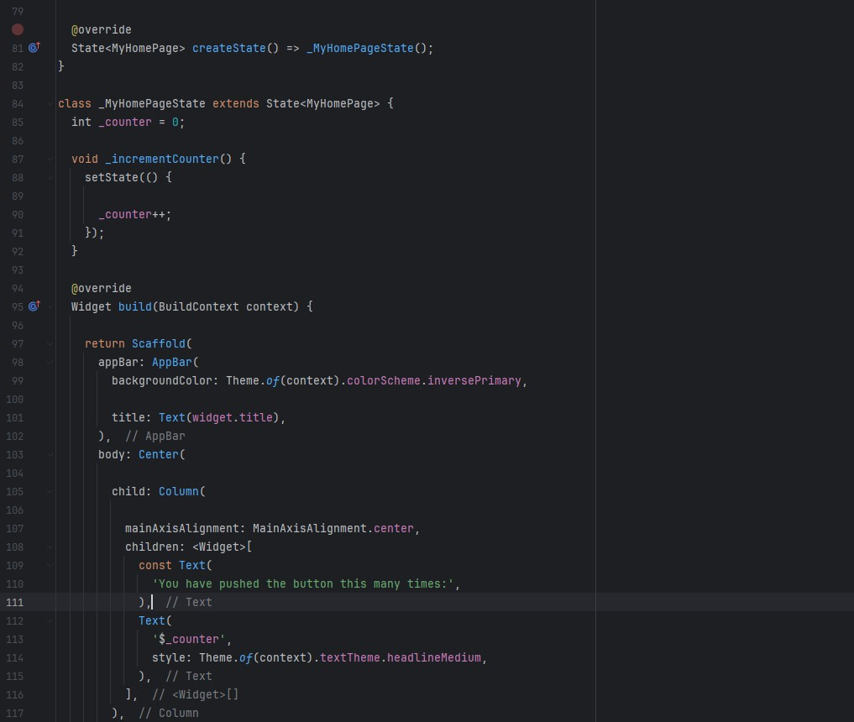

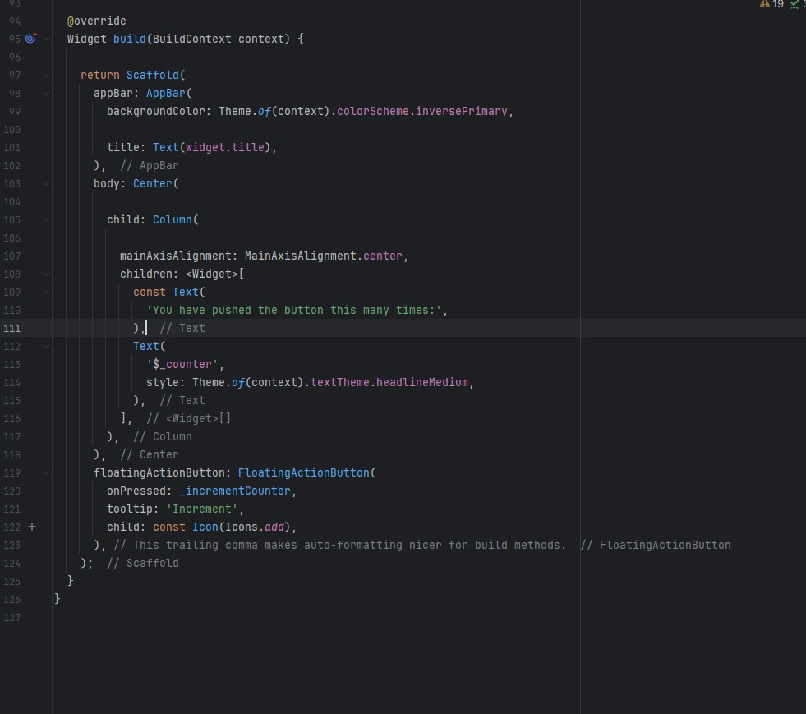

# **The application running on Flutter emulator**

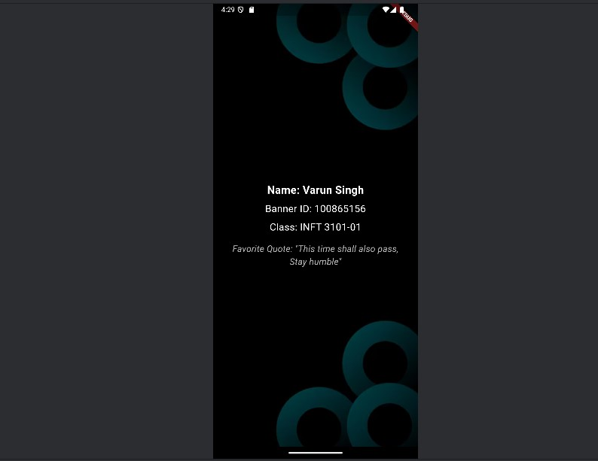

# **The application running on an external emulator**

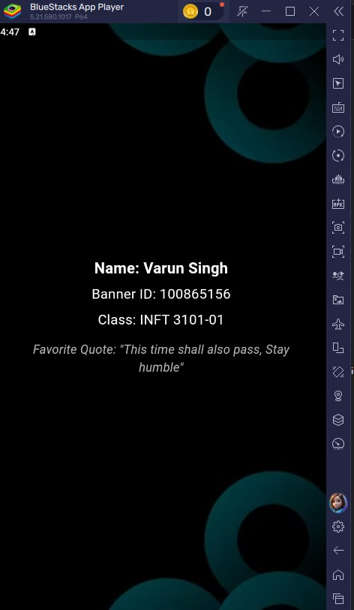

# **Reflection**

This classwork introduced us to some of the new concepts of mobile development. This classwork was our first hands-on with Flutter. The process involved setting up Flutter in Android Studio/ VS Code. Creating mobile applications with Flutter and Dart was fun because it introduced us to a new way of developing mobile applications that can be compatible with multiple operating systems. Setting up Flutter on the IDE was the longest step as it asked for installing multiple dependencies. The application creation and design itself was easier as compared to other things. All the steps for the classwork were provided in the Word document attached to the Dropbox. I had an amazing experience completing this lab and learned several new things doing it. The only challenging part was setting up Flutter as there were some errors when setting it up.