Drashya Patel (100863337), Varun Deep Singh (100865156)

Travel Companion App

Creating a travel companion app where you can search flights, book rooms, and review your itineraries.

Final Project Flutter

INFT-3101-01

Table of Contents

Application Name and Description: 2

• Name: 2

• Description: 2

• App Drawbacks: 3

• Possible Improvements: 4

Rough Design and Planning: 4

Screenshots and Testing: 4

Code Snippets: 5

Application Testing Snippets: 23

Reflection: 40

Drashya Patel 40

Varun Deep Singh 40

References: 41

# Application Name and Description:

* Name: Travel Solution
* Description: This application is designed to simplify the experience of organizing a tour. It has three core functionalities, Flight booking, Hotel room booking, and Complete itinerary of your tour. On the first page there are three option to select Flight Schedules, Hotel Bookings, and Travel Itinerary.

Flight Schedules Page: Asks you to select a flight booking by entering departing and arriving destinations. This fight data updates automatically using a real time flight data API.

Hotel Booking: This page asks you to enter the destination of your stay, date of check-in and check-out.   
  
Travel Itinerary Page: This page shows you the entire summary of your itinerary you created including the flight, and hotel booking details.

* App Drawbacks:  
  + For this demonstration and example, we have used the Flight data API which is free to use for 100 fetches per month.
  + Manual Hotel booking data.
  + The UI can be improved with more advanced features such as Profile/User-Login, Ability to book the flights and hotels on the app, payment method for the bookings, etc.,
  + It has limited integration with external services such as google maps, or payment method.
  + Users can face problems while using this app offline, as it uses APIs to fetch the data needed in the app.
  + The API call is not working on any external device/emulator, but it is working on the Android Studio’s emulator. The reason of this to happen is the device’s safety firewall as it is not letting the application talk to any resource online. To tackle this, we have to add the permissions and expose the API’s port.

## Possible Improvements:

* + The UI/UX can be improved with the ability to personalize the app, the current app has the features of themes and language preferences, but it could also integrate profile creation, or navigation capabilities, etc.,
  + Can include security measures such as end-to-end encryption for secured payments, Authentication for third party logins.
  + Performance: Lacks cross-platform compatibility, the application works perfectly fine on android devices but may not be compatible with iOS devices. Offline useability: Application should be available to use for offline use as well.
  + Can integrate feedback options for the application and user experiences.
  + Integrate Third-Party platforms such as Google maps, Expedia, or TripAdvisor, to improve group planning. Can use machine learning model to recommend places to visit, eat or explore based on user interactions.

# Rough Design and Planning:

# Work Breakdown:

Since our group had only 2 members, we had to divide the responsibilities among the 2. The duties of different sectors of development were divided as follows:

**Project Manager: Varun Deep Singh**

**UI/UX Designer: Drashya Patel**

**Backend Development: Varun Deep Singh**

The application of different concepts of flutter and dart were researched and studied together by the team. Meeting were organized where both of us came up with ideas on different techniques that can be used in the application.

Screenshots and Testing:

Code Snippets:  
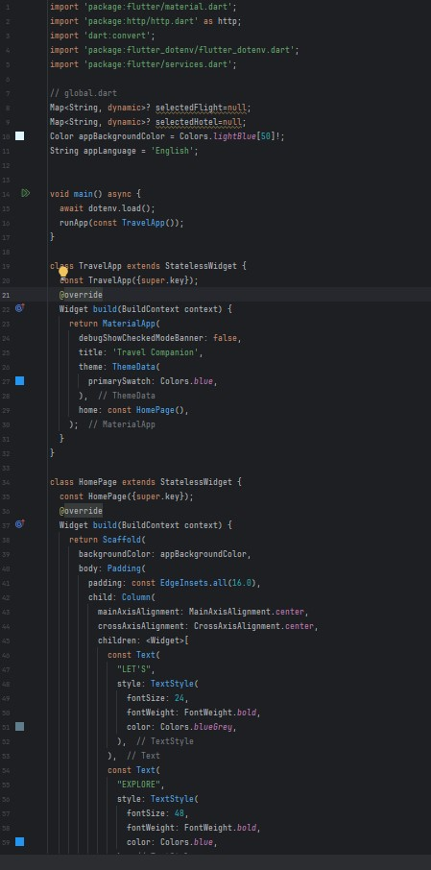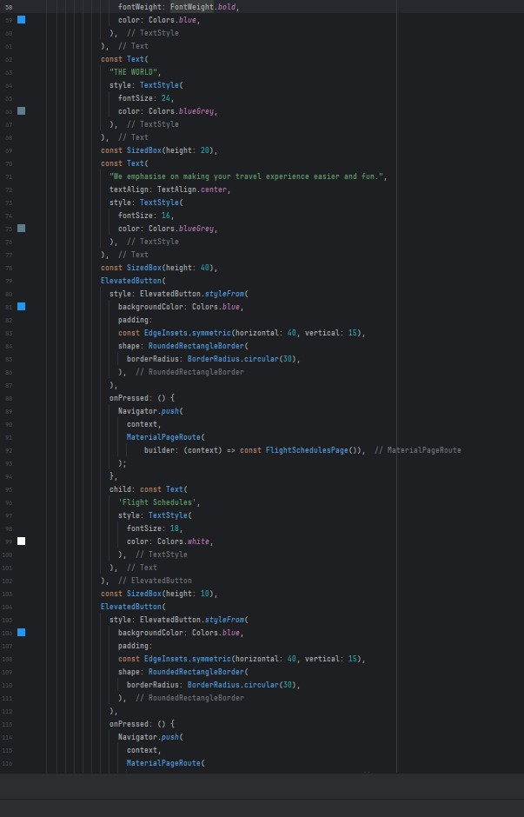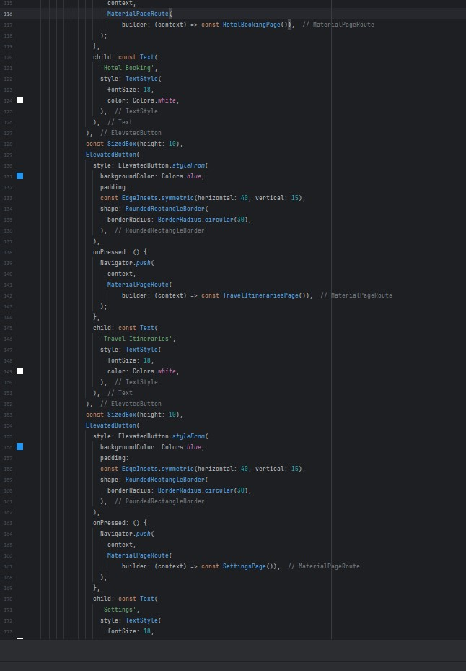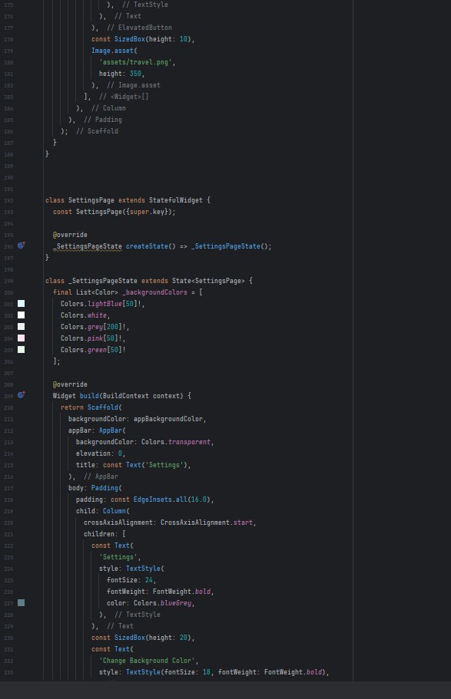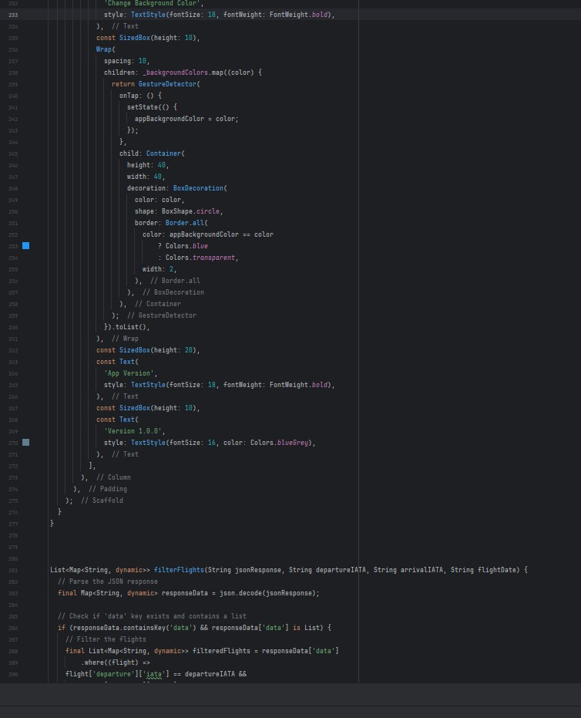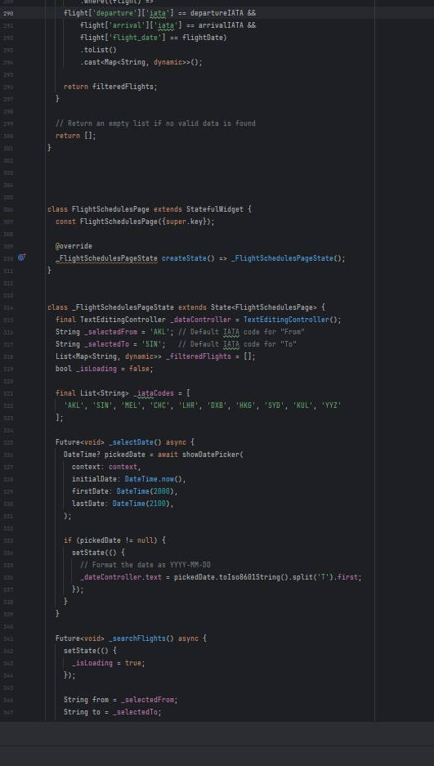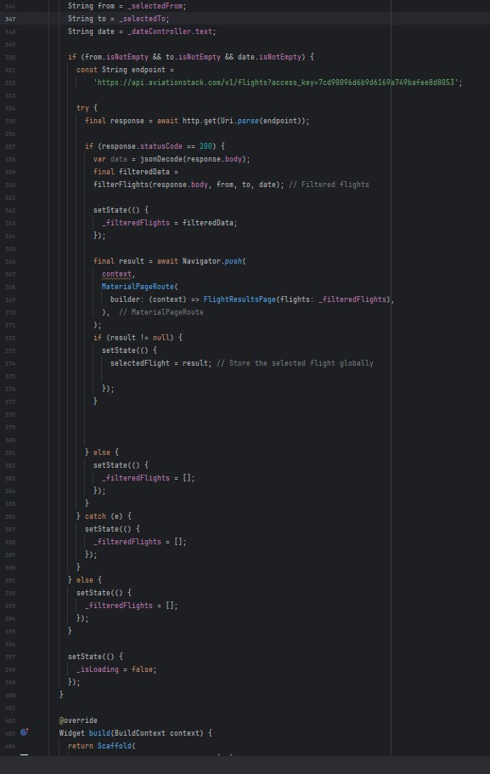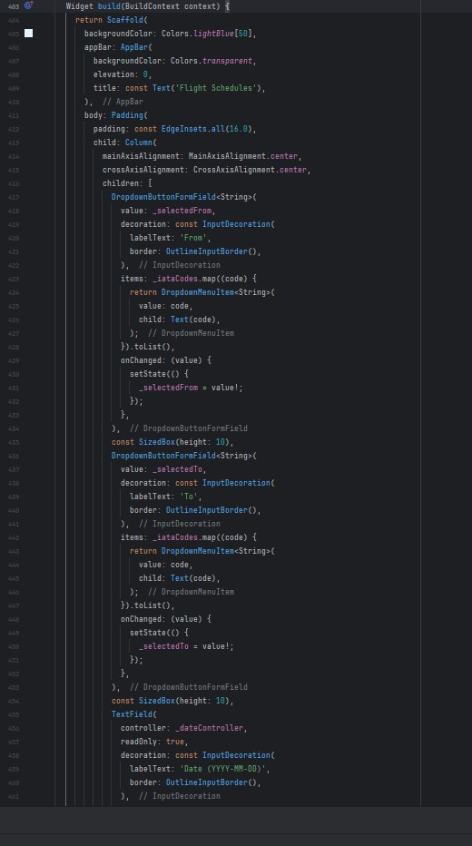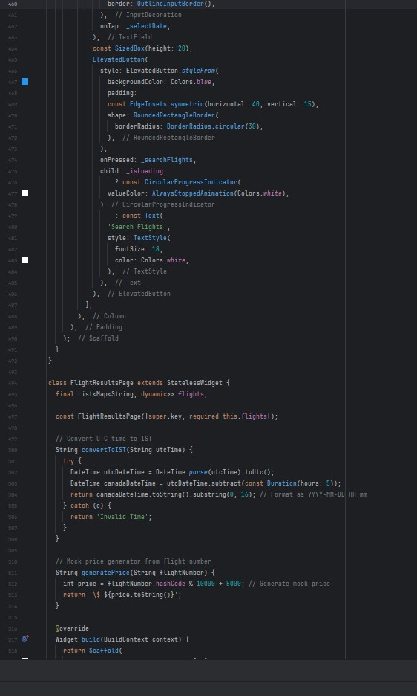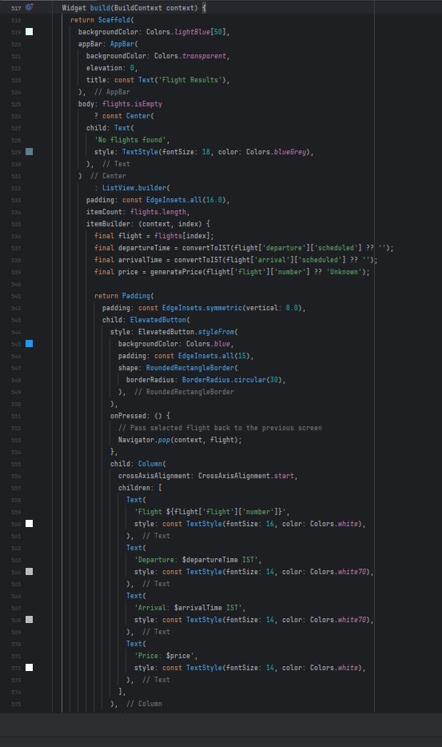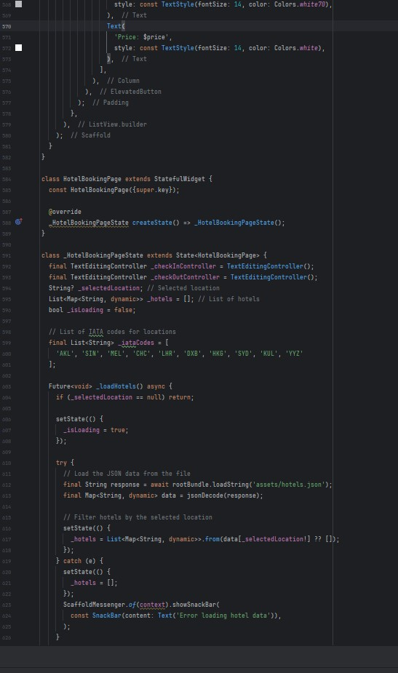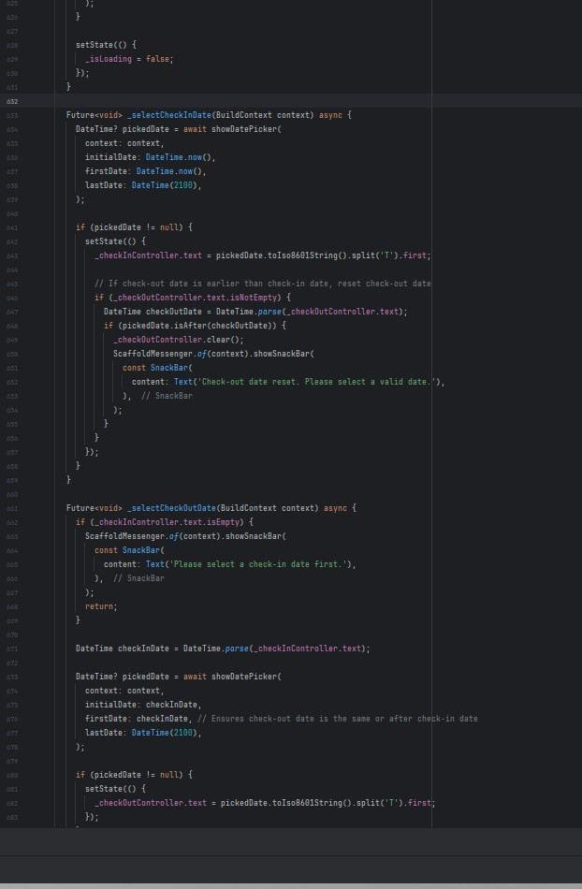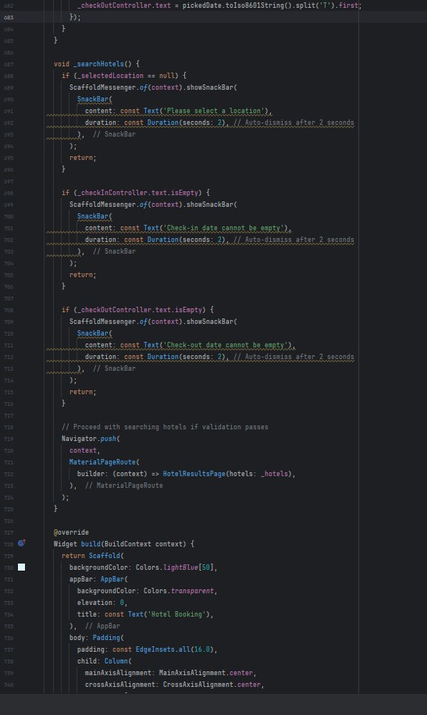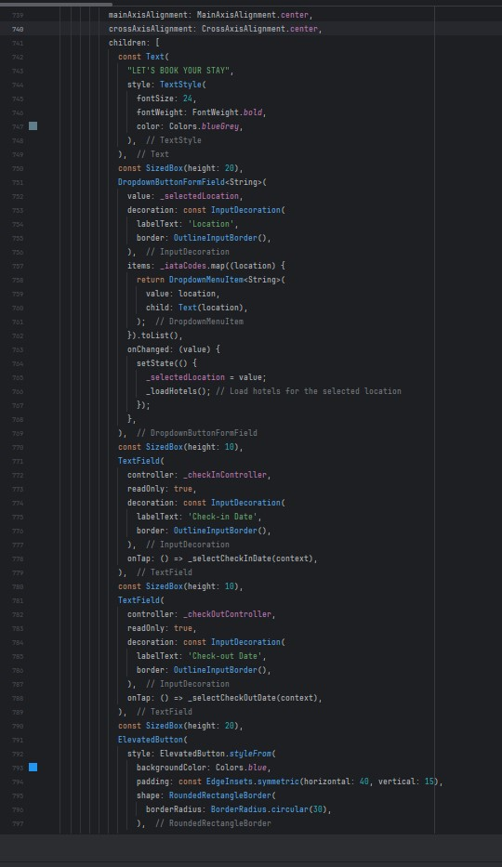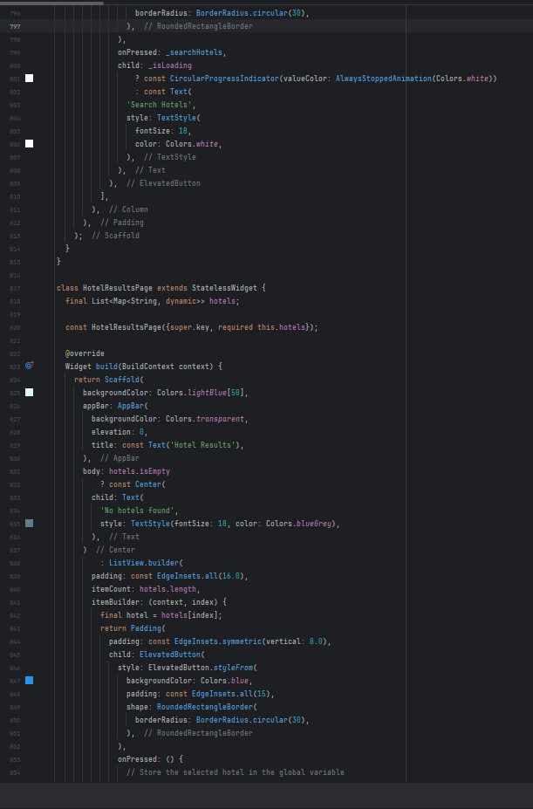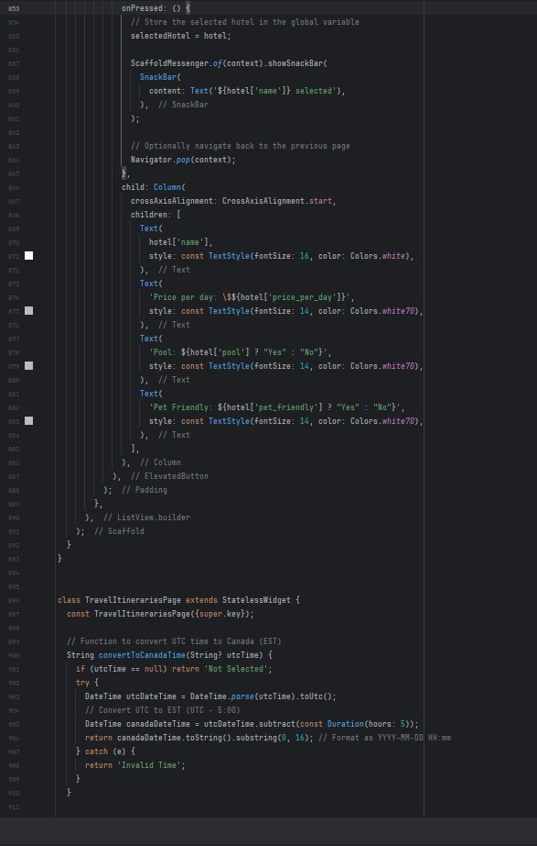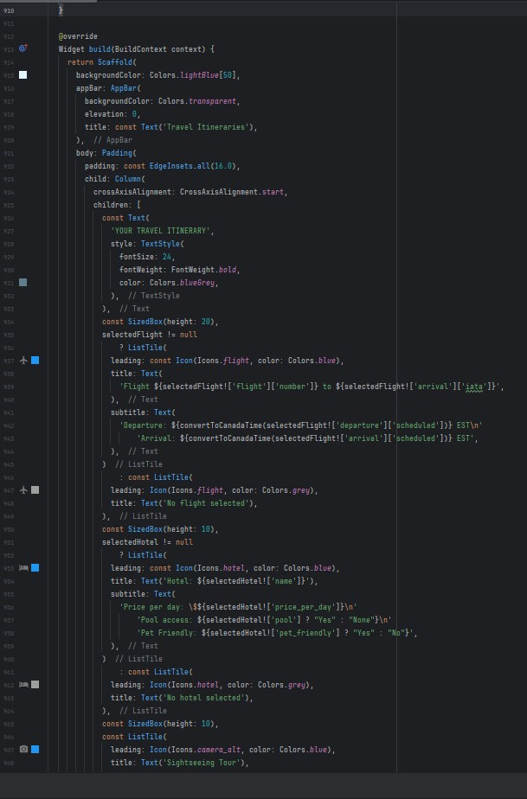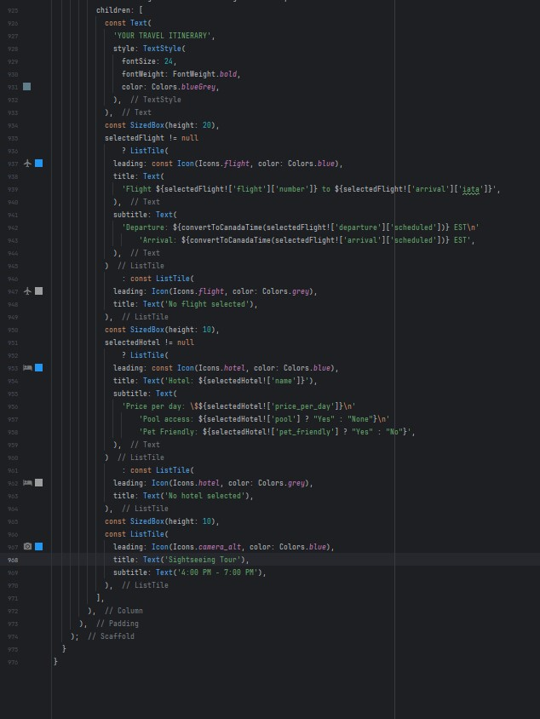

## Application Testing Snippets:

Home Page  
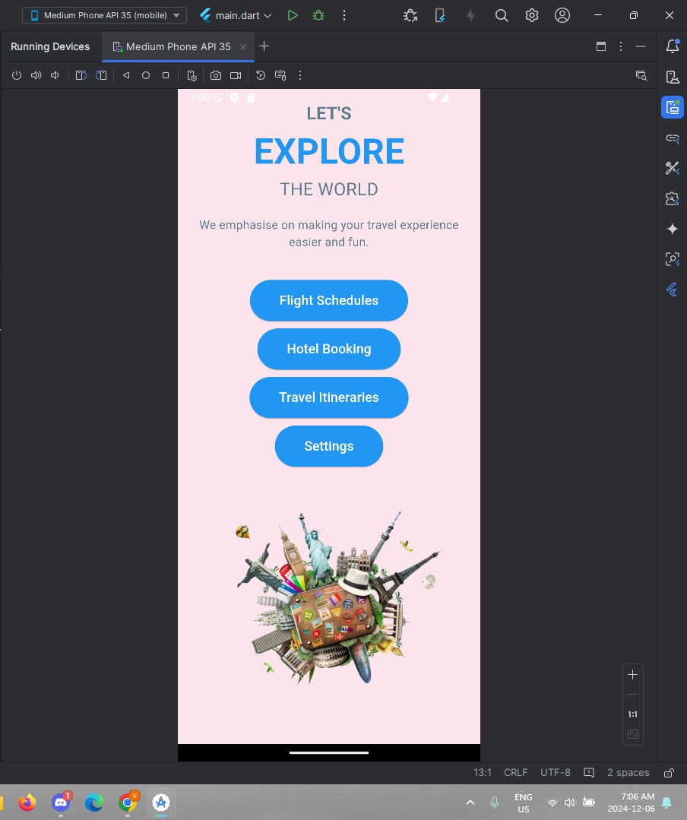

Flight Schedule Booking Page 2:

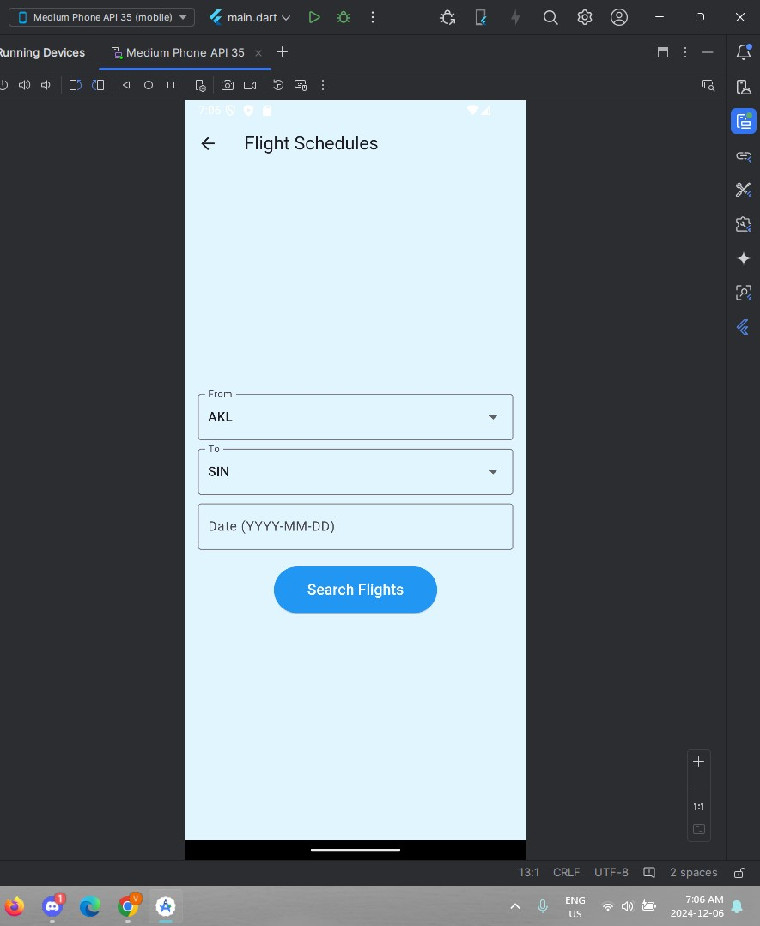

Flight Schedule Booking Page 3:

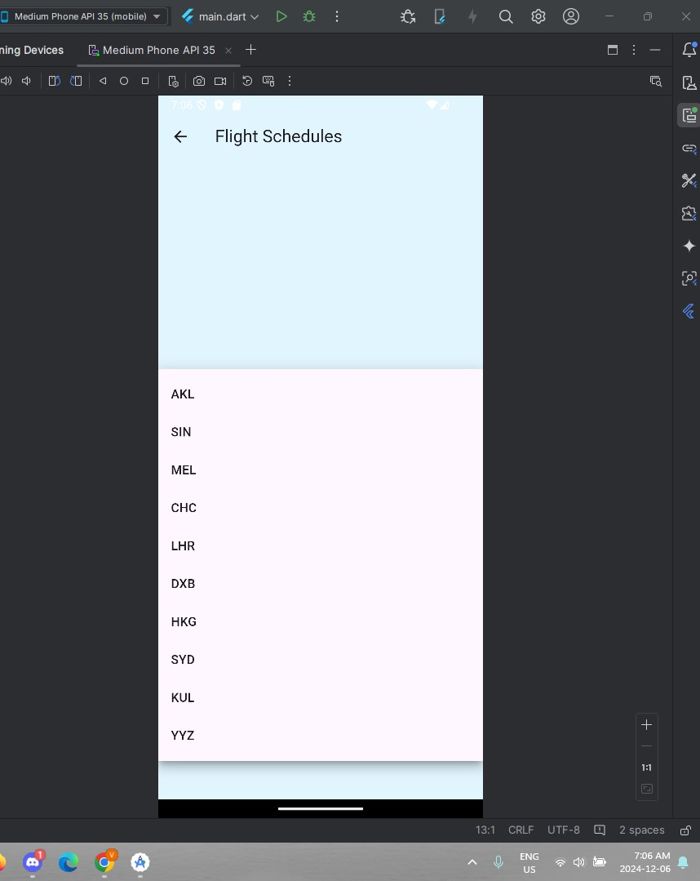

Flight Schedule Booking Page 4:

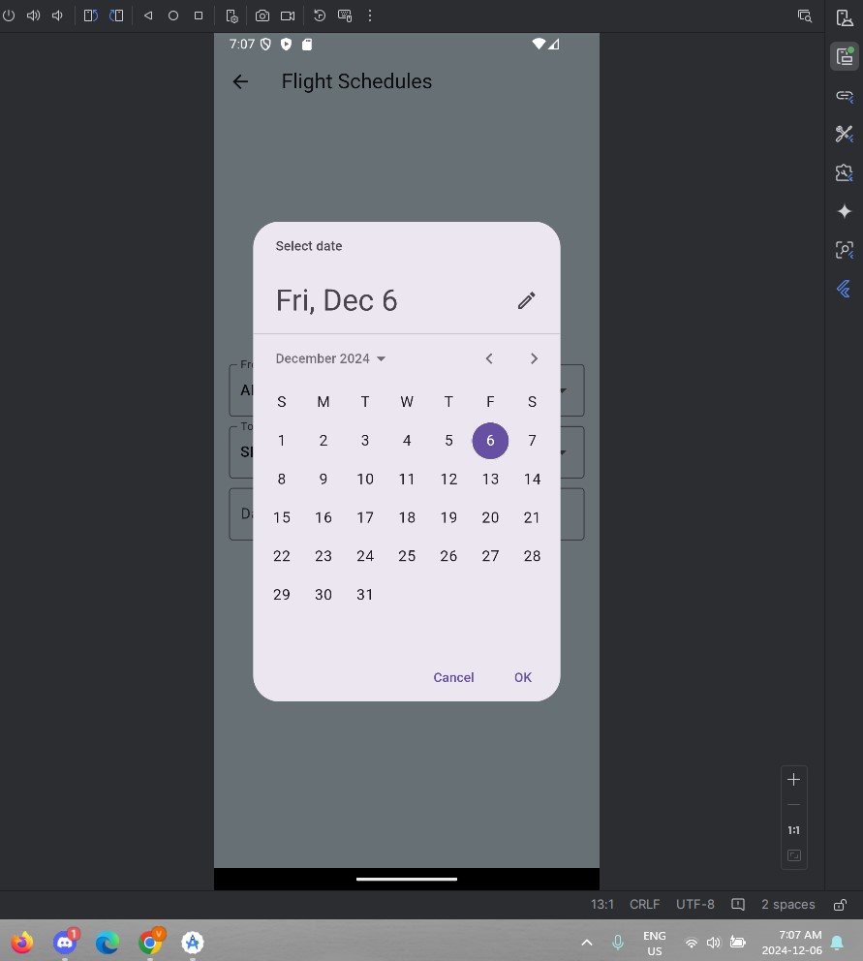

Flight Schedule Booking Page 5:

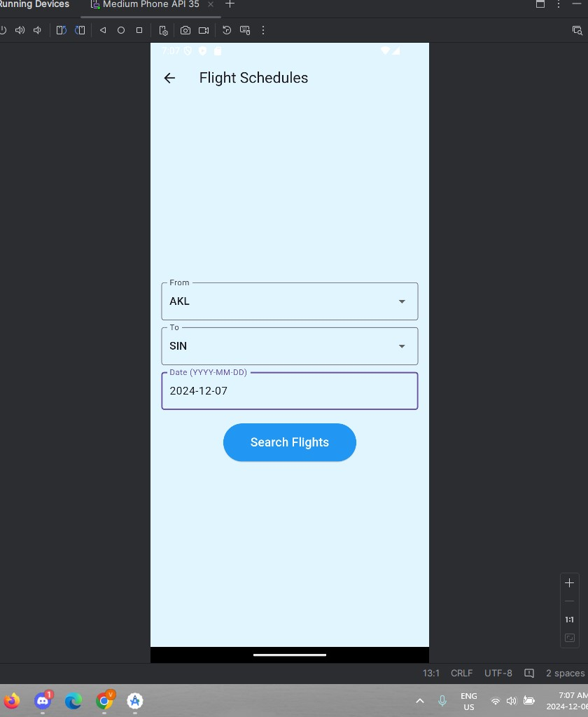

Flight Schedule Booking Page 6:

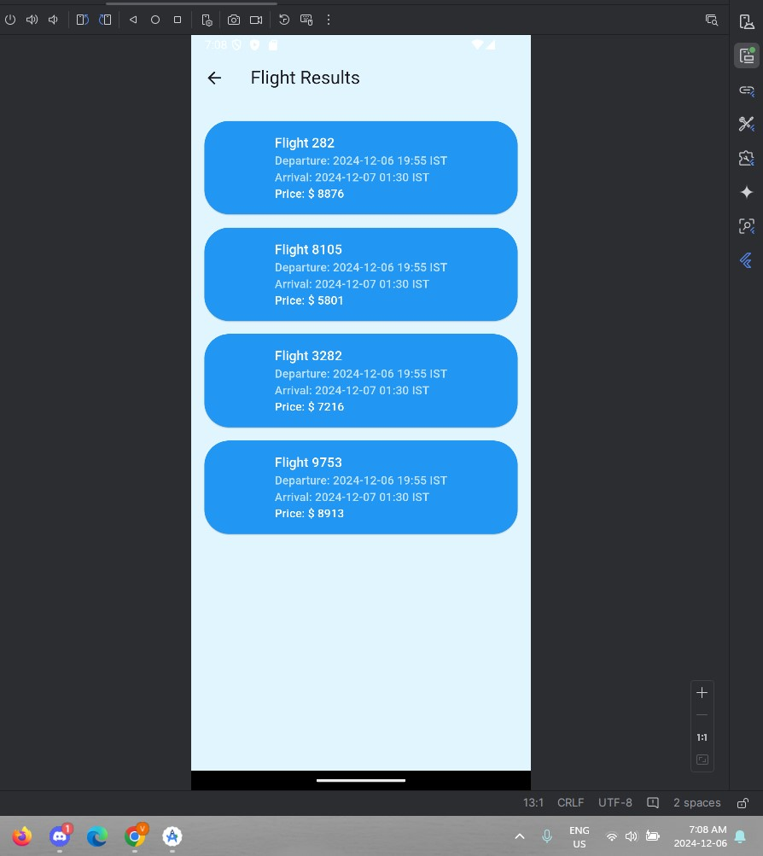

Itinerary for flights Page:

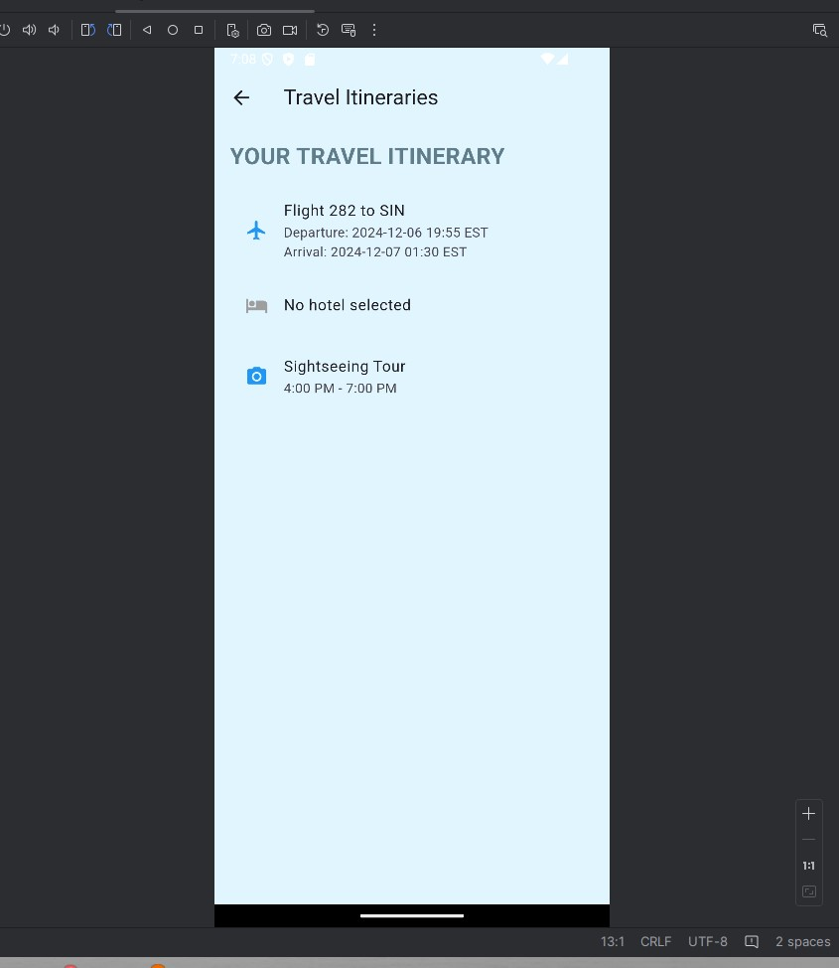

Hotel booking Page 1:  
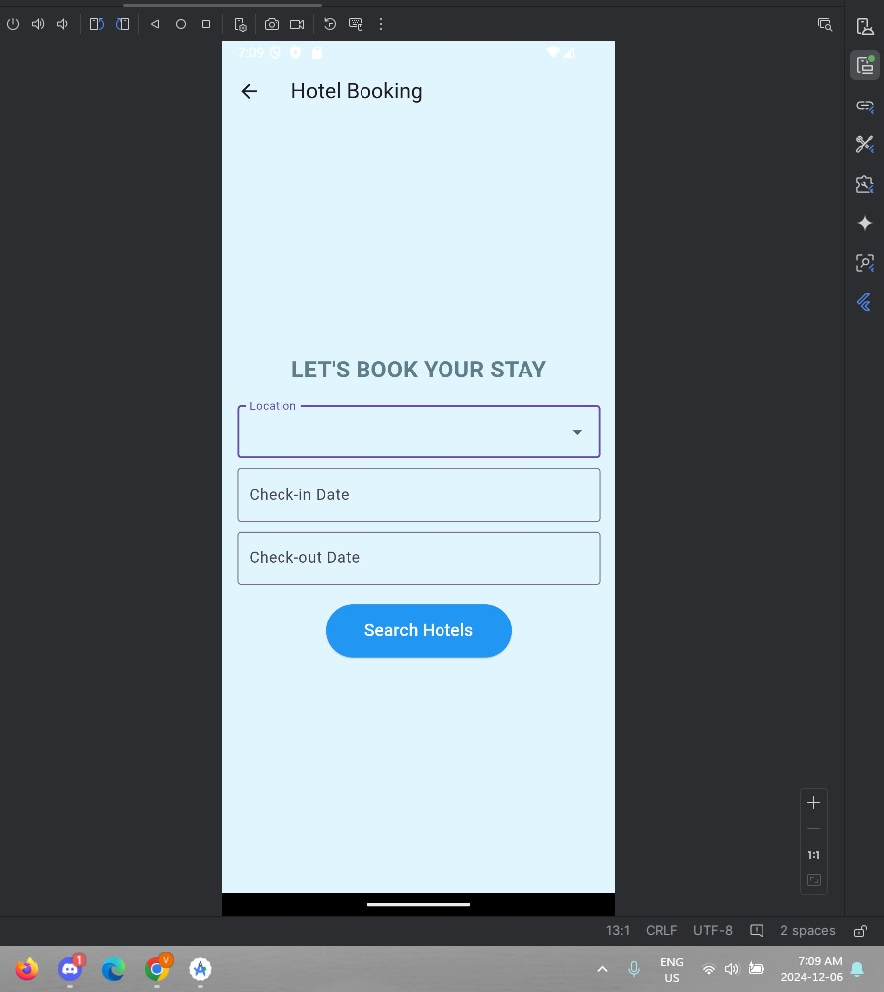

Hotel Booking Page 2:  
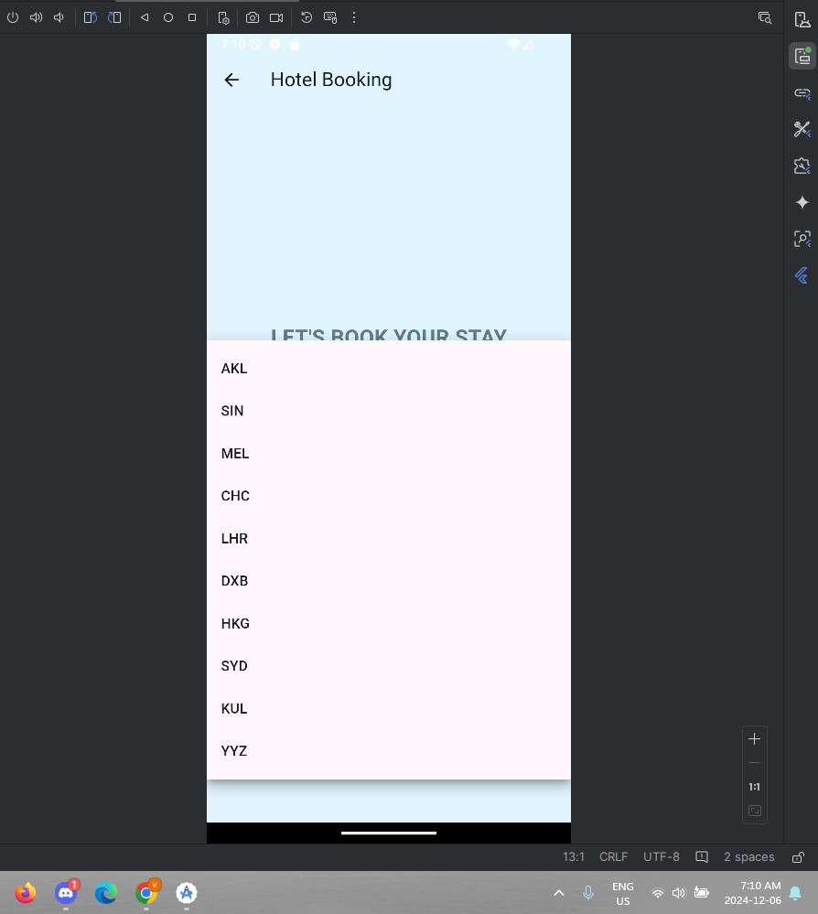  
  
  
  
  
  
  
  
Hotel Selection Page 1: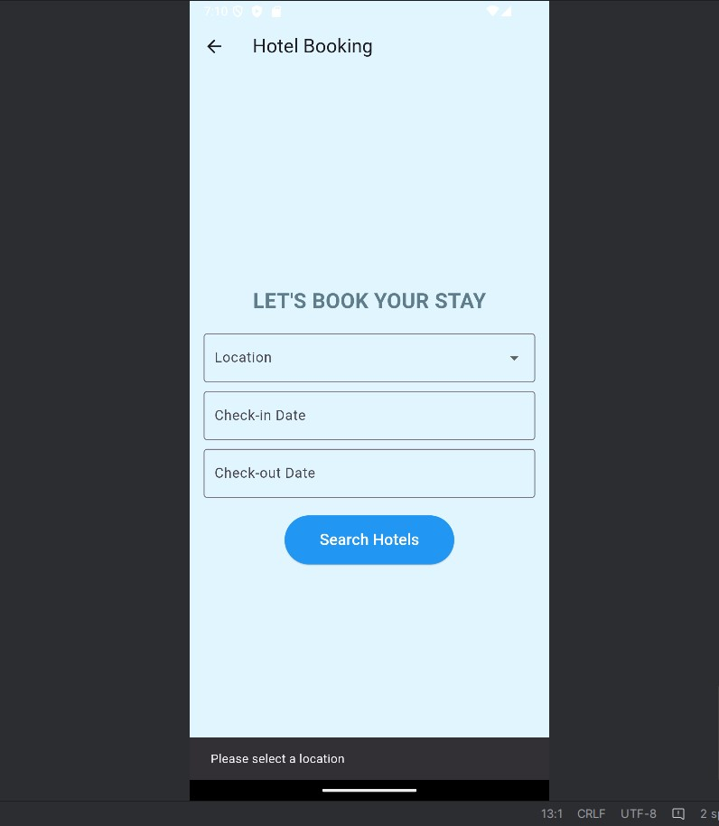

Hotel Selection Page 2:

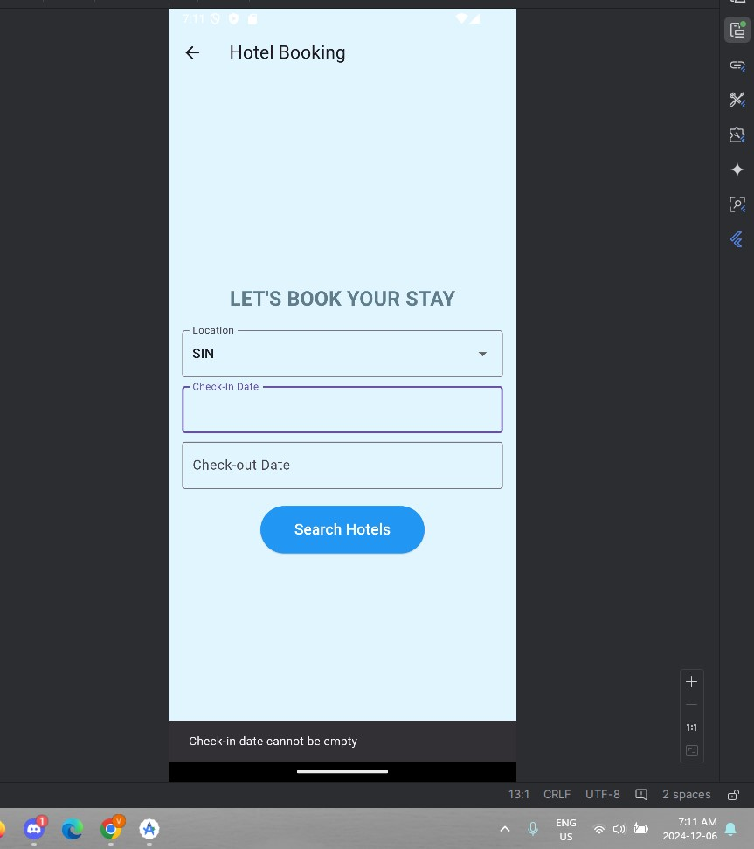

12 dates before checking date are blocked out for check out  
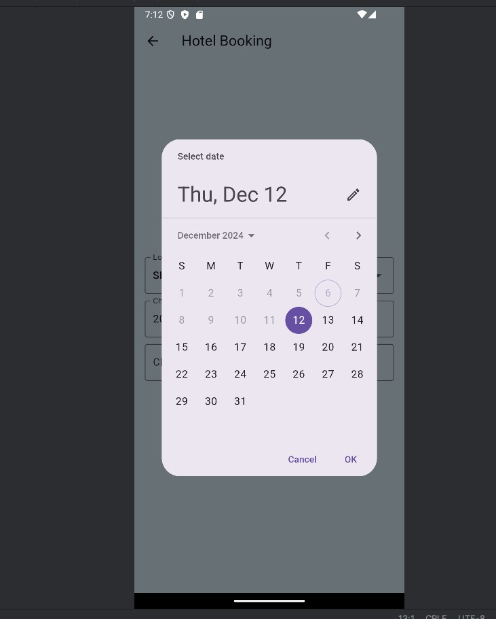  
  
  
  
13 hotel results with the data:  
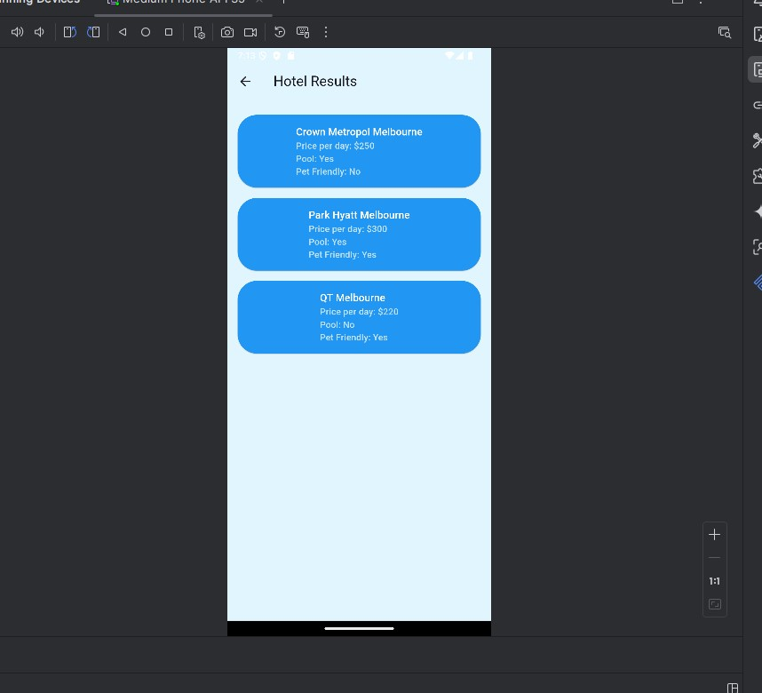

14 itinerary after hotel selection: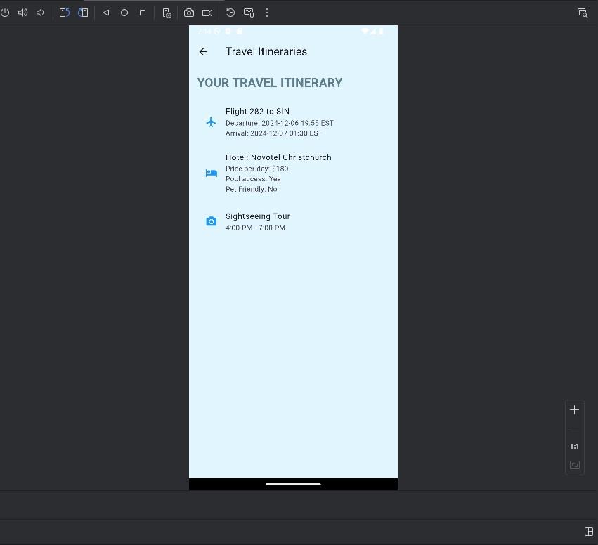

Settings:  
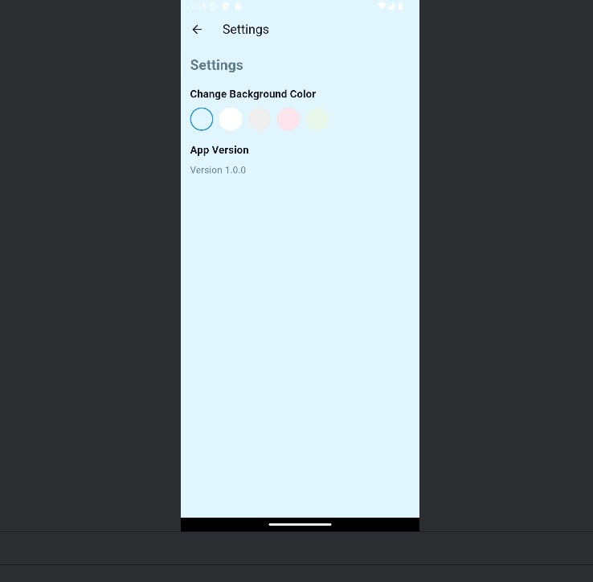  
  
  
  
  
  
  
  
  
  
  
  
  
16 color change is working:  
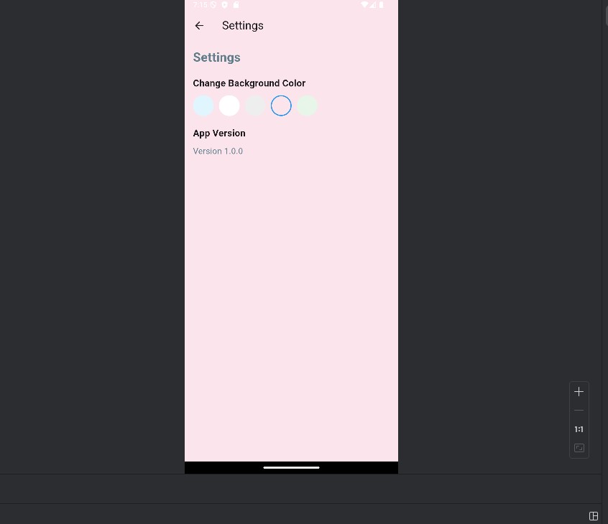

17 the data is being fetched from a public REST API:

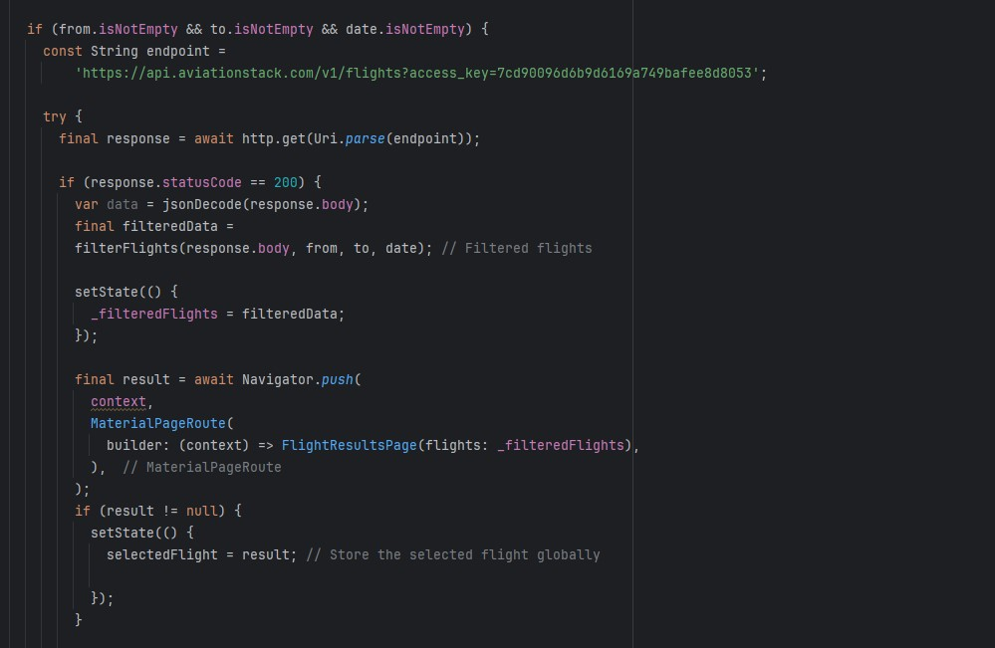

18 filtering the data:

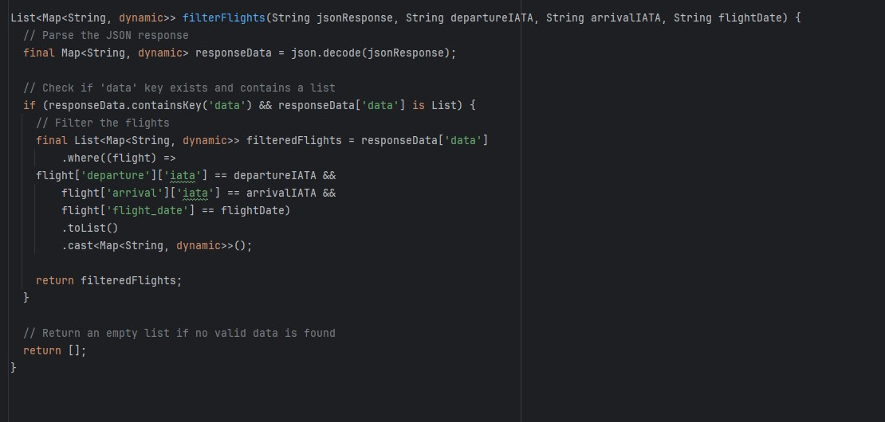

# Reflection:

## Drashya Patel

As a team member, I focused on designing the UI, implementing the app's main functionalities, and integrating key features. Challenges included debugging Flutter widgets and optimizing performance for seamless user interaction. Through this project, I gained valuable skills in Flutter development, UI/UX design, and problem-solving. Keeping the UI user friendly and easy to understand was the actual challenge as a lot of stuff was going on the backend and to make it work with the minimalistic frontend we had do a lot of changes to the data and show to the frontend.

## Varun Deep Singh

As a team member, I worked on developing the backend, including setting up and integrating APIs for location-based recommendations. The main challenges were managing real-time data and ensuring API compatibility as the data had a lot of fields in it when it was fetched from the free API. To tackle this problem, I created a function which takes the data and filtering criteria as parameters and returns the filtered data. I used the filtered data to display the Flight and hotel search results. This project enhanced my skills in backend development and API integration.

# References:

*Section-1*. Rapid API Marketplace & Management Tools. (n.d.). <https://rapidapi.com/>