10/12/2015

Project 1

VLSI Circuit Partitioning

-by Fiduccia-Matthesyses Algorithm

Varunsrivathsa Venkatesha

SBU ID: 110457727

email: varunsrivathsa.venkatesha@stonybrook.edu

**Table of Contents**

Problem Statement 2

Introduction 2

Related Work 3

Flowchart of FM algorithm 4

Steps in detail 5

Proposed Solution and Implementation 6

Proposed Solution 6

Implementation 7

Experimental Results 7

Conclusion 7

Bibliography 8

Appendix 9

**List of Figures**

Figure 1: Flowchart of FM Algorithm 4

Figure 2: Gain bucket data structure 5

Figure 3: Flowchart of proposed solution 6

Problem Statement:

To implement and experiment the Fiduccia-Mattheyses partitioning algorithm implemented for gate-level designs. Objective is to minimize the cutset-size while meeting given area constraints fixed for the partitions.

Introduction:

A problem can be solved efficiently by dividing it into number of smaller problems. In modern circuit there exists millions of transistors to deal with. Partitioning is such a technique to divide a circuit or a system in collection of subsystems. Each subsystem can be designed individually and then combined to speed up the design process.

There are three types of partitioning:

* System level partitioning: Whole system is divided in to subsystems. And the subsystems can be designed independently.
* Board level partitioning: Circuit assigned to each board is divided in to smaller sub circuits.
* Chip level partitioning: Circuits assigned to each chip can be further divided in to smaller units.

Partitioning of the circuit can be done using many Algorithms. Fiduccia-Mattheyses is one such algorithm which is a classical approach that operates on Hypergraph model.

Related Work:

A circuit can be partitioned using many Algorithms. Few of them are Fiduccia-Mattheyses algorithm, Kernighan–Lin Algorithm, Simulated annealing Algorithm. Kernighan–Lin Algorithm solves the NP-hard Balanced Bi-Partitioning Problem, where the given gate-level circuit is divided into two equal-sized partitions. It follows “gain-based cell swap”. Simulated annealing is a randomized local search algorithm. This algorithm is a generic probabilistic metaheuristic for the global optimization problem of locating a good approximation to the global optimum of a given function in a large search space. It is often used when the search space is discrete. Fiduccia-Mattheyses algorithm, improvement over Kernighan-Lin algorithm is a classical approach that operates directly on the Hypergraph model.

Fiduccia-Mattheyses is a modified version of Kernighan- Lin algorithm. The first modification is that only a single vertex is moved across the cut in a single move. This permits the handling of unbalanced partitions and non-uniform vertex weights. The other modification is the extension of the concept of cutsize to hypergraphs. Finally, the vertices to be moved across the cut are selected in such a way so that the algorithm runs much faster at O(n). As in Kernighan-Lin algorithm, a vertex is locked when it is tentatively moved. When no moves are possible, only those moves which give the best cutsize are actually carried out.

Flowchart of FM algorithm:

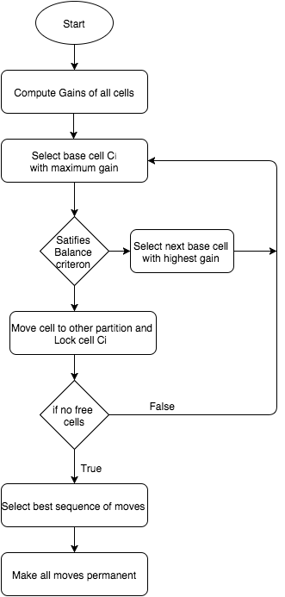

Figure : Flowchart of FM Algorithm

Steps in detail:

Step1: Gain of all a cell *x* is calculated by using the formula

$$gain=FS\left(x\right)-TE(x)$$

where F(s) = Moving force

T(s) = Retention force

Step2: Add all the to gain bucket structure, which helps to select the cell with maximum gain to move from P1 to P2.

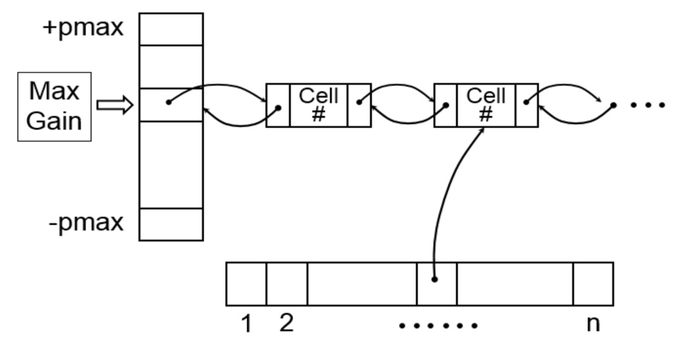

Figure : Gain bucket data structure

Step3: Select the cell with maximum gain and if it satisfies balance criterion move the cell to other partition. Lock the moved cell.

* Balance criterion:

$\left[r.area\left(G\right)-areamax\left(G\right)\right]≤area\left(A\right) ≤[r.area\left(G\right)+areamax(G)]$

where *1) $r=\frac{area\left(A\right)}{area\left(A\right)+area(B)}$*

*2)* *area(A)* and *area(B)* are areas partition A and B

*3) area(G)* is the total area of graph

*4) areamax(G)* is the maximum cell area in G

Step4: Update gains values of all the cells which are connected to the moved cell and calculate cutset size.

Step5: Repeat steps 3 and 4 until are the cells are locked.

Proposed Solution and Implementation:

Proposed Solution:

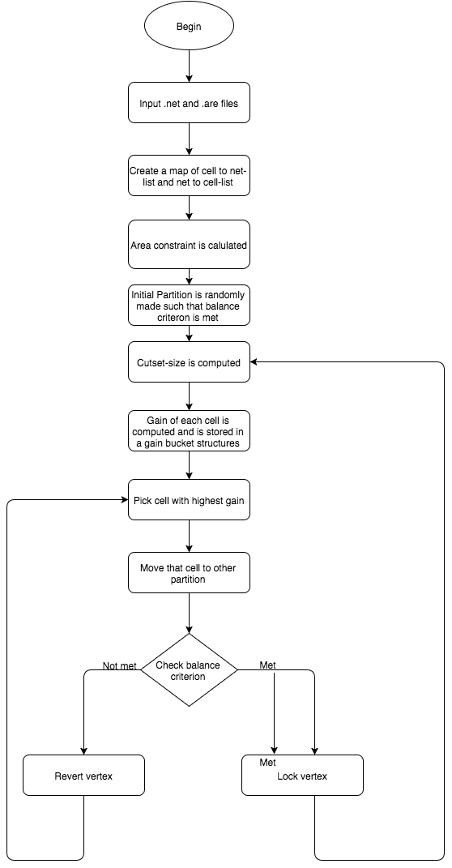

Figure : Flowchart of proposed solution

Implementation:

Code implemented has two files ‘main.cpp’ and ‘cell.h’

1. The file ‘vertex.h’ has a class cell which has methods
   1. ‘retPartition’ – T get the partition of cell.
   2. ‘chckLocked’ – Returns if the cell the is locked or not.
   3. ‘retGain’ – Returns the gain of cell.
   4. ‘changePartition’ – Changes the partition of cell.
2. The file ‘main.cpp’ has functions
   1. ‘rdAreFile’ and ‘rdNetFile’ – Reads the given .net and .are file.
   2. ‘CellNumToCellMap’ – Prints cell number to cell map.
   3. ‘NetToCellMap’ – Prints net to cell map.
   4. ‘givePartition’ – Assigns partition to each cell randomly.
   5. ‘calcFs’ – Returns F(s) value of each cell.
   6. ‘calcTs’ – Returns T(s) value of each cell.
   7. ‘retGain’ – Computes gain and returns gain.
   8. ‘cutSize’ – Returns cutset size of the graph.
   9. ‘gainBucket’ – Creates a map of gains to list of cells.
   10. ‘retAreaPartition’ – Returns area of the first partition.
   11. ‘calcTotalArea’ – Return area of total graph.
   12. ‘calcMaxCell’ – Returns the cell with maximum area and its area.
   13. ‘chkBalanceCriterion’ – Checks the Balance criterion and returns a Boolean value 0 or 1.
   14. ‘updateGain’ – Updates the gain cells after each move.
   15. ‘MoveCell’ – Starts to move cell from one partition to other by toggling partition bits.

Experimental Results:

|  |  |  |  |  |  |
| --- | --- | --- | --- | --- | --- |
| Benchmark  files | Number of  nodes | Ratio cut | Initial Cut set size | Min Cut size Achieved | % reduction in cutset size |
| File1.hgr | 8 | 0.3 | 3 | 2 | 33 |
| File1.hgr | 8 | 0.6 | 6 | 3 | 50 |
| File2.hgr | 18 | 0.3 | 3 | 2 | 33 |
| File2.hgr | 18 | 0.6 | 4 | 2 | 50 |
| File3.hgr | 20 | 0.4 | 3 | 1 | 66 |
| File3.hgr | 20 | 0.6 | 4 | 1 | 75 |

Conclusion:

Fiduccia-Mattheyses algorithm is implemented in ‘C++’ for a given .are and .net file. Code was tested on three input files and the outputs are tabulated.

Bibliography:

[1] B.W Kernighan and S. Lin –An Efficient Heuristic procedure for partitioning Graphs, The Bell system technical journal, Vol.49 ,Feb 1970,pp.291-307.

[2] A linear-time heuristic for improving Networt Partitions by C.M. Fiduccia and R.M Metheyeses.

[3] Text Book: Algorithms for VLSI physical design automation, third edition by Naveed A. Sherwani.

[4] Prof. Alexa Doboli Notes.

[5] <http://users.ece.gatech.edu/limsk/book/slides/pdf/FM-partitioning.pdf>

Appendix:

1)‘vertex.h’

class vertex

{

public:

int vertexID;

int partition;

bool chkLocked;

int gain;

int area;

std::list<int> netList;

bool retPartition();

bool chkLocked()

{

return isLocked;

}

void setIsLocked()

{

isLocked = true;

}

bool retGain();

void changePartition()

{

if(partition == 0)

partition = 1;

else //if(partition ==1)

partition = 0;

}

};

2)‘main.cpp’

#include <iostream>

#include<iostream>

#include<fstream>

#include<vector>

#include<map>

#include<list>

#include <sstream>

#include <cstdlib>

#include<string>

#include<queue>

#include<algorithm>

#include "cell.h"

using namespace std;

int num_cells = 8;

int num_nets;

int cutSetSize = 0;

float ratioCut = 0.6;

int areaOfPartitionA = 0;

int areaOfPartitionB = 0;

int totalArea = 0;

int maxAreaCell = 0;

map<int,Cell> cellIdToCellMap;

map<int, list<Cell> > netToCellListMap;

map<int, list<int> > gainToCellIdListMap;

vector<int> gainVector;

void rdAreFile();

void rdNetFile();

std::list<Cell> split(std::string str,char delimiter);

void CellNumToCellMap (/*map<int,Cell> cellIdToCellMap*/);

void NetToCellMap (/*map<int, list<int> > netToCellListMap*/);

void givePartition();

int calcFs(int A);

int calcTs(int A);

int retGain(int A);

int cutSize();

int gainBucket();

int retAreaPartition(int partition);

int calcTotalArea();

int calcMaxCell();

bool chkBalanceCriterion();

void updateGain(int cellId);

void MoveCell();

int main ()

{

rdAreFile();

givePartition();

rdNetFile();

CellNumToCellMap (/*cellIdToCellMap*/);

NetToCellMap(/*netToCellListMap*/);

//int s = calcFs(3);

int g = retGain(3);

//cout<<"FofS is "<<s<<endl;

cout<<"Gain of is "<<g<<endl;

cutSetSize = cutSize();

cout<<"Cutset size "<<cutSetSize<<endl;

gainBucket();

int a = retAreaPartition(0);

cout<<"area of partition 0 is "<<a<<endl;

int b = retAreaPartition(1);

cout<<"area of partition 1 is "<<b<<endl;

totalArea = calcTotalArea();

cout<<"Total area is "<<totalArea<<endl;

maxAreaCell = calcMaxCell();

cout<<"Max area among Cells "<<maxAreaCell<<endl;

bool isAreaConstraint = chkBalanceCriterion();

cout<< " area constraint is "<<isAreaConstraint<<endl;

MoveCell();

return 0;

}

std::list<Cell>& split(std::string str,char delimiter,int i,std::list<Cell>& cellList)

{

std::stringstream sp(str);

// std::list <Cell> data;

std::string t;

int t1;

while(getline(sp,t,delimiter))

{

t1=atoi(t.c_str());

Cell temp = cellIdToCellMap[t1];

//temp.netList.push_back(i);

cellIdToCellMap[t1].netList.push_back(i);

//cout<<"t1 "<<t1<<endl;

//cout<<"temp.CellID "<<temp.cellID<<endl;

cellList.push_back(temp);

}

return cellList;

}

void rdNetFile()

{

string line;

ifstream myfile("XX.hgr");

if(!myfile)

{

cout<<"File cannot be opened" << endl;

}

else

{

int a=0;

while(getline(myfile, line))

{

list<Cell> cellList;

if(a >= 1)

{

cellList = split(line,' ',a,cellList);

netToCellListMap.insert(pair<int,list<Cell> >(a,cellList));

}

else

{

std::stringstream sp(line);

std::string t;

int b[3];

int i=0;

while(getline(sp,t,' '))

{

b[i] = atoi(t.c_str());

i++;

}

num_nets = b[0];

num_cells = b[1];

}

list<Cell>::iterator i;

for( i =cellList.begin(); i != cellList.end(); ++i)

cout << (*i).cellID << " ";

cout << endl;

a++;

}

}

cout<<"num_nets "<<num_nets<<endl;

cout<<"num_cells "<<num_cells <<endl;

}

void rdAreFile()

{

string line;

int cellCount = 1;

ifstream myfile("ibm01.are");

if(!myfile)

{

cout<<"File cannot be opened" << endl;

}

else

{

while(getline(myfile,line)&& (cellCount<=num_cells) )

{

std::stringstream sp(line);

std::string t;

Cell temp;

int b[2];

int i=0;

while(getline(sp,t,' '))

{

b[i] = atoi(t.c_str());

i++;

}

//cout<<b[0]<<" "<<endl;

cout<<b[1]<<" "<<endl;

temp.cellID = cellCount;

temp.area = b[1];

cellIdToCellMap.insert(pair<int,Cell>(cellCount,temp));

cellCount ++;

}

cout<<"Cell Count is "<<cellCount-1<<endl;

}

}

void CellNumToCellMap (/*map<int,Cell> cellIdToCellMap*/)

{

cout<<"CellID Cell area partition netlist "<<endl;

for(map<int,Cell>::const_iterator it1 = cellIdToCellMap.begin();

it1!= cellIdToCellMap.end(); ++it1)

{

cout<<it1->first<<" "<<(it1->second).cellID<<" "<<(it1->second).area<<" "<<(it1->second).partition<<" ";

for(list<int>::const_iterator it2 = (it1->second).netList.begin(); it2!=(it1->second).netList.end();++it2)

cout<<(*it2)<<" ";

cout<<endl;

}

}

void NetToCellMap (/*map<int, list<Cell> > netToCellListMap*/)

{

//cout<<"printing values of maps"<<endl;

cout<<endl<<"net Cell List "<<endl;

for(map<int, list<Cell> >::const_iterator it1 = netToCellListMap.begin();

it1!= netToCellListMap.end(); ++it1)

{

cout<<it1->first<<" ";

for(list<Cell>::const_iterator it2 = it1->second.begin(); it2 != it1->second.end(); ++it2)

{

cout<<(*it2).cellID<<" ";

}

cout<<endl;

}

}

void givePartition()

{

cellIdToCellMap[1].partition = 0;

cellIdToCellMap[2].partition = 1;

cellIdToCellMap[3].partition = 0;

cellIdToCellMap[4].partition = 0;

cellIdToCellMap[5].partition = 0;

cellIdToCellMap[6].partition = 1;

cellIdToCellMap[7].partition = 0;

cellIdToCellMap[8].partition = 1;

}

int calcFs(int A)

{

int FofS = 0;

Cell temp = cellIdToCellMap[A];

//cout<<"temp.partition = "<< temp.partition<<endl;

for(list<int> ::const_iterator it1 = cellIdToCellMap[A].netList.begin(); it1!=cellIdToCellMap[A].netList.end();++it1)

{

int FofS_net =0;

for(list<Cell>::const_iterator it2 = netToCellListMap[*it1].begin(); it2!= netToCellListMap[*it1].end();++it2)

{

if(temp.partition == it2->partition)

{

FofS_net++;

}

cout<<"current Cell ID "<<it2->cellID<<" "<< "partition " << it2->partition <<endl;

}

if(FofS_net<=1)

FofS++;

}

return FofS;

}

int calcTs(int A)

{

int TofS = 0;

Cell temp = cellIdToCellMap[A];

for(list<int> ::const_iterator it1 = cellIdToCellMap[A].netList.begin(); it1!=cellIdToCellMap[A].netList.end();++it1)

{

int TofS_net =0;

for(list<Cell>::const_iterator it2 = netToCellListMap[*it1].begin(); it2!= netToCellListMap[*it1].end();++it2)

{

if(temp.partition != it2->partition)

{

TofS_net++;

}

// cout<<"current Cell ID "<<it2->cellID<<" ";//<< "partition " << it2->partition <<endl;

}

if(TofS_net==0)

TofS++;

}

return TofS;

}

int retGain(int A)

{

int FofS=calcFs(A);

int TofS=calcTs(A) ;

return (FofS-TofS);

}

int cutSize()

{

int cutsize = 0;

for(map<int, list<Cell> >::const_iterator it1 = netToCellListMap.begin();

it1!= netToCellListMap.end(); ++it1)

{

Cell temp = it1->second.front();

for(list<Cell>::const_iterator it2 = it1->second.begin(); it2 != it1->second.end(); ++it2)

{

if(temp.partition != it2->partition)

{

cutsize++;

break;

}

}

}

return cutsize;

}

int gainBucket()

{

int gain =0;

for(map<int,Cell>::iterator it1 = cellIdToCellMap.begin();it1!= cellIdToCellMap.end(); ++it1)

{

gain = retGain(it1->first);

(it1->second).gain = gain;

// gainVector.push_back(gain);

// cout<<"it1->first "<< it1->first<<endl;

map<int, std::list<int> >::iterator finder;

finder = gainToCellIdListMap.find(gain);

if(finder==gainToCellIdListMap.end())

{

list<int> celllist;

celllist.push_back(it1->first);

gainToCellIdListMap.insert(pair<int,list<int> >(gain,celllist));

}

else

finder->second.push_back(it1->first);

}

sort(gainVector.begin(), gainVector.end());

reverse(gainVector.begin(), gainVector.end());

for(vector<int>::iterator it1 = gainVector.begin(); it1!= gainVector.end(); ++it1)

cout<< *it1 <<endl;

cout<<"gain Cell list"<<endl;

for(map<int,list<int> >::const_reverse_iterator it1 = gainToCellIdListMap.rbegin(); it1 != gainToCellIdListMap.rend(); ++it1)

{

cout<<it1->first<<" ";

for(list<int>::const_iterator it2 = (it1->second).begin(); it2!= (it1->second).end(); ++it2)

{

cout<<*it2<<" ";

}

cout<<endl;

}

}

int retAreaPartition(int partition)

{

int sumArea = 0;

for(map<int,Cell>::const_iterator it1 = cellIdToCellMap.begin();

it1!= cellIdToCellMap.end(); ++it1)

{

if(it1->second.partition == partition)

{

sumArea+=it1->second.area;

}

}

return sumArea;

}

int calcTotalArea()

{

return (retAreaPartition(0) + retAreaPartition(1));

}

int calcMaxCell()

{

int maxArea = cellIdToCellMap[1].area ;

for(map<int,Cell>::const_iterator it1 = cellIdToCellMap.begin();

it1!= cellIdToCellMap.end(); ++it1)

{

if(maxArea < (it1->second).area)

{

maxArea=it1->second.area;

}

}

return maxArea;

}

bool chkBalanceCriterion()

{

int areaPartitionA = retAreaPartition(0);

int areaPartitionB = retAreaPartition(1);

//cout<<"ratio cut is "<<ratioCut<<endl;

//cout<<"total area is "<<totalArea<<endl;

//cout<<"range 1 is "<<(ratioCut*totalArea - maxAreaCell)<<endl;

//cout<<"partition A is "<<areaPartitionA<<endl;

//cout<<"range 2 is "<<

if (((ratioCut*totalArea - maxAreaCell)<= areaPartitionA)&&(areaPartitionA<=(ratioCut*totalArea + maxAreaCell)))

return true;

else

return false;

}

void MoveCell()

{

int initialCutset = cutSize();

int cutSet = 0;

int i=0;

cout<<"initial Cutset = "<<initialCutset<<endl;

int cellId =0;

bool stop = false;

for(map<int,list<int> >::reverse_iterator it1 = gainToCellIdListMap.rbegin(); it1 != gainToCellIdListMap.rend(); ++it1)

{

cout<<"for cell of gain "<<it1->first<<endl;

do{

for(list<int>::iterator it2 = (it1->second).begin(); it2!= (it1->second).end(); ++it2)

{

if(cellIdToCellMap[*it2].getIsLocked()== false)

{

cellIdToCellMap[*it2].changePartition();

if(chkBalanceCriterion() == false)

{

cellIdToCellMap[*it2].changePartition();

continue;

}

cellIdToCellMap[*it2].setIsLocked();

cout<<"updating gain bucket"<<endl;

int temp = *it2;

list<int>::iterator it3 = it2;

//(it1->second).remove(*it3);

updateGain(temp);

cutSet = cutSize();

i++;

//cout<<"cutset size after "<< i <<" move = "<<cutSet<<endl;

}

}

}while(it1->first > 0);

}

}

void updateGain(int cellId)

{

int gain =0;

for(list<int> ::const_iterator it1 = cellIdToCellMap[cellId].netList.begin(); it1!=cellIdToCellMap[cellId].netList.end();++it1)

{

for(list<Cell>::const_iterator it2 = netToCellListMap[*it1].begin(); it2!= netToCellListMap[*it1].end();++it2)

{

//if(cellId == it2->cellID)

//continue;

gain = retGain(it2->cellID);

map<int, std::list<int> >::iterator finder;

finder = gainToCellIdListMap.find(gain);

if(finder==gainToCellIdListMap.end())

{

list<int> celllist;

celllist.push_back(it2->cellID);

gainToCellIdListMap.insert(pair<int,list<int> >(gain,celllist));

}

else

finder->second.push_back(it2->cellID);

}

}

cout<<"updated gain bucket is"<<endl;

cout<<"gain Cell list"<<endl;

for(map<int,list<int> >::const_reverse_iterator it1 = gainToCellIdListMap.rbegin(); it1 != gainToCellIdListMap.rend(); ++it1)

{

cout<<it1->first<<" ";

for(list<int>::const_iterator it2 = (it1->second).begin(); it2!= (it1->second).end(); ++it2)

{

cout<<*it2<<" ";

}

cout<<endl;

}

}