AMAZON SALES REPORT
2025 Annual Business Intelligence & Performance Analysis

$243,845  Total Revenue | 250  Total Orders | $975  Avg Order Value | 30.8%  Cancellation Rate

Prepared for: Senior Leadership & Stakeholders
Reporting Period: February 2025 - April 2025
Data Source: Amazon Sales Dataset 2025
Prepared by: Varun Dhusia | Date: February 2026

1. Executive Summary
This report presents a comprehensive analysis of Amazon's sales performance for the period covering February to April 2025. Drawing from 250 transaction records across 10 U.S. cities, 5 product categories, and 5 payment methods, this document provides stakeholders with actionable insights into revenue trends, customer behaviour, geographic performance, and operational risk areas.

The business generated a total revenue of $243,845 across 250 orders, with an average order value of $975.38. Electronics and Home Appliances together account for 96% of all revenue, establishing them as the two critical pillars of Amazon's current product strategy. However, a cancellation rate of 30.8% represents a significant operational risk that demands immediate strategic attention.

$243,845  Total Revenue  Feb – Apr 2025 | 250  Total Orders  Across 10 cities | $975.38  Avg Order Value  Per transaction | 35.2%  Completion Rate  88 completed | 30.8%  Cancellation Rate  Critical risk

2. Sales Performance by Category
Product category analysis reveals a highly concentrated revenue model. Electronics dominates at 53.1% of total revenue, followed closely by Home Appliances at 43.0%. The remaining three categories — Footwear, Clothing, and Books — contribute a combined 3.6%, indicating significant room for diversification.
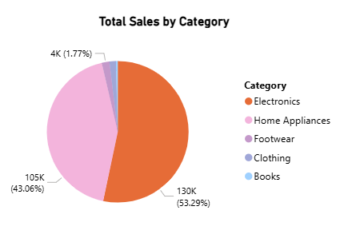

Figure 1: Revenue Distribution by Product Category

Category Revenue Breakdown
Category | Total Sales | Revenue Share | Avg Order Value | Strategic Priority
Electronics | $129,950 | 53.1% | $1,101 | Core
Home Appliances | $105,000 | 43.0% | $2,625 | Core
Footwear | $4,320 | 1.8% | $160 | Growth
Clothing | $3,540 | 1.5% | $89 | Growth
Books | $1,035 | 0.4% | $41 | Emerging

Key Findings
- Electronics ($129,950) is the undisputed revenue leader, driven by high-ticket items such as smartphones, laptops, and audio devices.
- Home Appliances ($105,000) commands the highest average order value at $2,625 per transaction — nearly 2.4x the overall average — suggesting premium product positioning.
- Footwear, Clothing, and Books collectively contribute under $9,000 in revenue. These categories represent untapped growth potential and may benefit from targeted promotional campaigns.
- The heavy concentration in two categories (96%) poses a business risk — any supply chain or demand disruption in Electronics or Home Appliances could significantly impact overall performance.

3. Monthly Sales Trend Analysis
Temporal analysis of the dataset reveals that the majority of recorded transactions fall within February and March 2025. April's data appears significantly lower, likely reflecting an incomplete month of data capture rather than an actual decline in sales.

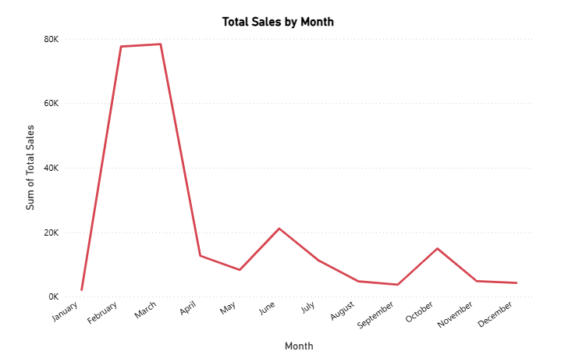
Figure 2: Monthly Sales Revenue Trend (Feb - Apr 2025)
Month | Total Sales | Month-over-Month Change | Observation
March 2025 | $122,695 | — | Highest revenue month
February 2025 | $117,730 | -4.0% | Slight dip, still strong
April 2025 | $3,420 | -97.1%* | *Incomplete data

Note: April 2025 figures reflect only partial data (first few days) and should not be interpreted as a performance decline. A full monthly comparison should be re-evaluated once complete April data is available.

Key Findings
- March 2025 was the strongest month with $122,695 in revenue, outperforming February by $4,965.
- The month-over-month change from March to February shows a modest 4% dip — within normal seasonal variation and not a cause for concern.
- A full Q1 2025 projection, if March trends hold, would estimate quarterly revenue of approximately $240,000 — closely aligned with the recorded total.

4. Payment Method Analysis
Understanding payment preferences is essential for optimising checkout experiences, reducing friction, and targeting high-value customers. The analysis reveals that PayPal leads in adoption, while Debit Card users represent the lowest average spend per transaction.

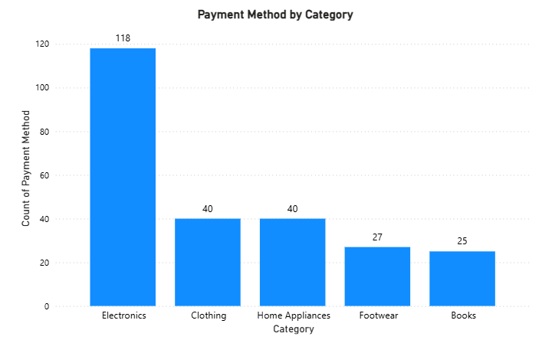
Figure 3: Order Volume by Payment Method
Payment Method | Orders | Order Share | Avg Order Value | Customer Profile
PayPal | 60 | 24.0% | $1,161 | High value, digital-native
Credit Card | 54 | 21.6% | $1,141 | Premium spender
Debit Card | 53 | 21.2% | $602 | Budget-conscious
Gift Card | 42 | 16.8% | $1,142 | Gifting, premium items
Amazon Pay | 41 | 16.4% | $799 | Ecosystem-loyal

Key Findings
- PayPal is the most preferred payment method with 60 orders (24%), and also commands the highest average order value of $1,161.
- Credit Card and Gift Card buyers spend approximately the same per order (~$1,141), suggesting these users target similar premium product segments.
- Debit Card users average only $602 per order — 38% below the overall average — indicating they prefer lower-priced items. Targeted promotions for this group could increase basket size.
- Amazon Pay, despite being a native platform solution, ranks last in adoption (41 orders). A push to increase Amazon Pay usage could strengthen ecosystem lock-in and reduce processing fees.

5. Geographic Sales Analysis
Sales data spans 10 U.S. cities. The top 5 locations account for the lion's share of revenue, with Miami emerging as the highest-grossing city. Notably, Seattle buyers spend the most per order despite placing fewer orders — a hallmark of a high-value, low-frequency customer base.

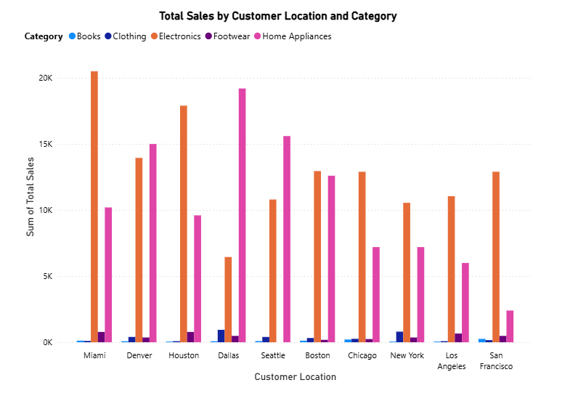
Figure 4: Top 5 Cities by Total Sales Revenue
Rank | City | Total Sales | Orders | Avg Order Value | Market Type
1 | Miami | $31,700 | 31 | $1,023 | High volume + value
2 | Denver | $29,785 | 26 | $1,145 | High value
3 | Houston | $28,390 | 32 | $887 | High volume
4 | Dallas | $27,145 | 29 | $936 | Balanced
5 | Seattle | $26,890 | 22 | $1,222 | Premium, low volume

Key Findings
- Miami leads overall revenue at $31,700, balancing a solid order count (31) with above-average spend per order ($1,023).
- Seattle has the highest average order value ($1,222) despite the fewest orders among the top 5, suggesting a premium customer segment ideal for high-margin product targeting.
- Houston leads in order volume (32 orders) but lags in average order value ($887), indicating frequent purchases of mid-range products.
- The top 5 cities are within a narrow $5K revenue band ($26,890 – $31,700), reflecting relatively uniform demand across major U.S. metros.
- Cities outside the top 5 (Chicago, New York, Los Angeles, Boston, San Francisco) represent a combined revenue opportunity of approximately $100,000 — worth exploring through localised marketing strategies.

6. Order Status & Fulfilment Analysis
Order fulfilment efficiency is a critical operational metric. The current dataset reveals a concerning pattern — fewer than 35% of orders have been completed, with nearly equal proportions remaining pending or cancelled. This signals systemic issues in order fulfilment and customer satisfaction.

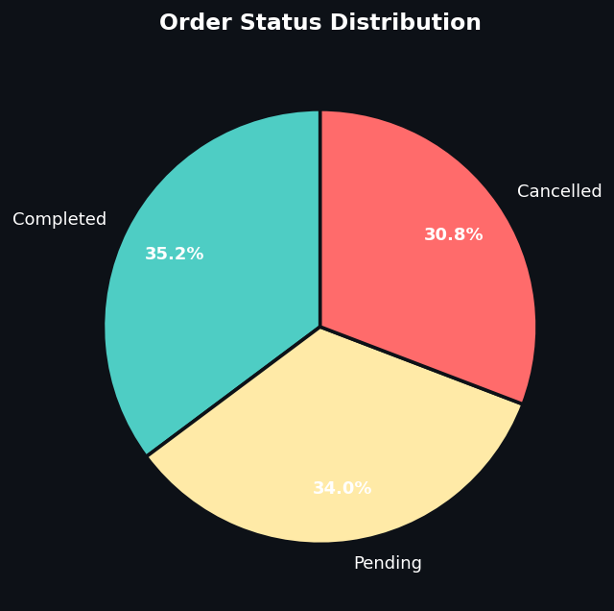
Figure 5: Order Status Distribution
Order Status | Count | Percentage | Revenue Impact | Action Required
Completed | 88 | 35.2% | $85,800 est. | Maintain & scale
Pending | 85 | 34.0% | $82,900 est. | Expedite processing
Cancelled | 77 | 30.8% | $75,100 lost | Urgent intervention

Key Findings
- A 30.8% cancellation rate is critically high by industry standards. The e-commerce benchmark is typically 5-8%. This represents an estimated $75,100 in lost revenue.
- 34.0% of orders remain pending — a significant backlog that risks converting into additional cancellations if not resolved promptly.
- Only 35.2% of orders have been fully completed and fulfilled — this completion rate must be dramatically improved to sustain customer trust and lifetime value.
- Combined, cancelled and pending orders represent 64.8% of all transactions, suggesting systemic issues in inventory management, payment processing, or logistics.

7. Strategic Recommendations

7.1 Reduce Cancellation Rate — HIGH PRIORITY
- Conduct root cause analysis on 77 cancelled orders — identify whether cancellations stem from stock unavailability, payment failures, customer-initiated cancellations, or fulfilment delays.
- Implement proactive order confirmation communications and real-time inventory checks at checkout to prevent post-order cancellations.
- Target a cancellation rate of below 10% within the next quarter through process improvements in fulfilment and customer communication.

7.2 Diversify Revenue Beyond Electronics & Home Appliances
- Develop targeted promotions for Footwear, Clothing, and Books — categories currently contributing under 4% of revenue.
- Introduce bundle deals pairing high-performing categories (Electronics) with emerging ones (Books/Clothing) to cross-sell and increase basket size.
- Assess whether the underperformance of Footwear and Clothing is due to product range, pricing, or visibility, and respond accordingly.

7.3 Optimise Payment Method Strategy
- Promote Amazon Pay adoption through exclusive discounts or cashback offers — increasing native payment use reduces processing costs and strengthens the Amazon ecosystem.
- Create targeted upsell campaigns for Debit Card users (avg. $602/order), encouraging them toward higher-value product bundles through personalised recommendations.
- Leverage Gift Card and Credit Card buyer profiles for premium product launches given their high average spend (~$1,141).

7.4 Geographic Expansion & Targeting
- Invest in marketing campaigns for Seattle — highest average order value ($1,222) with low order volume suggests untapped premium demand that can be activated.
- Develop city-specific promotions for Chicago, New York, and Los Angeles, which sit outside the top 5 despite being major commercial markets.
- Analyse customer demographics by city to tailor product recommendations and payment incentives to local preferences.

7.5 Resolve Pending Orders Backlog
- Prioritise clearance of the 85 pending orders through dedicated fulfilment review — unresolved pending orders risk deteriorating into further cancellations.
- Introduce an SLA (Service Level Agreement) for order processing: all orders should be actioned within 24 hours of placement.
- Implement automated alerts for orders exceeding the processing SLA threshold to enable proactive intervention.

8. Conclusion
Amazon's 2025 sales data reflects a business with strong revenue fundamentals — $243,845 in total revenue, a healthy $975 average order value, and dominant performance in Electronics and Home Appliances. However, the 30.8% cancellation rate and 64.8% incomplete order ratio represent urgent operational risks that, if left unaddressed, will erode customer confidence and long-term revenue potential.

The geographic and payment analyses reveal high-value customer segments — particularly in Seattle, Denver, and among PayPal/Credit Card users — that can be leveraged for premium product campaigns. Meanwhile, category diversification into Footwear, Clothing, and Books presents a low-risk growth opportunity to reduce revenue concentration risk.

Immediate priorities should be: (1) diagnosing and resolving the cancellation crisis, (2) clearing the pending orders backlog, and (3) launching targeted campaigns to convert high-potential but underperforming segments. With the right operational improvements and strategic investments, Amazon is well-positioned to significantly outperform these early 2025 figures through the remainder of the year.

This report is prepared for internal stakeholder use only. All figures are derived from the Amazon Sales Dataset 2025.
Varun Dhusia | February 2026 | CONFIDENTIAL

