# Additional Instructions for Hyper-V

This is an additional guide on how to bring the **Hyper-V** hypervisor to sort of a parity with the **Oracle VirtualBox** and **VMware Workstation** solutions in terms of **NAT** network connectivity

### Where We Want to Go

In order to achieve this - a set of virtual machines in an **isolated network** with **Internet access**, **automatic IP addresses** and a way to **access them from the host**

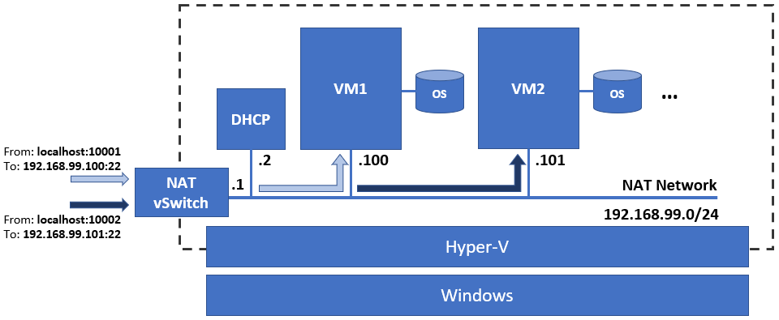

You must create the following:

* A custom NAT switch
* A DHCP virtual machine
* One or more rules

The NAT switch and the DHCP virtual machine can be created either manually or via an installation script

### The NAT Switch (Standalone)

*Note that you can skip this one, if you go for the complete DHCP solution*

To create one, open the **PowerShell** terminal window with **Run as administrator** and execute the following commands:

* Create an internal switch named **NAT Switch** *(or whatever you like)*

**New-VMSwitch -SwitchName "NAT Switch" -SwitchType Internal**

* Set an IP address to the virtual network interface *(the name in the parenthesis must match the one above)*

**New-NetIPAddress -IPAddress 192.168.99.1 -PrefixLength 24 -InterfaceAlias "vEthernet (NAT Switch)"**

* Create a NAT network *(the IP address above must be part of this range, usually the first, or the last)*

**New-NetNAT -Name "NAT Network" -InternalIPInterfaceAddressPrefix 192.168.99.0/24**

Now our machines will be able to access the Internet but won’t get their IP addresses automatically

### The DHCP Server (Complete solution)

You can check the instructions here <https://github.com/shekeriev/ahvdhcp> for more information

In general, to deploy the complete solution, you must do the following

Open a PowerShell session with **Run as administrator** option (right click on the icon and select the option)

Navigate to the root folder

**cd c:\**

Temporary change the execution policy (you must confirm when asked)

**Set-ExecutionPolicy -ExecutionPolicy Unrestricted -Scope Process**

Download the setup script (execute this as one long command – either do a copy/paste, or type it on one row)

**Invoke-WebRequest -UseBasicParsing -Uri https://raw.githubusercontent.com/shekeriev/ahvdhcp/main/setup-ahvdhcp.ps1 -OutFile setup-ahvdhcp.ps1**

Source the script (this will make all the functions there available)

**. .\setup-ahvdhcp.ps1**

Now, to create the switch and the special VM that will act as a DHCP server, execute

**Create-AHVDHCPSetup**

After a while the procedure will finish

The result is a NAT switch and a small virtual machine that plays the role of a DHCP server

If the machine did not start automatically, then start it

That is, it. It should work now 😊

Ah, and don’t forget to connect the virtual machines to the new switch (NAT vSwitch)

If you are curious and want to look inside it, you can use **root** / **Parolka1!** as credentials

*Please note that if you have changed the IP address and range in the previous step, you should alter the configuration of the* ***DHCP*** *machine as well. You will have to edit the following two files*

* *For the connectivity –* ***/etc/network/interfaces***
* *For the DHCP server –* ***/etc/dhcp/dhcpd.conf***

### The Port Forwarding Rules

The last step is to allow communication from the host to a particular machine

This is done via port forwarding rules *(see on the picture above)*

We must have one for each service and every machine that we want to access

Open a PowerShell terminal with **Run as administrator** and then create the rules

For example, if we want to be able to establish a **SSH** session to **VM1** *(if its IP address is 192.168.99.100)*, we must create the rule with the following command

**Add-NetNatStaticMapping -ExternalIPAddress "0.0.0.0/24" -ExternalPort 10001 -Protocol TCP -InternalIPAddress 192.168.99.100 -InternalPort 22 -NatName "NAT Network"**

In the same manner, if we want another one but for the **VM2** *(if its IP address is 192.168.99.101)*, we must execute

**Add-NetNatStaticMapping -ExternalIPAddress "0.0.0.0/24" -ExternalPort 10002 -Protocol TCP -InternalIPAddress 192.168.99.101 -InternalPort 22 -NatName "NAT Network"**

*(1) Please note that each of the above two commands are a single row*

*(2) Please note that you should adjust the ports (both local and on the VMs) and the IP addresses to match your situation and needs*