# Homework M4: Network. Software. Services

For successful completion of the tasks, you should have at least one server and one client configured according to the class practice. Should you have any questions about its setup, do not hesitate to contact your colleagues or me.

You must create a small environment, separate from the one you are working in class. The environment should consist of:

* one VM (name it **rila.lsa.lab**) with two network adapters
* and another one (name it **pirin.lsa.lab**) with just one network adapter

More or less the environment should look like this:

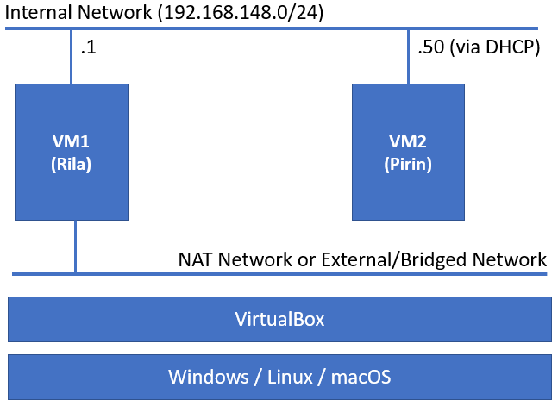

The following tasks must be performed on the **Rila** host:

1. Set one of the network cards with static IP **192.168.148.1/24** and connect it to the **same virtual network** as the only card of the other VM
2. Install and configure **DHCP** with range from **192.168.148.50 – 192.168.148.59**. Make sure that you pass the **8.8.8.8** DNS server as an option as well either on global or subnet level
3. **SSH** service installed and running
4. Firewall up and running, and allowing **SSH** connections

*You* ***can skip*** *this one under Debian (yes, you will see some errors during the checks)*

1. Enabled **NAT** and forwarding functionality, so the internal station can have access to Internet
2. Register the **repos.zahariev.pro** repository *(check for details on* ***https://repos.zahariev.pro****)*
3. Install the **hello-lsa** package

The following tasks must be performed on the **Pirin** host:

1. Make sure that the network adapter is set to get its IP address via **DHCP**
2. Create a user **homework** with password **Parolka3** and make it a **sudoer** *(part of the* ***admin****,* ***sudo****, or* ***wheel*** *group, depending on you distribution)*
3. **SSH** service installed and running but on port **50022** instead of the default (**22**)
4. Firewall up and running, and allowing **SSH** connections

*You* ***can skip*** *this one under Debian (yes, you will see some errors during the checks)*

## Proof

After you are done with the tasks, you can check how well you did them

In a terminal session execute one of the following commands (depending on which executable you have)

* Option 1 (**wget** installed, usually for **Debian**-based distributions)

On VM1: **wget -q https://courses.zahariev.pro/m4.sh -O - | sudo vm=1 bash**

On VM2: **wget -q https://courses.zahariev.pro/m4.sh -O - | sudo vm=2 bash**

* Option 2 (**curl** installed, most of the distributions)

On VM1: **curl -s https://courses.zahariev.pro/m4.sh | sudo vm=1 bash**

On VM2: **curl -s https://courses.zahariev.pro/m4.sh | sudo vm=2 bash**

Repeat the procedure until you get as much **PASS** marks as possible. This may include adjustments on what you did or even start from the beginning

Once, satisfied by what you accomplished, use the homework template document (available in the section for the module – ***Домашно – M4 - Шаблон за решение***) and paste the link you received as a result

Include the commands you used for every step. Also include the output if you like (either as pictures or as text)