Name: Dayigil Basil Boeloeplat
Matric Number: 2019/1/75427CT
Course Code: CPT 523

QUESTION 2:
DIVERSITY COMBINING TECHNIQUES
(SELECTION COMBINING, MAXIMUM RATIO COMBINING, AND EQUAL GAIN COMBINING)
Wireless communication channels are subject to multipath fading due to reflections, scattering, and diffraction. Diversity combining techniques are used to mitigate these effects by combining multiple received versions of the same signal, thereby improving signal quality and reliability. Among the various combining techniques, Selection Combining (SC), Maximum Ratio Combining (MRC), and Equal Gain Combining (EGC) are the most widely used. This paper provides an in-depth explanation and mathematical representation of each technique.
1. Selection Combining (SC)
Definition:
Selection combining involves choosing the branch (or antenna) with the highest instantaneous signal-to-noise ratio (SNR) for further processing. Only one signal path is used at any given time.
Working Principle:
- Measure SNR on each diversity branch.
- Select the branch with the maximum SNR.
- Discard the others.
Mathematical Representation:
Let there be N branches with received signals r₁, r₂, ..., r_{N} and their corresponding SNRs γ₁, γ₂, ..., γ_{N}.
γSC = max (γ₁, γ₂, ..., γ_{N})
Advantages:
- Simpler hardware implementation.
- Lower power consumption.

Limitations:
- Does not use the full potential of available diversity.
- Performance is inferior to MRC.
2. Maximum Ratio Combining (MRC)
Definition:
MRC combines all received signals, weighting each branch proportionally to its SNR, and coherently summing them to maximize the output SNR.
Working Principle:
- Apply weights based on amplitude and phase to each signal.
- Align phases for coherent addition.
- Maximize the combined SNR.
Mathematical Representation:
Let the signal at each branch be represented as:
r_{i} = h_{i}s + n_{i}
Where:
- h_{i}: channel gain for branch i
- s: transmitted symbol
- n_{i}: additive noise
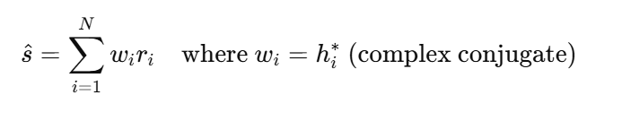
MRC output signal:

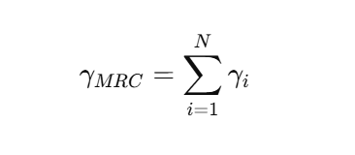
Output SNR:

Advantages:
- Optimal performance in terms of SNR.
- Fully utilizes spatial diversity.
Limitations:
- More complex hardware and signal processing.
- Requires accurate channel estimation.
3. Equal Gain Combining (EGC)
Definition:
EGC is a compromise between SC and MRC. It combines all received signals like MRC but uses equal amplitude weights (without considering SNR), adjusting only for phase.
Working Principle:
- Adjust phases of all received signals.
- Combine with equal amplitude weighting.
Mathematical Representation:
Let the received signals be:
r_{i} = ∣hi∣ e^{jθi} s + n_{i}
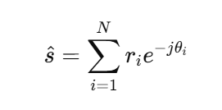
The EGC output is:

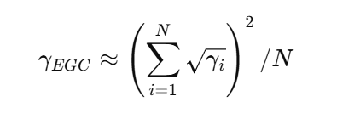
Output SNR approximation:

Advantages:
- Simpler than MRC.
- Better performance than SC.
Limitations:
- Still requires phase alignment.
- Slightly lower SNR performance than MRC.
Comparison Summary:
Technique | Complexity | Performance | Diversity Gain
Selection Combining | Low | Lowest | Limited
Equal Gain Combining | Moderate | Medium | Good
Maximum Ratio Combining | High | Best | Optimal

References
Goldsmith, A. (2021). Wireless communications. Cambridge University Press. https://doi.org/10.1017/9781139871533
Rappaport, T. S. (2021). Wireless communications: Principles and practice (2nd ed.). Pearson Education.
Simon, M. K., & Alouini, M.-S. (2021). Digital communication over fading channels. Wiley-IEEE Press.
Proakis, J. G., & Salehi, M. (2022). Digital communications (6th ed.). McGraw-Hill Education.

