Smart Parking System

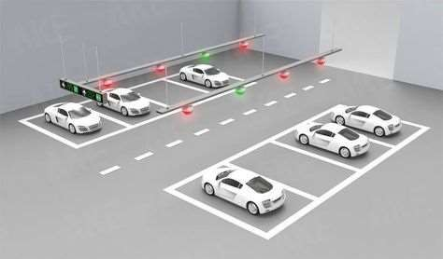Under the guidance of



Prof. Indushree Shetty

Created by:

B04- Vansh Bandi B54- Dwij Patel C10- Vasant Dave

2



**INDE**

* Company Profile
* Project Profile



* Sample Screen Layout
* Conclusion



**COMPANY PROFILE**

* Company Name: **Hindustan Traders**
* Owner Name: **Yogesh Patel**
* E-mail: [**htshoppe@gmail.com**](mailto:htshoppe@gmail.com)
* Contact No: **+91 9408011233**

4



**Project Guide**

* + Internal Guide Prof. Indushree Shetty
  + External Guide Mr. Yogesh Patel

5

## PROJECT PROFILE

**Title** - Smart Parking System

### Objective-

The goal of this project is to create a user-friendly and adaptable system that can be implemented in large, multi-level parking garages in order to alleviate parking hassles. The ultimate goal is that the ideas and planning demonstrated through this system can then be easily upgraded to an actual parking facility. The purpose of the Development of Smart Parking System is to eliminate the unnecessary frustration drivers experience as they waste priceless minutes circling parking garages looking for the optimal parking spot. In addition, traffic flow within the garage will be better regulated, creating a safer atmosphere for both drivers and pedestrians.

6

## PROJECT DESCRIPTION

1. Optimized parking – Users find the best spot available, saving time, resources and effort. The parking lot fills up efficiently and space can be utilized properly by commercial and corporate entities.
2. Reduced traffic – Traffic flow increases as fewer cars are required to drive

around in search of an open parking space.

1. Reduced pollution – Searching for parking burns around one million barrels of oil a day. An optimal parking solution will significantly decrease driving time, thus lowering the amount of daily vehicle emissions and ultimately reducing the global environmental footprint.
2. Increased Safety – Parking lot employees and security guards contain real- time lot data that can help prevent parking violations and suspicious activity. OTP verification helps to prevent theft of a vehicle.
3. Decreased Management Costs – More automation and less manual activity

saves on labor cost and resource exhaustion.

7

1. ***Arduino Uno-Tools and Technologies used (Module-wise)-***

o Arduino UNO is a microcontroller board. It has 14 digital input/output pins (of which 6 can be used as PWM outputs), 6 analog inputs, a 16 MHz ceramic resonator, a USB connection, a power jack, an ICSP header and a reset

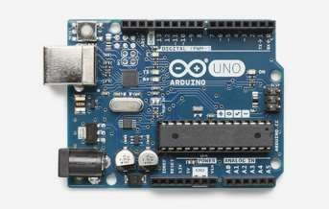button. It contains everything needed to support the microcontroller; simply connect it to a computer with a USB cable or power it with a AC-to-DC adapter or battery to get started. You can tinker with your UNO without worrying too much about doing something wrong, worst case scenario you can replace the chip for a few dollars and start over again.

**“**

8

**“**

1. *IR sensor-*

* *Infrared Sensor - IR Sensor*
* *An infrared sensor (IR sensor) is a radiation-sensitive optoelectronic*

*component with a spectral sensitivity in the infrared wavelength range 780*

*nm … 50 µm. IR sensors are now widely used in motion detectors, which are used in building services to switch on lamps or in alarm systems to detect unwelcome guests.*

* *For optical sensing and optical communication, photo optics technologies*

*are used in the near infrared region as the light is less complex than RF when*

*implemented as a source of signal. Optical wireless communication is done*

*with IR data transmission for short range applications.*

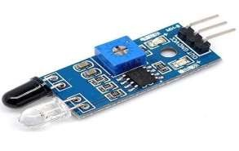9



◦

◦

### Existing System –

* Currently Company don’t have any existing system.

### Proposed System -

* In our website user have to register there name, phone

number, email, car number and password.

* After registering user information will be saved in the system.
* It will generate code and send it to the user after

registering/login.

* After that it will display parking area where parking is empty(green light) and full(red light) with the help of IR sensor.
* User will get safety because of code verification at the time of

exit.

* User can easily use our website.

10



# ADMIN PANEL SCREEN SHOTS

11

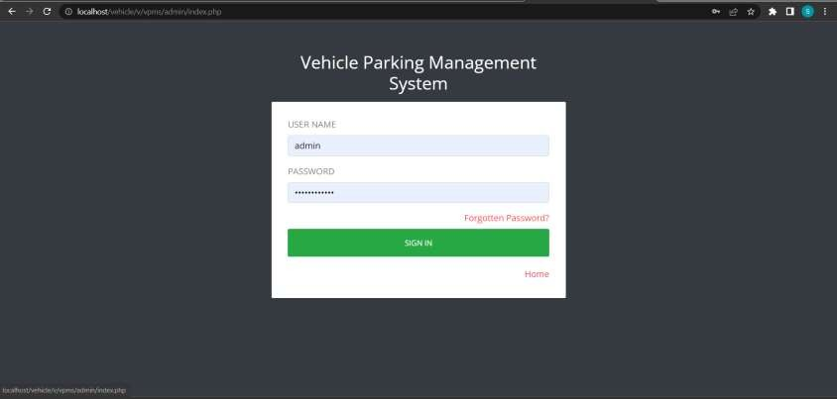 **Admin Login Page**

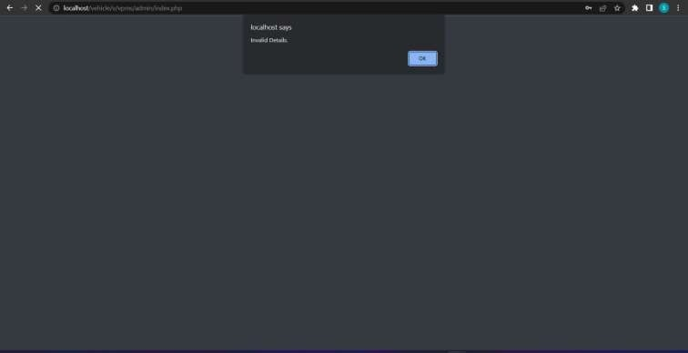**Notification Page**

**This Pop-Up menu will display when admin enters wrong details during login.**

**Admin Dashboard**

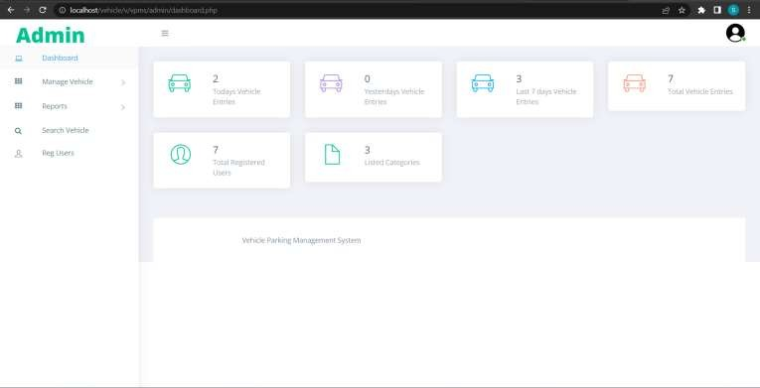

**Admin Profile Page**

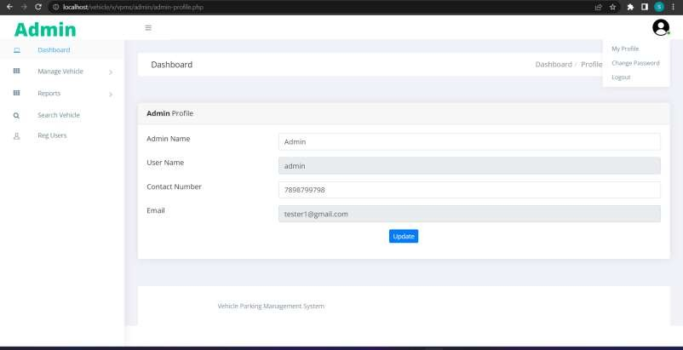

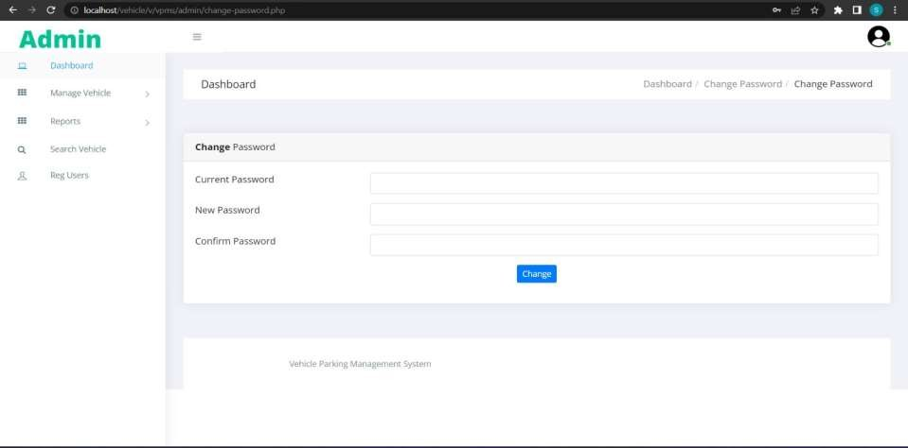**Change Password Page**

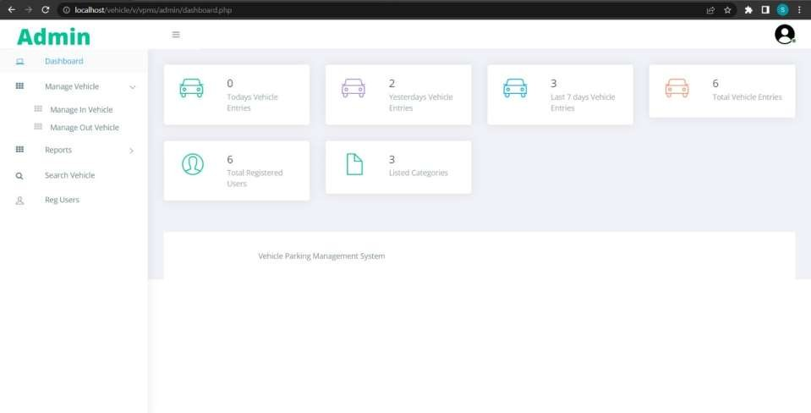**Manage Vehicle Page**

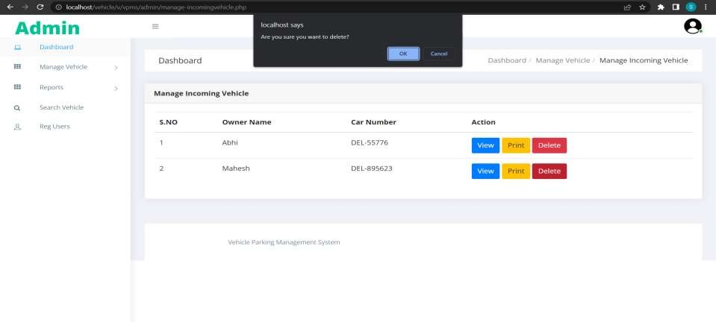**Manage In Vehicle Page**

**This Pop-Up is shown when admin clicks delete button from Mahesh’s action column.**

## Manage In Vehicle Page

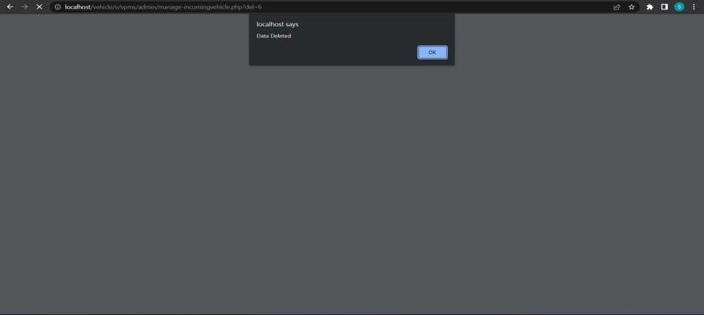

**This Pop-Up will be shown when Mahesh’s data is deleted.**

## Manage In Vehicle Page

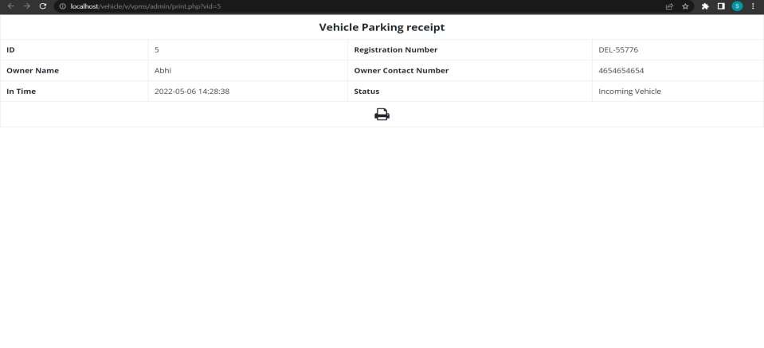**Manage In Vehicle Page**

**This screen will be shown when admin clicks print button from action column.**

## Manage In Vehicle Page

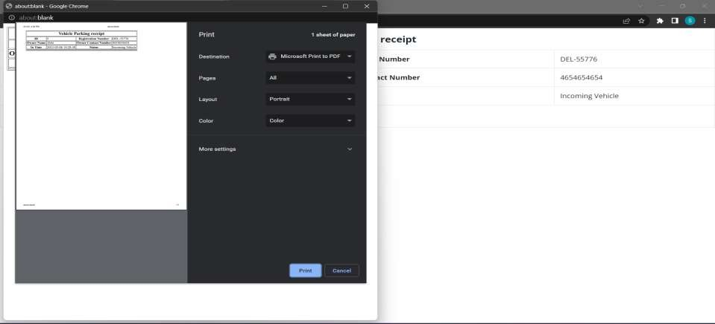

**This screen will display printing options when admin clicks print button.**

## Manage In Vehicle Page

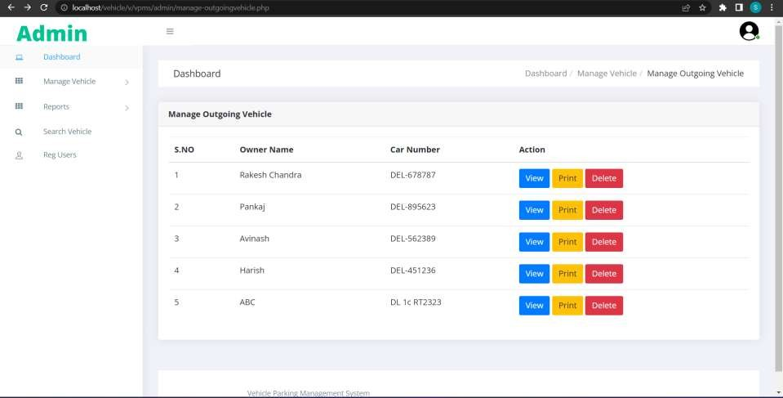**Manage Out Vehicle Page**

## Report Page

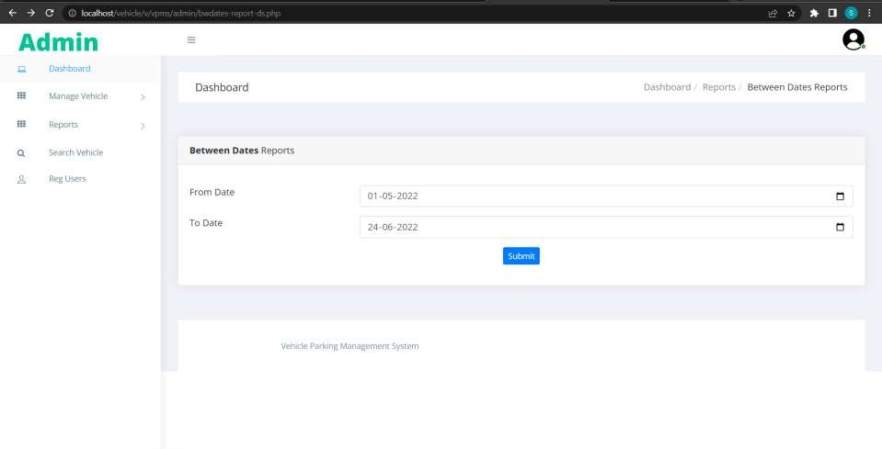**Between Dates Report Page**

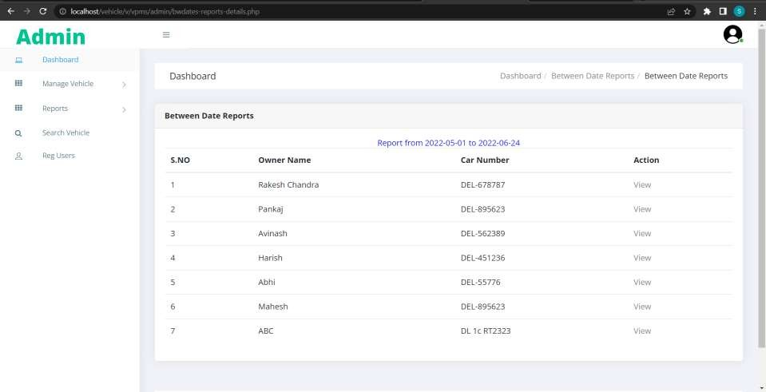**Between Dates Report Page**

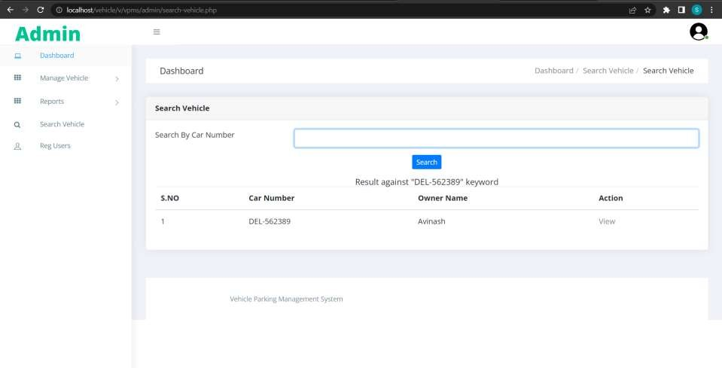**Search Vehicle Page**

**Search Vehicle Page**

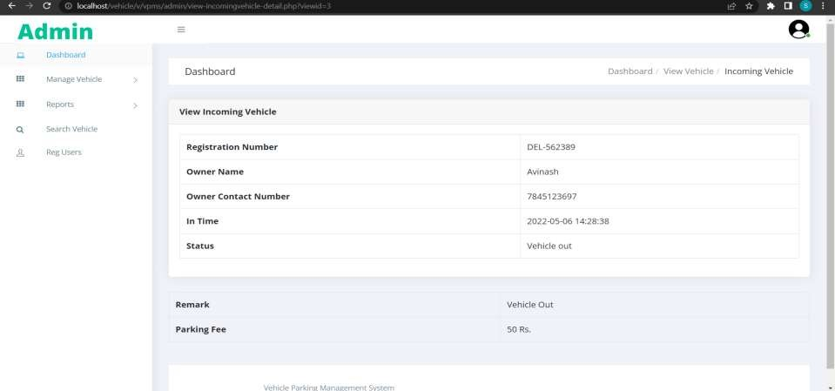

**This page will show details of user after clicking view button from previous page**

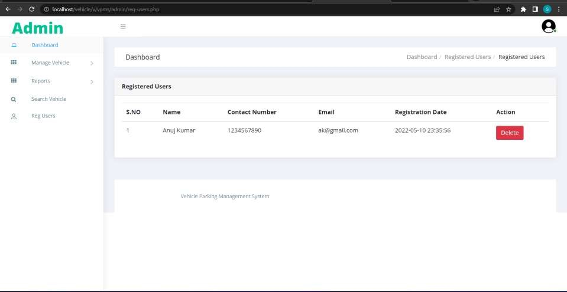**Registered Users**

# WEBPAGE SCREEN SHOTS

**Scanning QR Code**

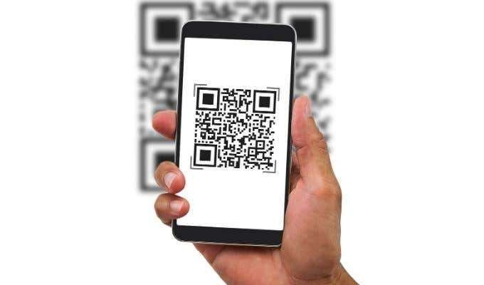

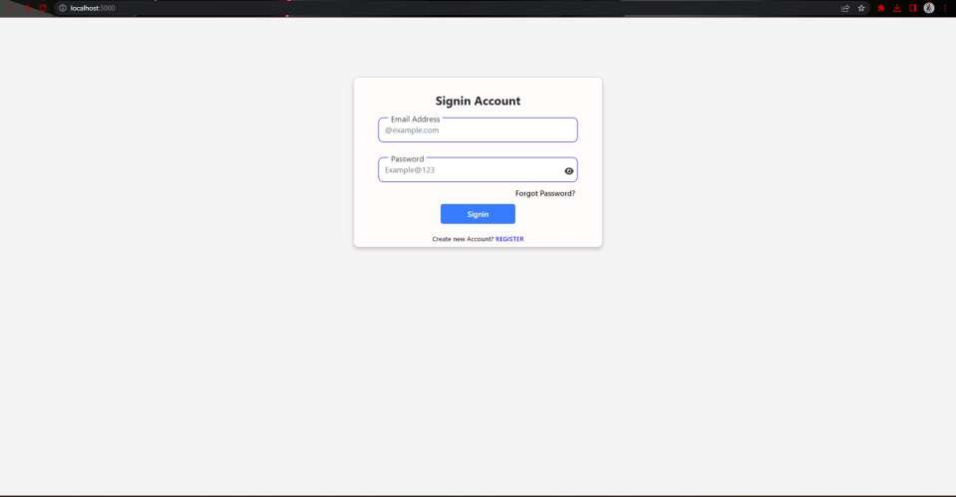**Sign-In Page**

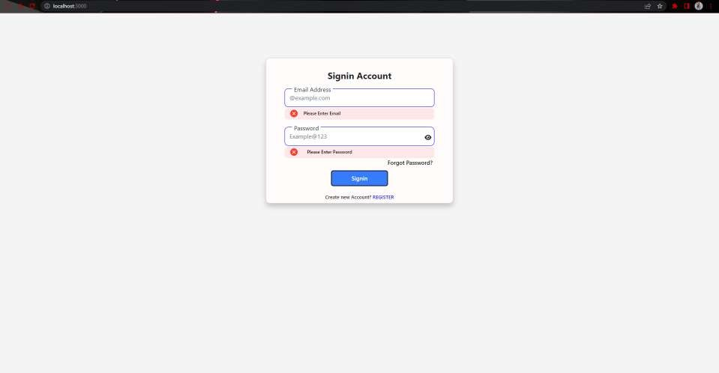**Sign-In Fail Page**

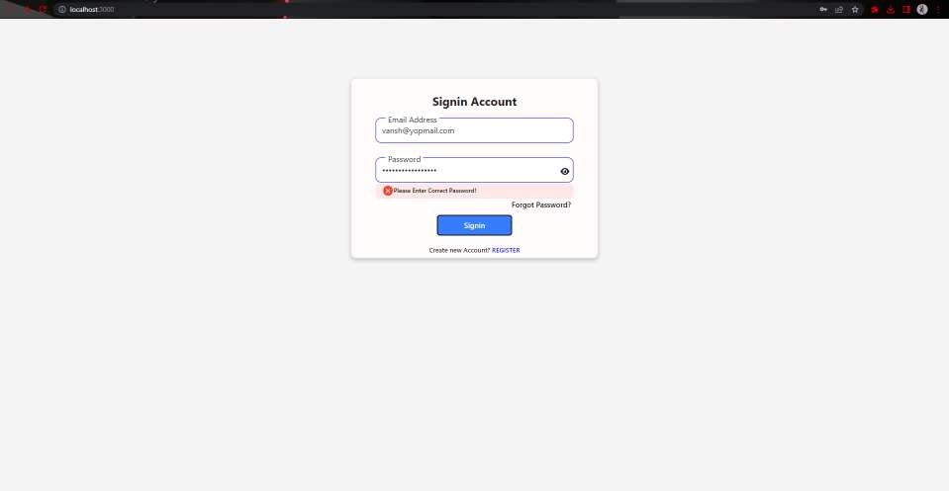**Sign-In Fail Page**

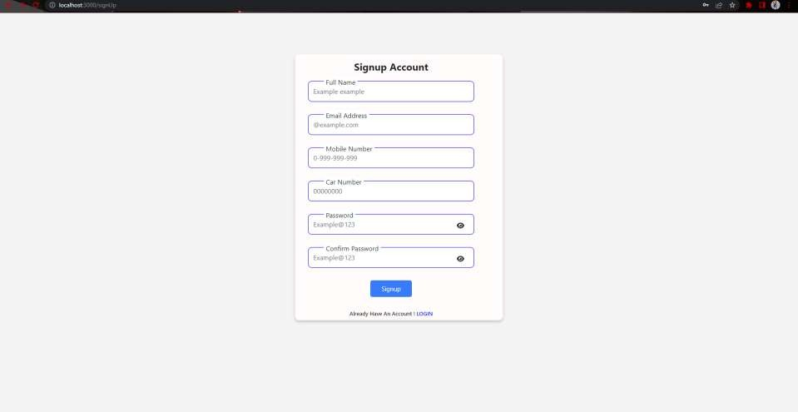**Signup Page**

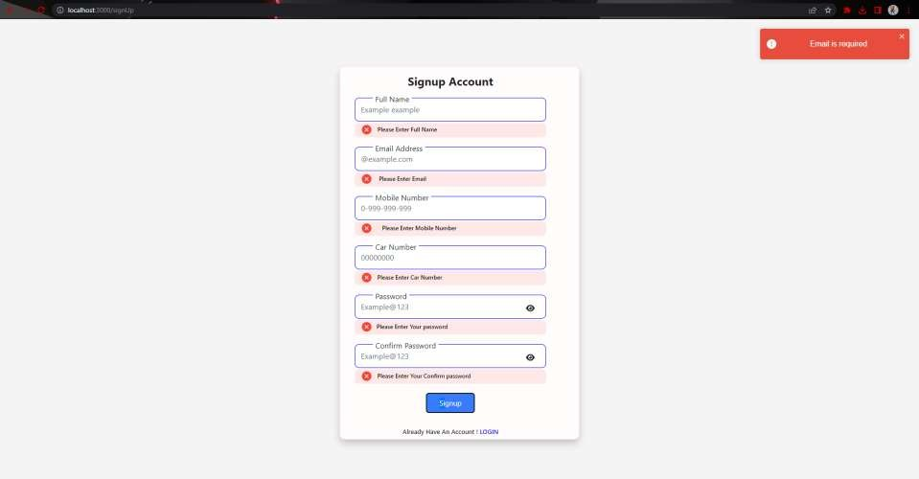**Signup Fail Page**

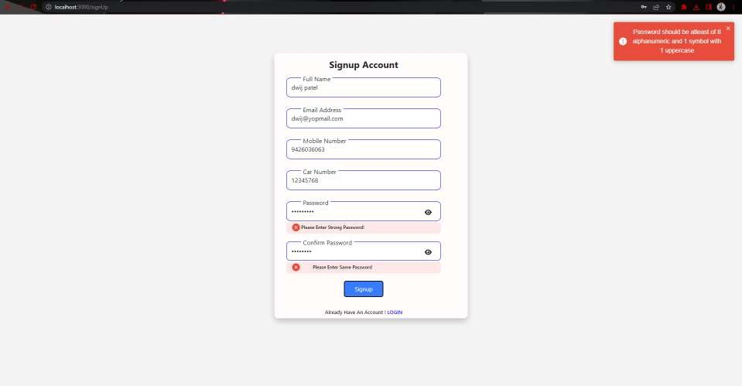**Signup Fail Page**

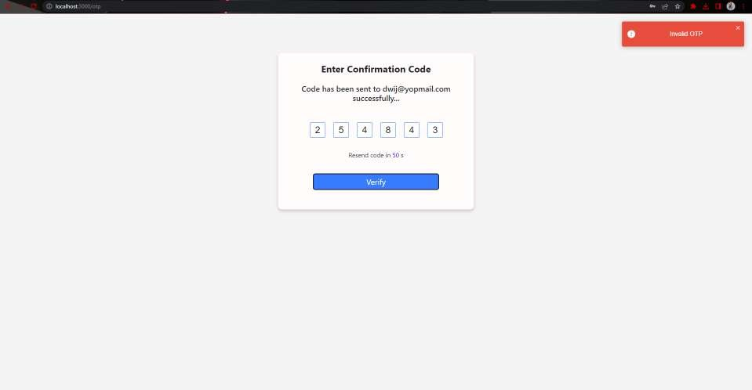**Signup Fail Page**

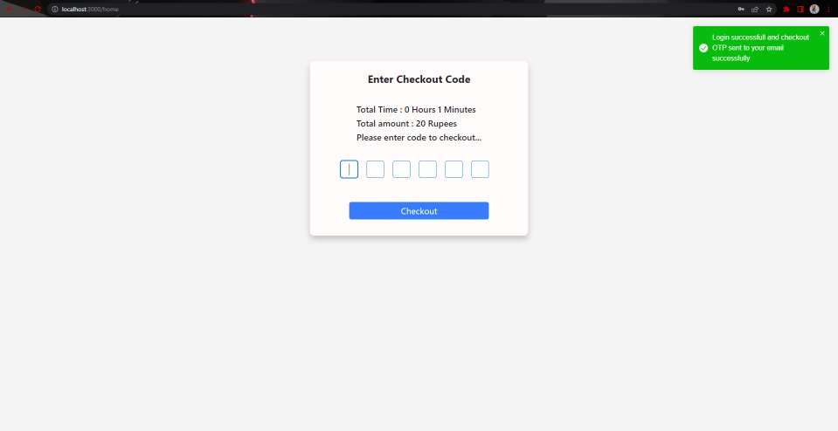**Sign Up Success Page**

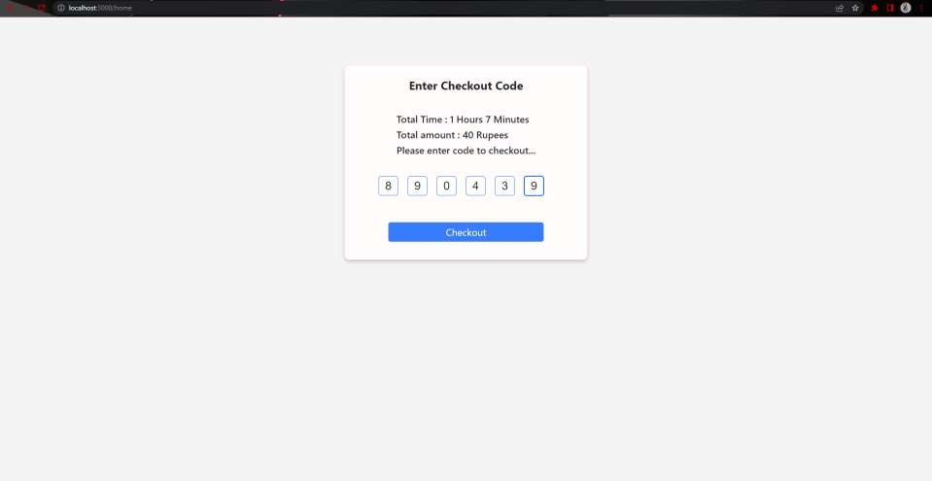**Checkout Page**

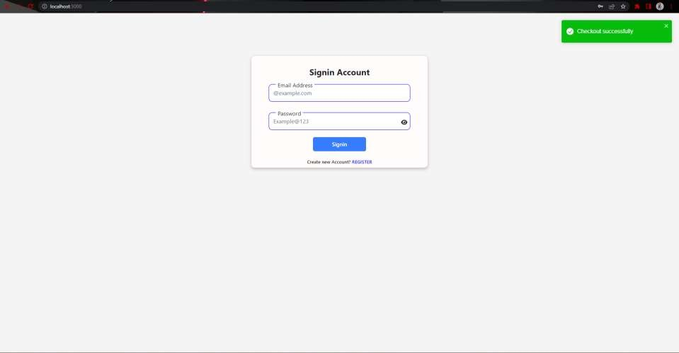**Checkout Success Page**

**CONCLUSION**

* The system benefits of smart parking go well beyond avoiding the needless circling of city blocks. It also enables cities to develop fully integrated multimodal intelligent transportation systems that don’t rely on cars in the first place.
* Developing smart parking solutions within a city requires data standardization and management; mobile phone integration; hardware and software innovation; and coordination among various stakeholders (on and off street parking facility owners, business owners, municipalities, transportation authorities, customers, and software developers).

**THANK YOU**