**Open Expample3.sln in Visual Studio**:

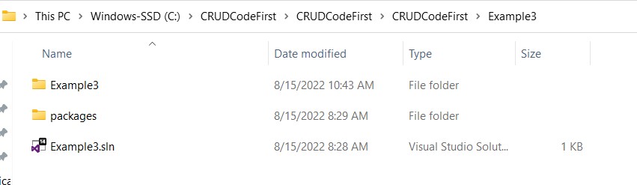

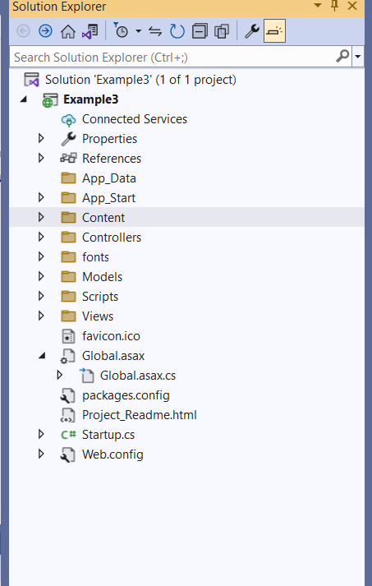

**Change connection string in Web.config file and build the solution:**

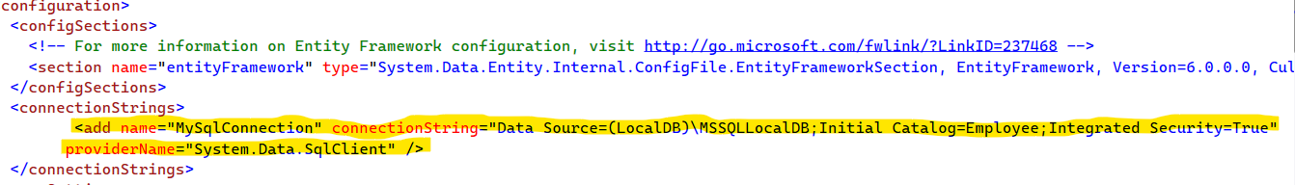

**Now go to Tools ->NuGet Package Manager -> Package Manager Console:**

Run the NuGet commands.

1. Enable-migrations
2. add-migration
3. Update-Database

**Run the application:**

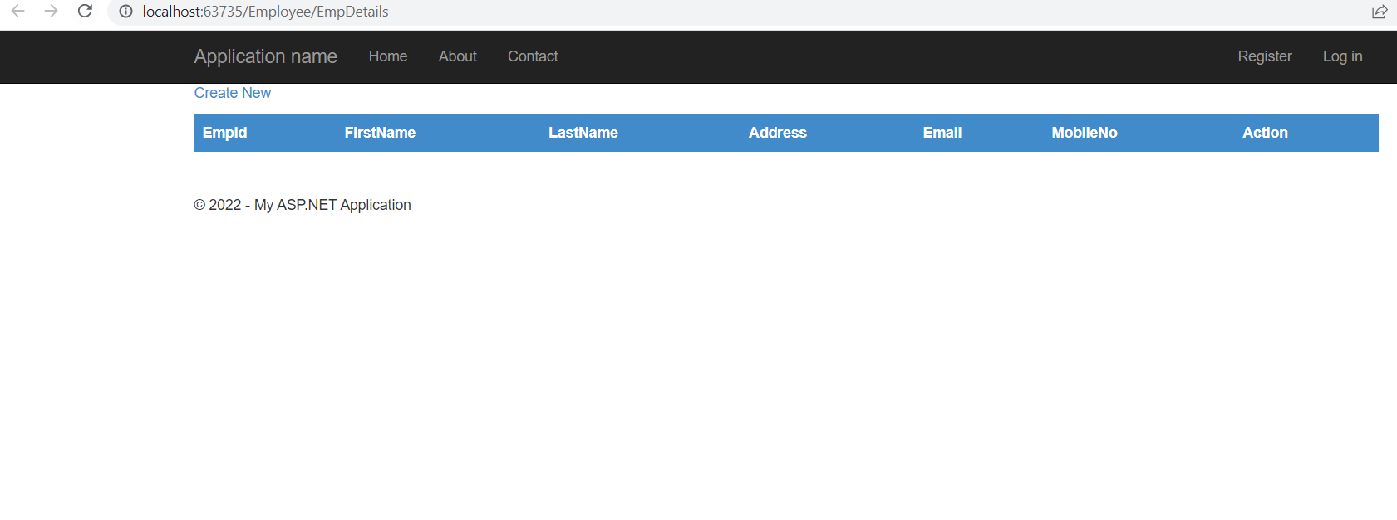

**Add Employee**

Click on **Create New** to add the employee details.

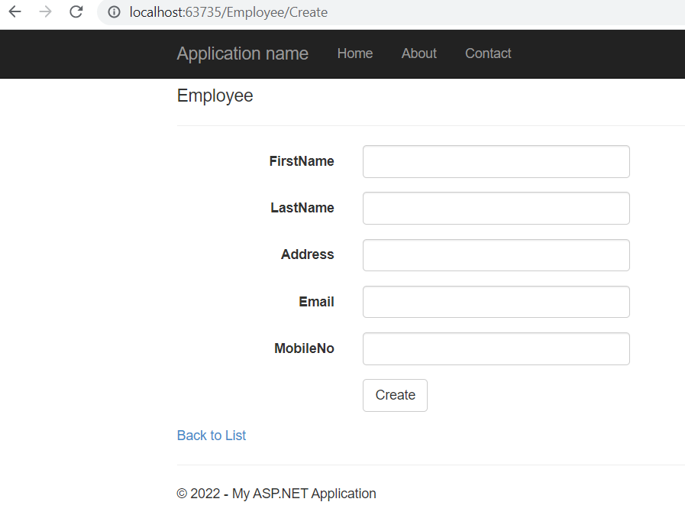

Enter all the details and click on create button.

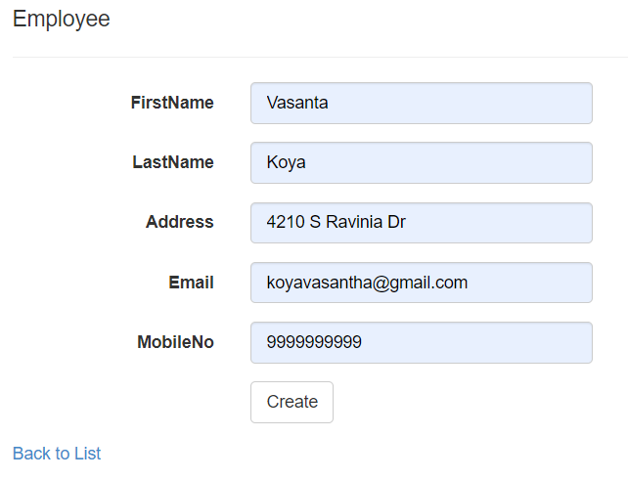

After adding the employee details, below screen is displayed.

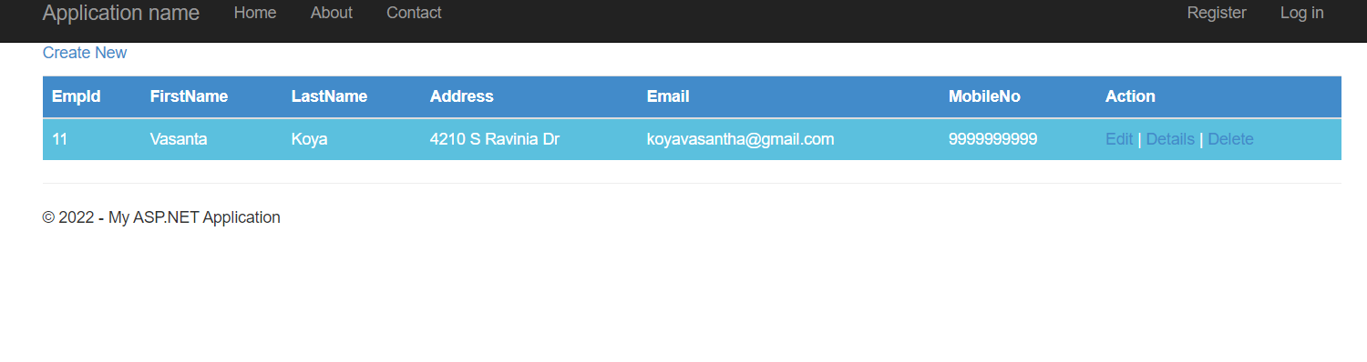

**Edit Employee details**

Click on edit, against an employee, to edit the details.

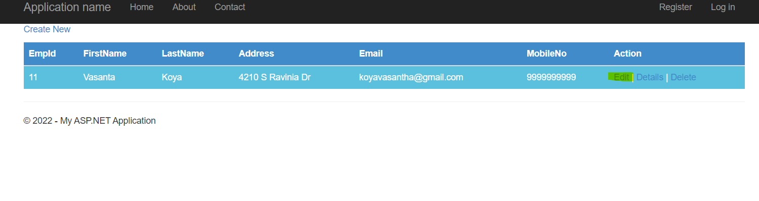

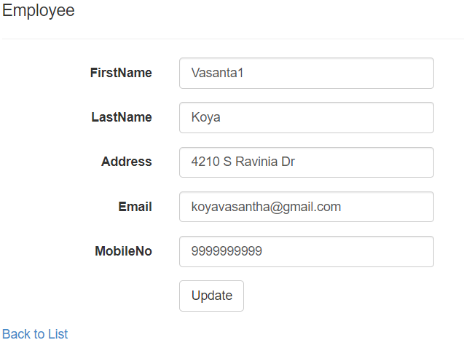

Edit the details and click on update. After updating it will rediect back to the list of employees screen.

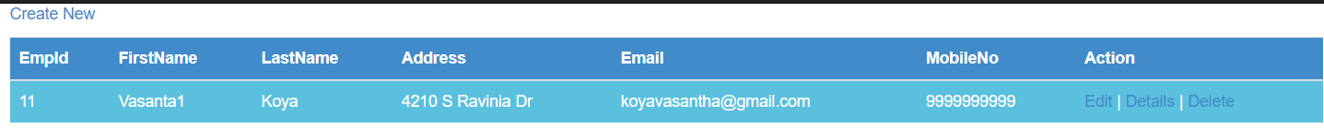

**Delete Employee:**

Click on the delete, against an employee.

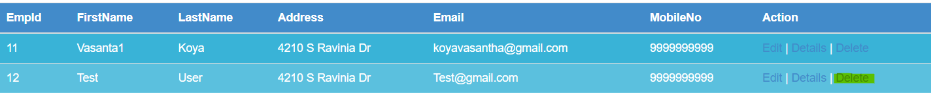

Below screen will display. Click on Delete button. It will delete the employee and it will redirect back to the list of employees screen.

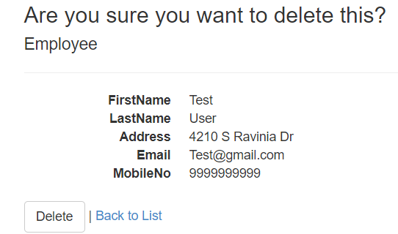

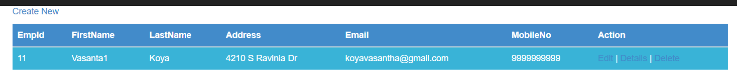

**Back to List:**

It will display the list of employees