DATA SCIENCE TOOL MASTERY
Retail Sales Analysis Using Excel, SQL, Python and Power BI
Project Report and Evidence Portfolio

1. Executive Summary
This project demonstrates a retail sales analysis workflow using Excel, MySQL, Python (Pandas and Matplotlib), and Microsoft Power BI. The workflow examines sales totals, order volume, units sold, category performance, regional performance, and monthly sales trends. The current starter dataset contains synthetic demonstration records, not verified business transactions. Results should therefore be described as findings from the sample dataset rather than from a real company.

2. Project Objectives
- Inspect and summarize retail sales records.
- Use Excel formulas and summaries to explore sales data.
- Use SQL to calculate totals, check duplicates, and aggregate sales by month, product, and region.
- Use Python/Pandas for data preview, quality checks, grouped analysis, and charts.
- Build a Power BI report with KPI cards and category, region, and monthly-trend visuals.
- Document the steps and include screenshots as evidence of the work performed.

3. Dataset Description
The demonstration CSV is named retail_sales.csv. It includes OrderID, OrderDate, CustomerID, Region, Product, Category, Quantity, UnitPrice, and Sales. The notebook preview shows records from 2025. The project pack contains 240 sample order rows. Because the data is synthetic, it is suitable for demonstrating tool usage but should be replaced if the internship provides an official dataset.

4. Methodology

4.1 Data preparation and quality checks
The CSV was loaded into the analysis tools. In Python, Pandas was used to read the file and parse OrderDate as a date field. The analysis checks the dataset structure, missing values, duplicate order identifiers, and numeric sales fields before summarizing results. In SQL, the table was queried for total sales, number of orders, units sold, and duplicate OrderIDs.

4.2 Excel analysis
The supplied workbook includes a sales data sheet and a summary sheet with formulas and charts. Review the workbook and add a screenshot of the actual workbook if the evaluator requires direct visual evidence of Excel execution. Do not report a formula or result that has not been checked in the workbook.

4.3 SQL analysis
MySQL queries were used to summarize total sales, order count, units sold, duplicate OrderIDs, monthly sales, and sales by product. The SQL screenshots recorded during the work are intended to support this section. The figures visible in the reported SQL results were: total sales ₹6,245,738.00, 240 orders, 702 units sold, and zero duplicate OrderIDs. Confirm these figures against the saved SQL output before final submission.

4.4 Python analysis
The Jupyter notebook uses Pandas to load and inspect the CSV, group sales by category and region, aggregate sales by month, and use Matplotlib to produce charts. The screenshots in the evidence section show the executed notebook and visual outputs.

4.5 Power BI dashboard
The Power BI report was created from the retail_sales table. Work shown in the screenshot includes a total sales card and a Sales by Category chart. The screenshot also shows a First Product card and an OrderID list visual; these are not intended final KPIs. Before submission, replace them with the intended KPI cards (Total Orders, Units Sold, and Unique Products), and add the Sales by Region and Monthly Sales Trend charts if they are not yet present. Save the completed report as a .pbix file.

5. Results and Observations
- SQL summary shown during the work: total sales ₹6,245,738.00.
- SQL summary shown during the work: 240 orders and 702 units sold.
- SQL duplicate check shown during the work: 0 duplicate OrderIDs.
- Python category analysis shows Electronics as the largest sales category in the demonstration dataset.
- Python regional analysis shows North as the highest-sales region in the demonstration dataset.
- The monthly aggregation provides sales totals for each month in 2025; inspect the full output to identify high and low months.
These observations apply only to the synthetic demonstration dataset. They should not be represented as findings from a real retailer.

6. Tools Used
- Microsoft Excel — workbook-based summary and charts.
- MySQL Workbench — SQL queries and aggregation.
- Python 3.10 with Pandas and Matplotlib — data inspection and visual analysis.
- Visual Studio Code with Jupyter Notebook — Python execution environment.
- Microsoft Power BI Desktop — interactive report visuals.

7. Evidence Screenshots
The following images were added from screenshots shared in this conversation. Keep the original notebook, SQL script, Excel workbook, and Power BI .pbix file alongside this report as supporting deliverables.

Evidence 1 — Python dataset preview
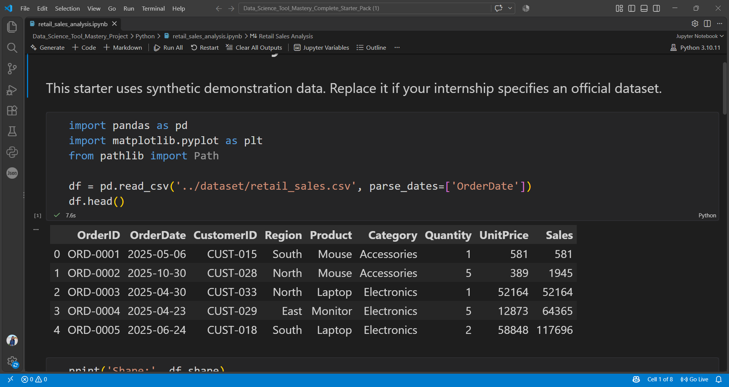
Executed Jupyter cell showing the first five records from retail_sales.csv.

Evidence 2 — Python sales by category
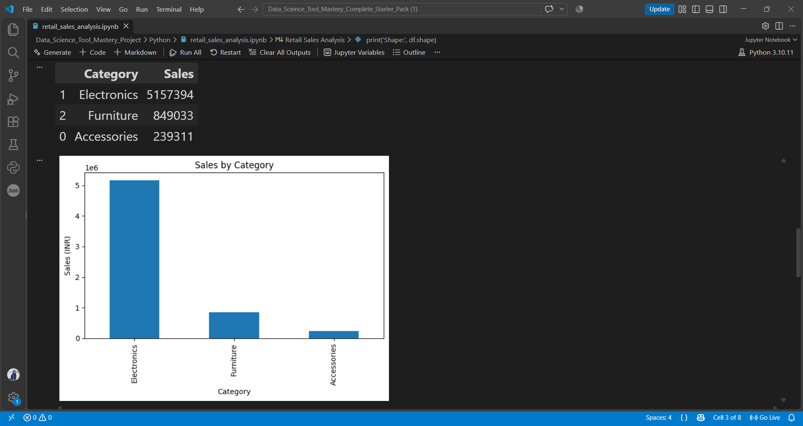
Pandas category aggregation and Matplotlib bar chart; Electronics has the largest sample sales.

Evidence 3 — Python sales by region
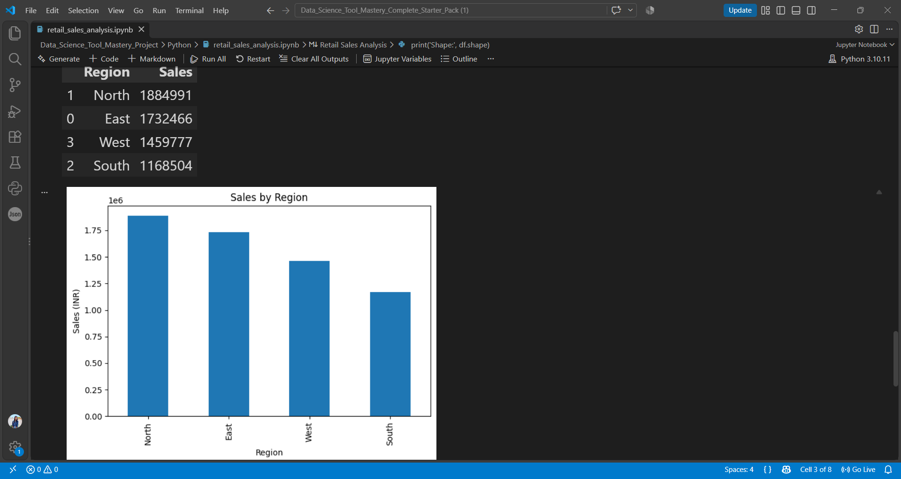
Pandas regional aggregation and Matplotlib bar chart; North has the largest sample sales.

Evidence 4 — Python monthly sales
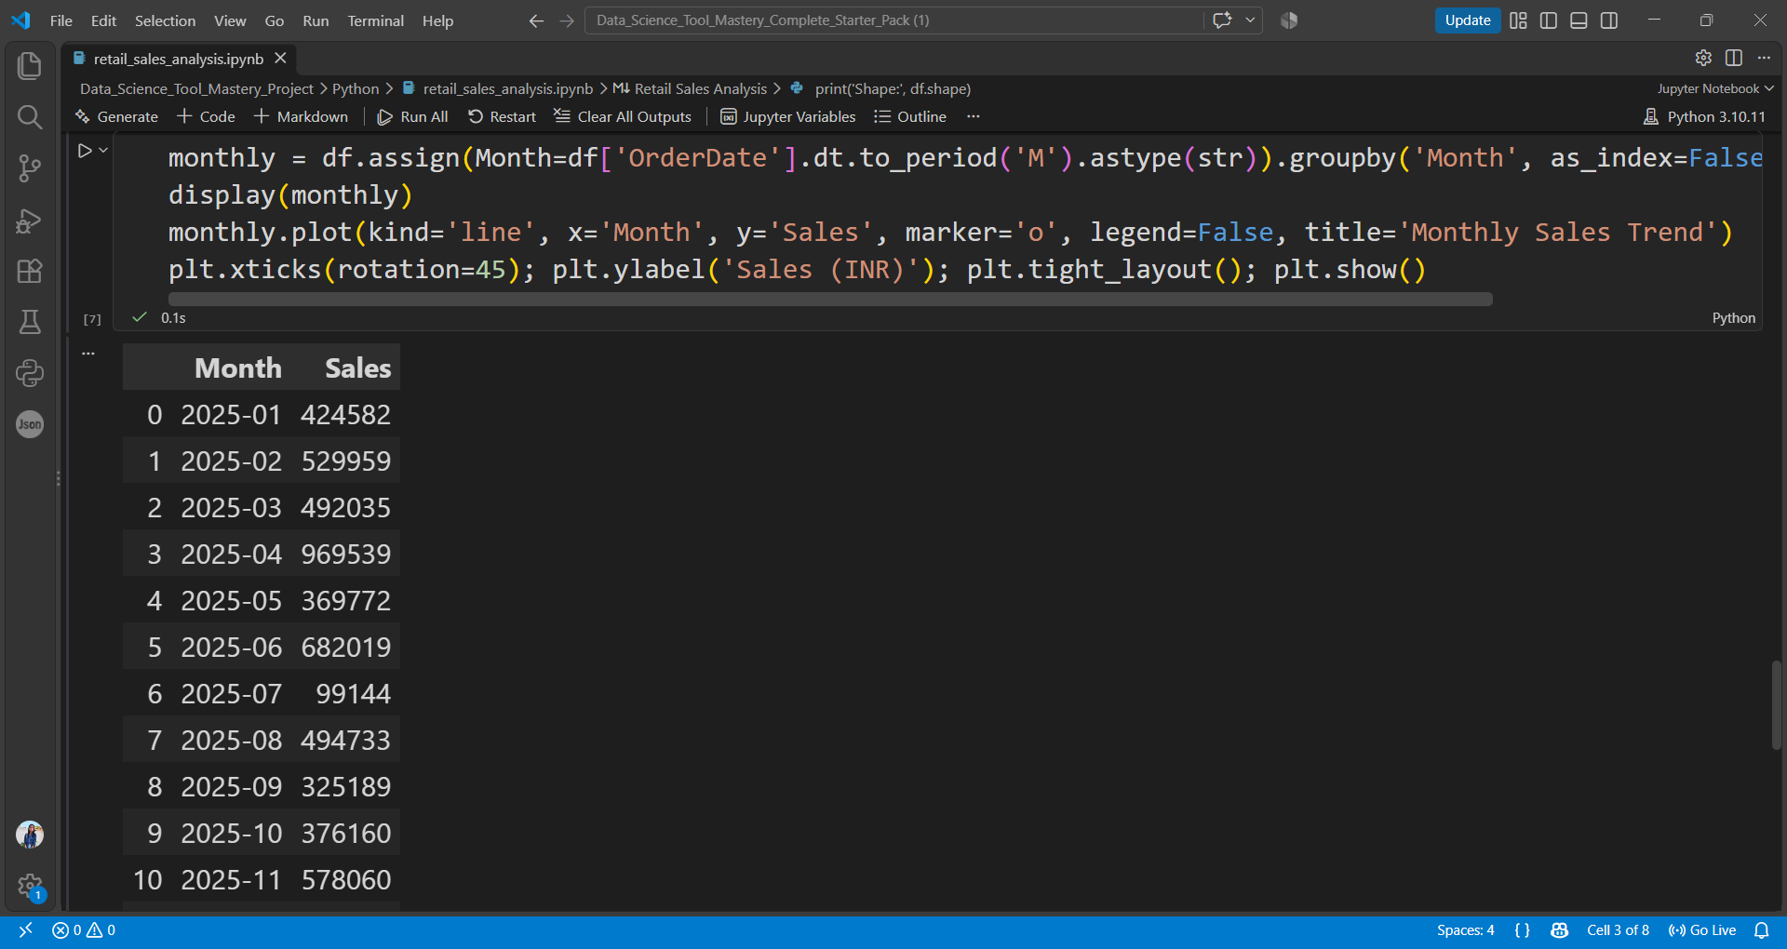
Monthly sales aggregation for 2025 in the executed Jupyter notebook.

Evidence 5 — Power BI report in progress
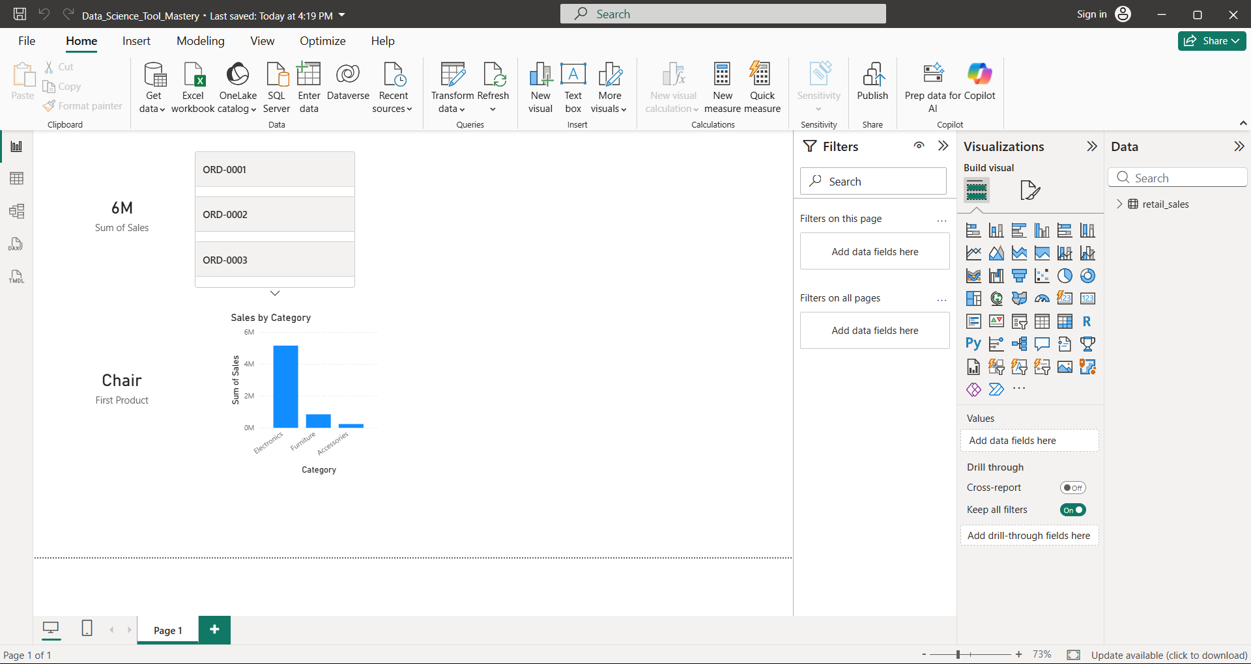
Power BI Desktop screenshot. This shows a sales card and category chart, plus visuals that still need correction; it is progress evidence, not a finished dashboard.

Evidence 6 — SQL execution screenshots
Screenshots from the SQL work are included below as evidence of query execution.

SQL screenshot 1
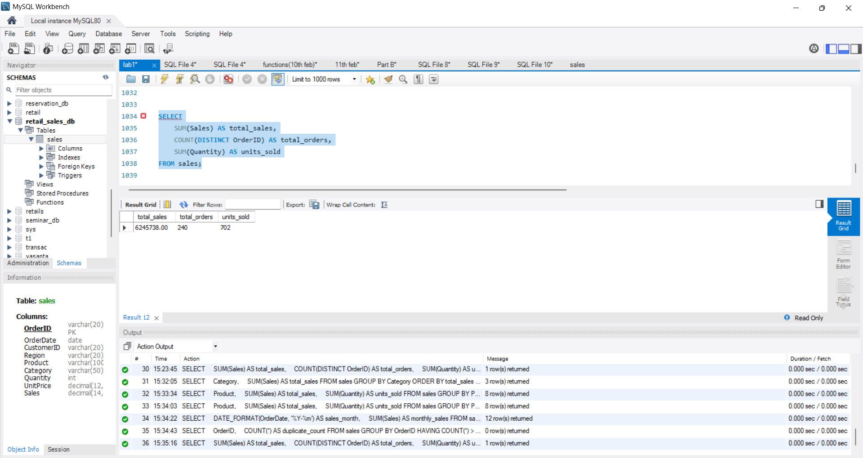
SQL workbench screenshot supplied during the project workflow.

SQL screenshot 2
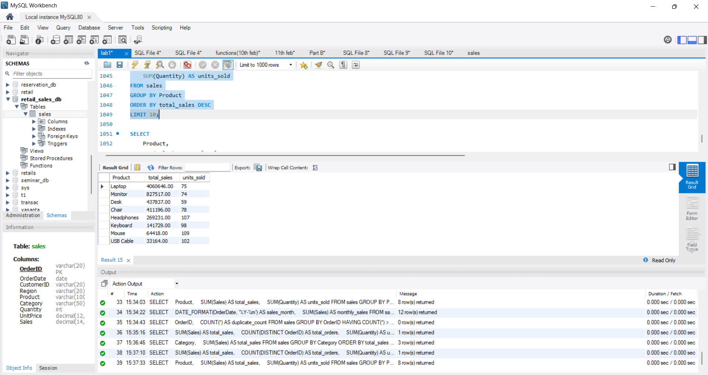
SQL workbench screenshot supplied during the project workflow.

SQL screenshot 3
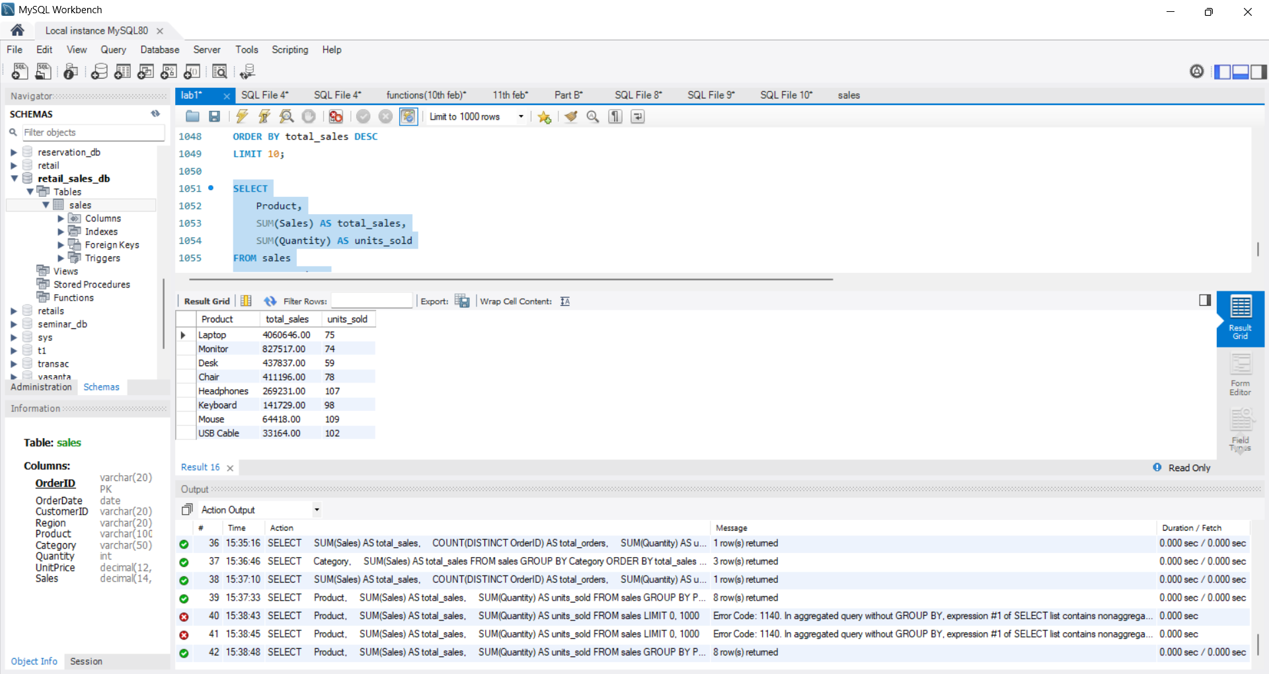
SQL workbench screenshot supplied during the project workflow.

SQL screenshot 4
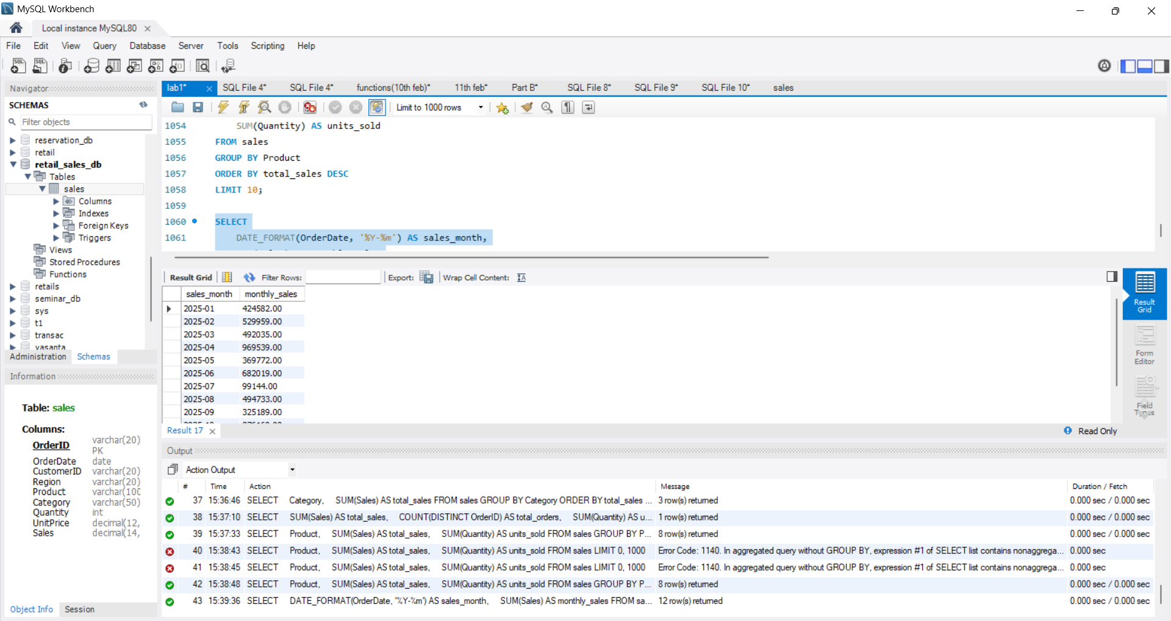
SQL workbench screenshot supplied during the project workflow.

8. Limitations and Improvements
- The dataset is synthetic demonstration data; it does not establish real-world business performance.
- The Power BI screenshot shows the report in progress. Correct the First Product and OrderID visuals and verify all KPI calculations.
- Add a screenshot of the Excel workbook opened in Excel to provide direct evidence of Excel execution.
- Verify every result against the actual tool output and retain the .xlsx, .sql, .ipynb, .csv, and .pbix files.
- If the internship evaluator supplies an official dataset, repeat the workflow with that dataset and regenerate all results and screenshots.

9. Conclusion
This project demonstrates a multi-tool workflow for retail sales analysis: inspecting the data, querying it with SQL, summarizing it with Excel, analyzing and plotting it with Python, and visualizing it in Power BI. The current report includes available evidence screenshots and identifies remaining improvements honestly. Before resubmission, ensure the Power BI dashboard is complete, add direct Excel evidence, and confirm that the report's results match the final files.

Appendix — Deliverable Checklist
☐ retail_sales.csv
☐ retail_sales_analysis.xlsx
☐ retail_sales_analysis.sql
☐ retail_sales_analysis.ipynb
☐ Data_Science_Tool_Mastery.pbix
☐ Screenshots folder with SQL, Python, Excel, and Power BI evidence
☐ This project report

