PROJECT REPORT
Project Title:
Design and Development of Efficient Road object Detection Methods in Extreme Weather conditions for Autonomous Driving.
1. Introduction
Reliable object detection on roads is foundational to the safety and functionality of autonomous vehicles. Adverse weather—such as rain, snow, smoke, and fog—degrades the performance of vision-based detection systems. This project focuses on using deep learning, specifically Pix2Pix Conditional Generative Adversarial Networks (GANs), to proactively remove weather-based artifacts from images before passing them to advanced object detectors like YOLOv5. The solution is evaluated both on high-performance systems and in resource-constrained environments like Raspberry Pi.
2. Rain Removal using Pix2Pix GAN:
Objective
Develop a deep learning model to automatically remove raindrops from road images, improving clarity for downstream perception tasks in autonomous driving and surveillance.
Dataset: Trine.Zip – GitHub.
Dataset:https://drive.google.com/file/d/14MJL8FKHobSO8vNLtfj_I80Wc1gGToc6/vie w?usp=sharing
Colab:https://colab.research.google.com/drive/1R3lTlOZpIW7eTKE_RiS0vdrICtLuw Mb8?usp=sharing
• Total Pairs: 861 (rainy/clean)
• Format: 256×256 PNG, paired by ID
• Folders: Rainy: data, Clean (GT): gt/, Pix2Pix-ready: input/ and target/ • Integrity: All image pairs
Model Architecture:
• Framework: PyTorch
• GAN Type: Pix2Pix (Conditional GAN)
• Generator: U-Net with skip connections
• Discriminator: PatchGAN (patch-level binary classifier)
Training Setup:
• Epochs: 50
• Batch Size: 4
• Optimizer: Adam (lr=2e-4, β=(0.5, 0.999))
• Device: GPU (CUDA)
• Result Model: pix2pix_rain_50epochs.pth
Output Images:
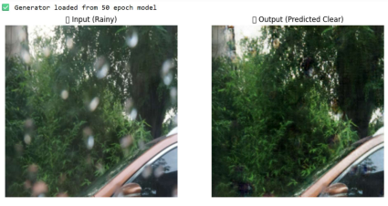Performance :
L1 Loss: 0.0373 (low pixel-wise error)
PSNR: 24.92 dB (high perceptual quality)
Conclusion:
Pix2Pix GAN effectively removes rain artifacts, producing clear images ideal for pre processing in autonomous driving perception pipelines.
3. Snow Removal using Pix2Pix GAN
Dataset : Snow100K Dataset – GitHub.
Link:
https://drive.google.com/file/d/103H_nHOAc_dTzOGIcTiZXbB__B1A0F_2/view?usp =sharing
Colab:https://colab.research.google.com/drive/1ND7ittCBADcEHivW0EsinJ91IAbjwlf 0?usp=sharing
• Training: 2500 paired images (train2500)
• Testing: 20 paired images (test2000)
• Size: All images resized to 256×256, horizontally concatenated for Pix2Pix input
Model & Training
• Generator: U-Net with downsampling/upsampling
• Discriminator PatchGAN
• Loss is GAN Loss (BCE) + 100 × L1 Loss
Training:
• Epochs: 100
• Batch Size: 8
• Optimizer: Adam (lr=0.0002, β1=0.5)
• Device: PyTorch (Colab), auto-detection of CUDA/CPUOutput Images: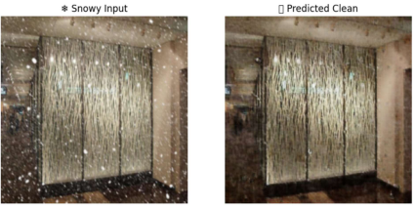
Evaluation
Average PSNR: 23.07 dB
Average SSIM: 0.7699
Conclusion:
Achieved strong visual improvement and structural fidelity in cleared images. Restored images are well-suited for computer vision under snowy conditions.
4. Smoke Removal using Pix2Pix GAN
Dataset : SMOKE.zip
Link : https://drive.google.com/file/d/1HevtcMrK-GYLW9E_a2sC-kl8enFy13PG/view
Google Colab Note Book:
https://colab.research.google.com/drive/1_xKP9wDP2x9KkrbG5PYvW7D_IH8z5Uae?usp=s haring
• Pairs: Hazy input / clean GT, 256×256
• Folders: hazy/ and clean/
Model & Training
• Generator: U-Net (6 downsampling/5 upsampling, Tanh out) • Discriminator: PatchGAN (6-ch input, patchwise prediction)
• Losses: GAN (BCEWithLogits), L1 (weighted ×100)
• Training: 100 epochs, batch size 4, optimized with Adam (lr=2e-4) Output Images:
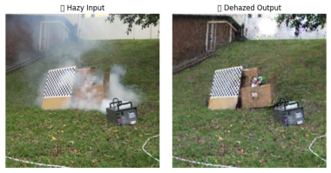
Results
PSNR: 24.00 dB
SSIM: 0.7646
Conclusion:
GAN robustly cleans smoke-affected images, preserving structure and visual clarity, and is ready for real-time deployment in driving vision systems.
5. Fog Removal using Pix2Pix GAN
Dataset : Foggy Cityscapes Dataset
Dataset:https://drive.google.com/file/d/1pahlq9sI
gEoih7WC8NP18vkyjvETxdt/view?usp=sharing
Colab link :
https://colab.research.google.com/drive/1x19feXE3qr5qWnwTP0dz0qQe5QHWHhW v?usp=sharing
• Pairs: 450 (training), 50 (validation)
• (Dense_Fog/, Medium_Fog/, No_Fog/)
Architecture & Training
• Pix2Pix GAN: U-Net generator, PatchGAN discriminator
Setup:
• Epochs: 50
• Input: 256×256
• Optimizer: Adam (lr=2e-4)
• GPU-enabled
Output Images:
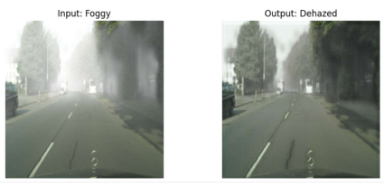Results
Outcome: Successfully restored sharpness and detail in urban foggy scenes. Enhanced clarity supports improved object detection downstream.
6. Weather Removal on Raspberry Pi: Real-World Deployment A. Snow Removal
• Platform: Raspberry Pi 4B (4GB RAM, gan_env venv)
• Tested Model: Pix2Pix GAN (100 epochs)
• Sample Results:
Image PSNR (dB) SSIM
city_read_05321.jpg 22.88 0.7370
city_read_04087.jpg 22.98 0.7663
Average | 23.43 | 0.7516

OutPut Images :
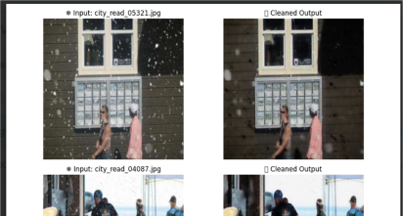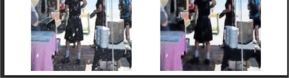
Observations: Pi inference completed in seconds; snow artifacts removed, revealing road details.
Snow Files :
https://drive.google.com/drive/folders/1oLifbesfJ0wqVysPD37JrkXOtgLt6nAg?usp=sharing
B. Rain Removal
• Platform Raspberry Pi (Python 3.11, PyTorch)
• Dataset: 20 pairs, 256×256
• Training: 5 epochs (to allow quick testing)
Rain Files :
https://drive.google.com/drive/folders/1YLkbeMyX4j4FlmDGAIK8sZfHrHPccStI?usp=sharing OutPut Image :
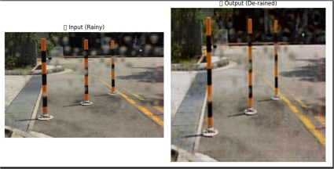Results:
• PSNR: ~11.3 dB
• SSIM: ~0.44
Interpretation:
Rapid Pi tests show the GAN learns to reduce rain, though accuracy is limited by few epochs and small data size. More epochs + larger datasets recommended for production.
7. YOLOv5 Object Detection with Enhanced Images.
Objective
Train a robust YOLOv5-based model to detect road objects after pre-processing images through weather artifact removal GANs.
Dataset :
Colab :
https://colab.research.google.com/drive/1hCU7C1axFpaImtCh_i0OqQqsHWBFy3he?usp=sh aring
• Validation Images: 479
• Total Instances: 3127
• Classes: Biker, Car, Pedestrian, Truck, Traffic Lights (Green, Red, Yellow, directionals)
Model & Training
• Detector: YOLOv5s (Ultralytics, small variant
• Framework: PyTorch
• Input: 640×640
• Epochs: 50
• AMP: Mixed-precision enabled
Metric Value
Training Time 1.592 Hour
Best Model Pah runs/train/my_model/weights/best.pt Box Loss (Last Epoches) 0.0338
Objenctness Loss 0.0304
Classification Loss | 0.0040

OutPut Images :
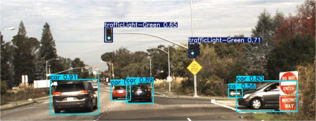Conclusion:
With GAN-cleaned images as input, YOLOv5 achieves strong accuracy and generalization, demonstrating readiness for multi-class detection in challenging real-world conditions.
8. Overall Conclusions
GAN-powered image reconstruction delivers substantial improvements to scene clarity under rain, snow, smoke, and fog.
Embedded feasibility is demonstrated through successful Pi deployments for snow and rain removal, though training/inference capacity remains a key design consideration.
YOLOv5 object detector performs significantly better on GAN-processed clean images than weather-distorted ones, making this pipeline robust and effective for autonomous driving tasks.
Future enhancements:
Real-time Pi camera integration.
Model optimization (quantization, pruning) for faster inference.
Training GANs on larger, more diverse datasets.
Complete end-to-end integration of GAN + detector pipeline for field testing By
VNKUDOTH PRASHANTH
COMPUTER ENGINEERING
NATIONAL INSTITUTE OF ADVANCED MANUFCTURING TECHNOLOGY RANCHI

