Beneath the Surface: Assessing Underground Water Quality at IIT Tirupati

Introduction

Water quality has been a growing concern, significantly affecting the daily lives of students and faculty at IIT Tirupati, particularly regarding health issues such as skin irritation [(Danby](https://www.sciencedirect.com/science/article/pii/S0022202X1732938X) [et al., 2018)](https://www.sciencedirect.com/science/article/pii/S0022202X1732938X) and hair damage.[(Parmar, 2024)](https://www.skushodhsanchar.com/pdf/m-7.pdf) This study's primary objective is to comprehensively analyse the water-related challenges on the IIT Tirupati campus and explore feasible, sustainable, and cost-effective solutions. The campus depends on external water sources despite local groundwater and rainwater reservoirs. This raises critical questions regarding water sustainability, treatment, and management [(Telugu Ganga](https://en.wikipedia.org/wiki/Telugu_Ganga_project) [Project, Wikipedia)](https://en.wikipedia.org/wiki/Telugu_Ganga_project). The Telugu Ganga Project, originally designed to provide drinking water to Chennai, diverts water from the Krishna River and passes through several regions, impacting groundwater and water availability in Tirupati.

Aim

 **Water Quality Assessment** – Analyze chemical composition and contaminants in campus water sources and nearby groundwater (Yerpedu).

 **Groundwater Feasibility Study** – Investigate why IIT Tirupati depends on external water sources instead of its own groundwater reserves.

 **Purification System Design** – Develop a cost-effective water purification system to improve water quality for general use.

 **Sustainability G Impact Analysis** – Evaluate environmental, industrial, and policy factors affecting groundwater availability and usage.

Roles

|  |  |  |
| --- | --- | --- |
| **SNo** | **Role G Members** | **Responsibilities** |
| 1 | **Research G Analysis Team (5)** | Study existing research, identify key testing parameters, and determine suitable analysis methods. |
| 2 | **Survey G Data Collection Team (15)** | Conduct surveys among students and faculty, gather insights on water usage and health concerns, and collect water samples from different sources. |
| 3 | **Water Testing Team (5)** | Perform laboratory examinations to detect contaminants and assess water quality. |
|  | | |

|  |  |  |
| --- | --- | --- |
| 4 | **Prototype Development Team (10)** | Design and test potential purification techniques based on lab results to propose viable solutions. |
| 5 | **Report G Documentation Team(6)** | Compile and Analyse Data to make report |

Methodology

# Review & Problem Statement

 Analyze geological, hydrological, and environmental reports on IIT Tirupati's groundwater trends. Study past research on contamination and purification technologies.

 Define the core issue: Why does IIT Tirupati rely on external water sources despite groundwater availability?

# Surveys & Interviews

 Conduct campus-wide surveys on water-related health issues (skin irritation, hair damage). Interview local farmers, water authorities, and experts to assess groundwater trends and industrial impacts.

 Collect data on water usage, dependency on external sources, and historical shifts in campus water policies.

# Data Collection & Sampling

Sampling Sources:

 **North Campus (Drinfiing G General-Use Water):** Assess water quality in areas where drinking water was discontinued.

 **Campus Borewells:** Evaluate groundwater feasibility.

 **Nearby Groundwater (Yerpedu):** Compare regional quality against the campus water supply.

 **Rainwater Reservoirs G Pond Water (South Campus):** Assess alternative sources.

 Sampling Strategy:

 Collect from different depths and locations to capture contamination variability. (Stratified Sampling)

# Laboratory Testing & Chemical Analysis

Key Contaminants G Effects:

|  |  |  |
| --- | --- | --- |
| **Parameter** | **Max Limit (WHO/BIS)** | **Effects of Excess Levels** |
| **Fluoride (F⁻)** | 1.5 mg/L (WHO), 1.0 mg/L (BIS) | Dental & skeletal fluorosis |
| **Chlorine (Cl⁻)** | 5 mg/L (WHO), 0.2–1 mg/L (BIS) | Throat irritation, nausea, long-term cancer risks |
| **Calcium (Ca²⁺)** | 200 mg/L | Scaling in pipes, kidney stones |
| **Magnesium (Mg²⁺)** | 100 mg/L | Bitter taste, diarrhea |
| **Bicarbonates (HCO₃⁻), Carbonates (CO₃²⁻)** | No limit | High alkalinity, corrosion |
| **Total Hardness (CaCO₃)** | 200 mg/L (Desirable), 600 mg/L (Permissible) | Scaling, poor soap lather, skin dryness |

Testing Methods Selection:

 Testing Methods: Chromatography (organic compounds), Electrochemical (pH, ion concentration), and Titration (hardness, chloride). Compare results with WHO/BIS standards.

 **Data Comparison:** WHO & BIS standards.

# Data Analysis & Problem Diagnosis

 Compare historical vs. current water quality trends.

 Assess industrialization impact and reasons groundwater remains unused.

# Solution Development & Purification Methods

**Why These Purification Techniques?** The choice is based on effectiveness, cost, and scalability:

 **Plasma G Ozone Purification** – Effective for eliminating organic contaminants and pathogens.

 **Membrane Filtration (Reverse Osmosis, Nanofiltration, Ultrafiltration)** – Removes dissolved salts, hardness, and heavy metals.

 **Ion Exchange Resins** – Targets fluoride and hardness removal.

 **Activated Carbon G Bio-Sand Filtration** – Cost-effective for removing chlorine and organic impurities.

Cost-Effective Implementation:

 Use affordable local membranes, explore community-level treatment, and assess groundwater feasibility for campus supply.

# Report & Recommendations

 Compile findings into a report with cost-benefit analysis.

 Recommend sustainable water management strategies for IIT Tirupati.  Present findings to campus authorities for potential implementation.

Expected Outcomes

Campus Water Insights:

 Identify reasons why IIT Tirupati relies on external water sources.  Determine key contaminants affecting campus water quality.

Groundwater Quality Analysis:

 Report on groundwater changes over the past 10 years.  Identify major pollutants and their sources.

Groundwater Utilization G Feasibility:

 Assess the viability of using campus groundwater.  Provide cost-effective solutions for safe usage.

Water Purification System G Application:

 Develop a low-cost purifier targeting identified contaminants.

 Install filtration units at key water access points, including drinking water taps, washroom faucets, showerheads, kitchen sinks, and water dispensers in hostels, academic blocks, and community areas.

 Learning Objectives:

 This project provides hands-on experience in water quality assessment, purification system design, data analysis, and sustainability, while enhancing problem-solving, teamwork, communication, and urban water management skills.

Milestone/Gantt Chart

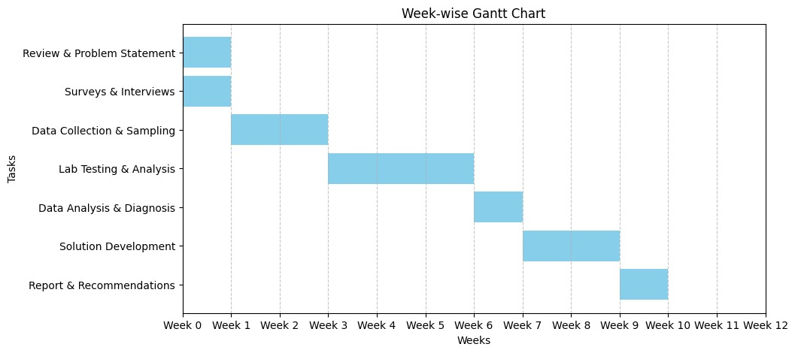

Filtration Stages and Components

|  |  |  |  |
| --- | --- | --- | --- |
| **Stage** | **Component** | **Purpose** | **Cost (₹)** |
| **Stage 1** | Sediment Filter (5 Micron PP Filter) | Removes dirt, sand, rust, and large particles | **500** |
| **Stage 2** | Granular Activated Carbon (GAC) Filter | Removes chlorine, organic compounds, and odor | **800** |
| **Stage 3** | Bone Char Filter | Removes fluoride (F⁻) and heavy metals | **1,500** |
| **Stage 4** | Ceramic Filter with Silver Nanoparticles | Final purification kills bacteria, improves taste | **1,200** |
| **Housing G Accessories** | Filter Housing, Tubing, Taps, Connectors | Assembly and setup | **500** |
| **TOTAL COST** |  |  | **₹5,000** |

References

[Subbaiah, P. V., Naidu, M. V. S., Krishna, Y. R., & Kaledhonkar, M. J. (2020). Assessment](https://drive.google.com/file/d/1jiuBTKOouRHOtblhM-4aMTPabDHBfDLY/view?usp=drive_link) [of Groundwater Quality for Irrigation in Chittoor District of Andhra Pradesh. The Andhra](https://drive.google.com/file/d/1jiuBTKOouRHOtblhM-4aMTPabDHBfDLY/view?usp=drive_link) [Agricultural Journal, 67(2), 46-55.](https://drive.google.com/file/d/1jiuBTKOouRHOtblhM-4aMTPabDHBfDLY/view?usp=drive_link)

[Swathi, K., Nikitha, B., Malleswari, M., Munisankar, M., Meena, S. D., & Roja, A. (2023).](https://pubmed.ncbi.nlm.nih.gov/37581825/#%3A~%3Atext%3DBased%20on%20the%20physico%2Dchemical%2CSettipalli%2C%20Andhra%20Pradesh%2C%20India) [Water Quality Analysis Using Physicochemical Parameters and Estimation of Pesticides](https://pubmed.ncbi.nlm.nih.gov/37581825/#%3A~%3Atext%3DBased%20on%20the%20physico%2Dchemical%2CSettipalli%2C%20Andhra%20Pradesh%2C%20India) [in Water from Various Sources of Tirupati, Andhra Pradesh, India.](https://pubmed.ncbi.nlm.nih.gov/37581825/#%3A~%3Atext%3DBased%20on%20the%20physico%2Dchemical%2CSettipalli%2C%20Andhra%20Pradesh%2C%20India)

[Veeraswamy, G., Balaji, E., & Subba Rao, M. (2019). Ground water quality assessment for](https://drive.google.com/file/d/1qLYpNAf00qNkE-SL5CVjQIZGgebxDzeC/view?usp=sharing)

[Central Ground Water Board. (2016). Ground water year book 2014-15: Andhra Pradesh.](https://drive.google.com/file/d/1CjwcCPa37V7N7jwpBzyB5rxH-v64xBnZ/view?usp=sharing) [Ministry of Water Resources, River Development and Ganga Rejuvenation, Government](https://drive.google.com/file/d/1CjwcCPa37V7N7jwpBzyB5rxH-v64xBnZ/view?usp=sharing) [of India.](https://drive.google.com/file/d/1CjwcCPa37V7N7jwpBzyB5rxH-v64xBnZ/view?usp=sharing)

[Yang, Y., Zhang, S., Yang, G., Li, H., Wang, J., & Li, W. (2023). Biological Activated](https://www.mdpi.com/2073-4441/15/21/3803?utm_source=chatgpt.com) [Carbon Filtration Controls Membrane Fouling and Reduces By-Products from Chemically](https://www.mdpi.com/2073-4441/15/21/3803?utm_source=chatgpt.com) [Enhanced Backwashing during Ultrafiltration Treatment. Water, 15(21), 3803.](https://www.mdpi.com/2073-4441/15/21/3803?utm_source=chatgpt.com)

[Li, C., Yang, J., Zhang, L., Li, S., Yuan, Y., Xiao, X., Fan, X., & Song, C. (2021). Carbon-](https://link.springer.com/article/10.1007/s10311-020-01112-8?utm_source=chatgpt.com) [based membrane materials and applications in water and wastewater treatment: a](https://link.springer.com/article/10.1007/s10311-020-01112-8?utm_source=chatgpt.com) [review. Environmental Chemistry Letters, 19, 1457-1475.](https://link.springer.com/article/10.1007/s10311-020-01112-8?utm_source=chatgpt.com)