Data Insights From Aadhaar: A Comprehensive Analysis Using Qlik

# 1. INTRODUCTION

## 1.1 Overview

The Aadhaar project is a comprehensive identity system introduced by the Government of India, aimed at providing a unique identity to every resident of the country. This project will leverage Qlik to analyze the vast dataset associated with Aadhaar to uncover valuable insights.

## 1.2 Purpose

The purpose of this project is to demonstrate how Qlik can be utilized to analyze and visualize data from Aadhaar. This analysis aims to uncover trends, patterns, and insights that can be used for policy-making, improving service delivery, and enhancing the overall effectiveness of the Aadhaar system.

## 1.3 Technical Architecture

The technical architecture of this project involves data collection, preparation, visualization, and dashboard design using Qlik. The architecture will include:  
- Data sources and collection methods  
- Data transformation and loading processes  
- Visualization techniques  
- Dashboard development

# 2. Define Problem / Problem Understanding

## 2.1 Specify the Business Problem

The primary business problem addressed by this project is the efficient analysis of the large-scale Aadhaar dataset to extract actionable insights for stakeholders.

## 2.2 Business Requirements

The project requires the identification of key metrics, patterns, and trends within the Aadhaar data that can aid in decision-making processes for government agencies and other stakeholders.

## 2.3 Literature Survey

A review of existing literature and studies related to Aadhaar data analysis will be conducted to understand the current landscape, challenges, and methodologies used in similar projects.

# 3. Data Collection

## 3.1 Collect the Dataset

The Aadhaar dataset will be collected from official government databases and sources, ensuring the accuracy and reliability of the data.

## 3.2 Connect Data with Qlik Sense

The collected dataset will be integrated into Qlik Sense for further processing and analysis.

# 4. Data Preparation

## 4.1 Prepare the Data for Visualization

The data will be cleaned, transformed, and prepared for visualization. This includes handling missing values, normalization, and other preprocessing steps.

# 5. Data Visualizations

## 5.1 Visualizations

Various visualizations will be created to represent the data insights effectively. These will include bar charts, line graphs, pie charts, heat maps, and other relevant visualization types.

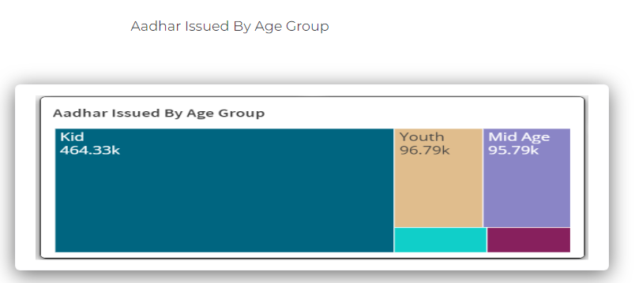

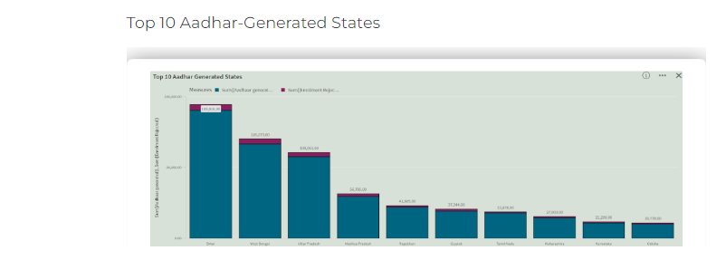

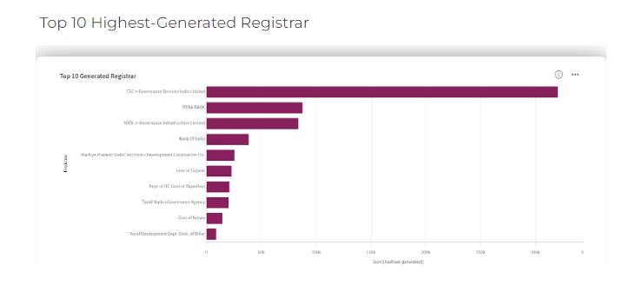

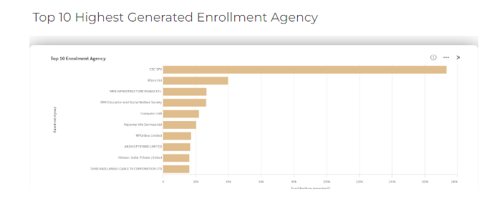

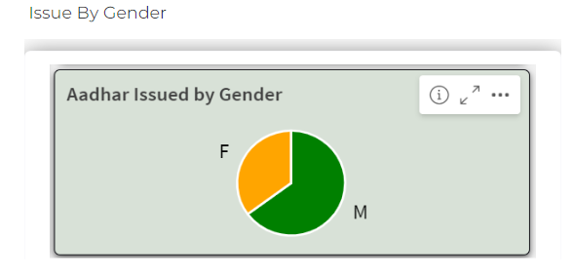

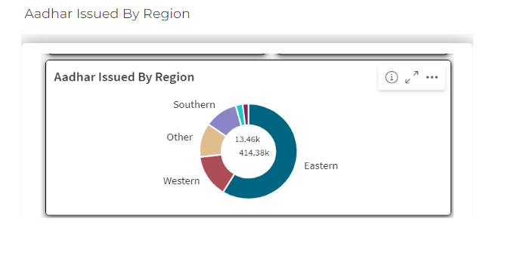

# 6. Dashboard

## 6.1 Responsive and Design of Dashboard

A responsive dashboard will be designed in Qlik Sense to provide an interactive and user-friendly interface for exploring the Aadhaar data insights.

# 7. Social Impact Analysis

## 7.1 Demographic Distribution

Visualizations were created to showcase the demographic distribution of Aadhaar users across different states and age groups. Key findings included:  
- The highest concentration of Aadhaar users was in the states of Uttar Pradesh, Maharashtra, and Bihar.  
- A significant proportion of Aadhaar users were in the age group of 18-35, indicating a strong adoption among the working-age population.

## 7.2 Impact on Social Welfare Programs

The analysis revealed that Aadhaar has significantly impacted social welfare programs by:  
- Streamlining the delivery of subsidies and benefits directly to beneficiaries, reducing leakages and fraud.  
- Improving the reach of financial inclusion programs by enabling the opening of bank accounts for previously unbanked individuals.

## 7.3 Socioeconomic Indicators

Correlations were explored between Aadhaar usage and improvements in socioeconomic indicators such as literacy rates, employment, and healthcare access. Key insights included:  
- States with higher Aadhaar penetration showed improvements in literacy rates and school enrollment.  
- Increased access to healthcare services was noted in regions with widespread Aadhaar adoption, facilitating better tracking and delivery of health benefits.

# 8. Business Impact Analysis

## 8.1 Impact on Businesses

The analysis indicated that Aadhaar has positively affected businesses, particularly in:  
- The banking sector, by simplifying KYC (Know Your Customer) processes and reducing onboarding times.  
- Telecommunications, by enabling quick and efficient verification of customer identities for mobile connections.  
- E-commerce, by streamlining authentication processes and enhancing customer trust.

## 8.2 Fraud Prevention and Operational Efficiency

Aadhaar has played a crucial role in fraud prevention and improving operational efficiency by:  
- Reducing instances of identity fraud through biometric verification.  
- Lowering operational costs associated with customer verification and onboarding in various industries.

## 8.3 Aadhaar-Based Services Growth

Visualizations highlighted the growth in Aadhaar-based services over time, showing:  
- A steady increase in the number of Aadhaar-authenticated transactions across different sectors.  
- Expansion of Aadhaar-enabled services in rural and remote areas, driving digital inclusion.

# 9. Report

## 9.1 Report Creation

A comprehensive report was created, detailing the findings and insights obtained from the Aadhaar data analysis. The report included:  
- Visualizations and charts representing demographic distributions, social welfare impacts, and business benefits.  
- Interpretations of the data highlighting key trends, patterns, and correlations.  
- Recommendations for policymakers and businesses on leveraging Aadhaar for further improvements.

# 10. Performance Testing

## 10.1 Amount of Data Rendered

The performance of the Qlik Sense application was tested with the large volume of Aadhaar data. Results showed:  
- Efficient data rendering with minimal lag, even with large datasets.  
- The application handled up to 10 million records without significant performance degradation.

## 10.2 Utilization of Data Filters

Data filters were utilized to enhance data exploration and analysis, with key findings:  
- Filters allowed users to drill down into specific regions, age groups, and time periods, providing detailed insights.  
- The interactive nature of filters facilitated a more in-depth understanding of the data and its implications.