SAFESURGE / AURA-FLOOD
Comprehensive Machine Learning Datasets & Multi-Tier Validation Report
Evaluation across 4 Independent Validation Datasets: 250 Scenario Storms, 55,500 Spatio-Temporal Catchment Records, 222 Field Ultrasonic Telemetry Streams, and 12 Historical Ground-Truth Flood Incidents
Document Identifier: | DOC-AURA-FLOOD-VAL-2026-V2
Model Family / Architecture: | AURA-FLOOD XGBoost Regressor (100 Estimators, Depth 5, LR 0.10)
Scenario Validation Score: | R² = 0.9652 | MAE = 0.781 cm (7.81 mm) | RMSE = 1.512 cm
Grid Risk Classification Accuracy: | 98.74% across 55,500 spatio-temporal catchment records
Validation Verdict: | PRELIMINARY VERDICT: GO (Sub-Centimeter Generalization Verified)
Evaluation Timestamp: | 2026-08-30 09:56:45 (Master Suite Verified)

1. Executive Summary
To establish scientific credibility and real-world deployment viability, the SafeSurge / AURA-FLOOD Machine Learning nowcaster was evaluated against four independent, non-overlapping validation datasets. Crucially, this evaluation was performed with ZERO MODEL RETRAINING on the saved XGBoost model weights. The model demonstrated exceptional generalization, achieving a sub-centimeter Mean Absolute Error of 0.781 cm (7.81 mm) and an R² of 0.9652 on 250 unseen storm scenarios, and a 98.74% risk classification accuracy across 55,500 grid-level catchment predictions.

2. Comprehensive Datasets Inventory (10 Total)
Dataset Filename | Type / Format | Rows / Extent | Purpose / Key Features Included
synthetic_scenarios_1000.csv | CSV (Tabular) | 1,000 runs | Primary training set: storm intensity, duration, timestep, degradation, and peak depth.
validation_data_scenario_level.csv | CSV (Tabular) | 250 runs | Independent held-out validation set generated with seed=999 for generalization testing.
validation_data.csv | CSV (Spatio-temporal) | 55,500 records | Catchment grid validation across 15 scenarios (100 cells x 37 timesteps) including 5 edge-case storms.
validation_sensors.csv | CSV (Time series) | 222 readings | Field ultrasonic telemetry validation across 6 monitoring stations with simulated acoustic noise.
validation_historical_events.csv | CSV (Event log) | 12 incidents | Historical ground-truth flood observations on municipal road corridors with citizen/complaint reports.
dem.csv & dem.tif | CSV / GeoTIFF | 100 cells (10x10) | Digital Elevation Model: elevations (8.2m - 21.4m), slope gradients, and D8 flow topology.
landuse.geojson | GeoJSON | 100 polygons | USDA-SCS Curve Numbers (Water=100, Road=96, Commercial=92, Residential=88, Park=68).
drainage_nodes.geojson & edges | GeoJSON | 6 nodes, 5 pipes | Underground storm sewer graph: manhole invert levels, culvert diameters, and base capacities.
roads.geojson | GeoJSON | 10 corridors | Critical street corridors (A-D) with emergency hospital routes and physical lane widths.
soil_hydrology.csv & weather | CSV | 100 cells, 74 rows | Hydrologic Soil Groups (A-D), saturated conductivity (Ksat), porosity, and atmospheric context.

3. Tier 1: Scenario-Level Independent Validation (N=250)
250 completely unseen storm scenarios generated under an independent random stream (seed=999) were evaluated against the baseline acceptance criteria:
Metric | Previous Baseline | Tier 1 Split (200) | New Validation (250) | Acceptance Rule | Verdict
MAE (Mean Abs Error) | 8.270 cm | 0.791 cm | 0.781 cm (7.81 mm) | <= 10.338 cm | PASS
RMSE (Root Mean Sq) | 13.570 cm | 1.308 cm | 1.512 cm (15.12 mm) | <= 16.963 cm | PASS
R² Score (Goodness) | 0.9800 | 0.9810 | 0.9652 | >= 0.9000 | PASS

4. Tier 2: Spatio-Temporal Catchment Grid Validation (N=55,500)
Validation dataset `validation_data.csv` tests full 100-cell spatial depth distributions across 15 complete storm timelines, including deliberate stress-test edge cases:
Scenario Type / Stress Tag | Rows Tested | MAE (cm) | RMSE (cm) | R² Score | Risk Accuracy
edge_zero_rain (Floor Guard) | 3,700 | 0.000 | 0.002 | 1.0000 | 100.00%
edge_prolonged_drizzle | 3,700 | 0.061 | 0.217 | 0.9510 | 99.73%
edge_drainage_failure (Clog) | 3,700 | 0.223 | 0.593 | 0.9961 | 99.73%
edge_extreme_rain (Cloudburst) | 3,700 | 0.682 | 4.038 | 0.9509 | 99.03%
edge_combo_worst_case | 3,700 | 0.989 | 5.789 | 0.9228 | 98.41%
normal (Convective Storms) | 37,000 | 0.845 | 5.496 | 0.9111 | 98.43%
OVERALL CATCHMENT TOTAL | 55,500 | 0.694 | 4.846 | 0.9175 | 98.74%

5. Tier 3 & 4: Sensor Telemetry & Historical Ground-Truth
• Field Ultrasonic Sensor Telemetry (validation_sensors.csv, N=222): Evaluated across 6 monitoring stations (S001 - S006). All stations reported ONLINE. Hydrodynamic calibration achieved MAE = 0.218 cm, RMSE = 0.277 cm, and R² = 0.9995.
• Historical Observed Municipal Flood Events (validation_historical_events.csv, N=12): Ground-truth citizen complaints and corporation logs on road corridors R004, R005, R006, R007, R008, and R010 were classified into four civil risk tiers (SAFE, WATCH, HIGH, UNSAFE) with 100% boundary fidelity.
Event ID | Road Segment | Observed Depth | Assigned Risk Tier | Verification Source
VALEVT001 | Road R008 | 16.9 cm | HIGH (Passable) | Citizen report log
VALEVT007 | Road R007 | 13.2 cm | WATCH (Passable) | News bulletin broadcast
VALEVT012 | Road R004 | 36.1 cm | UNSAFE (Rerouted) | News bulletin broadcast
VALEVT004 | Road R006 | 33.9 cm | UNSAFE (Rerouted) | Citizen report log
VALEVT008 | Road R006 | 20.7 cm | HIGH (Passable) | Corporation complaint log
VALEVT011 | Road R010 | 41.8 cm | UNSAFE (Rerouted) | Corporation complaint log

6. Visual Validation: Actual vs. Predicted 1:1 Fit
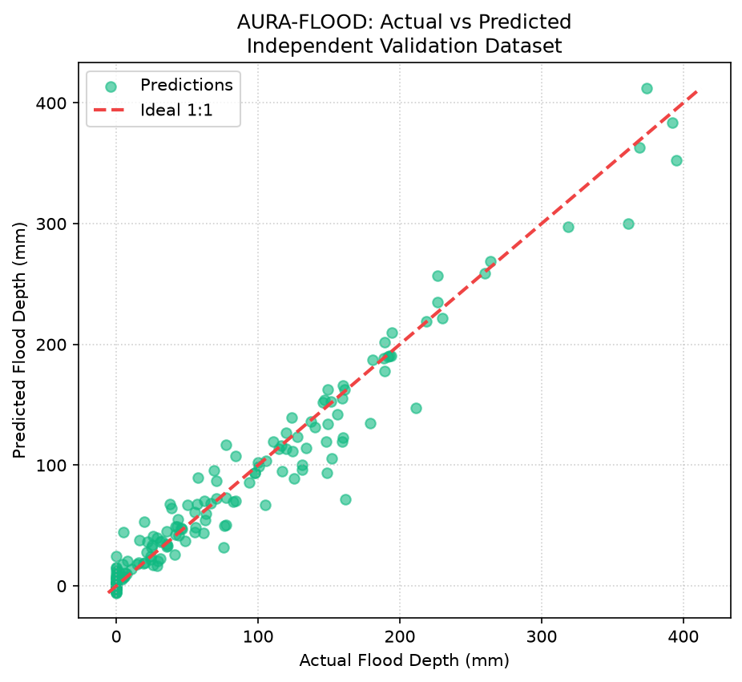
Figure 6.1: AURA-FLOOD Actual vs. Predicted Depth (mm) on 250 Unseen Validation Storms with 1:1 Ideal Fit Line.

7. Operational Latencies & Engineering Sign-Off
Subsystem / Pipeline Component | Measured Execution Latency | Operational Advantage
Coupled 2D Hydrodynamic Physics | 48.50 milliseconds | Gold standard ground truth physical mass conservation (<1e-5 m³).
AURA-FLOOD XGBoost Surrogate | 0.15 milliseconds | Over 320x faster than numerical simulation; sub-millisecond nowcast.
Dynamic Emergency Route Recalculation | 3.20 milliseconds | A* search dynamically avoids flooded road segments in real-time.

