Question #11
DRAG DROP -
You need to create a partitioned table in an Azure Synapse Analytics dedicated SQL pool.
How should you complete the Transact-SQL statement? To answer, drag the appropriate values to the correct targets. Each value may be used once, more than once, or not at all. You may need to drag the split bar between panes or scroll to view content.
NOTE: Each correct selection is worth one point.
Select and Place:
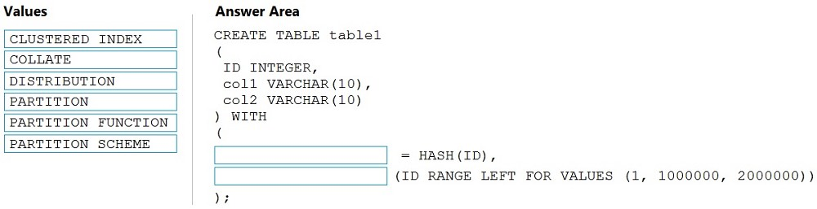
Answer:
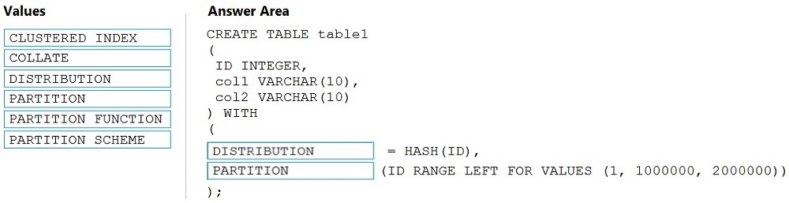

Box 1: DISTRIBUTION -
Table distribution options include DISTRIBUTION = HASH ( distribution_column_name ), assigns each row to one distribution by hashing the value stored in distribution_column_name.
Box 2: PARTITION -
Table partition options. Syntax:
PARTITION ( partition_column_name RANGE [ LEFT | RIGHT ] FOR VALUES ( [ boundary_value [,...n] ] ))
Reference:
https://docs.microsoft.com/en-us/sql/t-sql/statements/create-table-azure-sql-data-warehouse?

Question #12
You need to design an Azure Synapse Analytics dedicated SQL pool that meets the following requirements:
✑ Can return an employee record from a given point in time.
✑ Maintains the latest employee information.
✑ Minimizes query complexity.
How should you model the employee data?
- A. as a temporal table
- B. as a SQL graph table
- C. as a degenerate dimension table
- D. as a Type 2 slowly changing dimension (SCD) table

Answer D; Temporal table is better than SCD2, but it is not supported in Synpase yet
Here's the documentation for how to implement temporal tables in Synapse from 2019. https://docs.microsoft.com/en-us/azure/synapse-analytics/sql-data-warehouse/sql-data-warehouse-tables-temporary
Temporal tables and Temporary tables are two very distinct concepts. Your link has absolutely nothing to do with this question.
Sorry Answer is D: SCD 2 , as according to microsoft docs ,"Temporal tables keep data closely related to time context so that stored facts can be interpreted as valid only within the specific period." , as in the question it is mentioned "from a given point in time", so D seems to be the correct.
temPORAL table purpose is to query point in time data which can perform beyond what SCD2 can do, but its not supported in synapse

Question #13
You have an enterprise-wide Azure Data Lake Storage Gen2 account. The data lake is accessible only through an Azure virtual network named VNET1.
You are building a SQL pool in Azure Synapse that will use data from the data lake.
Your company has a sales team. All the members of the sales team are in an Azure Active Directory group named Sales. POSIX controls are used to assign the
Sales group access to the files in the data lake.
You plan to load data to the SQL pool every hour.
You need to ensure that the SQL pool can load the sales data from the data lake.
Which three actions should you perform? Each correct answer presents part of the solution.
NOTE: Each area selection is worth one point.
- A. Add the managed identity to the Sales group.
- B. Use the managed identity as the credentials for the data load process.
- C. Create a shared access signature (SAS).
- D. Add your Azure Active Directory (Azure AD) account to the Sales group.
- E. Use the shared access signature (SAS) as the credentials for the data load process.
- F. Create a managed identity.

Correct Answer should be
F. Create a managed identity.
A. Add the managed identity to the Sales group.
B. Use the managed identity as the credentials for the data load process.

Is answer A properly worded? "Add the managed identity to the Sales group" should be "Add the Sales group to managed identity"
So Since the synapse dedicated sql pool is only accessible through an Azure virtual network wouldn't it make more since for the following steps: 1. Create a managed identity for synapse analytics workspace 2. Give role based access to managed identity 3. Use the managed identity as the credentials for the data load process. This would not be giving the managed identity to the sales group and follows the least permissions principle

Question #14
HOTSPOT -
You have an Azure Synapse Analytics dedicated SQL pool that contains the users shown in the following table.
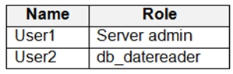
User1 executes a query on the database, and the query returns the results shown in the following exhibit.
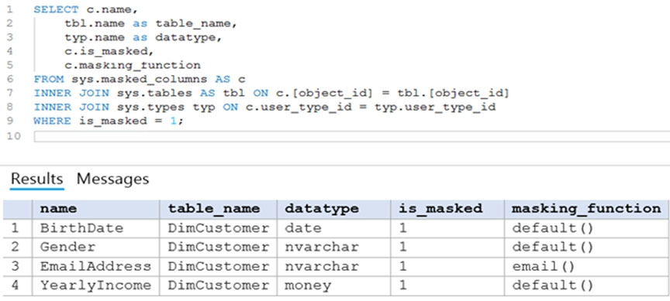
User1 is the only user who has access to the unmasked data.
Use the drop-down menus to select the answer choice that completes each statement based on the information presented in the graphic.
NOTE: Each correct selection is worth one point.
Hot Area:
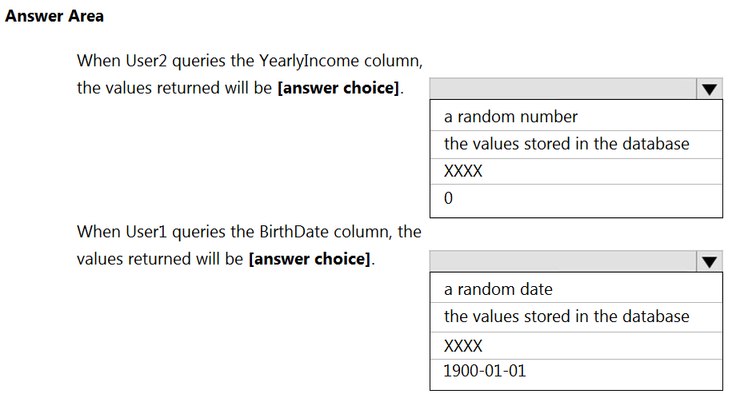

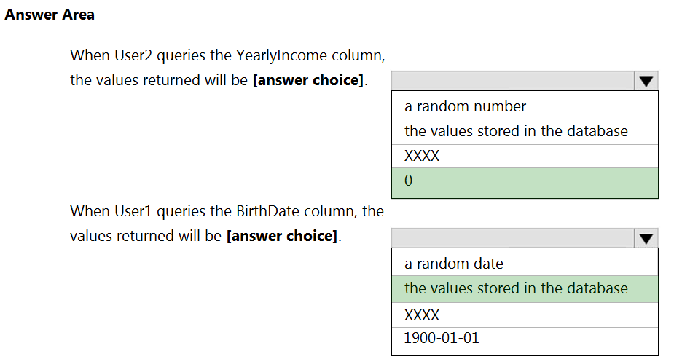

Box 1: 0 -
The YearlyIncome column is of the money data type.
The Default masking function: Full masking according to the data types of the designated fields
✑ Use a zero value for numeric data types (bigint, bit, decimal, int, money, numeric, smallint, smallmoney, tinyint, float, real).
Box 2: the values stored in the database
Users with administrator privileges are always excluded from masking, and see the original data without any mask.
Reference:
https://docs.microsoft.com/en-us/azure/azure-sql/database/dynamic-data-masking-overview

Question #15
You have an enterprise data warehouse in Azure Synapse Analytics.
Using PolyBase, you create an external table named [Ext].[Items] to query Parquet files stored in Azure Data Lake Storage Gen2 without importing the data to the data warehouse.
The external table has three columns.
You discover that the Parquet files have a fourth column named ItemID.
Which command should you run to add the ItemID column to the external table?
A.
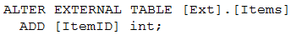
B.
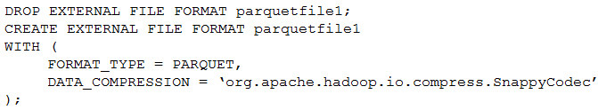
C.
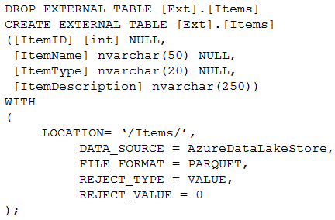
D.
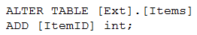

Correct Answer: C
Incorrect Answers:
A, D: Only these Data Definition Language (DDL) statements are allowed on external tables:
✑ CREATE TABLE and DROP TABLE
✑ CREATE STATISTICS and DROP STATISTICS
✑ CREATE VIEW and DROP VIEW
Reference:
https://docs.microsoft.com/en-us/sql/t-sql/statements/create-external-table-transact-sql

C is correct, since "altering the schema or format of an external SQL table is not supported". https://learn.microsoft.com/en-us/azure/data-explorer/kusto/management/external-sql-tables
ALTER statement is not supported on external table, you need to DROP it and CREATE it again

Question #16
HOTSPOT -
You have two Azure Storage accounts named Storage1 and Storage2. Each account holds one container and has the hierarchical namespace enabled. The system has files that contain data stored in the Apache Parquet format.
You need to copy folders and files from Storage1 to Storage2 by using a Data Factory copy activity. The solution must meet the following requirements:
✑ No transformations must be performed.
✑ The original folder structure must be retained.
✑ Minimize time required to perform the copy activity.
How should you configure the copy activity? To answer, select the appropriate options in the answer area.
NOTE: Each correct selection is worth one point.
Hot Area:
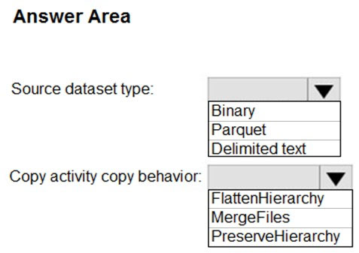

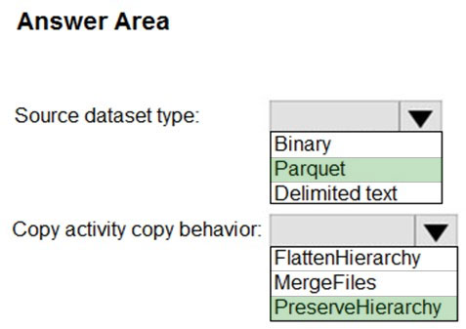

Box 1: Parquet -
For Parquet datasets, the type property of the copy activity source must be set to ParquetSource.
Box 2: PreserveHierarchy -
PreserveHierarchy (default): Preserves the file hierarchy in the target folder. The relative path of the source file to the source folder is identical to the relative path of the target file to the target folder.
Incorrect Answers:
✑ FlattenHierarchy: All files from the source folder are in the first level of the target folder. The target files have autogenerated names.
✑ MergeFiles: Merges all files from the source folder to one file. If the file name is specified, the merged file name is the specified name. Otherwise, it's an autogenerated file name.
Reference:
https://docs.microsoft.com/en-us/azure/data-factory/format-parquet https://docs.microsoft.com/en-us/azure/data-factory/connector-azure-data-lake-storage

Question #17
You have an Azure Data Lake Storage Gen2 container that contains 100 TB of data.
You need to ensure that the data in the container is available for read workloads in a secondary region if an outage occurs in the primary region. The solution must minimize costs.
Which type of data redundancy should you use?
- A. geo-redundant storage (GRS)
- B. read-access geo-redundant storage (RA-GRS)
- C. zone-redundant storage (ZRS)
- D. locally-redundant storage (LRS)

B is right Geo-redundant storage (with GRS or GZRS) replicates your data to another physical location in the secondary region to protect against regional outages. However, that data is available to be read only if the customer or Microsoft initiates a failover from the primary to secondary region. When you enable read access to the secondary region, your data is available to be read at all times, including in a situation where the primary region becomes unavailable.
A looks correct answer. RA-GRS is always avialable because its auto failover. Since this is not asked in the question but more importantly the question is about reducing cost which GRS.

It should be A because of two reasons: 1. Minimize cost 2. When primary is unavailable. Hence No need for RA_GRS
its not A, dude, if you dont understand the difference between GRS and RA-GRS then u need az 101. With GRS, the 2nd region is NEVER available for access until Microsoft fails over the first failed region. Otherwise, you can NEVER access the 2nd regions data. Hence RA-GRS.
The question clearly says "is available for read workloads in a secondary region". This is only available when choosing RA-GRS.* With GRS, when a disaster happens in the primary region, the user has to initiate a failover so that the secondary region becomes the primary region**. At no point you are reading from your secondary region with GRS. Hence i believe the answers should be B. *https://learn.microsoft.com/en-us/azure/storage/common/storage-redundancy#geo-redundant-storage **https://learn.microsoft.com/en-us/azure/storage/common/storage-disaster-recovery-guidance

Question #18
You plan to implement an Azure Data Lake Gen 2 storage account.
You need to ensure that the data lake will remain available if a data center fails in the primary Azure region. The solution must minimize costs.
Which type of replication should you use for the storage account?
- A. geo-redundant storage (GRS)
- B. geo-zone-redundant storage (GZRS)
- C. locally-redundant storage (LRS)
- D. zone-redundant storage (ZRS)

First, about the Question: What fails? -> The (complete) DataCenter, not the region and not components inside a DataCenter. So, what helps us in this situation? LRS: "..copies your data synchronously three times within a single physical location in the primary region." Important is here the SINGLE PHYSICAL LOCATION (meaning inside the same Data Center. So in our scenario all copies wouldn't work anymore.) -> C is wrong. ZRS: "...copies your data synchronously across three Azure availability zones in the primary region" (meaning, in different Data Centers. In our scenario this would meet the requirements) -> D is right GRS/GZRS: are like LRS/ZRS but with the Data Centers in different azure regions. This works too but is more expensive than ZRS. So ZRS is the right answer. https://docs.microsoft.com/en-us/azure/storage/common/storage-redundancy

Question #19
HOTSPOT -
You have a SQL pool in Azure Synapse.
You plan to load data from Azure Blob storage to a staging table. Approximately 1 million rows of data will be loaded daily. The table will be truncated before each daily load.
You need to create the staging table. The solution must minimize how long it takes to load the data to the staging table.
How should you configure the table? To answer, select the appropriate options in the answer area.
NOTE: Each correct selection is worth one point.
Hot Area:
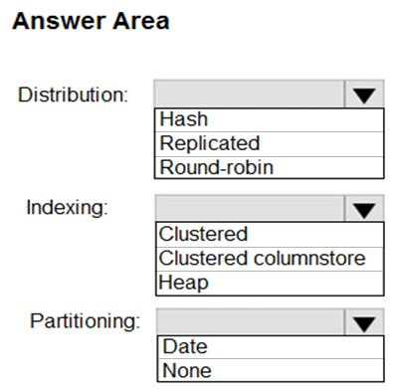

Box 1: Hash -
Hash-distributed tables improve query performance on large fact tables. They can have very large numbers of rows and still achieve high performance.
Incorrect Answers:
Round-robin tables are useful for improving loading speed.
Box 2: Clustered columnstore -
When creating partitions on clustered columnstore tables, it is important to consider how many rows belong to each partition. For optimal compression and performance of clustered columnstore tables, a minimum of 1 million rows per distribution and partition is needed.
Box 3: Date -
Table partitions enable you to divide your data into smaller groups of data. In most cases, table partitions are created on a date column.
Partition switching can be used to quickly remove or replace a section of a table.
Reference:
https://docs.microsoft.com/en-us/azure/synapse-analytics/sql-data-warehouse/sql-data-warehouse-tables-partition
https://docs.microsoft.com/en-us/azure/synapse-analytics/sql-data-warehouse/sql-data-warehouse-tables-distribute

Actual Answer and Justification
Round-robin - this is the simplest distribution model, not great for querying but fast to process Heap - no brainer when creating staging tables No partitions - this is a staging table, why add effort to partition, when truncated daily?

Question #20
You are designing a fact table named FactPurchase in an Azure Synapse Analytics dedicated SQL pool. The table contains purchases from suppliers for a retail store. FactPurchase will contain the following columns.
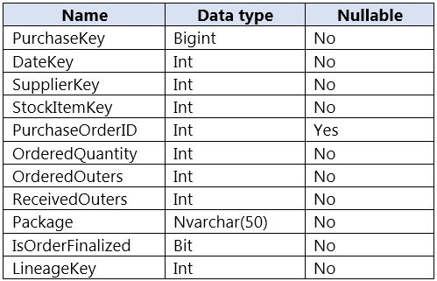
FactPurchase will have 1 million rows of data added daily and will contain three years of data.
Transact-SQL queries similar to the following query will be executed daily.
SELECT -
SupplierKey, StockItemKey, IsOrderFinalized, COUNT(*)
FROM FactPurchase -
WHERE DateKey >= 20210101 -
AND DateKey <= 20210131 -
GROUP By SupplierKey, StockItemKey, IsOrderFinalized
Which table distribution will minimize query times?
- A. replicated
- B. hash-distributed on PurchaseKey
- C. round-robin
- D. hash-distributed on IsOrderFinalized

Correct Answer: B. Hash-Distributed on PurchaseKey 💡 Explanation: Azure Synapse Analytics supports three table distribution methods: Replicated, Hash-Distributed, and Round-Robin. The best choice depends on the workload and query patterns. 1️⃣ Why Use Hash Distribution? The FactPurchase table will have 1 million rows added daily and contain three years of data → This results in over 1 billion rows, making hash distribution the best option for efficient querying. Queries GROUP BY SupplierKey, StockItemKey, and IsOrderFinalized → A hash-distributed table will ensure these columns are evenly distributed across compute nodes, reducing data movement and improving query performance. 2️⃣ Why Hash on PurchaseKey? PurchaseKey is the primary key (unique for each purchase). Ideal for distributing data evenly across compute nodes, avoiding data skew. Improves aggregation queries where GROUP BY is used on multiple dimensions.

hash distribution on high cardinatlity column can also avoid data skew
Hash-distributed tables improve query performance on large fact tables. The PurchaseKey has many unique values, does not have NULLs and is not a date column.

Question #21
HOTSPOT -
From a website analytics system, you receive data extracts about user interactions such as downloads, link clicks, form submissions, and video plays.
The data contains the following columns.
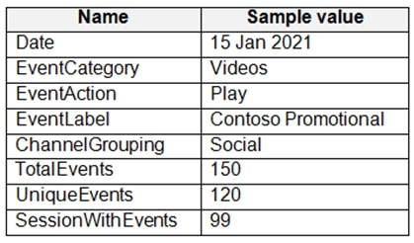
You need to design a star schema to support analytical queries of the data. The star schema will contain four tables including a date dimension.
To which table should you add each column? To answer, select the appropriate options in the answer area.
NOTE: Each correct selection is worth one point.
Hot Area:
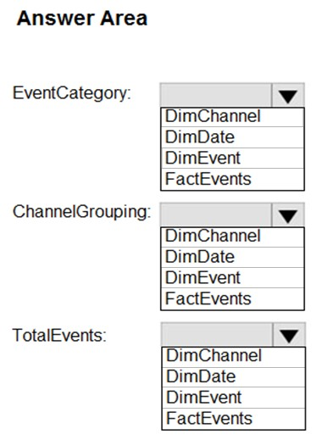
Answer: 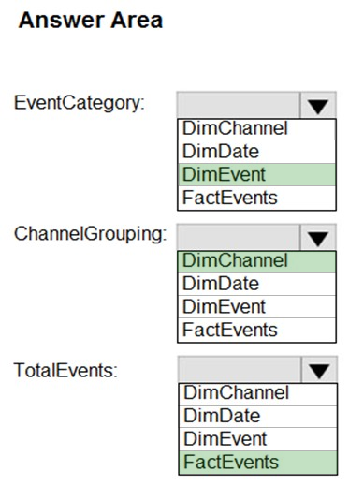
Box 1: DimEvent -
Box 2: DimChannel -
Box 3: FactEvents -
Fact tables store observations or events, and can be sales orders, stock balances, exchange rates, temperatures, etc
Reference:
https://docs.microsoft.com/en-us/power-bi/guidance/star-schema

Question #22
Note: This question is part of a series of questions that present the same scenario. Each question in the series contains a unique solution that might meet the stated goals. Some question sets might have more than one correct solution, while others might not have a correct solution.
After you answer a question in this section, you will NOT be able to return to it. As a result, these questions will not appear in the review screen.
You have an Azure Storage account that contains 100 GB of files. The files contain rows of text and numerical values. 75% of the rows contain description data that has an average length of 1.1 MB.
You plan to copy the data from the storage account to an enterprise data warehouse in Azure Synapse Analytics.
You need to prepare the files to ensure that the data copies quickly.
Solution: You convert the files to compressed delimited text files.
Does this meet the goal?
- A. Yes
- B. No

Compression doesn't not only help to reduce the size or space occupied by a file in a storage but also increases the speed of file movement during transfer
https://azure.microsoft.com/en-gb/blog/increasing-polybase-row-width-limitation-in-azure-sql-data-warehouse/
Yes, converting the files to compressed delimited text files is a good solution to ensure the data copies quickly to Azure Synapse Analytics.

Question #23
Note: This question is part of a series of questions that present the same scenario. Each question in the series contains a unique solution that might meet the stated goals. Some question sets might have more than one correct solution, while others might not have a correct solution.
After you answer a question in this section, you will NOT be able to return to it. As a result, these questions will not appear in the review screen.
You have an Azure Storage account that contains 100 GB of files. The files contain rows of text and numerical values. 75% of the rows contain description data that has an average length of 1.1 MB.
You plan to copy the data from the storage account to an enterprise data warehouse in Azure Synapse Analytics.
You need to prepare the files to ensure that the data copies quickly.
Solution: You copy the files to a table that has a columnstore index.
Does this meet the goal?
- A. Yes
- B. No

From the documentation, loads to heap table are faster than indexed tables. So, better to use heap table than columnstore index table in this case. https://docs.microsoft.com/en-us/azure/synapse-analytics/sql-data-warehouse/sql-data-warehouse-tables-index#heap-tables
- A columnstore index stores columns separately, allowing queries to only read relevant columns, making queries much faster! - Columnstore indexes automatically compress data, reducing storage size and I/O. - This is especially useful for large text data like descriptions and numerical values
To achieve the fastest loading speed for moving data into a data warehouse table, load data into a staging table. Define the staging table as a heap and use round-robin for the distribution option

Question #24
Note: This question is part of a series of questions that present the same scenario. Each question in the series contains a unique solution that might meet the stated goals. Some question sets might have more than one correct solution, while others might not have a correct solution.
After you answer a question in this section, you will NOT be able to return to it. As a result, these questions will not appear in the review screen.
You have an Azure Storage account that contains 100 GB of files. The files contain rows of text and numerical values. 75% of the rows contain description data that has an average length of 1.1 MB.
You plan to copy the data from the storage account to an enterprise data warehouse in Azure Synapse Analytics.
You need to prepare the files to ensure that the data copies quickly.
Solution: You modify the files to ensure that each row is more than 1 MB.
Does this meet the goal?
- A. Yes
- B. No

No, rows need to have less than 1 MB. A batch size between 100 K to 1M rows is the recommended baseline for determining optimal batch size capacity.
PolyBase can't load rows that have more than 1,000,000 bytes of data. When you put data into the text files in Azure Blob storage or Azure Data Lake Store, they must have fewer than 1,000,000 bytes of data. This byte limitation is true regardless of the table schema.

Question #25
You build a data warehouse in an Azure Synapse Analytics dedicated SQL pool.
Analysts write a complex SELECT query that contains multiple JOIN and CASE statements to transform data for use in inventory reports. The inventory reports will use the data and additional WHERE parameters depending on the report. The reports will be produced once daily.
You need to implement a solution to make the dataset available for the reports. The solution must minimize query times.
What should you implement?
- A. an ordered clustered columnstore index
- B. a materialized view
- C. result set caching
- D. a replicated table

Materialized view and result set caching These two features in dedicated SQL pool are used for query performance tuning. Result set caching is used for getting high concurrency and fast response from repetitive queries against static data. To use the cached result, the form of the cache requesting query must match with the query that produced the cache. In addition, the cached result must apply to the entire query. Materialized views allow data changes in the base tables. Data in materialized views can be applied to a piece of a query. This support allows the same materialized views to be used by different queries that share some computation for faster performance.
A materialized view is a database object that contains the results of a query. A materialized view is not simply a window on the base table. It is actually a separate object holding data in itself. So query data against a materialized view with different filters should be quick. Difference Between View and Materialized View: https://techdifferences.com/difference-between-view-and-materialized-view.html
also why C is incorrect: "When cached results are used: There is an exact match between the new query and the previous query that generated the result set cache." but in our case we need additional WHERE clause
https://learn.microsoft.com/en-us/azure/synapse-analytics/sql-data-warehouse/performance-tuning-result-set-caching#when-cached-results-are-used

Question #26
You have an Azure Synapse Analytics workspace named WS1 that contains an Apache Spark pool named Pool1.
You plan to create a database named DB1 in Pool1.
You need to ensure that when tables are created in DB1, the tables are available automatically as external tables to the built-in serverless SQL pool.
Which format should you use for the tables in DB1?
- A. CSV
- B. ORC
- C. JSON
- D. Parquet

Both A and D are correct "For each Spark external table based on Parquet or CSV and located in Azure Storage, an external table is created in a serverless SQL pool database. As such, you can shut down your Spark pools and still query Spark external tables from serverless SQL pool."
"For each Spark external table based on Parquet or CSV and located in Azure Storage, an external table is created in a serverless SQL pool database. As such, you can shut down your Spark pools and still query Spark external tables from serverless SQL pool."

Question #27
You are planning a solution to aggregate streaming data that originates in Apache Kafka and is output to Azure Data Lake Storage Gen2. The developers who will implement the stream processing solution use Java.
Which service should you recommend using to process the streaming data?
- A. Azure Event Hubs
- B. Azure Data Factory
- C. Azure Stream Analytics
- D. Azure Databricks

Question #28
You plan to implement an Azure Data Lake Storage Gen2 container that will contain CSV files. The size of the files will vary based on the number of events that occur per hour.
File sizes range from 4 KB to 5 GB.
You need to ensure that the files stored in the container are optimized for batch processing.
What should you do?
- A. Convert the files to JSON
- B. Convert the files to Avro
- C. Compress the files
- D. Merge the files
You can not merge the files if u don't know how many files exist in ADLS2. In this case, you could easily create a file larger than 100 GB in size and decrease performance. so B is the correct answer. Convert to AVRO
Because we need to ensure files stored in the container are optimized for batch processing. converting the files to AVRO would be suitable for optimized for batch processing. So, the answer is "Convert to AVRO"

Option B: Convert the files to Avro (WRONG FOR ME) While converting the files to Avro is a valid option for optimizing data storage and processing, it may not be the most suitable choice in this specific scenario. Avro is a binary serialization format that is efficient for compact storage and fast data processing. It provides schema evolution support and is widely used in big data processing frameworks like Apache Hadoop and Apache Spark. However, in the given scenario, the files are already in CSV format. Converting them to Avro would require additional processing and potentially introduce complexity. Avro is better suited for scenarios where data is generated or consumed by systems that natively support Avro or for cases where schema evolution is a critical requirement. On the other hand, merging the files (Option D) is a more straightforward and common approach to optimize batch processing. It helps reduce the overhead associated with managing a large number of small files, improves data scanning efficiency, and enhances overall processing performance. Merging files is a recommended practice to achieve better performance and cost efficiency in scenarios where file sizes vary.

If you store your data as many small files, this can negatively affect performance. In general, organize your data into larger sized files for better performance (256 MB to 100 GB in size). https://docs.microsoft.com/en-us/azure/storage/blobs/data-lake-storage-best-practices#optimize-for-data-ingest

I choose B, To optimize the files stored in your Azure Data Lake Storage Gen2 container for batch processing, the best option is to convert the files to Avro (Option B). Here's why: Avro is a binary format that is highly efficient for both storage and processing. It supports schema evolution, which is beneficial for handling changes in data structure over time1. Compression: Avro files can be compressed, reducing storage costs and improving read/write performance. Splittable: Avro files are splittable, which means they can be processed in parallel, enhancing batch processing efficiency. While compressing the files (Option C) can also help reduce storage size and improve transfer speeds, converting to Avro provides additional benefits like schema support and better performance for large-scale data processing.

Question #29
HOTSPOT -
You store files in an Azure Data Lake Storage Gen2 container. The container has the storage policy shown in the following exhibit.
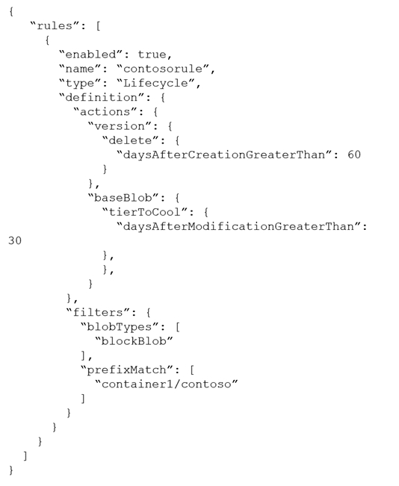
Use the drop-down menus to select the answer choice that completes each statement based on the information presented in the graphic.
NOTE: Each correct selection is worth one point.
Hot Area:
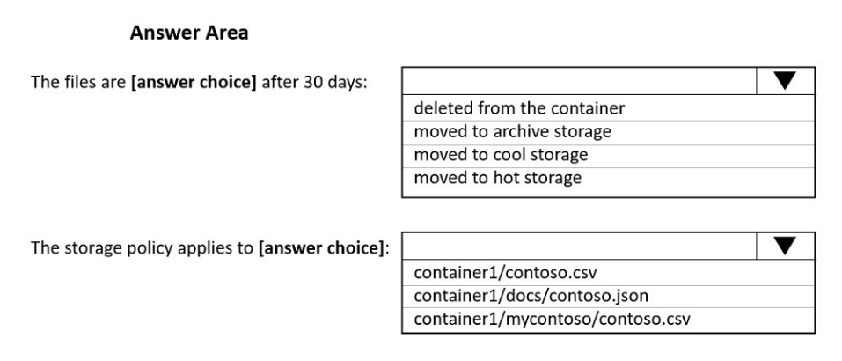
Answer:
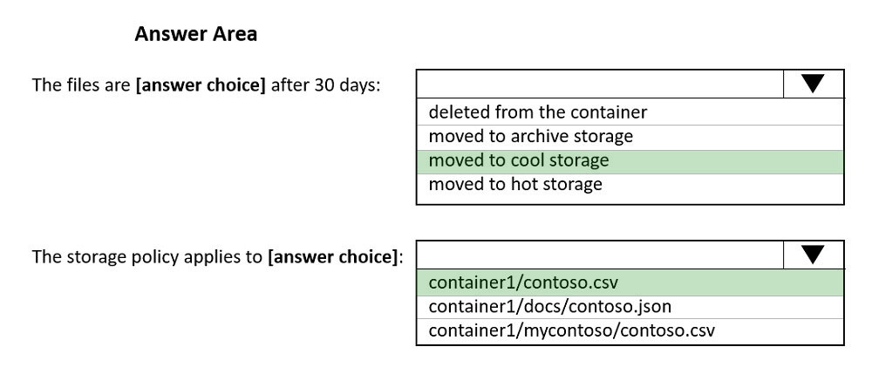

Box 1: moved to cool storage -
The ManagementPolicyBaseBlob.TierToCool property gets or sets the function to tier blobs to cool storage. Support blobs currently at Hot tier.
Box 2: container1/contoso.csv -
As defined by prefixMatch.
prefixMatch: An array of strings for prefixes to be matched. Each rule can define up to 10 case-senstive prefixes. A prefix string must start with a container name.
Reference:
https://docs.microsoft.com/en-us/dotnet/api/microsoft.azure.management.storage.fluent.models.managementpolicybaseblob.tiertocool
Question #30
You are designing a financial transactions table in an Azure Synapse Analytics dedicated SQL pool. The table will have a clustered columnstore index and will include the following columns:
✑ TransactionType: 40 million rows per transaction type
✑ CustomerSegment: 4 million per customer segment
✑ TransactionMonth: 65 million rows per month
AccountType: 500 million per account type
You have the following query requirements:
✑ Analysts will most commonly analyze transactions for a given month.
✑ Transactions analysis will typically summarize transactions by transaction type, customer segment, and/or account type
You need to recommend a partition strategy for the table to minimize query times.
On which column should you recommend partitioning the table?
- A. CustomerSegment
- B. AccountType
- C. TransactionType
- D. TransactionMonth

Considering row count, the answer is Transaction Month or Account Type. Partitioning with Trans. Month, it will end up with hot partition and cannot utilize parallel processing, because all data for the query will be in the same partition. To minimize the processing time, parallel processing should happen. So Transaction Month can not be the answer. My answer is Account Type. There is a similar question in Microsoft site and the explanation was given with answer as follows. Product ensures parallelism when querying data from a given month within the same region, or multiple regions. Using date and partitioning by month, all sales for a month will be in the same partition, not providing parallelism. All sales for a given region will be in the same partition, not providing parallelism....

I think you are confusing partition with distribution. Each partition will still be distributed over 60 distributions.
Partitioning and Distributing are different concepts In most cases data is partitioned on a date column that is closely tied to the order in which the data is loaded into the SQL pool. https://docs.microsoft.com/en-us/azure/synapse-analytics/sql-data-warehouse/sql-data-warehouse-tables-partition

To minimize query times for your financial transactions table in Azure Synapse Analytics, you should recommend partitioning the table on the TransactionMonth column (Option D). Here's why: Query Requirements: Analysts will most commonly analyze transactions for a given month. Partitioning by TransactionMonth allows queries to quickly filter and access the relevant partitions, significantly improving query performance1. Data Distribution: With 65 million rows per month, partitioning by TransactionMonth ensures that each partition contains a manageable amount of data, optimizing both storage and query efficiency1. Partitioning by TransactionMonth aligns well with your query patterns and helps in efficiently managing and querying large datasets.
For optimal compression and performance of clustered columnstore tables, a minimum of 1 million rows per distribution and partition is needed. Before partitions are created, dedicated SQL pool already divides each table into 60 distributed databases.
Parallelization is for distributions I believe, and every partition will automatically be distributed as well. Partitioning is done to reduce the amount of data that is scanned. If I partition the data by months, then each month partition is further distributed into 60 distributions which are split across different nodes, thereby ensuring parallelism

