DP-203: Data Engineering on Microsoft Azure Exam Questions Page 1 | PassnExam
https://www.passnexam.com/microsoft/dp-203/1



✅ Correct answer: An AI engineer
Answer is An AI engineer
Artificial intelligence (AI) engineers work with AI services such as Cognitive Services, Cognitive Search, and the Bot Framework.
Data engineers are responsible for the provisioning and configuration of both on-premises and cloud data platform technologies.
Data scientists perform advanced analytics to help drive value from data.

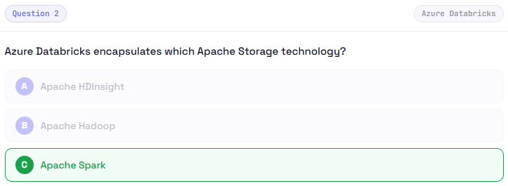

✅ Correct answer: Apache Spark
Answer is Apache Spark
Azure Databricks is an Apache Spark-based analytics platform optimized for the Microsoft Azure.
Apache HDInsight does not exist, Azure HDInsight is a fully managed, full-spectrum, open-source analytics service for enterprises. HDInsight is a cloud service that makes it easy, fast, and cost-effective to process massive amounts of data.
Apache Hadoop is the original open-source framework for distributed processing and analysis of big data sets on clusters.

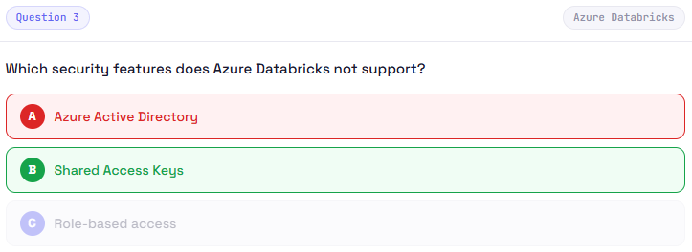

✅ Correct answer: Shared Access Keys
Answer is Shared Access Keys
Shared Access Keys are a security feature used within Azure storage accounts. Azure Active Directory and Role-based access are supported security features in Azure Databricks.

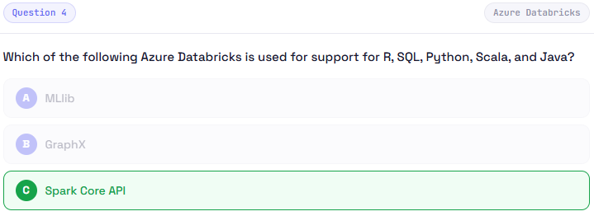
✅ Correct answer: Spark Core API
Answer is Spark Core API
Spark Core API support for R, SQL, Python, Scala, and Java in Azure Databricks.
MLlib is the Machine Learning library consisting of common learning algorithms and utilities, including classification, regression, clustering, collaborative filtering, dimensionality reduction, as well as underlying optimization primitives.
GraphX provides graphs and graph computation for a broad scope of use cases from cognitive analytics to data exploration.

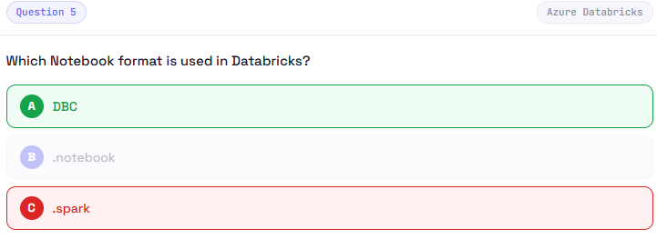
✅ Correct answer: DBC
Answer is D-B-C
dbc file types are the supported Databricks notebook format. There is no no .notebook or .spark file format available.



✅ Correct answer: Chrome and Firefox
Answer is Chrome and Firefox
Chrome and Firefox are the recommended browsers by Databricks. Microsoft Edge and IE 11 are not recommended because of faulty rendering of iFrames, but Safari is also an acceptable browser.

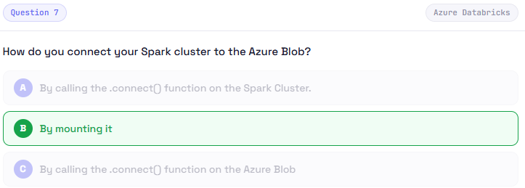

✅ Correct answer: By mounting it
Answer is By mounting it
By mounting it. Mounts require Azure credentials such as SAS keys and give access to a virtually infinite store for your data. The .connect() function is not a valid method.

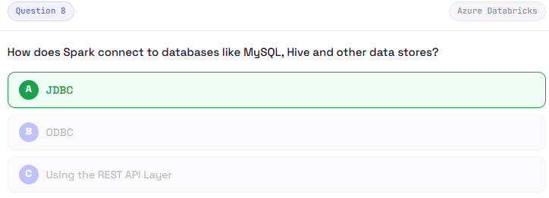

✅ Correct answer: JDBC
Answer is JDBC
JDBC. JDBC stands for Java Database Connectivity, and is a Java API for connecting to databases such as MySQL, Hive, and other data stores. ODBC is not an option and the REST API Layer is not available
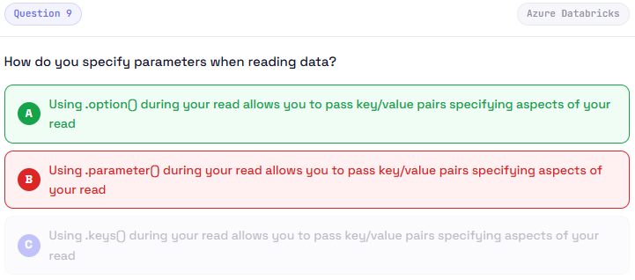

✅ Correct answer: Using .option() during your read allows you to pass key/value pairs specifying aspects of your read
Answer is "Using .option() during your read allows you to pass key/value pairs specifying aspects of your read"
Using .option() during your read allows you to pass key/value pairs specifying aspects of your read. For instance, options for reading CSV data include header, delimiter, and inferSchema.
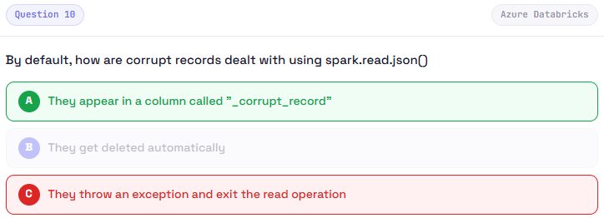
✅ Correct answer: They appear in a column called "_corrupt_record"
Answer is "They appear in a column called _corrupt_record"
They appear in a column called "_corrupt_record". They do not get deleted automatically or throw an exception and exit the read operation

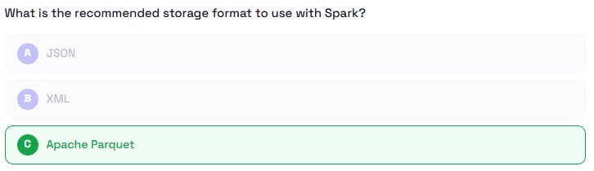
✅ Correct answer: Apache Parquet
Answer is Apache Parquet
Apache Parquet. Apache Parquet is a highly optimized solution for data storage and is the recommended option for storage.

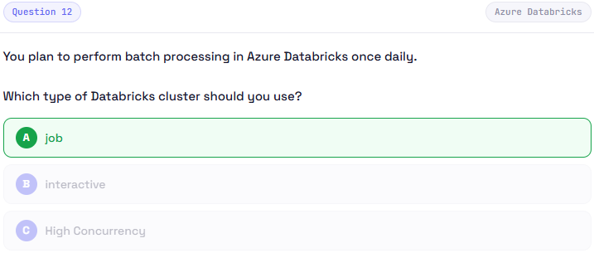

✅ Correct answer: job
Answer is job
Scheduled batch workloads (data engineers running ETL jobs)
This scenario involves running batch job JARs and notebooks on a regular cadence through the Databricks platform.
The suggested best practice is to launch a new cluster for each run of critical jobs. This helps avoid any issues (failures, missing SLA, and so on) due to an existing workload (noisy neighbor) on a shared cluster.
Note: Azure Databricks has two types of clusters: interactive and automated. You use interactive clusters to analyze data collaboratively with interactive notebooks. You use automated clusters to run fast and robust automated jobs.
References:
https://docs.databricks.com/administration-guide/cloud-configurations/aws/cmbp.html#scenario-3-scheduled-batch-workloads-data-engineers-running-etl-jobs

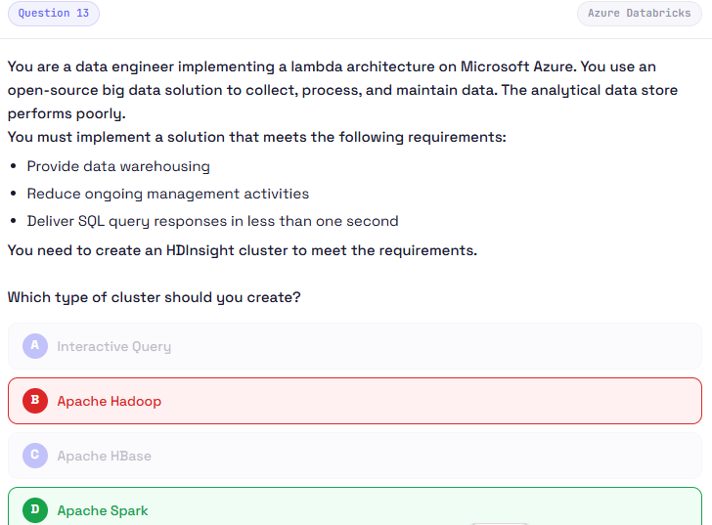

✅ Correct answer: Apache Spark
Answer is Apache Spark
Lambda Architecture with Azure:
Azure offers you a combination of following technologies to accelerate real-time big data analytics:
1. Azure Cosmos DB, a globally distributed and multi-model database service.
2. Apache Spark for Azure HDInsight, a processing framework that runs large-scale data analytics applications.
3. Azure Cosmos DB change feed, which streams new data to the batch layer for HDInsight to process.
4. The Spark to Azure Cosmos DB Connector
Note: Lambda architecture is a data-processing architecture designed to handle massive quantities of data by taking advantage of both batch processing and stream processing methods, and minimizing the latency involved in querying big data.
References:
https://sqlwithmanoj.com/2018/02/16/what-is-lambda-architecture-and-what-azure-offers-with-its-new-cosmos-db/

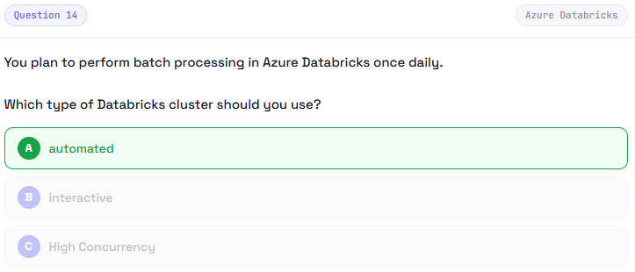

✅ Correct answer: automated
Answer is automated
Azure Databricks has two types of clusters: interactive and automated. You use interactive clusters to analyze data collaboratively with interactive notebooks. You use automated clusters to run fast and robust automated jobs.
Example: Scheduled batch workloads (data engineers running ETL jobs)
This scenario involves running batch job JARs and notebooks on a regular cadence through the Databricks platform.
The suggested best practice is to launch a new cluster for each run of critical jobs. This helps avoid any issues (failures, missing SLA, and so on) due to an existing workload (noisy neighbor) on a shared cluster.
Reference:
https://docs.databricks.com/administration-guide/cloud-configurations/aws/cmbp.html#scenario-3-scheduled-batch-workloads-data-engineers-running-etl-jobs

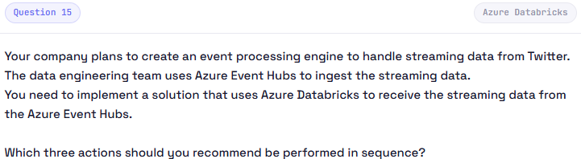
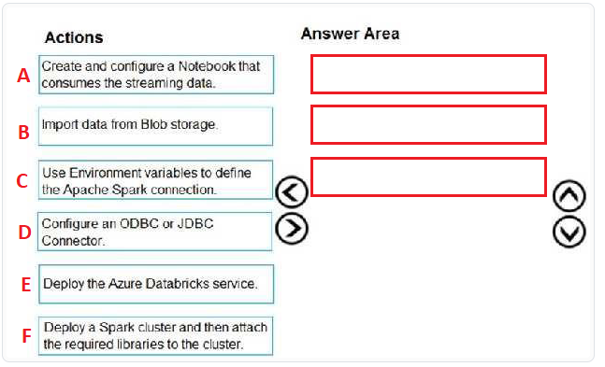
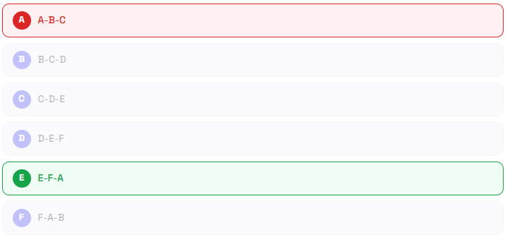
Step 1: Deploy the Azure Databricks service
Create an Azure Databricks workspace by setting up an Azure Databricks Service.
Step 2: Deploy a Spark cluster and then attach the required libraries to the cluster.
To create a Spark cluster in Databricks, in the Azure portal, go to the Databricks workspace that you created, and then select Launch Workspace.
Attach libraries to Spark cluster: you use the Twitter APIs to send tweets to Event Hubs. You also use the Apache Spark Event Hubs connector to read and write data into Azure Event Hubs. To use these APIs as part of your cluster, add them as libraries to Azure Databricks and associate them with your Spark cluster.
Step 3: Create and configure a Notebook that consumes the streaming data.
You create a notebook named ReadTweetsFromEventhub in Databricks workspace. ReadTweetsFromEventHub is a consumer notebook you use to read the tweets from Event Hubs.
References:
https://docs.microsoft.com/en-us/azure/azure-databricks/databricks-stream-from-eventhubs

Question 16 Azure Databricks
You are developing a solution using a Lambda architecture on Microsoft Azure.
The data at rest layer must meet the following requirements:
Data storage:
- Serve as a repository for high volumes of large files in various formats.
- Implement optimized storage for big data analytics workloads.
- Ensure that data can be organized using a hierarchical structure.
Batch processing:
- Use a managed solution for in-memory computation processing.
- Natively support Scala, Python, and R programming languages.
Provide the ability to resize and terminate the cluster automatically.
Analytical data store:
- Support parallel processing.
- Use columnar storage.
- Support SQL-based languages.
You need to identify the correct technologies to build the Lambda architecture.
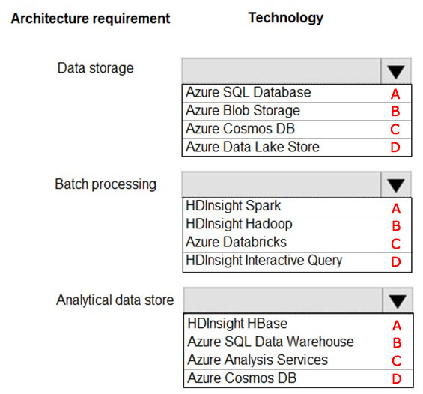

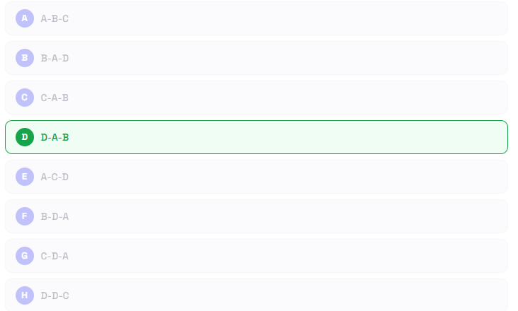
✅ Correct answer: D-A-B
Answer is D-A-B
Data storage: Azure Data Lake Store
A key mechanism that allows Azure Data Lake Storage Gen2 to provide file system performance at object storage scale and prices is the addition of a hierarchical namespace. This allows the collection of objects/files within an account to be organized into a hierarchy of directories and nested subdirectories in the same way that the file system on your computer is organized. With the hierarchical namespace enabled, a storage account becomes capable of providing the scalability and cost-effectiveness of object storage, with file system semantics that are familiar to analytics engines and frameworks.
Batch processing: HD Insight Spark
Aparch Spark is an open-source, parallel-processing framework that supports in-memory processing to boost the performance of big-data analysis applications.
HDInsight is a managed Hadoop service. Use it deploy and manage Hadoop clusters in Azure. For batch processing, you can use Spark, Hive, Hive LLAP, MapReduce.
Languages: R, Python, Java, Scala, SQL
Analytic data store: SQL Data Warehouse
SQL Data Warehouse is a cloud-based Enterprise Data Warehouse (EDW) that uses Massively Parallel Processing (MPP).
SQL Data Warehouse stores data into relational tables with columnar storage.
References:
https://docs.microsoft.com/en-us/azure/storage/blobs/data-lake-storage-namespace
https://docs.microsoft.com/en-us/azure/architecture/data-guide/technology-choices/batch-processing
https://docs.microsoft.com/en-us/azure/sql-data-warehouse/sql-data-warehouse-overview-what-is

Question 17Azure Databricks
You need to collect application metrics, streaming query events, and application log messages for an Azure Databricks cluster.
Which type of library and workspace should you implement?

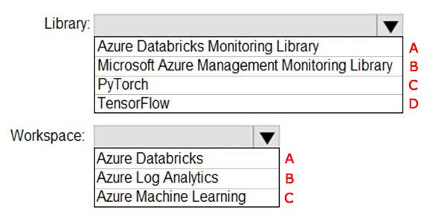

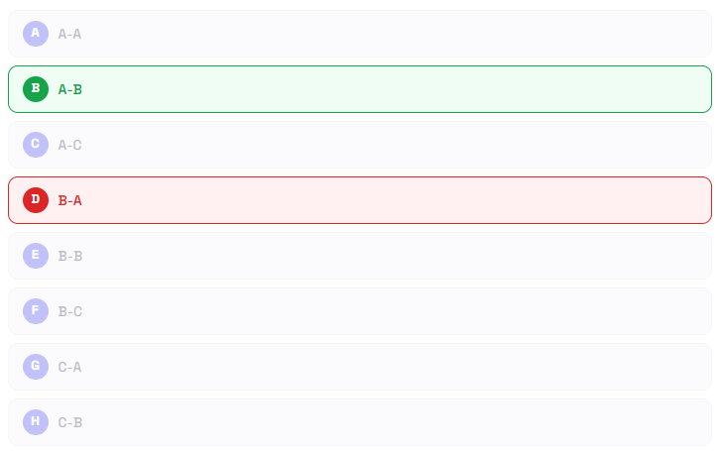

✅ Correct answer: A-B
Answer is A-B
You can send application logs and metrics from Azure Databricks to a Log Analytics workspace. It uses the Azure Databricks Monitoring Library, which is available on GitHub.
References:
https://docs.microsoft.com/en-us/azure/architecture/databricks-monitoring/application-logs

Question 18Azure Databricks
You have an Azure Databricks resource.
You need to log actions that relate to compute changes triggered by the Databricks resources.
Which Databricks services should you log?

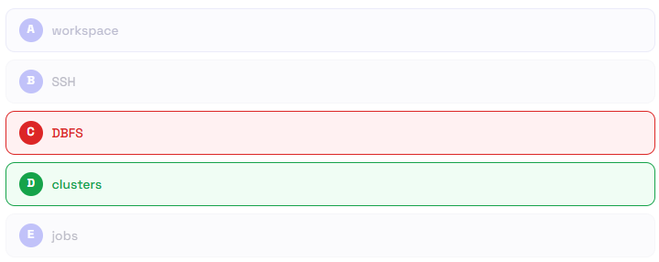
✅ Correct answer: clusters
Answer is clusters
An Azure Databricks cluster is a set of computation resources and configurations on which you run data engineering, data science, and data analytics workloads.
Incorrect Answers:
A: An Azure Databricks workspace is an environment for accessing all of your Azure Databricks assets. The workspace organizes objects (notebooks, libraries, and experiments) into folders, and provides access to data and computational resources such as clusters and jobs.
B: SSH allows you to log into Apache Spark clusters remotely.
C: Databricks File System (DBFS) is a distributed file system mounted into an Azure Databricks workspace and available on Azure Databricks clusters.
E: A job is a way of running a notebook or JAR either immediately or on a scheduled basis.
Reference:
https://docs.microsoft.com/en-us/azure/databricks/clusters/

Question 19Azure Databricks
Your company analyzes images from security cameras and sends alerts to security teams that respond to unusual activity. The solution uses Azure Databricks.
You need to send Apache Spark level events, Spark Structured Streaming metrics, and application metrics to Azure Monitor.
Which three actions should you perform in sequence?
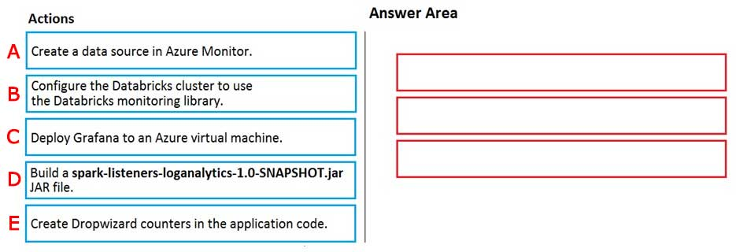

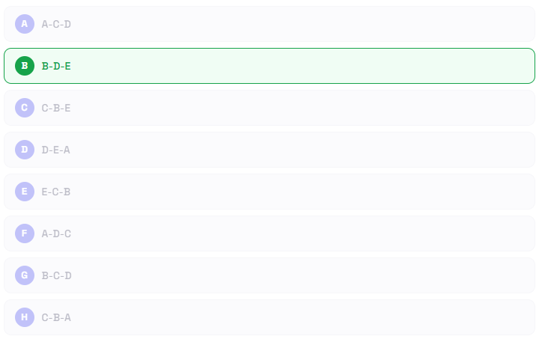
✅ Correct answer: B-D-E
Answer is B-D-E
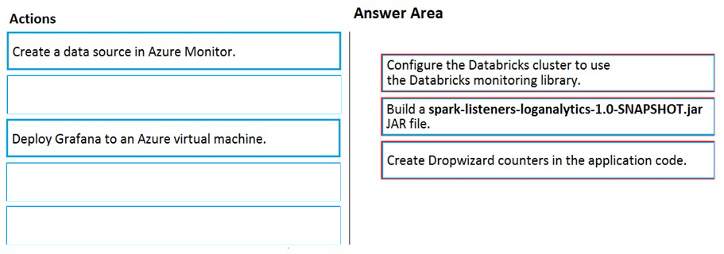
You can send application logs and metrics from Azure Databricks to a Log Analytics workspace.
Spark uses a configurable metrics system based on the Dropwizard Metrics Library.
Prerequisites: Configure your Azure Databricks cluster to use the monitoring library.
Note: The monitoring library streams Apache Spark level events and Spark Structured Streaming metrics from your jobs to Azure Monitor.
To send application metrics from Azure Databricks application code to Azure Monitor, follow these steps:
Step 1. Build the spark-listeners-loganalytics-1.0-SNAPSHOT.jar JAR file
Step 2: Create Dropwizard gauges or counters in your application code.
Reference:
https://docs.microsoft.com/bs-latn-ba/azure/architecture/databricks-monitoring/application-logs

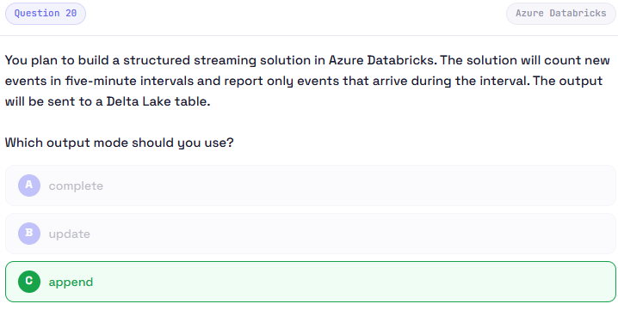

✅ Correct answer: append
Answer is append
Append Mode: Only new rows appended in the result table since the last trigger are written to external storage. This is applicable only for the queries where existing rows in the Result Table are not expected to change.
Incorrect Answers:
A: Complete Mode: The entire updated result table is written to external storage. It is up to the storage connector to decide how to handle the writing of the entire table.
B: Update Mode: Only the rows that were updated in the result table since the last trigger are written to external storage. This is different from Complete Mode in that Update Mode outputs only the rows that have changed since the last trigger. If the query doesn't contain aggregations, it is equivalent to Append mode.
Reference:
https://docs.databricks.com/getting-started/spark/streaming.html

Question 21Azure Databricks
You have an Azure Data Lake Storage Gen2 account that contains JSON files for customers. The files contain two attributes named FirstName and LastName.
You need to copy the data from the JSON files to an Azure Synapse Analytics table by using Azure Databricks. A new column must be created that concatenates the FirstName and LastName values.
You create the following components:
- A destination table in Azure Synapse
- An Azure Blob storage container
- A service principal
Which five actions should you perform in sequence next in a Databricks notebook?
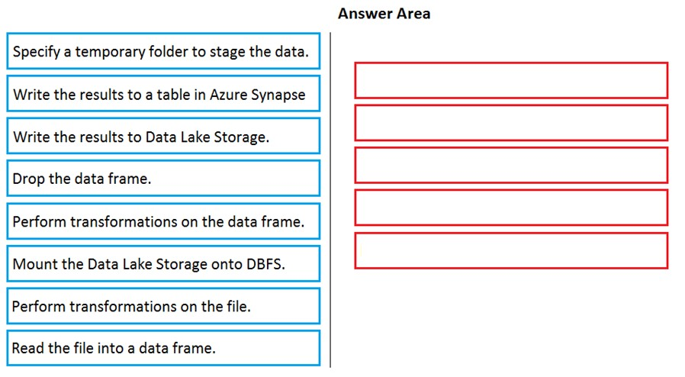
✅ Correct answer: F-H-E-A-B de olabilir deniyor
Step 1: Read the file into a data frame.
You can load the json files as a data frame in Azure Databricks.
Step 2: Perform transformations on the data frame.
Step 3:Specify a temporary folder to stage the data
Specify a temporary folder to use while moving data between Azure Databricks and Azure Synapse.
Step 4: Write the results to a table in Azure Synapse.
You upload the transformed data frame into Azure Synapse. You use the Azure Synapse connector for Azure Databricks to directly upload a dataframe as a table in a Azure Synapse.
Step 5: Drop the data frame
Clean up resources. You can terminate the cluster. From the Azure Databricks workspace, select Clusters on the left. For the cluster to terminate, under Actions, point to the ellipsis (...) and select the Terminate icon.
Reference:
https://docs.microsoft.com/en-us/azure/azure-databricks/databricks-extract-load-sql-data-warehouse

Question 22Azure Databricks
You are designing an Azure Databricks interactive cluster.
You need to ensure that the cluster meets the following requirements:
- Enable auto-termination
- Retain cluster configuration indefinitely after cluster termination.
What should you recommend?

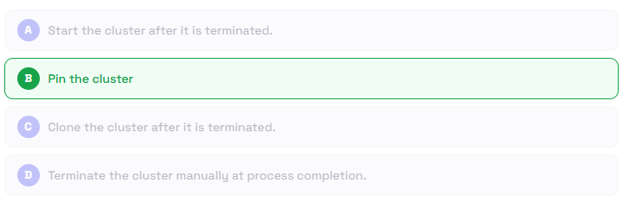

✅ Correct answer: Pin the cluster
Answer is Pin the cluster
To keep an interactive cluster configuration even after it has been terminated for more than 30 days, an administrator can pin a cluster to the cluster list.
Reference:
https://docs.azuredatabricks.net/user-guide/clusters/terminate.html
https://docs.databricks.com/clusters/clusters-manage.html#pin-a-cluster

Question 23Azure Databricks
You are designing an Azure Databricks table. The table will ingest an average of 20 million streaming events per day.
You need to persist the events in the table for use in incremental load pipeline jobs in Azure Databricks. The solution must minimize storage costs and incremental load times.
What should you include in the solution?

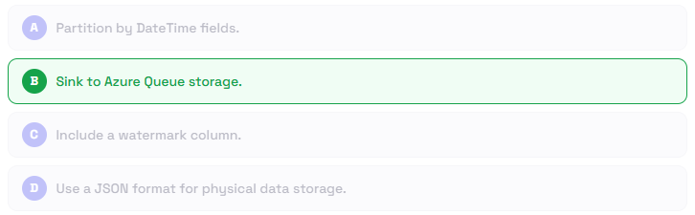

✅ Correct answer: Sink to Azure Queue storage.
Answer is Sink to Azure Queue storage.
The Databricks ABS-AQS connector uses Azure Queue Storage (AQS) to provide an optimized file source that lets you find new files written to an Azure Blob storage (ABS) container without repeatedly listing all of the files. This provides two major advantages:
- Lower latency: no need to list nested directory structures on ABS, which is slow and resource intensive.
- Lower costs: no more costly LIST API requests made to ABS.
Reference:
https://docs.microsoft.com/en-us/azure/databricks/spark/latest/structured-streaming/aqs

Question 24Azure Databricks
You have an Azure Databricks workspace named workspace1 in the Standard pricing tier.
You need to configure workspace1 to support autoscaling all-purpose clusters. The solution must meet the following requirements:
- Automatically scale down workers when the cluster is underutilized for three minutes.
- Minimize the time it takes to scale to the maximum number of workers.
- Minimize costs.
What should you do first?
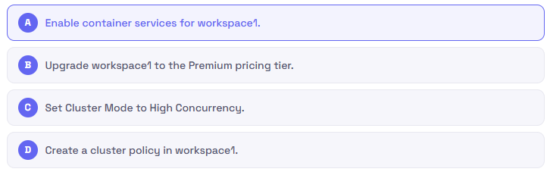

✅ Correct answer: Upgrade workspace1 to the Premium pricing tier.
Answer is Upgrade workspace1 to the Premium pricing tier.
For clusters running Databricks Runtime 6.4 and above, optimized autoscaling is used by all-purpose clusters in the Premium plan
Optimized autoscaling:
Scales up from min to max in 2 steps.
Can scale down even if the cluster is not idle by looking at shuffle file state.
Scales down based on a percentage of current nodes.
On job clusters, scales down if the cluster is underutilized over the last 40 seconds.
On all-purpose clusters, scales down if the cluster is underutilized over the last 150 seconds.
The spark.databricks.aggressiveWindowDownS Spark configuration property specifies in seconds how often a cluster makes down-scaling decisions. Increasing the value causes a cluster to scale down more slowly. The maximum value is 600.
Note: Standard autoscaling
Starts with adding 8 nodes. Thereafter, scales up exponentially, but can take many steps to reach the max. You can customize the first step by setting the spark.databricks.autoscaling.standardFirstStepUp Spark configuration property.
Scales down only when the cluster is completely idle and it has been underutilized for the last 10 minutes.
Scales down exponentially, starting with 1 node.
Reference:
https://docs.databricks.com/clusters/configure.html

Question 25Azure Databricks
You are designing an Azure Databricks cluster that runs user-defined local processes.
You need to recommend a cluster configuration that meets the following requirements:
- Minimize query latency.
- Maximize the number of users that can run queries on the cluster at the same time.
- Reduce overall costs without compromising other requirements.
Which cluster type should you recommend?

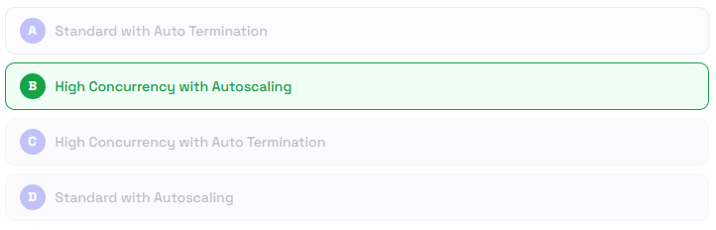

✅ Correct answer: High Concurrency with Autoscaling
Answer is High Concurrency with Autoscaling
A High Concurrency cluster is a managed cloud resource. The key benefits of High Concurrency clusters are that they provide fine-grained sharing for maximum resource utilization and minimum query latencies.
Databricks chooses the appropriate number of workers required to run your job. This is referred to as autoscaling. Autoscaling makes it easier to achieve high cluster utilization, because you don't need to provision the cluster to match a workload.
Incorrect Answers:
C: The cluster configuration includes an auto terminate setting whose default value depends on cluster mode:
Standard and Single Node clusters terminate automatically after 120 minutes by default.
High Concurrency clusters do not terminate automatically by default.
Reference:
https://docs.microsoft.com/en-us/azure/databricks/clusters/configure

Question 26Azure Databricks
You are planning a solution to aggregate streaming data that originates in Apache Kafka and is output to Azure Data Lake Storage Gen2. The developers who will implement the stream processing solution use Java.
Which service should you recommend using to process the streaming data?
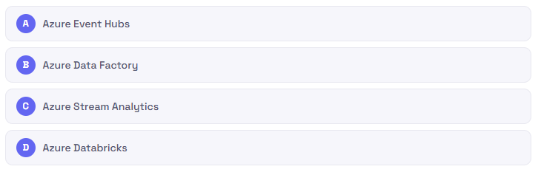
✅ Correct answer: Azure Databricks
Answer is Azure Databricks
The following tables summarize the key differences in capabilities for stream processing technologies in Azure.
General capabilities -
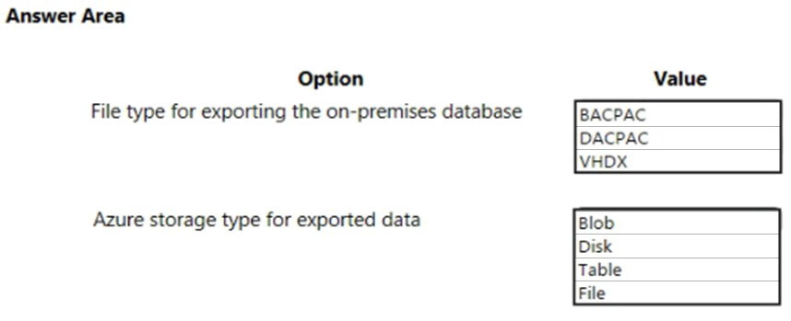
Integration capabilities -
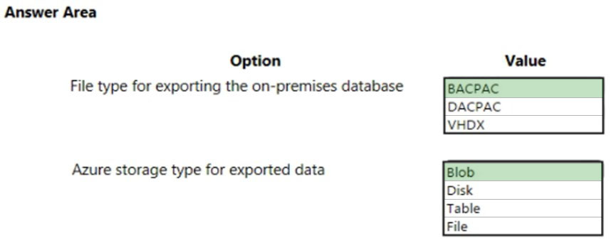
Reference:
https://docs.microsoft.com/en-us/azure/architecture/data-guide/technology-choices/stream-processing

Question 27Azure Databricks
You plan to develop a dataset named Purchases by using Azure Databricks. Purchases will contain the following columns:
● ProductID
● ItemPrice
● LineTotal
● Quantity
● StoreID
● Minute
● Month
● Hour
● Year
● Day
You need to store the data to support hourly incremental load pipelines that will vary for each Store ID. The solution must minimize storage costs.
How should you complete the code?
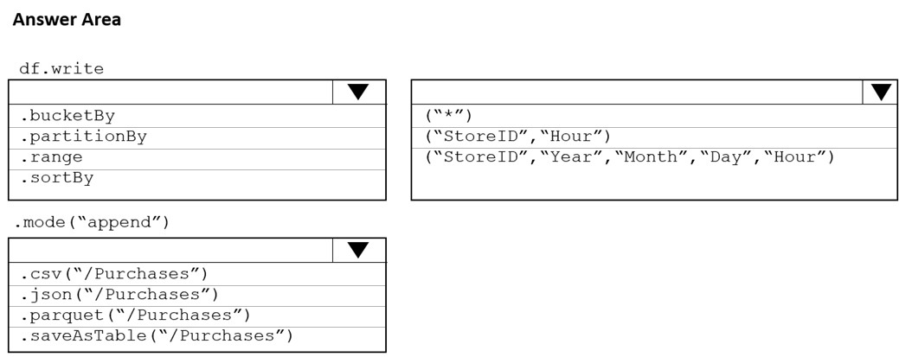

Box 1: partitionBy
We should overwrite at the partition level.
Example:
df.write.partitionBy("y","m","d")
.mode(SaveMode.Append)
.parquet("/data/hive/warehouse/db_name.db/" + tableName)
Box 2: ("StoreID", "Year", "Month", "Day", "Hour", "StoreID")
Box 3: parquet("/Purchases")
Reference:
https://intellipaat.com/community/11744/how-to-partition-and-write-dataframe-in-spark-without-deleting-partitions-with-no-new-data

Question 28Azure Databricks
The following code segment is used to create an Azure Databricks cluster.
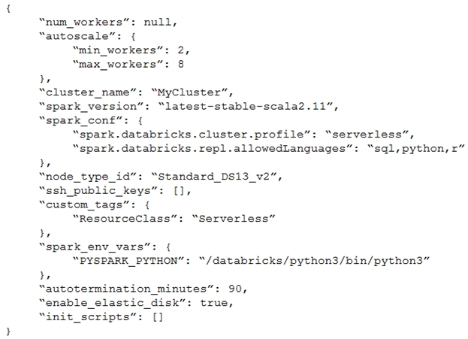
For each of the following statements, select Yes if the statement is true. Otherwise, select No.
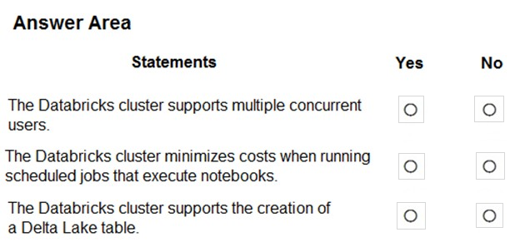
Box 1: Yes
A cluster mode of High Concurrency is selected, unlike all the others which are Standard. This results in a worker type of Standard_DS13_v2.
Box 2: No
When you run a job on a new cluster, the job is treated as a data engineering (job) workload subject to the job workload pricing. When you run a job on an existing cluster, the job is treated as a data analytics (all-purpose) workload subject to all-purpose workload pricing.
Box 3: Yes
Delta Lake on Databricks allows you to configure Delta Lake based on your workload patterns.
Reference:
https://adatis.co.uk/databricks-cluster-sizing/
https://docs.microsoft.com/en-us/azure/databricks/jobs
https://docs.databricks.com/administration-guide/capacity-planning/cmbp.html
https://docs.databricks.com/delta/index.html

Question 29Azure Databricks
You are designing a statistical analysis solution that will use custom proprietary Python functions on near real-time data from Azure Event Hubs.
You need to recommend which Azure service to use to perform the statistical analysis. The solution must minimize latency.
What should you recommend?

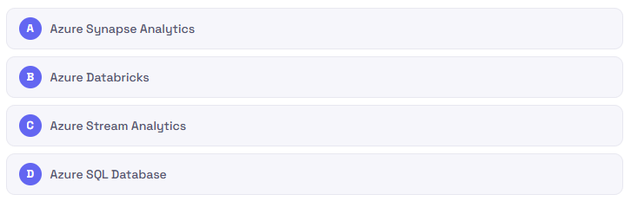

✅ Correct answer: Azure Databricks
Answer is Azure Databricks
Stream Analytics supports "extending SQL language with JavaScript and C# user-defined functions (UDFs)". Stream Analytics does not support Python.
Azure Databricks supports near real-time data from Azure Event Hubs. And includes support for R, SQL, Python, Scala, and Java. So I will go for option B.
Reference:
https://docs.microsoft.com/en-us/azure/stream-analytics/stream-analytics-introduction

Question 30Azure Databricks
You are creating a new notebook in Azure Databricks that will support R as the primary language but will also support Scala and SQL.
Which switch should you use to switch between languages?

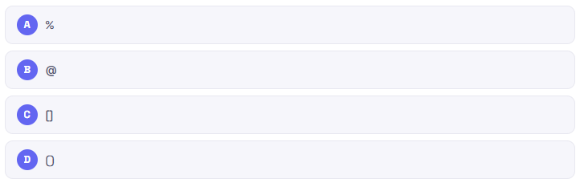

✅ Correct answer: %
Answer is %
To change the language in Databricks' cells to either Scala, SQL, Python or R, prefix the cell with %, followed by the language.
%python //or r, scala, sql
Reference:
https://www.theta.co.nz/news-blogs/tech-blog/enhancing-digital-twins-part-3-predictive-maintenance-with-azure-databricks

Question 31Azure Databricks
You develop a dataset named DBTBL1 by using Azure Databricks.
DBTBL1 contains the following columns:
● SensorTypeID
● GeographyRegionID
● Year
● Month
● Day
● Hour
● Minute
● Temperature
● WindSpeed
● Other
You need to store the data to support daily incremental load pipelines that vary for each GeographyRegionID. The solution must minimize storage costs.
How should you complete the code?
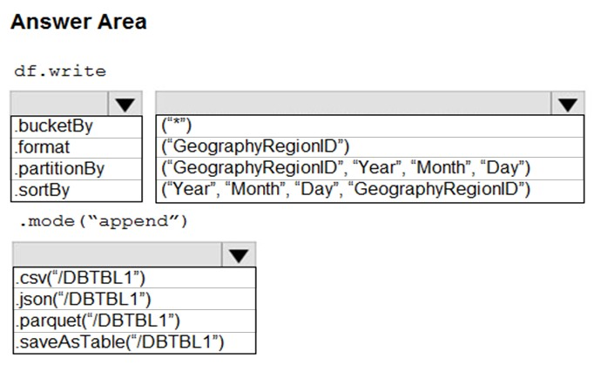

Box 1: .partitionBy
Incorrect Answers:
- .format:
Method: format():
Arguments: "parquet", "csv", "txt", "json", "jdbc", "orc", "avro", etc.
- .bucketBy:
Method: bucketBy()
Arguments: (numBuckets, col, col..., coln)
The number of buckets and names of columns to bucket by. Uses Hive's bucketing scheme on a filesystem.
Box 2: ("Year", "Month", "Day","GeographyRegionID")
Specify the columns on which to do the partition. Use the date columns followed by the GeographyRegionID column.
Box 3: .saveAsTable("/DBTBL1")
Method: saveAsTable()
Argument: "table_name"
The table to save to.
Reference:
https://www.oreilly.com/library/view/learning-spark-2nd/9781492050032/ch04.html
https://docs.microsoft.com/en-us/azure/databricks/delta/delta-batch

Question 32Azure Databricks
You need to implement an Azure Databricks cluster that automatically connects to Azure Data Lake Storage Gen2 by using Azure Active Directory (Azure AD) integration.
How should you configure the new cluster?
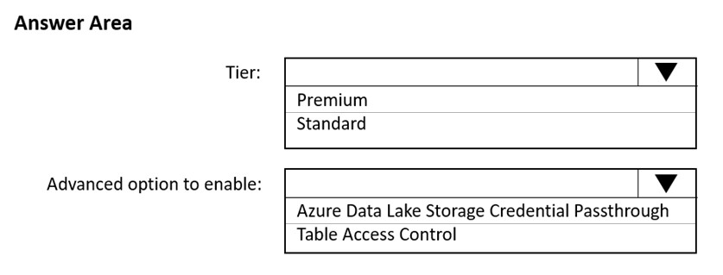

Box 1: Premium
Credential passthrough requires an Azure Databricks Premium Plan
Box 2: Azure Data Lake Storage credential passthrough
You can access Azure Data Lake Storage using Azure Active Directory credential passthrough.
When you enable your cluster for Azure Data Lake Storage credential passthrough, commands that you run on that cluster can read and write data in Azure Data
Lake Storage without requiring you to configure service principal credentials for access to storage.
Reference:
https://docs.microsoft.com/en-us/azure/databricks/security/credential-passthrough/adls-passthrough

Question 33Azure Databricks
You create an Azure Databricks cluster and specify an additional library to install.
When you attempt to load the library to a notebook, the library in not found.
You need to identify the cause of the issue.
What should you review?

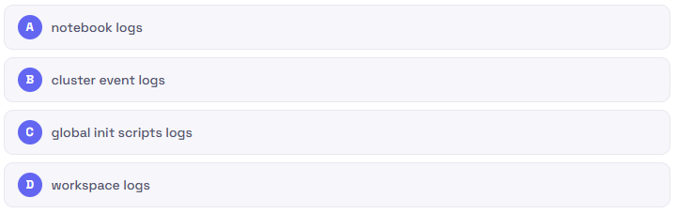
✅ Correct answer: cluster event logs
Answer is cluster event logs
Azure Databricks provides three kinds of logging of cluster-related activity: Cluster event logs, which capture cluster lifecycle events, like creation, termination, configuration edits, and so on. Apache Spark driver and worker logs, which you can use for debugging. Cluster init-script logs, valuable for debugging init scripts.
Reference:
https://docs.microsoft.com/en-us/azure/databricks/clusters/clusters-manage#event-log

Question 34Azure Databricks
You are designing an Azure Databricks interactive cluster. The cluster will be used infrequently and will be configured for auto-termination.
You need to use that the cluster configuration is retained indefinitely after the cluster is terminated. The solution must minimize costs.
What should you do?

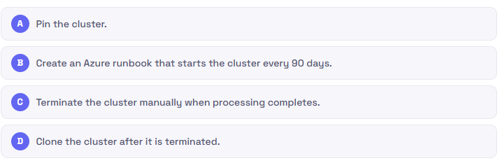

✅ Correct answer: Pin the cluster.
Answer is Pin the cluster.
Azure Databricks retains cluster configuration information for up to 70 all-purpose clusters terminated in the last 30 days and up to 30 job clusters recently terminated by the job scheduler. To keep an all-purpose cluster configuration even after it has been terminated for more than 30 days, an administrator can pin a cluster to the cluster list.
Reference:
https://docs.microsoft.com/en-us/azure/databricks/clusters/

Question 35Azure Databricks
You have an Azure Databricks resource.
You need to log actions that relate to changes in compute for the Databricks resource.
Which Databricks services should you log?
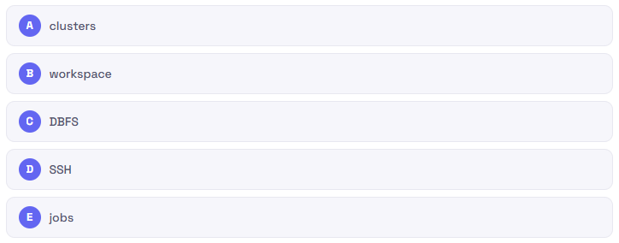

✅ Correct answer: clusters
Answer is clusters
Workspace logs does not have any cluster related resource change. In general, all logs are belongs to workspace-level audit log if you check the title of the table. But if you check in details, cluster related logs belongs to clusters part.
Reference:
https://docs.databricks.com/administration-guide/account-settings/audit-logs.html#workspace-level-audit-log-events

Question 36Azure Databricks
You are planning a streaming data solution that will use Azure Databricks. The solution will stream sales transaction data from an online store. The solution has the following specifications:
- The output data will contain items purchased, quantity, line total sales amount, and line total tax amount.
- Line total sales amount and line total tax amount will be aggregated in Databricks.
- Sales transactions will never be updated. Instead, new rows will be added to adjust a sale.
You need to recommend an output mode for the dataset that will be processed by using Structured Streaming. The solution must minimize duplicate data.
What should you recommend?

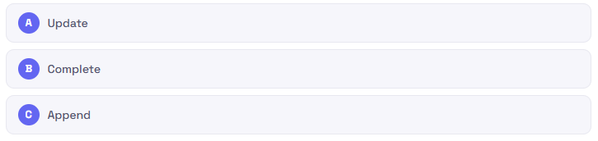
✅ Correct answer: Append
Answer is Append
Append: This mode adds new rows to the output sink for each received event. It's perfect for your scenario where sales transactions are never updated but adjusted by adding new rows. This guarantees no duplicate data due to updates, minimizing duplicates.
Update: This mode updates existing rows in the output sink if a matching key is found. Since you mentioned no updates occur, using this mode would lead to unnecessary operations and potential inconsistencies.
Complete: This mode writes the entire dataset to the output sink for each micro-batch interval. This is unnecessary and inefficient for your scenario since only new rows need to be added, and it potentially duplicates data across micro-batches.
Reference:
https://docs.databricks.com/delta/delta-streaming.html

Question 37Azure Databricks
You need to collect application metrics, streaming query events, and application log messages for an Azure Databrick cluster.
Which type of library and workspace should you implement?
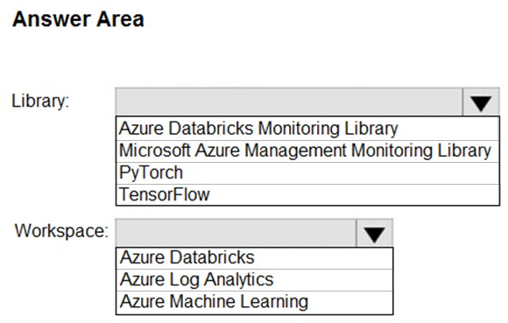

Answer is Azure Databricks Monitoring Library and Azure Log Analytics
You can send application logs and metrics from Azure Databricks to a Log Analytics workspace. It uses the Azure Databricks Monitoring Library, which is available on GitHub.
Reference:
https://docs.microsoft.com/en-us/azure/architecture/databricks-monitoring/application-logs

Question 38Azure Databricks
You are planning a solution to aggregate streaming data that originates in Apache Kafka and is output to Azure Data Lake Storage Gen2. The developers who will implement the stream processing solution use Java.
Which service should you recommend using to process the streaming data?
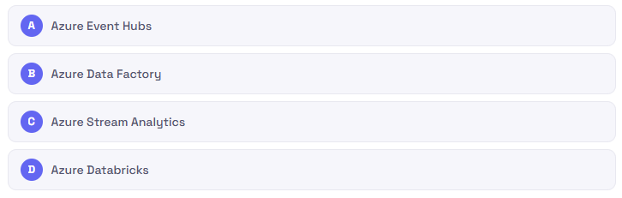

✅ Correct answer: Azure Databricks
Answer is Azure Databricks
Azure Databrics supports Java programming.
Reference:
https://docs.microsoft.com/en-us/azure/architecture/data-guide/technology-choices/stream-processing

Question 39Azure Databricks
You have an Azure Data Lake Storage Gen2 account that contains a JSON file for customers. The file contains two attributes named FirstName and LastName.
You need to copy the data from the JSON file to an Azure Synapse Analytics table by using Azure Databricks. A new column must be created that concatenates the FirstName and LastName values.
You create the following components:
- A destination table in Azure Synapse
- An Azure Blob storage container
- A service principal
Which five actions should you perform in sequence next in is Databricks notebook?
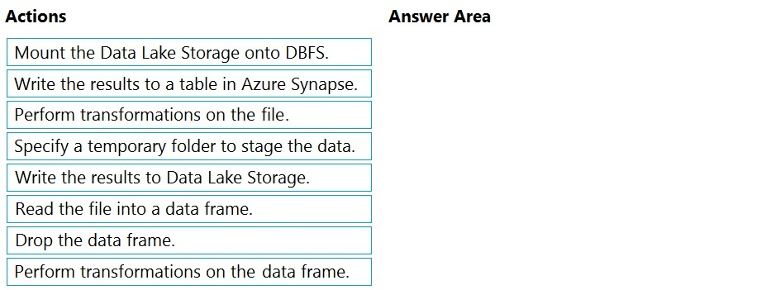

Step 1: Mount the Data Lake Storage onto DBFS
Begin with creating a file system in the Azure Data Lake Storage Gen2 account.
Step 2: Read the file into a data frame.
You can load the json files as a data frame in Azure Databricks.
Step 3: Perform transformations on the data frame.
Step 4: Specify a temporary folder to stage the data
Specify a temporary folder to use while moving data between Azure Databricks and Azure Synapse.
Step 5: Write the results to a table in Azure Synapse.
You upload the transformed data frame into Azure Synapse. You use the Azure Synapse connector for Azure Databricks to directly upload a dataframe as a table in a Azure Synapse.
Reference:
https://docs.microsoft.com/en-us/azure/azure-databricks/databricks-extract-load-sql-data-warehouse

Question 40Azure Data Factory
Which Azure Data Factory process involves using compute services to produce data to feed production environments with cleansed data?

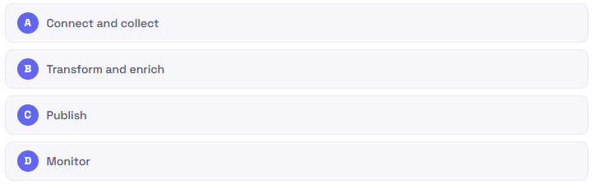

✅ Correct answer: Transform and enrich
Answer is Transform and enrich
This is used to invoke compute services to produce date to feed production environments with cleansed data. Connect and collect defines and connect all the required sources of data together. Publish load the data into a data store or analytical engine for your business users to point their business intelligence tools. Monitor is used to monitor the scheduled activities and pipelines for success and failure rates.

Question 41Azure Data Factory
Which Azure Data Factory component contains the transformation logic or the analysis commands of the Azure Data Factory’s work?

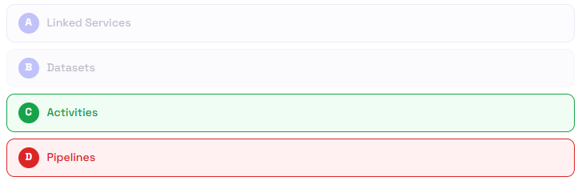

✅ Correct answer: Activities
Answer is Activities
Activities contains the transformation logic or the analysis commands of the Azure Data Factory’s work. Linked Services are objects that are used to define the connection to data stores or compute resources in Azure. Datasets represent data structures within the data store that is being referenced by the Linked Service object. Pipelines are a logical grouping of activities.

Question 42Azure Data Factory
A pipeline JSON definition is embedded into an Activity JSON definition. True of False?

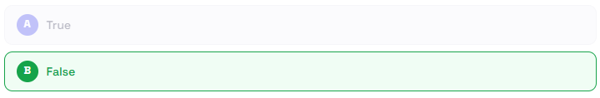

✅ Correct answer: False
Answer is False
an Activity JSON definition is embedded into a pipeline JSON definition.

Question 43Azure Data Factory
Which transformation in the Mapping Data Flow is used to routes data rows to different streams based on matching conditions?

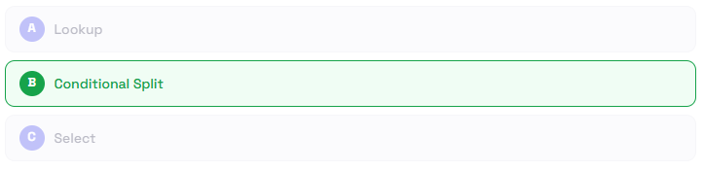
✅ Correct answer: Conditional Split
Answer is Conditional Split
A Conditional Split transformation routes data rows to different streams based on matching conditions. The conditional split transformation is similar to a CASE decision structure in a programming language. A Lookup transformation is used to add reference data from another source to your Data Flow. The Lookup transform requires a defined source that points to your reference table and matches on key fields. A Select transformation is used for selecting and/or defining your columns

Question 44Azure Data Factory
Which transformation is used to load data into a data store or compute resource?

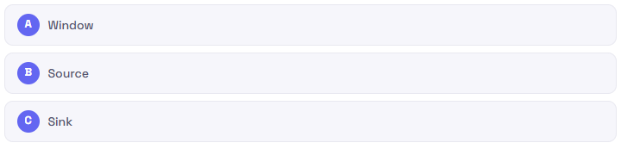

✅ Correct answer: Sink
Answer is Sink
A Sink transformation allows you to choose a dataset definition for the destination output data. You can have as many sink transformations as your data flow requires.
A Window transformation is where you will define window-based aggregations of columns in your data streams.
A Source transformation configures your data source for the data flow. When designing data flows, your first step will always be configuring a source transformation.

Question 45Azure Data Factory
What is the DataFrame method call to create temporary view?

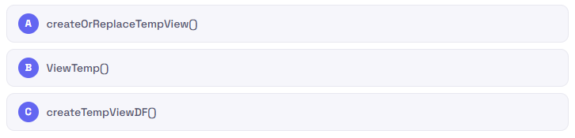

✅ Correct answer: createOrReplaceTempView()
Answer is createOrReplaceTempView()
createOrReplaceTempView(). This is the correct method name for creating temporary views in DataFrames and createTempViewDF() are incorrect method name.

Question 46Azure Data Factory
You have an Azure Storage account and an Azure SQL data warehouse in the UK South region.
You need to copy blob data from the storage account to the data warehouse by using Azure Data Factory.
The solution must meet the following requirements:
- Ensure that the data remains in the UK South region at all times.
- Minimize administrative effort.
Which type of integration runtime should you use?

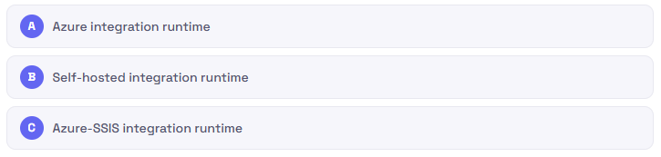

✅ Correct answer: Azure integration runtime
Answer is Azure integration runtime
Self-hosted integration runtime is to be used On-premises.
References:
https://docs.microsoft.com/en-us/azure/data-factory/concepts-integration-runtime

Question 47Azure Data Factory
You develop data engineering solutions for a company.
You must integrate the company's on-premises Microsoft SQL Server data with Microsoft Azure SQL Database. Data must be transformed incrementally.
You need to implement the data integration solution.
Which tool should you use to configure a pipeline to copy data?

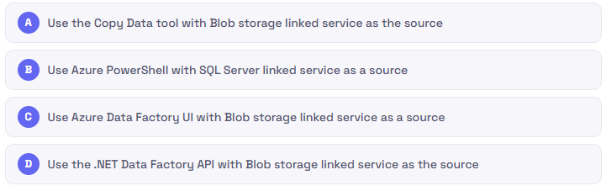

✅ Correct answer: Use Azure Data Factory UI with Blob storage linked service as a source
Answer is "Use Azure Data Factory UI with Blob storage linked service as a source"
The Integration Runtime is a customer managed data integration infrastructure used by Azure Data Factory to provide data integration capabilities across different network environments.
A linked service defines the information needed for Azure Data Factory to connect to a data resource. We have three resources in this scenario for which linked services are needed:
- On-premises SQL Server
- Azure Blob Storage
- Azure SQL database
Note: Azure Data Factory is a fully managed cloud-based data integration service that orchestrates and automates the movement and transformation of data. The key concept in the ADF model is pipeline. A pipeline is a logical grouping of Activities, each of which defines the actions to perform on the data contained in Datasets. Linked services are used to define the information needed for Data Factory to connect to the data resources.
References:
https://docs.microsoft.com/en-us/azure/machine-learning/team-data-science-process/move-sql-azure-adf

Question 48Azure Data Factory
You have an Azure virtual machine that has Microsoft SQL Server installed. The server contains a table named Table1.
You need to copy the data from Table1 to an Azure Data Lake Storage Gen2 account by using an Azure Data Factory V2 copy activity.
Which type of integration runtime should you use?

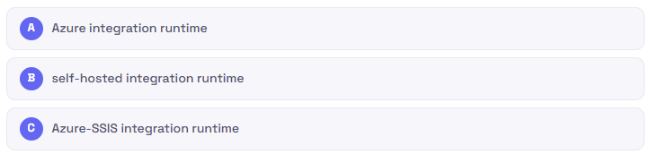

✅ Correct answer: self-hosted integration runtime
Answer is self-hosted integration runtime
Copying between a cloud data source and a data source in private network: if either source or sink linked service points to a self-hosted IR, the copy activity is executed on that self-hosted Integration Runtime.
References:
https://docs.microsoft.com/en-us/azure/data-factory/concepts-integration-runtime#determining-which-ir-to-use

Question 49Azure Data Factory
You have a new Azure Data Factory environment.
You need to periodically analyze pipeline executions from the last 60 days to identify trends in execution durations. The solution must use Azure Log Analytics to query the data and create charts.
Which diagnostic settings should you configure in Data Factory?
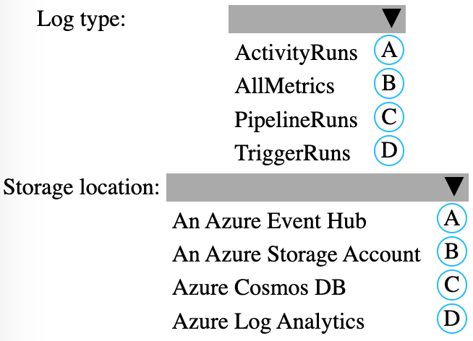



✅ Correct answer: C-B
Answer is C - B
Log type: PipelineRuns
A pipeline run in Azure Data Factory defines an instance of a pipeline execution.
Storage location: An Azure Storage account
Data Factory stores pipeline-run data for only 45 days. Use Monitor if you want to keep that data for a longer time. With Monitor, you can route diagnostic logs for analysis. You can also keep them in a storage account so that you have factory information for your chosen duration.
Save your diagnostic logs to a storage account for auditing or manual inspection. You can use the diagnostic settings to specify the retention time in days.
References:
https://docs.microsoft.com/en-us/azure/data-factory/concepts-pipeline-execution-triggers
https://docs.microsoft.com/en-us/azure/data-factory/monitor-using-azure-monitor

Question 50Azure Data Factory
You have an activity in an Azure Data Factory pipeline. The activity calls a stored procedure in a data warehouse in Azure Synapse Analytics and runs daily.
You need to verify the duration of the activity when it ran last.
What should you use?

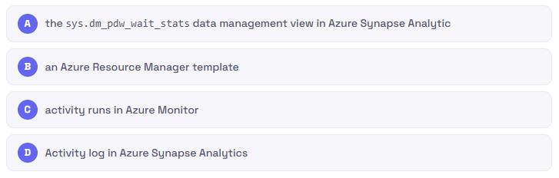

✅ Correct answer: activity runs in Azure Monitor
Answer is activity runs in Azure Monitor
Monitor activity runs. To get a detailed view of the individual activity runs of a specific pipeline run, click on the pipeline name.
The list view shows activity runs that correspond to each pipeline run. Hover over the specific activity run to get run-specific information such as the JSON input, JSON output, and detailed activity-specific monitoring experiences. On this screen you can check the Duration.
Incorrect Answers:
sys.dm_pdw_wait_stats holds information related to the SQL Server OS state related to instances running on the different nodes.
Reference:
https://docs.microsoft.com/en-us/azure/data-factory/monitor-visually

Question 51Azure Data Factory
You have an Azure data factory that has two pipelines named PipelineA and PipelineB.
PipelineA has four activities as shown in the following exhibit.
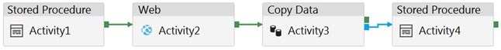
PipelineB has two activities as shown in the following exhibit.
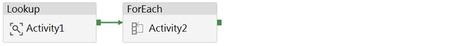
You create an alert for the data factory that uses Failed pipeline runs metrics for both pipelines and all failure types. The metric has the following settings:
- Operator: Greater than
- Aggregation type: Total
- Threshold value: 2
- Aggregation granularity (Period): 5 minutes
- Frequency of evaluation: Every 5 minutes
Data Factory monitoring records the failures shown in the following table.
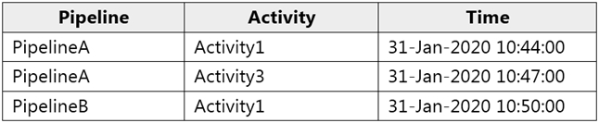
For each of the following statements, select yes if the statement is true. Otherwise, select no.
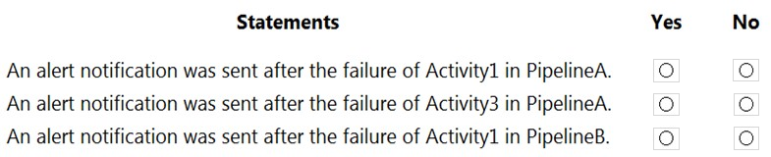

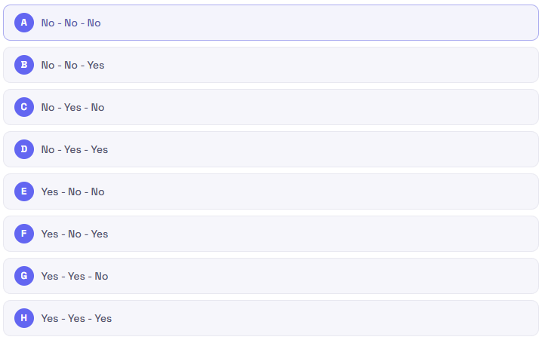

✅ Correct answer: No - No - Yes
Answer is No - No - Yes
Box 1: No
Only one failure at this point.
Box 2: No
Only two failures within 5 minutes.
Box 3: Yes
More than two (three) failures in 5 minutes
Reference:
https://docs.microsoft.com/en-us/azure/azure-sql/database/alerts-insights-configure-portal

Question 52Azure Data Factory
You plan to monitor an Azure data factory by using the Monitor & Manage app.
You need to identify the status and duration of activities that reference a table in a source database.
Which three actions should you perform in sequence?
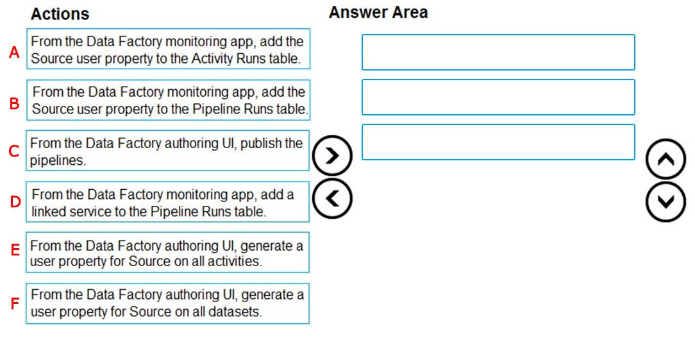



✅ Correct answer: E-B-C
Answer is E-B-C
Step 1: From the Data Factory authoring UI, generate a user property for Source on all activities.
Step 2: From the Data Factory monitoring app, add the Source user property to Activity Runs table.
You can promote any pipeline activity property as a user property so that it becomes an entity that you can monitor. For example, you can promote the Source and
Destination properties of the copy activity in your pipeline as user properties. You can also select Auto Generate to generate the Source and Destination user properties for a copy activity.
Step 3: From the Data Factory authoring UI, publish the pipelines
Publish output data to data stores such as Azure SQL Data Warehouse for business intelligence (BI) applications to consume.
References:
https://docs.microsoft.com/en-us/azure/data-factory/monitor-visually

Question 53Azure Data Factory
You have an Azure Data Factory that contains 10 pipelines.
You need to label each pipeline with its main purpose of either ingest, transform, or load. The labels must be available for grouping and filtering when using the monitoring experience in Data Factory.
What should you add to each pipeline?

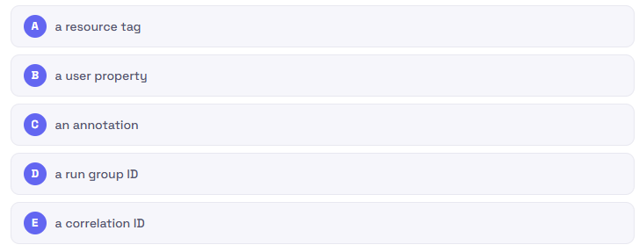

✅ Correct answer: an annotation
Answer is an annotation
Annotations are additional, informative tags that you can add to specific factory resources: pipelines, datasets, linked services, and triggers. By adding annotations, you can easily filter and search for specific factory resources.
Reference:
https://www.cathrinewilhelmsen.net/annotations-user-properties-azure-data-factory/

Question 54Azure Data Factory
You are implementing mapping data flows in Azure Data Factory to convert daily logs of taxi records into aggregated datasets. You configure a data flow and receive the error shown in the following exhibit.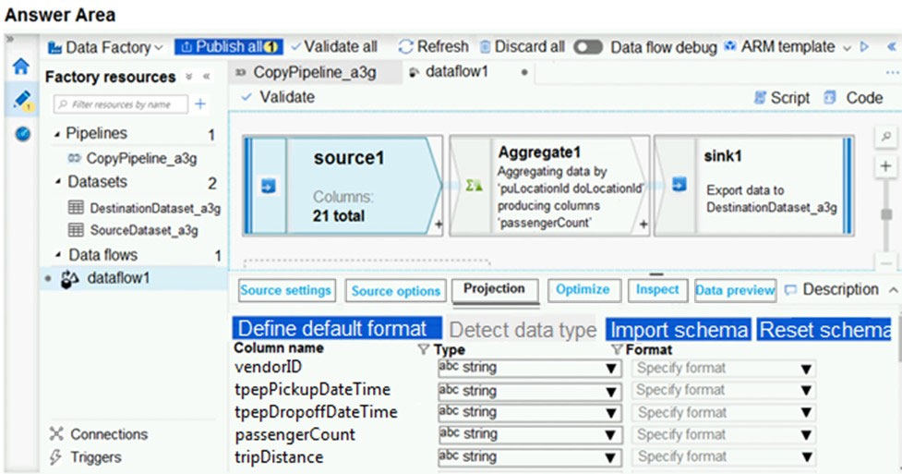

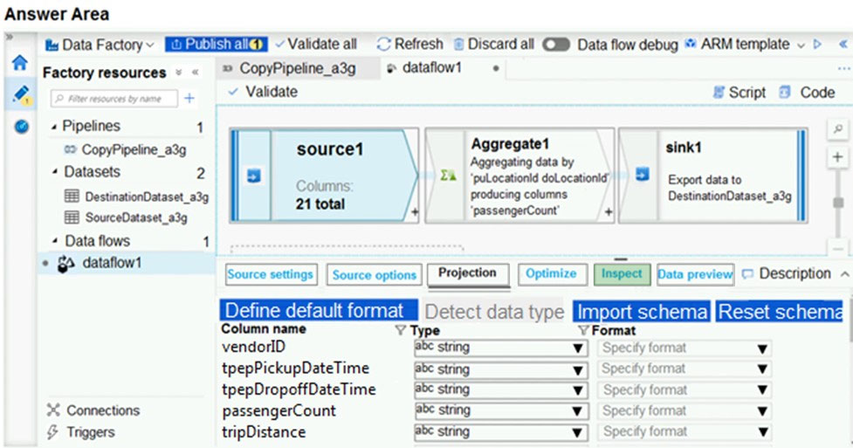

The Inspect tab provides a view into the metadata of the data stream that you're transforming. You can see column counts, the columns changed, the columns added, data types, the column order, and column references. Inspect is a read-only view of your metadata. You don't need to have debug mode enabled to see metadata in the Inspect pane.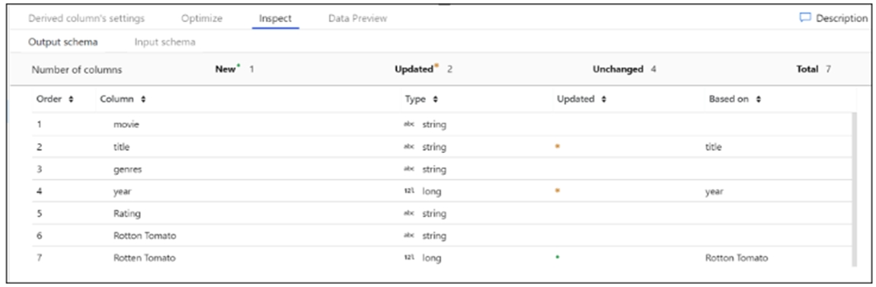Reference: https://docs.microsoft.com/en-us/azure/data-factory/concepts-data-flow-overview

Question 55Azure Data Factory
You have an Azure subscription that contains an Azure Storage account.
You plan to implement changes to a data storage solution to meet regulatory and compliance standards.
Every day, Azure needs to identify and delete blobs that were NOT modified during the last 100 days.
Solution: You schedule an Azure Data Factory pipeline with a delete activity.

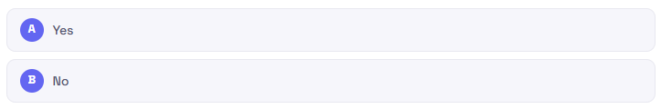

✅ Correct answer: Yes
Answer is Yes
You can use the Delete Activity in Azure Data Factory to delete files or folders from on-premises storage stores or cloud storage stores.
Azure Blob storage is supported.
Note: You can also apply an Azure Blob storage lifecycle policy.
Reference:
https://docs.microsoft.com/en-us/azure/data-factory/delete-activity
https://docs.microsoft.com/en-us/azure/storage/blobs/storage-lifecycle-management-concepts?tabs=azure-portal

Question 56Azure Data Factory
You are creating dimensions for a data warehouse in an Azure Synapse Analytics dedicated SQL pool.
You create a table by using the Transact-SQL statement shown in the following exhibit.
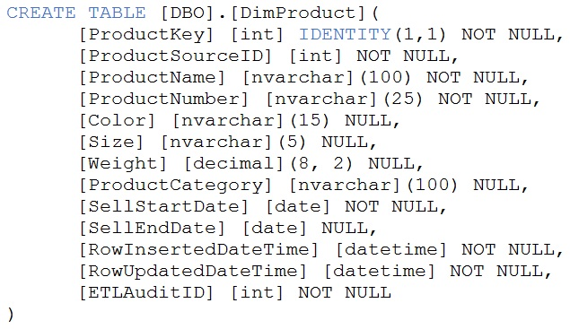
Use the drop-down menus to select the answer choice that completes each statement based on the information presented in the graphic.
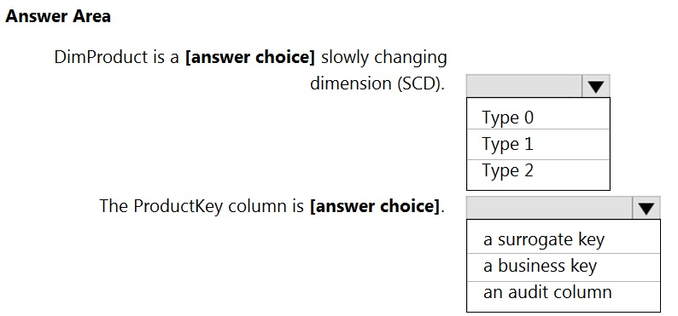

Answer is Type 1 and surrogate key
"In data warehousing, IDENTITY functionality is particularly important as it makes easier the creation of surrogate keys."
Why ProductKey is certainly not a business key: "The IDENTITY value in Synapse is not guaranteed to be unique if the user explicitly inserts a duplicate value with 'SET IDENTITY_INSERT ON' or reseeds IDENTITY". Business key is an index which identifies uniqueness of a row and here Microsoft says that identity doesn't guarantee uniqueness.
References:
https://azure.microsoft.com/en-us/blog/identity-now-available-with-azure-sql-data-warehouse/
https://docs.microsoft.com/en-us/azure/synapse-analytics/sql-data-warehouse/sql-data-warehouse-tables-identity
https://docs.microsoft.com/en-us/learn/modules/populate-slowly-changing-dimensions-azure-synapse-analytics-pipelines/3-choose-between-dimension-types

Question 57Azure Data Factory
You have files and folders in Azure Data Lake Storage Gen2 for an Azure Synapse workspace as shown in the following exhibit.
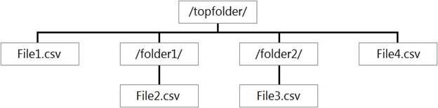
You create an external table named ExtTable that has LOCATION='/topfolder/'.
When you query ExtTable by using an Azure Synapse Analytics serverless SQL pool, which files are returned?

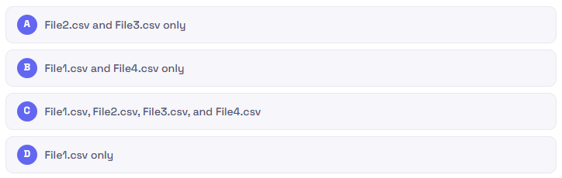

✅ Correct answer: File1.csv and File4.csv only
Answer is File1.csv and File4.csv only
Unlike Hadoop external tables, native external tables don't return subfolders unless you specify /** at the end of path. In this example, if LOCATION='/webdata/', a serverless SQL pool query, will return rows from mydata.txt. It won't return mydata2.txt and mydata3.txt because they're located in a subfolder. Hadoop tables will return all files within any sub-folder.
Reference:
https://docs.microsoft.com/en-us/azure/synapse-analytics/sql/develop-tables-external-tables?tabs=hadoop

Question 58Azure Data Factory
You need to output files from Azure Data Factory.
Which file format should you use for each type of output?
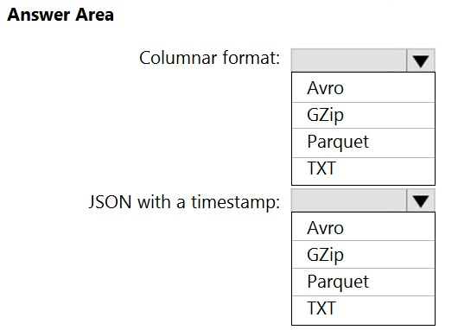

Box 1: Parquet
Parquet stores data in columns, while Avro stores data in a row-based format. By their very nature, column-oriented data stores are optimized for read-heavy analytical workloads, while row-based databases are best for write-heavy transactional workloads.
Box 2: Avro
An Avro schema is created using JSON format.
AVRO supports timestamps.
Note: Azure Data Factory supports the following file formats (not GZip or TXT).
- Avro format
- Binary format
- Delimited text format
- Excel format
- JSON format
- ORC format
- Parquet format
- XML format
Reference:
https://www.datanami.com/2018/05/16/big-data-file-formats-demystified

Question 59Azure Data Factory
You use Azure Data Factory to prepare data to be queried by Azure Synapse Analytics serverless SQL pools.
Files are initially ingested into an Azure Data Lake Storage Gen2 account as 10 small JSON files. Each file contains the same data attributes and data from a subsidiary of your company.
You need to move the files to a different folder and transform the data to meet the following requirements:
- Provide the fastest possible query times.
- Automatically infer the schema from the underlying files.
How should you configure the Data Factory copy activity?
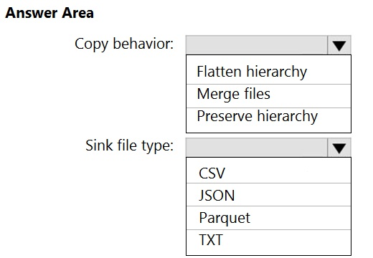

- Merge Files - Question clearly says "initially ingested as 10 small json files". There is no hint on hierarchy or partition information. so clearly we need to merge these files for better performance
2) Parquet -> Always gives better performance for columnar based data
Reference:
https://docs.microsoft.com/en-us/azure/storage/blobs/data-lake-storage-performance-tuning-guidance

Question 60Azure Data Factory
You are creating an Azure Data Factory data flow that will ingest data from a CSV file, cast columns to specified types of data, and insert the data into a table in an Azure Synapse Analytic dedicated SQL pool. The CSV file contains three columns named username, comment, and date.
The data flow already contains the following:
- A source transformation.
- A Derived Column transformation to set the appropriate types of data.
- A sink transformation to land the data in the pool.
You need to ensure that the data flow meets the following requirements:
- All valid rows must be written to the destination table.
- Truncation errors in the comment column must be avoided proactively.
- Any rows containing comment values that will cause truncation errors upon insert must be written to a file in blob storage.
Which two actions should you perform?

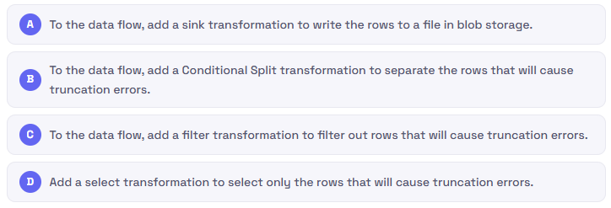

✅ Correct answer: To the data flow, add a sink transformation to write the rows to a file in blob storage., To the data flow, add a Conditional Split transformation to separate the rows that will cause truncation errors.
Answer is A and B
B: Example:
1. This conditional split transformation defines the maximum length of "title" to be five. Any row that is less than or equal to five will go into the GoodRows stream.
Any row that is larger than five will go into the BadRows stream.
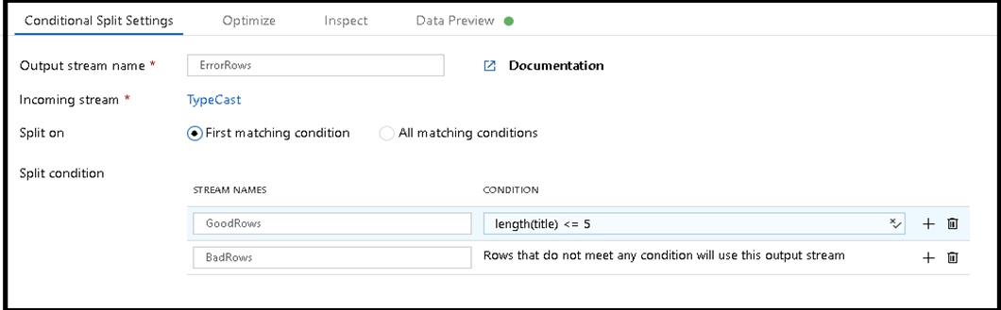
2. This conditional split transformation defines the maximum length of "title" to be five. Any row that is less than or equal to five will go into the GoodRows stream.
Any row that is larger than five will go into the BadRows stream.
A:
3. Now we need to log the rows that failed. Add a sink transformation to the BadRows stream for logging. Here, we'll "auto-map" all of the fields so that we have logging of the complete transaction record. This is a text-delimited CSV file output to a single file in Blob Storage. We'll call the log file "badrows.csv".
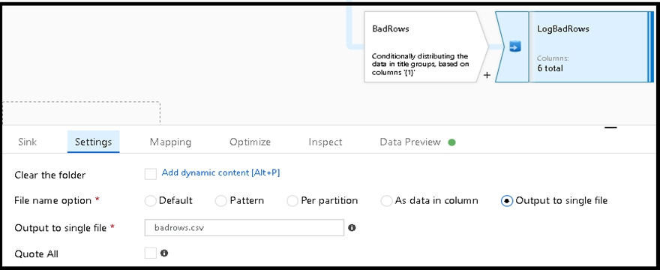
4. The completed data flow is shown below. We are now able to split off error rows to avoid the SQL truncation errors and put those entries into a log file.
Meanwhile, successful rows can continue to write to our target database.
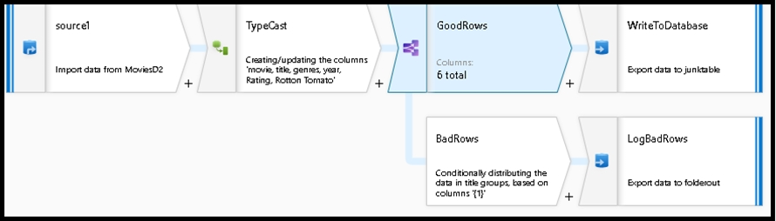
Reference:
https://docs.microsoft.com/en-us/azure/data-factory/how-to-data-flow-error-rows

Question 61Azure Data Factory
You build an Azure Data Factory pipeline to move data from an Azure Data Lake Storage Gen2 container to a database in an Azure Synapse Analytics dedicated SQL pool.
Data in the container is stored in the following folder structure.
/in/{YYYY}/{MM}/{DD}/{HH}/{mm}
The earliest folder is /in/2021/01/01/00/00. The latest folder is /in/2021/01/15/01/45.
You need to configure a pipeline trigger to meet the following requirements:
- Existing data must be loaded.
- Data must be loaded every 30 minutes.
- Late-arriving data of up to two minutes must he included in the load for the time at which the data should have arrived.
How should you configure the pipeline trigger?
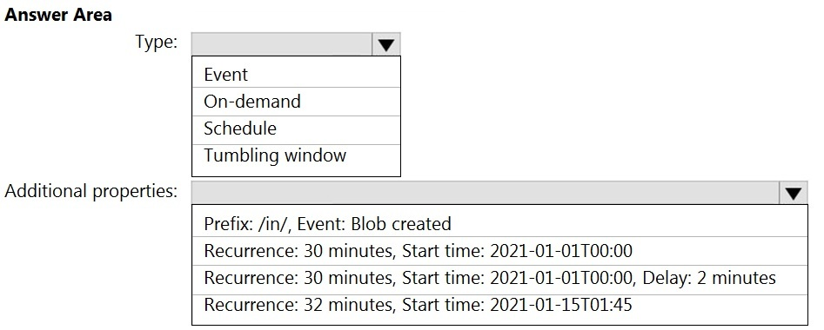
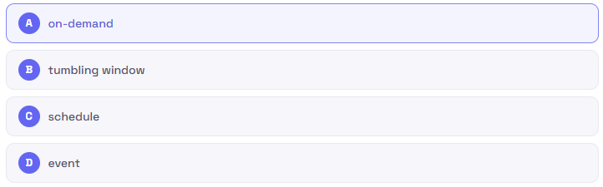
Box 1: Tumbling window
To be able to use the Delay parameter we select Tumbling window.
Box 2: Recurrence: 30 minutes, not 32 minutes. Delay: 2 minutes.
The amount of time to delay the start of data processing for the window. The pipeline run is started after the expected execution time plus the amount of delay.
The delay defines how long the trigger waits past the due time before triggering a new run. The delay doesn't alter the window startTime.
Reference:
https://docs.microsoft.com/en-us/azure/data-factory/how-to-create-tumbling-window-trigger

Question 62Azure Data Factory
You need to schedule an Azure Data Factory pipeline to execute when a new file arrives in an Azure Data Lake Storage Gen2 container.
Which type of trigger should you use?
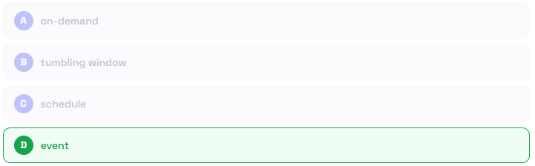

✅ Correct answer: event
Answer is event
Event-driven architecture (EDA) is a common data integration pattern that involves production, detection, consumption, and reaction to events. Data integration scenarios often require Data Factory customers to trigger pipelines based on events happening in storage account, such as the arrival or deletion of a file in Azure Blob Storage account.
Reference:
https://docs.microsoft.com/en-us/azure/data-factory/how-to-create-event-trigger

Question 63Azure Data Factory
You have two Azure Data Factory instances named ADFdev and ADFprod. ADFdev connects to an Azure DevOps Git repository.
You publish changes from the main branch of the Git repository to ADFdev.
You need to deploy the artifacts from ADFdev to ADFprod.
What should you do first?

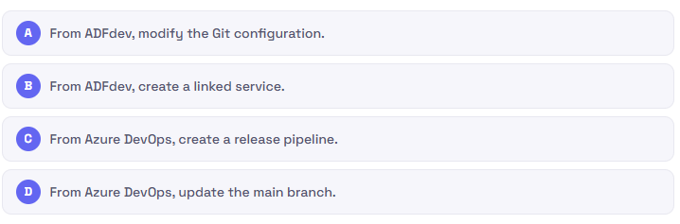

✅ Correct answer: From Azure DevOps, create a release pipeline.
Answer is From Azure DevOps, create a release pipeline.
In Azure Data Factory, continuous integration and delivery (CI/CD) means moving Data Factory pipelines from one environment (development, test, production) to another.
Note:
The following is a guide for setting up an Azure Pipelines release that automates the deployment of a data factory to multiple environments.
1. In Azure DevOps, open the project that's configured with your data factory.
2. On the left side of the page, select Pipelines, and then select Releases.
3. Select New pipeline, or, if you have existing pipelines, select New and then New release pipeline.
4. In the Stage name box, enter the name of your environment.
5. Select Add artifact, and then select the git repository configured with your development data factory. Select the publish branch of the repository for the Default branch. By default, this publish branch is adf_publish.
6. Select the Empty job template.
Reference:
https://docs.microsoft.com/en-us/azure/data-factory/continuous-integration-deployment

Question 64Azure Data Factory
You have a self-hosted integration runtime in Azure Data Factory.
The current status of the integration runtime has the following configurations:
- Status: Running
- Type: Self-Hosted
- Version: 4.4.7292.1
- Running / Registered Node(s): 1/1
- High Availability Enabled: False
- Linked Count: 0
- Queue Length: 0
- Average Queue Duration. 0.00s
The integration runtime has the following node details:
- Name: X-M
- Status: Running
- Version: 4.4.7292.1
- Available Memory: 7697MB
- CPU Utilization: 6%
- Network (In/Out): 1.21KBps/0.83KBps
- Concurrent Jobs (Running/Limit): 2/14
- Role: Dispatcher/Worker
- Credential Status: In Sync
Use the drop-down menus to select the answer choice that completes each statement based on the information presented.
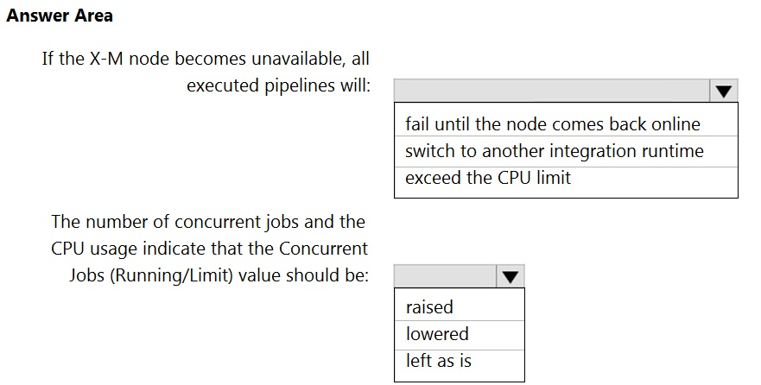

Box 1: fail until the node comes back online
We see: High Availability Enabled: False
Note: Higher availability of the self-hosted integration runtime so that it's no longer the single point of failure in your big data solution or cloud data integration with Data Factory.
Box 2: lowered
We see:
Concurrent Jobs (Running/Limit): 2/14
CPU Utilization: 6%
Note: When the processor and available RAM aren't well utilized, but the execution of concurrent jobs reaches a node's limits, scale up by increasing the number of concurrent jobs that a node can run
Reference:
https://docs.microsoft.com/en-us/azure/data-factory/create-self-hosted-integration-runtime

Question 65Azure Data Factory
You have an Azure data factory.
You need to examine the pipeline failures from the last 60 days.
What should you use?
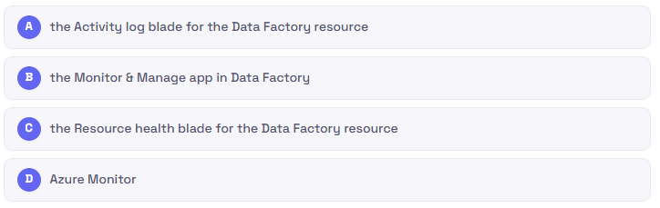

✅ Correct answer: Azure Monitor
Answer is Azure Monitor
Data Factory stores pipeline-run data for only 45 days. Use Azure Monitor if you want to keep that data for a longer time.
Reference:
https://docs.microsoft.com/en-us/azure/data-factory/monitor-using-azure-monitor

Question 66Azure Data Factory
You have two Azure Storage accounts named Storage1 and Storage2. Each account contains an Azure Data Lake Storage file system. The system has files that contain data stored in the Apache Parquet format.
You need to copy folders and files from Storage1 to Storage2 by using a Data Factory copy activity. The solution must meet the following requirements:
- No transformations must be performed.
- The original folder structure must be retained.
How should you configure the copy activity?
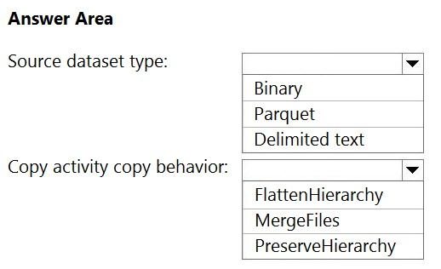
Box 1: Parquet
For Parquet datasets, the type property of the copy activity source must be set to ParquetSource..
Box 2: PreserveHierarchy
PreserveHierarchy (default): Preserves the file hierarchy in the target folder. The relative path of the source file to the source folder is identical to the relative path of the target file to the target folder.
Incorrect Answers:
FlattenHierarchy: All files from the source folder are in the first level of the target folder. The target files have autogenerated names. MergeFiles: Merges all files from the source folder to one file. If the file name is specified, the merged file name is the specified name. Otherwise, it's an autogenerated file name.
Reference:
https://docs.microsoft.com/en-us/azure/data-factory/format-parquet
https://docs.microsoft.com/en-us/azure/data-factory/connector-azure-data-lake-storage

Question 67Azure Data Factory
A company plans to develop solutions to perform batch processing of multiple sets of geospatial data.
You need to implement the solutions.
Which Azure services should you use?
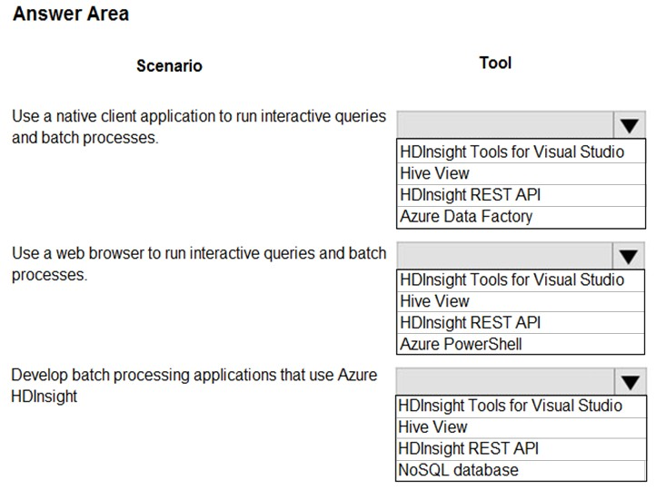

Box 1: HDInsight Tools for Visual Studio
Azure HDInsight Tools for Visual Studio Code is an extension in the Visual Studio Code Marketplace for developing Hive Interactive Query, Hive Batch Job and PySpark Job against Microsoft HDInsight.
Box 2: Hive View
You can use Apache Ambari Hive View with Apache Hadoop in HDInsight. The Hive View allows you to author, optimize, and run Hive queries from your web browser.
Box 3: HDInsight REST API
Azure HDInsight REST APIs are used to create and manage HDInsight resources through Azure Resource Manager.
References:
https://visualstudiomagazine.com/articles/2019/01/25/vscode-hdinsight.aspx
https://docs.microsoft.com/en-us/azure/hdinsight/hadoop/apache-hadoop-use-hive-ambari-view
https://docs.microsoft.com/en-us/rest/api/hdinsight/

Question 68Azure Data Factory
You have an Azure Data Factory pipeline that performs an incremental load of source data to an Azure Data Lake Storage Gen2 account.
Data to be loaded is identified by a column named LastUpdatedDate in the source table.
You plan to execute the pipeline every four hours.
You need to ensure that the pipeline execution meets the following requirements:
- Automatically retries the execution when the pipeline run fails due to concurrency or throttling limits.
- Supports backfilling existing data in the table.
Which type of trigger should you use?

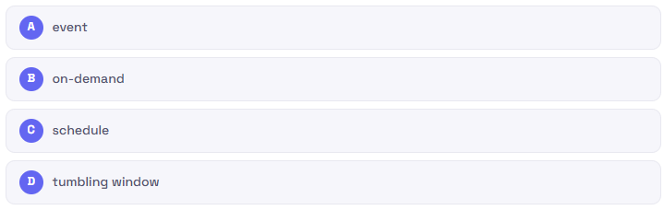

✅ Correct answer: tumbling window
Answer is tumbling window
Azure Data Factory pipeline executions using Triggers:
• Schedule Trigger: The schedule trigger is used to execute the Azure Data Factory pipelines on a wall-clock schedule.
• Tumbling Window Trigger: Can be used to process history data. Also can define Delay, Max concurrency, retry policy etc.
• Event-Based Triggers : The event-based trigger executes the pipelines in response to a blob-related event, such as creating or deleting a blob file, in an Azure Blob Storage
Reference:
https://docs.microsoft.com/en-us/azure/data-factory/how-to-create-tumbling-window-trigger
https://www.sqlshack.com/how-to-schedule-azure-data-factory-pipeline-executions-using-triggers/

Question 69Azure Data Factory
You are building an Azure Data Factory solution to process data received from Azure Event Hubs, and then ingested into an Azure Data Lake Storage Gen2 container.
The data will be ingested every five minutes from devices into JSON files. The files have the following naming pattern.
/{deviceType}/in/{YYYY}/{MM}/{DD}/{HH}/{deviceID}_{YYYY}{MM}{DD}HH}{mm}.json
You need to prepare the data for batch data processing so that there is one dataset per hour per deviceType. The solution must minimize read times.
How should you configure the sink for the copy activity?
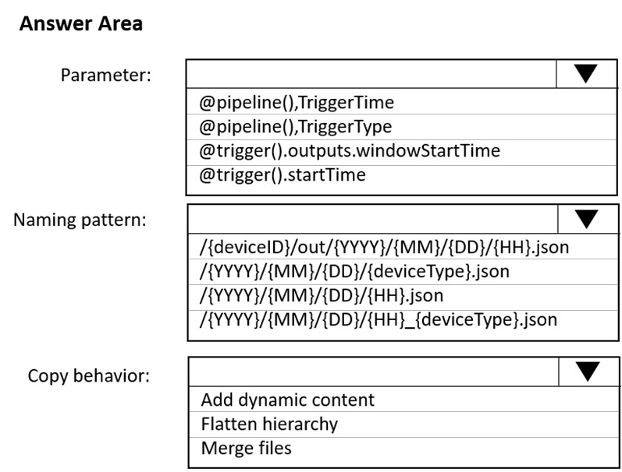

- @trigger().outputs.windowStartTime - this output is from a tumbling window trigger, and is required to identify the correct directory at the /{HH}/ level. Using windowStartTime will give the hour with complete data. The @trigger().startTime is for a schedule trigger, which corresponds to the hour for which data has not arrived yet.
2) /{YYYY}/{MM}/{DD}/{HH}_{deviceType}.json is the naming pattern to achieve an hourly dataset for each device type.
3) Multiple files for each device type will exist on the source side, since the naming pattern starts with {deviceID}... so the files must be merged in the sink to create a single file per device type.
Reference:
https://docs.microsoft.com/en-us/azure/data-factory/concepts-pipeline-execution-triggers
https://docs.microsoft.com/en-us/azure/data-factory/connector-file-system

Question 70Azure Data Factory
You have the following Azure Data Factory pipelines:
- Ingest Data from System1
- Ingest Data from System2
- Populate Dimensions
- Populate Facts
Ingest Data from System1 and Ingest Data from System2 have no dependencies. Populate Dimensions must execute after Ingest Data from System1 and Ingest Data from System2. Populate Facts must execute after Populate Dimensions pipeline. All the pipelines must execute every eight hours.
What should you do to schedule the pipelines for execution?

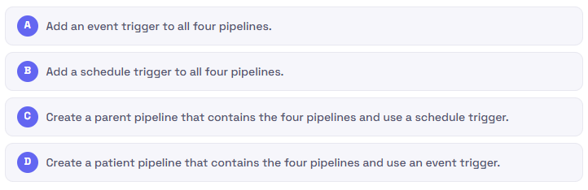

✅ Correct answer: Create a parent pipeline that contains the four pipelines and use a schedule trigger.
Answer is Create a parent pipeline that contains the four pipelines and use a schedule trigger.
The parent pipeline has 4 execute pipeline activities. Ingest 1 and Ingest 2 have no dependencies. Dimension pipeline has two dependencies from 'on completion' outputs of both Ingest 1 and Ingest 2 pipelines. Fact pipeline has one 'on completion' dependency on the Dimension pipeline. Absolutely nothing to do with a tumbling window trigger

Question 71Azure Data Factory
You need to trigger an Azure Data Factory pipeline when a file arrives in an Azure Data Lake Storage Gen2 container.
Which resource provider should you enable?

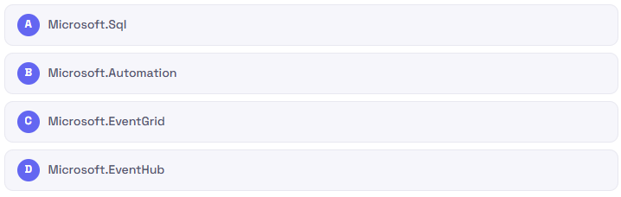

✅ Correct answer: Microsoft.EventGrid
Answer is Microsoft.EventGrid
Event-driven architecture (EDA) is a common data integration pattern that involves production, detection, consumption, and reaction to events. Data integration scenarios often require Data Factory customers to trigger pipelines based on events happening in storage account, such as the arrival or deletion of a file in Azure
Blob Storage account. Data Factory natively integrates with Azure Event Grid, which lets you trigger pipelines on such events.
Reference:
https://docs.microsoft.com/en-us/azure/data-factory/how-to-create-event-trigger
https://docs.microsoft.com/en-us/azure/data-factory/concepts-pipeline-execution-triggers

Question 72Azure Data Factory
You have an Azure Data Factory instance that contains two pipelines named Pipeline1 and Pipeline2.
Pipeline1 has the activities shown in the following exhibit.
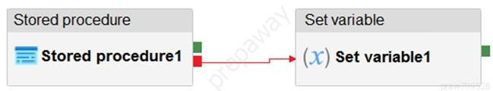
Pipeline2 has the activities shown in the following exhibit.
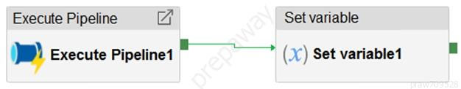
You execute Pipeline2, and Stored procedure1 in Pipeline1 fails.
What is the status of the pipeline runs?

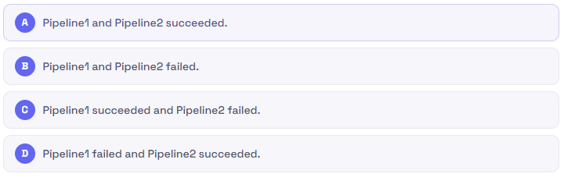

✅ Correct answer: Pipeline1 and Pipeline2 succeeded.
Answer is Pipeline1 and Pipeline2 succeeded.
Activities are linked together via dependencies. A dependency has a condition of one of the following: Succeeded, Failed, Skipped, or Completed.
Consider Pipeline1:
If we have a pipeline with two activities where Activity2 has a failure dependency on Activity1, the pipeline will not fail just because Activity1 failed. If Activity1 fails and Activity2 succeeds, the pipeline will succeed. This scenario is treated as a try-catch block by Data Factory.
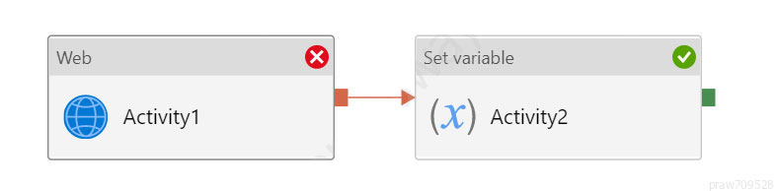
The failure dependency means this pipeline reports success.
Note:
If we have a pipeline containing Activity1 and Activity2, and Activity2 has a success dependency on Activity1, it will only execute if Activity1 is successful. In this scenario, if Activity1 fails, the pipeline will fail.
The trick is the fact that pipeline 1 only has a Failure dependency between de activity's. In this situation this results in a Succeeded pipeline if the Stored procedure failed. If also the success connection was linked to a follow up activity, and the SP would fail, the pipeline would be indeed marked as failed.
Reference:
https://datasavvy.me/category/azure-data-factory/

Question 73Azure Data Factory
You configure version control for an Azure Data Factory instance as shown in the following exhibit.
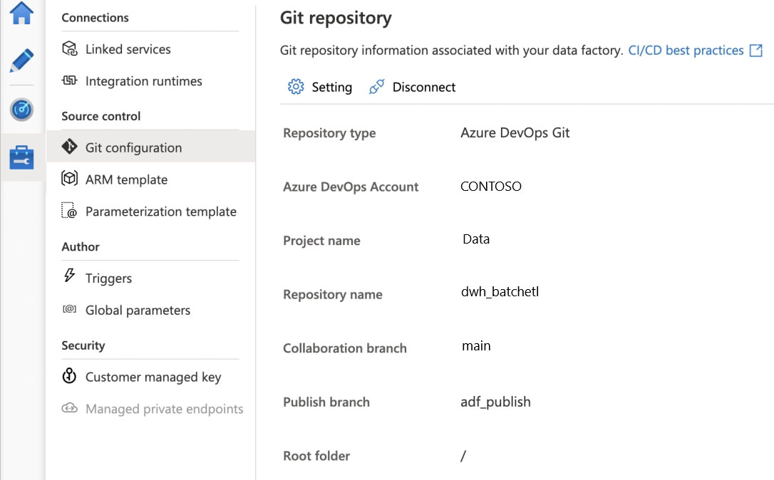
Use the drop-down menus to select the answer choice that completes each statement based on the information presented in the graphic.
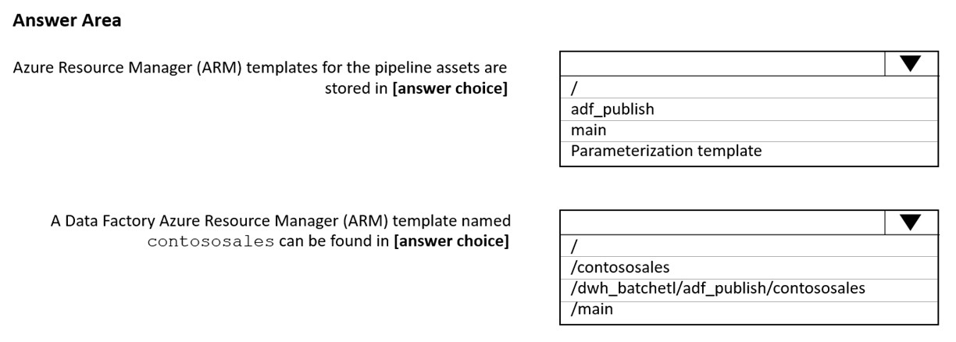

Box 1: adf_publish
The Publish branch is the branch in your repository where publishing related ARM templates are stored and updated. By default, it's adf_publish.
Box 2: / dwh_batchetl/adf_publish/contososales
Note: RepositoryName (here dwh_batchetl): Your Azure Repos code repository name. Azure Repos projects contain Git repositories to manage your source code as your project grows. You can create a new repository or use an existing repository that's already in your project.
Reference:
https://docs.microsoft.com/en-us/azure/data-factory/source-control

Question 74Azure Data Factory
You have an Azure Data Factory instance named ADF1 and two Azure Synapse Analytics workspaces named WS1 and WS2.
ADF1 contains the following pipelines:
● P1: Uses a copy activity to copy data from a nonpartitioned table in a dedicated SQL pool of WS1 to an Azure Data Lake Storage Gen2 account
● P2: Uses a copy activity to copy data from text-delimited files in an Azure Data Lake Storage Gen2 account to a nonpartitioned table in a dedicated SQL pool of
WS2 -
You need to configure P1 and P2 to maximize parallelism and performance.
Which dataset settings should you configure for the copy activity if each pipeline? To answer, select the appropriate options in the answer area.
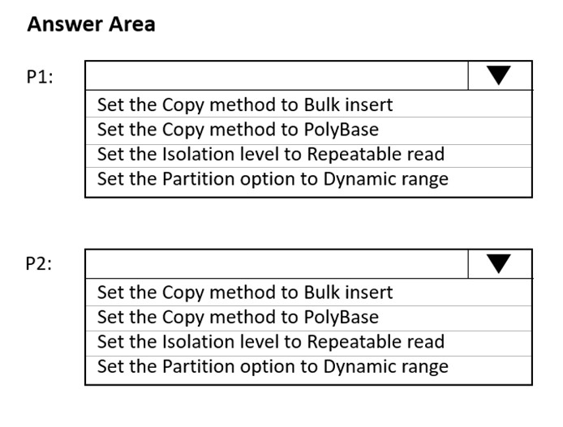
Both answers are PolyBase.
PolyBase supports both export to and import from ADLS as documented here: https://docs.microsoft.com/en-us/sql/relational-databases/polybase/polybase-versioned-feature-summary
PolyBase does support delimited text files, which contradicts the question's official answer. "Currently PolyBase can load data from UTF-8 and UTF-16 encoded delimited text files as well as the popular Hadoop file formats RC File, ORC, and Parquet (non-nested format)."
Reference:
https://docs.microsoft.com/en-us/azure/synapse-analytics/sql/load-data-overview

Question 75Azure Data Factory
You have an Azure Storage account that generates 200,000 new files daily. The file names have a format of {YYYY}/{MM}/{DD}/{HH}/{CustomerID}.csv.
You need to design an Azure Data Factory solution that will load new data from the storage account to an Azure Data Lake once hourly. The solution must minimize load times and costs.
How should you configure the solution? To answer, select the appropriate options in the answer area.
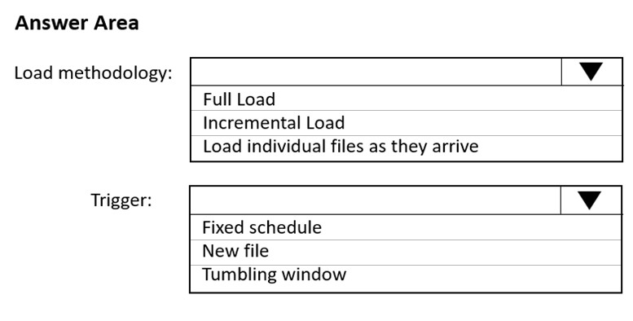

Box 1: Incremental load
Box 2: Tumbling window
Tumbling windows are a series of fixed-sized, non-overlapping and contiguous time intervals. The following diagram illustrates a stream with a series of events and how they are mapped into 10-second tumbling windows.
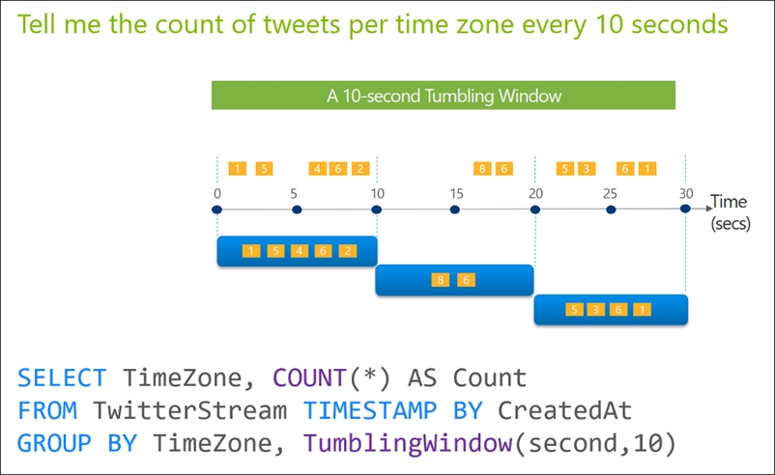
Reference:
https://docs.microsoft.com/en-us/stream-analytics-query/tumbling-window-azure-stream-analytics

Question 76Azure Data Factory
You are designing a solution that will copy Parquet files stored in an Azure Blob storage account to an Azure Data Lake Storage Gen2 account.
The data will be loaded daily to the data lake and will use a folder structure of {Year}/{Month}/{Day}/.
You need to design a daily Azure Data Factory data load to minimize the data transfer between the two accounts.
Which two configurations should you include in the design? Each correct answer presents part of the solut

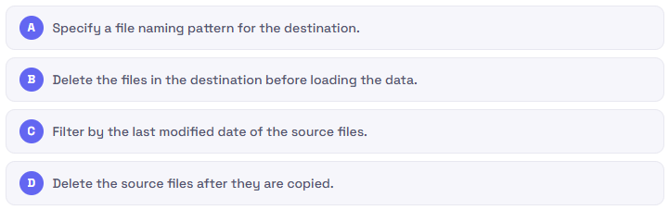

✅ Correct answer: Filter by the last modified date of the source files., Delete the source files after they are copied.
Answer is Filter by the last modified date of the source files. and Delete the source files after they are copied.
Copy only the daily files by using filtering.
Reference:
https://docs.microsoft.com/en-us/azure/data-factory/connector-azure-data-lake-storage

Question 77Azure Data Factory
You have an Azure Data Factory version 2 (V2) resource named Df1. Df1 contains a linked service.
You have an Azure Key vault named vault1 that contains an encryption key named key1.
You need to encrypt Df1 by using key1.
What should you do first?

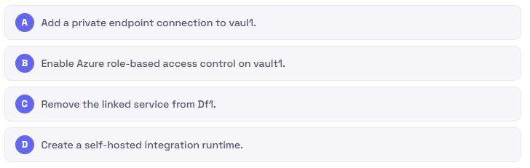

✅ Correct answer: Remove the linked service from Df1.
Answer is Remove the linked service from Df1.
Linked services are much like connection strings, which define the connection information needed for Data Factory to connect to external resources.
Incorrect Answers:
D: A self-hosted integration runtime copies data between an on-premises store and cloud storage.
Reference:
https://docs.microsoft.com/en-us/azure/data-factory/enable-customer-managed-key
https://docs.microsoft.com/en-us/azure/data-factory/concepts-linked-services
https://docs.microsoft.com/en-us/azure/data-factory/create-self-hosted-integration-runtime

Question 78Azure Data Factory
You have an Azure subscription that contains an Azure Data Lake Storage account. The storage account contains a data lake named DataLake1.
You plan to use an Azure data factory to ingest data from a folder in DataLake1, transform the data, and land the data in another folder.
You need to ensure that the data factory can read and write data from any folder in the DataLake1 file system. The solution must meet the following requirements:
● Minimize the risk of unauthorized user access.
● Use the principle of least privilege.
● Minimize maintenance effort.
How should you configure access to the storage account for the data factory?
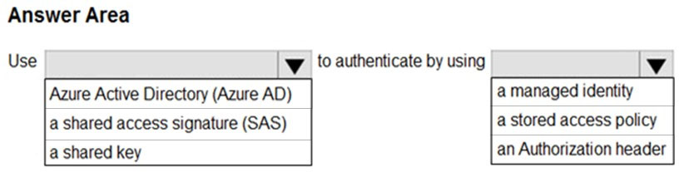

Box 1: Azure Active Directory (Azure AD)
On Azure, managed identities eliminate the need for developers having to manage credentials by providing an identity for the Azure resource in Azure AD and using it to obtain Azure Active Directory (Azure AD) tokens.
Box 2: a managed identity -
A data factory can be associated with a managed identity for Azure resources, which represents this specific data factory. You can directly use this managed identity for Data Lake Storage Gen2 authentication, similar to using your own service principal. It allows this designated factory to access and copy data to or from your Data Lake Storage Gen2.
Note: The Azure Data Lake Storage Gen2 connector supports the following authentication types.
● Account key authentication
● Service principal authentication
● Managed identities for Azure resources authentication
Reference:
https://docs.microsoft.com/en-us/azure/active-directory/managed-identities-azure-resources/overview
https://docs.microsoft.com/en-us/azure/data-factory/connector-azure-data-lake-storage

Question 79Azure Data Factory
HOTSPOT -
You have an Azure Data Factory pipeline that has the activities shown in the following exhibit.
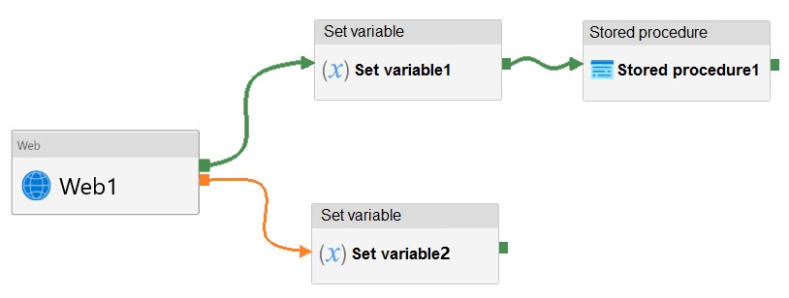
Use the drop-down menus to select the answer choice that completes each statement based on the information presented in the graphic.
NOTE: Each correct selection is worth one point.
Hot Area:
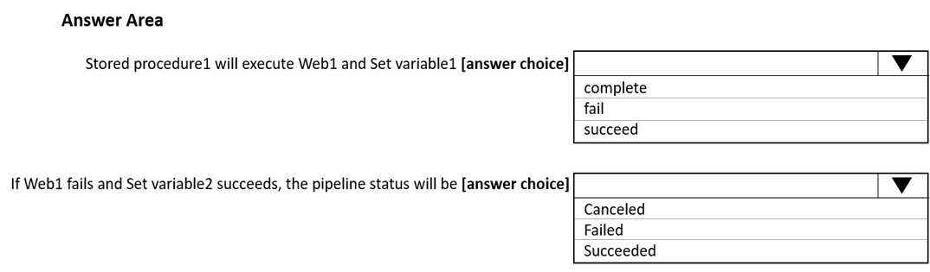

Box 1: succeed
Box 2: failed
Example:
Now let's say we have a pipeline with 3 activities, where Activity1 has a success path to Activity2 and a failure path to Activity3. If Activity1 fails and Activity3 succeeds, the pipeline will fail. The presence of the success path alongside the failure path changes the outcome reported by the pipeline, even though the activity executions from the pipeline are the same as the previous scenario.
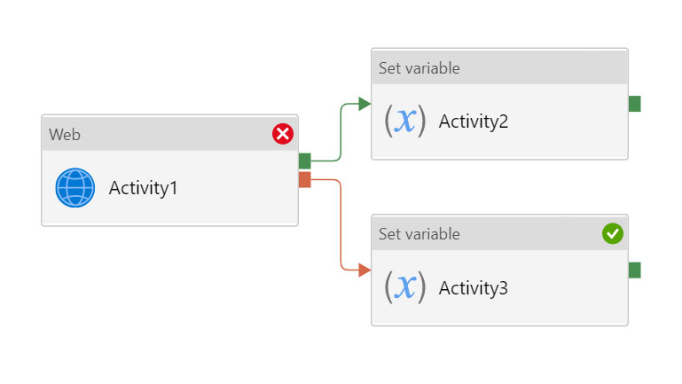
Activity1 fails, Activity2 is skipped, and Activity3 succeeds. The pipeline reports failure.
Reference:
https://datasavvy.me/2021/02/18/azure-data-factory-activity-failures-and-pipeline-outcomes/

Question 80Azure Data Factory
You have several Azure Data Factory pipelines that contain a mix of the following types of activities:
● Wrangling data flow
● Notebook
● Copy
● Jar
Which two Azure services should you use to debug the activities? Each correct answer presents part of the solution.
NOTE: Each correct selection is worth one point

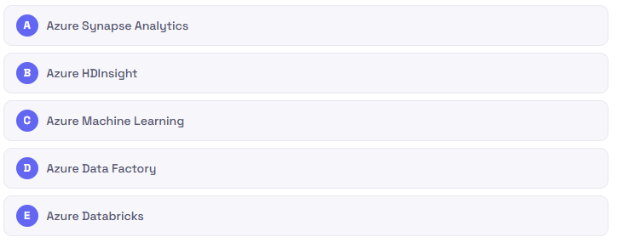
✅ Correct answer: Azure Data Factory, Azure Databricks
1. Data wangling is only supported by ADF not Synapse Analytics.
2. Notebook, Jar activity requires Databricks.
Reference:
https://docs.microsoft.com/en-us/azure/data-factory/wrangling-overview
https://docs.microsoft.com/en-us/azure/data-factory/transform-data-databricks-jar

Question 81Azure Data Factory
You plan to create an Azure Data Factory pipeline that will include a mapping data flow.
You have JSON data containing objects that have nested arrays.
You need to transform the JSON-formatted data into a tabular dataset. The dataset must have one row for each item in the arrays.
Which transformation method should you use in the mapping data flow?
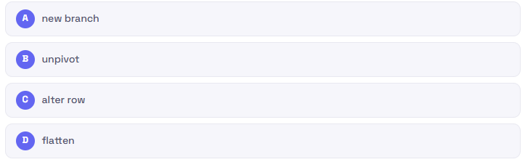

✅ Correct answer: flatten
Answer is flatten
Use the flatten transformation to take array values inside hierarchical structures such as JSON and unroll them into individual rows. This process is known as denormalization.
Reference:
https://docs.microsoft.com/en-us/azure/data-factory/data-flow-flatten

Question 82Azure Data Factory
You have an Azure Data Factory pipeline that is triggered hourly.
The pipeline has had 100% success for the past seven days.
The pipeline execution fails, and two retries that occur 15 minutes apart also fail. The third failure returns the following error.
ErrorCode=UserErrorFileNotFound,'Type=Microsoft.DataTransfer.Common.Shared.HybridDeliveryException,Message=ADLS Gen2 operation failed for: Operation returned an invalid status code 'NotFound'.
Account: 'contosoproduksouth'. Filesystem: wwi.
Path: 'BIKES/CARBON/year=2021/month=01/day=10/hour=06'.
ErrorCode: 'PathNotFound'.
Message: 'The specified path does not exist.'.
RequestId: '6d269b78-901f-001b-4924-e7a7bc000000'.
TimeStamp: 'Sun, 10 Jan 2021 07:45:05
What is a possible cause of the error?

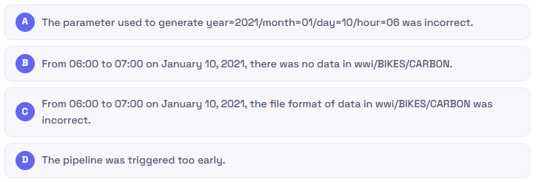
✅ Correct answer: From 06:00 to 07:00 on January 10, 2021, there was no data in wwi/BIKES/CARBON.
Answer is From 06:00 to 07:00 on January 10, 2021, there was no data in wwi/BIKES/CARBON.
The error message says a missing file, which matches with answer B: missing data from 06:00. The process had re-tried three times, 15 mins apart, which explains that the error was generated 07:45.

Question 83Azure Data Factory
You have an Azure data factory.
You need to examine the pipeline failures from the last 180 days.
What should you use?

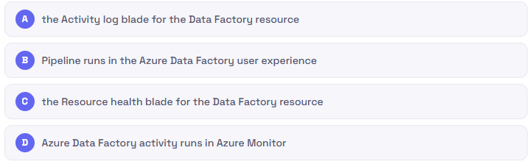

✅ Correct answer: Azure Data Factory activity runs in Azure Monitor
Answer is Azure Data Factory activity runs in Azure Monitor
Data Factory stores pipeline-run data for only 45 days. Use Azure Monitor if you want to keep that data for a longer time.
Reference:
https://docs.microsoft.com/en-us/azure/data-factory/monitor-using-azure-monitor

Question 84Azure Synapse Analytics
Which of the following terms refer to the scale of compute that is being used in an Azure SQL Synapse Analytics server?

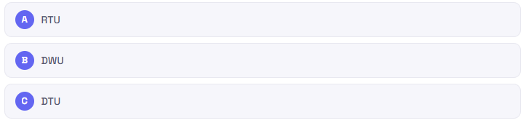

✅ Correct answer: DWU
Answer is DWU
DWU refers to Data Warehouse Units. It is the measure of compute scale that is assigned to an Azure SL Data Warehouse. RTU is a compute scale unit of Cosmos DB. DTU is a compute scale unit of Azure SQL Database.

Question 85Azure Synapse Analytics
You have an Azure Synapse Analytics database, within this, you have a dimension table named Stores that contains store information. There is a total of 263 stores nationwide. Store information is retrieved in more than half of the queries that are issued against this database. These queries include staff information per store, sales information per store and finance information. You want to improve the query performance of these queries by configuring the table geometry of the stores table. Which is the appropriate table geometry to select for the stores table?
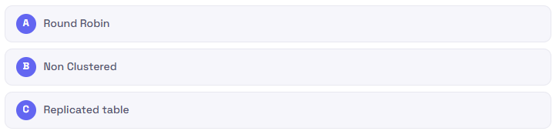
✅ Correct answer: Replicated table
Answer is Replicated table
A replicated table is an appropriate table geometry choice as the size of the data in the table is less than 200m and the table will be replicated to every distribution node of an Azure Synapse Analytics to improve the performance. A Round Robin distribution is a table geometry that is useful to perform initial data loads. Non Clustered is not a valid table geometry in Azure Synapse Analytics.

Question 86Azure Synapse Analytics
What is the default port for connecting to an enterprise data warehouse in Azure Synapse Analytics?

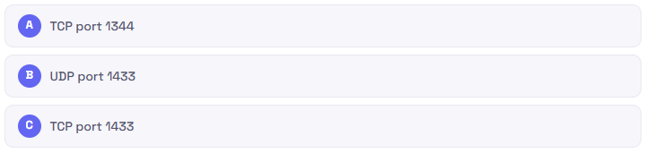

✅ Correct answer: TCP port 1433
Answer is TCP port 1433
The default port for connecting to an Azure Synapse Analytics is TCP port 1433.

Question 87Azure Synapse Analytics
You are moving data from an Azure Data Lake Gen2 store to Azure Synapse Analytics. Which Azure Data Factory integration runtime would be used in a data copy activity?

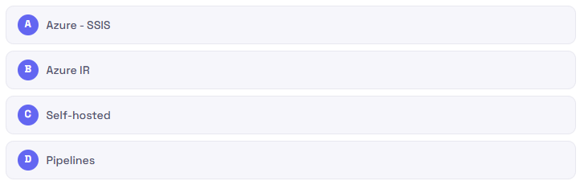

✅ Correct answer: Azure IR
Answer is Azure IR
When moving data between Azure data platform technologies, the Azure Integration runtime is used when copying data between two Azure data platforms. Azure-SSIS IR is used when you lift and shift existing SSIS workload, while Self-hosted IR is used when working with data movement from private networks to the cloud and vica versa

Question 88
Azure Synapse Analytics
How long is the Recovery Point Objective for Azure Synapse Analytics?
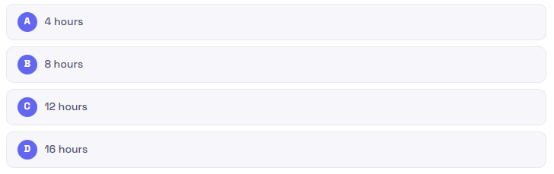

✅ Correct answer: 8 hours
Answer is 8 hours.
Azure Synapse Analytics has a Recovery Point Objective of 8 hours.

Question 89Azure Synapse Analytics
You have an enterprise data warehouse in Azure Synapse Analytics named DW1 on a server named Server1.
You need to verify whether the size of the transaction log file for each distribution of DW1 is smaller than 160 GB.
What should you do?

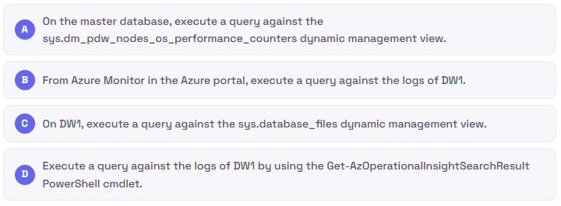

✅ Correct answer: On the master database, execute a query against the sys.dm_pdw_nodes_os_performance_counters dynamic management view.
Answer is On the master database, execute a query against the sys.dm_pdw_nodes_os_performance_counters dynamic management view.
The following query returns the transaction log size on each distribution. If one of the log files is reaching 160 GB, you should consider scaling up your instance or limiting your transaction size.
-- Transaction log size
SELECT
instance_name as distribution_db, cntr_value*1.0/1048576 as log_file_size_used_GB, pdw_node_id
FROM sys.dm_pdw_nodes_os_performance_counters
WHERE
instance_name like 'Distribution_%'
AND counter_name = 'Log File(s) Used Size (KB)'
References:
https://docs.microsoft.com/en-us/azure/sql-data-warehouse/sql-data-warehouse-manage-monitor

Question 90Azure Synapse Analytics
You have an enterprise data warehouse in Azure Synapse Analytics.
You need to monitor the data warehouse to identify whether you must scale up to a higher service level to accommodate the current workloads.
Which is the best metric to monitor?
More than one answer choice may achieve the goal. Select the BEST answer.

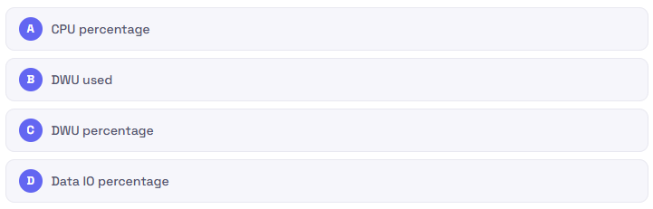

✅ Correct answer: DWU used
Answer is DWU used
DWU used, defined as DWU limit * DWU percentage, represents only a high-level representation of usage across the SQL pool and is not meant to be a comprehensive indicator of utilization. To determine whether to scale up or down, consider all factors which can be impacted by DWU such as concurrency, memory, tempdb, and adaptive cache capacity. We recommend running your workload at different DWU settings to determine what works best to meet your business objectives.
Reference:
https://docs.microsoft.com/bs-latn-ba/azure/synapse-analytics/sql-data-warehouse/sql-data-warehouse-concept-resource-utilization-query-activity

Question 91Azure Synapse Analytics
You plan to create a dimension table in Azure Synapse Analytics that will be less than 1 GB.
You need to create the table to meet the following requirements:
- Provide the fastest query time.
- Minimize data movement during queries.
Which type of table should you use?

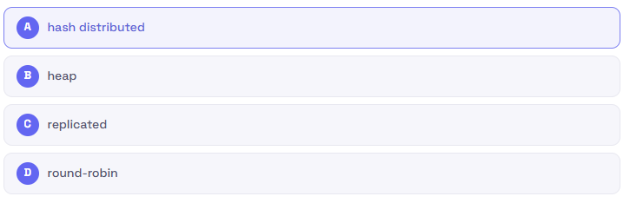

✅ Correct answer: replicated
Answer is Replicated
Usually common dimension tables or tables that doesn't distribute evenly are good candidates for round-robin distributed table. Note: Dimension tables or other lookup tables in a schema can usually be stored as round-robin tables. Usually these tables connect to more than one fact tables and optimizing for one join may not be the best idea. Also usually dimension tables are smaller which can leave some distributions empty when hash distributed.
Round-robin by definition guarantees a uniform data distribution.
Reference:
https://blogs.msdn.microsoft.com/sqlcat/2015/08/11/choosing-hash-distributed-table-vs-round-robin-distributed-table-in-azure-sql-dw-service/

Question 92Azure Synapse Analytics
You have an enterprise data warehouse in Azure Synapse Analytics that contains a table named FactOnlineSales. The table contains data from the start of 2009 to the end of 2012.
You need to improve the performance of queries against FactOnlineSales by using table partitions. The solution must meet the following requirements:
- Create four partitions based on the order date.
- Ensure that each partition contains all the orders placed during a given calendar year.
How should you complete the T-SQL command?
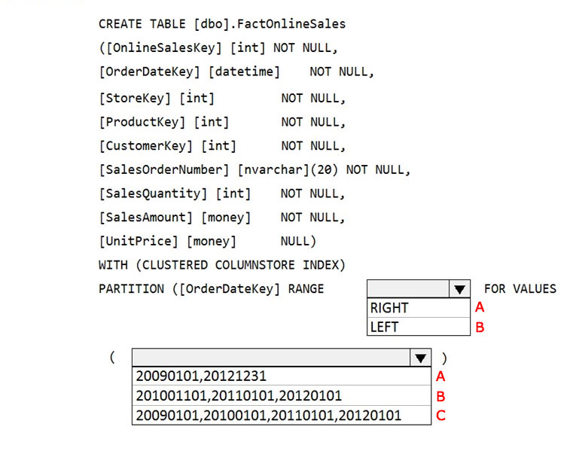

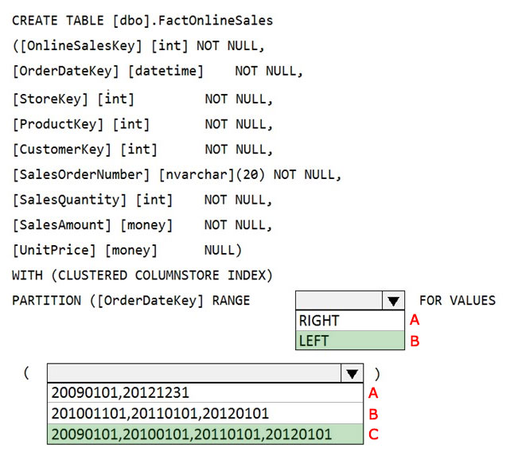
Box 1: LEFT
RANGE LEFT: Specifies the boundary value belongs to the partition on the left (lower values). The default is LEFT.
Box 2: 20090101, 20100101, 20110101, 20120101
FOR VALUES ( boundary_value [,...n] ) specifies the boundary values for the partition. boundary_value is a constant expression.
Reference:
https://docs.microsoft.com/en-us/sql/t-sql/statements/create-table-azure-sql-data-warehouse

Question 93Azure Synapse Analytics
You have a SQL pool in Azure Synapse that contains a table named dbo.Customers. The table contains a column name Email.
You need to prevent nonadministrative users from seeing the full email addresses in the Email column. The users must see values in a format of aXXX@XXXX.com instead.
What should you do?

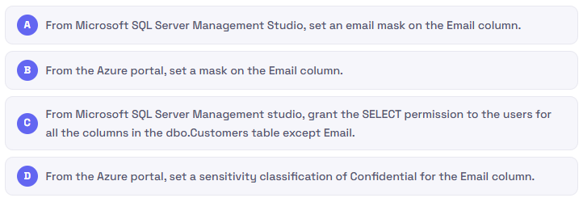

✅ Correct answer: From the Azure portal, set a mask on the Email column.
Answer is From the Azure portal, set a mask on the Email column.
Reference:
https://docs.microsoft.com/en-us/azure/azure-sql/database/dynamic-data-masking-overview

Question 94Azure Synapse Analytics
You are designing an enterprise data warehouse in Azure Synapse Analytics. You plan to load millions of rows of data into the data warehouse each day.
You must ensure that staging tables are optimized for data loading.
You need to design the staging tables.
What type of tables should you recommend?

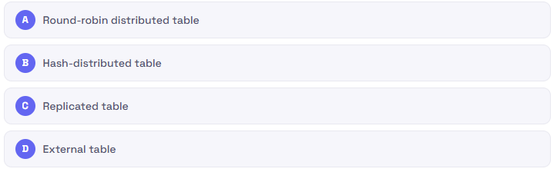

✅ Correct answer: Round-robin distributed table
Answer is Round-robin distributed table

Question 95Azure Synapse Analytics
You have a SQL pool in Azure Synapse.
A user reports that queries against the pool take longer than expected to complete.
You need to add monitoring to the underlying storage to help diagnose the issue.
Which two metrics should you monitor?

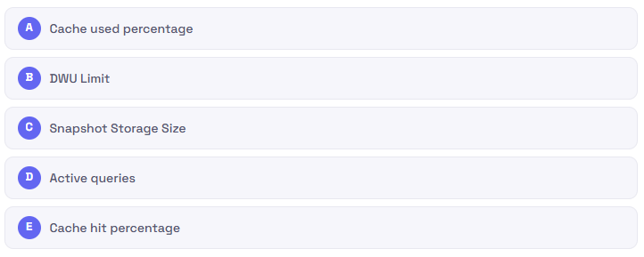

✅ Correct answer: Cache used percentage, Cache hit percentage
Answers are Cache used percentage and Cache hit percentage
Cache used percentage: Cache used is the sum of all bytes in the local SSD cache across all nodes and cache capacity is the sum of the storage capacity of the local SSD cache across all nodes.
Cache hit percentage: Cache hits is the sum of all columnstore segments hits in the local SSD cache and cache miss is the columnstore segments misses in the local SSD cache summed across all nodes.
Reference:
https://docs.microsoft.com/en-us/azure/synapse-analytics/sql-data-warehouse/sql-data-warehouse-concept-resource-utilization-query-activity

Question 96Azure Synapse Analytics
You have a SQL pool in Azure Synapse.
You discover that some queries fail or take a long time to complete.
You need to monitor for transactions that have rolled back.
Which dynamic management view should you query?

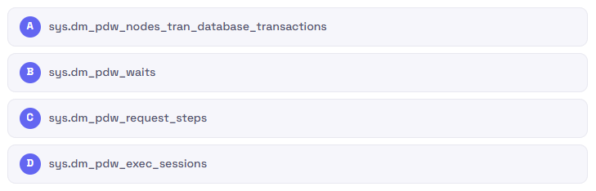

✅ Correct answer: sys.dm_pdw_nodes_tran_database_transactions
Answer is sys.dm_pdw_nodes_tran_database_transactions
You can use Dynamic Management Views (DMVs) to monitor your workload including investigating query execution in SQL pool.
If your queries are failing or taking a long time to proceed, you can check and monitor if you have any transactions rolling back.
Example:
-- Monitor rollback
SELECT
SUM(CASE WHEN t.database_transaction_next_undo_lsn IS NOT NULL THEN 1 ELSE 0 END), t.pdw_node_id, nod.[type]
FROM sys.dm_pdw_nodes_tran_database_transactions t
JOIN sys.dm_pdw_nodes nod ON t.pdw_node_id = nod.pdw_node_id
GROUP BY t.pdw_node_id, nod.[type]
Reference:
https://docs.microsoft.com/en-us/azure/synapse-analytics/sql-data-warehouse/sql-data-warehouse-manage-monitor#monitor-transaction-log-rollback

Question 97Azure Synapse Analytics
You are designing the folder structure for an Azure Data Lake Storage Gen2 container.
Users will query data by using a variety of services including Azure Databricks and Azure Synapse Analytics serverless SQL pools. The data will be secured by subject area. Most queries will include data from the current year or current month.
Which folder structure should you recommend to support fast queries and simplified folder security?
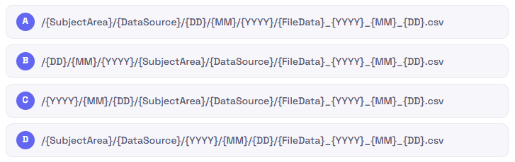

✅ Correct answer: /{SubjectArea}/{DataSource}/{YYYY}/{MM}/{DD}/{FileData}_{YYYY}_{MM}_{DD}.csv
Answer is /{SubjectArea}/{DataSource}/{YYYY}/{MM}/{DD}/{FileData}_{YYYY}_{MM}_{DD}.csv
There's an important reason to put the date at the end of the directory structure. If you want to lock down certain regions or subject matters to users/groups, then you can easily do so with the POSIX permissions. Otherwise, if there was a need to restrict a certain security group to viewing just the UK data or certain planes, with the date structure in front a separate permission would be required for numerous directories under every hour directory. Additionally, having the date structure in front would exponentially increase the number of directories as time went on.
Note: In IoT workloads, there can be a great deal of data being landed in the data store that spans across numerous products, devices, organizations, and customers. It's important to pre-plan the directory layout for organization, security, and efficient processing of the data for down-stream consumers. A general template to consider might be the following layout:
{Region}/{SubjectMatter(s)}/{yyyy}/{mm}/{dd}/{hh}/
Reference:
https://docs.microsoft.com/en-us/azure/storage/blobs/data-lake-storage-best-practices#batch-jobs-structure

Question 98Azure Synapse Analytics
You need to design an Azure Synapse Analytics dedicated SQL pool that meets the following requirements:
- Can return an employee record from a given point in time.
- Maintains the latest employee information.
- Minimizes query complexity.
How should you model the employee data?

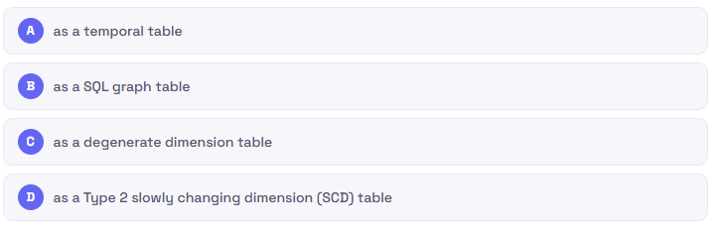

✅ Correct answer: as a Type 2 slowly changing dimension (SCD) table
Answer is as a Type 2 slowly changing dimension (SCD) table
A Type 2 SCD supports versioning of dimension members. Often the source system doesn't store versions, so the data warehouse load process detects and manages changes in a dimension table. In this case, the dimension table must use a surrogate key to provide a unique reference to a version of the dimension member. It also includes columns that define the date range validity of the version (for example, StartDate and EndDate) and possibly a flag column (for example, IsCurrent) to easily filter by current dimension members.
Reference:
https://docs.microsoft.com/en-us/learn/modules/populate-slowly-changing-dimensions-azure-synapse-analytics-pipelines/3-choose-between-dimension-types

Question 99Azure Synapse Analytics
You are building an Azure Analytics query that will receive input data from Azure IoT Hub and write the results to Azure Blob storage.
You need to calculate the difference in readings per sensor per hour.
How should you complete the query?
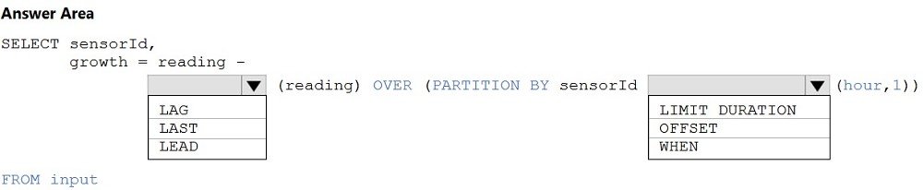
👁

Box 1: LAG
The LAG analytic operator allows one to look up a previous event in an event stream, within certain constraints. It is very useful for computing the rate of growth of a variable, detecting when a variable crosses a threshold, or when a condition starts or stops being true.
Box 2: LIMIT DURATION
Example: Compute the rate of growth, per sensor:
SELECT sensorId,
growth = reading
LAG(reading) OVER (PARTITION BY sensorId LIMIT DURATION(hour, 1))
FROM input
Reference:
https://docs.microsoft.com/en-us/stream-analytics-query/lag-azure-stream-analytics

Question 100Azure Synapse Analytics
You have an Azure Synapse Analytics dedicated SQL pool.
You need to ensure that data in the pool is encrypted at rest. The solution must NOT require modifying applications that query the data.
What should you do?

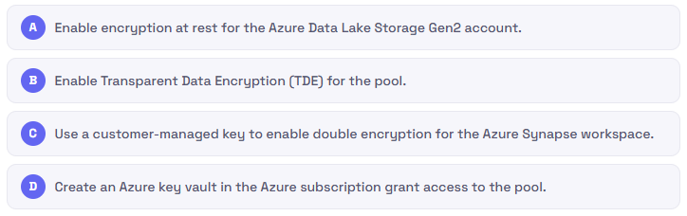

✅ Correct answer: Enable Transparent Data Encryption (TDE) for the pool.
Answer is Enable Transparent Data Encryption (TDE) for the pool.
Transparent Data Encryption (TDE) helps protect against the threat of malicious activity by encrypting and decrypting your data at rest. When you encrypt your database, associated backups and transaction log files are encrypted without requiring any changes to your applications. TDE encrypts the storage of an entire database by using a symmetric key called the database encryption key.
Reference:
https://docs.microsoft.com/en-us/azure/synapse-analytics/sql-data-warehouse/sql-data-warehouse-overview-manage-security

Question 101Azure Synapse Analytics
You have an Azure subscription that contains a logical Microsoft SQL server named Server1. Server1 hosts an Azure Synapse Analytics SQL dedicated pool named Pool1.
You need to recommend a Transparent Data Encryption (TDE) solution for Server1.
The solution must meet the following requirements:
- Track the usage of encryption keys.
- Maintain the access of client apps to Pool1 in the event of an Azure datacenter outage that affects the availability of the encryption keys.
What should you include in the recommendation?
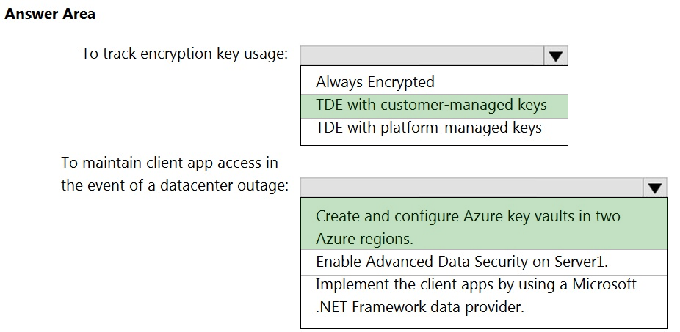

Box 1: TDE with customer-managed keys
Customer-managed keys are stored in the Azure Key Vault. You can monitor how and when your key vaults are accessed, and by whom. You can do this by enabling logging for Azure Key Vault, which saves information in an Azure storage account that you provide.
Box 2: Create and configure Azure key vaults in two Azure regions
The contents of your key vault are replicated within the region and to a secondary region at least 150 miles away, but within the same geography to maintain high durability of your keys and secrets.
Reference:
https://docs.microsoft.com/en-us/azure/azure-sql/database/transparent-data-encryption-byok-overview
https://docs.microsoft.com/en-us/azure/synapse-analytics/security/workspaces-encryption
https://docs.microsoft.com/en-us/azure/key-vault/general/logging

Question 102Azure Synapse Analytics
You plan to create an Azure Synapse Analytics dedicated SQL pool.
You need to minimize the time it takes to identify queries that return confidential information as defined by the company's data privacy regulations and the users who executed the queues.
Which two components should you include in the solution?

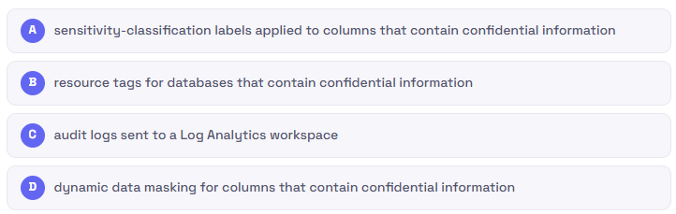

✅ Correct answer: sensitivity-classification labels applied to columns that contain confidential information, audit logs sent to a Log Analytics workspace
Answers are;
sensitivity-classification labels applied to columns that contain confidential information
audit logs sent to a Log Analytics workspace
A: You can classify columns manually, as an alternative or in addition to the recommendation-based classification:
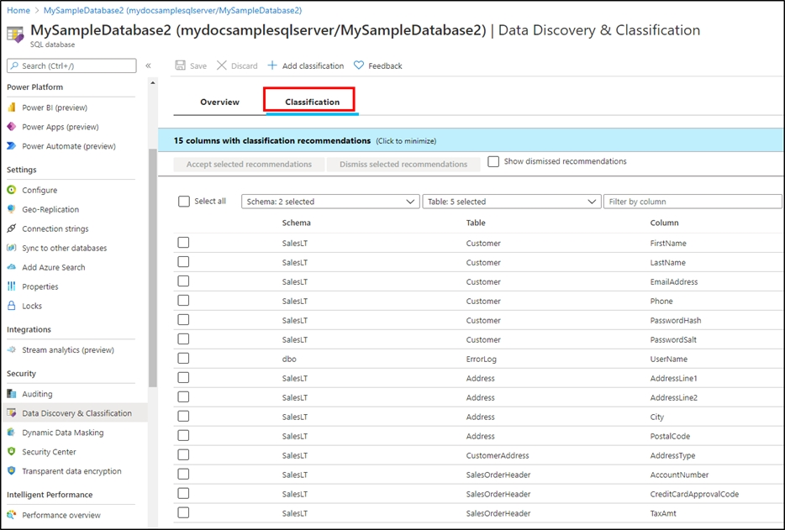
1. Select Add classification in the top menu of the pane.
2. In the context window that opens, select the schema, table, and column that you want to classify, and the information type and sensitivity label.
3. Select Add classification at the bottom of the context window.
C: An important aspect of the information-protection paradigm is the ability to monitor access to sensitive data. Azure SQL Auditing has been enhanced to include a new field in the audit log called data_sensitivity_information. This field logs the sensitivity classifications (labels) of the data that was returned by a query. Here's an example:
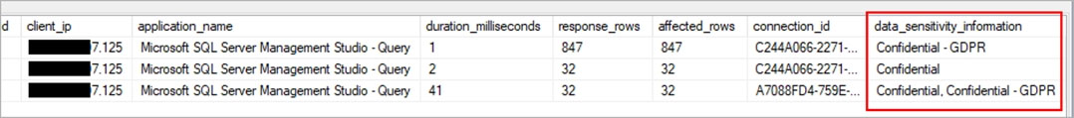
Reference:
https://docs.microsoft.com/en-us/azure/azure-sql/database/data-discovery-and-classification-overview
Question 103Azure Synapse Analytics
You are designing an enterprise data warehouse in Azure Synapse Analytics that will contain a table named Customers. Customers will contain credit card information.
You need to recommend a solution to provide salespeople with the ability to view all the entries in Customers. The solution must prevent all the salespeople from viewing or inferring the credit card information.
What should you include in the recommendation?

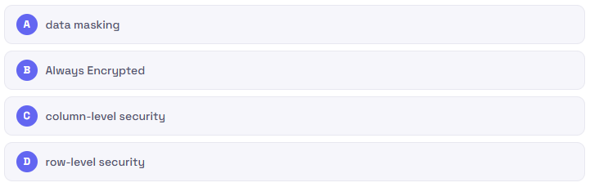

✅ Correct answer: column-level security
Answer is column-level security
"Column-level security simplifies the design and coding of security in your application, allowing you to restrict column access to protect sensitive data. "
Reference:
https://docs.microsoft.com/en-us/azure/synapse-analytics/sql-data-warehouse/column-level-security

Question 104Azure Synapse Analytics
You have a partitioned table in an Azure Synapse Analytics dedicated SQL pool. You need to design queries to maximize the benefits of partition elimination. What should you include in the Transact-SQL queries?

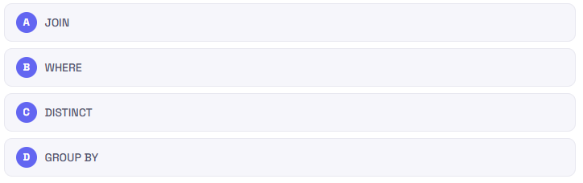
✅ Correct answer: WHERE
Answer is WHERE
When you add the "WHERE" clause to your T-SQL query it allows the query optimizer accesses only the relevant partitions to satisfy the filter criteria of the query - which is what partition elimination is all about.

Question 105Azure Synapse Analytics
You implement an enterprise data warehouse in Azure Synapse Analytics.
You have a large fact table that is 10 terabytes (TB) in size.
Incoming queries use the primary key SaleKey column to retrieve data as displayed in the following table:
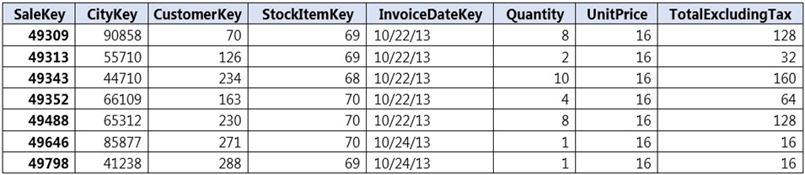
You need to distribute the large fact table across multiple nodes to optimize performance of the table.
Which technology should you use?

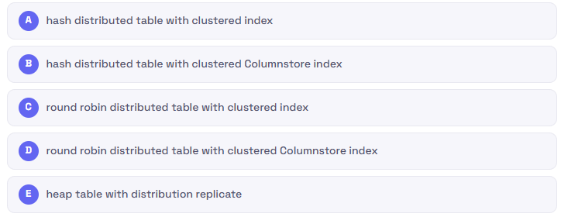

✅ Correct answer: hash distributed table with clustered Columnstore index
Answer is hash distributed table with clustered Columnstore index
Hash-distributed tables improve query performance on large fact tables.
Columnstore indexes can achieve up to 100x better performance on analytics and data warehousing workloads and up to 10x better data compression than traditional rowstore indexes.
Incorrect Answers:
C, D: Round-robin tables are useful for improving loading speed.
Reference:
https://docs.microsoft.com/en-us/azure/sql-data-warehouse/sql-data-warehouse-tables-distribute
https://docs.microsoft.com/en-us/sql/relational-databases/indexes/columnstore-indexes-query-performance

Question 106Azure Synapse Analytics
You have an Azure Synapse Analytics dedicated SQL pool that contains a large fact table. The table contains 50 columns and 5 billion rows and is a heap.
Most queries against the table aggregate values from approximately 100 million rows and return only two columns.
You discover that the queries against the fact table are very slow.
Which type of index should you add to provide the fastest query times?

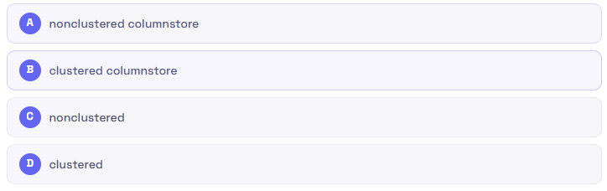

✅ Correct answer: clustered columnstore
Answer is clustered columnstore
Clustered columnstore indexes are one of the most efficient ways you can store your data in dedicated SQL pool.
Columnstore tables won't benefit a query unless the table has more than 60 million rows.
Reference:
https://docs.microsoft.com/en-us/azure/synapse-analytics/sql/best-practices-dedicated-sql-pool

Question 107Azure Synapse Analytics
You have an enterprise data warehouse in Azure Synapse Analytics.
Using PolyBase, you create an external table named [Ext].[Items] to query Parquet files stored in Azure Data Lake Storage Gen2 without importing the data to the data warehouse.
The external table has three columns.
You discover that the Parquet files have a fourth column named ItemID.
Which command should you run to add the ItemID column to the external table?
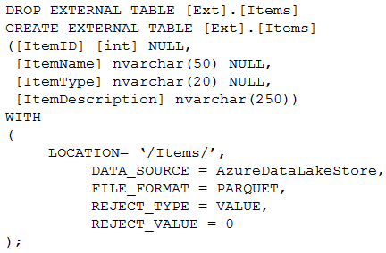

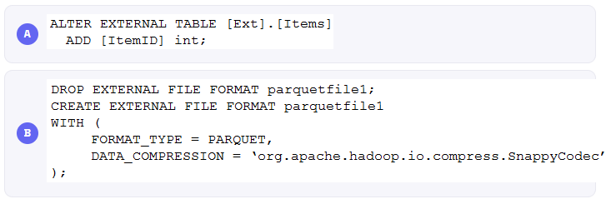
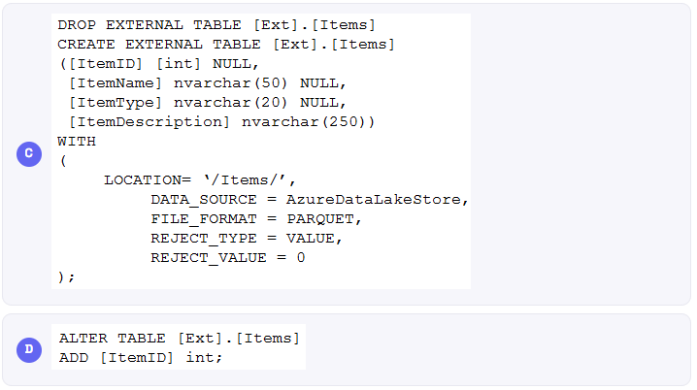
✅ Correct answer:

ALTER statement is not supported on external table, you need to DROP it and CREATE it again
Reference:
https://learn.microsoft.com/en-us/azure/data-explorer/kusto/management/external-sql-tables
https://docs.microsoft.com/en-us/sql/t-sql/statements/create-external-table-transact-sql
Question 108Azure Synapse Analytics
You have an Azure Synapse Analytics dedicated SQL pool that contains the users shown in the following table.
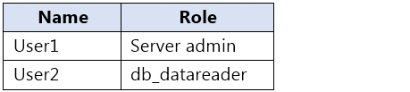
User1 executes a query on the database, and the query returns the results shown in the following exhibit.
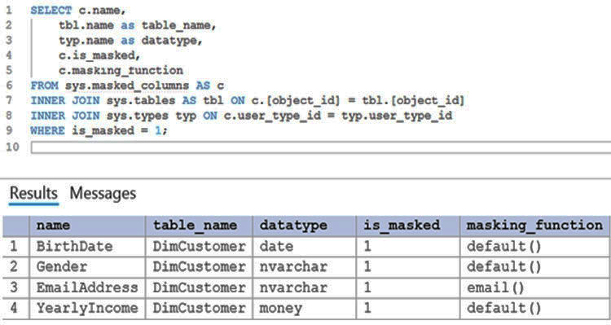
User1 is the only user who has access to the unmasked data.
Use the drop-down menus to select the answer choice that completes each statement based on the information presented in the graphic.
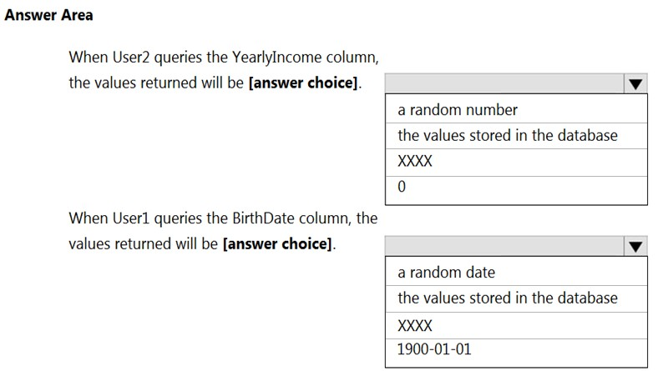

Box 1: 0
The YearlyIncome column is of the money data type.
The Default masking function: Full masking according to the data types of the designated fields
Use a zero value for numeric data types (bigint, bit, decimal, int, money, numeric, smallint, smallmoney, tinyint, float, real).
Box 2: the values stored in the database
Users with administrator privileges are always excluded from masking, and see the original data without any mask.
Reference:
https://docs.microsoft.com/en-us/azure/azure-sql/database/dynamic-data-masking-overview

Question 109Azure Synapse Analytics
You have a table in an Azure Synapse Analytics dedicated SQL pool. The table was created by using the following Transact-SQL statement.
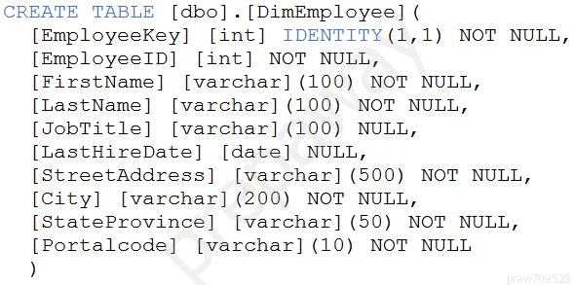
You need to alter the table to meet the following requirements:
● Ensure that users can identify the current manager of employees.
● Support creating an employee reporting hierarchy for your entire company.
● Provide fast lookup of the managers' attributes such as name and job title.
Which column should you add to the table?

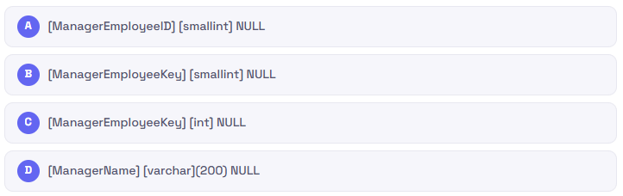

✅ Correct answer: [ManagerEmployeeKey] [int] NULL
Answer is [ManagerEmployeeKey] [int] NULL
We need an extra column to identify the Manager. Use the data type as the EmployeeKey column, an int column.
Reference:
https://docs.microsoft.com/en-us/analysis-services/tabular-models/hierarchies-ssas-tabular

Question 110Azure Synapse Analytics
You have a SQL pool in Azure Synapse.
You plan to load data from Azure Blob storage to a staging table. Approximately 1 million rows of data will be loaded daily. The table will be truncated before each daily load.
You need to create the staging table. The solution must minimize how long it takes to load the data to the staging table.
How should you configure the table?
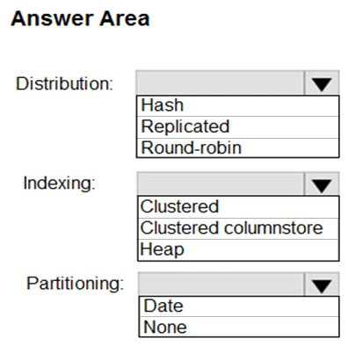

Answer is Round-Robin Heap None
Round-robin - this is the simplest distribution model, not great for querying but fast to process
Heap - The term heap basically refers to a table without a clustered index. Adding a clustered index to a temp table makes absolutely no sense and is a waste of compute resources for a table that would be entirely truncated daily. no clustered index = heap.
No partitions - Partitioning by date is useful when stage destination has data because you can hide the inserting data’s new partition (to keep users from hitting it), complete the load and then unhide the new partition.
However, in this question it states, “the table will be truncated before each daily load”, so, it appears it’s a true Staging table and there are no users with access, no existing data, and I see no reason to have a Date partition.
Reference:
https://docs.microsoft.com/en-us/azure/synapse-analytics/sql/data-loading-best-practices
https://docs.microsoft.com/en-us/azure/synapse-analytics/sql/develop-tables-overview

Question 111Azure Synapse Analytics
You build a data warehouse in an Azure Synapse Analytics dedicated SQL pool.
Analysts write a complex SELECT query that contains multiple JOIN and CASE statements to transform data for use in inventory reports. The inventory reports will use the data and additional WHERE parameters depending on the report. The reports will be produced once daily.
You need to implement a solution to make the dataset available for the reports. The solution must minimize query times.
What should you implement?
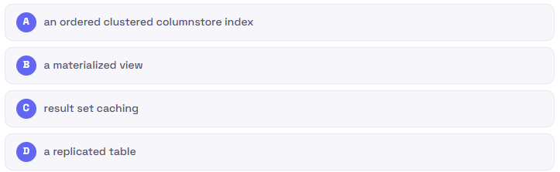

✅ Correct answer: a materialized view
Answer is a materialized view
Materialized views for dedicated SQL pools in Azure Synapse provide a low maintenance method for complex analytical queries to get fast performance without any query change.
Incorrect Answers:
C: One daily execution does not make use of result cache caching.
Note: When result set caching is enabled, dedicated SQL pool automatically caches query results in the user database for repetitive use. This allows subsequent query executions to get results directly from the persisted cache so recomputation is not needed. Result set caching improves query performance and reduces compute resource usage. In addition, queries using cached results set do not use any concurrency slots and thus do not count against existing concurrency limits.
Reference:
https://docs.microsoft.com/en-us/azure/synapse-analytics/sql-data-warehouse/performance-tuning-materialized-views
https://docs.microsoft.com/en-us/azure/synapse-analytics/sql-data-warehouse/performance-tuning-result-set-caching

Question 112Azure Synapse Analytics
You have an Azure Synapse Analytics workspace named WS1 that contains an Apache Spark pool named Pool1.
You plan to create a database named DB1 in Pool1.
You need to ensure that when tables are created in DB1, the tables are available automatically as external tables to the built-in serverless SQL pool.
Which formats should you use for the tables in DB1?

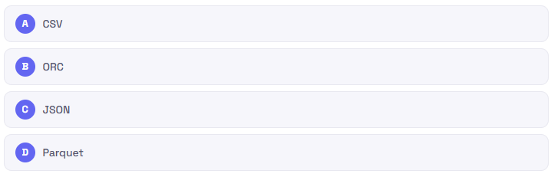

✅ Correct answer: CSV, Parquet
Answer is CSV and Parquet are both correct answers.
Serverless SQL pool can automatically synchronize metadata from Apache Spark. A serverless SQL pool database will be created for each database existing in serverless Apache Spark pools.
For each Spark external table based on Parquet or CSV and located in Azure Storage, an external table is created in a serverless SQL pool database.
Reference:
https://docs.microsoft.com/en-us/azure/synapse-analytics/sql/develop-storage-files-spark-tables
Question 113Azure Synapse Analytics
You are designing a financial transactions table in an Azure Synapse Analytics dedicated SQL pool. The table will have a clustered columnstore index and will include the following columns:
● TransactionType: 40 million rows per transaction type
● CustomerSegment: 4 million per customer segment
● TransactionMonth: 65 million rows per month
AccountType: 500 million per account type
You have the following query requirements:
● Analysts will most commonly analyze transactions for a given month.
● Transactions analysis will typically summarize transactions by transaction type, customer segment, and/or account type
You need to recommend a partition strategy for the table to minimize query times.
On which column should you recommend partitioning the table?

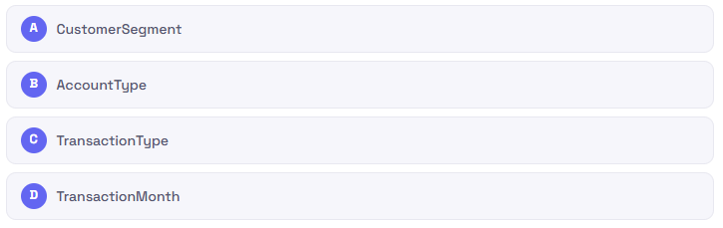

✅ Correct answer: TransactionMonth
Answer is TransactionMonth
For optimal compression and performance of clustered columnstore tables, a minimum of 1 million rows per distribution and partition is needed. Before partitions are created, dedicated SQL pool already divides each table into 60 distributed databases.
Example: Any partitioning added to a table is in addition to the distributions created behind the scenes. Using this example, if the sales fact table contained 36 monthly partitions, and given that a dedicated SQL pool has 60 distributions, then the sales fact table should contain 60 million rows per month, or 2.1 billion rows when all months are populated. If a table contains fewer than the recommended minimum number of rows per partition, consider using fewer partitions in order to increase the number of rows per partition.
Reference:
https://www.linkedin.com/pulse/partitioning-distribution-azure-synapse-analytics-swapnil-mule

Question 114Azure Synapse Analytics
You have an Azure Synapse Analytics dedicated SQL pool named Pool1. Pool1 contains a partitioned fact table named dbo.Sales and a staging table named stg.Sales that has the matching table and partition definitions.
You need to overwrite the content of the first partition in dbo.Sales with the content of the same partition in stg.Sales. The solution must minimize load times.
What should you do?

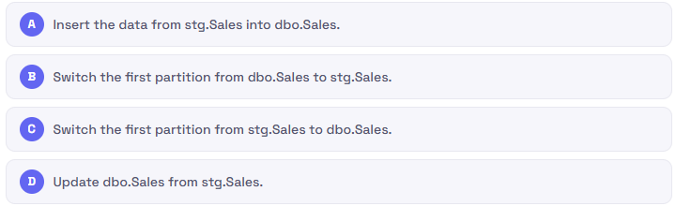

✅ Correct answer: Switch the first partition from stg.Sales to dbo.Sales.
Answer is Switch the first partition from stg.Sales to dbo.Sales.
Since the need is to overwrite dbo.Sales with the content of stg.Sales. SWITCH source TO target
Reference:
https://docs.microsoft.com/en-us/azure/synapse-analytics/sql/best-practices-dedicated-sql-pool

Question 115Azure Synapse Analytics
You are designing a slowly changing dimension (SCD) for supplier data in an Azure Synapse Analytics dedicated SQL pool.
You plan to keep a record of changes to the available fields.
The supplier data contains the following columns.
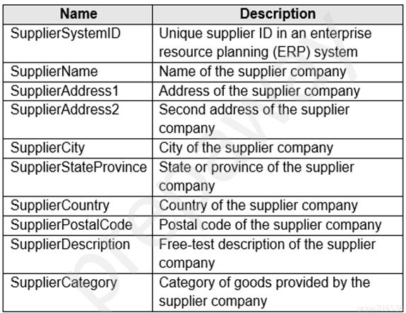
Which three additional columns should you add to the data to create a Type 2

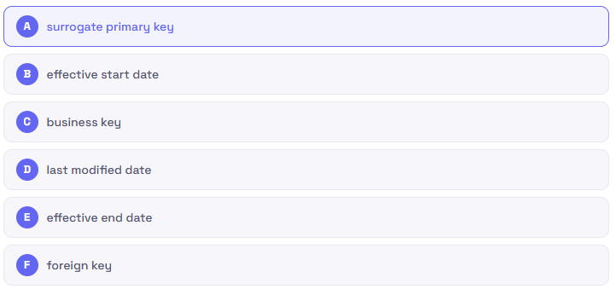

✅ Correct answer: surrogate primary key, effective start date, effective end date
Answers are surrogate primary key, effective start date, effective end date
A type 2 SCD requires a surrogate key to uniquely identify each record when versioning. See https://docs.microsoft.com/en-us/learn/modules/populate-slowly-changing-dimensions-azure-synapse-analytics-pipelines/3-choose-between-dimension-types
under SCD Type 2 “ the dimension table must use a surrogate key to provide a unique reference to a version of the dimension member.” A business key is already part of this table - SupplierSystemID. The column is derived from the source data.
Reference:
https://docs.microsoft.com/en-us/sql/integration-services/data-flow/transformations/slowly-changing-dimension-transformation

Question 116Azure Synapse Analytics
You have a Microsoft SQL Server database that uses a third normal form schema.
You plan to migrate the data in the database to a star schema in an Azure Synapse Analytics dedicated SQL pool.
You need to design the dimension tables. The solution must optimize read operations.
What should you include in the solution?
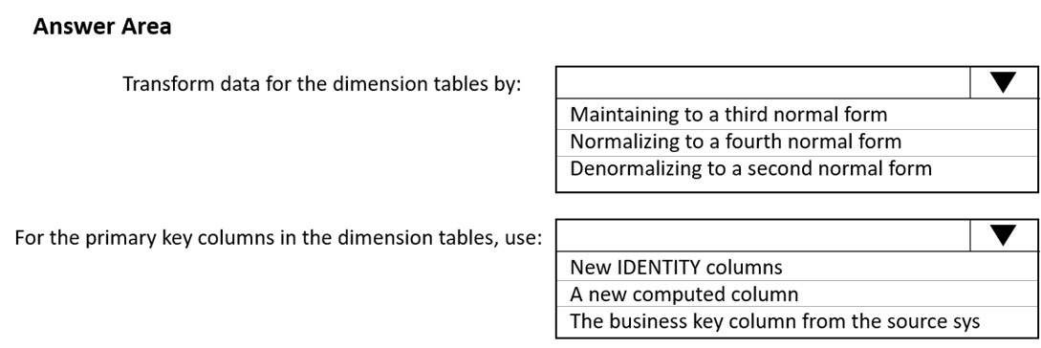
Box 1: Denormalize to a second normal form
Denormalization is the process of transforming higher normal forms to lower normal forms via storing the join of higher normal form relations as a base relation.
Denormalization increases the performance in data retrieval at cost of bringing update anomalies to a database.
Box 2: New identity columns
The collapsing relations strategy can be used in this step to collapse classification entities into component entities to obtain flat dimension tables with single-part keys that connect directly to the fact table. The single-part key is a surrogate key generated to ensure it remains unique over time.
Example:
Note: A surrogate key on a table is a column with a unique identifier for each row. The key is not generated from the table data. Data modelers like to create surrogate keys on their tables when they design data warehouse models. You can use the IDENTITY property to achieve this goal simply and effectively without affecting load performance.
Reference:
https://www.mssqltips.com/sqlservertip/5614/explore-the-role-of-normal-forms-in-dimensional-modeling/
https://docs.microsoft.com/en-us/azure/synapse-analytics/sql-data-warehouse/sql-data-warehouse-tables-identity

Question 117Azure Synapse Analytics
You are designing a partition strategy for a fact table in an Azure Synapse Analytics dedicated SQL pool. The table has the following specifications:
● Contain sales data for 20,000 products.
● Use hash distribution on a column named ProductID.
● Contain 2.4 billion records for the years 2019 and 2020.
Which number of partition ranges provides optimal compression and performance for the clustered columnstore index?

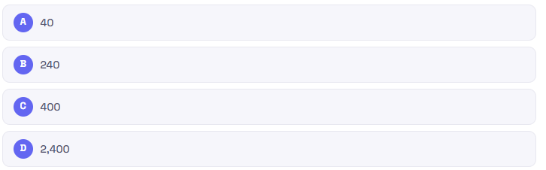

✅ Correct answer: 40
Answer is 40
Each partition should have around 1 millions records. Dedication SQL pools already have 60 partitions.
We have the formula: Records/(Partitions*60)= 1 million
Partitions= Records/(1 million * 60)
Partitions= 2.4 x 1,000,000,000/(1,000,000 * 60) = 40
Note: Having too many partitions can reduce the effectiveness of clustered columnstore indexes if each partition has fewer than 1 million rows. Dedicated SQL pools automatically partition your data into 60 databases. So, if you create a table with 100 partitions, the result will be 6000 partitions.
Reference:
https://docs.microsoft.com/en-us/azure/synapse-analytics/sql/best-practices-dedicated-sql-pool

Question 118Azure Synapse Analytics
You are creating dimensions for a data warehouse in an Azure Synapse Analytics dedicated SQL pool.
You create a table by using the Transact-SQL statement shown in the following exhibit.

Use the drop-down menus to select the answer choice that completes each statement based on the information presented in the graphic.


Box 1: Type 2
A Type 2 SCD supports versioning of dimension members. Often the source system doesn't store versions, so the data warehouse load process detects and manages changes in a dimension table. In this case, the dimension table must use a surrogate key to provide a unique reference to a version of the dimension member. It also includes columns that define the date range validity of the version (for example, StartDate and EndDate) and possibly a flag column (for example,
IsCurrent) to easily filter by current dimension members.
Incorrect Answers:
A Type 1 SCD always reflects the latest values, and when changes in source data are detected, the dimension table data is overwritten.
Box 2: Surrogate key
"In data warehousing, IDENTITY functionality is particularly important as it makes easier the creation of surrogate keys." Why ProductKey is certainly not a business key: "The IDENTITY value in Synapse is not guaranteed to be unique if the user explicitly inserts a duplicate value with 'SET IDENTITY_INSERT ON' or reseeds IDENTITY".
Type-1: Because here we are keeping, RowInsertedDate and RowUpdatedDate, and both are set to NOT NULL.
Surrogate Key: Because identity key is auto-incremented by System and not decided by business stakeholders.
Reference:
https://docs.microsoft.com/en-us/learn/modules/populate-slowly-changing-dimensions-azure-synapse-analytics-pipelines/3-choose-between-dimension-types

Question 119Azure Synapse Analytics
You are designing a fact table named FactPurchase in an Azure Synapse Analytics dedicated SQL pool. The table contains purchases from suppliers for a retail store. FactPurchase will contain the following columns.
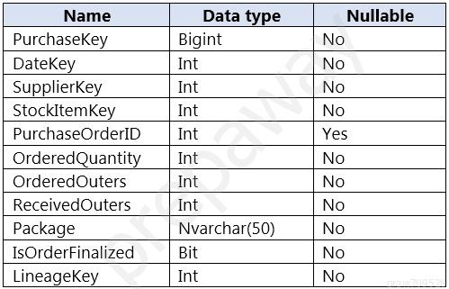
FactPurchase will have 1 million rows of data added daily and will contain three years of data.
Transact-SQL queries similar to the following query will be executed daily.
SELECT
SupplierKey,
StockItemKey,
COUNT(*)
FROM FactPurchase
WHERE 1=1
AND DateKey >= 20210101
AND DateKey <= 20210131
GROUP By SupplierKey, StockItemKey
Which table distribution will minimize query times?

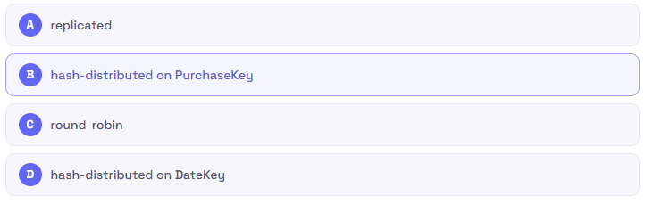

✅ Correct answer: hash-distributed on PurchaseKey
Answer is hash-distributed on PurchaseKey
Hash-distributed tables improve query performance on large fact tables, and are the focus of this article. Round-robin tables are useful for improving loading speed.
Incorrect:
Not D: Do not use a date column. . All data for the same date lands in the same distribution. If several users are all filtering on the same date, then only 1 of the 60 distributions do all the processing work.
Reference:
https://docs.microsoft.com/en-us/azure/synapse-analytics/sql-data-warehouse/sql-data-warehouse-tables-distribute

Question 120Azure Synapse Analytics
You are designing a data mart for the human resources (HR) department at your company. The data mart will contain employee information and employee transactions.
From a source system, you have a flat extract that has the following fields:
● EmployeeID
● FirstName
● LastName
● Recipient
● GrossAmount
● TransactionID
● GovernmentID
● NetAmountPaid
● TransactionDate
You need to design a star schema data model in an Azure Synapse Analytics dedicated SQL pool for the data mart.
Which two tables should you create?

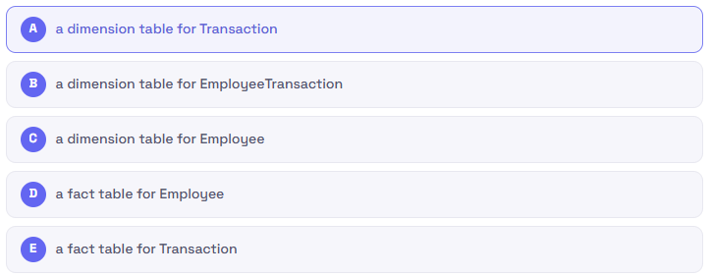

✅ Correct answer: a dimension table for Employee, a fact table for Transaction
a dimension table for Employee: Dimension tables contain attribute data that might change but usually changes infrequently. For example, a customer's name and address are stored in a dimension table and updated only when the customer's profile changes. To minimize the size of a large fact table, the customer's name and address don't need to be in every row of a fact table. Instead, the fact table and the dimension table can share a customer ID. A query can join the two tables to associate a customer's profile and transactions.
a fact table for Transaction: Fact tables contain quantitative data that are commonly generated in a transactional system, and then loaded into the dedicated SQL pool. For example, a retail business generates sales transactions every day, and then loads the data into a dedicated SQL pool fact table for analysis.
Reference:
https://docs.microsoft.com/en-us/azure/synapse-analytics/sql-data-warehouse/sql-data-warehouse-tables-overview

Question 121Azure Synapse Analytics
You are building an Azure Synapse Analytics dedicated SQL pool that will contain a fact table for transactions from the first half of the year 2020.
You need to ensure that the table meets the following requirements:
● Minimizes the processing time to delete data that is older than 10 years
● Minimizes the I/O for queries that use year-to-date values
How should you complete the Transact-SQL statement?
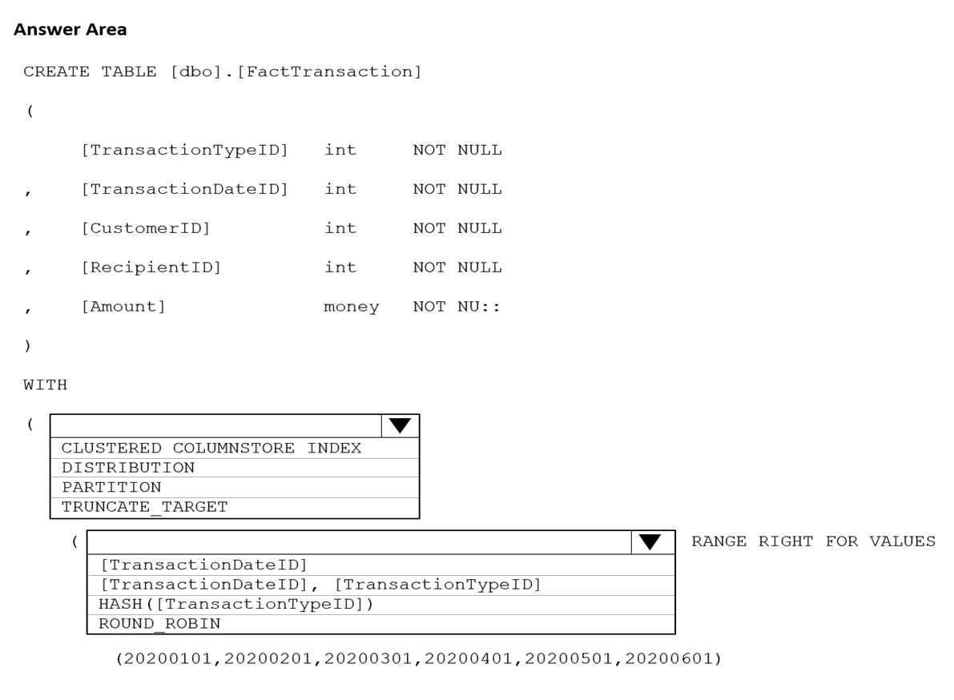

Answer is
Box 1: PARTITION
RANGE RIGHT FOR VALUES is used with PARTITION.
Part 2: [TransactionDateID]
Partition on the date column.
Example: Creating a RANGE RIGHT partition function on a datetime column
The following partition function partitions a table or index into 12 partitions, one for each month of a year's worth of values in a datetime column.
CREATE PARTITION FUNCTION [myDateRangePF1] (datetime)
AS RANGE RIGHT FOR VALUES ('20030201', '20030301', '20030401',
'20030501', '20030601', '20030701', '20030801',
'20030901', '20031001', '20031101', '20031201');
Reference:
https://docs.microsoft.com/en-us/sql/t-sql/statements/create-partition-function-transact-sql

Question 122Azure Synapse Analytics
You are performing exploratory analysis of the bus fare data in an Azure Data Lake Storage Gen2 account by using an Azure Synapse Analytics serverless SQL pool.
You execute the Transact-SQL query shown in the following exhibit.
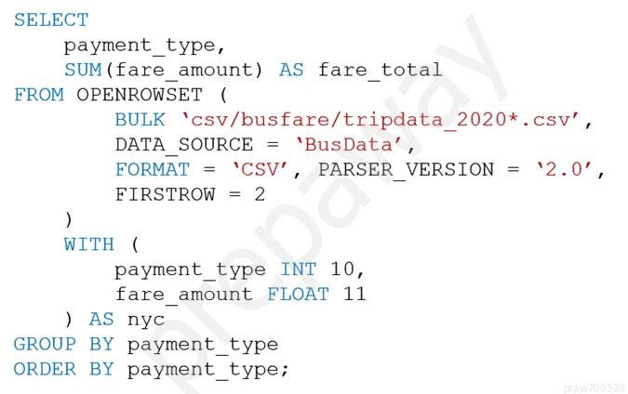
What do the query results include?

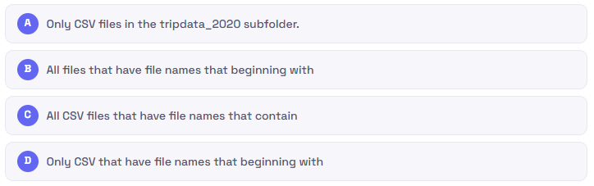
✅ Correct answer: Only CSV that have file names that beginning with
Answer is Only CSV that have file names that beginning with

Question 123Azure Synapse Analytics
You have an enterprise data warehouse in Azure Synapse Analytics that contains a table named FactOnlineSales. The table contains data from the start of 2009 to the end of 2012.
You need to improve the performance of queries against FactOnlineSales by using table partitions. The solution must meet the following requirements:
● Create four partitions based on the order date.
● Ensure that each partition contains all the orders places during a given calendar year.
How should you complete the T-SQL command?
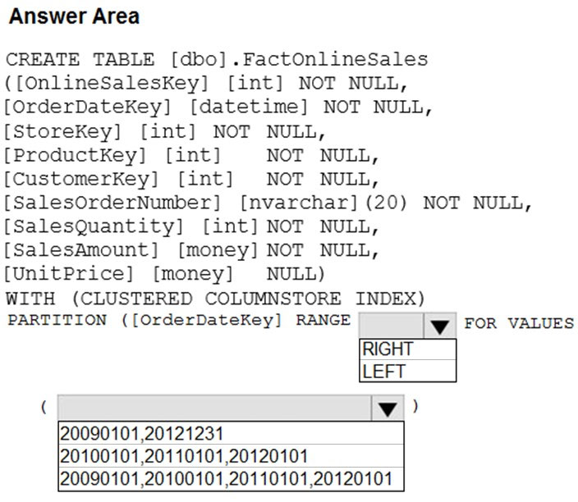

Range Left or Right, both are creating similar partition but there is difference in comparison
For example: in this scenario, when you use LEFT and 20100101,20110101,20120101
Partition will be, datecol<=20100101, datecol>20100101 and datecol<=20110101, datecol>20110101 and datecol<=20120101, datecol>20120101
But if you use range RIGHT and 20100101,20110101,20120101
Partition will be, datecol<20100101, datecol>=20100101 and datecol<20110101, datecol>=20110101 and datecol<20120101, datecol>=20120101
In this example, Range RIGHT will be suitable for calendar comparison Jan 1st to Dec 31st
Reference:
https://docs.microsoft.com/en-us/sql/t-sql/statements/create-partition-function-transact-sql?view=sql-server-ver15

Question 124Azure Synapse Analytics
You need to implement a Type 3 slowly changing dimension (SCD) for product category data in an Azure Synapse Analytics dedicated SQL pool.
You have a table that was created by using the following Transact-SQL statement.
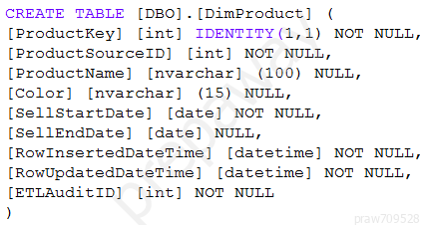
Which two columns should you add to the table? Each correct answer presents part of the solut
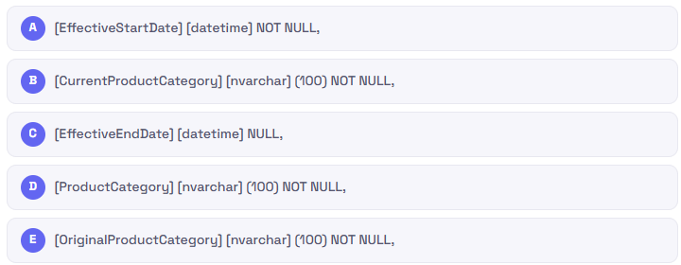

✅ Correct answer: [CurrentProductCategory] [nvarchar] (100) NOT NULL,, [OriginalProductCategory] [nvarchar] (100) NOT NULL,
Answers are; [CurrentProductCategory] [nvarchar] (100) NOT NULL, and [OriginalProductCategory] [nvarchar] (100) NOT NULL,
A Type 3 SCD supports storing two versions of a dimension member as separate columns. The table includes a column for the current value of a member plus either the original or previous value of the member. So Type 3 uses additional columns to track one key instance of history, rather than storing additional rows to track each change like in a Type 2 SCD.
This type of tracking may be used for one or two columns in a dimension table. It is not common to use it for many members of the same table. It is often used in combination with Type 1 or Type 2 members.
Reference:
https://k21academy.com/microsoft-azure/azure-data-engineer-dp203-q-a-day-2-live-session-review/

Question 125Azure Synapse Analytics
You are designing an Azure Stream Analytics solution that will analyze Twitter data.
You need to count the tweets in each 10-second window. The solution must ensure that each tweet is counted only once.
Solution: You use a hopping window that uses a hop size of 10 seconds and a window size of 10 seconds.
Does this meet the goal?

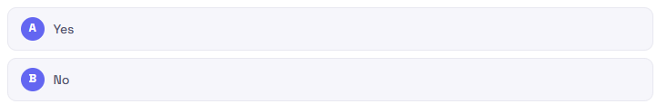
✅ Correct answer: Yes
Answer is Yes
Instead use a tumbling window. Tumbling windows are a series of fixed-sized, non-overlapping and contiguous time intervals. Unlike tumbling windows, hopping windows model scheduled overlapping windows. A hopping window specification consist of three parameters: the timeunit, the windowsize (how long each window lasts) and the hopsize (by how much each window moves forward relative to the previous one). Additionally, offsetsize may be used as an optional fourth parameter. Note that a tumbling window is simply a hopping window whose ‘hop’ is equal to its ‘size’.
Reference:
https://docs.microsoft.com/en-us/stream-analytics-query/tumbling-window-azure-stream-analytics

Question 126Azure Synapse Analytics
You are designing an Azure Stream Analytics solution that receives instant messaging data from an Azure Event Hub.
You need to ensure that the output from the Stream Analytics job counts the number of messages per time zone every 15 seconds.
How should you complete the Stream Analytics query? To answer, select the appropriate options in the answer area.
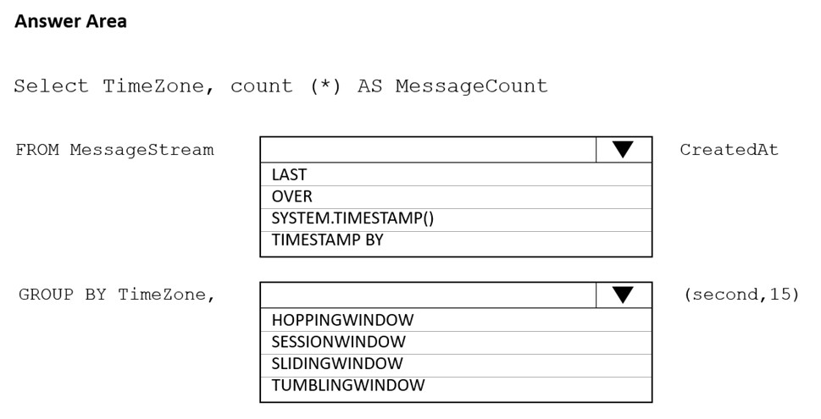

Box 1: timestamp by
Box 2: Tumbling window
Tumbling window functions are used to segment a data stream into distinct time segments and perform a function against them, such as the example below. The key differentiators of a Tumbling window are that they repeat, do not overlap, and an event cannot belong to more than one tumbling window.
Reference:
https://docs.microsoft.com/en-us/azure/stream-analytics/stream-analytics-window-functions

Question 127
Azure Synapse Analytics
You have an Azure Synapse Analytics dedicated SQL pool that contains a table named Table1.
You have files that are ingested and loaded into an Azure Data Lake Storage Gen2 container named container1.
You plan to insert data from the files in container1 into Table1 and transform the data. Each row of data in the files will produce one row in the serving layer of
Table1.
You need to ensure that when the source data files are loaded to container1, the DateTime is stored as an additional column in Table1.

Solution: You use a dedicated SQL pool to create an external table that has an additional DateTime column.
Does this meet the goal?


✅ Correct answer: No
Answer is No

Instead use the derived column transformation to generate new columns in your data flow or to modify existing fields.

Reference:
https://docs.microsoft.com/en-us/azure/data-factory/data-flow-derived-column

Question 128Azure Synapse Analytics
You have an Azure subscription that is linked to a hybrid Azure Active Directory (Azure AD) tenant. The subscription contains an Azure Synapse Analytics SQL pool named Pool1.
You need to recommend an authentication solution for Pool1. The solution must support multi-factor authentication (MFA) and database-level authentication.
Which authentication solution or solutions should you include m the recommendation?
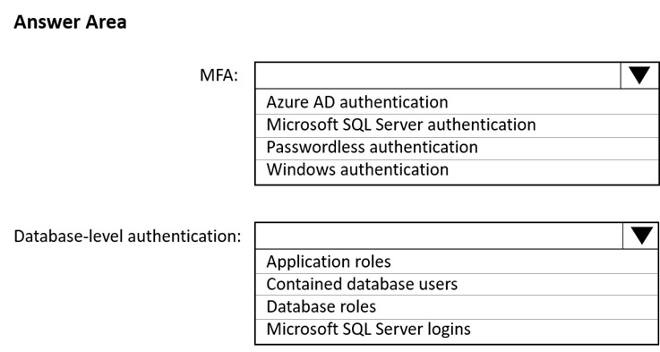

Box 1: Azure AD authentication
Azure AD authentication has the option to include MFA.
Box 2: Contained database users
Azure AD authentication uses contained database users to authenticate identities at the database level.
Reference:
https://docs.microsoft.com/en-us/azure/azure-sql/database/authentication-mfa-ssms-overview
https://docs.microsoft.com/en-us/azure/azure-sql/database/authentication-aad-overview

Question 129Azure Synapse Analytics
You are designing an Azure Synapse Analytics dedicated SQL pool.
You need to ensure that you can audit access to Personally Identifiable Information (PII).
What should you include in the solution?

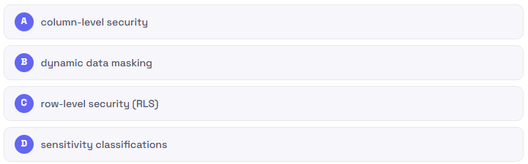

✅ Correct answer: sensitivity classifications
Answer is sensitivity classifications
Data Discovery & Classification is built into Azure SQL Database, Azure SQL Managed Instance, and Azure Synapse Analytics. It provides basic capabilities for discovering, classifying, labeling, and reporting the sensitive data in your databases.
Your most sensitive data might include business, financial, healthcare, or personal information. Discovering and classifying this data can play a pivotal role in your organization's information-protection approach. It can serve as infrastructure for:
● Helping to meet standards for data privacy and requirements for regulatory compliance.
● Various security scenarios, such as monitoring (auditing) access to sensitive data.
● Controlling access to and hardening the security of databases that contain highly sensitive data.
Reference:
https://docs.microsoft.com/en-us/azure/azure-sql/database/data-discovery-and-classification-overview

Question 130Azure Synapse Analytics
You are designing an Azure Synapse Analytics dedicated SQL pool.
Groups will have access to sensitive data in the pool as shown in the following table.
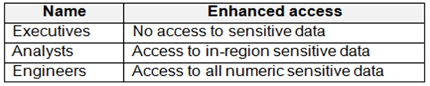
You have policies for the sensitive data. The policies vary be region as shown in the following table.
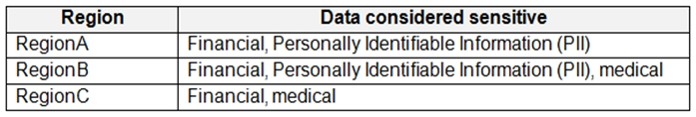
You have a table of patients for each region. The tables contain the following potentially sensitive columns.
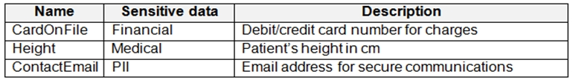
You are designing dynamic data masking to maintain compliance.
For each of the following statements, select Yes if the statement is true. Otherwise, select No.
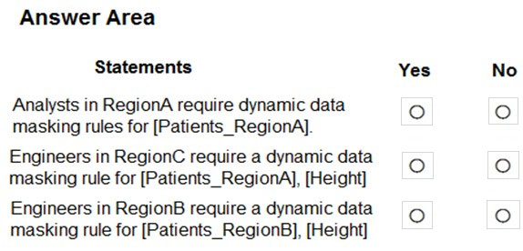

Answer is No - No - Yes
Statement 1: Analysts in Region A have access to (all) the following sensitive data in region A: CardOnFile, Heigth and ContactEmail. Since financial (CardOnFike) and PII (ContactEmail) are considered sensitive data in Region A, hence you don't need any dynamic data masking for Height: so NO. Statement 2 & 3: Engineers have access to all numeric sensitive data (which means in every region). So they have access to height. Height is medical and therefore only sensitive in Region B according to the second table, but not in Region A. So Statement 2 is “No” and Statement 3 is “Yes”
Reference:
https://docs.microsoft.com/en-us/azure/azure-sql/database/dynamic-data-masking-overview

Question 131Azure Synapse Analytics
You are designing a date dimension table in an Azure Synapse Analytics dedicated SQL pool. The date dimension table will be used by all the fact tables.
Which distribution type should you recommend to minimize data movement?

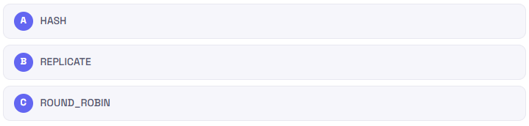
✅ Correct answer: REPLICATE
Answer is REPLICATE
A replicated table has a full copy of the table available on every Compute node. Queries run fast on replicated tables since joins on replicated tables don't require data movement. Replication requires extra storage, though, and isn't practical for large tables.
Incorrect Answers:
A: A hash distributed table is designed to achieve high performance for queries on large tables.
C: A round-robin table distributes table rows evenly across all distributions. The rows are distributed randomly. Loading data into a round-robin table is fast. Keep in mind that queries can require more data movement than the other distribution methods.
Reference:
https://docs.microsoft.com/en-us/azure/synapse-analytics/sql-data-warehouse/sql-data-warehouse-tables-overview

Question 132Azure Synapse Analytics
You are designing a security model for an Azure Synapse Analytics dedicated SQL pool that will support multiple companies.
You need to ensure that users from each company can view only the data of their respective company.
Which two objects should you include in the solution? Each correct answer presents part of the solution.
NOTE: Each correct selection is worth one point.

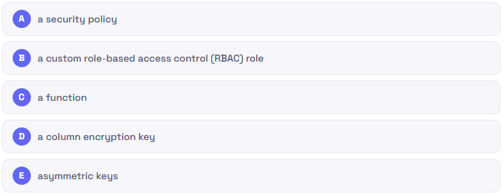

✅ Correct answer: a security policy, a custom role-based access control (RBAC) role
A: Row-Level Security (RLS) enables you to use group membership or execution context to control access to rows in a database table. Implement RLS by using the CREATE SECURITY POLICYTransact-SQL statement.
B: Azure Synapse provides a comprehensive and fine-grained access control system, that integrates:
Azure roles for resource management and access to data in storage,
● Synapse roles for managing live access to code and execution,
● SQL roles for data plane access to data in SQL pools.
Reference:
https://docs.microsoft.com/en-us/sql/relational-databases/security/row-level-security
https://docs.microsoft.com/en-us/azure/synapse-analytics/security/synapse-workspace-access-control-overview

Question 133Azure Synapse Analytics
You have a SQL pool in Azure Synapse that contains a table named dbo.Customers. The table contains a column name Email.
You need to prevent nonadministrative users from seeing the full email addresses in the Email column. The users must see values in a format of aXXX@XXXX.com instead.
What should you do?

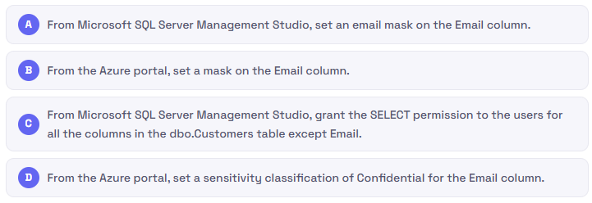

✅ Correct answer: From Microsoft SQL Server Management Studio, set an email mask on the Email column.
Answer is From Microsoft SQL Server Management Studio, set an email mask on the Email column.
B can work but not by default.
The Email masking method, which exposes the first letter and replaces the domain with XXX.com using a constant string prefix in the form of an email address. aXX@XXXX.com
Reference:
https://docs.microsoft.com/en-us/azure/azure-sql/database/dynamic-data-masking-overview

Question 134Azure Synapse Analytics
You have an Azure Data Lake Storage Gen2 account named adls2 that is protected by a virtual network.
You are designing a SQL pool in Azure Synapse that will use adls2 as a source.
What should you use to authenticate to adls2?

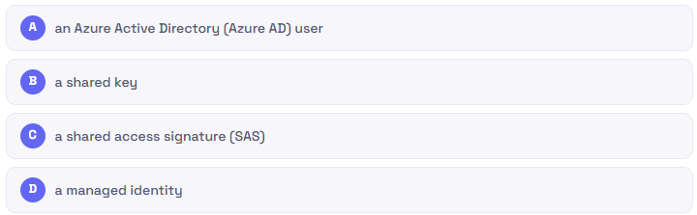

✅ Correct answer: a managed identity
Answer is a managed identity
Managed Identity authentication is required when your storage account is attached to a VNet.
Reference:
https://docs.microsoft.com/en-us/azure/synapse-analytics/sql-data-warehouse/quickstart-bulk-load-copy-tsql-examples

Question 135Azure Synapse Analytics
You are designing an Azure Synapse solution that will provide a query interface for the data stored in an Azure Storage account. The storage account is only accessible from a virtual network.
You need to recommend an authentication mechanism to ensure that the solution can access the source data.
What should you recommend?

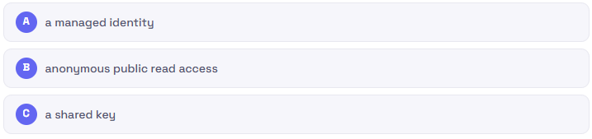
✅ Correct answer: a managed identity
Answer is a managed identity
Managed Identity authentication is required when your storage account is attached to a VNet.
Reference:
https://docs.microsoft.com/en-us/azure/synapse-analytics/sql-data-warehouse/quickstart-bulk-load-copy-tsql-examples

Question 136Azure Synapse Analytics
You have an Azure Synapse Analytics dedicated SQL pool that contains a table named Contacts. Contacts contains a column named Phone.
You need to ensure that users in a specific role only see the last four digits of a phone number when querying the Phone column.
What should you include in the solution?

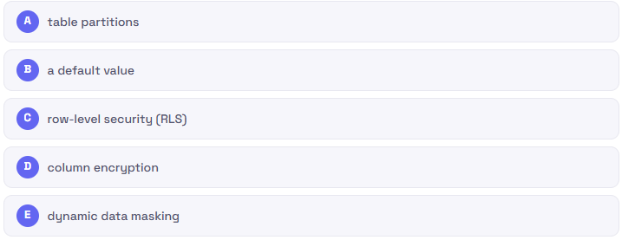

✅ Correct answer: dynamic data masking
Answer is dynamic data masking
Dynamic data masking helps prevent unauthorized access to sensitive data by enabling customers to designate how much of the sensitive data to reveal with minimal impact on the application layer. It's a policy-based security feature that hides the sensitive data in the result set of a query over designated database fields, while the data in the database is not changed.
Reference:
https://docs.microsoft.com/en-us/azure/azure-sql/database/dynamic-data-masking-overview

Question 137Azure Synapse Analytics
You have an on-premises data warehouse that includes the following fact tables. Both tables have the following columns: DateKey, ProductKey, RegionKey. There are 120 unique product keys and 65 unique region keys.
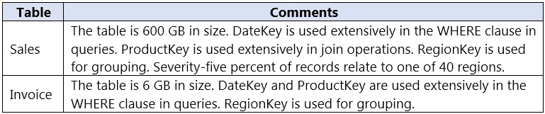
Queries that use the data warehouse take a long time to complete.
You plan to migrate the solution to use Azure Synapse Analytics. You need to ensure that the Azure-based solution optimizes query performance and minimizes processing skew.
What should you recommend?
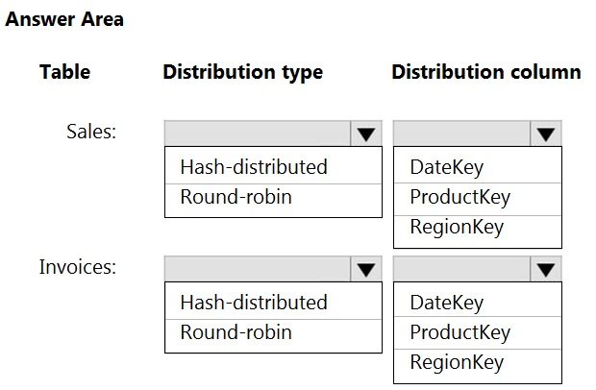

1. Hash Distributed, ProductKey
because >2GB and ProductKey is extensively used in joins
2. Hash Distributed, RegionKey
because "The table size on disk is more than 2 GB." and you have to chose a distribution column which: "Is not used in WHERE clauses. This could narrow the query to not run on all the distributions."
Reference:
https://docs.microsoft.com/en-us/azure/synapse-analytics/sql-data-warehouse/sql-data-warehouse-tables-distribute#choosing-a-distribution-column

Question 138Azure Synapse Analytics
You have an Azure data solution that contains an enterprise data warehouse in Azure Synapse Analytics named DW1.
Several users execute ad hoc queries to DW1 concurrently.
You regularly perform automated data loads to DW1.
You need to ensure that the automated data loads have enough memory available to complete quickly and successfully when the adhoc queries run.
What should you do?

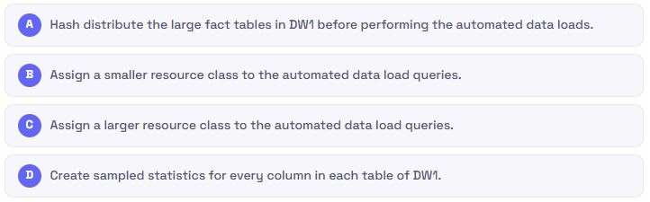

✅ Correct answer: Assign a larger resource class to the automated data load queries.
Answer is Assign a larger resource class to the automated data load queries.
The performance capacity of a query is determined by the user's resource class. Resource classes are pre-determined resource limits in Synapse SQL pool that govern compute resources and concurrency for query execution.
Resource classes can help you configure resources for your queries by setting limits on the number of queries that run concurrently and on the compute-resources assigned to each query. There's a trade-off between memory and concurrency.
Smaller resource classes reduce the maximum memory per query, but increase concurrency.
Larger resource classes increase the maximum memory per query, but reduce concurrency.
Reference:
https://docs.microsoft.com/en-us/azure/synapse-analytics/sql-data-warehouse/resource-classes-for-workload-management

Question 139Azure Synapse Analytics
You have an Azure Synapse Analytics dedicated SQL pool named Pool1 and a database named DB1. DB1 contains a fact table named Table1.
You need to identify the extent of the data skew in Table1.
What should you do in Synapse Studio?

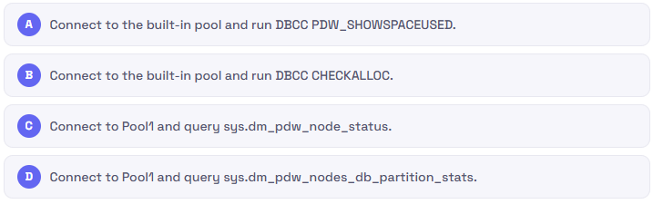

✅ Correct answer: Connect to Pool1 and query sys.dm_pdw_nodes_db_partition_stats.
Answer is Connect to Pool1 and query sys.dm_pdw_nodes_db_partition_stats.
Microsoft recommends use of sys.dm_pdw_nodes_db_partition_stats to analyze any skewness in the data.
Reference:
https://docs.microsoft.com/en-us/azure/synapse-analytics/sql-data-warehouse/cheat-sheet

Question 140
Azure Synapse Analytics
You are designing an inventory updates table in an Azure Synapse Analytics dedicated SQL pool. The table will have a clustered columnstore index and will include the following columns:

You identify the following usage patterns:
● Analysts will most commonly analyze transactions for a warehouse.
● Queries will summarize by product category type, date, and/or inventory event type.
You need to recommend a partition strategy for the table to minimize query times.
On which column should you partition the table?

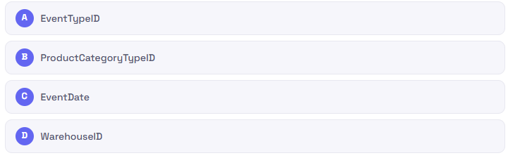

✅ Correct answer: WarehouseID
Answer is WarehouseID
The number of records for each warehouse is big enough for a good partitioning.
Note: Table partitions enable you to divide your data into smaller groups of data. In most cases, table partitions are created on a date column.
When creating partitions on clustered columnstore tables, it is important to consider how many rows belong to each partition. For optimal compression and performance of clustered columnstore tables, a minimum of 1 million rows per distribution and partition is needed. Before partitions are created, dedicated SQL pool already divides each table into 60 distributed databases.
"When creating partitions on clustered columnstore tables, it is important to consider how many rows belong to each partition. For optimal compression and performance of clustered columnstore tables, a minimum of 1 million rows per distribution and partition is needed. Before partitions are created, dedicated SQL pool already divides each table into 60 distributed databases. Any partitioning added to a table is in addition to the distributions created behind the scenes. Using this example, if the sales fact table contained 36 monthly partitions, and given that a dedicated SQL pool has 60 distributions, then the sales fact table should contain 60 million rows per month, or 2.1 billion rows when all months are populated. If a table contains fewer than the recommended minimum number of rows per partition, consider using fewer partitions in order to increase the number of rows per partition."
It is recommended to have at least 1 million rows per partition and distribution. Since there are 60 distributions, the number of rows for each partition must exceed 60 millions.
Reference:
https://docs.microsoft.com/en-us/azure/synapse-analytics/sql-data-warehouse/sql-data-warehouse-tables-partition

Question 141Azure Synapse Analytics
You manage an enterprise data warehouse in Azure Synapse Analytics.
Users report slow performance when they run commonly used queries. Users do not report performance changes for infrequently used queries.
You need to monitor resource utilization to determine the source of the performance issues.
Which metric should you monitor?

