Deep Learning Basics

Introduction to Deep Learning - GeeksforGeeks
https://www.geeksforgeeks.org/deep-learning/introduction-deep-learning/

Introduction to Deep Learning
Deep Learning is transforming the way machines understand, learn and interact with complex data. Deep learning mimics neural networks of the human brain, it enables computers to autonomously uncover patterns and make informed decisions from vast amounts of unstructured data.
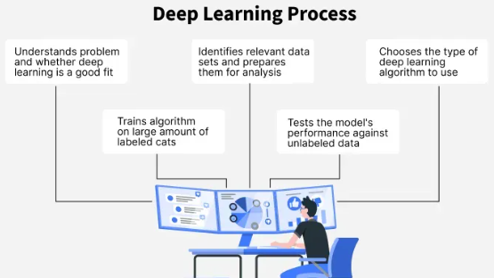
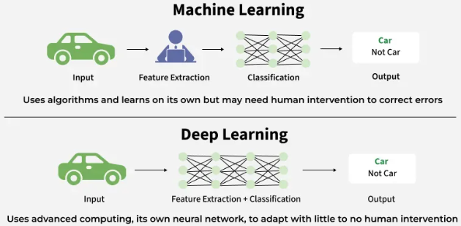
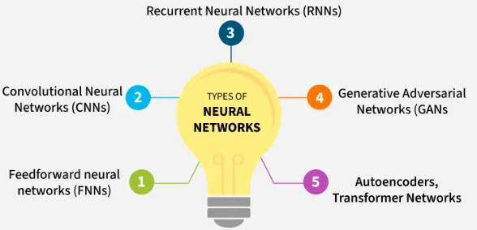
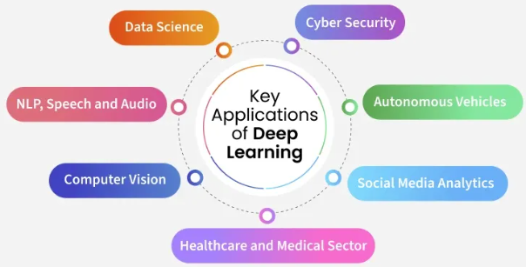
How Deep Learning Works?
Neural network consists of layers of interconnected nodes or neurons that collaborate to process input data. In a fully connected deep neural network, data flows through multiple layers where each neuron performs nonlinear transformations, allowing the model to learn intricate representations of the data.
In a deep neural network, the input layer receives data which passes through hidden layers that transform the data using nonlinear functions. The final output layer generates the model’s prediction.
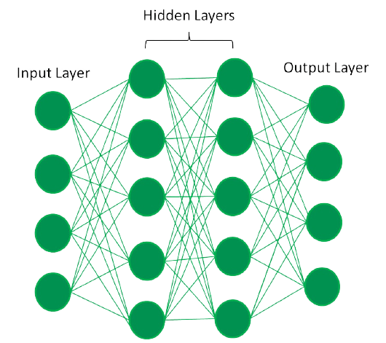
Difference between Machine Learning and Deep Learning
Machine learning and Deep Learning both are subsets of artificial intelligence but there are many similarities and differences between them.
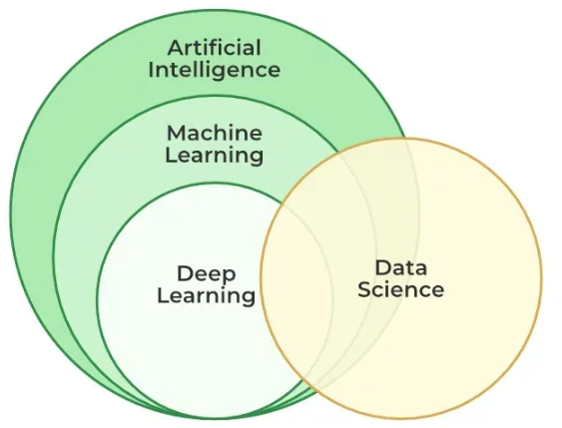
Machine Learning | Deep Learning
Apply statistical algorithms to learn the hidden patterns and relationships in the dataset. | Uses artificial neural network architecture to learn the hidden patterns and relationships in the dataset.
Can work on the smaller amount of dataset | Requires the larger volume of dataset compared to machine learning
Better for the low-label task. | Better for complex task like image processing, natural language processing, etc.
Takes less time to train the model. | Takes more time to train the model.
A model is created by relevant features which are manually extracted from images to detect an object in the image. | Relevant features are automatically extracted from images. It is an end-to-end learning process.
Less complex and easy to interpret the result. | More complex, it works like the black box interpretations of the result are not easy.
It can work on the CPU or requires less computing power as compared to deep learning. | It requires a high-performance computer with GPU.

Evolution of Neural Architectures
Perceptron (1950s)
- First simple neural network with a single layer
- Could only solve linearly separable problems
- Failed on complex tasks like the XOR problem
Multi-Layer Perceptrons (MLPs)
- Introduced hidden layers and non-linear activation functions
- Enabled modeling of non-linear relationships
- Trained effectively using backpropagation
- Marked a major leap in neural network capabilities
Types of neural networks
- Feedforward neural networks (FNNs): They are the simplest type of ANN, where data flows in one direction from input to output. It is used for basic tasks like classification.
- Convolutional Neural Networks (CNNs): They are specialized for processing grid-like data, such as images. CNNs use convolutional layers to detect spatial hierarchies, making them ideal for computer vision tasks.
- Recurrent Neural Networks (RNNs): They are able to process sequential data, such as time series and natural language. RNNs have loops to retain information over time, enabling applications like language modelling and speech recognition. Variants like LSTMs and GRUs address vanishing gradient issues.
- Generative Adversarial Networks (GANs): This consist of two networks—a generator and a discriminator—that compete to create realistic data. GANs are widely used for image generation, style transfer and data augmentation.
- Autoencoders: They are unsupervised networks that learn efficient data encodings. They compress input data into a latent representation and reconstruct it, useful for dimensionality reduction and anomaly detection.
- Transformer Networks: It has revolutionized NLP with self-attention mechanisms. Transformers excel at tasks like translation, text generation and sentiment analysis, powering models like GPT and BERT.
Applications
1. Computer vision
In computer vision, deep learning models enable machines to identify and understand visual data. Some of the main applications of deep learning in computer vision include:
- Object detection and recognition: Deep learning models are used to identify and locate objects within images and videos, making it possible for machines to perform tasks such as self-driving cars, surveillance and robotics.
- Image classification: Deep learning models can be used to classify images into categories such as animals, plants and buildings. This is used in applications such as medical imaging, quality control and image retrieval.
- Image segmentation: Deep learning models can be used for image segmentation into different regions, making it possible to identify specific features within images.

Natural language processing (NLP)
In NLP, deep learning model enables machines to understand and generate human language. Some of the main applications of deep learning in NLP include:
- Automatic Text Generation: Deep learning model can learn the corpus of text and new text like summaries, essays can be automatically generated using these trained models.
- Language translation: Deep learning models can translate text from one language to another, making it possible to communicate with people from different linguistic backgrounds.
- Sentiment analysis: Deep learning models can analyse the sentiment of a piece of text, making it possible to determine whether the text is positive, negative or neutral.
- Speech recognition: Deep learning models can recognize and transcribe spoken words, making it possible to perform tasks such as speech-to-text conversion, voice search and voice-controlled devices.
Reinforcement learning
In reinforcement learning, deep learning works as training agents to take action in an environment to maximize a reward. Some of the main applications of deep learning in reinforcement learning include:
- Game playing: Deep reinforcement learning models have been able to beat human experts at games such as Go, Chess and Atari.
- Robotics: Deep reinforcement learning models can be used to train robots to perform complex tasks such as grasping objects, navigation and manipulation.
- Control systems: Deep reinforcement learning models can be used to control complex systems such as power grids, traffic management and supply chain optimization.
Advantages
- High accuracy: Deep Learning algorithms can achieve state-of-the-art performance in various tasks such as image recognition and natural language processing.
- Automated feature engineering: Deep Learning algorithms can automatically discover and learn relevant features from data without the need for manual feature engineering.
- Scalability: Deep Learning models can scale to handle large and complex datasets and can learn from massive amounts of data.
- Flexibility: Deep Learning models can be applied to a wide range of tasks and can handle various types of data such as images, text and speech.
Disadvantages
Here are some of the main challenges in deep learning:
- Data availability: It requires large amounts of data to learn from. For using deep learning it's a big concern to gather as much data for training.
- Computational Resources: For training the deep learning model, it is computationally expensive because it requires specialized hardware like GPUs and TPUs.
- Interpretability: Deep learning models are complex, it works like a black box. It is very difficult to interpret the result.
- Overfitting: when the model is trained again and again it becomes too specialized for the training data leading to overfitting and poor performance on new data.

Artificial intelligence vs Machine Learning vs Deep Learning

We often confuse the terms Artificial Intelligence (AI), Machine Learning (ML) and Deep Learning (DL), assuming they all mean the same thing. But in reality, they represent different levels of intelligent computing. AI is the broadest field, ML is a subset of AI and DL is a further subset of ML. Let’s define each one, highlight its features and compare them.
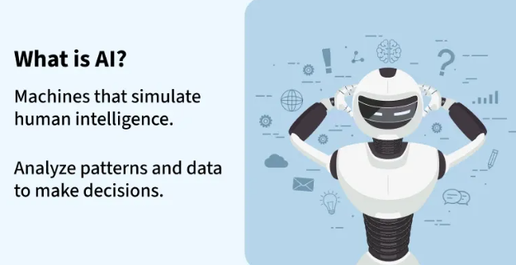
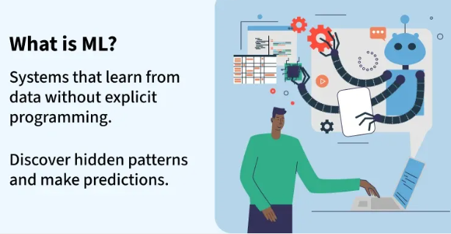
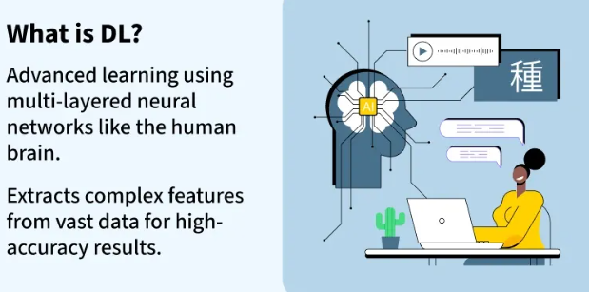
1. Artificial Intelligence (AI)
Artificial intelligence is the field of computer science focused on creating systems that can perform tasks requiring human-like intelligence such as reasoning, problem-solving, planning and understanding natural language. It includes rule-based systems as well as data-driven approaches like ML and DL.
- The broadest field covering ML, DL, robotics and NLP.
- Mimics human cognitive abilities like learning and decision-making.
- Divided into Narrow AI (task-specific) and General AI (human-level, not yet achieved).
- Still evolving but already powerful in real-world use cases.
- Examples: Sophia robot, AI chatbots, fraud detection, medical diagnosis.
2. Machine Learning (ML)
Machine Learning is a branch of AI that enables systems to learn from data and improve their performance without being explicitly programmed. Instead of following fixed rules, ML algorithms analyse past data, detect patterns and use them to make predictions or decisions in new situations.
- Learns from structured and labelled datasets.
- Requires human input for training and corrections.
- Uses algorithms such as regression, clustering and decision trees.
- Improves accuracy with more data.
- Examples: Amazon recommendations, Netflix suggestions, spam detection.
3. Deep Learning (DL)
Deep Learning is a subset of machine learning that uses artificial neural networks with many layers to automatically learn complex patterns from large datasets. Unlike traditional ML, it can extract features on its own making it useful for handling unstructured data such as images, speech and text.
- Built on neural networks inspired by the human brain.
- Learns automatically with minimal human guidance.
- Needs massive datasets and high computational power.
- Excels in tasks like vision, speech and natural language.
- Examples: Self-driving cars, facial recognition, voice assistants.
AI vs. ML vs. DL
Let's see the differences between them:
Aspect | AI | ML | DL
Scope & Application | Broad – includes ML, DL, expert systems, robotics, computer vision, NLP, symbolic AI, etc. | Narrower – focuses on data-driven algorithms and statistical learning. | Narrowest – focuses specifically on deep neural networks.
Core Techniques | Rule-based systems, search algorithms, expert systems, ML, DL, reinforcement learning, NLP. | Supervised learning, unsupervised learning, reinforcement learning, regression, classification, clustering. | CNNs (Convolutional Neural Networks), RNNs (Recurrent Neural Networks), LSTMs, Transformers, GANs.
Data Type | Can work with structured, semi-structured or unstructured data depending on the approach. | Mainly structured and labeled data (though some algorithms handle unstructured data). | Primarily unstructured data (images, audio, text, video).
Learning Dependency | May or may not involve learning (AI can be purely rule-based). | Always involves learning from historical data. | Fully dependent on large-scale learning with neural networks.
Model Complexity | Can range from simple decision trees to complex hybrid AI systems. | Relatively simpler – linear models, trees, SVMs, ensemble methods. | Very complex – multi-layer neural networks with millions to billions of parameters.
Computation Power | Low to high depending on the AI technique (expert systems vs DL). | Moderate – runs well on CPUs for most algorithms. | Very high – requires GPUs/TPUs for training large models.

Deep Learning Examples: Practical Applications in Real Life
Deep learning is a branch of artificial intelligence (AI) that uses algorithms inspired by how the human brain works. It helps computers learn from large amounts of data and make smart decisions. Deep learning is behind many technologies we use every day like voice assistants and medical tools.
This article covers real-world examples of deep learning and explains how it's being used in different fields.
1. Image and Video Recognition
Deep learning has made it possible for machines to understand visual information in ways similar to humans.
- Self-driving cars use deep learning with cameras to detect pedestrians, traffic signs and other vehicles to navigate safely.
- Facial recognition systems match people’s facial features for security, phone unlocking or crowd identification.
- Apps use image classification to recognize plants, animals and products making it useful in education and e-commerce.
2. Natural Language Processing (NLP)
NLP allows systems to read, understand and write human language with context and clarity.
- Virtual assistants like Siri and Alexa use NLP to interpret spoken commands and respond naturally.
- Chatbots use NLP to interact with users and answer queries in customer support.
- Text summarization helps create short summaries from long documents, saving time.
3. Speech Recognition
Deep learning has made voice interaction with machines more practical and accurate. It converts speech into text and understands spoken language.
- Voice typing and dictation tools let users speak instead of typing.
- Automated customer support systems respond to voice commands and help users navigate services.
- It is used in virtual meetings and live events for real-time transcription.
- Many smart devices now come with voice control features powered by deep learning.

4. Recommendation Systems
Recommendation engines use deep learning to personalize content and product suggestions. These systems learn from user behaviour and improve experiences across platforms.
- Netflix and YouTube suggest videos based on your watch history and preferences.
- E-commerce platforms like Amazon recommend products based on browsing and purchase patterns.
- Music apps suggest playlists and songs that match your taste.
5. Healthcare and Drug Discovery
Deep learning in healthcare helps by speeding up diagnosis and drug development. It assists doctors and researchers in making medical decisions with higher confidence.
- Medical imaging tools detect diseases like cancer from scans such as X-rays and MRIs.
- AI models can predict drug effectiveness by simulating molecular behaviour.
- Researchers use it to find potential drug targets faster from biological datasets.
- Deep learning reduces trial-and-error in medicine.
6. Cybersecurity and Scientific Research
Deep learning plays a key role in both securing digital systems and driving scientific discovery. It can detect threats and support faster breakthroughs in research.
- Cybersecurity systems use it to detect unusual activity and prevent hacking or malware attacks.
- Fraud detection models flag suspicious transactions in real time, reducing financial losses.
- It processes massive datasets in fields like physics and material science.
Machine Learning vs Deep Learning
Machine learning and deep learning are two important branches of artificial intelligence, often used for similar tasks but with different capabilities and approaches. This section offers a simple comparison to help understand where each technique fits best and how they differ in real-world use.

Machine Learning | Deep Learning
Spam email detection | Image recognition
Predictive maintenance | Language translation
Credit scoring | Self-driving cars
Fraud detection | Voice assistants
Customer segmentation | Medical diagnosis
Stock prediction | Robotics

Deep learning is a core part of many technologies we use today. It is making systems smarter and more useful, as technology continues to grow, we expect even more helpful and creative uses of deep learning in the future.
Challenges in Deep Learning
Deep learning, a branch of artificial intelligence, uses neural networks to analyse and learn from large datasets. It powers advancements in image recognition, natural language processing, and autonomous systems. Despite its impressive capabilities, deep learning is not without its challenges. It includes issues such as data quality, computational demands, and model interpretability are common obstacles.
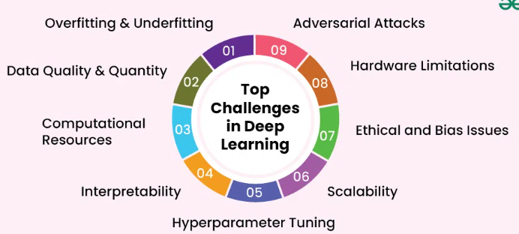

Deep learning faces significant challenges such as data quality, computational demands, and model interpretability. This article explores Deep Learning Challenges and strategies to address them effectively. Understanding these challenges and finding ways to overcome them is crucial for successful implementation.

Table of Content
- Overview of Deep Learning
- Top Deep Learning Challenges
  - 1. Overfitting and Underfitting
  - 2. Data Quality and Quantity
  - 3. Computational Resources
  - 4. Interpretability
  - 5. Hyperparameter Tuning
  - 6. Scalability
  - 7. Ethical and Bias Issues
  - 8. Hardware Limitations
  - 10. Adversarial Attacks
- Strategies to Overcome Deep Learning Challenges
  - Enhancing Data Quality and Quantity
  - Leveraging Cloud Computing
  - Implementing Regularization Techniques
  - Improving Model Interpretability
  - Automating Hyperparameter Tuning
  - Optimizing Algorithms and Hardware
  - Addressing Bias and Ethical Concerns
Overview of Deep Learning
Deep learning is a subset of machine learning that involves neural networks with many layers, often referred to as deep neural networks. These networks mimic the human brain's structure and function, allowing machines to process complex data inputs and recognize patterns. Deep learning has become integral in fields such as image and speech recognition, natural language processing, and autonomous systems. Its ability to learn and make decisions from vast amounts of data has revolutionized how we approach and solve complex problems.

Top Deep Learning Challenges
Deep learning offers immense potential, but several challenges can hinder its effective implementation. Addressing these challenges is crucial for developing reliable and efficient models. Here are the main challenges faced in deep learning:
1. Overfitting and Underfitting
Balancing model complexity to ensure it generalizes well to new data is challenging. Overfitting occurs when a model is too complex and captures noise in the training data. Underfitting happens when a model is too simple and fails to capture the underlying patterns.
2. Data Quality and Quantity
Deep learning models require large, high-quality datasets for training. Insufficient or poor-quality data can lead to inaccurate predictions and model failures. Acquiring and annotating large datasets is often time-consuming and expensive.
3. Computational Resources
Training deep learning models demands significant computational power and resources. This can be expensive and inaccessible for many organizations. High-performance hardware like GPUs and TPUs are often necessary to handle the intensive computations.
4. Interpretability
Deep learning models often function as "black boxes," making it difficult to understand how they make decisions. This lack of transparency can be problematic, especially in critical applications. Understanding the decision-making process is crucial for trust and accountability.
5. Hyperparameter Tuning
Finding the optimal settings for a model’s hyperparameters requires expertise. This process can be time-consuming and computationally intensive. Hyperparameters significantly impact the model’s performance, and tuning them effectively is essential for achieving high accuracy.
6. Scalability
Scaling deep learning models to handle large datasets and complex tasks efficiently is a major challenge. Ensuring models perform well in real-world applications often requires significant adjustments. This involves optimizing both algorithms and infrastructure to manage increased loads.
7. Ethical and Bias Issues
Deep learning models can inadvertently learn and perpetuate biases present in the training data. This can lead to unfair outcomes and ethical concerns. Addressing bias and ensuring fairness in models is critical for their acceptance and trustworthiness.
8. Hardware Limitations
Training deep learning models requires substantial computational resources, including high-performance GPUs or TPUs. Access to such hardware can be a bottleneck for researchers and practitioners.
10. Adversarial Attacks
Deep learning models are susceptible to adversarial attacks, where subtle perturbations to input data can cause misclassification. Robustness against such attacks remains a significant concern in safety-critical applications.
Strategies to Overcome Deep Learning Challenges
Addressing the challenges in deep learning is crucial for developing effective and reliable models. By implementing the right strategies, we can mitigate these issues and enhance the performance of our deep learning systems. Here are the key strategies:
Enhancing Data Quality and Quantity
- Preprocessing: Invest in data preprocessing techniques to clean and organize data.
- Data Augmentation: Use data augmentation methods to artificially increase the size of your dataset.
- Data Collection: Gathering more labelled data improves model accuracy and robustness.
Leveraging Cloud Computing
- Cloud Platforms: Utilize cloud-based platforms like AWS, Google Cloud, or Azure for accessing computational resources.
- Scalable Computing: These platforms offer scalable computing power without the need for significant upfront investment.
- Tools and Frameworks: Cloud services also provide tools and frameworks that simplify the deployment and management of deep learning models.
Implementing Regularization Techniques
- Dropout: Use techniques like dropout to prevent overfitting.
- L2 Regularization: Regularization helps the model generalize better by adding constraints or noise during training.
- Data Augmentation: This ensures that the model performs well on new, unseen data.
Improving Model Interpretability
- Interpretability Tools: Employ tools like LIME (Local Interpretable Model-agnostic Explanations) or SHAP (SHapley Additive explanations) to understand model decisions.
- Transparency: Enhancing interpretability helps build trust in the model, especially in critical applications.
Automating Hyperparameter Tuning
- Automated Tuning: Use automated tools like grid search, random search, or Bayesian optimization for hyperparameter tuning.
- Efficiency: Automated tuning saves time and computational resources by systematically exploring the hyperparameter space.
Optimizing Algorithms and Hardware
- Efficient Algorithms: Implement efficient algorithms and leverage specialized hardware like GPUs and TPUs.
- Advanced Hardware: These optimizations significantly reduce training time and improve model performance.
Addressing Bias and Ethical Concerns
- Fairness Practices: Implement fairness-aware machine learning practices to identify and mitigate biases.
- Regular Audits: Regularly audit models to ensure they do not perpetuate harmful biases present in the training data.
Conclusion
Deep learning presents both incredible opportunities and significant challenges. Overcoming these challenges requires understanding the underlying issues and implementing effective strategies. By enhancing data quality, leveraging advanced tools, and addressing ethical concerns, we can use deep learning's full potential. Continuous improvement and adaptation are key to success. Embracing these practices will lead to more robust and impactful deep learning models.
Why Deep Learning is Important
Deep learning has emerged as one of the most transformative technologies of our time, revolutionizing numerous fields from computer vision to natural language processing. Its significance extends far beyond just improving predictive accuracy; it has reshaped entire industries and opened up new possibilities.
Table of Content
- Understanding Deep Learning
- Key Areas of Impact
  - Computer Vision:
  - Natural Language Processing (NLP):
  - Healthcare:
  - Finance:
- Advantages of Deep Learning
  - Feature Learning:
  - High Performance:
  - Scalability:
  - Versatility:
- Challenges and Considerations
  - Data Requirements:
  - Computational Resources:
  - Interpretability:
  - Ethical Concerns:
- The Future of Deep Learning
- Conclusion
This article delves into why deep learning is important, exploring its core principles, applications, benefits, and the challenges it addresses.
Understanding Deep Learning
Deep learning is a subset of machine learning, characterized by its use of artificial neural networks with many layers (hence "deep"). These networks are designed to model complex patterns and representations in data. Unlike traditional machine learning algorithms that require manual feature extraction, deep learning models automatically learn features from raw data, making them highly effective for tasks involving large and complex datasets.
Core Principles:
- Neural Networks: Deep learning models are built on neural networks that consist of interconnected nodes or "neurons." Each layer of the network transforms the input data, passing it through multiple layers to learn increasingly abstract features.
- Layer Depth: The depth of a neural network refers to the number of layers it has. Deep networks with many layers can capture intricate relationships and features in data.
- Backpropagation: This is the process used to train neural networks by adjusting the weights of the connections based on the error of the predictions.

Key Areas of Impact
Computer Vision:
Deep learning has revolutionized computer vision, enabling machines to interpret and understand visual information with remarkable accuracy. Key applications include:
- Image Classification: Identifying objects or scenes in images, such as in medical imaging where deep learning helps in detecting tumours or abnormalities.
- Object Detection: Locating and classifying objects within an image, used in autonomous vehicles for detecting pedestrians, other vehicles, and road signs.
- Image Generation: Creating realistic images or enhancing existing ones through techniques like Generative Adversarial Networks (GANs).
Natural Language Processing (NLP):
Deep learning has significantly advanced NLP, leading to more natural and intuitive interactions with machines. Applications include:
- Machine Translation: Translating text between languages with high accuracy, as seen in services like Google Translate.
- Sentiment Analysis: Determining the sentiment or emotion behind text, used for customer feedback analysis and social media monitoring.
- Text Generation: Creating coherent and contextually relevant text, as demonstrated by language models like GPT-3.
Healthcare:
Deep learning's applications in healthcare are transformative:
- Medical Imaging: Enhancing the interpretation of X-rays, MRIs, and CT scans, aiding in early diagnosis and treatment planning.
- Drug Discovery: Accelerating the process of discovering new drugs by predicting how different compounds will interact with biological targets.
- Personalized Medicine: Tailoring treatments based on individual patient data, improving the efficacy and reducing side effects.
Finance:
In the finance sector, deep learning is used to:
- Fraud Detection: Identifying unusual patterns in transactions to detect and prevent fraudulent activities.
- Algorithmic Trading: Developing sophisticated trading algorithms that can make high-frequency trading decisions based on market data.
- Risk Management: Assessing and managing financial risks through predictive models that analyse market trends and economic indicators.
Advantages of Deep Learning
Feature Learning:
Deep learning models automatically learn features from raw data, eliminating the need for manual feature extraction. This capability allows them to handle a wide range of data types and complexities.
High Performance:
Deep learning models achieve state-of-the-art performance in many tasks, outperforming traditional machine learning algorithms in accuracy and efficiency. This is particularly evident in image recognition and language processing tasks.
Scalability:
Deep learning algorithms can scale with the amount of data and computational power available. As more data becomes available, these models continue to improve and adapt, leading to better performance.
Versatility:
Deep learning is applicable across various domains, from image and speech recognition to time-series forecasting and robotics. Its versatility makes it a valuable tool for solving complex problems in diverse fields.

Challenges and Considerations
Data Requirements:
Deep learning models require large amounts of data to train effectively. The need for extensive datasets can be a barrier in fields where data is scarce or difficult to obtain.
Computational Resources:
Training deep learning models can be resource-intensive, requiring powerful hardware like GPUs and TPUs. This can be a limitation for organizations with limited computational resources.
Interpretability:
Deep learning models are often considered "black boxes" due to their complexity, making it challenging to interpret their decision-making processes. This lack of transparency can be problematic, especially in critical applications like healthcare and finance.
Ethical Concerns:
The use of deep learning raises ethical concerns, including issues related to privacy, bias, and fairness. Ensuring that models are trained on diverse and representative data is crucial to addressing these concerns
The Future of Deep Learning
The future of deep learning holds promising advancements:
- Improved Efficiency: Ongoing research aims to develop more efficient algorithms that require less computational power and data.
- Better Interpretability: Advances in explainable AI will enhance our ability to understand and trust deep learning models.
- Cross-Domain Applications: Deep learning will continue to expand into new domains, offering innovative solutions to a wide range of challenges.

Conclusion
Deep learning is a cornerstone of modern artificial intelligence, driving significant advancements across various fields. Its ability to learn complex patterns from large datasets, coupled with its high performance and versatility, makes it an indispensable tool in today's technological landscape. Despite its challenges, the ongoing research and development in deep learning promise to further enhance its capabilities and applications, shaping the future of AI and impacting our lives in profound ways

Neural Network Basics
Neural networks are machine learning models that mimic the complex functions of the human brain. These models consist of interconnected nodes or neurons that process data, learn patterns and enable tasks such as pattern recognition and decision-making.
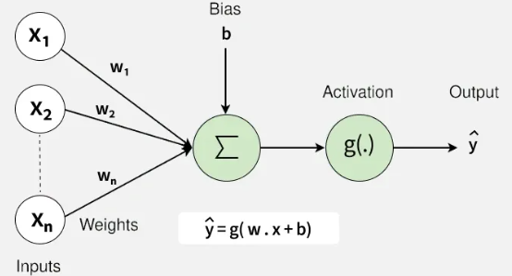
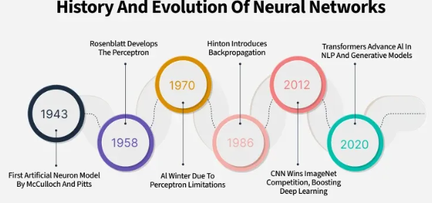
Neural networks are capable of learning and identifying patterns directly from data without pre-defined rules. These networks are built from several key components:
- Neurons: The basic units that receive inputs, each neuron is governed by a threshold and an activation function.
- Connections: Links between neurons that carry information, regulated by weights and biases.
- Weights and Biases: These parameters determine the strength and influence of connections.
- Propagation Functions: Mechanisms that help process and transfer data across layers of neurons.
- Learning Rule: The method that adjusts weights and biases over time to improve accuracy.
Learning in neural networks follows a structured, three-stage process:
- Input Computation: Data is fed into the network.
- Output Generation: Based on the current parameters, the network generates an output.
- Iterative Refinement: The network refines its output by adjusting weights and biases, gradually improving its performance on diverse tasks.
In an adaptive learning environment:
- The neural network is exposed to a simulated scenario or dataset.
- Parameters such as weights and biases are updated in response to new data or conditions.
- With each adjustment, the network’s response evolves allowing it to adapt effectively to different tasks or environments.
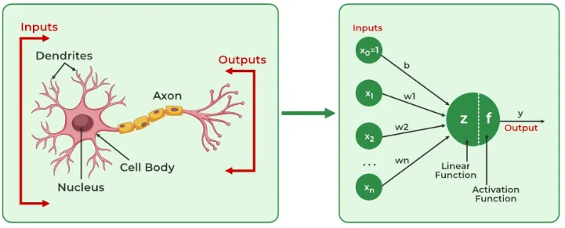

Importance of Neural Networks
- Identify Complex Patterns: Recognize intricate structures and relationships in data; adapt to dynamic and changing environments.
- Learn from Data: Handle vast datasets efficiently; improve performance with experience and retraining.
- Drive Key Technologies: Power natural language processing (NLP); enable self-driving vehicles; support automated decision-making systems.
- Boost Efficiency: Streamline workflows and processes; enhance productivity across industries.
- Backbone of AI: Serve as the core driver of artificial intelligence progress; continue shaping the future of technology and innovation.
Layers in Neural Network Architecture
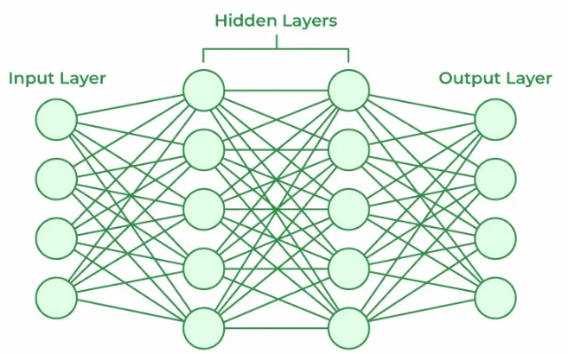

- Input Layer: This is where the network receives its input data. Each input neuron in the layer corresponds to a feature in the input data.
- Hidden Layers: These layers perform most of the computational heavy lifting. A neural network can have one or multiple hidden layers. Each layer consists of units (neurons) that transform the inputs into something that the output layer can use.
- Output Layer: The final layer produces the output of the model. The format of these outputs varies depending on the specific task like classification, regression.
Working of Neural Networks
1. Forward Propagation
When data is input into the network, it passes through the network in the forward direction, from the input layer through the hidden layers to the output layer. This process is known as forward propagation. Here’s what happens during this phase:
1. Linear Transformation: Each neuron in a layer receives inputs which are multiplied by the weights associated with the connections. These products are summed together and a bias is added to the sum. This can be represented mathematically as:

where
- w represents the weights
- x represents the inputs
- b is the bias
2. Activation: The result of the linear transformation (denoted as z) is then passed through an activation function. The activation function is crucial because it introduces non-linearity into the system, enabling the network to learn more complex patterns. Popular activation functions include ReLU, sigmoid and tanh.
2. Backpropagation
After forward propagation, the network evaluates its performance using a loss function which measures the difference between the actual output and the predicted output. The goal of training is to minimize this loss. This is where backpropagation comes into play:
- Loss Calculation: The network calculates the loss which provides a measure of error in the predictions. The loss function could vary; common choices are mean squared error for regression tasks or cross-entropy loss for classification.
- Gradient Calculation: The network computes the gradients of the loss function with respect to each weight and bias in the network. This involves applying the chain rule of calculus to find out how much each part of the output error can be attributed to each weight and bias.
- Weight Update: Once the gradients are calculated, the weights and biases are updated using an optimization algorithm like stochastic gradient descent (SGD). The weights are adjusted in the opposite direction of the gradient to minimize the loss. The size of the step taken in each update is determined by the learning rate.
3. Iteration
This process of forward propagation, loss calculation, backpropagation and weight update is repeated for many iterations over the dataset. Over time, this iterative process reduces the loss and the network's predictions become more accurate.
Through these steps, neural networks can adapt their parameters to better approximate the relationships in the data, thereby improving their performance on tasks such as classification, regression or any other predictive modeling.
Example of Email Classification
Let's consider a record of an email dataset:
Email ID | Email Content | Sender | Subject Line | Label
1 | "Get free gift cards now!" | spam@example.com | "Exclusive Offer" | 1
To classify this email, we will create a feature vector based on the analysis of keywords such as "free" "win" and "offer"
The feature vector of the record can be presented as:
- "free": Present (1)
- "win": Absent (0)
- "offer": Present (1)
How Neurons Process Data in a Neural Network
In a neural network, input data is passed through multiple layers, including one or more hidden layers. Each neuron in these hidden layers performs several operations, transforming the input into a usable output.
1. Input Layer: The input layer contains 3 nodes that indicates the presence of each keyword.
2. Hidden Layer: The input vector is passed through the hidden layer. Each neuron in the hidden layer performs two primary operations: a weighted sum followed by an activation function.
Weights:
- Neuron H1: [0.5,−0.2,0.3]
- Neuron H2: [0.4,0.1,−0.5]
Input Vector: [1,0,1]
Weighted Sum Calculation
- For H1: (1×0.5)+(0×−0.2)+(1×0.3)=0.5+0+0.3=0.8
- For H2: (1×0.4)+(0×0.1)+(1×−0.5)=0.4+0−0.5=−0.1
Activation Function
Here we will use ReLu activation function:
- H1 Output: ReLU(0.8)= 0.8
- H2 Output: ReLu(-0.1) = 0
3. Output Layer: The activated values from the hidden neurons are sent to the output neuron where they are again processed using a weighted sum and an activation function.
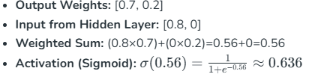
4. Final Classification:
- The output value of approximately 0.636 indicates the probability of the email being spam.
- Since this value is greater than 0.5, the neural network classifies the email as spam (1).
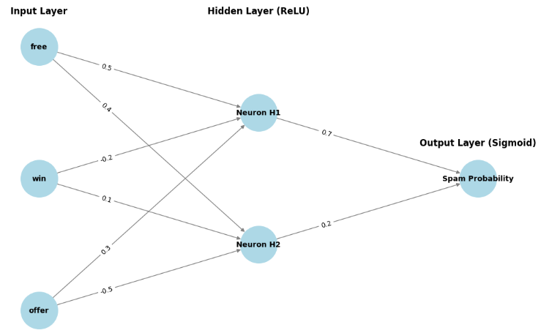
Learning of a Neural Network
1. Learning with Supervised Learning
In supervised learning, a neural network learns from labelled input-output pairs provided by a teacher. The network generates outputs based on inputs and by comparing these outputs to the known desired outputs, an error signal is created. The network iteratively adjusts its parameters to minimize errors until it reaches an acceptable performance level.
2. Learning with Unsupervised Learning
Unsupervised learning involves data without labelled output variables. The primary goal is to understand the underlying structure of the input data (X). Unlike supervised learning, there is no instructor to guide the process. Instead, the focus is on modelling data patterns and relationships, with techniques like clustering and association commonly used.
3. Learning with Reinforcement Learning
Reinforcement learning enables a neural network to learn through interaction with its environment. The network receives feedback in the form of rewards or penalties, guiding it to find an optimal policy or strategy that maximizes cumulative rewards over time. This approach is widely used in applications like gaming and decision-making.

Types of Neural Networks
There are seven types of neural networks that can be used.
- Feedforward Networks: It is a simple artificial neural network architecture in which data moves from input to output in a single direction.
- Singlelayer Perceptron: It has one layer and it applies weights, sums inputs and uses activation to produce output.
- Multilayer Perceptron (MLP): It is a type of feedforward neural network with three or more layers, including an input layer, one or more hidden layers and an output layer. It uses nonlinear activation functions.
- Convolutional Neural Network (CNN): It is designed for image processing. It uses convolutional layers to automatically learn features from input images, enabling effective image recognition and classification.
- Recurrent Neural Network (RNN): Handles sequential data using feedback loops to retain context over time.
- Long Short-Term Memory (LSTM): A type of RNN with memory cells and gates to handle long-term dependencies and avoid vanishing gradients.
Implementation of Neural Network using TensorFlow
Here, we implement simple feedforward neural network that trains on a sample dataset and makes predictions using following steps:
Step 1: Import Necessary Libraries
Import necessary libraries, primarily TensorFlow and Keras, along with other required packages such as NumPy and Pandas for data handling.
import numpy as np
import pandas as pd
from tensorflow.keras.models import Sequential
from tensorflow.keras.layers import Dense

Step 2: Create and Load Dataset
- Create or load a dataset. Convert the data into a format suitable for training (usually NumPy arrays).
- Define features (X) and labels (y).
data = {
'feature1': [0.1, 0.2, 0.3, 0.4, 0.5],
'feature2': [0.5, 0.4, 0.3, 0.2, 0.1],
'label': [0, 0, 1, 1, 1]
}

df = pd.DataFrame(data)
X = df[['feature1', 'feature2']].values
y = df['label'].values

Step 3: Create a Neural Network
Instantiate a Sequential model and add layers. The input layer and hidden layers are typically created using Dense layers, specifying the number of neurons and activation functions.
model = Sequential()
model.add(Dense(8, input_dim=2, activation='relu'))
model.add(Dense(1, activation='sigmoid'))

Step 4: Compiling the Model
Compile the model by specifying the loss function, optimizer and metrics to evaluate during training. Here we will use binary crossentropy and adam optimizer.

model.compile(loss='binary_crossentropy',
optimizer='adam', metrics=['accuracy'])

Step 5: Train the Model
Fit the model on the training data, specifying the number of epochs and batch size. This step trains the neural network to learn from the input data.

model.fit(X, y, epochs=100, batch_size=1, verbose=1)

Step 6: Make Predictions
Use the trained model to make predictions on new data. Process the output to interpret the predictions like converting probabilities to binary outcomes.

test_data = np.array([[0.2, 0.4]])
prediction = model.predict(test_data)
predicted_label = (prediction > 0.5).astype(int)

Output:
Predicted label: 1

Advantages
Neural networks are widely used in many different applications because of their many benefits:
- Adaptability: Neural networks are useful for activities where the link between inputs and outputs is complex or not well defined because they can adapt to new situations and learn from data.
- Pattern Recognition: Their proficiency in pattern recognition renders them efficacious in tasks like as audio and image identification, natural language processing and other intricate data patterns.
- Parallel Processing: Because neural networks are capable of parallel processing by nature, they can process numerous jobs at once which speeds up and improves the efficiency of computations.
- Non-Linearity: Neural networks are able to model and comprehend complicated relationships in data by virtue of the non-linear activation functions found in neurons which overcome the drawbacks of linear models.

Limitations
Neural networks while powerful, are not without drawbacks and difficulties:
- Computational Intensity: Large neural network training can be a laborious and computationally demanding process that demands a lot of computing power.
- Black box Nature: As "black box" models, neural networks pose a problem in important applications since it is difficult to understand how they make decisions.
- Overfitting: Overfitting is a phenomenon in which neural networks commit training material to memory rather than identifying patterns in the data. Although regularization approaches help to alleviate this, the problem still exists.
- Need for Large datasets: For efficient training, neural networks frequently need sizable, labelled datasets; otherwise, their performance may suffer from incomplete or skewed data.

Applications
Neural networks have numerous applications across various fields:
- Image and Video Recognition: CNNs are extensively used in applications such as facial recognition, autonomous driving and medical image analysis.
- Natural Language Processing (NLP): RNNs and transformers power language translation, chatbots and sentiment analysis.
- Finance: Predicting stock prices, fraud detection and risk management.
- Healthcare: Neural networks assist in diagnosing diseases, analyzing medical images and personalizing treatment plans.
- Gaming and Autonomous Systems: Neural networks enable real-time decision-making, enhancing user experience in video games and enabling autonomous systems like self-driving cars.

Types of Neural Networks

Neural networks are computational models that mimic the way biological neural networks in the human brain process information. They consist of layers of neurons that transform the input data into meaningful outputs through a series of mathematical operations.
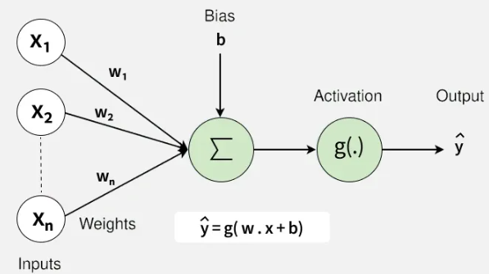

1. Feedforward Neural Networks
Feedforward neural networks are a form of artificial neural network where without forming any cycles between layers or nodes means inputs can pass data through those nodes within the hidden level to the output nodes.

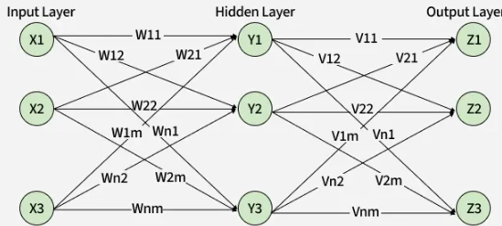

- Architecture: Made up of layers with unidirectional flow of data i.e., from input through hidden and the output layer.
- Training: Backpropagation is often used during training for the main aim of reducing the prediction errors.
- Applications: In visual and voice recognition, NLP, financial forecasting and recommending system
- When to use: Best for general-purpose tasks like classification and regression. Ideal when data is static and has no sequential dependencies.
2. Convolutional Neural Networks (CNNs)
Convolutional neural networks structure is focused on processing the grid type data like images and videos by using convolutional layers filtering driving the patterns and spatial hierarchies.
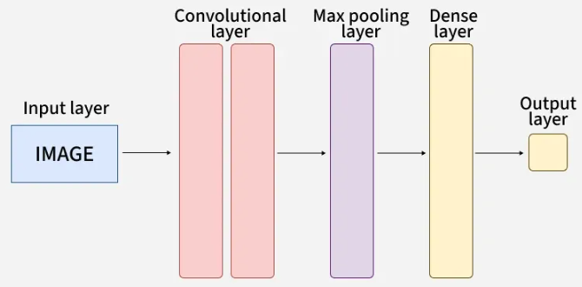
- Key Components: Utilizing convolutional layers, pooling layers and fully connected layers.
- Applications: Used for classification of images, object detection, medical imaging analyzes, autonomous driving and visualization in augmented reality.
- When to use: Use when working with image, video or grid-structured data.

3. Recurrent Neural Networks (RNNs)
Recurrent neural network handles sequential data in which the current output is a result of previous inputs by looping over themselves to hold internal state (memory).
- Architecture: Contains recurrent connections that enable feedback loops for processing sequences.
- Challenges: Problems such as vanishing gradients become apparent since they limit capturing interdependence on a long scale.
- Applications: Language translation, open-ended text classification, ones to ones interaction and time series prediction are its applications.
- When to use: Use for tasks involving sequences like text, speech or time series.
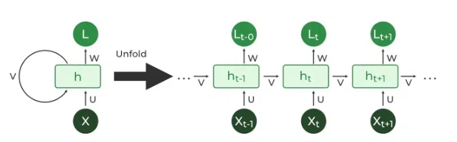
4. Long Short-Term Memory Networks (LSTMs)
Long Short-Term Memory Networks (LSTMs) are a variant of RNNs. They exhibit memory cells to solve the disappearing gradient issue and keep large ranges of information in their memory.

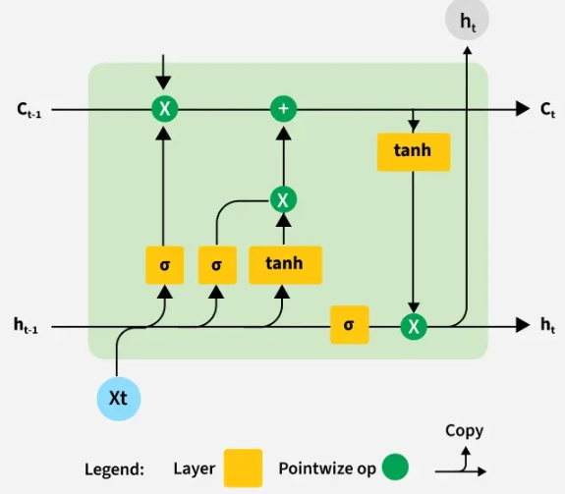

- Key Features: Capture memory cells in pass information flowing and graduate greediness issue.
- Applications: Value of RNNs is in terms of importing long-term memory into the model like language translation and time-series forecasting.
- When to use: Use when you need to model long-term dependencies in sequences.
5. Gated Recurrent Units (GRUs)
Gated Recurrent Units (GRUs) is the second usual variant of RNNs which is working on gating mechanism just like LSTM but with little parameter.
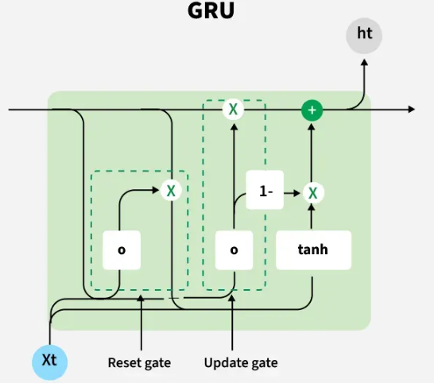

- Advantages: Vanishing gradient issue is addressed, and it is compute-efficient than LSTM.
- Applications: LSTM is also involved in tasks that can be categorized as similar to speech recognition and text monitoring.
- When to use: Use when LSTM-like performance is needed but with lower computational cost.

6. Radial Basis Function Networks (RBFNs)
Radial basis function (RBF) networks can be regarded as models which define radial basis functions that are very useful in the function approximation and classification approaches and is used in complex input-output data modelling.
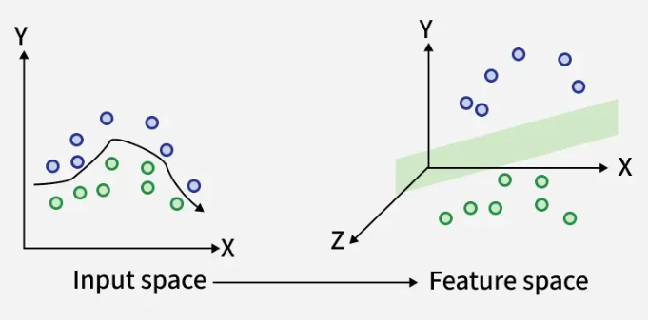

- Applications: It includes regression, pattern recognition and system control methods for fast-tracking.
- When to use: Good choice for function approximation and small to medium-scale classification tasks.

7. Self-Organizing Maps (SOMs)
Self-Organizing Maps are unsupervised neural networks, these networks are used for unsupervised cluster generation based on the retaining of topological features of the high dimensional data from an upper dimensional source, transformed into low dimensional form of output data.

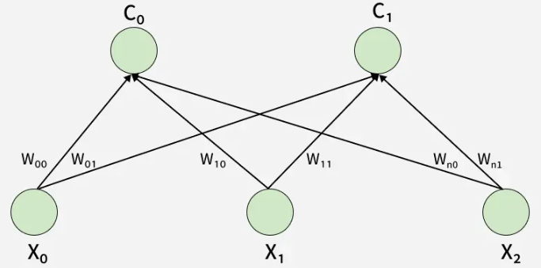

- Features: Design methods that reduces the dimension of data from the high dimension into a low dimension without loss of the underlying geometry of the data.
- Applications: Visualizing data, discovering customers segments, locating anomalies and selecting needed features.
- When to use: Ideal for data visualization, clustering and dimensionality reduction.
8. Deep Belief Networks (DBNs)
The architecture of the Deep Belief Networks is built on many stochastic, latent variables that are used for both deep supervised and unsupervised tasks such as nonlinear feature learning and mid dimensional representation.
- Function: If you are looking for the most effective architecture of data that can be learned via classification, this algorithm is very useful.
- Applications: Image and voice recognition, natural language understanding and smart devices as recommendations systems.
- When to use: Use when you're interested in unsupervised pre-training or deep feature extraction.

9. Generative Adversarial Networks (GANs)
Generative Adversarial Networks has made up of two neural networks, the generator and discriminator which compete against each other. The generator creates a fake generated data, and the discriminator learns to differentiate the real from fake data.

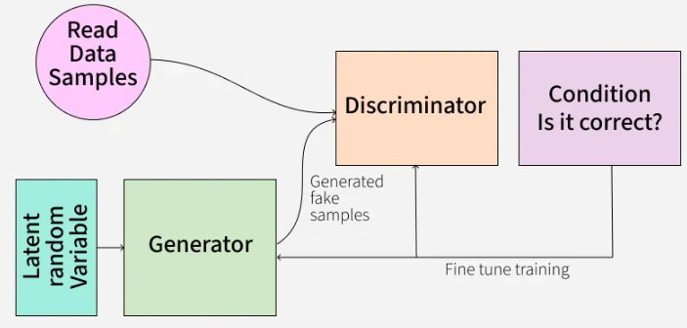

- Working Principle: Generator evolves after each iteration while the fake data being generated. This simultaneously makes the discriminator more discriminating as it determines whether the components are real or generated.
- Applications: They have proved useful not only for pattern generation but also data augmentation, style transfer and learning without any supervision.
- When to use: Use when you need to generate realistic synthetic data.

10. Autoencoders (AE)
Autoencoders are feedforward networks (ANNs) that are trained to acquire the most helpful presentations of the information through the process of re-coding the input data. The encoder is pinpointed to precisely map the input into the legal latent space representation while the decoder does the opposite, decoding the space from this representation.

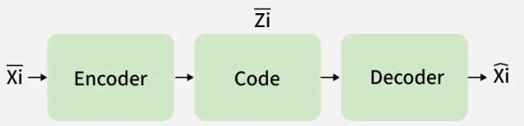

- Functionality: Help in techniques like dimensionality reduction, information extraction, noise removal and generative modelling the images become comprehensible.
- Types: Variants include undercomplete, overcomplete and variational autoencoders.
- When to use: Use for unsupervised learning tasks like data compression, noise removal and anomaly detection.
11. Transformer Networks
Transformer Networks do this by way of self-attention mechanism which results into a parallel process used for making the tokenization inputs faster and thus improved capturing of long range dependencies.
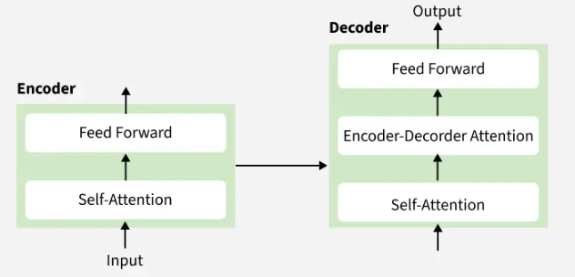

- Key Features: Provides better performance than any of the other models due to their capability to process natural language sufficiently and handle tasks related to machine translation, generating text and document summarization.
- Applications: The application of this technology had got more popular, especially in language understanding tasks and image and audio data processing applications of this time and more similar tasks.
- When to use: Use for NLP tasks like translation, text generation and summarization.

12. Siamese Neural Networks
Siamese Neural Network work with networks of the same structure and an identical architecture. Comparison is being made via a similarity metric that can tell the degree of resemblance the two networks have.
- Applications: Face recognition as the signature, retrieval of information, image similarity comparison and category tasks.
- When to use: Ideal when comparing two inputs to determine similarity like face verification.

13. Capsule Networks (CapsNet)
The layers of Capsule Networks do not only incorporate localization relations of data but allows multilevel structure by passing the information from lower convolutional layers to higher. They use cyclicals to the items and their bodies too, of course, they do not do that at the same time.
- Applications: Image classification, object detection and scene understanding via the immense visual data exposure.
- When to use: Use for image classification where part-to-whole relationships matter.

14. Spiking Neural Networks (SNN)
Main thing related with Spiking Neural Networks is the brain functionality which is processed by action potentials (spikes) in biological neurons in the same way. These are the key factors of "neuromorphic" technology which perform the deep learning and avoid another type of processing as well.
- Applications: Neuromorphic processes, learning and computation in spiro-neural computing, cognitive processes modeling and mind-related computing are also carried out with this.
- When to use: Use when working on neuromorphic computing and biologically inspired architectures.
Applications
The uses of neural networks are diverse and cut across many distinct industries and domains. Some of its applications are:
- Healthcare: Neural networks play a critical role in medical image analysis, disease diagnosis, personalized treatment plans, drug discovery and healthcare management systems.
- Finance: They have a very strong influence on algorithmic trading, fraud detection, credit scoring, risk management and portfolio optimization.
- Entertainment: They allow development of recommendation systems for movies, music, books and character animation as well as virtual reality experiences.
- Manufacturing: They innovate in supply chain management especially in optimizing it, predictive maintenance, quality control processes and industrial automation.
- Transportation: The human brain is incorporated into the auto-piloted cars for the purpose of perception, making decisions and navigation.
- Environmental Sciences: They help construct climate models, satellite monitoring and ecological observation.

Layers in Artificial Neural Networks (ANN)

In Artificial Neural Networks (ANNs), data flows from the input layer to the output layer through one or more hidden layers. Each layer consists of neurons that receive input, process it, and pass the output to the next layer. The layers work together to extract features, transform data, and make predictions.
An Artificial Neural Networks (ANNs) consists of three primary types of layers:
- Input Layer
- Hidden Layers
- Output Layer
Each layer is composed of nodes (neurons) that are interconnected. The layers work together to process data through a series of transformations.
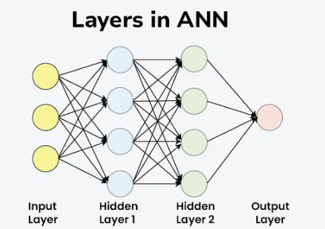

Basic Layers in ANN
1. Input Layer
Input layer is the first layer in an ANN and is responsible for receiving the raw input data. This layer's neurons correspond to the features in the input data. For example, in image processing, each neuron might represent a pixel value. The input layer doesn't perform any computations but passes the data to the next layer.
Key Points:
- Role: Receives raw data.
- Function: Passes data to the hidden layers.
- Example: For an image, the input layer would have neurons for each pixel value.

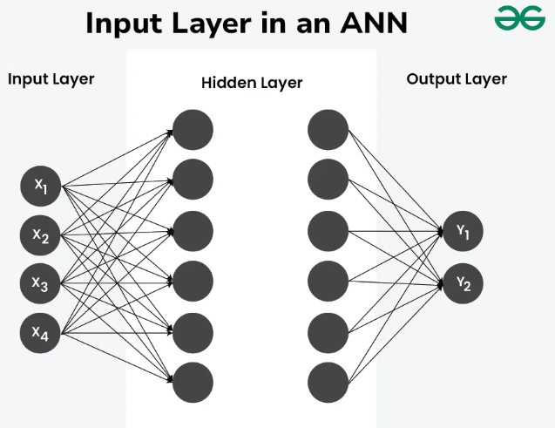

2. Hidden Layers
Hidden Layers are the intermediate layers between the input and output layers. They perform most of the computations required by the network. Hidden layers can vary in number and size, depending on the complexity of the task.
Each hidden layer applies a set of weights and biases to the input data, followed by an activation function to introduce non-linearity.
3. Output Layer
Output Layer is the final layer in an ANN. It produces the output predictions. The number of neurons in this layer corresponds to the number of classes in a classification problem or the number of outputs in a regression problem.
The activation function used in the output layer depends on the type of problem:
- Softmax for multi-class classification
- Sigmoid for binary classification
- Linear for regression
For better understanding of the activation functions, Refer to the article - Activation functions in Neural Networks
Types of Hidden Layers in Artificial Neural Networks
Till now we have covered the basic layers: input, hidden, and output. Let’s now dive into the specific types of hidden layers.
1. Dense (Fully Connected) Layer
Dense (Fully Connected) Layer is the most common type of hidden layer in an ANN. Every neuron in a dense layer is connected to every neuron in the previous and subsequent layers. This layer performs a weighted sum of inputs and applies an activation function to introduce non-linearity. The activation function (like ReLU, Sigmoid, or Tanh) helps the network learn complex patterns.
- Role: Learns representations from input data.
- Function: Performs weighted sum and activation.

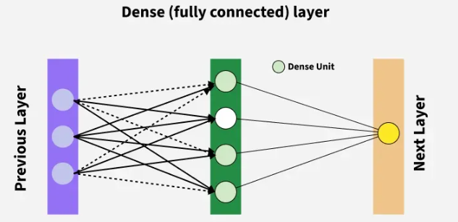

2. Convolutional Layer
Convolutional layers are used in Convolutional Neural Networks (CNNs) for image processing tasks. They apply convolution operations to the input, capturing spatial hierarchies in the data. Convolutional layers use filters to scan across the input and generate feature maps. This helps in detecting edges, textures, and other visual features.
- Role: Extracts spatial features from images.
- Function: Applies convolution using filters.

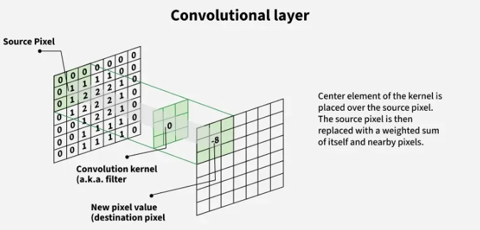

3. Recurrent Layer
Recurrent layers are used in Recurrent Neural Networks (RNNs) for sequence data like time series or natural language. They have connections that loop back, allowing information to persist across time steps. This makes them suitable for tasks where context and temporal dependencies are important.
- Role: Processes sequential data with temporal dependencies.
- Function: Maintains state across time steps.

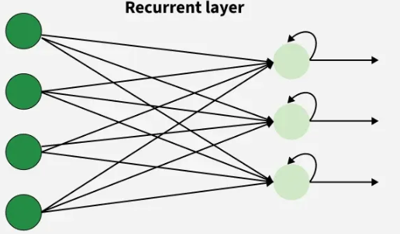

4. Dropout Layer
Dropout layers are a regularization technique used to prevent overfitting. They randomly drop a fraction of the neurons during training, which forces the network to learn more robust features and reduces dependency on specific neurons. During training, each neuron is retained with a probability p.
- Role: Prevents overfitting.
- Function: Randomly drops neurons during training.

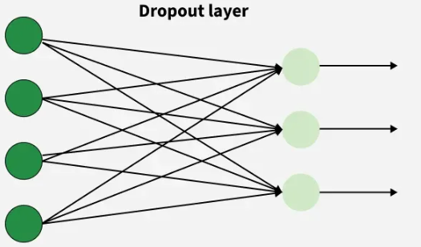

5. Pooling Layer
Pooling Layer is used to reduce the spatial dimensions of the data, thereby decreasing the computational load and controlling overfitting. Common types of pooling include Max Pooling and Average Pooling.
Use Cases: Dimensionality reduction in CNNs

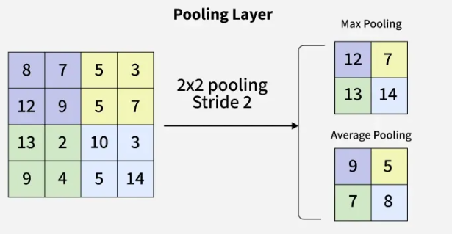

6. Batch Normalization Layer
A Batch Normalization Layer normalizes the output of a previous activation layer by subtracting the batch mean and dividing by the batch standard deviation. This helps in accelerating the training process and improving the performance of the network.
Use Cases: Stabilizing and speeding up training

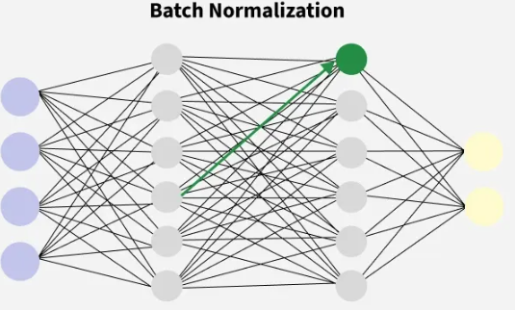

Understanding the different types of layers in an ANN is essential for designing effective neural networks. Each layer has a specific role, from receiving input data to learning complex patterns and producing predictions. By combining these layers, we can build powerful models capable of solving a wide range of tasks.

Activation functions in Neural Networks

An activation function in a neural network is a mathematical function applied to the output of a neuron. It introduces non-linearity, enabling the model to learn and represent complex data patterns. Without it, even a deep neural network would behave like a simple linear regression model.
Activation functions decide whether a neuron should be activated based on the weighted sum of inputs and a bias term. They also make backpropagation possible by providing gradients for weight updates.

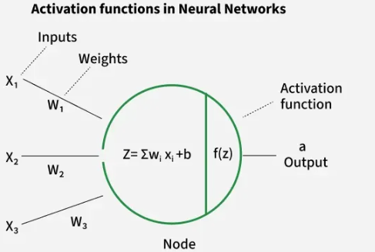

Why Non-Linearity is Important
- Real-world data is rarely linearly separable.
- Non-linear functions allow neural networks to form curved decision boundaries, making them capable of handling complex patterns (e.g., classifying apples vs. bananas under varying colors and shapes).
- They ensure networks can model advanced problems like image recognition, NLP and speech processing.

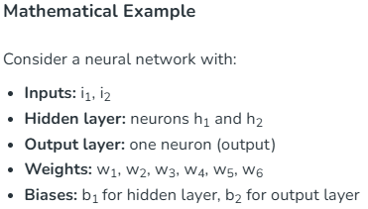
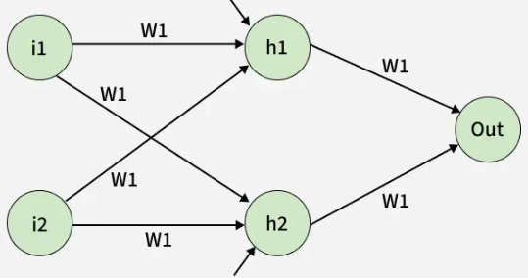

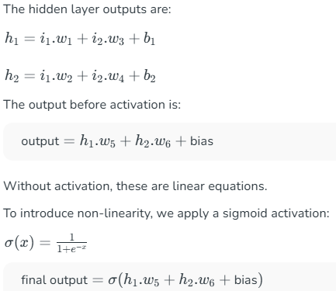

This gives the final output of the network after applying the sigmoid activation function in output layers, introducing the desired non-linearity.

Types of Activation Functions in Deep Learning

1. Linear Activation Function
Linear Activation Function resembles straight line define by y=x. No matter how many layers the neural network contains if they all use linear activation functions the output is a linear combination of the input.
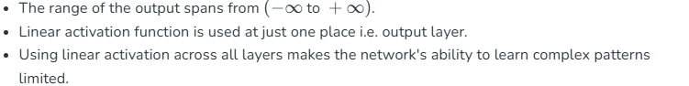
Linear activation functions are useful for specific tasks but must be combined with non-linear functions to enhance the neural network’s learning and predictive capabilities.
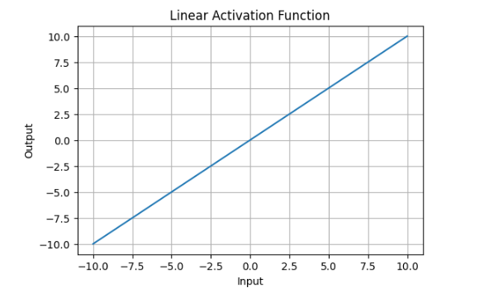

2. Non-Linear Activation Functions
1. Sigmoid Function

- It allows neural networks to handle and model complex patterns that linear equations cannot.
- The output ranges between 0 and 1, hence useful for binary classification.
- The function exhibits a steep gradient when x values are between -2 and 2. This sensitivity means that small changes in input x can cause significant changes in output y which is critical during the training process.
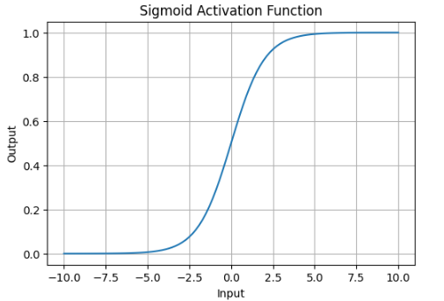

2. Tanh Activation Function
Tanh function(hyperbolic tangent function) is a shifted version of the sigmoid, allowing it to stretch across the y-axis. It is defined as:

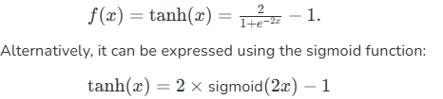
- Value Range: Outputs values from -1 to +1.
- Non-linear: Enables modeling of complex data patterns.
- Use in Hidden Layers: Commonly used in hidden layers due to its zero-centered output, facilitating easier learning for subsequent layers.

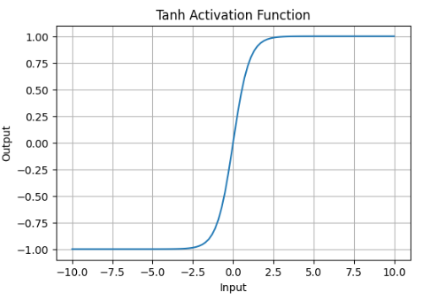

3. ReLU (Rectified Linear Unit) Function
ReLU activation is defined by A(x)=max(0,x), this means that if the input x is positive, ReLU returns x, if the input is negative, it returns 0.

- Value Range: [0,∞), meaning the function only outputs non-negative values.
- Nature: It is a non-linear activation function, allowing neural networks to learn complex patterns and making backpropagation more efficient.
- Advantage over other Activation: ReLU is less computationally expensive than tanh and sigmoid because it involves simpler mathematical operations. At a time only a few neurons are activated making the network sparse making it efficient and easy for computation.
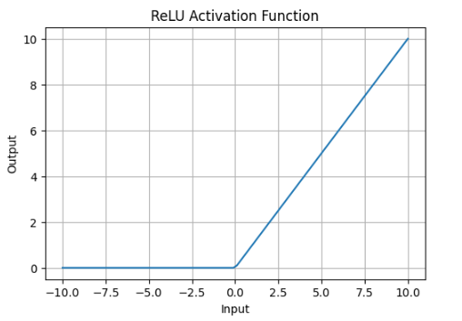

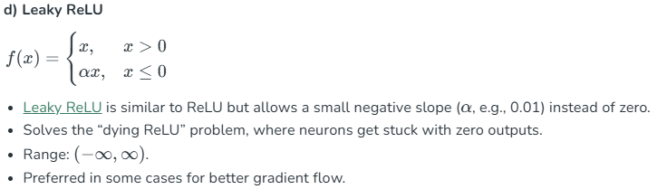

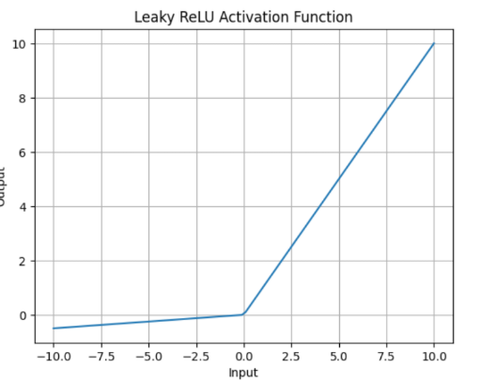

3. Exponential Linear Units
1. Softmax Function
Softmax function is designed to handle multi-class classification problems. It transforms raw output scores from a neural network into probabilities. It works by squashing the output values of each class into the range of 0 to 1 while ensuring that the sum of all probabilities equals 1.
- Softmax is a non-linear activation function.
- The Softmax function ensures that each class is assigned a probability, helping to identify which class the input belongs to.
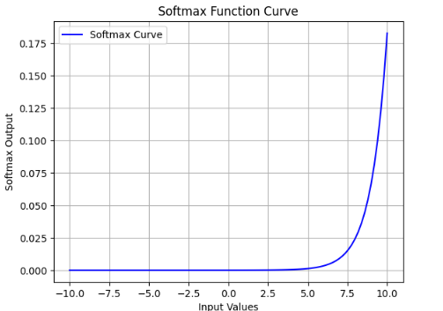

2. SoftPlus Function

This equation ensures that the output is always positive and differentiable at all points which is an advantage over the traditional ReLU function.
- Nature: The Softplus function is non-linear.
- Range: The function outputs values in the range (0,∞)(0,∞), similar to ReLU, but without the hard zero threshold that ReLU has.
- Smoothness: Softplus is a smooth, continuous function, meaning it avoids the sharp discontinuities of ReLU which can sometimes lead to problems during optimization.

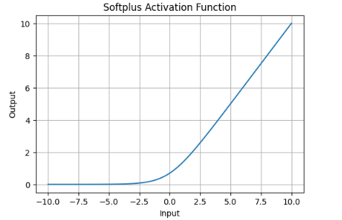

Impact of Activation Functions on Model Performance
The choice of activation function has a direct impact on the performance of a neural network in several ways:
- Convergence Speed: Functions like ReLU allow faster training by avoiding the vanishing gradient problem while Sigmoid and Tanh can slow down convergence in deep networks.
- Gradient Flow: Activation functions like ReLU ensure better gradient flow, helping deeper layers learn effectively. In contrast Sigmoid can lead to small gradients, hindering learning in deep layers.
- Model Complexity: Activation functions like Softmax allow the model to handle complex multi-class problems, whereas simpler functions like ReLU or Leaky ReLU are used for basic layers.

Feedforward Neural Network

Feedforward Neural Network (FNN) is a type of artificial neural network in which information flows in a single direction i.e from the input layer through hidden layers to the output layer without loops or feedback. It is mainly used for pattern recognition tasks like image and speech classification.
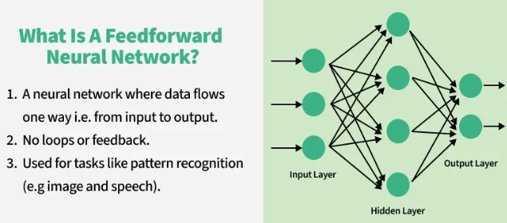

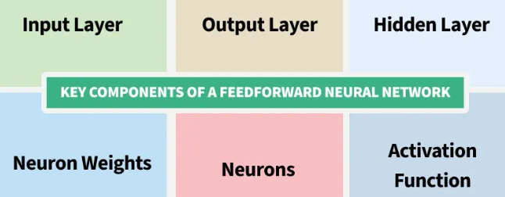

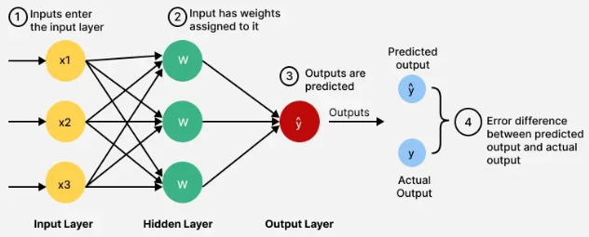

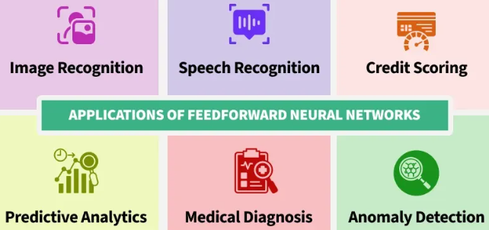

For example in a credit scoring system, banks use an FNN which analyze users financial profiles such as income, credit history and spending habits to determine their creditworthiness.
Each piece of information flows through the network’s layers where various calculations are made to produce a final score.
Structure of a Feedforward Neural Network
Feedforward Neural Networks have a structured layered design where data flows sequentially through each layer.
- Input Layer: The input layer consists of neurons that receive the input data. Each neuron in the input layer represents a feature of the input data.
- Hidden Layers: One or more hidden layers are placed between the input and output layers. These layers are responsible for learning the complex patterns in the data. Each neuron in a hidden layer applies a weighted sum of inputs followed by a non-linear activation function.
- Output Layer: The output layer provides the final output of the network. The number of neurons in this layer corresponds to the number of classes in a classification problem or the number of outputs in a regression problem.
Each connection between neurons in these layers has an associated weight that is adjusted during the training process to minimize the error in predictions.

Activation Functions
Activation functions introduce non-linearity into the network enabling it to learn and model complex data patterns.
Common activation functions include:

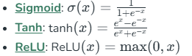

Training a Feedforward Neural Network
Training a Feedforward Neural Network involves adjusting the weights of the neurons to minimize the error between the predicted output and the actual output. This process is typically performed using backpropagation and gradient descent.
- Forward Propagation: During forward propagation the input data passes through the network and the output is calculated.
- Loss Calculation: The loss (or error) is calculated using a loss function such as Mean Squared Error (MSE) for regression tasks or Cross-Entropy Loss for classification tasks.
- Backpropagation: In backpropagation the error is propagated back through the network to update the weights. The gradient of the loss function with respect to each weight is calculated and the weights are adjusted using gradient descent.

Note: During training, a feedforward neural network performs forward pass followed by backpropagation to update weights, while during prediction only the forward pass is used.

Gradient Descent
Gradient Descent is an optimization algorithm used to minimize the loss function by iteratively updating the weights in the direction of the negative gradient. Common variants of gradient descent include:
- Batch Gradient Descent: Updates weights after computing the gradient over the entire dataset.
- Stochastic Gradient Descent (SGD): Updates weights for each training example individually.
- Mini-batch Gradient Descent: It Updates weights after computing the gradient over a small batch of training examples.

Evaluation of Feedforward neural network
Evaluating the performance of the trained model involves several metrics:
- Accuracy: The proportion of correctly classified instances out of the total instances.
- Precision: The ratio of true positive predictions to the total predicted positives.
- Recall: The ratio of true positive predictions to the actual positives.
- F1 Score: The harmonic mean of precision and recall, providing a balance between the two.
- Confusion Matrix: A table used to describe the performance of a classification model, showing the true positives, true negatives, false positives and false negatives.

Implementation of Feedforward Neural Network
This code demonstrates the process of building, training and evaluating a neural network model using TensorFlow and Keras to classify handwritten digits from the MNIST dataset.
The model architecture is defined using the Sequential consisting of:
- a Flatten layer to convert the 2D image input into a 1D array
- a Dense layer with 128 neurons and ReLU activation
- a final Dense layer with 10 neurons and softmax activation to output probabilities for each digit class.
Model is compiled with
- Adam optimizer
- Sparse Categorical Crossentropy loss function
- Sparse Categorical Accuracy metric
- Then trained for 5 epochs on the training data

import tensorflow as tf
from tensorflow.keras.models import Sequential
from tensorflow.keras.layers import Dense, Flatten
from tensorflow.keras.optimizers import Adam
from tensorflow.keras.losses import SparseCategoricalCrossentropy
from tensorflow.keras.metrics import SparseCategoricalAccuracy

# Load and prepare the MNIST dataset
mnist = tf.keras.datasets.mnist
(x_train, y_train), (x_test, y_test) = mnist.load_data()
x_train, x_test = x_train / 255.0, x_test / 255.0

# Build the model
model = Sequential([
Flatten(input_shape=(28, 28)),
Dense(128, activation='relu'),
Dense(10, activation='softmax')
])

# Compile the model
model.compile(optimizer=Adam(),
loss=SparseCategoricalCrossentropy(),
metrics=[SparseCategoricalAccuracy()])

# Train the model
model.fit(x_train, y_train, epochs=5)

# Evaluate the model
test_loss, test_acc = model.evaluate(x_test, y_test)
print(f'\nTest accuracy: {test_acc}')

Output:
Test accuracy: 0.9767000079154968

By understanding their architecture, activation functions and training process, one can make real world projects. Continuous advancements in optimization techniques and activation functions have made feedforward networks more efficient and effective in the field of artificial intelligence.

Backpropagation in Neural Network
Backpropagation, short for Backward Propagation of Errors, is a key algorithm used to train neural networks by minimizing the difference between predicted and actual outputs. It works by propagating errors backward through the network, using the chain rule of calculus to compute gradients and then iteratively updating the weights and biases. Combined with optimization techniques like gradient descent, backpropagation enables the model to reduce loss across epochs and effectively learn complex patterns from data.

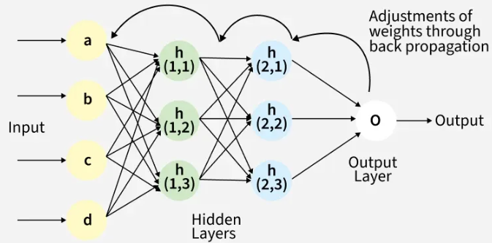

Back Propagation plays a critical role in how neural networks improve over time. Here's why:
- Efficient Weight Update: It computes the gradient of the loss function with respect to each weight using the chain rule making it possible to update weights efficiently.
- Scalability: The Back Propagation algorithm scales well to networks with multiple layers and complex architectures making deep learning feasible.
- Automated Learning: With Back Propagation the learning process becomes automated and the model can adjust itself to optimize its performance.
Working of Back Propagation Algorithm
The Back Propagation algorithm involves two main steps: the Forward Pass and the Backward Pass.
1. Forward Pass Work
In forward pass the input data is fed into the input layer. These inputs combined with their respective weights are passed to hidden layers. For example in a network with two hidden layers (h1 and h2) the output from h1 serves as the input to h2. Before applying an activation function, a bias is added to the weighted inputs.
Each hidden layer computes the weighted sum (`a`) of the inputs then applies an activation function like ReLU (Rectified Linear Unit) to obtain the output (`o`). The output is passed to the next layer where an activation function such as softmax converts the weighted outputs into probabilities for classification.
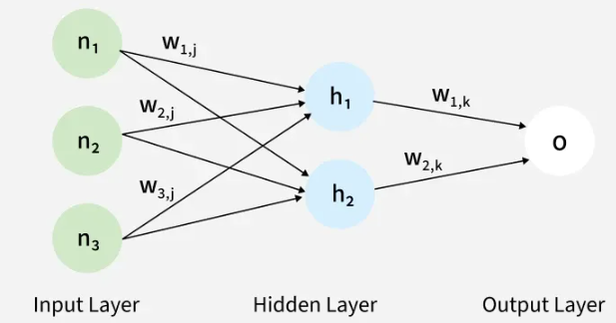

2. Backward Pass
In the backward pass the error (the difference between the predicted and actual output) is propagated back through the network to adjust the weights and biases. One common method for error calculation is the Mean Squared Error (MSE) given by:

Once the error is calculated the network adjusts weights using gradients which are computed with the chain rule. These gradients indicate how much each weight and bias should be adjusted to minimize the error in the next iteration. The backward pass continues layer by layer ensuring that the network learns and improves its performance. The activation function through its derivative plays a crucial role in computing these gradients during Back Propagation.
Example of Back Propagation in Machine Learning
Let’s walk through an example of Back Propagation in machine learning. Assume the neurons use the sigmoid activation function for the forward and backward pass. The target output is 0.5 and the learning rate is 1.
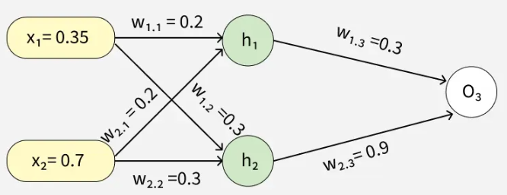

Forward Propagation
1. Initial Calculation
The weighted sum at each node is calculated using:
Where,
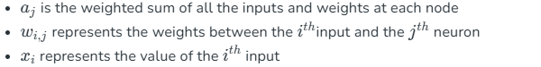

O (output): After applying the activation function to a, we get the output of the neuron:

2. Sigmoid Function
The sigmoid function returns a value between 0 and 1, introducing non-linearity into the model.
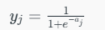

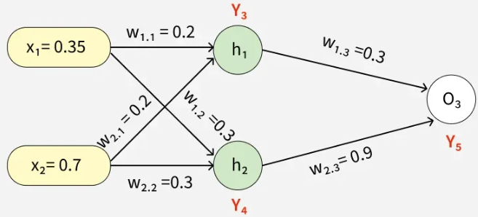
3. Computing Outputs
At h1 node

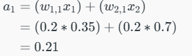

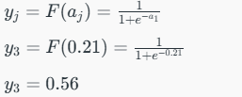
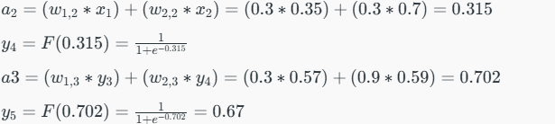

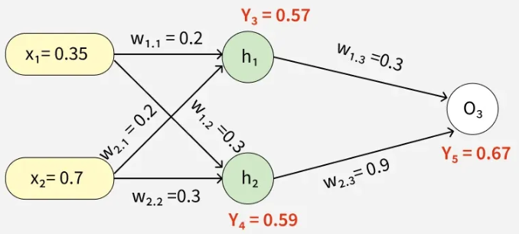

4. Error Calculation
Our actual output is 0.5 but we obtained 0.67. To calculate the error we can use the below formula:

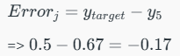
Using this error value we will be backpropagating.

Back Propagation
1. Calculating Gradients
The change in each weight is calculated as:
Where:
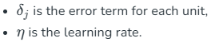

2. Output Unit Error
For O3:

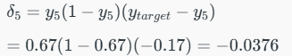

3. Hidden Unit Error
For h1:

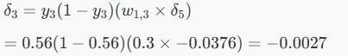
For h2:
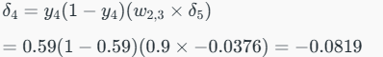

4. Weight Updates
For the weights from hidden to output layer:

New weight:

For weights from input to hidden layer:

New weight:

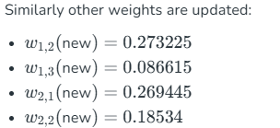

The updated weights are illustrated below
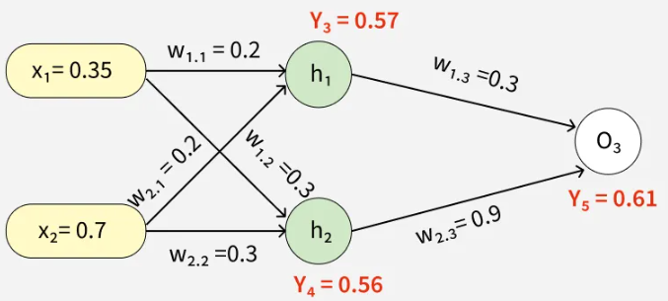

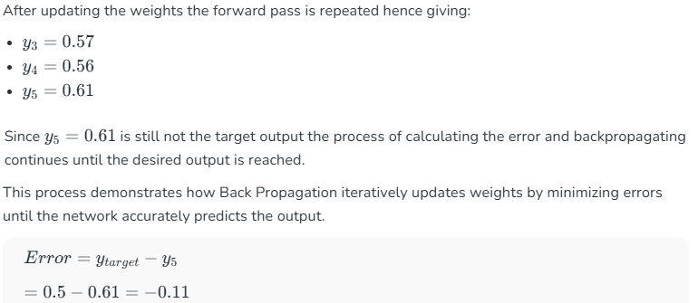

This process is said to be continued until the actual output is gained by the neural network.
Back Propagation Implementation in Python for XOR Problem
This code demonstrates how Back Propagation is used in a neural network to solve the XOR problem. The neural network consists of:
1. Defining Neural Network
We define a neural network as Input layer with 2 inputs, Hidden layer with 4 neurons, Output layer with 1 output neuron and use Sigmoid function as activation function.
- self.input_size = input_size: stores the size of the input layer
- self.hidden_size = hidden_size: stores the size of the hidden layer
- self.weights_input_hidden = np.random.randn(self.input_size, self.hidden_size): initializes weights for input to hidden layer
- self.weights_hidden_output = np.random.randn(self.hidden_size, self.output_size): initializes weights for hidden to output layer
- self.bias_hidden = np.zeros((1, self.hidden_size)): initializes bias for hidden layer
- self.bias_output = np.zeros((1, self.output_size)): initializes bias for output layer

import numpy as np

class NeuralNetwork:
def __init__(self, input_size, hidden_size, output_size):
self.input_size = input_size
self.hidden_size = hidden_size
self.output_size = output_size

self.weights_input_hidden = np.random.randn(
self.input_size, self.hidden_size)
self.weights_hidden_output = np.random.randn(
self.hidden_size, self.output_size)

self.bias_hidden = np.zeros((1, self.hidden_size))
self.bias_output = np.zeros((1, self.output_size))

def sigmoid(self, x):
return 1 / (1 + np.exp(-x))

def sigmoid_derivative(self, x):
return x * (1 - x)

2. Defining Feed Forward Network
In Forward pass inputs are passed through the network activating the hidden and output layers using the sigmoid function.
- self.hidden_activation = np.dot(X, self.weights_input_hidden) + self.bias_hidden: calculates activation for hidden layer
- self.hidden_output= self.sigmoid(self.hidden_activation): applies activation function to hidden layer
- self.output_activation= np.dot(self.hidden_output, self.weights_hidden_output) + self.bias_output: calculates activation for output layer
- self.predicted_output = self.sigmoid(self.output_activation): applies activation function to output layer

def feedforward(self, X):
self.hidden_activation = np.dot(
X, self.weights_input_hidden) + self.bias_hidden
self.hidden_output = self.sigmoid(self.hidden_activation)

self.output_activation = np.dot(
self.hidden_output, self.weights_hidden_output) +
self.bias_output
self.predicted_output =
self.sigmoid(self.output_activation)

return self.predicted_output

3. Defining Backward Network
In Backward pass or Back Propagation the errors between the predicted and actual outputs are computed. The gradients are calculated using the derivative of the sigmoid function and weights and biases are updated accordingly.
- output_error = y - self.predicted_output: calculates the error at the output layer
- output_delta = output_error * self.sigmoid_derivative(self.predicted_output): calculates the delta for the output layer
- hidden_error = np.dot(output_delta, self.weights_hidden_output.T): calculates the error at the hidden layer
- hidden_delta = hidden_error * self.sigmoid_derivative(self.hidden_output): calculates the delta for the hidden layer
- self.weights_hidden_output += np.dot(self.hidden_output.T, output_delta) * learning_rate: updates weights between hidden and output layers
- self.weights_input_hidden += np.dot(X.T, hidden_delta) * learning_rate: updates weights between input and hidden layers

def backward(self, X, y, learning_rate):
output_error = y - self.predicted_output
output_delta = output_error * \
self.sigmoid_derivative(self.predicted_output)

hidden_error = np.dot(output_delta,
self.weights_hidden_output.T)
hidden_delta = hidden_error *
self.sigmoid_derivative(self.hidden_output)

self.weights_hidden_output += np.dot(self.hidden_output.T,
output_delta) * learning_rate
self.bias_output += np.sum(output_delta, axis=0,
keepdims=True) * learning_rate
self.weights_input_hidden += np.dot(X.T, hidden_delta) *
learning_rate
self.bias_hidden += np.sum(hidden_delta, axis=0,
keepdims=True) * learning_rate

4. Training Network
The network is trained over 10,000 epochs using the Back Propagation algorithm with a learning rate of 0.1 progressively reducing the error.
- output = self.feedforward(X): computes the output for the current inputs
- self.backward(X, y, learning_rate): updates weights and biases using Back Propagation
- loss = np.mean(np.square(y - output)): calculates the mean squared error (MSE) loss

def train(self, X, y, epochs, learning_rate):
for epoch in range(epochs):
output = self.feedforward(X)
self.backward(X, y, learning_rate)
if epoch % 4000 == 0:
loss = np.mean(np.square(y - output))
print(f"Epoch {epoch}, Loss:{loss}")

5. Testing Neural Network
- X = np.array([[0, 0], [0, 1], [1, 0], [1, 1]]): defines the input data
- y = np.array([[0], [1], [1], [0]]): defines the target values
- nn = NeuralNetwork(input_size=2, hidden_size=4, output_size=1): initializes the neural network
- nn.train(X, y, epochs=10000, learning_rate=0.1): trains the network
- output = nn.feedforward(X): gets the final predictions after training

X = np.array([[0, 0], [0, 1], [1, 0], [1, 1]])
y = np.array([[0], [1], [1], [0]])

nn = NeuralNetwork(input_size=2, hidden_size=4, output_size=1)
nn.train(X, y, epochs=10000, learning_rate=0.1)

output = nn.feedforward(X)
print("Predictions after training:")
print(output)
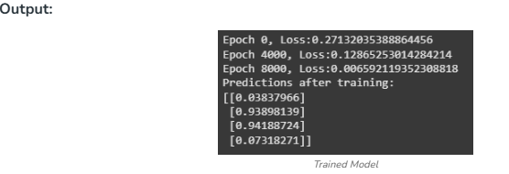

- The output shows the training progress of a neural network over 10,000 epochs. Initially the loss was high (0.2713) but it gradually decreased as the network learned reaching a low value of 0.0066 by epoch 8000.
- The final predictions are close to the expected XOR outputs: approximately 0 for [0, 0] and [1, 1] and approximately 1 for [0, 1] and [1, 0] indicating that the network successfully learned to approximate the XOR function.
Advantages
The key benefits of using the Back Propagation algorithm are:
- Ease of Implementation: Back Propagation is beginner-friendly requiring no prior neural network knowledge and simplifies programming by adjusting weights with error derivatives.
- Simplicity and Flexibility: Its straightforward design suits a range of tasks from basic feedforward to complex convolutional or recurrent networks.
- Efficiency: Back Propagation accelerates learning by directly updating weights based on error especially in deep networks.
- Generalization: It helps models generalize well to new data improving prediction accuracy on unseen examples.
- Scalability: The algorithm scales efficiently with larger datasets and more complex networks making it ideal for large-scale tasks.
Challenges
While Back Propagation is useful it does face some challenges:
- Vanishing Gradient Problem: In deep networks the gradients can become very small during Back Propagation making it difficult for the network to learn. This is common when using activation functions like sigmoid or tanh.
- Exploding Gradients: The gradients can also become excessively large causing the network to diverge during training.
- Overfitting: If the network is too complex it might memorize the training data instead of learning general patterns.

Deep Learning Models

Convolutional Neural Network (CNN) in Machine Learning

Convolutional Neural Networks (CNNs) are deep learning models designed to process data with a grid-like topology such as images. They are the foundation for most modern computer vision applications to detect features within visual data.

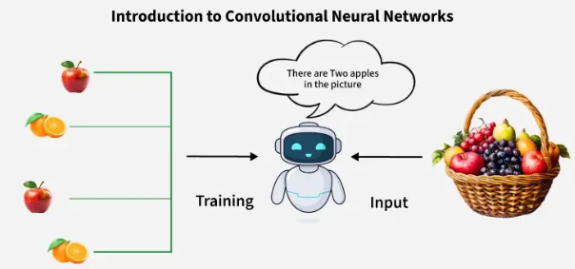

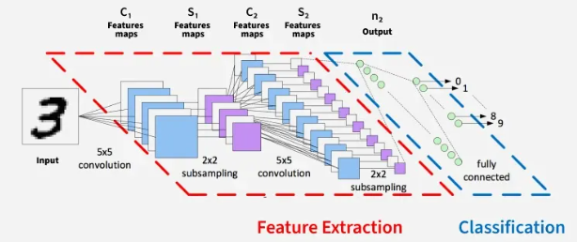

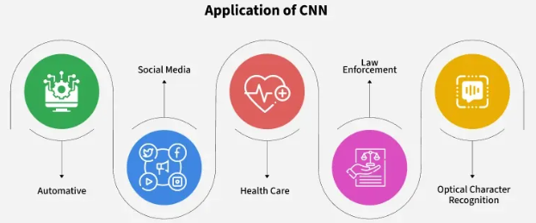

Key Components
- Convolutional Layers: These layers apply convolutional operations to input images using filters or kernels to detect features such as edges, textures and more complex patterns. Convolutional operations help preserve the spatial relationships between pixels.
- Pooling Layers: They downsample the spatial dimensions of the input, reducing the computational complexity and the number of parameters in the network. Max pooling is a common pooling operation where we select a maximum value from a group of neighboring pixels.
- Activation Functions: They introduce non-linearity to the model by allowing it to learn more complex relationships in the data.
- Fully Connected Layers: These layers are responsible for making predictions based on the high-level features learned by the previous layers. They connect every neuron in one layer to every neuron in the next layer.
Working of CNN
- Input Image: CNN receives an input image which is preprocessed to ensure uniformity in size and format.
- Convolutional Layers: Filters are applied to the input image to extract features like edges, textures and shapes.
- Pooling Layers: The feature maps generated by the convolutional layers are downsampled to reduce dimensionality.
- Fully Connected Layers: The downsampled feature maps are passed through fully connected layers to produce the final output, such as a classification label.
- Output: The CNN outputs a prediction, such as the class of the image.

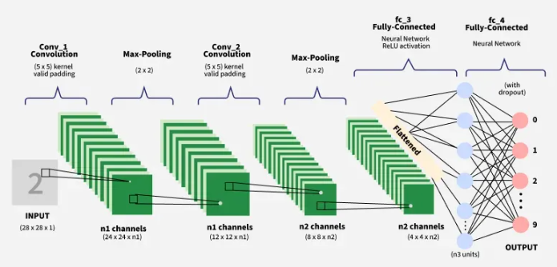

Training a Convolutional Neural Network
CNNs are trained using a supervised learning approach. This means that the CNN is given a set of labeled training images. The CNN learns to map the input images to their correct labels.
The training process for a CNN involves the following steps:
- Data Preparation: The training images are preprocessed to ensure that they are all in the same format and size.
- Loss Function: A loss function is used to measure how well the CNN is performing on the training data. The loss function is typically calculated by taking the difference between the predicted labels and the actual labels of the training images.
- Optimizer: An optimizer is used to update the weights of the CNN in order to minimize the loss function.
- Backpropagation: Backpropagation is a technique used to calculate the gradients of the loss function with respect to the weights of the CNN. The gradients are then used to update the weights of the CNN using the optimizer.

How to Evaluate CNN Models
Efficiency of CNN can be evaluated using a variety of criteria. Among the most popular metrics are:
- Accuracy: Accuracy is the percentage of test images that the CNN correctly classifies.
- Precision: Precision is the percentage of test images that the CNN predicts as a particular class and that are actually of that class.
- Recall: Recall is the percentage of test images that are of a particular class and that the CNN predicts as that class.
- F1 Score: The F1 Score is a harmonic mean of precision and recall. It is a good metric for evaluating the performance of a CNN on classes that are imbalanced.

Different Types of CNN Models
1. LeNet: LeNet developed by Yann LeCun and his colleagues in the late 1990s was one of the first successful CNNs designed for handwritten digit recognition. It laid the foundation for modern CNNs and achieved high accuracy on the MNIST dataset which contains 70,000 images of handwritten digits (0-9).
2. AlexNet: AlexNet is a CNN architecture that was developed by Alex Krizhevsky, Ilya Sutskever and Geoffrey Hinton in 2012. It was the first CNN to win the ImageNet Large Scale Visual Recognition Challenge (ILSVRC) a major image recognition competition. It consists of several layers of convolutional and pooling layers followed by fully connected layers. The architecture includes five convolutional layers, three pooling layers and three fully connected layers.
3. Resnet: ResNets (Residual Networks) are designed for image recognition and processing tasks. They are renowned for their ability to train very deep networks without overfitting making them highly effective for complex tasks. It introduces skip connections that allow the network to learn residual functions making it easier to train deep architecture.
4. GoogleNet: GoogleNet also known as InceptionNet is renowned for achieving high accuracy in image classification while using fewer parameters and computational resources compared to other state-of-the-art CNNs. The core component of GoogleNet allows the network to learn features at different scales simultaneously to enhance performance.
5. VGG: VGGs are developed by the Visual Geometry Group at Oxford, it uses small 3x3 convolutional filters stacked in multiple layers, creating a deep and uniform structure. Popular variants like VGG-16 and VGG-19 achieved state-of-the-art performance on the ImageNet dataset demonstrating the power of depth in CNNs.
Applications
- Image classification: CNNs are the state-of-the-art models for image classification. They can be used to classify images into different categories such as cats and dogs.
- Object detection: It can be used to detect objects in images such as people, cars and buildings. They can also be used to localize objects in images which means that they can identify the location of an object in an image.
- Image segmentation: It can be used to segment images which means that they can identify and label different objects in an image. This is useful for applications such as medical imaging and robotics.
- Video analysis: It can be used to analyze videos such as tracking objects in a video or detecting events in a video. This is useful for applications such as video surveillance and traffic monitoring.
Advantages
- High Accuracy: They can achieve high accuracy in various image recognition tasks.
- Efficiency: They are efficient, especially when implemented on GPUs.
- Robustness: They are robust to noise and variations in input data.
- Adaptability: It can be adapted to different tasks by modifying their architecture.

Disadvantages
- Complexity: It can be complex and difficult to train, especially for large datasets.
- Resource-Intensive: It require significant computational resources for training and deployment.
- Data Requirements: They need large amounts of labeled data for training.
- Interpretability: They can be difficult to interpret making it challenging to understand their predictions.

Introduction to Recurrent Neural Networks

Recurrent Neural Networks (RNNs) differ from regular neural networks in how they process information. While standard neural networks pass information in one direction i.e. from input to output, RNNs feed information back into the network at each step.

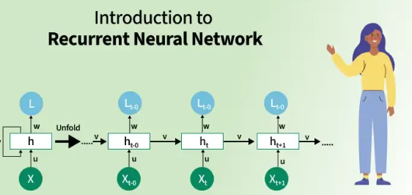

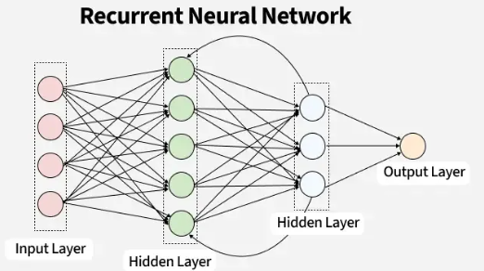

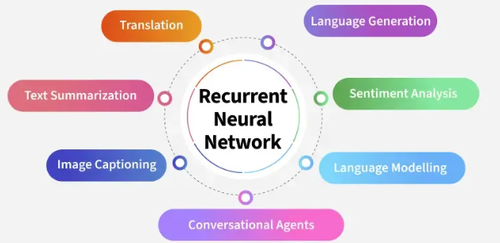

Lets understand RNN with a example:
Imagine reading a sentence and you try to predict the next word, you don’t rely only on the current word but also remember the words that came before. RNNs work similarly by “remembering” past information and passing the output from one step as input to the next i.e it considers all the earlier words to choose the most likely next word. This memory of previous steps helps the network understand context and make better predictions.
Key Components of RNNs
There are mainly two components of RNNs that we will discuss.
1. Recurrent Neurons
The fundamental processing unit in RNN is a Recurrent Unit. They hold a hidden state that maintains information about previous inputs in a sequence. Recurrent units can "remember" information from prior steps by feeding back their hidden state, allowing them to capture dependencies across time.
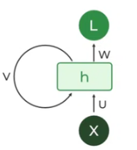
2. RNN Unfolding
RNN unfolding or unrolling is the process of expanding the recurrent structure over time steps. During unfolding each step of the sequence is represented as a separate layer in a series illustrating how information flows across each time step.
This unrolling enables backpropagation through time (BPTT) a learning process where errors are propagated across time steps to adjust the network’s weights enhancing the RNN’s ability to learn dependencies within sequential data.

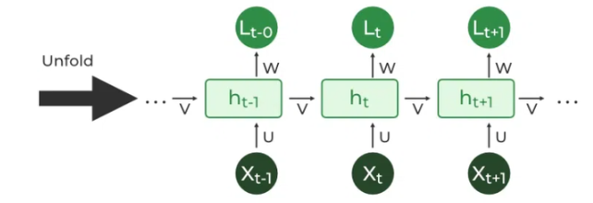

Recurrent Neural Network Architecture
RNNs share similarities in input and output structures with other deep learning architectures but differ significantly in how information flows from input to output. Unlike traditional deep neural networks where each dense layer has distinct weight matrices. RNNs use shared weights across time steps, allowing them to remember information over sequences.

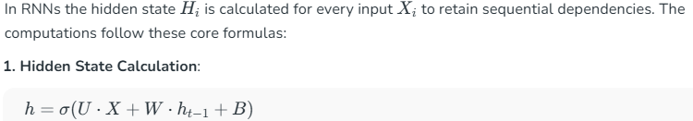
Here:
- h represents the current hidden state.
- U and W are weight matrices.
- B is the bias.

2. Output Calculation:

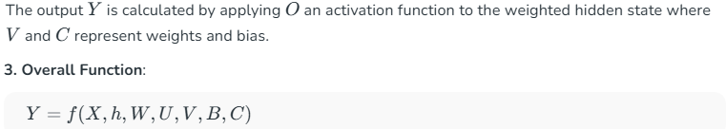

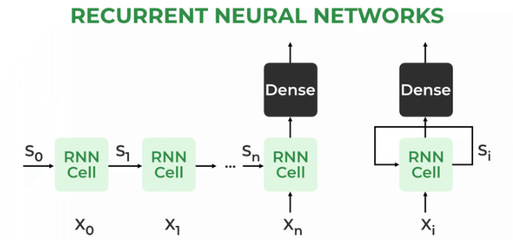

How does RNN work?
At each time step RNNs process units with a fixed activation function. These units have an internal hidden state that acts as memory that retains information from previous time steps. This memory allows the network to store past knowledge and adapt based on new inputs.
Updating the Hidden State in RNNs

1. State Update:

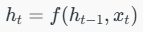
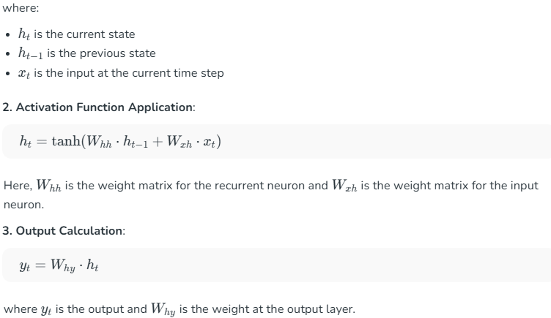

These parameters are updated using backpropagation. However, since RNN works on sequential data here we use an updated backpropagation which is known as backpropagation through time.

Backpropagation Through Time (BPTT) in RNNs

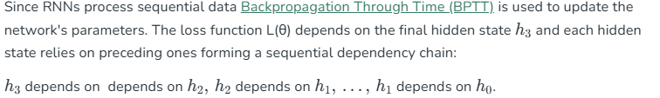

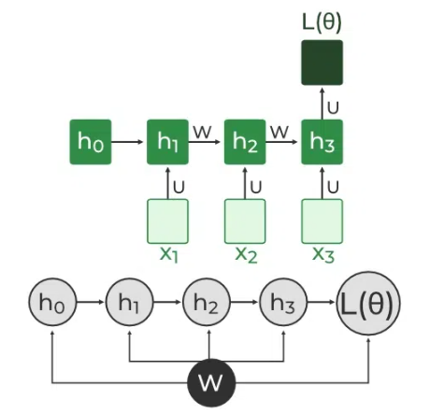

In BPTT, gradients are backpropagated through each time step. This is essential for updating network parameters based on temporal dependencies.
1. Simplified Gradient Calculation:

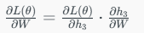

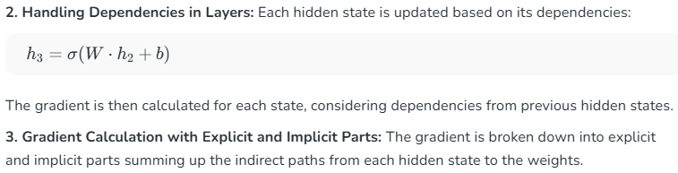
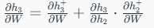
4. Final Gradient Expression: The final derivative of the loss function with respect to the weight matrix W is computed:

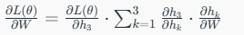
This iterative process is the essence of backpropagation through time.
Types Of Recurrent Neural Networks
There are four types of RNNs based on the number of inputs and outputs in the network:
1. One-to-One RNN
This is the simplest type of neural network architecture where there is a single input and a single output. It is used for straightforward classification tasks such as binary classification where no sequential data is involved.

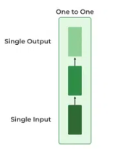
2. One-to-Many RNN
In a One-to-Many RNN the network processes a single input to produce multiple outputs over time. This is useful in tasks where one input triggers a sequence of predictions (outputs). For example in image captioning a single image can be used as input to generate a sequence of words as a caption.

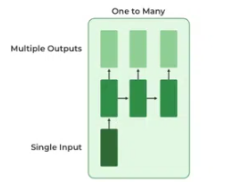
3. Many-to-One RNN
The Many-to-One RNN receives a sequence of inputs and generates a single output. This type is useful when the overall context of the input sequence is needed to make one prediction. In sentiment analysis the model receives a sequence of words (like a sentence) and produces a single output like positive, negative or neutral.

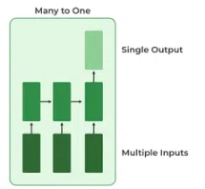

4. Many-to-Many RNN
The Many-to-Many RNN type processes a sequence of inputs and generates a sequence of outputs. In language translation task a sequence of words in one language is given as input and a corresponding sequence in another language is generated as output.

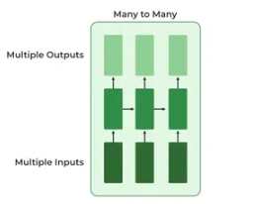

Variants of Recurrent Neural Networks (RNNs)
There are several variations of RNNs, each designed to address specific challenges or optimize for certain tasks:
1. Vanilla RNN
This simplest form of RNN consists of a single hidden layer where weights are shared across time steps. Vanilla RNNs are suitable for learning short-term dependencies but are limited by the vanishing gradient problem, which hampers long-sequence learning.
2. Bidirectional RNNs
Bidirectional RNNs process inputs in both forward and backward directions, capturing both past and future context for each time step. This architecture is ideal for tasks where the entire sequence is available, such as named entity recognition and question answering.
3. Long Short-Term Memory Networks (LSTMs)
Long Short-Term Memory Networks (LSTMs) introduce a memory mechanism to overcome the vanishing gradient problem. Each LSTM cell has three gates:
- Input Gate: Controls how much new information should be added to the cell state.
- Forget Gate: Decides what past information should be discarded.
- Output Gate: Regulates what information should be output at the current step. This selective memory enables LSTMs to handle long-term dependencies, making them ideal for tasks where earlier context is critical.
4. Gated Recurrent Units (GRUs)
Gated Recurrent Units (GRUs) simplify LSTMs by combining the input and forget gates into a single update gate and streamlining the output mechanism. This design is computationally efficient, often performing similarly to LSTMs and is useful in tasks where simplicity and faster training are beneficial.
How RNN Differs from Feedforward Neural Networks?
Feedforward Neural Networks (FNNs) process data in one direction from input to output without retaining information from previous inputs. This makes them suitable for tasks with independent inputs like image classification. However FNNs struggle with sequential data since they lack memory.
Recurrent Neural Networks (RNNs) solve this by incorporating loops that allow information from previous steps to be fed back into the network. This feedback enables RNNs to remember prior inputs making them ideal for tasks where context is important.
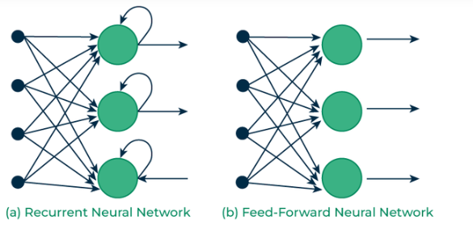

Implementing a Text Generator Using Recurrent Neural Networks (RNNs)
In this section, we create a character-based text generator using Recurrent Neural Network (RNN) in TensorFlow and Keras. We'll implement an RNN that learns patterns from a text sequence to generate new text character-by-character.
1. Importing Necessary Libraries
We start by importing essential libraries for data handling and building the neural network.
import numpy as np
import tensorflow as tf
from tensorflow.keras.models import Sequential
from tensorflow.keras.layers import SimpleRNN, Dense

2. Defining the Input Text and Prepare Character Set
We define the input text and identify unique characters in the text which we’ll encode for our model.

text = "This is GeeksforGeeks a software training institute"
chars = sorted(list(set(text)))
char_to_index = {char: i for i, char in enumerate(chars)}
index_to_char = {i: char for i, char in enumerate(chars)}

3. Creating Sequences and Labels
To train the RNN, we need sequences of fixed length (seq_length) and the character following each sequence as the label.

seq_length = 3
sequences = []
labels = []

for i in range(len(text) - seq_length):
seq = text[i:i + seq_length]
label = text[i + seq_length]
sequences.append([char_to_index[char] for char in seq])
labels.append(char_to_index[label])

X = np.array(sequences)
y = np.array(labels)

4. Converting Sequences and Labels to One-Hot Encoding
For training we convert X and y into one-hot encoded tensors.

X_one_hot = tf.one_hot(X, len(chars))
y_one_hot = tf.one_hot(y, len(chars))

5. Building the RNN Model
We create a simple RNN model with a hidden layer of 50 units and a Dense output layer with softmax activation.

model = Sequential()
model.add(SimpleRNN(50, input_shape=(seq_length, len(chars)), activation='relu'))
model.add(Dense(len(chars), activation='softmax'))

6. Compiling and Training the Model
We compile the model using the categorical_crossentropy loss and train it for 100 epochs.

model.compile(optimizer='adam', loss='categorical_crossentropy', metrics=['accuracy'])
model.fit(X_one_hot, y_one_hot, epochs=100)

Output:
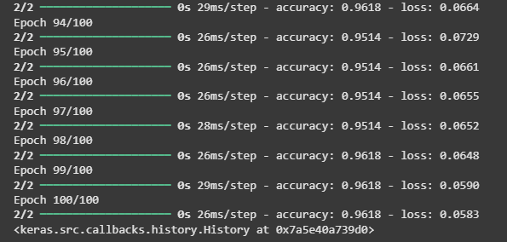

7. Generating New Text Using the Trained Model
After training we use a starting sequence to generate new text character by character.

start_seq = "This is G"
generated_text = start_seq

for i in range(50):
x = np.array([[char_to_index[char] for char in generated_text[-seq_length:]]])
x_one_hot = tf.one_hot(x, len(chars))
prediction = model.predict(x_one_hot)
next_index = np.argmax(prediction)
next_char = index_to_char[next_index]
generated_text += next_char

print("Generated Text:")
print(generated_text)

Output:
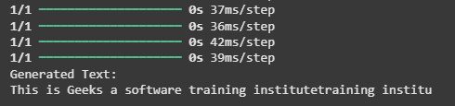

Advantages
- Sequential Memory: RNNs retain information from previous inputs making them ideal for time-series predictions where past data is crucial.
- Enhanced Pixel Neighborhoods: RNNs can be combined with convolutional layers to capture extended pixel neighborhoods improving performance in image and video data processing.
Limitations
While RNNs excel at handling sequential data they face two main training challenges i.e vanishing gradient and exploding gradient problem:
- Vanishing Gradient: During backpropagation gradients diminish as they pass through each time step leading to minimal weight updates. This limits the RNN’s ability to learn long-term dependencies which is crucial for tasks like language translation.
- Exploding Gradient: Sometimes gradients grow uncontrollably causing excessively large weight updates that de-stabilize training.
These challenges can hinder the performance of standard RNNs on complex, long-sequence tasks.
Applications
RNNs are used in various applications where data is sequential or time-based:
- Time-Series Prediction: RNNs excel in forecasting tasks, such as stock market predictions and weather forecasting.
- Natural Language Processing (NLP): RNNs are fundamental in NLP tasks like language modeling, sentiment analysis and machine translation.
- Speech Recognition: RNNs capture temporal patterns in speech data, aiding in speech-to-text and other audio-related applications.
- Image and Video Processing: When combined with convolutional layers, RNNs help analyze video sequences, facial expressions and gesture recognition.

What is LSTM - Long Short Term Memory?

Long Short-Term Memory (LSTM) is an enhanced version of the Recurrent Neural Network (RNN) designed by Hochreiter and Schmidhuber. LSTMs can capture long-term dependencies in sequential data making them ideal for tasks like language translation, speech recognition and time series forecasting. Unlike traditional RNNs which use a single hidden state passed through time LSTMs introduce a memory cell that holds information over extended periods addressing the challenge of learning long-term dependencies.
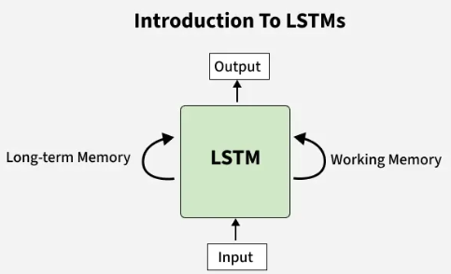

Problem with Long-Term Dependencies in RNN
Recurrent Neural Networks (RNNs) are designed to handle sequential data by maintaining a hidden state that captures information from previous time steps. However they often face challenges in learning long-term dependencies where information from distant time steps becomes crucial for making accurate predictions for current state. This problem is known as the vanishing gradient or exploding gradient problem.
- Vanishing Gradient: When training a model over time, the gradients which help the model learn can shrink as they pass through many steps. This makes it hard for the model to learn long-term patterns since earlier information becomes almost irrelevant.
- Exploding Gradient: Sometimes gradients can grow too large causing instability. This makes it difficult for the model to learn properly as the updates to the model become erratic and unpredictable.
Both of these issues make it challenging for standard RNNs to effectively capture long-term dependencies in sequential data.
LSTM Architecture
LSTM architectures involves the memory cell which is controlled by three gates:
- Input gate: Controls what information is added to the memory cell.
- Forget gate: Determines what information is removed from the memory cell.
- Output gate: Controls what information is output from the memory cell.
This allows LSTM networks to selectively retain or discard information as it flows through the network which allows them to learn long-term dependencies. The network has a hidden state which is like its short-term memory. This memory is updated using the current input, the previous hidden state and the current state of the memory cell.
Working of LSTM
LSTM architecture has a chain structure that contains four neural networks and different memory blocks called cells.
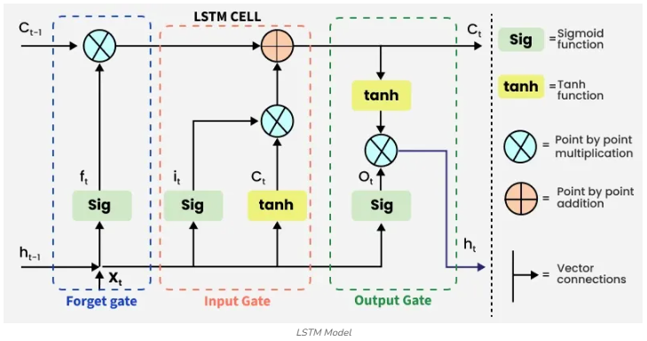
Information is retained by the cells and the memory manipulations are done by the gates. There are three gates -
1. Forget Gate
The information that is no longer useful in the cell state is removed with the forget gate. Two inputs xt​ (input at the particular time) and ht−1​ (previous cell output) are fed to the gate and multiplied with weight matrices followed by the addition of bias. The resultant is passed through sigmoid activation function which gives output in range of [0,1]. If for a particular cell state the output is 0 or near to 0, the piece of information is forgotten and for output of 1 or near to 1, the information is retained for future use.

The equation for the forget gate is:
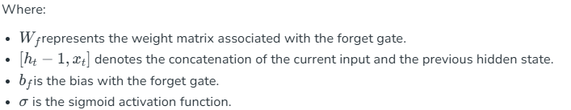

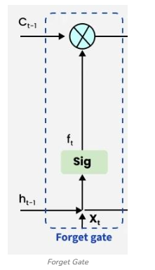
2. Input gate

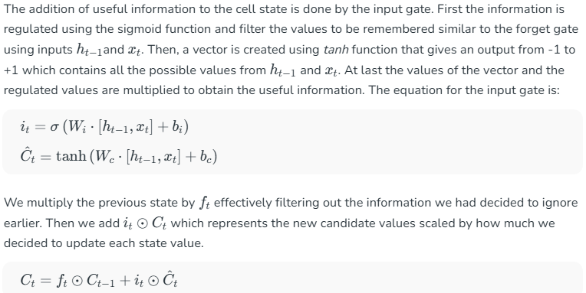
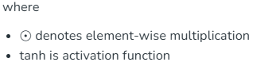

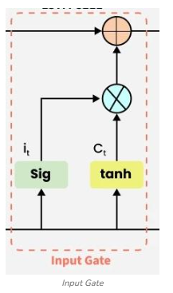
3. Output gate

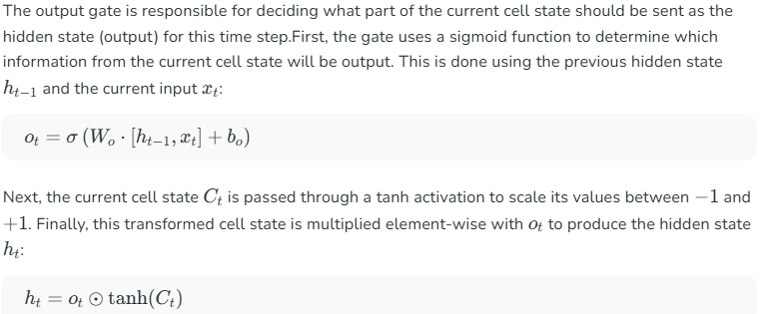

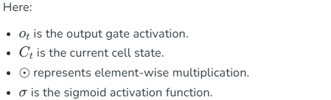

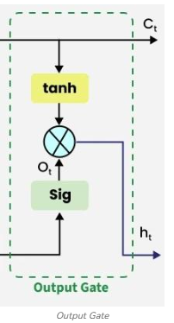
Applications
Some of the famous applications of LSTM includes:
- Language Modeling: Used in tasks like language modeling, machine translation and text summarization. These networks learn the dependencies between words in a sentence to generate coherent and grammatically correct sentences.
- Speech Recognition: Used in transcribing speech to text and recognizing spoken commands. By learning speech patterns they can match spoken words to corresponding text.
- Time Series Forecasting: Used for predicting stock prices, weather and energy consumption. They learn patterns in time series data to predict future events.
- Anomaly Detection: Used for detecting fraud or network intrusions. These networks can identify patterns in data that deviate drastically and flag them as potential anomalies.
- Recommender Systems: In recommendation tasks like suggesting movies, music and books. They learn user behavior patterns to provide personalized suggestions.
- Video Analysis: Applied in tasks such as object detection, activity recognition and action classification. When combined with Convolutional Neural Networks (CNNs) they help analyze video data and extract useful information.

Gated Recurrent Unit Networks

In machine learning Recurrent Neural Networks (RNNs) are essential for tasks involving sequential data such as text, speech and time-series analysis. While traditional RNNs struggle with capturing long-term dependencies due to the vanishing gradient problem architectures like Long Short-Term Memory (LSTM) networks were developed to overcome this limitation.

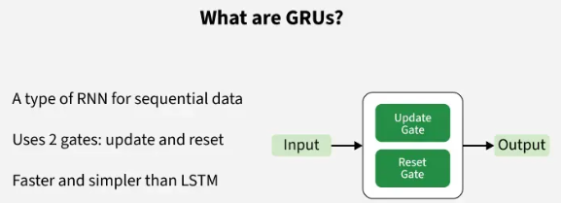
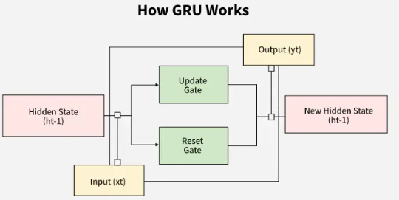
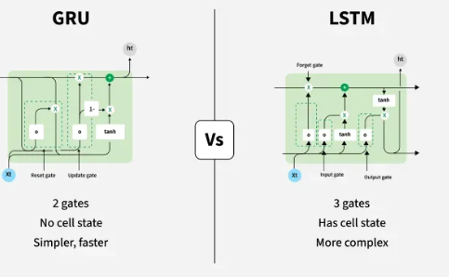

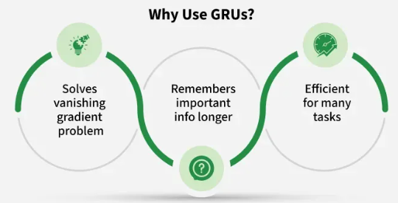

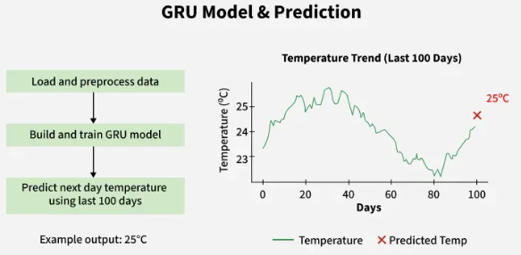

However LSTMs are very complex structure with higher computational cost. To overcome this Gated Recurrent Unit (GRU) where introduced which uses LSTM architecture by merging its gating mechanisms offering a more efficient solution for many sequential tasks without sacrificing performance.
What are Gated Recurrent Units (GRU) ?
Gated Recurrent Units (GRUs) are a type of RNN introduced by Cho et al. in 2014. The core idea behind GRUs is to use gating mechanisms to selectively update the hidden state at each time step allowing them to remember important information while discarding irrelevant details. GRUs aim to simplify the LSTM architecture by merging some of its components and focusing on just two main gates: the update gate and the reset gate.

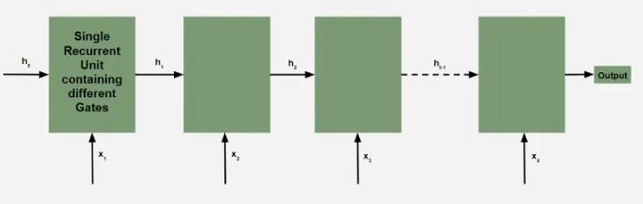

The GRU consists of two main gates:
- Update Gate (ztzt​​): This gate decides how much information from previous hidden state should be retained for the next time step.
- Reset Gate (rtrt​​): This gate determines how much of the past hidden state should be forgotten.
These gates allow GRU to control the flow of information in a more efficient manner compared to traditional RNNs which solely rely on hidden state.
Equations for GRU Operations
The internal workings of a GRU can be described using following equations:
1. Reset gate:
The reset gate determines how much of the previous hidden state h(t−1)​ should be forgotten.

2. Update gate:

The update gate controls how much of the new information x(t)​​ should be used to update the hidden state.

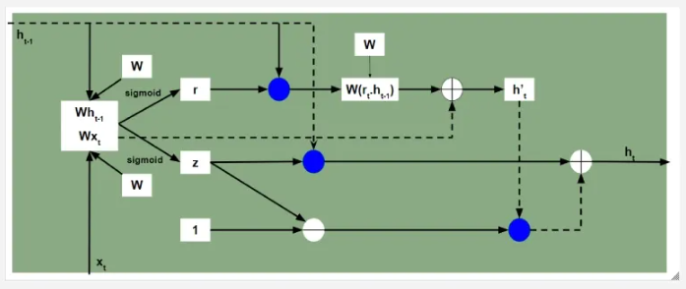

3. Candidate hidden state:

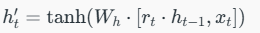
This is the potential new hidden state calculated based on the current input and the previous hidden state.

4. Hidden state:

How GRUs Solve the Vanishing Gradient Problem
Like LSTMs, GRUs were designed to address the vanishing gradient problem which is common in traditional RNNs. GRUs help mitigate this issue by using gates that regulate the flow of gradients during training ensuring that important information is preserved and that gradients do not shrink excessively over time. By using these gates, GRUs maintain a balance between remembering important past information and learning new, relevant data.
GRU vs LSTM
GRUs are more computationally efficient because they combine the forget and input gates into a single update gate. GRUs do not maintain an internal cell state as LSTMs do, instead they store information directly in the hidden state making them simpler and faster.
Feature | LSTM (Long Short-Term Memory) | GRU (Gated Recurrent Unit)
Gates | 3 (Input, Forget, Output) | 2 (Update, Reset)
Cell State | Yes it has cell state | No (Hidden state only)
Training Speed | Slower due to complexity | Faster due to simpler architecture
Computational Load | Higher due to more gates and parameters | Lower due to fewer gates and parameters
Performance | Often better in tasks requiring long-term memory | Performs similarly in many tasks with less complexity

Implementation in Python
Now let's implement simple GRU model in Python using Keras. We'll start by preparing the necessary libraries and dataset.
1. Importing Libraries
We will import the necessary libraries for implementing our GRU model such as numpy, pandas, MinMaxScaler, TensorFlow and Adam.

import numpy as np
import pandas as pd
from sklearn.preprocessing import MinMaxScaler
from tensorflow.keras.models import Sequential
from tensorflow.keras.layers import GRU, Dense
from tensorflow.keras.optimizers import Adam

2. Loading the Dataset
The dataset we're using is a time-series dataset containing daily temperature data i.e forecasting dataset. It spans 8,000 days starting from January 1, 2010.
You can download dataset from here.
- pd.read_csv(): Reads a CSV file into a pandas DataFrame. Here, we are assuming that the dataset has a Date column which is set as the index of the DataFrame.
- date_parser=True: Ensures that pandas parses the 'Date' column as datetime.

df = pd.read_csv('data.csv', parse_dates=['Date'], index_col='Date')
print(df.head())

Output:
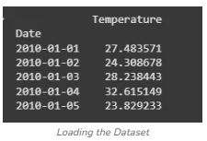

3. Preprocessing the Data
We will scale our data to ensure all features have equal weight and avoid any bias. In this example, we will use MinMaxScaler, which scales the data to a range between 0 and 1. Proper scaling is important because neural networks tend to perform better when input features are normalized.

scaler = MinMaxScaler(feature_range=(0, 1))
scaled_data = scaler.fit_transform(df.values)

4. Preparing Data for GRU
We will define a function to prepare our data for training our model.
- create_dataset(): Prepares the dataset for time-series forecasting. It creates sliding windows of time_step length to predict the next time step.
- X.reshape(): Reshapes the input data to fit the expected shape for the GRU which is 3D: [samples, time steps, features].

def create_dataset(data, time_step=1):
X, y = [], []
for i in range(len(data) - time_step - 1):
X.append(data[i:(i + time_step), 0])
y.append(data[i + time_step, 0])
return np.array(X), np.array(y)

time_step = 100
X, y = create_dataset(scaled_data, time_step)
X = X.reshape(X.shape[0], X.shape[1], 1)
5. Building the GRU Model
We will define our GRU model with the following components:
- GRU(units=50): Adds a GRU layer with 50 units (neurons).
- return_sequences=True: Ensures that the GRU layer returns the entire sequence (required for stacking multiple GRU layers).
- Dense(units=1): The output layer which predicts a single value for the next time step.
- Adam(): An adaptive optimizer commonly used in deep learning.

model = Sequential()
model.add(GRU(units=50, return_sequences=True, input_shape=(X.shape[1], 1)))
model.add(GRU(units=50))
model.add(Dense(units=1))
model.compile(optimizer=Adam(learning_rate=0.001), loss='mean_squared_error')

Output:
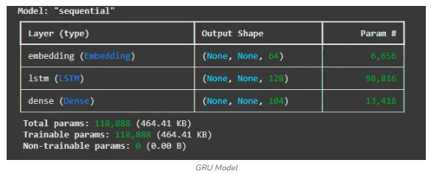

6. Training the Model
model.fit() trains the model on the prepared dataset. The epochs=10 specifies the number of iterations over the entire dataset, and batch_size=32 defines the number of samples per batch.

model.fit(X, y, epochs=10, batch_size=32)

Output:
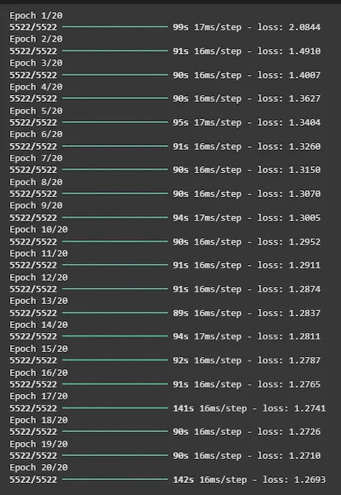

7. Making Predictions
We will be now making predictions using our trained GRU model.
- Input Sequence: The code takes the last 100 temperature values from the dataset (scaled_data[-time_step:]) as an input sequence.
- Reshaping the Input Sequence: The input sequence is reshaped into the shape (1, time_step, 1) because the GRU model expects a 3D input: [samples, time_steps, features]. Here samples=1 because we are making one prediction, time_steps=100 (the length of the input sequence) and features=1 because we are predicting only the temperature value.
- model.predict(): Uses the trained model to predict future values based on the input data

input_sequence = scaled_data[-time_step:].reshape(1, time_step, 1)
predicted_values = model.predict(input_sequence)

8. Inverse Transforming the Predictions
Inverse Transforming the Predictions refers to the process of converting the scaled (normalized) predictions back to their original scale.

- scaler.inverse_transform(): Converts the normalized predictions back to their original scale.

predicted_values = scaler.inverse_transform(predicted_values)
print(
f"The predicted temperature for the next day is: {predicted_values[0][0]:.2f}°C")

Output:
The predicted temperature for the next day is: 25.03°C
The output25.03οC25.03οC is the GRU model's prediction for the next day's temperature based on the past 100 days of data. The model uses historical patterns to forecast future values and converts the prediction back to the original temperature scale.

Transformers in Machine Learning

Transformer is a neural network architecture used for performing machine learning tasks particularly in natural language processing (NLP) and computer vision. In 2017 Vaswani et al. published a paper " Attention is All You Need" in which the transformers architecture was introduced. The article explores the architecture, workings and applications of transformers.

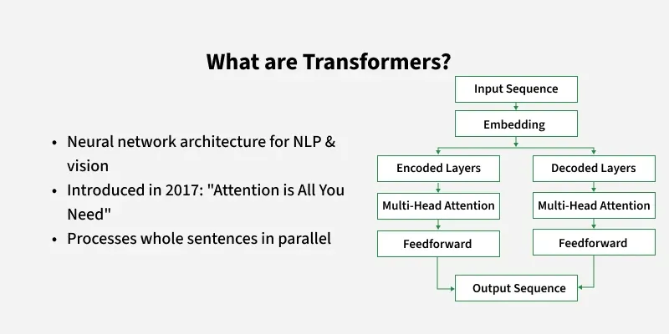
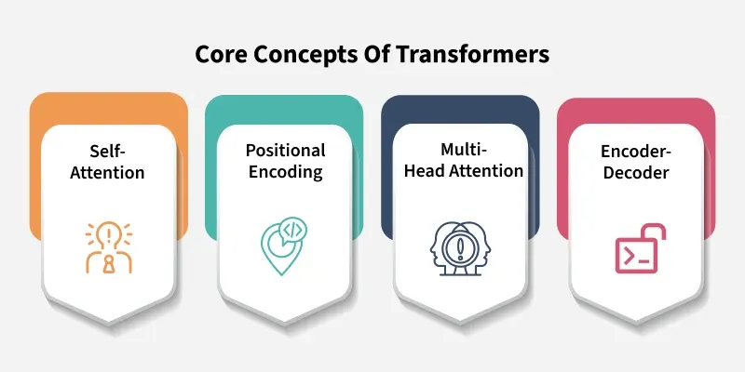
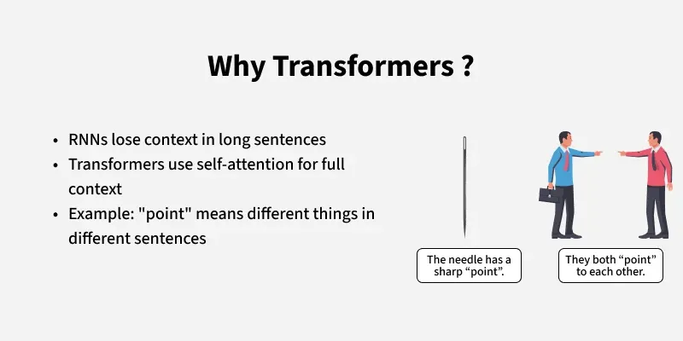
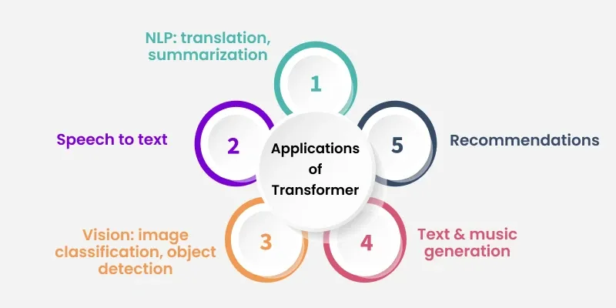

Need For Transformers Model in Machine Learning
Transformer Architecture uses self-attention to transform one whole sentence into a single sentence. This is useful because older models work step by step and it helps overcome the challenges seen in models like RNNs and LSTMs. Traditional models like RNNs (Recurrent Neural Networks) suffer from the vanishing gradient problem which leads to long-term memory loss. RNNs process text sequentially meaning they analyze words one at a time.

For example:
In the sentence: "XYZ went to France in 2019 when there were no cases of COVID and there he met the president of that country" the word "that country" refers to "France".
However RNN would struggle to link "that country" to "France" since it processes each word in sequence leading to losing context over long sentences. This limitation prevents RNNs from understanding the full meaning of the sentence.
While adding more memory cells in LSTMs (Long Short-Term Memory networks) helped address the vanishing gradient issue they still process words one by one. This sequential processing means LSTMs can't analyze an entire sentence at once.
For example:
The word "point" has different meanings in these two sentences:
- "The needle has a sharp point." (Point = Tip)
- "It is not polite to point at people." (Point = Gesture)

Traditional models struggle with this context dependence, whereas Transformer model through its self-attention mechanism processes the entire sentence in parallel addressing these issues and making it significantly more effective at understanding context.

Core Concepts of Transformers
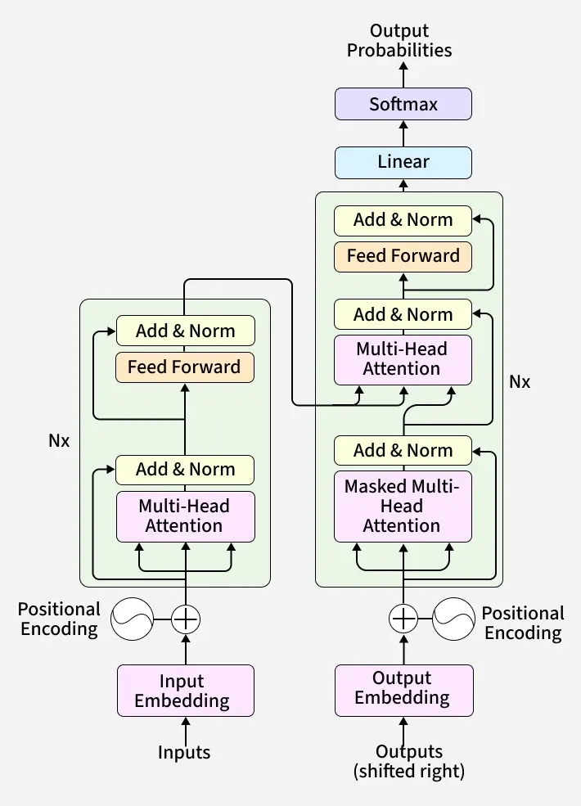
1. Self Attention Mechanism
The self attention mechanism allows transformers to determine which words in a sentence are most relevant to each other. This is done using a scaled dot-product attention approach:
Each word in a sequence is mapped to three vectors:
- Query (Q)
- Key (K)
- Value (V)

These scores determine how much attention each word should pay to others.
2. Positional Encoding
Unlike RNNs, transformers lack an inherent understanding of word order since they process data in parallel. To solve this problem Positional Encodings are added to token embeddings providing information about the position of each token within a sequence.
3. Multi-Head Attention
Instead of one attention mechanism, transformers use multiple attention heads running in parallel. Each head captures different relationships or patterns in the data, enriching the model’s understanding.
4. Position-wise Feed-Forward Networks
The Feed-Forward Networks consist of two linear transformations with a ReLU activation. It is applied independently to each position in the sequence.
Mathematically:

This transformation helps refine the encoded representation at each position.
5. Encoder-Decoder Architecture
The encoder-decoder structure is key to transformer models. The encoder processes the input sequence into a vector, while the decoder converts this vector back into a sequence. Each encoder and decoder layer includes self-attention and feed-forward layers. In the decoder, an encoder-decoder attention layer is added to focus on relevant parts of the input.
For example, a French sentence "Je suis étudiant" is translated into "I am a student" in English.
The encoder consists of multiple layers (typically 6 layers). Each layer has two main components:
- Self-Attention Mechanism: Helps the model understand word relationships.
- Feed-Forward Neural Network: Further transforms the representation.
The decoder also consists of 6 layers but with an additional encoder-decoder attention mechanism. This allows the decoder to focus on relevant parts of the input sentence while generating output.
Intuition with Example
For instance in the sentence "The cat didn't chase the mouse, because it was not hungry" the word 'it' refers to 'cat'. The self-attention mechanism helps the model correctly associate 'it' with 'cat' ensuring an accurate understanding of sentence structure.
Applications
Some of the applications of transformers are:
- NLP Tasks: Transformers are used for machine translation, text summarization, named entity recognition and sentiment analysis.
- Speech Recognition: They process audio signals to convert speech into transcribed text.
- Computer Vision: Transformers are applied to image classification, object detection and image generation.
- Recommendation Systems: They provide personalized recommendations based on user preferences.
- Text and Music Generation: Transformers are used for generating text like articles and composing music.

Autoencoders in Machine Learning

Autoencoders are a special type of neural networks that learn to compress data into a compact form and then reconstruct it to closely match the original input. They consist of an:
- Encoder that captures important features by reducing dimensionality.
- Decoder that rebuilds the data from this compressed representation.
The model trains by minimizing reconstruction error using loss functions like Mean Squared Error or Binary Cross-Entropy. These are applied in tasks such as noise removal, error detection and feature extraction where capturing efficient data representations is important.

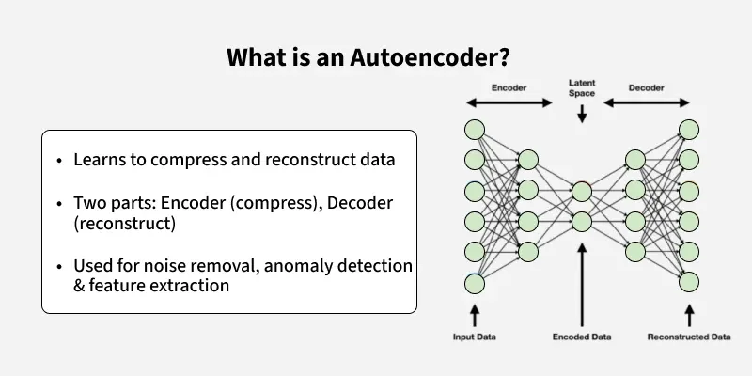
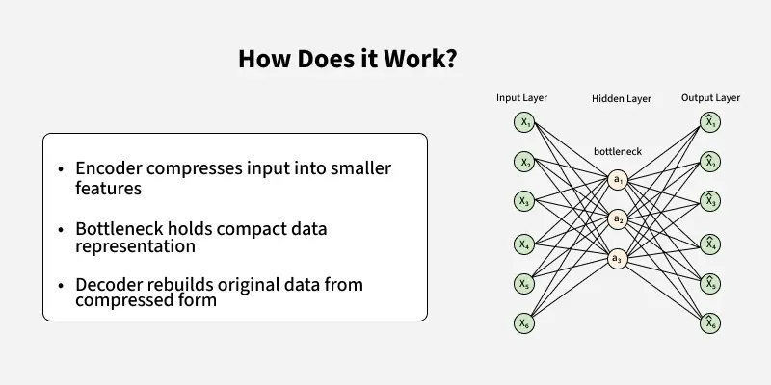
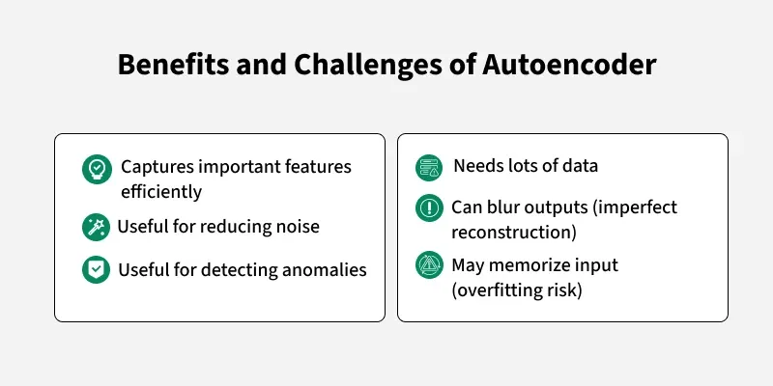
Architecture of Autoencoder
An autoencoder’s architecture consists of three main components that work together to compress and then reconstruct data which are as follows:

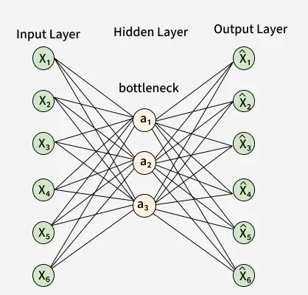

1. Encoder
It compress the input data into a smaller, more manageable form by reducing its dimensionality while preserving important information. It has three layers which are:
- Input Layer: This is where the original data enters the network. It can be images, text features or any other structured data.
- Hidden Layers: These layers perform a series of transformations on the input data. Each hidden layer applies weights and activation functions to capture important patterns, progressively reducing the data's size and complexity.
- Output(Latent Space): The encoder outputs a compressed vector known as the latent representation or encoding. This vector captures the important features of the input data in a condensed form helps in filtering out noise and redundancies.

2. Bottleneck (Latent Space)
It is the smallest layer of the network which represents the most compressed version of the input data. It serves as the information bottleneck which force the network to prioritize the most significant features. This compact representation helps the model learn the underlying structure and key patterns of the input helps in enabling better generalization and efficient data encoding.
3. Decoder
It is responsible for taking the compressed representation from the latent space and reconstructing it back into the original data form.
- Hidden Layers: These layers progressively expand the latent vector back into a higher-dimensional space. Through successive transformations decoder attempts to restore the original data shape and details
- Output Layer: The final layer produces the reconstructed output which aims to closely resemble the original input. The quality of reconstruction depends on how well the encoder-decoder pair can minimize the difference between the input and output during training.

Loss Function in Autoencoder Training
During training an autoencoder’s goal is to minimize the reconstruction loss which measures how different the reconstructed output is from the original input. The choice of loss function depends on the type of data being processed:
- Mean Squared Error (MSE): This is commonly used for continuous data. It measures the average squared differences between the input and the reconstructed data.
- Binary Cross-Entropy: Used for binary data (0 or 1 values). It calculates the difference in probability between the original and reconstructed output.
During training the network updates its weights using backpropagation to minimize this reconstruction loss. By doing this it learns to extract and retain the most important features of the input data which are encoded in the latent space.

Efficient Representations in Autoencoders
Constraining an autoencoder helps it learn meaningful and compact features from the input data which leads to more efficient representations. After training only the encoder part is used to encode similar data for future tasks. Various techniques are used to achieve this are as follows:
- Keep Small Hidden Layers: Limiting the size of each hidden layer forces the network to focus on the most important features. Smaller layers reduce redundancy and allows efficient encoding.
- Regularization: Techniques like L1 or L2 regularization add penalty terms to the loss function. This prevents overfitting by removing excessively large weights which helps in ensuring the model to learns general and useful representations.
- Denoising: In denoising autoencoders random noise is added to the input during training. It learns to remove this noise during reconstruction which helps it focus on core, noise-free features and helps in improving robustness.
- Tuning the Activation Functions: Adjusting activation functions can promote sparsity by activating only a few neurons at a time. This sparsity reduces model complexity and forces the network to capture only the most relevant features.

Types of Autoencoders
Lets see different types of Autoencoders which are designed for specific tasks with unique features:
1. Denoising Autoencoder
Denoising Autoencoder is trained to handle corrupted or noisy inputs, it learns to remove noise and helps in reconstructing clean data. It prevent the network from simply memorizing the input and encourages learning the core features.
2. Sparse Autoencoder
Sparse Autoencoder contains more hidden units than input features but only allows a few neurons to be active simultaneously. This sparsity is controlled by zeroing some hidden units, adjusting activation functions or adding a sparsity penalty to the loss function.
3. Variational Autoencoder
Variational autoencoder (VAE) makes assumptions about the probability distribution of the data and tries to learn a better approximation of it. It uses stochastic gradient descent to optimize and learn the distribution of latent variables. They used for generating new data such as creating realistic images or text.
It assumes that the data is generated by a Directed Graphical Model and tries to learn an approximation to qϕ(z∣x)qϕ​(z∣x) to the conditional property qθ(z∣x)qθ​(z∣x) where ϕ ϕ and θ θ are the parameters of the encoder and the decoder respectively.
4. Convolutional Autoencoder
Convolutional autoencoder uses convolutional neural networks (CNNs) which are designed for processing images. The encoder extracts features using convolutional layers and the decoder reconstructs the image through deconvolution also called as upsampling.
Implementation of Autoencoders
We will create a simple autoencoder with two Dense layers: an encoder that compresses images into a 64-dimensional latent vector and a decoder that reconstructs the original image from this compressed form.
Step 1: Import necessary libraries
We will be using Matplotlib, NumPy, TensorFlow and the MNIST dataset loader for this.

import numpy as np
import matplotlib.pyplot as plt
import tensorflow as tf
from tensorflow import keras
from tensorflow.keras import layers, losses
from tensorflow.keras.models import Model
from keras.datasets import mnist

Step 2: Load the MNIST dataset
We will be loading the MNIST dataset which is inbuilt dataset and normalize pixel values to [0,1] also reshape the data to fit the model.

(x_train, _), (x_test, _) = mnist.load_data()

x_train = x_train.astype('float32') / 255.
x_test = x_test.astype('float32') / 255.

x_train = np.reshape(x_train, (len(x_train), 28, 28, 1))
x_test = np.reshape(x_test, (len(x_test), 28, 28, 1))

Output:
Shape of the training data: (60000, 28, 28)
Shape of the testing data: (10000, 28, 28)

Step 3: Define a basic Autoencoder
Creating a simple autoencoder class with an encoder and decoder using Keras Sequential model.
- layers.Input(shape=(28, 28, 1)): Input layer expecting grayscale images of size 28x28.
- layers.Dense(latent_dimensions, activation='relu'): Dense layer that compresses the input to the latent space using ReLU activation.
- layers.Dense(28 * 28, activation='sigmoid'): Dense layer that expands the latent vector back to the original image size with sigmoid activation.

class SimpleAutoencoder(Model):
def __init__(self, latent_dimensions):
super(SimpleAutoencoder, self).__init__()
self.encoder = tf.keras.Sequential([
layers.Input(shape=(28, 28, 1)),
layers.Flatten(),
layers.Dense(latent_dimensions, activation='relu'),
])

self.decoder = tf.keras.Sequential([
layers.Dense(28 * 28, activation='sigmoid'),
layers.Reshape((28, 28, 1))
])

def call(self, input_data):
encoded = self.encoder(input_data)
decoded = self.decoder(encoded)
return decoded

Step 4: Compiling and Fitting Autoencoder
Here we compile the model using Adam optimizer and Mean Squared Error loss also we train for 10 epochs with batch size 256.
- latent_dimensions = 64: Sets the size of the compressed latent space to 64.

latent_dimensions = 64
autoencoder = SimpleAutoencoder(latent_dimensions)
autoencoder.compile(optimizer='adam', loss=losses.MeanSquaredError())

autoencoder.fit(x_train, x_train,
epochs=10,
batch_size=256,
shuffle=True,
validation_data=(x_test, x_test))

Output:
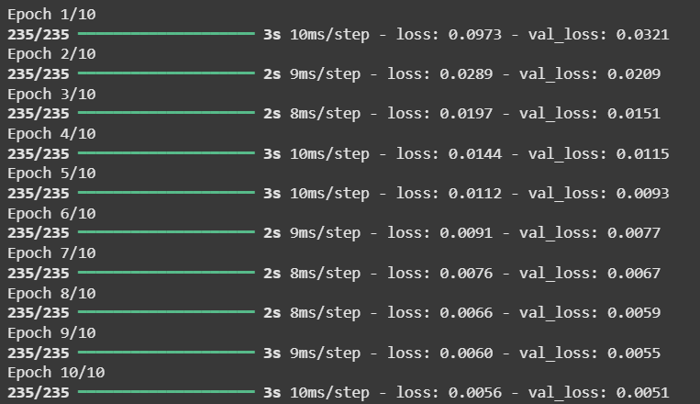

Step 5: Visualize original and reconstructed data
Now compare original images and their reconstructions from the autoencoder.
- encoded_imgs = autoencoder.encoder(x_test).numpy(): Passes test images through the encoder to get their compressed latent representations as NumPy arrays.
- decoded_imgs = autoencoder.decoder(encoded_imgs).numpy(): Reconstructs images by passing the latent representations through the decoder and converts them to NumPy arrays.

encoded_imgs = autoencoder.encoder(x_test).numpy()
decoded_imgs = autoencoder.decoder(encoded_imgs).numpy()

n = 6
plt.figure(figsize=(12, 6))
for i in range(n):
ax = plt.subplot(2, n, i + 1)
plt.imshow(x_test[i].reshape(28, 28), cmap='gray')
plt.title("Original")
plt.axis('off')

ax = plt.subplot(2, n, i + 1 + n)
plt.imshow(decoded_imgs[i].reshape(28, 28), cmap='gray')
plt.title("Reconstructed")
plt.axis('off')

plt.show()

Output:

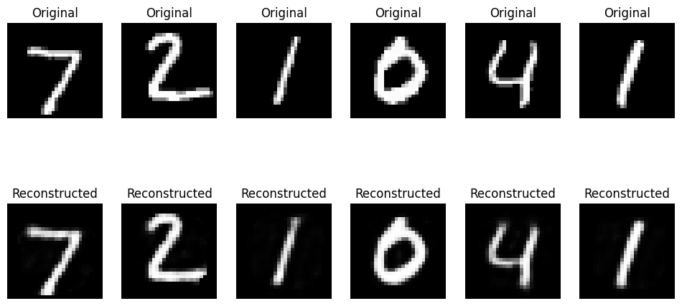

The visualization compares original MNIST images (top row) with their reconstructed versions (bottom row) showing that the autoencoder effectively captures key features despite some minor blurriness.
Limitations
Autoencoders are useful but also have some limitations:
- Memorizing Instead of Learning Patterns: It can sometimes memorize the training data rather than learning meaningful patterns which reduces their ability to generalize to new data.
- Reconstructed Data Might Not Be Perfect: Output may be blurry or distorted with noisy inputs or if the model architecture lacks sufficient complexity to capture all details.
- Requires a Large Dataset and Good Parameter Tuning: It require large amounts of data and careful parameter tuning (latent dimension size, learning rate, etc) to perform well. Insufficient data or poor tuning can result in weak feature representations.

Generative Adversarial Network (GAN)

Generative Adversarial Networks (GAN) help machines to create new, realistic data by learning from existing examples. It is introduced by Ian Goodfellow and his team in 2014 and they have transformed how computers generate images, videos, music and more. Unlike traditional models that only recognize or classify data, they take a creative way by generating entirely new content that closely resembles real-world data. This ability helped various fields such as art, gaming, healthcare and data science. In this article, we will see more about GANs and its core concepts.

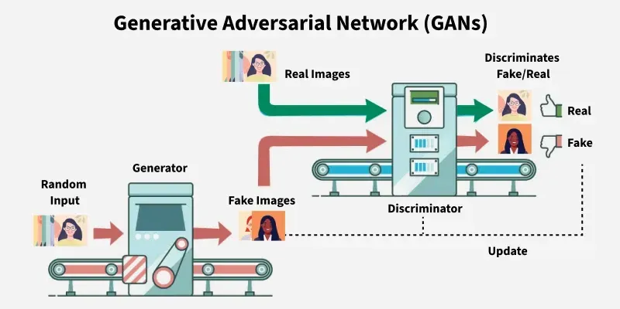
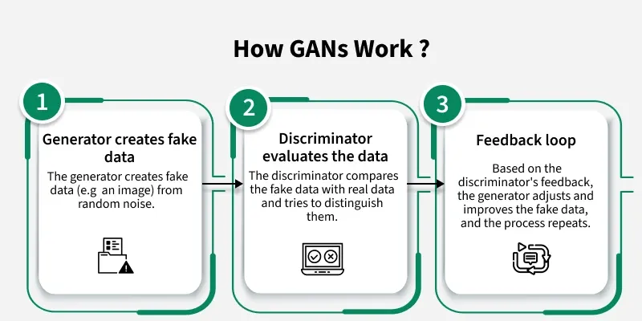

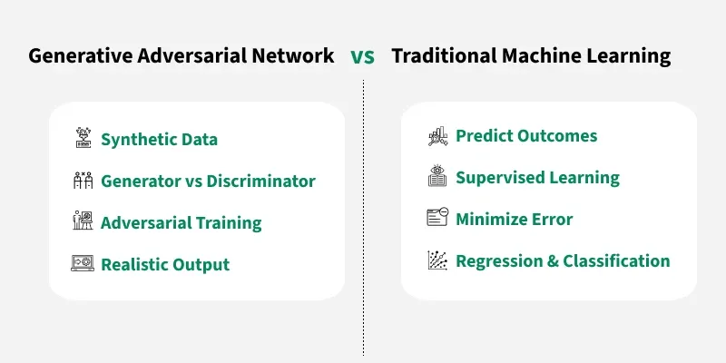

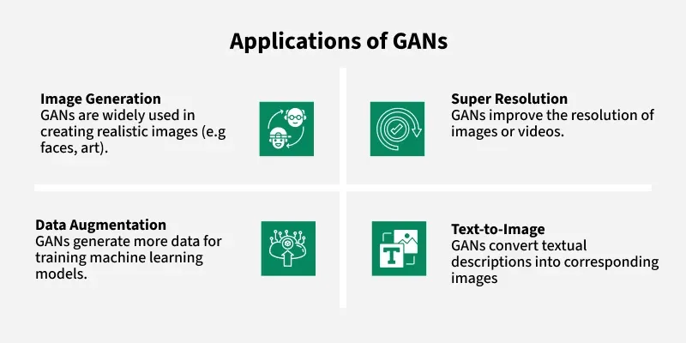

Architecture of GAN
GAN consist of two main models that work together to create realistic synthetic data which are as follows:
1. Generator Model
The generator is a deep neural network that takes random noise as input to generate realistic data samples like images or text. It learns the underlying data patterns by adjusting its internal parameters during training through backpropagation. Its objective is to produce samples that the discriminator classifies as real.
Generator Loss Function: The generator tries to minimize this loss:

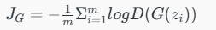

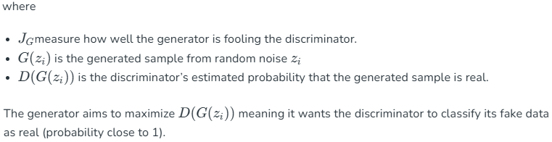

2. Discriminator Model
The discriminator acts as a binary classifier helps in distinguishing between real and generated data. It learns to improve its classification ability through training, refining its parameters to detect fake samples more accurately. When dealing with image data, the discriminator uses convolutional layers or other relevant architectures which help to extract features and enhance the model’s ability.
Discriminator Loss Function: The discriminator tries to minimize this loss:

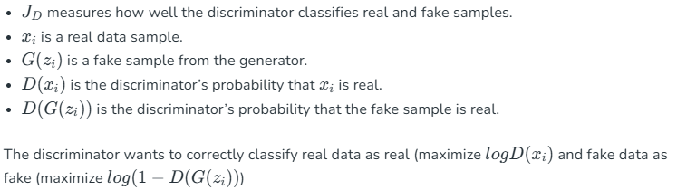

MinMax Loss
GANs are trained using a MinMax Loss between the generator and discriminator:

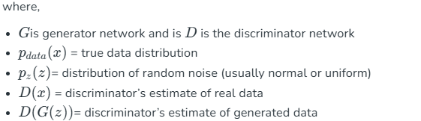

The generator tries to minimize this loss (to fool the discriminator) and the discriminator tries to maximize it (to detect fakes accurately).

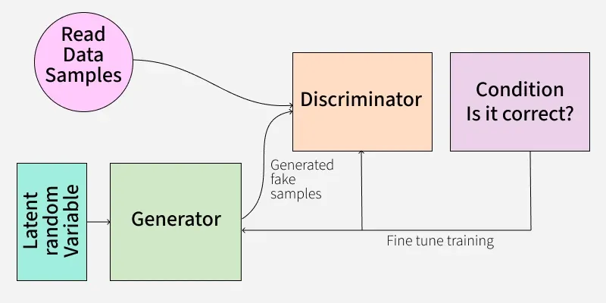

How does a GAN work?
GAN train by having two networks the Generator (G) and the Discriminator (D) compete and improve together. Here's the step-by-step process
1. Generator's First Move
The generator starts with a random noise vector like random numbers. It uses this noise as a starting point to create a fake data sample such as a generated image. The generator’s internal layers transform this noise into something that looks like real data.
2. Discriminator's Turn
The discriminator receives two types of data:
- Real samples from the actual training dataset.
- Fake samples created by the generator.
D's job is to analyze each input and find whether it's real data or something G cooked up. It outputs a probability score between 0 and 1. A score of 1 shows the data is likely real and 0 suggests it's fake.
3. Adversarial Learning
- If the discriminator correctly classifies real and fake data it gets better at its job.
- If the generator fools the discriminator by creating realistic fake data, it receives a positive update and the discriminator is penalized for making a wrong decision.
4. Generator's Improvement
- Each time the discriminator mistakes fake data for real, the generator learns from this success.
- Through many iterations, the generator improves and creates more convincing fake samples.
5. Discriminator's Adaptation
- The discriminator also learns continuously by updating itself to better spot fake data.
- This constant back-and-forth makes both networks stronger over time.
6. Training Progression
- As training continues, the generator becomes highly proficient at producing realistic data.
- Eventually the discriminator struggles to distinguish real from fake shows that the GAN has reached a well-trained state.
- At this point, the generator can produce high-quality synthetic data that can be used for different applications.
Types of GAN
There are several types of GANs each designed for different purposes. Here are some important types:
1. Vanilla GAN
Vanilla GAN is the simplest type of GAN. It consists of:
- A generator and a discriminator both are built using multi-layer perceptrons (MLPs).
- The model optimizes its mathematical formulation using stochastic gradient descent (SGD).
While foundational, Vanilla GAN can face problems like:
- Mode collapse: The generator produces limited types of outputs repeatedly.
- Unstable training: The generator and discriminator may not improve smoothly.
2. Conditional GAN (CGAN)
Conditional GAN (CGAN) adds an additional conditional parameter to guide the generation process. Instead of generating data randomly they allow the model to produce specific types of outputs.
Working of CGANs:
- A conditional variable (y) is fed into both the generator and the discriminator.
- This ensures that the generator creates data corresponding to the given condition (e.g generating images of specific objects).
- The discriminator also receives the labels to help distinguish between real and fake data.
Example: Instead of generating any random image, CGAN can generate a specific object like a dog or a cat based on the label.
3. Deep Convolutional GAN (DCGAN)
Deep Convolutional GAN (DCGAN) are among the most popular types of GANs used for image generation.
They are important because they:
- Uses Convolutional Neural Networks (CNNs) instead of simple multi-layer perceptrons (MLPs).
- Max pooling layers are replaced with convolutional stride helps in making the model more efficient.
- Fully connected layers are removed, which allows for better spatial understanding of images.
DCGANs are successful because they generate high-quality, realistic images.
4. Laplacian Pyramid GAN (LAPGAN)
Laplacian Pyramid GAN (LAPGAN) is designed to generate ultra-high-quality images by using a multi-resolution approach.
Working of LAPGAN:
- Uses multiple generator-discriminator pairs at different levels of the Laplacian pyramid.
- Images are first down sampled at each layer of the pyramid and upscaled again using Conditional GAN (CGAN).
- This process allows the image to gradually refine details and helps in reducing noise and improving clarity.
Due to its ability to generate highly detailed images, LAPGAN is considered a superior approach for photorealistic image generation.
5. Super Resolution GAN (SRGAN)
Super-Resolution GAN (SRGAN) is designed to increase the resolution of low-quality images while preserving details.
Working of SRGAN:
- Uses a deep neural network combined with an adversarial loss function.
- Enhances low-resolution images by adding finer details helps in making them appear sharper and more realistic.
- Helps to reduce common image upscaling errors such as blurriness and pixelation.
Implementation
Generative Adversarial Networks (GAN) can generate realistic images by learning from existing image datasets. Here we will be implementing a GAN trained on the CIFAR-10 dataset using PyTorch.
Step 1: Importing Required Libraries
We will be using Pytorch, Torchvision, Matplotlib and Numpy libraries for this. Set the device to GPU if available otherwise use CPU.

import torch
import torch.nn as nn
import torch.optim as optim
import torchvision
from torchvision import datasets, transforms
import matplotlib.pyplot as plt
import numpy as np

device = torch.device('cuda' if torch.cuda.is_available() else 'cpu')
Step 2: Defining Image Transformations
We use PyTorch’s transforms to convert images to tensors and normalize pixel values between -1 and 1 for better training stability.

transform = transforms.Compose([
transforms.ToTensor(),
transforms.Normalize((0.5, 0.5, 0.5), (0.5, 0.5, 0.5))
])

Step 3: Loading the CIFAR-10 Dataset
Download and load the CIFAR-10 dataset with defined transformations. Use a DataLoader to process the dataset in mini-batches of size 32 and shuffle the data.

train_dataset = datasets.CIFAR10(root='./data',\
train=True, download=True, transform=transform)
dataloader = torch.utils.data.DataLoader(train_dataset, \
batch_size=32, shuffle=True)

Step 4: Defining GAN Hyperparameters
Set important training parameters:
- latent_dim: Dimensionality of the noise vector.
- lr: Learning rate of the optimizer.
- beta1, beta2: Beta parameters for Adam optimizer (e.g 0.5, 0.999)
- num_epochs: Number of times the entire dataset will be processed (e.g 10)

latent_dim = 100
lr = 0.0002
beta1 = 0.5
beta2 = 0.999
num_epochs = 10

Step 5: Building the Generator
Create a neural network that converts random noise into images. Use transpose convolutional layers, batch normalization and ReLU activations. The final layer uses Tanh activation to scale outputs to the range [-1, 1].
- nn.Linear(latent_dim, 128 * 8 * 8): Defines a fully connected layer that projects the noise vector into a higher dimensional feature space.
- nn.Upsample(scale_factor=2): Doubles the spatial resolution of the feature maps by upsampling.
- nn.Conv2d(128, 128, kernel_size=3, padding=1): Applies a convolutional layer keeping the number of channels the same to refine features.
class Generator(nn.Module):
def __init__(self, latent_dim):
super(Generator, self).__init__()

self.model = nn.Sequential(
nn.Linear(latent_dim, 128 * 8 * 8),
nn.ReLU(),
nn.Unflatten(1, (128, 8, 8)),
nn.Upsample(scale_factor=2),
nn.Conv2d(128, 128, kernel_size=3, padding=1),
nn.BatchNorm2d(128, momentum=0.78),
nn.ReLU(),
nn.Upsample(scale_factor=2),
nn.Conv2d(128, 64, kernel_size=3, padding=1),
nn.BatchNorm2d(64, momentum=0.78),
nn.ReLU(),
nn.Conv2d(64, 3, kernel_size=3, padding=1),
nn.Tanh()
)

def forward(self, z):
img = self.model(z)
return img

Step 6: Building the Discriminator
Create a binary classifier network that distinguishes real from fake images. Use convolutional layers, batch normalization, dropout, LeakyReLU activation and a Sigmoid output layer to give a probability between 0 and 1.
- nn.Conv2d(32, 64, kernel_size=3, stride=2, padding=1): Second convolutional layer increasing channels to 64, downsampling further.
- nn.BatchNorm2d(256, momentum=0.8): Batch normalization for 256 feature maps with momentum 0.8.

class Discriminator(nn.Module):
def __init__(self):
super(Discriminator, self).__init__()

self.model = nn.Sequential(
nn.Conv2d(3, 32, kernel_size=3, stride=2, padding=1),
nn.LeakyReLU(0.2),
nn.Dropout(0.25),
nn.Conv2d(32, 64, kernel_size=3, stride=2, padding=1),
nn.ZeroPad2d((0, 1, 0, 1)),
nn.BatchNorm2d(64, momentum=0.82),
nn.LeakyReLU(0.25),
nn.Dropout(0.25),
nn.Conv2d(64, 128, kernel_size=3, stride=2, padding=1),
nn.BatchNorm2d(128, momentum=0.82),
nn.LeakyReLU(0.2),
nn.Dropout(0.25),
nn.Conv2d(128, 256, kernel_size=3, stride=1, padding=1),
nn.BatchNorm2d(256, momentum=0.8),
nn.LeakyReLU(0.25),
nn.Dropout(0.25),
nn.Flatten(),
nn.Linear(256 * 5 * 5, 1),
nn.Sigmoid()
)

def forward(self, img):
validity = self.model(img)
return validity

Step 7: Initializing GAN Components
- Generator and Discriminator are initialized on the available device (GPU or CPU).
- Binary Cross-Entropy (BCE) Loss is chosen as the loss function.
- Adam optimizers are defined separately for the generator and discriminator with specified learning rates and betas.

generator = Generator(latent_dim).to(device)
discriminator = Discriminator().to(device)

adversarial_loss = nn.BCELoss()

optimizer_G = optim.Adam(generator.parameters()\
, lr=lr, betas=(beta1, beta2))
optimizer_D = optim.Adam(discriminator.parameters()\
, lr=lr, betas=(beta1, beta2))

Step 8: Training the GAN
Train the discriminator on real and fake images, then update the generator to improve its fake image quality. Track losses and visualize generated images after each epoch.
- valid = torch.ones(real_images.size(0), 1, device=device): Create a tensor of ones representing real labels for the discriminator.
- fake = torch.zeros(real_images.size(0), 1, device=device): Create a tensor of zeros representing fake labels for the discriminator.
- z = torch.randn(real_images.size(0), latent_dim, device=device): Generate random noise vectors as input for the generator.
- g_loss = adversarial_loss(discriminator(gen_images), valid): Calculate generator loss based on the discriminator classifying fake images as real.
- grid = torchvision.utils.make_grid(generated, nrow=4, normalize=True): Arrange generated images into a grid for display, normalizing pixel values.

for epoch in range(num_epochs):
for i, batch in enumerate(dataloader):

real_images = batch[0].to(device)

valid = torch.ones(real_images.size(0), 1, device=device)
fake = torch.zeros(real_images.size(0), 1, device=device)

real_images = real_images.to(device)

optimizer_D.zero_grad()

z = torch.randn(real_images.size(0), latent_dim, device=device)

fake_images = generator(z)

real_loss = adversarial_loss(discriminator\
(real_images), valid)
fake_loss = adversarial_loss(discriminator\
(fake_images.detach()), fake)
d_loss = (real_loss + fake_loss) / 2

d_loss.backward()
optimizer_D.step()

optimizer_G.zero_grad()

gen_images = generator(z)

g_loss = adversarial_loss(discriminator(gen_images), valid)
g_loss.backward()
optimizer_G.step()

if (i + 1) % 100 == 0:
print(
f"Epoch [{epoch+1}/{num_epochs}]\
Batch {i+1}/{len(dataloader)} "
f"Discriminator Loss: {d_loss.item():.4f} "
f"Generator Loss: {g_loss.item():.4f}"
)
if (epoch + 1) % 10 == 0:
with torch.no_grad():
z = torch.randn(16, latent_dim, device=device)
generated = generator(z).detach().cpu()
grid = torchvision.utils.make_grid(generated,\
nrow=4, normalize=True)
plt.imshow(np.transpose(grid, (1, 2, 0)))
plt.axis("off")
plt.show()

Output:

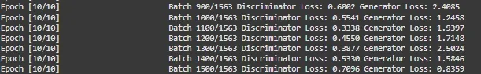

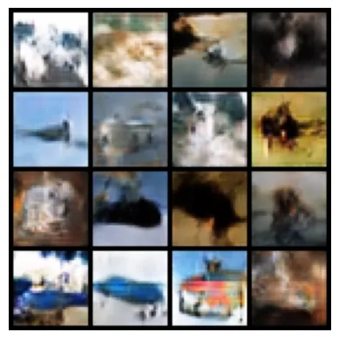

By following these steps we successfully implemented and trained a GAN that learns to generate realistic CIFAR-10 images through adversarial training.
Applications
- Image Synthesis & Generation: GANs generate realistic images, avatars and high-resolution visuals by learning patterns from training data. They are used in art, gaming and AI-driven design.
- Image-to-Image Translation: They can transform images between domains while preserving key features. Examples include converting day images to night, sketches to realistic images or changing artistic styles.
- Text-to-Image Synthesis: They create visuals from textual descriptions helps applications in AI-generated art, automated design and content creation.
- Data Augmentation: They generate synthetic data to improve machine learning models helps in making them more robust and generalizable in fields with limited labeled data.
- High-Resolution Image Enhancement: They upscale low-resolution images which helps in improving clarity for applications like medical imaging, satellite imagery and video enhancement.
Advantages
Lets see various advantages of the GANs:
- Synthetic Data Generation: GANs produce new, synthetic data resembling real data distributions which is useful for augmentation, anomaly detection and creative tasks.
- High-Quality Results: They can generate photorealistic images, videos, music and other media with high quality.
- Unsupervised Learning: They don’t require labeled data helps in making them effective in scenarios where labeling is expensive or difficult.
- Versatility: They can be applied across many tasks including image synthesis, text-to-image generation, style transfer, anomaly detection and more.
GANs are evolving and shaping the future of artificial intelligence. As the technology improves, we can expect even more innovative applications that will change how we create, work and interact with digital content.

