Here are the key prerequisites for learning PySpark (practical, not theoretical-heavy). I’ll keep it structured so you can actually use it as a checklist.

1. Basic Python (Mandatory)
You don’t need advanced Python, but you must be comfortable with:
Must-know:
- Variables, data types
- Lists, tuples, dictionaries
- Loops (for, while)
- Functions
- Basic OOP (helpful but not critical)
- File handling (CSV/JSON basics)
Why?
PySpark code is written in Python, but you’ll mainly use Python syntax to manipulate distributed data.

2. SQL Basics (Very Important)
PySpark is heavily SQL-driven.
Must-know:
- SELECT, WHERE
- GROUP BY
- JOIN
- ORDER BY
- Aggregations (SUM, COUNT, AVG)
- Window functions (bonus but very useful)
Why?
Most PySpark DataFrame operations map directly to SQL.
Example:
SELECT department, SUM(salary)
FROM employees
GROUP BY department;
Same in PySpark:
df.groupBy("department").sum("salary")

3. Basic Data Concepts
You should understand:
- Structured vs semi-structured data
- CSV, JSON, Parquet formats
- Rows and columns
- Primary key / foreign key (basic idea)
- Data cleaning concepts

4. Linux / Command Line (Helpful)
Not strictly required, but useful for real-world Spark:
- Basic commands: ls, cd, mkdir
- Running scripts
- File paths
- Environment variables

5. Basic Understanding of Big Data (Important)
You should know why Spark exists:
- What is big data?
- Why single-machine tools (like Pandas) fail at scale
- What is distributed computing (basic idea)
Key concept:
Instead of 1 machine processing data → Spark uses many machines (cluster).

6. Optional but Very Useful
a) Pandas basics
- DataFrames
- Filtering, grouping
b) Cloud basics (for jobs)
- AWS / Azure / GCP basics
- Storage systems like S3 / ADLS
c) Databricks / Fabric basics
- Since most PySpark jobs run there

7. Hardware / Setup
You don’t need a powerful machine.
Options:
- Local Spark install (for learning)
- Databricks Community Edition (best for beginners)
- Microsoft Fabric notebooks (modern enterprise option)

Recommended Learning Order
Python basics
↓
SQL basics
↓
Data concepts
↓
PySpark DataFrame API
↓
Joins + Aggregations
↓
Window functions
↓
ETL projects
↓
Real-world pipelines

Minimum Prerequisite Summary (Interview Answer)
If someone asks in interview:
To learn PySpark, you need basic Python programming, SQL knowledge, and an understanding of fundamental data concepts like structured data and file formats. Familiarity with big data concepts and distributed computing is helpful but not mandatory for beginners.

Here’s a practical 30-day PySpark learning roadmap (focused on hands-on skills, not theory overload). You can compress it into 7–10 days if you go full-time.

🚀 30-Day PySpark Learning Roadmap
🧱 Week 1 — Foundations (Python + SQL + Data Basics)
Day 1–2: Python essentials

Focus:

Variables, loops, functions
Lists, dictionaries
File handling (CSV/JSON)

Practice:

Read a CSV file in Python
Count frequency of values in a list
Day 3–4: SQL basics

Focus:

SELECT, WHERE
GROUP BY
JOIN
ORDER BY

Practice:

SELECT department, COUNT(*)
FROM employees
GROUP BY department;
Day 5–7: Data fundamentals

Focus:

Structured vs semi-structured data
CSV vs JSON vs Parquet
Basic data cleaning concepts

Mini task:

Clean a messy CSV (nulls, duplicates)
⚙️ Week 2 — PySpark Basics (Core Skills)
Day 8–9: Setup + Spark basics

Use:

Databricks Community Edition OR local Spark

Learn:

SparkSession
DataFrame concept
from pyspark.sql import SparkSession
spark = SparkSession.builder.appName("learn").getOrCreate()
Day 10–11: DataFrame operations

Focus:

select()
filter()
withColumn()

Practice:

df.select("name")
df.filter(df.salary > 50000)
df.withColumn("bonus", df.salary * 0.1)
Day 12–14: Actions + basic analysis

Focus:

show(), count(), collect()
basic profiling

Mini project:

Load CSV → filter → compute average salary
🔥 Week 3 — Core PySpark (Real Work Skills)
Day 15–16: GroupBy + Aggregations
df.groupBy("department").sum("salary")

Practice:

Top departments by salary
Count employees per region
Day 17–18: Joins

Focus:

inner join
left join
right join
orders.join(customers, "customer_id", "inner")

Practice:

Join sales + customer datasets
Day 19–20: Data cleaning

Focus:

handling nulls
dropping duplicates
casting data types
df.dropna()
df.fillna(0)
Day 21: Mini Project #1

💡 Sales Analysis Pipeline

Tasks:

Load dataset
Clean data
Join tables
Generate revenue report
⚡ Week 4 — Advanced PySpark + Real Projects
Day 22–23: Window Functions

Focus:

ranking
running totals
from pyspark.sql.window import Window

Use cases:

Top 3 customers per region
Salary ranking per department
Day 24–25: File formats

Focus:

Parquet
Delta tables (important for modern systems)
df.write.format("delta").save("/data/sales")
Day 26–27: Performance basics

Learn:

partitioning
caching
avoiding shuffles
Day 28–30: Final Project (Capstone)

💡 End-to-End Data Pipeline

Build:

Ingest raw CSV/JSON
Clean data
Transform (joins + aggregations)
Store as Parquet/Delta
Generate final report table

Example:

E-commerce analytics system
Sales + customer + product insights
🧠 Bonus Skills (after 30 days)
PySpark in cloud:
Microsoft Fabric
Databricks
Delta Lake (ACID tables)
Streaming basics (Spark Structured Streaming)
Optimization (partitioning, caching)
📌 Tools You Should Use
Databricks Community Edition (best for beginners)
Or Microsoft Fabric notebooks
Optional local Spark setup
🎯 What You’ll Be Able to Do After This

You’ll be able to:

Build ETL pipelines
Handle GB–TB datasets
Work with real data engineering jobs
Use Spark in cloud platforms

𝐌𝐨𝐬𝐭 𝐩𝐞𝐨𝐩𝐥𝐞 𝐦𝐚𝐤𝐞 𝐏𝐲𝐒𝐩𝐚𝐫𝐤 𝐡𝐚𝐫𝐝𝐞𝐫 𝐭𝐡𝐚𝐧 𝐢𝐭 𝐧𝐞𝐞𝐝𝐬 𝐭𝐨 𝐛𝐞.
They jump into advanced topics like Window Functions, Optimization, Broadcast Joins, and Delta Lake before understanding the basics.
The result?
Lots of tutorials watched.
Very little PySpark actually learned.
If you're serious about learning PySpark for Data Engineering, follow this roadmap:
✅ Spark Fundamentals
✅ SparkSession & DataFrames
✅ Schema & Data Types
✅ Reading/Writing Data (CSV, JSON, Parquet, Delta)
✅ Basic Transformations (`select`, `filter`, `withColumn`)
✅ Aggregations & GroupBy
✅ Joins (Inner, Left, Right, Broadcast)
✅ Window Functions (`ROW_NUMBER`, `RANK`, `LAG`, `LEAD`)
✅ Handling Missing Data & Nulls
✅ UDFs & Higher Order Functions
✅ Partitioning & Performance Tuning
✅ Spark Optimization (Shuffle, Skew, Caching)
And instead of spending months searching for resources, use these platforms:
📚 Apache Spark Official Docs – Best for fundamentals
📚 Databricks Academy – Hands-on Spark learning
📚 YouTube (Databricks / Spark channels) – Visual understanding
📚 Spark By Examples – Practical code snippets
📚 Kaggle – Practice datasets
📚 GitHub Projects – Real-world Spark pipelines
📚 LeetCode SQL + Spark practice – Build problem-solving skills
My recommended learning path:
Spark Docs → Databricks Academy → Build Mini Projects → Practice Optimizations → Real ETL Pipelines
The secret isn’t finding another course.
> The secret is building PySpark pipelines consistently.
Even 30–45 minutes daily for 90 days can completely change your understanding of distributed data processing.
Because watching PySpark videos won’t make you a Data Engineer.
> Debugging failed Spark jobs will.
Save this roadmap for later.
📌𝗥𝗲𝗴𝗶𝘀𝘁𝗿𝗮𝘁𝗶𝗼𝗻𝘀 𝗮𝗿𝗲 𝗰𝗹𝗼𝘀𝗶𝗻𝗴 𝘀𝗼𝗼𝗻!
𝗗𝗼𝗻'𝘁 𝗺𝗶𝘀𝘀 𝘆𝗼𝘂𝗿 𝗰𝗵𝗮𝗻𝗰𝗲 𝘁𝗼 𝗷𝗼𝗶𝗻 𝗼𝘂𝗿 𝟰𝘁𝗵 𝗗𝗮𝘁𝗮 𝗘𝗻𝗴𝗶𝗻𝗲𝗲𝗿𝗶𝗻𝗴 𝗖𝗼𝗵𝗼𝗿𝘁 𝗮𝗻𝗱 𝗯𝘂𝗶𝗹𝗱 𝘁𝗵𝗲 𝘀𝗸𝗶𝗹𝗹𝘀 𝗻𝗲𝗲𝗱𝗲𝗱 𝘁𝗼 𝗹𝗮𝘂𝗻𝗰𝗵 𝘆𝗼𝘂𝗿 𝗗𝗮𝘁𝗮 𝗘𝗻𝗴𝗶𝗻𝗲𝗲𝗿𝗶𝗻𝗴 𝗰𝗮𝗿𝗲𝗲𝗿. - https://lnkd.in/gPiDZuyS
Activate to view larger image,
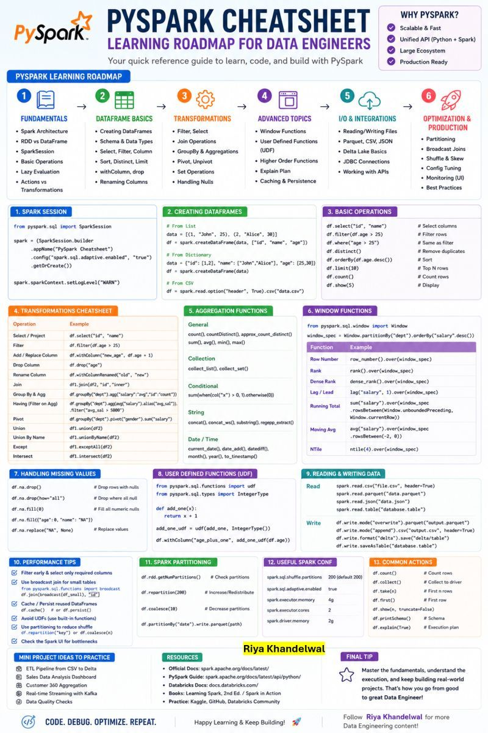

PySpark Interview Series | Day 1/15
Preparing for Senior PySpark interviews (3–8+ YOE)
Over the next 15 days, I'll share some of the most frequently asked PySpark interview questions, along with simple explanations, real-world production scenarios, and practical interview tips.
Whether you're preparing for interviews at Accenture, Deloitte, EY, TCS Digital, Cognizant, Capgemini, Microsoft, Databricks, or any product-based company, this series will help you strengthen your PySpark fundamentals and production knowledge.
Let's begin with one of the most frequently asked interview questions.
❓ Why is Apache Spark faster than traditional SQL or Python for Big Data?
Apache Spark is built for distributed computing.
Instead of processing data on a single machine, Spark distributes the workload across multiple executors and processes data in parallel.
Spark delivers better performance because it:
✅ Processes data in memory whenever possible
✅ Executes thousands of tasks simultaneously
✅ Optimizes queries using the Catalyst Optimizer
✅ Improves CPU and memory efficiency through the Tungsten Engine
✅ Scales horizontally by adding more worker nodes
💼 Real-World Example
Imagine an e-commerce company processing 5 TB of clickstream and transaction data every day.
Running this workload on a traditional database can take hours.
Using Apache Spark on Azure Databricks, the data is distributed across multiple worker nodes, enabling near real-time analytics, recommendation engines, and reporting.
🎯 Key Takeaways
🔹 Distributed Processing
🔹 Parallel Execution
🔹 In-Memory Computing
🔹 Catalyst Optimizer
🔹 Tungsten Engine
💡 Interview Tip
Don't simply say:
"Spark is faster because it's distributed."
A stronger answer is:
"Spark is faster because it combines distributed processing, in-memory computation, parallel execution, Catalyst query optimization, and the Tungsten execution engine to minimize disk I/O and maximize cluster resource utilization."
That level of explanation immediately differentiates experienced candidates.
💬 Question for you
What was the biggest dataset you've processed using PySpark, and what was the biggest performance challenge you faced?
Share your experience in the comments.
📅 Tomorrow (Day 2/15)
What actually happens internally when you execute a PySpark job?
We'll explore Driver, Executors, Jobs, Stages, Tasks, and the complete execution flow.
hashtag#PySpark hashtag#ApacheSpark hashtag#AzureDatabricks hashtag#DataEngineering hashtag#BigData hashtag#SparkOptimization hashtag#AzureDataEngineer hashtag#InterviewPreparation hashtag#DistributedComputing hashtag#TechCommunity hashtag#LearnInPublic
Activate to view larger image,
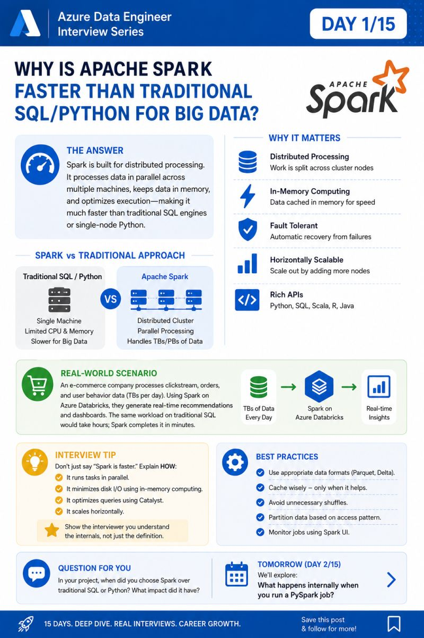

🚀 PySpark Interview Series | Day 2/15
Preparing for Senior PySpark interviews (3–8+ YOE)?
Yesterday, we discussed why Apache Spark is faster than traditional SQL/Python.
Today, let's answer one of the most frequently asked interview questions.
❓ What actually happens internally when you execute a PySpark job?
Many engineers use PySpark every day, but very few can clearly explain what happens behind the scenes.
Here's the execution flow:
1️⃣ Driver Program receives your PySpark code and creates the execution plan.
2️⃣ Cluster Manager (Standalone, YARN, Kubernetes, etc.) allocates the required resources.
3️⃣ Executors are launched on worker nodes.
4️⃣ The Driver divides the job into Stages and Tasks.
5️⃣ Executors process the tasks in parallel, reading data, performing transformations, and writing the results.
6️⃣ The Driver monitors execution, retries failed tasks if required, and completes the job.
💼 Real-World Example
Suppose your team has a daily pipeline that reads 500 GB of sales data from ADLS, cleans it, joins it with customer data, and writes the output to a Delta table.
Instead of one server processing everything:
✅ The Driver creates the execution plan.
✅ The Cluster Manager allocates executors.
✅ The dataset is split into multiple partitions.
✅ Each executor processes its assigned partition in parallel.
✅ The final result is written to Delta Lake in minutes instead of hours.
🚀 Key Components
🔹 Driver → Coordinates the entire Spark application.
🔹 Cluster Manager → Allocates cluster resources.
🔹 Executors → Execute tasks and store intermediate data.
🔹 Jobs → Stages → Tasks → The execution hierarchy inside Spark.
💡 Interview Tip
When asked "Explain Spark Architecture", avoid listing only the components.
Instead, explain the complete execution flow:
Driver → Cluster Manager → Executors → Jobs → Stages → Tasks → Results
This demonstrates that you understand how Spark actually works in production, not just the terminology.
💬 Question for you
Have you ever debugged a slow Spark job?
What was the root cause—shuffle, data skew, memory, or partitioning?
Share your experience in the comments.
📅 Tomorrow (Day 3/15)
How does Spark build and execute a DAG (Directed Acyclic Graph)?
We'll explore Lazy Evaluation, Lineage, Stages, and DAG Optimization—one of the most important topics in senior PySpark interviews.
hashtag#PySpark hashtag#ApacheSpark hashtag#AzureDatabricks hashtag#AzureDataEngineer hashtag#DataEngineering hashtag#BigData hashtag#SparkArchitecture hashtag#InterviewPreparation hashtag#DistributedComputing hashtag#TechCommunity hashtag#LearnInPublic
Activate to view larger image,
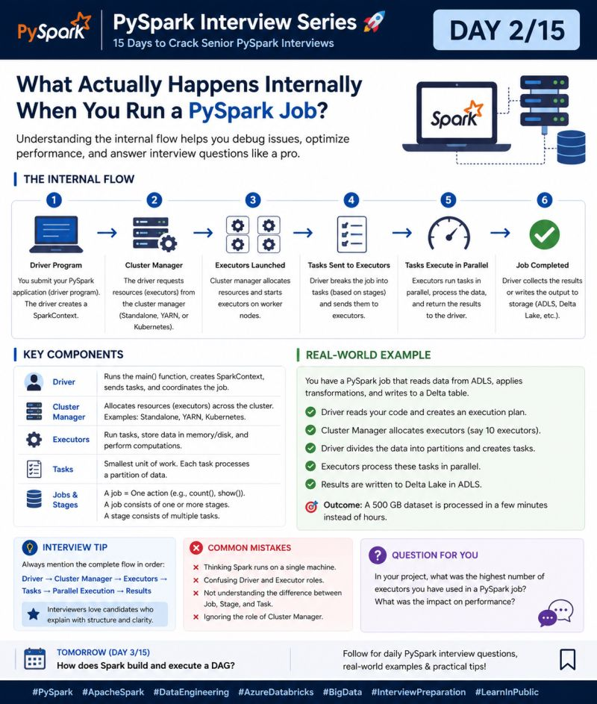

🚀 PySpark Interview Series | Day 3/15
Preparing for Senior PySpark interviews (3–8+ YOE)?
In Day 2, we explored what happens internally when a PySpark job runs.
Today, let's discuss one of the most important Spark concepts that interviewers love to ask.
❓ How does Spark build and execute a DAG (Directed Acyclic Graph)?
One of the biggest reasons Spark is fast is that it doesn't execute your code line by line.
Instead, Spark first builds a DAG (Directed Acyclic Graph) based on all the transformations you've written. It waits until an Action (like count(), show(), collect(), or write()) is triggered before executing anything.
This approach is called Lazy Evaluation.
Before execution, Spark analyzes the DAG, optimizes it, and then splits it into Stages and Tasks, which are executed in parallel across multiple executors.
That's why Spark avoids unnecessary computations and delivers much better performance.
💼 Real-World Example
Imagine your pipeline performs the following operations:
Read 2 TB of sales data from ADLS
Filter records for the current year
Join with the customer master
Aggregate sales by region
Write the output to a Delta table
Spark doesn't execute each step immediately.
Instead, it builds a DAG containing all transformations, optimizes the execution plan, identifies shuffle boundaries, creates stages, and finally executes everything only when the write() action is called.
This reduces redundant work and significantly improves performance.
🚀 Key Takeaways
🔹 Transformations are lazy
🔹 Actions trigger execution
🔹 Spark builds a DAG before running the job
🔹 DAG is divided into Stages
🔹 Each Stage is divided into Tasks
🔹 Tasks execute in parallel on Executors
💡 Interview Tip
If the interviewer asks:
"What is Lazy Evaluation?"
Don't stop there.
A stronger answer is:
"Spark records transformations, builds a DAG, applies optimizations using Catalyst Optimizer, splits the DAG into stages at shuffle boundaries, and executes the tasks only when an Action is triggered."
This shows you understand Spark's execution model, not just the definition.
💬 Question for you
In your project, which transformation caused the most shuffle or performance impact?
Was it a join(), groupBy(), distinct(), or something else?
Share your experience in the comments.
📅 Tomorrow (Day 4/15)
How does Catalyst Optimizer make Spark queries faster?
We'll explore Logical Plan → Optimized Logical Plan → Physical Plan, along with the optimization techniques Spark applies automatically before execution.
hashtag#PySpark hashtag#ApacheSpark hashtag#AzureDatabricks hashtag#AzureDataEngineer hashtag#DataEngineering hashtag#BigData hashtag#SparkDAG hashtag#LazyEvaluation hashtag#InterviewPreparation hashtag#DistributedComputing hashtag#LearnInPublic
Activate to view larger image,
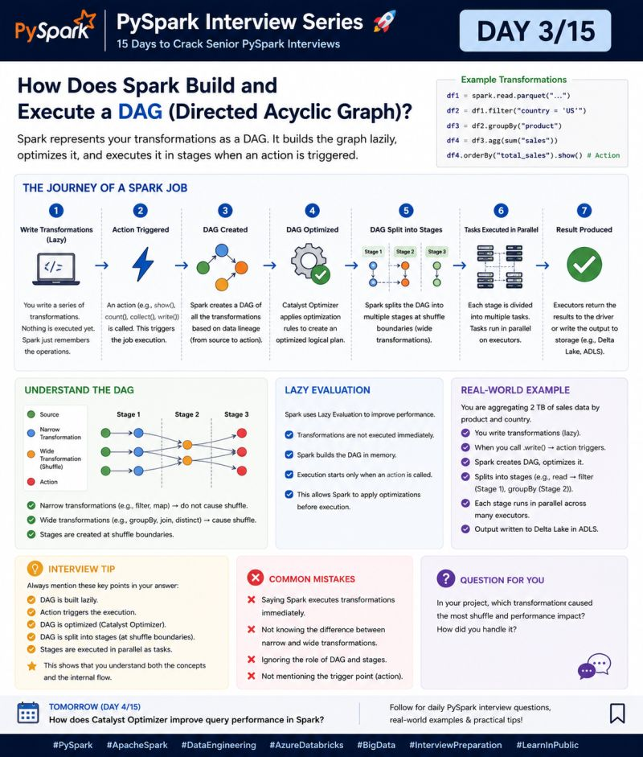

🚀 PySpark Interview Series | Day 4/15
Preparing for Senior PySpark interviews (3–8+ YOE)?
In Day 3, we learned how Spark builds a DAG and executes it only when an Action is triggered.
Today, let's understand the brain behind Spark SQL—a topic that is frequently asked in senior Data Engineer interviews.
❓ How does Catalyst Optimizer make Spark queries faster?
Writing an optimized query is important, but here's the interesting part:
Even if your query isn't perfect, Spark tries to optimize it before execution.
That's exactly what the Catalyst Optimizer does.
Catalyst is Spark SQL's built-in query optimizer. Before your code is executed, it analyzes the query and transforms it into the most efficient execution plan.
The optimization journey looks like this:
✅ Unparsed Query → Your SQL/PySpark code
✅ Logical Plan → Spark understands what you're trying to do.
✅ Optimized Logical Plan → Catalyst applies optimization rules.
✅ Physical Plan → Spark selects the best execution strategy.
Finally, the optimized plan is executed across the cluster.
💼 Real-World Example
Imagine you have a 2 TB sales dataset partitioned by Year and Country.
Your query filters only Country = 'US' and selects Product and SalesAmount.
Without optimization, Spark could read the entire dataset.
With Catalyst Optimizer:
✅ Applies Filter Pushdown
✅ Removes unused columns (Column Pruning)
✅ Reorders operations when beneficial
✅ Chooses an efficient join strategy
The result?
📈 Less data scanned, less shuffle, and significantly faster execution.
🚀 Key Optimizations Performed by Catalyst
🔹 Filter Pushdown
🔹 Column Pruning
🔹 Constant Folding
🔹 Predicate Simplification
🔹 Join Reordering
🔹 Broadcast Join Selection
💡 Interview Tip
If you're asked:
"What is Catalyst Optimizer?"
Don't just answer:
"It optimizes Spark queries."
Instead explain the execution flow:
Query → Logical Plan → Optimized Logical Plan → Physical Plan → Execution
Then mention 2–3 optimization techniques such as Filter Pushdown, Column Pruning, and Join Reordering.
That demonstrates a much deeper understanding of Spark internals.
💬 Question for you
Which Catalyst optimization has had the biggest impact in your project?
Filter Pushdown, Column Pruning, Broadcast Join, or something else?
Share your experience in the comments.
📅 Tomorrow (Day 5/15)
What is the Tungsten Engine, and why did it make Spark dramatically faster?
We'll explore Whole-Stage Code Generation, Off-Heap Memory, and Binary Processing—the technologies that significantly improved Spark's execution performance.
hashtag#PySpark hashtag#ApacheSpark hashtag#SparkSQL hashtag#CatalystOptimizer hashtag#AzureDatabricks hashtag#DataEngineering hashtag#BigData hashtag#InterviewPreparation hashtag#SparkPerformance hashtag#AzureDataEngineer hashtag#LearnInPublic
Activate to view larger image,
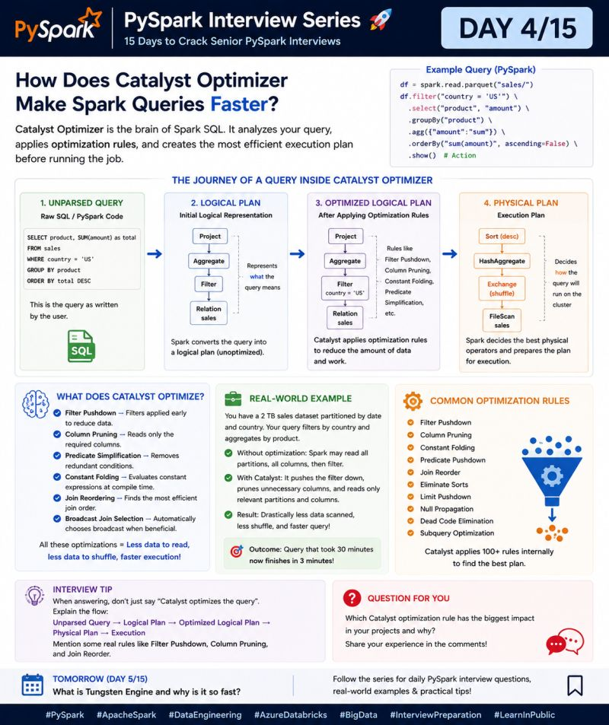

🚀 PySpark Interview Series | Day 5/15
Preparing for Senior PySpark interviews (3–8+ YOE)?
In Day 4, we explored how Catalyst Optimizer improves query execution by generating the best execution plan.
Today, let's understand another core reason behind Spark's performance.
❓ What is the Tungsten Engine, and why did it make Spark dramatically faster?
One of the most common misconceptions is:
"Spark is fast because it processes data in memory."
That's only part of the story.
The Tungsten Engine is Spark's execution engine, introduced to maximize CPU efficiency and memory utilization. Instead of relying entirely on the JVM's object model, Tungsten manages memory more efficiently and executes operations closer to the hardware.
It improves performance through:
✅ Whole-Stage Code Generation – Combines multiple operators into optimized machine-level code, reducing CPU overhead.
✅ Off-Heap Memory Management – Stores data outside the JVM heap, reducing Garbage Collection (GC) pauses.
✅ Compact Binary Processing – Uses an efficient binary format instead of Java objects, improving cache utilization.
✅ Reduced Serialization – Minimizes the cost of converting data between different formats.
The result?
More CPU utilization, lower memory overhead, and significantly faster Spark jobs.
💼 Real-World Example
Imagine you're processing a 1 TB customer transaction dataset with multiple joins and aggregations.
Without Tungsten:
Frequent object creation
High GC activity
Increased serialization overhead
Job completes in 45 minutes
With Tungsten:
Optimized code generation
Efficient off-heap memory
Better CPU cache utilization
Same workload finishes in 12 minutes
That's why modern Spark applications can process massive datasets much more efficiently.
🚀 Key Benefits of Tungsten
🔹 Higher CPU utilization
🔹 Lower Garbage Collection overhead
🔹 Better memory efficiency
🔹 Faster joins and aggregations
🔹 Improved overall query performance
💡 Interview Tip
If you're asked:
"What is the difference between Catalyst Optimizer and Tungsten Engine?"
A strong answer is:
Catalyst Optimizer decides the best execution plan.
Tungsten Engine executes that plan as efficiently as possible using code generation, optimized memory management, and binary processing.
Think of it like this:
Catalyst decides what is the best route. Tungsten decides how to drive on that route as fast as possible.
This explanation is simple, memorable, and interview-friendly.
💬 Question for you
Have you ever noticed a performance improvement after upgrading your Spark or Databricks Runtime version?
What was the biggest improvement—CPU usage, memory efficiency, or overall execution time?
hashtag#PySpark hashtag#ApacheSpark hashtag#SparkInternals hashtag#Tungsten hashtag#AzureDatabricks hashtag#DataEngineering hashtag#BigData hashtag#SparkPerformance hashtag#InterviewPreparation hashtag#AzureDataEngineer
Activate to view larger image,
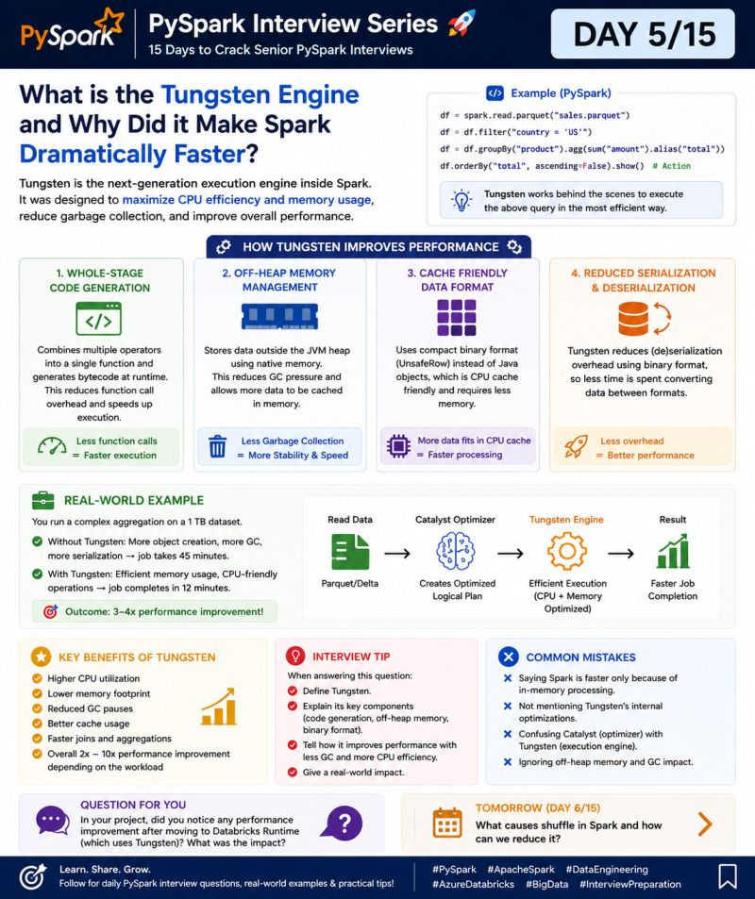

🚀 PySpark Interview Series | Day 6/15
Preparing for Senior PySpark interviews (3–8+ YOE)?
Over the last few posts, we've explored Spark Internals, DAGs, Catalyst Optimizer, and the Tungsten Engine.
Now let's talk about one of the biggest reasons why Spark jobs become slow in production.
❓ What causes Shuffle in Spark, and how can you reduce it?
If you've ever seen a Spark job that suddenly takes 30 minutes instead of 5, chances are Shuffle is one of the main reasons.
A shuffle occurs when Spark needs to redistribute data across partitions so that records with the same key end up together.
This data movement involves:
✅ Network I/O
✅ Disk I/O
✅ Serialization & Deserialization
✅ Additional CPU and memory usage
Because of this, shuffle is one of the most expensive operations in Spark.
Operations that commonly trigger a shuffle include:
groupBy()
join()
distinct()
orderBy()
repartition()
The more data Spark moves across the cluster, the slower your job becomes.
💼 Real-World Example
Imagine you're processing 2 TB of sales data and joining it with a customer dimension table.
Without optimization:
❌ No early filtering
❌ Regular join instead of Broadcast Join
❌ Unnecessary repartitioning
❌ Massive shuffle across executors
Result:
⏳ Job takes 55 minutes.
After optimization:
✅ Filter data before the join
✅ Broadcast the 2 MB customer dimension
✅ Remove unnecessary repartition
✅ Enable Adaptive Query Execution (AQE)
Result:
🚀 Job completes in 12 minutes with significantly less shuffle.
🚀 How to Reduce Shuffle
🔹 Filter data as early as possible
🔹 Broadcast small lookup tables
🔹 Select only required columns
🔹 Avoid unnecessary repartition()
🔹 Use AQE (Adaptive Query Execution)
🔹 Handle data skew proactively
💡 Interview Tip
If the interviewer asks:
"Why is shuffle expensive?"
Don't just say:
"Because data moves across the network."
A stronger answer is:
"Shuffle is expensive because it requires network transfer, disk writes, serialization/deserialization, and synchronization between executors. Reducing unnecessary shuffle is one of the biggest performance optimization techniques in Spark."
That answer immediately shows production-level understanding.
💬 Question for you
Which Spark operation has caused the biggest performance issue in your project?
join(), groupBy(), repartition(), or something else?
Share your experience in the comments.
📅 Tomorrow (Day 7/15)
How do you identify and fix Data Skew in Spark?
We'll discuss one of the most challenging real-world production issues and the techniques senior Data Engineers use to solve it.
hashtag#PySpark hashtag#ApacheSpark hashtag#SparkPerformance hashtag#DataEngineering hashtag#AzureDatabricks hashtag#BigData hashtag#Shuffle hashtag#InterviewPreparation hashtag#AzureDataEngineer hashtag#SparkOptimization hashtag#LearnInPublic
Activate to view larger image,
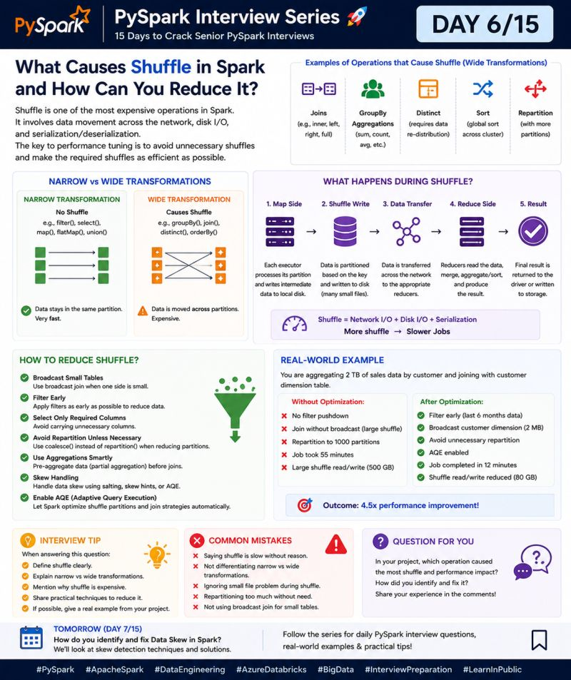

🚀 PySpark Interview Series | Day 7/15
Preparing for Senior PySpark interviews (3–8+ YOE)?
In Day 6, we learned why Shuffle is one of the costliest operations in Spark.
But here's something even more challenging...
👉 What if only ONE executor is doing most of the work while the others are idle?
That's exactly what Data Skew looks like—and it's one of the most common production issues in large-scale Spark jobs.
❓ How do you identify and fix Data Skew in Spark?
Data Skew occurs when a small number of keys contain a disproportionately large amount of data.
As a result:
❌ One or two executors process millions of records.
✅ The remaining executors finish quickly and wait.
Your entire Spark job cannot complete until the slowest task (often called a straggler) finishes.
💼 Real-World Example
Imagine you're joining:
1.5 TB Orders table
200 MB Customer dimension
Everything looks fine—until you discover that Customer ID = 999 has 50+ million records, while most customers have only a few thousand.
Without optimization:
❌ One executor receives almost all records for Customer 999
❌ Massive shuffle
❌ One task runs for 60+ minutes
❌ Entire stage waits for a single executor
After optimization:
✅ Broadcast the customer dimension
✅ Apply Salting to distribute the skewed key
✅ Enable Adaptive Query Execution (AQE)
✅ Filter unnecessary data before the join
🚀 Result: Stage completes in 11 minutes instead of 70 minutes.
🚀 How to Identify Data Skew
🔹 Check Spark UI → Stages → Tasks
🔹 Look for one task running much longer than others
🔹 Compare Shuffle Read/Write sizes
🔹 Check partition sizes
🔹 Profile high-frequency keys using SQL or PySpark
🚀 Common Techniques to Fix Data Skew
✅ Salting
✅ Broadcast Join
✅ Pre-Aggregation
✅ Smart Repartitioning
✅ Adaptive Query Execution (AQE)
💡 Interview Tip
If the interviewer asks:
"How do you handle Data Skew in Spark?"
Avoid listing techniques immediately.
Instead explain your approach:
1️⃣ Identify skew using Spark UI
2️⃣ Find the heavy keys
3️⃣ Choose the right solution (Broadcast, Salting, AQE, or Repartitioning)
4️⃣ Validate the improvement using execution metrics
Interviewers appreciate candidates who focus on diagnosis first, optimization second.
💬 Question for you
Have you ever faced Data Skew in production?
Which solution worked best for your project—Broadcast Join, Salting, AQE, or Repartitioning?
Share your experience in the comments.
📅 Tomorrow (Day 8/15)
Broadcast Join vs Sort Merge Join vs Shuffle Hash Join
We'll discuss how Spark chooses a join strategy and how selecting the right join can reduce execution time from hours to minutes.
hashtag#PySpark hashtag#ApacheSpark hashtag#DataSkew hashtag#SparkPerformance hashtag#AzureDatabricks hashtag#DataEngineering hashtag#BigData hashtag#InterviewPreparation hashtag#SparkOptimization hashtag#AzureDataEngineer hashtag#LearnInPublic
Activate to view larger image,
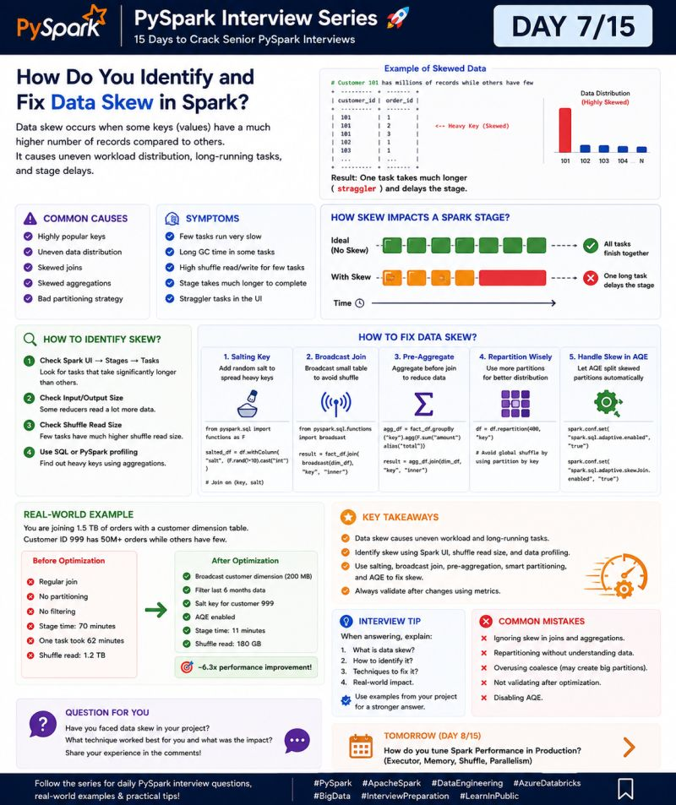

🚀 PySpark Interview Series | Day 8/15
Preparing for Senior PySpark interviews (3–8+ YOE)?
Today's interview question is one that almost every experienced Data Engineer encounters.
❓ Broadcast Join vs Sort Merge Join vs Shuffle Hash Join — Which one should you use?
A common mistake is saying:
"Broadcast Join is always the fastest."
The correct answer is:
It depends on your data size, cluster resources, and Spark's execution plan.
🚀 Broadcast Join
✅ Best for Small + Large table
Small table is copied to every executor
No shuffle on the large table
Fastest option when applicable
Example:
Orders (1.5 TB) + Customer (200 MB)
🚀 Sort Merge Join
✅ Best for Large + Large tables
Both tables are shuffled and sorted
Reliable for huge datasets
Default strategy for many Spark workloads
🚀 Shuffle Hash Join
✅ Best for Large + Medium table
Builds an in-memory hash table for the smaller side
Faster than Sort Merge Join in some cases
Requires sufficient executor memory
💼 Real-World Example
We joined:
Orders → 1.5 TB
Customer → 200 MB
Before Optimization
❌ Sort Merge Join
❌ Shuffle Read: 800 GB
⏳ Runtime: 70 mins
After Using Broadcast Join
✅ Minimal shuffle
✅ Runtime: 11 mins
🚀 6× faster execution
💡 Interview Tip
If asked:
"Which join strategy is the best?"
Don't answer with a single join type.
Instead say:
"I choose the strategy based on table size, statistics, available memory, and shuffle cost. Broadcast Join is ideal for small lookup tables, while Sort Merge Join is generally preferred for large datasets."
This demonstrates production-level thinking.
💬 Question for you
Which join strategy has delivered the biggest performance improvement in your project?
👇 Share your experience in the comments.
📅 Tomorrow (Day 9/15): Adaptive Query Execution (AQE)
How Spark automatically changes its execution plan at runtime to improve performance.
hashtag#PySpark hashtag#ApacheSpark hashtag#BroadcastJoin hashtag#SortMergeJoin hashtag#AzureDatabricks hashtag#DataEngineering hashtag#BigData hashtag#SparkPerformance hashtag#InterviewPreparation hashtag#AzureDataEngineer
Activate to view larger image,
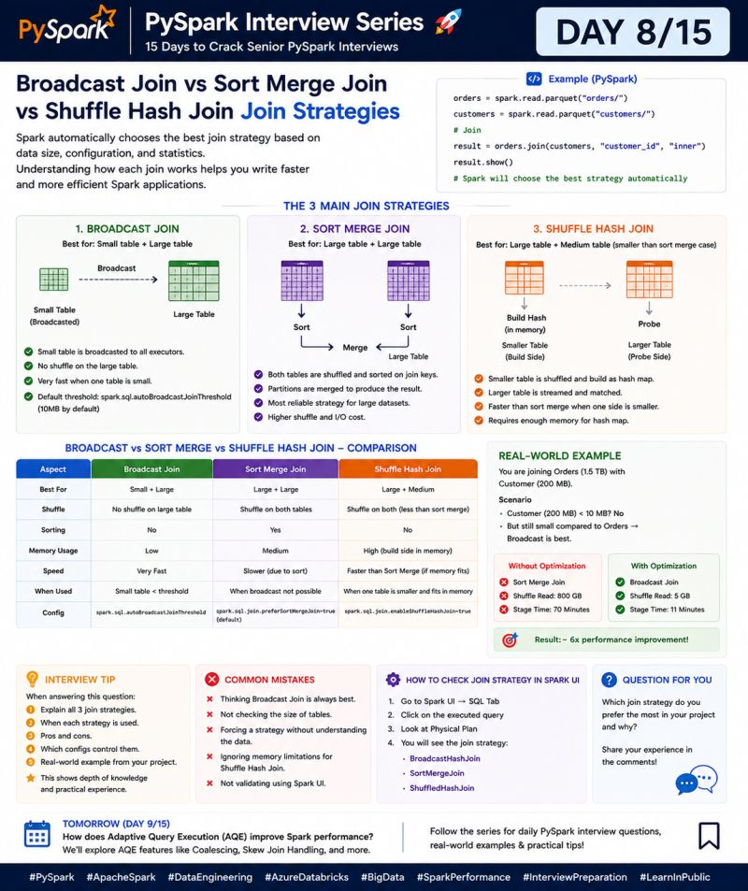

🚀 PySpark Interview Series | Day 9/15
Preparing for Senior PySpark interviews (3–8+ YOE)?
Yesterday, we discussed how Spark chooses the right Join Strategy.
Today, let's explore one of Spark's smartest optimization features.
❓ What is Adaptive Query Execution (AQE), and how does it improve Spark performance?
Before Spark 3.0, the execution plan was created before the job started and remained unchanged—even if runtime conditions were different.
With Adaptive Query Execution (AQE), Spark can re-optimize the execution plan while the job is running using real-time statistics.
Instead of relying only on estimates, AQE makes smarter decisions during execution.
🚀 What Can AQE Do?
✅ Coalesce Small Shuffle Partitions
Merges many small partitions into fewer larger ones, reducing scheduling overhead.
✅ Handle Data Skew Automatically
Detects skewed partitions and splits them into smaller tasks to avoid long-running executors.
✅ Switch Join Strategy at Runtime
If Spark discovers one table is much smaller than expected, it can automatically switch from a Sort Merge Join to a Broadcast Join.
No code changes required.
💼 Real-World Example
Imagine you're joining:
Orders: 1.5 TB
Customers: 200 MB
Without AQE
❌ 200 shuffle partitions
❌ Sort Merge Join
❌ One skewed partition delays the entire stage
⏳ Runtime: 75 minutes
With AQE Enabled
✅ Partitions automatically coalesced
✅ Skewed partition split into smaller tasks
✅ Join strategy switched to Broadcast Join
🚀 Runtime reduced to 12 minutes
🚀 Why AQE Matters
✔️ Better resource utilization
✔️ Less shuffle overhead
✔️ Automatic skew handling
✔️ Smarter join selection
✔️ Faster jobs with minimal manual tuning
💡 Interview Tip
If the interviewer asks:
"Why should we enable AQE?"
Don't just say:
"It improves performance."
Instead explain:
"AQE continuously collects runtime statistics and dynamically optimizes the execution plan by coalescing shuffle partitions, handling data skew, and selecting better join strategies."
That answer clearly demonstrates production-level knowledge.
💬 Question for you
Have you enabled AQE in your Spark jobs?
Which feature gave you the biggest improvement—partition coalescing, skew handling, or dynamic join selection?
👇 Share your experience in the comments.
📅 Tomorrow (Day 10/15)
Window Functions in PySpark
We'll cover ROW_NUMBER(), RANK(), DENSE_RANK(), LEAD(), and LAG() with real production use cases.
hashtag#PySpark hashtag#ApacheSpark hashtag#AQE hashtag#AdaptiveQueryExecution hashtag#AzureDatabricks hashtag#DataEngineering hashtag#SparkPerformance hashtag#BigData hashtag#InterviewPreparation hashtag#AzureDataEngineer hashtag#LearnInPublic
Activate to view larger image,
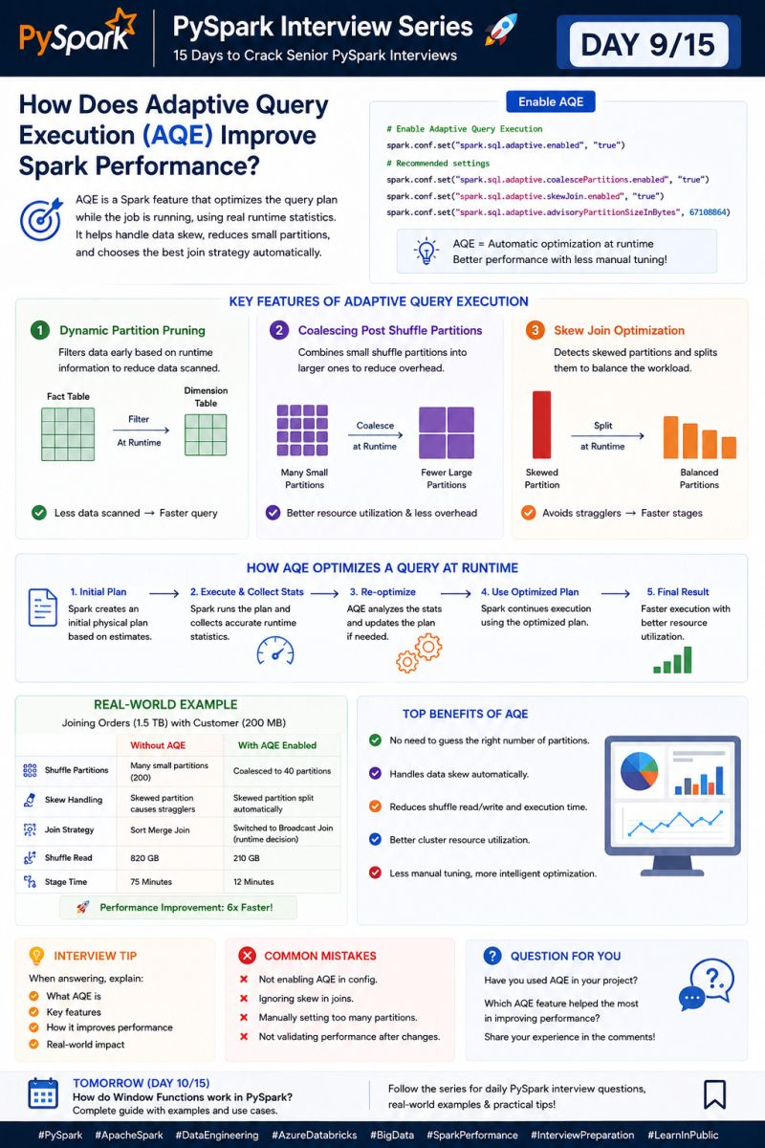

🚀 PySpark Interview Series | Day 10/15
Preparing for Senior PySpark interviews (3–8+ YOE)?
So far, we've covered Spark Internals, Shuffle, Data Skew, Join Strategies, and AQE.
Today, let's discuss one of the most practical topics you'll encounter in both interviews and production projects.
❓ What are Window Functions in PySpark, and when should you use them?
A common misconception is that Window Functions are just another way of writing GROUP BY.
They're not.
Unlike GROUP BY, Window Functions do not reduce the number of rows. Instead, they perform calculations across a group of related rows while preserving every record.
That's why they're widely used for ranking, running totals, and time-based analytics.
🚀 Most Common Window Functions
✅ ROW_NUMBER()
Assigns a unique number to each row within a partition.
👉 Perfect for removing duplicates or selecting the latest record.
✅ RANK() & DENSE_RANK()
Used to rank records.
RANK() leaves gaps when there are ties.
DENSE_RANK() does not leave gaps.
✅ LEAD() & LAG()
Compare the current row with the next or previous row.
Ideal for trend analysis, sales comparisons, and identifying changes over time.
💼 Real-World Example
Suppose your Employee table contains multiple salary records for each employee.
Your manager asks:
"Return only the latest salary record for every employee."
Instead of using complex joins or subqueries, you can use:
ROW_NUMBER()
PARTITION BY EmployeeID
ORDER BY UpdatedDate DESC
Then filter where Row_Number = 1.
This is one of the most common production use cases for Window Functions.
🚀 Where You'll Use Them
✔️ Remove duplicate records
✔️ Top N records per group
✔️ Running totals
✔️ Previous vs Current value comparison
✔️ Latest record per customer or employee
💡 Interview Tip
If the interviewer asks:
"When would you use Window Functions instead of GROUP BY?"
A strong answer is:
"I use GROUP BY when I need aggregated results with fewer rows. I use Window Functions when I need calculations like ranking, running totals, or previous/next values while keeping all original rows."
This clearly demonstrates that you understand the difference.
💬 Question for you
Which Window Function do you use the most in your projects?
ROW_NUMBER(), RANK(), DENSE_RANK(), LEAD(), or LAG()?
👇 Share your experience in the comments.
📅 Tomorrow (Day 11/15)
UDF vs Pandas UDF vs Built-in Functions
We'll discuss when to use each, their performance impact, and why built-in Spark functions are usually the best choice.
hashtag#PySpark hashtag#ApacheSpark hashtag#WindowFunctions hashtag#SparkSQL hashtag#AzureDatabricks hashtag#DataEngineering hashtag#BigData hashtag#InterviewPreparation hashtag#SparkPerformance hashtag#AzureDataEngineer hashtag#LearnInPublic
Activate to view larger image,
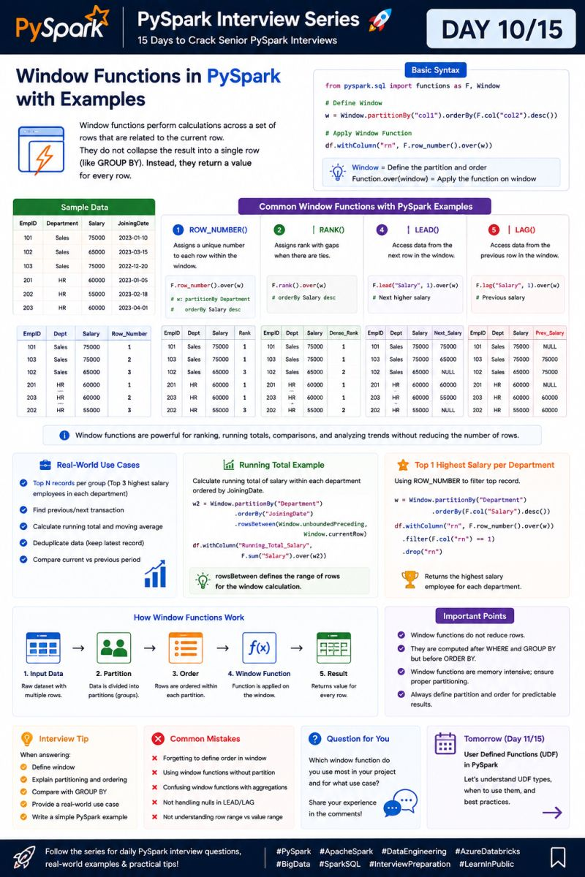

🚀 PySpark Interview Series | Day 11/15
Preparing for Senior PySpark interviews (3–8+ YOE)?
Yesterday, we discussed Window Functions and how they're used in real production scenarios.
Today, let's tackle a question that can make a big difference in Spark performance.
❓ UDF vs Pandas UDF vs Built-in Functions — Which one should you use?
A common mistake is:
"If I can write it in Python, I'll create a UDF."
In Spark, that's often a performance problem.
The general rule is:
Built-in Function → Pandas UDF → Python UDF
Choose the simplest option that solves the problem.
🚀 1️⃣ Built-in Spark Functions
First choice whenever possible.
Functions like when(), regexp_replace(), split(), date_format() and coalesce() are optimized by Spark's engine.
✅ Best performance
✅ Catalyst can optimize them
✅ No Python serialization overhead
🚀 2️⃣ Pandas UDF
Use when your transformation genuinely requires Python/Pandas logic and cannot be expressed efficiently with built-in Spark functions.
Pandas UDFs process data in batches using Apache Arrow, reducing the row-by-row overhead of a regular Python UDF.
✅ Faster than regular Python UDFs in many workloads
✅ Useful for complex transformations
⚠️ Still has Python/Arrow overhead
🚀 3️⃣ Regular Python UDF
A Python UDF executes custom Python logic outside Spark's JVM execution engine.
❌ Serialization/deserialization overhead
❌ Harder for Spark to optimize
❌ Can become a major bottleneck on large datasets
Use it only when there's no practical built-in or Pandas UDF alternative.
💼 Real-World Example
Imagine a clickstream pipeline processing 2 TB of data.
A developer uses a Python UDF for string transformations.
⏳ Runtime: 2.5 hours
After replacing the UDF with Spark's built-in functions:
🚀 Runtime: 8 minutes
The biggest optimization wasn't adding more executors.
It was choosing the right function.
💡 Interview Tip
If asked:
"Which is better: UDF or built-in function?"
Don't just say "built-in."
Explain why:
"I prefer built-in Spark functions because they remain within Spark's optimized execution engine and can benefit from Catalyst optimization. I use Pandas UDFs when vectorized Python logic is genuinely required, and regular Python UDFs only as a last resort."
That's a much stronger 3+ YOE answer.
💬 Question for you
Have you ever replaced a Python UDF with a built-in Spark function?
How much performance improvement did you get?
👇 Share your experience.
📅 Tomorrow (Day 12/15)
Caching vs Checkpointing in PySpark
When should you use each, and what's the difference between performance optimization and fault-tolerant recovery?
hashtag#PySpark hashtag#ApacheSpark hashtag#UDF hashtag#PandasUDF hashtag#AzureDatabricks hashtag#DataEngineering hashtag#BigData hashtag#SparkPerformance hashtag#InterviewPreparation hashtag#AzureDataEngineer hashtag#LearnInPublic
Activate to view larger image,

🚀 PySpark Interview Series | Day 12/15
Preparing for Senior PySpark interviews (3–8+ YOE)?
Yesterday, we discussed UDF vs Pandas UDF vs Built-in Functions and why choosing the right function can have a huge impact on Spark performance.
Today, let's cover another interview favorite.
❓ Caching vs Checkpointing in PySpark — What's the difference?
Both can improve Spark applications, but they solve different problems.
Think of it this way:
⚡ Cache = Performance
🛡️ Checkpoint = Reliability
🚀 Caching
Caching keeps a DataFrame/RDD in memory (or memory + disk) so it can be reused without recomputing the entire lineage.
Use it when:
✅ The same dataset is used multiple times
✅ You have iterative transformations
✅ Recomputing the data is expensive
Example:
df.cache() df.count() # Materialize cache
🛡️ Checkpointing
Checkpointing saves the data to reliable distributed storage and breaks the existing lineage.
It's especially useful when your pipeline has a very long or complex lineage and recomputation would be expensive.
spark.sparkContext.setCheckpointDir("/checkpoints") df = df.checkpoint(eager=True)
💼 Real-World Example
Imagine a pipeline processing 2 TB of data with 20+ transformations.
The resulting DataFrame is reused in several downstream operations.
Without caching:
❌ Same transformations repeatedly recomputed
❌ Higher execution time
❌ More cluster resources consumed
With caching:
✅ Dataset reused from cache
✅ Faster downstream actions
✅ Less recomputation
Now imagine the lineage itself becomes extremely long.
That's where Checkpointing becomes useful:
✅ Saves the result to reliable storage
✅ Truncates lineage
✅ Reduces risk from extremely long dependency chains
🎯 Quick Comparison
Cache → "I need this data again."
Checkpoint → "I need to break this lineage and make recovery easier."
💡 Interview Tip
If asked:
"When would you use cache vs checkpoint?"
A strong answer is:
"I use cache when the same DataFrame will be reused and I want to avoid recomputation. I use checkpoint when the lineage becomes very long or I need a reliable recovery point. Cache is primarily a performance optimization, while checkpointing is primarily about reliability and lineage management."
💬 Question for you
In your production projects, which have you used more:
Caching or Checkpointing?
And what problem were you solving?
👇 Share your experience in the comments.
📅 Tomorrow (Day 13/15)
Spark Partitioning Deep Dive
We'll explore Hash Partitioning, Range Partitioning, Repartition vs Coalesce, and how the right partition strategy can improve Spark performance.

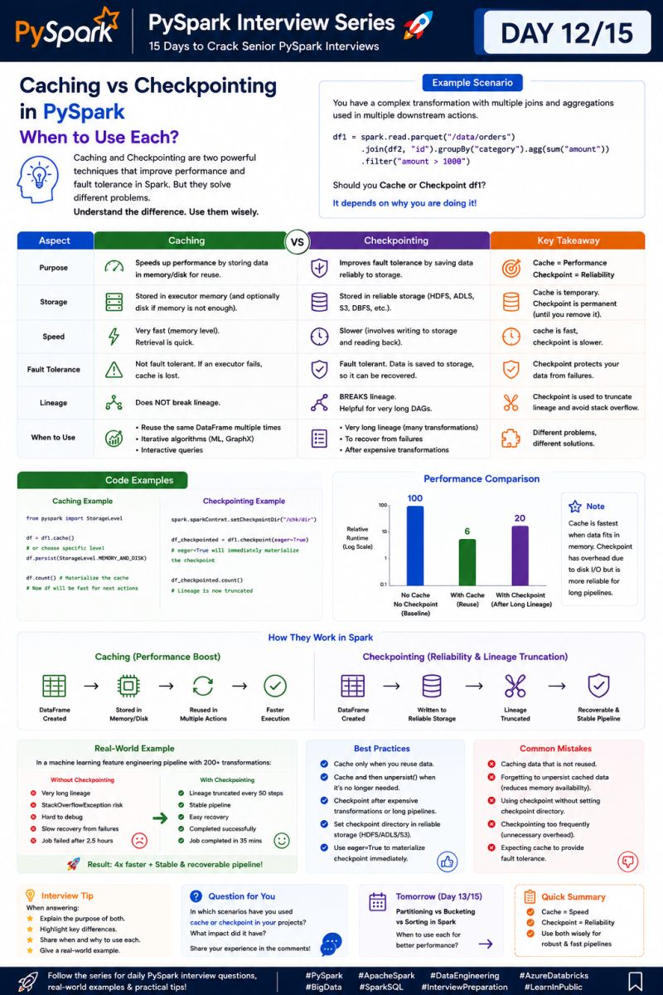

🚀 PySpark Interview Series | Day 13/15
Preparing for Senior PySpark interviews (3–8+ YOE)?
So far, we've covered Shuffle, Data Skew, Join Strategies, AQE, Window Functions, UDFs, and Caching.
But there's one concept connecting many of these performance problems:
❓ How do you choose the right partitioning strategy in Spark?
Partitioning determines how Spark distributes data across executors.
Good partitioning → better parallelism, less skew, and faster jobs.
Bad partitioning → uneven workloads, excessive shuffle, and wasted resources.
🚀 3 Partitioning Strategies
1️⃣ Hash Partitioning
Data is distributed based on the hash of a key.
👉 Useful for joins and aggregations.
df.repartition("customer_id")
2️⃣ Range Partitioning
Data is distributed based on value ranges.
👉 Useful for range queries and ordered workloads.
3️⃣ Round-Robin
Rows are distributed relatively evenly when there's no natural partitioning key.
⚡ Repartition vs Coalesce
This is a very common interview question.
repartition()
✅ Can increase or decrease partitions
⚠️ Causes a full shuffle
👉 Useful when you need better data distribution.
coalesce()
✅ Primarily reduces partitions
✅ Avoids a full shuffle
👉 Useful before writing output files.
Quick Rule:
Need redistribution? → repartition()
Just need fewer partitions? → coalesce()
💼 Real-World Example
A production pipeline was joining data using customer_id, but a few customers had millions of records.
Result:
❌ Severe data skew
❌ One executor became a straggler
⏳ Job took 2+ hours
After repartitioning around the join key and addressing the skew:
🚀 Runtime dropped to 22 minutes.
💡 Interview Tip
Don't say:
"More partitions always means better performance."
Instead explain that partition count depends on:
Data volume
Cluster cores
Partition size
Shuffle operations
Data distribution
The goal is balanced partitions, not simply more partitions.
💬 Question for you
Which partitioning strategy has helped you most in production?
Repartition, Coalesce, Hash Partitioning, or Range Partitioning?
👇 Share your experience.
📅 Tomorrow (Day 14/15)
Delta Lake Optimization in PySpark
We'll cover OPTIMIZE, Z-ORDER, VACUUM, file sizes, and data skipping—all important topics for Azure Databricks interviews.
#PySpark #ApacheSpark #SparkPartitioning #AzureDatabricks #DataEngineering #BigData #SparkPerformance #InterviewPreparation #AzureDataEngineer

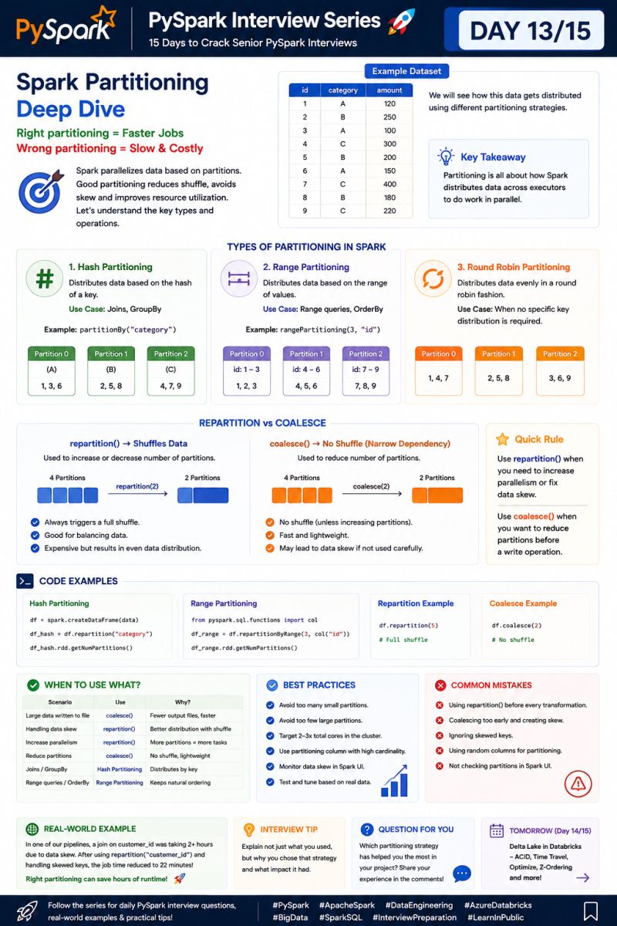

🚀 PySpark Interview Series | Day 14/15
Preparing for Senior PySpark interviews (3–8+ YOE)?
We've covered Spark internals, Shuffle, Data Skew, Join Strategies, AQE, UDFs, Partitioning, and more.
Today, let's move from Spark execution to Delta Lake performance—a very common topic in Azure Databricks interviews.
❓ How do you optimize a Delta Lake table in production?
A Delta table can work perfectly from a functional perspective and still become slow and expensive because of poor file layout.
The biggest problems are usually:
❌ Too many small files
❌ Poor data layout
❌ Excessive data scanning
❌ Unnecessary storage buildup
Here are the key optimization techniques:
🚀 1️⃣ OPTIMIZE
Compacts many small files into larger files.
spark.sql(""" OPTIMIZE sales """)
👉 Helps reduce file-opening overhead and improves query performance.
🚀 2️⃣ Z-ORDER
Clustering data based on frequently filtered columns can improve data skipping.
spark.sql(""" OPTIMIZE sales ZORDER BY (customer_id, order_date) """)
👉 Useful when queries frequently filter on those columns.
🧹 3️⃣ VACUUM
Removes old data files that are no longer required by Delta's retention rules.
spark.sql(""" VACUUM sales RETAIN 168 HOURS """)
⚠️ Don't blindly reduce retention in production—understand your recovery and time-travel requirements first.
📁 4️⃣ Control File Sizes
Millions of tiny files can seriously hurt performance.
Instead of:
10,000 tiny files → slow queries
Aim for:
fewer appropriately sized files → better parallelism + lower overhead
💼 Real-World Example
A sales Delta table was growing every day and queries started taking 45 minutes.
After investigating:
❌ Thousands of small files
❌ Poor data layout
❌ Large amount of unnecessary data being scanned
The team applied:
✅ OPTIMIZE
✅ Z-ORDER on frequently filtered columns
✅ VACUUM according to retention requirements
✅ Better partition/write strategy
Result:
🚀 Query runtime reduced from 45 minutes → 6 minutes.
💡 Interview Tip
If asked:
"How would you optimize a slow Delta table?"
Don't just say "run OPTIMIZE."
A stronger answer is:
"I'd first inspect file sizes, number of files, query patterns and data skipping. Then I'd address small files with OPTIMIZE, consider Z-ORDER for selective filter columns, review partitioning, and use VACUUM according to the required retention policy."
That shows production troubleshooting, not command memorization.
📅 Tomorrow (Day 15/15)
🔥 End-to-End PySpark Production Interview Scenario
We'll put everything together and walk through a real-world PySpark pipeline, from data ingestion to optimization and troubleshooting.
#PySpark #DeltaLake #AzureDatabricks #DataEngineering #BigData #SparkPerformance #DataEngineer #InterviewPreparation #AzureDataEngineer #Databricks

🚀 PySpark Interview Series | Day 15/15
15 days. 15 interview-focused topics. One goal — become stronger at PySpark interviews.
If you've followed the complete series, you've covered everything from Spark Internals to production optimization.
Let's finish with a scenario that brings it all together.
1️⃣ Ingest → Bronze
Load raw data into Delta Lake.
✅ Incremental ingestion
✅ Schema handling
✅ Preserve raw data
2️⃣ Transform → Silver
Clean, deduplicate and standardize the data.
Use:
Built-in Spark functions
Window Functions
Appropriate partitioning
Data quality checks
3️⃣ Join & Optimize
Before joining large datasets:
🔹 Filter unnecessary records
🔹 Select only required columns
🔹 Broadcast small dimensions
🔹 Enable AQE
🔹 Check for Data Skew
4️⃣ Aggregate → Gold
Create business-ready datasets using:
groupBy() → aggregations → Delta tables
Partition based on actual query patterns—not simply because a column exists.
5️⃣ Optimize Delta Lake
For frequently queried tables:
✅ OPTIMIZE → compact small files
✅ Z-ORDER → improve data skipping where appropriate
✅ VACUUM → clean up old files according to retention requirements
6️⃣ Monitor & Troubleshoot
If the pipeline suddenly becomes slow, check:
🔍 Spark UI
🔍 Shuffle Read/Write
🔍 Task duration & skew
🔍 Partition sizes
🔍 Executor memory
🔍 Small-file count
🔍 Join strategy
💼 Real Production Thinking
A senior engineer doesn't immediately add more cluster resources when a job is slow.
First ask:
Where is the bottleneck?
Is it:
Data Skew → Shuffle → Join → Partitioning → Memory → Small Files → I/O?
Then optimize the actual bottleneck.
💡 Final Interview Tip
When answering architecture questions, don't just explain what you would use.
Explain:
Why → Where → Trade-off → Expected impact
For example:
"I'd use a Broadcast Join because the dimension is small enough to replicate across executors, avoiding a large shuffle on the fact dataset."
That's the difference between knowing PySpark and thinking like a production Data Engineer.
🎯 15-Day Series Recap
Spark Internals → DAG → Catalyst → Tungsten → Shuffle → Data Skew → Joins → AQE → Window Functions → UDFs → Cache/Checkpoint → Partitioning → Delta Optimization → Production Debugging
We've covered the concepts.
Now the next step is applying them to real projects and interviews.
💬 Final Question
If you had to choose ONE PySpark topic that has helped you most in production, what would it be?
Performance Optimization, Joins, Data Skew, Partitioning, or something else?
👇 Share it in the comments.
And if you've followed the series from Day 1 → Day 15, thank you! 🙌
📌 Save this series for your next PySpark interview revision.
#PySpark #ApacheSpark #AzureDatabricks #DataEngineering #BigData #SparkPerformance #DeltaLake #AzureDataEngineer #InterviewPreparation #Databricks #SparkSQL #LearnInPublic

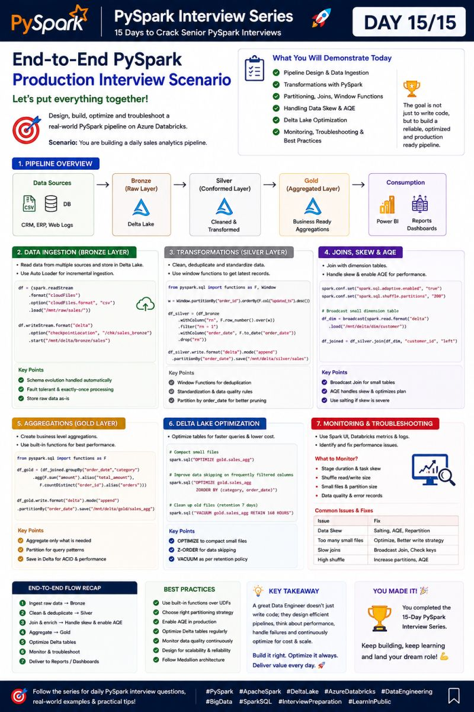

Just Published: 100 Real-World PySpark Interview Questions & Answers for Data Engineers
PySpark is one of the most requested skills in modern Data Engineering interviews.
However, most interview preparation focuses on DataFrame syntax rather than real production challenges.
To bridge that gap, I've compiled a handbook covering 100 real-world PySpark interview questions and answers inspired by scenarios commonly discussed in large enterprises, banking, fintech, consulting, and cloud-native data platforms.
📘 Topics Covered:
✅ Spark Architecture
✅ Transformations vs Actions
✅ Narrow vs Wide Transformations
✅ Partitioning & Repartitioning
✅ Data Skew Handling
✅ Broadcast Joins
✅ Window Functions
✅ Delta Lake
✅ CDC Pipelines
✅ Structured Streaming
✅ Watermarking & Late Arriving Data
✅ Performance Optimization
✅ Spark SQL
✅ Databricks Best Practices
✅ Azure & AWS Data Lake Architectures
✅ Banking & Financial Services Use Cases
Some real-world interview questions include:
🔹 Why is your Spark job taking 2 hours and how would you optimize it?
🔹 How would you handle data skew in a 10-billion-row transaction table?
🔹 When should you use broadcast joins?
🔹 How would you implement CDC using Delta Lake?
🔹 How do you process late-arriving events in streaming pipelines?
🔹 What happens during a Spark shuffle and why is it expensive?
🔹 How would you design a fraud detection pipeline using PySpark?
The biggest difference between average and top Data Engineers is not coding ability.
It's understanding how distributed systems behave in production.
💡 Spark is easy to learn.
Building scalable, reliable, and cost-efficient Spark platforms is the real skill.
Which PySpark interview question challenged you the most?
Drop it in the comments and let's discuss solutions.
🔄 Repost if this helps someone preparing for Data Engineering interviews.
hashtag#PySpark hashtag#DataEngineering hashtag#Databricks hashtag#ApacheSpark hashtag#BigData hashtag#DataEngineer hashtag#Azure hashtag#AWS hashtag#DeltaLake hashtag#StructuredStreaming hashtag#CloudComputing hashtag#AnalyticsEngineering hashtag#DataArchitecture hashtag#MachineLearning hashtag#ArtificialIntelligence hashtag#InterviewPreparation hashtag#CareerGrowth hashtag#TechLeadership hashtag#DataPlatform hashtag#ETL

