SMART PARKING USING IOT

INNOVATION:

Team Leader name and Members:

VIGNESH SEKAR.S (Leader)

[vigneshsekar2003s@gmail.com](mailto:vigneshsekar2003s@gmail.com)

SYED ALTHAF.F

[althafkhankhan19@gmail.com](mailto:althafkhankhan19@gmail.com)

CHRISTY MATHAI

[christymathai008@gmail.com](mailto:christymathai008@gmail.com)

VASANTHARAM.R

vasantharam321@gmail.com

Creating innovation in an IOT smart parking project involves thinking creatively and incorporating advanced technologies and es. approachHere are some ideas to foster innovation

1.Sensor Technology:

Explore advanced sensor technologies like ultrasonic,LiDAR,or images recognition to improve parking space detection accuracy

2.Data Analytics:

Implement machine learning algorithms to analyze parking data.Predictive analytics can help drivers find available spots more efficiently

3.Mobile apps:

Develop user friendly app that not only helps users find parking spaces but also features like reservations,payment and navigation to the spot

4.Integration:

Integrate with other IOT systems,such as traffic management,to optimize traffic flow and reduce congestionaround parking areas

5.Energy Efficiency:

Use Renewable energy sources to power IOT devices,making the system more sustainable

Real-time Updates:

Provide real-time updates on parking availability through various communication channels,including social media,to keep users informed

Smart parking Garages:

The project to include multi-level parking garages with automated car stacking systems

Security:

Ensure robust cyber security measures to protect user data and the IOT infrastructure

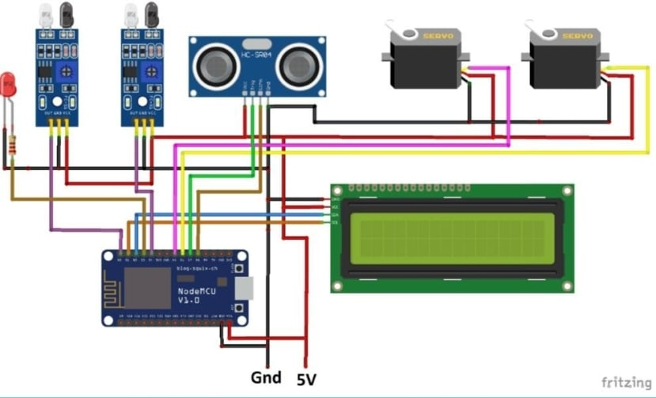

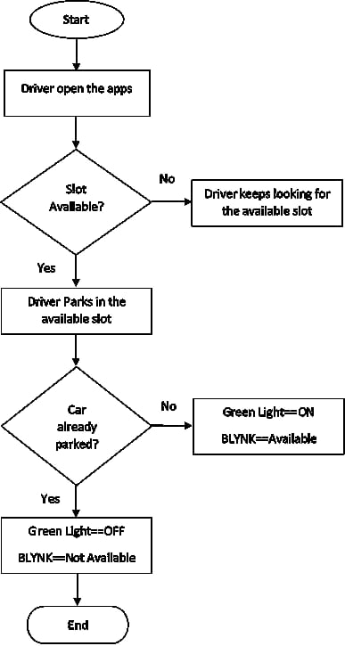

Technology:

1.Python Programming

2.Open cv

3.Ultrasonic sensor

4.Microcontroller

5.Mobile application