- A company is developing a smart security system for a research laboratory. Every employee entering the lab
uses a digital access card that generates a sequence of symbols:
a → Valid ID scan
b→ Biometric verification
c→ Door access confirmation
The security rule states that:
1. Every valid access sequence must start with a.
2. It may contain any number of biometric checks (b).
3. The sequence must end with c.
Examples of valid sequences: ac, abc, abbc, abbbc

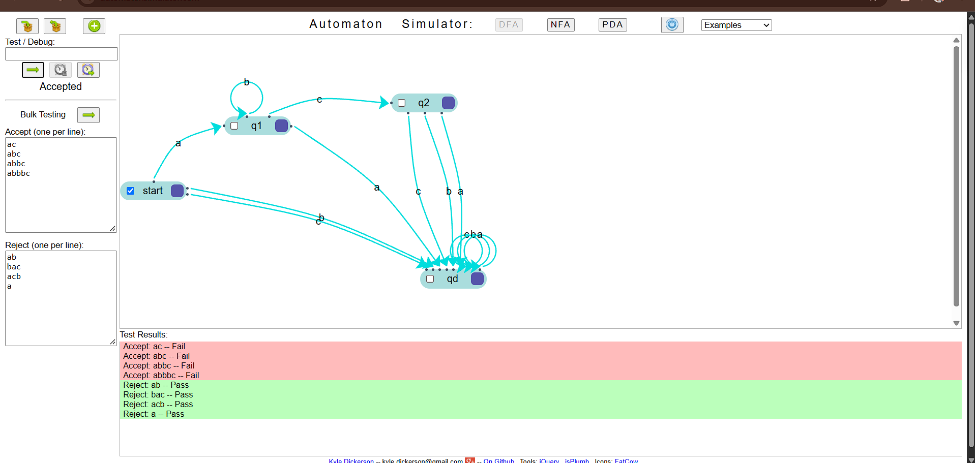

2.Given a DFA used for validating a specific PIN pattern bbbc, bcac, ca, caaaaaa minimize the DFA and explain how state reduction improves performance and efficiency in embedded systems

