1.wrp in c to simulate DFA for a given langugae reprsenting STRINGS that start with 0 and end with 1

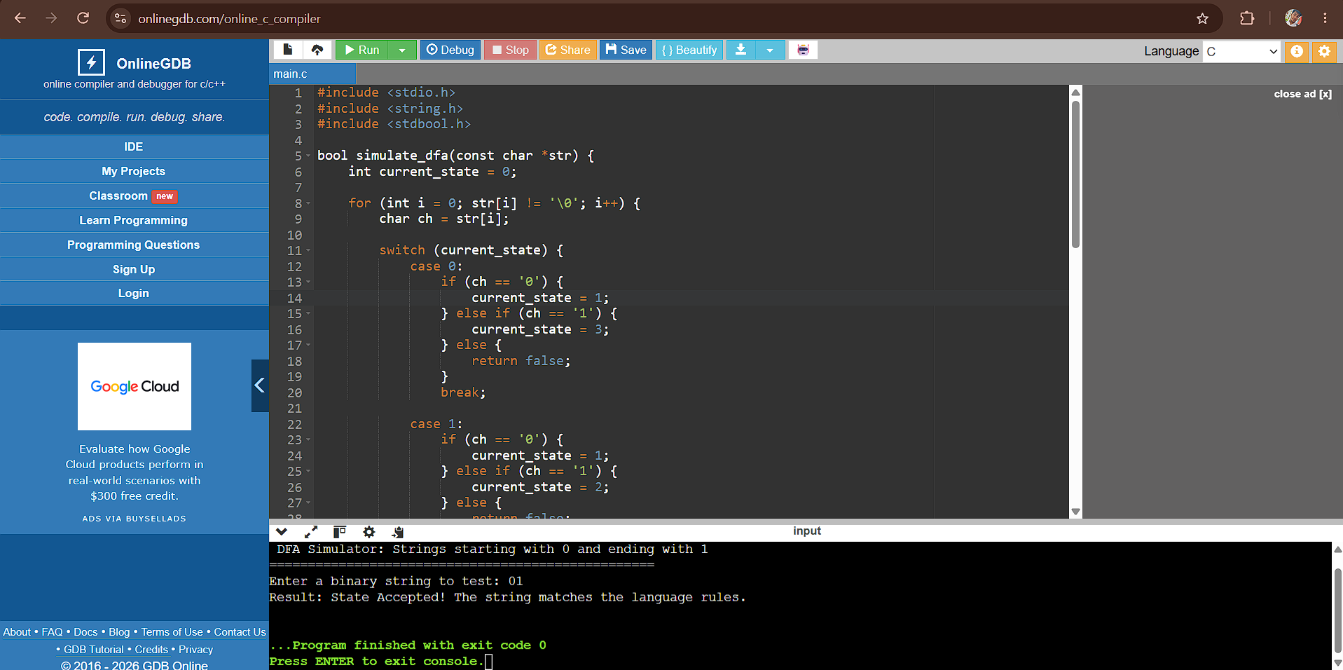
#include <stdio.h>
#include <string.h>
#include <stdbool.h>

bool simulate_dfa(const char *str) {
int current_state = 0;

for (int i = 0; str[i] != '\0'; i++) {
char ch = str[i];

switch (current_state) {
case 0:
if (ch == '0') {
current_state = 1;
} else if (ch == '1') {
current_state = 3;
} else {
return false;
}
break;

case 1:
if (ch == '0') {
current_state = 1;
} else if (ch == '1') {
current_state = 2;
} else {
return false;
}
break;

case 2:
if (ch == '0') {
current_state = 1;
} else if (ch == '1') {
current_state = 2;
} else {
return false;
}
break;

case 3:
if (ch == '0' || ch == '1') {
current_state = 3;
} else {
return false;
}
break;
}
}

return (current_state == 2);
}

int main() {
char input_string[100];

printf("==================================================\n");
printf(" DFA Simulator: Strings starting with 0 and ending with 1 \n");
printf("==================================================\n");
printf("Enter a binary string to test: ");

if (fgets(input_string, sizeof(input_string), stdin)) {
input_string[strcspn(input_string, "\n")] = '\0';

if (simulate_dfa(input_string)) {
printf("Result: State Accepted! The string matches the language rules.\n");
} else {
printf("Result: State Rejected! The string fails the language rules.\n");
}
}

return 0;
}

2.In C – The given language that start with “a” and end with “a”
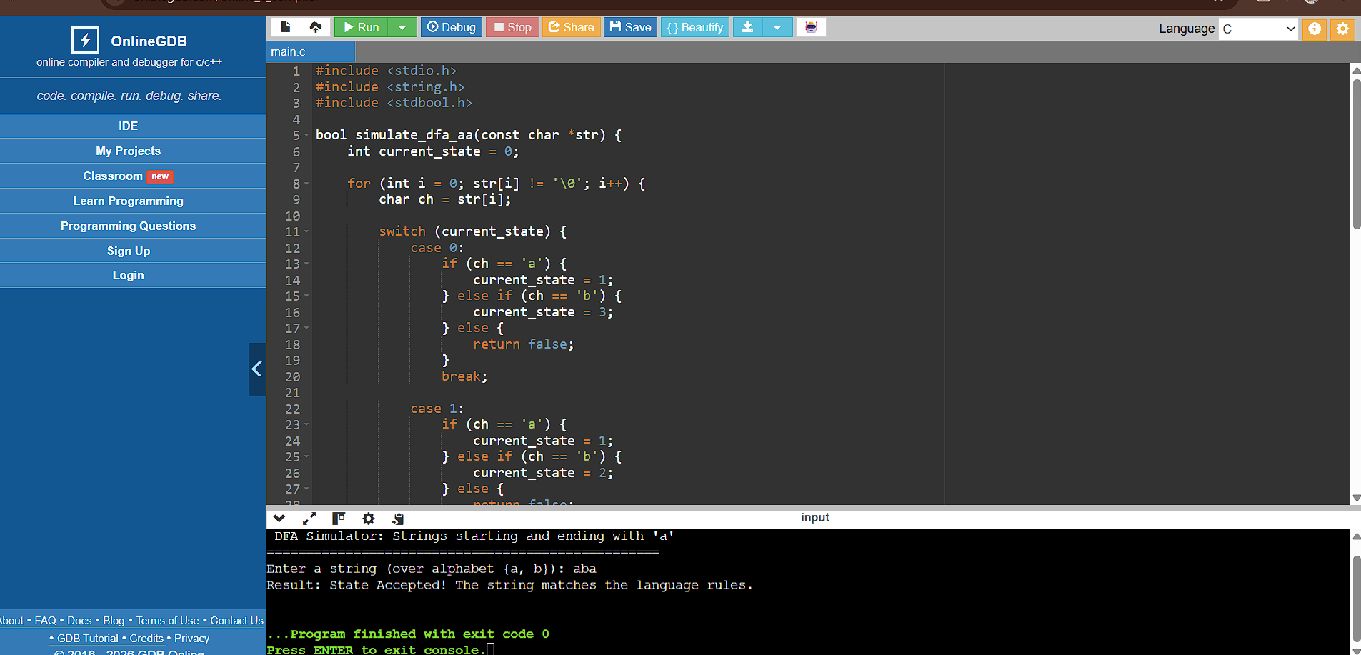

#include <stdio.h>
#include <string.h>
#include <stdbool.h>

bool simulate_dfa_aa(const char *str) {
int current_state = 0;

for (int i = 0; str[i] != '\0'; i++) {
char ch = str[i];

switch (current_state) {
case 0:
if (ch == 'a') {
current_state = 1;
} else if (ch == 'b') {
current_state = 3;
} else {
return false;
}
break;

case 1:
if (ch == 'a') {
current_state = 1;
} else if (ch == 'b') {
current_state = 2;
} else {
return false;
}
break;

case 2:
if (ch == 'a') {
current_state = 1;
} else if (ch == 'b') {
current_state = 2;
} else {
return false;
}
break;

case 3:
if (ch == 'a' || ch == 'b') {
current_state = 3;
} else {
return false;
}
break;
}
}

return (current_state == 1);
}

int main() {
char input_string[100];

printf("==================================================\n");
printf(" DFA Simulator: Strings starting and ending with 'a' \n");
printf("==================================================\n");
printf("Enter a string (over alphabet {a, b}): ");

if (fgets(input_string, sizeof(input_string), stdin)) {
input_string[strcspn(input_string, "\n")] = '\0';

if (simulate_dfa_aa(input_string)) {
printf("Result: State Accepted! The string matches the language rules.\n");
} else {
printf("Result: State Rejected! The string fails the language rules.\n");
}
}

return 0;
}

